一、电源问题 Power Issues

控制板灯不亮（适配器）No Led On the Control Board
1 检查接线，测控制板BAT端口的电压
2 如果电压正常，检查控制板power灯是否正常闪烁，如果没亮，检查更换保险丝
3 如果电压低于22VDC，断开电池和控制板之间的接线，测量电池电压是否正常，如果低，测TS24-U适配器的输出，如果输出正常，多充一会儿试试；
4 如果电池电压还是不行，检查电池，更换电池试试

- Check all the wires are connected as they should be. And please measure the voltage of the +BAT- terminals (11# and 12#) on the control board to see whether it is above 22V.

- If the voltage is normal, please check whether the power led on the control board is ON (blinks twice per second). If it is off, check the fuse whether it was burnt out and replace the fuse if necessary. There is a backup fuse packed within the user manual pack. The fuse type is ∅5*20mm 5A 250VAC fast blow glass fuse.
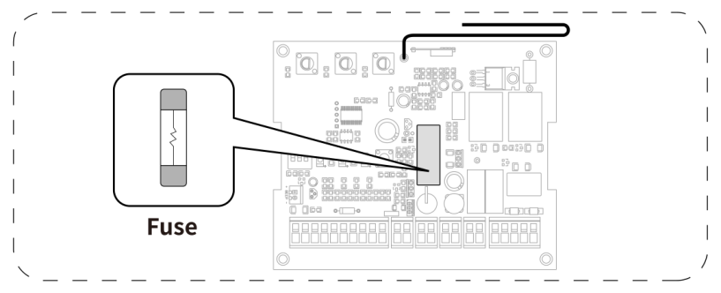

- If the voltage is below 22V, please check whether the output voltage of the adapter is 36VDC. If so, disconnect the batteries from the control board and measure the output voltage of the batteries to see whether it is above DC 22V. If the voltage of the batteries is also below 22V, please keep the batteries charged fully to try it again.

- If it still cannot work, please check the batteries. Kindly note that A 24V 12Ah battery (or 2pcs 12V batteries connected in series may function as 24V) is required to power the gate opener. Marine or Automotive type battery is compatible.

控制板灯不亮（纯太阳能）
1 检查接线，测控制板BAT断开的电压是否22V以上
2 如果电压正常，检查更换保险丝
3 如果电压低于正常值，把太阳能控制器和太阳板、控制板断开，用万用表测电池电压和控制器load端口的输出，
a 如果电池电压正常，但是控制器输出不对，控制器坏，需要更换；
b 如果电池电压低于22VDC，用额外的电池充电器把电池充满再试；
c 如果电池充满的情况下，电池电压依然22VDC以下，电池坏，需要更换电池；

1 Check all the wires are connected as they should be. And please measure the voltage of the +BAT- terminals (11# and 12#) on the control board to see whether it is above 22V.

2 If the voltage is normal, please check whether the power led on the control board is ON. If the power led is off, check the fuse whether it was burnt out and replace the fuse if necessary. There is a backup fuse packed within the user manual pack. The fuse type is ∅5*20mm 5A 250VAC fast blow glass fuse.

3 If the voltage is below 22V, disconnect the solar charge controller from the solar panels, and disconnect the solar controller from the control board. Use a multi-meter to test the voltage of the batteries, as well as the output voltage from the LOAD terminals of the solar charger controller.
a. If battery voltage is above 22 VDC, but there's no output voltage from LOAD of the solar charger controller or the output voltage is too low, then the solar charger controller is defective.
b. If the battery voltage is less than 22 VDC, please fully charge the batteries with an additional charger and do the test again.
c. If battery voltage is always below 22VDC even if fully charged, replace the batteries, fully charge new batteries and try again.

太阳能不能给电池充电 The Batteries Cannot Be Charged by Solar
科普文章链接：
Please click the following link to get more about the troubleshooting of the solar charge system:
https://topens.com/blogs/blog-posts/troubleshooting-your-solar-kit-for-solar-powered-automatic-gate-opener

1 断开太阳能板和太阳能控制器，断开太阳能板间的链接，在阳光直射太阳能板的时候，用万用表测太阳能板的开路电压，如果电压过低，太阳能板坏
2 有时电压不够准确排查太阳板是否正常充电，因此有时也需要测太阳能板和电池的充电电流。测充电电流时，注意万用表调电流档。
3 测太阳能控制器有没有充电电流

- Disconnect the solar controller from the solar panels, disconnect the solar panels from each other. Measure the output voltage of the solar panels one by one in the sunlight without shadow (please measure the voltage of the cables on the solar panel). In a normal case, it should be more than 42VDC. If either of the solar panels is faulty, it will affect the performance of the other one. If the value is too low, the solar panel might be defective.

2. If the output voltage of the solar panel is normal, directly connect the solar panel to the battery as picture below and test the charging current using a multi-meter (set it to DC Current and then connect it in series with the solar panel and battery). If no current is detected, it indicates that the solar panel is defective.
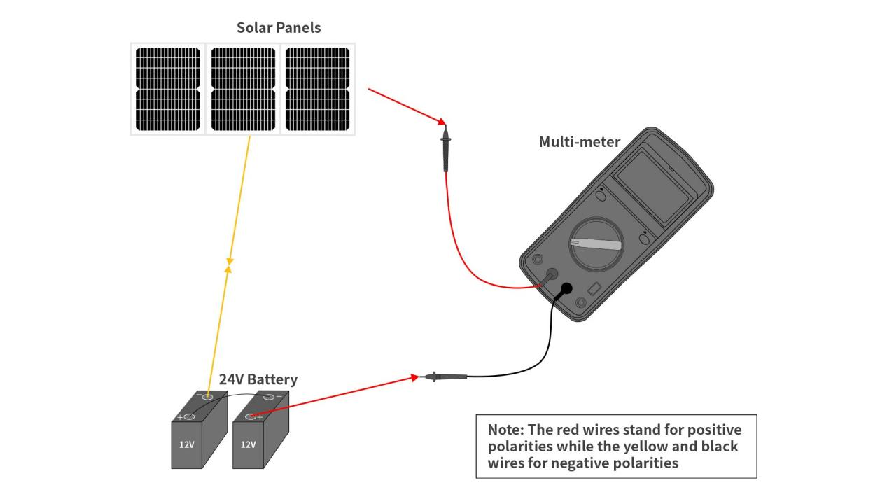

3. Check the TCS3 solar charge controller.
Measure the charging current of the TCS3. Connect the multimeter with the batteries and solar charge controller (BAT batteries) in series with reference to the following diagram. If there is no charging current, the problem should be with the TCS3.
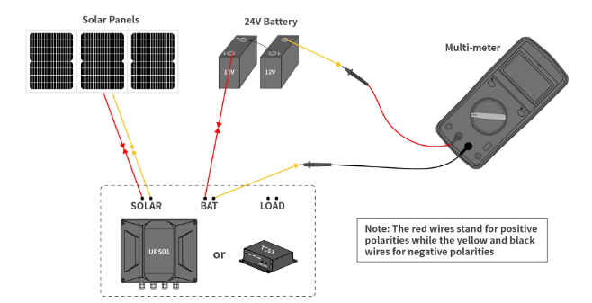

另一种测太阳能板能否充电的方法：把太阳能板的输出和电池按下图所示连接，测一下并在一起的电压，如果电压从42V左右降到跟电池电压差不多，就是给电池正常充电了。

Connect the output wires of the solar panel and fully charged battery as shown in the diagram below, then measure the voltage. If the voltage drops from 42V to match the battery voltage level, this indicates normal charging operation.
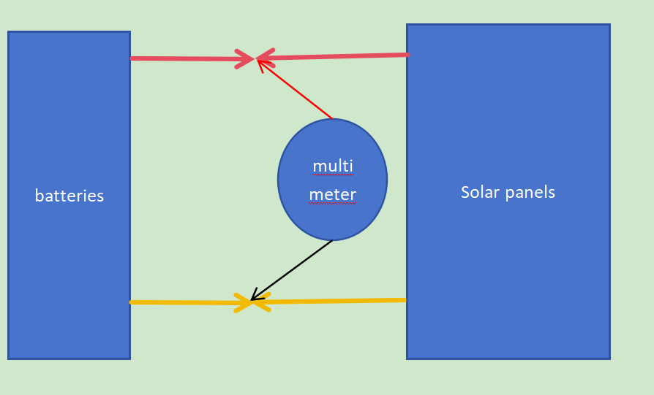

接上太阳能板就不工作 The Gate Opener Quits Working Once Solar Panels Connected
- 检查太阳能板（开路测试）
断开太阳能板与TCS3之间的连接，断开各块太阳能板之间的连接，在无遮挡的正午阳光下，测量每一块太阳能板的开路电压
正常值：>42VDC
如果某块板明显低于42VDC → 该太阳能板损坏
- 检查电池电压
断开TCS31与电池之间的连接, 测量电池电压
如果电压 <22VDC → 用外部充电器将电池充到24VDC以上，再重新接入系统
- 测试TCS31是否正常（断开太阳能板）
保持太阳能板断开, 仅连接电池到TCS3, 测量以下端口：
端口正常值 异常判断
BAT端口 = 电池电压; 若异常 → TCS3可能内部BAT通路故障
LOAD端口>22VDC ; 若低于22VDC或为0 → UPS01损坏
如果BAT和LOAD均正常 → TCS3是好的，继续第4步
- 接回太阳能板，整体验证
接回太阳能板到TCS3, 测量以下端口，三者应大致等于电池电压
SOL端口≈ 电池电压
BAT端口 ≈ 电池电压
LOAD端口≈ 电池电压
如果端口电压异常→ 太阳能板损坏

- Check the solar panel(s) – open circuit voltage test
Disconnect all solar panels from the TCS3 and also disconnect the panels from each other. Under direct sunlight with no shading, preferably around noon, measure the open circuit voltage of each solar panel. A normal reading should be above 42 VDC. If any panel shows a voltage significantly lower than 42 VDC, that solar panel is faulty and should be replaced.

- Check the battery voltage
Disconnect the battery from the TCS3 and measure battery voltage.
- If the battery voltage is above 24 VDC, please proceed step 3.
- If the voltage is below 22 VDC, use an external charger to charge the battery to above 24 VDC, then reconnect it to the TCS3 and continue test 3. If battery voltage is always below 22VDC even if fully charged, the batteries are defective and needs to be replaced.

- Test the TCS3 with solar panels disconnected
Keep all solar panels disconnected and connect only the battery to the TCS3. Measure the voltage of BAT terminal and the LOAD terminal of the TCS3. The BAT terminal should read the approximately same as the battery voltage and the LOAD terminal should read above 22 VDC.
- If the LOAD terminal voltage is below 22 VDC, the UPS01 is faulty.
- If the BAT terminal voltage is below 22 VDC, replace the battery to have a try. If the problem remains, the TCS3 should be defective.
- If both BAT and LOAD terminals show normal values, the TCS3 is good and you can proceed to Step 4.

- Final test with solar panels connected
Reconnect the solar panels to the TCS3. Then measure the SOL terminal, BAT terminal, and LOAD terminal. Under normal operation, all three terminals should read approximately the same as the battery voltage. If any of these terminals shows an abnormal voltage, the solar panel should be faulty.

电池耗电异常 Abnormal Battery Drain
- 确认电池规格、接线正确，
- 断开其他额外用电设备（如是否给其他外部用电器供电，如：备用灯、门禁读卡器等）。
- 拔掉所有配件及机臂，看是否还异常耗电。
- 还不行的话，换一组新的符合规格的电池试试。
好了 → 电池问题。
没好 → 继续下一步。
- 断开TCS3与控制板的连接。（用TCS3）
依然耗电 → TCS3问题。
不耗电了 → 接回空控制板（不接配件）。
又耗电 → 控制板问题。
不耗电 → 某个配件问题（逐个接回排查）。

- Please verify that the battery meet the required standards.
Generally, a 24V 12Ah battery (or 2pcs 12V 12Ah batteries connected in series may function as 24V) is required to power the gate opener. Lead acid / GEL / AGM / flooded (deep cycle) batteries can be used. Kindly note that the regulator is not compatible with most lithium-ion batteries, except for LiFePO4 batteries. And the battery should be waterproof type, or be placed in waterproof circumstance.
Moreover, if you only use solar panels to charge the batteries (no AC electricity), you’re required to increase the solar panels power and the batteries capacity in the following situations:
- Add continuously electricity-consuming accessories such as exit sensor wand, wired keypad, external receiver, etc. Normally, if you add such an accessory, you need to add 30W more solar panels.
- There is less than 6 hours sunlight or the gate opener should be operated more than 10 cycles per day.

Then check that all wiring is correct, especially the positive and negative connections and ensure no loose or short-circuited connections are present.

- If all above are verified, please disconnect any additional devices that may be powered by the same battery (e.g., auxiliary lights, access control readers, etc.).
If the battery is powering only the gate opener system, proceed to the next step.

- Disconnect all wired accessories and arm from the control board and leave only the main power input connected to the control board. If the problem persists, please move to step 4.

- Try another set of new batteries to have a try.
If the issue is resolved → The original battery is likely defective or has poor performance.
If the issue persists → Proceed to Step 5.

- Disconnect the TCS3 module from the control board. Leave the TCS3 connected only to the battery.
If abnormal drain continues → The TCS3 module is likely faulty and requires replacement.
If the drain stops → Proceed to Step 6.

- Reconnect the TCS3 module to the control board. Ensure that no accessories and arm are connected to the control board (power only).
If the drain returns → The control board itself is likely faulty.
If there is no drain → The issue is caused by the arm or accessories. Reconnect arm and each accessory one by one to identify the faulty device.

二、遥控器问题 Remote Control & Signal Problems

学不上遥控器 （学习灯不亮）Cannot Program Remote
1检查电源灯亮不亮，检查电压和保险丝，如果都好的控制板坏
2断开配件试试
- Check all the wires are connected as they should be. Please measure the voltage of the +BAT- terminals (11# and 12#) on the control board to see whether it is above 22V. If the voltage is normal, please check whether the power led on the control board is ON. If it is off, check the fuse whether it was burnt out and replace the fuse if necessary. There is a backup fuse packed within the user manual pack.
2. If the voltage and the power led are fine, press and release CODE SW button to see whether the CODE LED can be ON. If it is OFF, please disconnect all the wired accessories and try again. If there is still no luck, the control board should be defective.

学不上遥控器 （学习灯亮）
电源电压正常，电源灯亮、学习灯亮，但是学不上遥控器。
断开配件，换电池、换一个遥控器，试一试；清除所有密码重学，如果还不可以，瞬时短接push button端口试试
1 Please measure the voltage of the +BAT- terminals (11# and 12#) on the control board to see whether it is above 22V. Then further check if the CODE LED can light up after pressing and releasing CODE SW button. If yes, please attempt the following steps.
2 Check whether the blue indicator light of the remote control is on. If not, please further replace the battery in the remotes to try it again. Kindly note 2 PCS CR2025 batteries are used to power the remote control. You can also try another remote to see how it goes.
3 If the indicator light is ON, please disconnect all the wired accessories first. Erase the remote codes and then reprogram them with referring to the procedures on the user’s manual. And then try to operate the gate opener by pressing the remotes.
4 If all of the steps above cannot work, can you hear the clicking sound when pressing the remote? If not, please use a jumper wire to immediately short (plug the wire in, then pull it out immediately) the push button terminals (4#, 5#) on the control board to see how it works.
If the gate opener works in this step but all of your remotes cannot work, the control board might be defective.

其中一个遥控器无法工作 One (or Some) of Remotes Doesn't Work
症状：其他遥控器正常的，只是其中一个或者一些不能操控门机
换电池试试
清除重学试试
如果还是不行，且是我们自己的遥控器的话，遥控器坏了
- Check whether the blue indicator light of the remote control is on. If not, please further replace the battery in the remotes to try it again. Kindly note 2 PCS CR2025 batteries are used to power the remote control.
- Erase the remote codes and then reprogram them with referring to the procedures on the user’s manual to see how it goes.
- If the problem persists, please check if the remotes are sold by TOPENS authorized shops. If yes, the remote might be faulty.

遥控距离不够 Short Remote Range
1打开控制箱调整天线位置和方向
2 通过穿线孔尝试把天线拉出来点试试
3 更换遥控器电池试试
4 加外接收器
1 Please note that the M12 remote has an open-area range of approximately 65 feet. If the gate opener does not respond within this distance, open the motor cover and locate the black antenna on top of the control board. Adjust its position and direction—vertical, horizontal, or tilted—to improve signal reception, then test the remote again. If the range remains insufficient, proceed to Step 2.

2 Pull the Antenna Out from the Control Box: Pull the antenna through the cable gland at the bottom of the control box and extend it fully straight for optimal signal reception. Test the gate operation with the remote control to check if the control range has increased. If the range is still insufficient, proceed to Step 3.
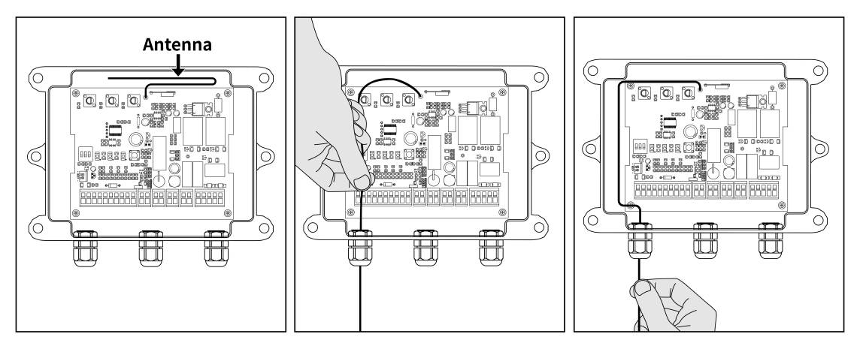

3 Replace Remote Control Battery: The remote control battery may be exhausted. Replace the battery with a new one and attempt to operate the gate again. 2 PCS 3V lithium cell CR2025 batteries are required for one remote. Try Step 4 if the problem persists.
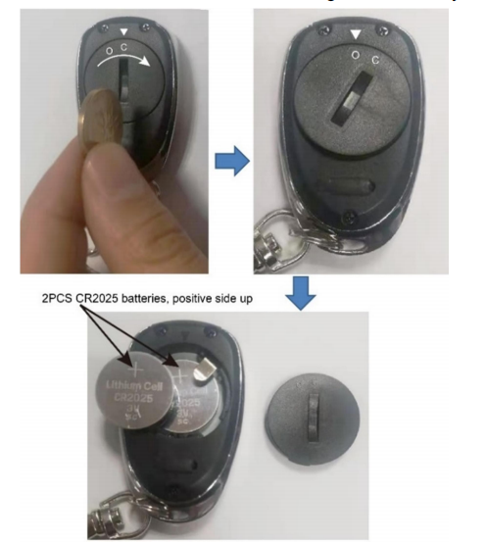
4 Add an ERM12 External Receiver: Connect the ERM12 external receiver to the control board of the gate opener. Program the M12 remote control with the ERM12 external receiver. Before programming, ensure the M12 remote control is removed from the control board to avoid conflicts. After programming, test the remote control to see if the range has improved.

多次按遥控器门机才反应 Remote Needs Multiple Presses
- 换遥控器电池，同时也清除遥控编码，重学试试
- 离门机近一点试试，如果有用，把天线放不同位置，方向（水平、竖直）试试
3. 瞬时短接push button，看看门机是不是每瞬时短接一次，都会有相应的动作
4. 打开离合，确保门可以手动推拉顺畅，同时保持离合打开，按遥控器，观察是否每按一下，门机都有相应的动作
5 观察周围环境是否有导致信号减弱或失效的干扰物，如是否紧邻紧高压线、大功率变压器，金属栅栏，电信基站、广播电台发射塔等

1 Check if the blue light on the remote lights up when a button is pressed. If not, replace the two CR2025 batteries and try again. Next, erase the remote codes and reprogram the remote following the instructions in the user manual. Then test whether the remote operates the gate opener.

2 Try moving the remote closer to the gate opener. If that helps, adjust the antenna on the control board—experiment with its position, angle, and direction to improve the signal.

3 Use a jumper wire to momentarily short the push button terminals on the control board (briefly touch and remove the wire), and observe whether the gate opener responds. Repeat the test several times to check if it triggers reliably each time.
- If so, the gate opener system should be fine, please do step 5.
- If the gate opener cannot respond correctly, please proceed to step 4.

4 Disengage the clutch and manually check whether the gate moves smoothly. If not so smooth, please check the gate, installation and lubricate the arm if necessary. Then keep the clutch disengaged and press the remote—observe whether the gate opener responds each time.
- If so, the motor and control board should be fine, the issue should be with extra mechanical resistance. Please double check the gate, installation and lubricate the arm if necessary to eliminate the resistance.
- If the motor still cannot respond properly, the control board or the motor might be defective. You can test the motor referring to the following step.
- Disconnect the RED & BLACK wires of the arm from the control board and directly connect the wires to the LOAD output terminal of the DC 24V power source directly, the motor should run (please listen to the motor sounds). Then exchange polarity of the wires, the arm should run in the opposite direction. If the motor run properly towards two directions, then the motor is good and control board should be defective.

5 Observe the surrounding environment for any potential sources of signal interference, such as nearby high-voltage power lines, large transformers, metal fences, telecom base stations, or radio transmission towers.

完全不工作 Complete Failure

按遥控器没有反应 No Response When The Remote Is Pressed
1 检查输入电压，重点是电池电压和控制器的排查，这里分两种情况，一种纯太阳能供电，一种是适配器+电池给机器供电，根据客人情况选择：
太阳能：先测BAT端口电压，正常情况应该是22V以上的，如果低，分别断开太阳能板、控制器、控制板，测电池电压。如果电池电压大于22VDC, 控制器坏了。如果电池电压低于22VDC，用额外充电器充满。 然后把充满的24VDC从电池直接接到BAT端口 (附图 说明书里有电池直接接在控制板BAT端口的 连接电源那个地方），看门机工作不。如果工作了，门机本身正常，可能是控制器切断输出，把太阳能组套接回去，测TCS3 LOAD端口输出电压，看看是不是22VDC以上，是的话，控制器是好的。如果还是在22VDC以下，那就是TCS3坏了。
如果充满的电池直接接BAT端口，门机也不工作，要分别排查配件影响，电机，限位
适配器+电池：先测BAT端口电压，是不是高于22VDC，如果是，电源好的，继续下面步骤的排查，如果电压低，检查适配器的输出，正常36VDC，如果适配器正常，断开电池，单独测电池的输出电压，如果也低，接回去，等充满，如果电压总是不够，那就需要检查电池接线类型；
2 排除配件影响
3 离合打开门推到中间试试，主要防止门开关到位后卡住
4 机臂红黑线直接接24V电源
5 短接限位

太阳能供电用这段：
1 Please measure the voltage of the +BAT- terminals (11# and 12#) on the control board to see whether it is above 22VDC.
- If so, please proceed to test 2.
- If not so, please disconnect the solar panels from the TCS3 solar charge controller, and disconnect the TCS3 controller from the control board. Test the output voltage of the batteries and solar charger controller.
- If the voltage of the batteries is more than 22VDC, but the voltage of LOAD terminals of the TCS3 is lower than 22VDC, the TCS3 might be defective.
- If the battery voltage is below 22VDC, please charge the batteries fully with an additional charger and connect the batteries to the +BAT- terminals (11# and 12#) on the control board. And press the remote to operate the gate opener to see whether it can work. If it can work in this case, please reconnect the TCS3 back to see whether it can still work. If not, the TCS3 is defective.
On the contrary, if the opener cannot work even when connecting the full batteries to the control board directly, please move to test 2.

用适配器+电池用这段：
1 Please measure the voltage of the +BAT- terminals (11# and 12#) on the control board to see whether it is above 22VDC.
- If so, please proceed to test 2.
- If the voltage is below 22VDC, please check whether the output voltage of the adapter is 36VDC. If so, disconnect the batteries from the control board and measure the output voltage of the batteries to see whether it is above 22VDC. If the voltage of the batteries is also below 22VDC, please keep the batteries charged fully to try it again. If it still cannot work, please check the batteries. Kindly note that a 24V 12Ah battery (or 2pcs 12V batteries connected in series may function as 24V) is required to power the gate opener. Marine or Automotive type battery is compatible.

2 Disconnect all accessories from the control board first (just leave the power source and the arm). And disable the photocell function by turning the dip switch #3 off. Then erase all remotes codes from the control board and reprogram them to have a try. If it fails, please instantaneously short (plug the wire in, then pull it out immediately) the push button terminals (4# and 5#) to check whether the opener can work.
How to instantaneously short the “O/S/C COM” terminals:
https://drive.google.com/file/d/1VdDhyHZxmpQE5pG7BYHOJi5GYb7iZHFS/view?usp=sharing
注意站内信不可发此链接

3 If there is still no luck, please release the clutches on the arm and push the gate to the middle position firstly. And engage the clutches and press the remote to see whether the gate can run towards the both directions. If it still doesn’t help, please go on the troubleshooting below.

4 Please check the motor. Connect the red & black wires of the arm to the DC 24V power source directly, the motor should run, and then exchange the polarity of the wires, the motor should run in the opposite direction. If the motor runs in both directions, the motor itself is good. Please connect the black & red wires back to the control board and check step4.

4 Disconnect the BLUE, GREEN & YELLOW wires of the faulty arm from the control board, use two jumper wires to short the ULT, COM & DLT terminals to which the wires were connected, and then press the remote to see if the arm could extend and retract. If it could move in both directions, then the limit switch is defective. When you do this test, you could press the remote in time in case the arm extends too much.
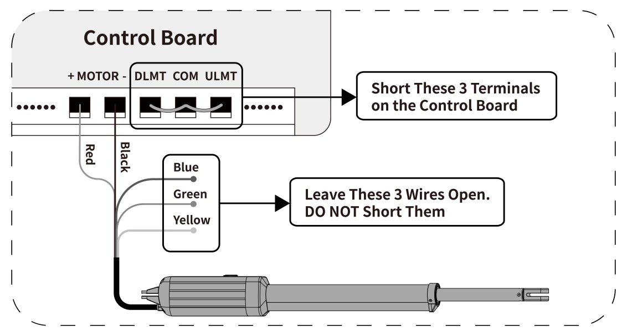

控制板有持续咔哒声 Control Board Clicking Continuously
1 先断开所有的配件及机臂，重新上电看看
2 如果还是响那么排查一下电源，按遥控器后是不是有电源压降大导致继电器无法保持吸合，如果电源没问题， 就是控制板坏；
3 如果没有异响了，再排查下是否是机臂或者配件的影响，把机臂或配件一个一个接回去，接一个测试一个，再看看有什么异常
1 Disconnect all wired accessories and the gate arm from the control board, leaving only power connections. Then, turn the power of the system off and on.

2 If the noise continues, check the voltage at the +BAT- terminals (11#, 12#) while pressing the remote.
- If the reading remains stable at approximately 24V (above 22V), the control board is likely defective.
- If the voltage is unstable or low, disconnect the power cable from the control board and test the output voltage of the UPS01 power supply directly to see if it is above 22VDC and stable.

3 If the noise stops after Step 1, the motor or a wired accessory is the cause. To identify it, first reconnect only the motor and test. If the noise does not return, proceed to reconnect accessories one at a time, testing after each connection, until the faulty part is found.

按遥控器保险丝烧 Fuse Blows When Pressing Remote
1 检查端口接的线与线之间是否有铜丝触碰到，确认保险丝规格对的；
2 断开控制板端口上的有线配件，机臂线，只保留电源接线，然后按遥控器；
- 如果保险丝烧，检查控制板的输入电压，正常电压24VDC左右；如果电压没问题，那就是控制板坏，可以看看控制板表面是否有元器件短路痕迹；
(2) 如果保险丝不烧，把机臂从门上拿下来，机臂电机线接回控制板，打开离合，按遥控器看看烧不烧，此时如果烧，问题在电机电流大，如果不烧，合上离合再按遥控器，如果烧，问题在机臂内部卡顿，手动推拉机臂是否顺畅；
3如果没问题，把机臂装门上再按遥控器试试，如果这个时候烧 说明负载过大，可能门本身较重或卡顿，需要检查门本身是否可以推拉顺畅，并问问门宽门重；
4如果以上都好的，依次把有线配件接回去，逐一排查哪个配件导致烧控制板的。

1 Verify no exposed copper strands are causing contact between wires at terminals. Confirm the fuse rating is correct (∅5*20mm 5A 250VAC fast blow glass fuse).

2 Disconnect all wired accessories and the gate arm from the control board, leaving only the power supply connected. Press the remote to test.
- If the fuse blows, measure the input voltage to the control board. The normal voltage should be around 24V DC. If the voltage is correct, the control board is likely faulty. Inspect the board surface for any signs of component short circuits. If the voltage is incorrect, check the power supply.
- If the fuse does not blow: Remove the arm from the gate and reconnect the motor wires to the control board. Disengage the clutch and press the remote.
- If the fuse blows, the motor is drawing excessive current.
- If it does not blow, re-engage the clutch and press the remote again.
If it now blows, the internal mechanism of the arm is jammed. Check if the arm moves smoothly manually.

3 If the arm tests fine off the gate, reinstall it to the gate and operate it via remote.
If the fuse blows now, this indicates excessive load, likely due to a heavy or obstructed gate. Use the release key to disengage the clutch of the arm, and check whether the gate itself can be manually opened & closed freely 3.3 feet (one meter) away from the gate hinge. If not, please let me know the weight and length of your gate and double check the gate to make sure the gate can run freely by hand.

4 If there is no problem after above steps, the problem lies in the wired accessories. Reconnect the accessories one at a time to identify the specific cause.

不工作（只CODE LED微微亮）
很大可能是输入电源线接到了适配器端口
把电池或开关电源接到adapter端口学习灯微弱的常亮；把适配器接adapter端口，不接电池code灯微微亮
Ensure the batteries are properly connected to BAT terminal of the control board, and verify that the wire connections are secure. Please note that two 12VDC batteries are required to power the gate opener. The included adapter is only intended for charging the batteries, not for directly powering the gate opener.

四、只朝一个方向 Only Opens/Closes One Direction
1 离合打开，把门推到中间试一试，判断是限位影响还是只朝一个方向转
2 断开红外、关闭红外功能
- 测电机
4 短接限位
没问题就是控制板坏
1 Please release the clutch and push the gate to the middle position firstly. And then try it again by pressing the remote to see whether the gate can run towards the both directions. If the problem still persists, please do the following tests.

2 Disconnect all wired accessories from the control board first (just leave the power source and the arm) and disable the photocell function by turning off DIP Switch 3#. Then press the remote again to see whether it can work properly.
- If the problem persists, please do step 3.
- If the problem disappears, reconnect each accessory one by one to identify which one causes the problem. If a photocell sensor is used, please double check the installation of the photocell, and make sure the photocell sensor beam is aligned and not blocked.

3 Please check the motor. Connect the red & black wires of the arm to the DC 24V power source directly, the motor should run, and then exchange the polarity of the wires, the motor should run in the opposite direction. If the motor runs in both directions, the motor itself is good. Please connect the black & red wires back to the control board and check step4.

4 Disconnect the BLUE, GREEN & YELLOW wires of the faulty arm from the control board, use two jumper wires to short the ULT, COM & DLT terminals to which the wires were connected, and then press the remote to see if the arm could extend and retract. If it could move in both directions, then the limit switch is defective. When you do this test, you could press the remote in time in case the arm extends too much.

如果判断是限位问题：
单臂拉开门，只关不开，近端坏；只开不关，远端坏。
单臂推开门，只关不开，远端坏；只开不关，近端坏。
像有些不会/不愿换限位的，若确定是远端限位坏，可以只换远端限位。

复杂方案：短接限位也只朝一个方向，换了控制板也不行
测量一下继电器CLICK的时候MOTOR端口的电压，如果没电压那么肯定是控制板或限位有问题（可以通过短接限位端口排查限位）。如果正常有电压但是电机不动那么可以直接将电机线从控制板上取下，电机线直接接电池（红线接电池正、黑线接电池负电机朝一个方向运行，红线接电池负、黑线接电池正电机朝一个方向运行），看看电池带上电机后是否能正常朝两个方向运行，如果可以，那么可以分别测量一下电机运行时的电池电压和电机电流，看看电池压降（正常运行时电压不能降低到21VDC以下）和电机电流有没有异常（正常应该是1.2-6A）。

五、随意开关门 Random Opening/Closing
1 检查推拉开门逻辑是不是正确
2 断开所有有线配件，关闭红外功能看看
3 清除所有遥控密码，重学
4 还不行换控制板

1 Check DIP Switch Setting: DIP Switch #1 on the control board is used to select the gate's operation mode (push/pull to open). If the gate opens into the property (pull to open), set the DIP Switch to OFF (factory default setting). If the gate opens out from the property (push to open), set the DIP Switch to ON.

2 Isolate the Issue with Wired Accessories: Disconnect all wired accessories from the control board. Turn off DIP Switch #3 to disable the photocell sensor function. Try operating the gate again.
- If the problem disappears, the issue might be with one of the accessories. Connect each accessory one by one to identify which one causes the problem.
- If the issue is still present after disconnecting all accessories, proceed to Step 3.

3 Reprogram Remote Controls: First remove all existing remote codes from the control board and then reprogram the remote controls. Operate the gate to see if the random opening issue has been resolved.

4 Replace the Control Board: If none of the above steps resolve the issue, the control board may be faulty.

六、缓停止有问题（缓停止错乱或者没有缓停止）Soft Stop Issues
1 断电重置，走个完整的开关门循环
2 检查限位功能，观察是否限位停
3 检查缓停止功能在机臂不带门的时候是否正常
4 还不行换控制板
1 If you have reset the soft stop time or used the release key to manually open the gate, turn off the power to the gate opener and restart it. Then, use the remote control to run a complete open and close cycle to calibrate the full open and close time.

2 Check if the limit switch is functioning and can stop the gate. Please shoot some videos showing the performance of the arms for further judgement. You can directly send the video to my E-mail via the attachment. If the sending is not successful, please share the photo or video link through dropbox, icloud or google drive. Thanks for your understanding and cooperation.

3 Test the soft stop function when it is not mounted on the gate. If it functions properly, ensure the gate is level, swings freely on its hinges, and that the gate opener is not affected by the inertia of gate opening and closing or by any gate spring force.

4 If none of the above steps resolve the issue, the control board may be faulty. Replace the control board with a new one.

Note: 门经常因为风等外界因素停下来，不是靠限位停、调过限位、或者动过离合等都可能导致缓停止错乱或者失效。

七、自动关门不生效 Auto Close Function Doesn't Work
1 断开有线配件，按遥控器让门停半路，等一会看看门会不会自动关，如果可以，应该是配件影响导致门无法自动关门，可以一个一个接配件，测试看看是哪个导致
2 如果断开配件后，自动关门还是没起作用，保持配件断开，然后把门机的电断开，把自动关门功能开启，上电按遥控器走一个完整的开关门循环，然后再按遥控器让门运行到半开位置停下，等一会
1 Please disconnect all wired accessories from the control board. Then open the gate by the remote and wait for a while to see whether the gate will close automatically.
- If so, please reconnect the accessories one by one, testing after each, to identify the faulty one.
- If this step cannot help, please do the following test.

2 Please disconnect all accessories and power off the system first (disconnect the power source from the +BAT- terminals on the control board). Turn DIP Switch #2 ON to enable the auto close function. Turn the AUTO CLOSE potentiometer clockwise or counter-clockwise to increase or decrease the auto close time as you require. Then power on and press the remote to operate the gate through one full open-close cycle. In the next cycle, press the remote again to have the gate stop in the course of closing. Wait for a while to have the auto close function take effect.

特殊案例：
可以自动开门，但是不会自动关门（每一次都是设定的时间，大概率是推拉开门逻辑反了）
The setting of DIP switch #1 might be incorrect. Ensure that the DIP switch is configured properly according to the installation type (push or pull to open) of the gate opener.

八、开关门过程中走停或反弹 Gate Stops or Bounces During Operation
1 排除红外遇阻影响
2 断电调遇阻缓停止
3 打开离合，手放拉耳处，去推拉门看看是否顺畅
4 机臂从门上拿下来试试按遥控器的时候机臂能否正常伸缩
5 还不行发视频
1 If the photocell is used, please ensure the photocell sensor beam is not blocked. Clear any objects blocking the photocell sensor. Check if the photocell sensor is defective and properly installed. If the photocell is not used, please set the switch #3 to OFF to disable the photocell sensor function.

2 Turn off the power to the gate opener (disconnect the power source from the +BAT- terminals), then locate FORCE Potentiometer on the control board and turn it slightly clockwise to increase the stall force. Then locate SOFT STOP Potentiometer and turn it slightly counterclockwise to decrease the soft stop time. After adjusting, turn on the power to the gate opener and press the remote control to open and close the gate through a full cycle. Press the remote again to see if the gate opener works better in the next cycle.
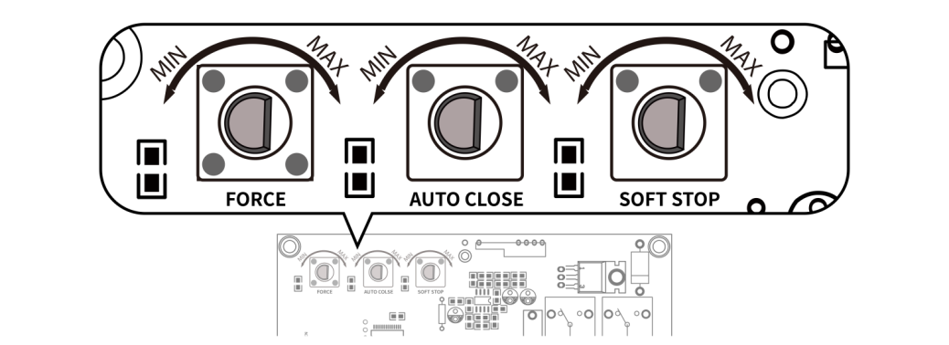
3 Use the release key to disengage the clutch of the arm, and check whether the gate can be manually opened & closed freely 3.3 feet (one meter) away from the gate hinge. If not, please double check the installation and gate itself to ensure it can move freely by hand. Lubricate the arm and the gate including the hinge if necessary. If there is still no help,please do the following test.
4 Please take down the arm from the gate and hold its front mount, then press the remote to see if the arm can extend and retract properly each time. If the arm can run normally in this case, the arm is fine. The problem might be from the cooperation between the gate opener and the gate. Please let me know the length and weight of your gate.

5 Please shoot some videos showing the performance of the arms when you do the test for further judgement. You can directly send the video to my E-mail via the attachment. If the sending is not successful, please share the photo or video link through dropbox, icloud or google drive. Thanks for your understanding and cooperation.

如果上面步骤还不行，可以考虑测电压，和转拉耳180°的排查
1 Please detect the voltage of the +BAT- (11#, 12#) terminals on the control board after pressing the remote to see whether the voltage can stay at almost 24V (above 22V). If the voltage is fine, please do the following tests. （一般情况走停需要监测电压是否压降，反弹不需要）
2 If the arm and gate are fine, please rotate the front mount 180 degrees to try again.

如果机臂不带门也伸出一点就反弹，其他已排除，客人不能测电机电流：
可以让客户把离合打开，按遥控器看看电机有没有问题，如果没问题，那么也很有可能机臂存在某个卡点。如果离合打开电机还有问题，可以做测电机，如果此时电机可以正常运行，那控制板可能有故障了。
1 Use the release key to disengage the clutch.
2 Press the remote button to check if the motor runs continuously in one direction. You may need to listen to the motor sound to confirm. Press the remote again to stop the motor, then press one more time to test if it runs normally in the opposite direction.
- If the motor runs normally in both directions, please manually extend and retract the arm (with the clutch still disengaged) to check for any difficulty in movement.
- If the motor cannot run continuously, you can check the motor. Keep the clutch released, connect the red & black wires of the arm to the DC 24V power source directly, the motor should run, and then exchange the polarity of the wires, the motor should run in the opposite direction. If the motor runs normally in both directions, the motor itself is good and the control board is likely faulty.

九、关到位后反弹 Gate Bounces Back After Closing Completely

拉开门安装 For pull-to-open installation
1 断电调大遇阻力
2 远端限位开关往里调，还不行可以转拉杆180°试试，还有问题需要更换远端限位
3 还不行建议发视频展示运行情况
1 Increase the Stall Force:
Turn off the power to the gate opener (disconnect the power source from the +BAT- terminals), then locate FORCE Potentiometer on the control board and turn it slightly clockwise to increase the stall force. After adjusting, turn on the power to the gate opener and press the remote control to open and close the gate through a full cycle. Press the remote again to see if the gate opener works better. Then check if the gate operates correctly. If not, proceed to steps below.
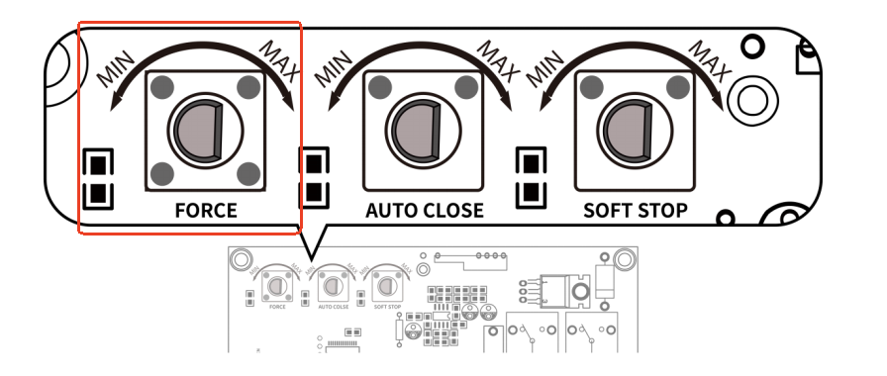
2 Please Adjust the Close Position. The close position is adjusted by Limit Switch B (located far from the motor). Adjust Limit Switch B inward on the arm, then press the remote to close the gate and see if the close position changes. If it changes, adjust Limit Switch B to the desired close position and tighten the screw. If the problem persists, rotate the Front Mount 180° and test again.
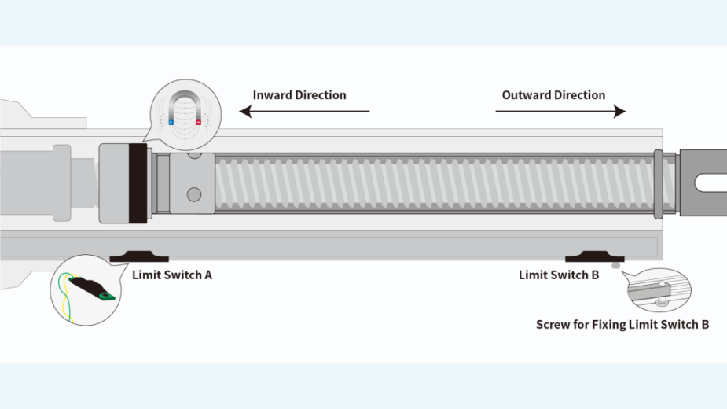
3 Please shoot some videos showing the working condition of the gates. You can directly send the video to my E-mail via the attachment. If the sending is not successful, please share the photo or video link through dropbox, icloud or google drive. Thanks for your understanding and cooperation.

推开门安装 For Push-to-Open Installation
1 断电调大遇阻力
2 重新调整关门位置
3 检查按遥控器缩到底后拉杆状态，如果拉杆是完全缩进去是不正常的，可以转拉杆180°试试，还不行需要更换近端限位。
4 还不行建议发视频展示安装情况

1 Increase the Stall Force
Turn off the power to the gate opener (disconnect the power source from the +BAT- terminals), then locate FORCE Potentiometer on the control board and turn it slightly clockwise to increase the stall force. After adjusting, turn on the power to the gate opener and press the remote control to open and close the gate through a full cycle. Press the remote again to see if the gate opener works better. Then check if the gate operates correctly. If not, proceed to steps below.
2 Please Reconfirm the Close Position of your gate. For Push-to-Open Installation Mode, the close position is determined by the gate bracket. Please check if the moving rod is properly retracted as instructed in the picture below when your gate is at the desired close position. Adjust the gate bracket inward a little if necessary.
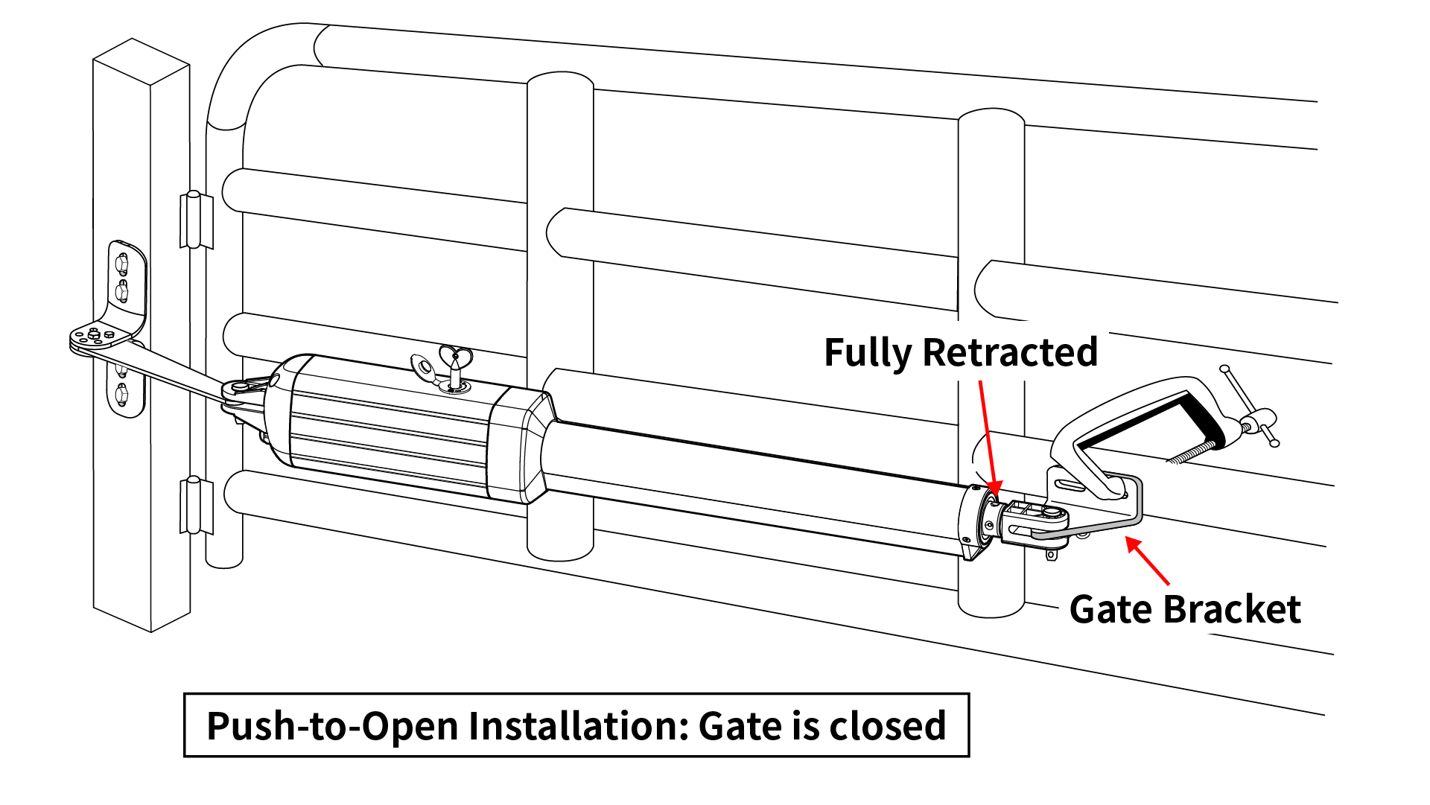
3 Check if the arm resembles Picture 1 (with about 0.4 inches of stainless rod left) or Picture 2 (no rod left) when pressing the remote to fully retract the arm. If the arm retracts with no stainless rod left when pressing the remote, rotate the Front Mount 180° and test again. If the problem persists, the limit switch A may be defective and needs to be replaced.
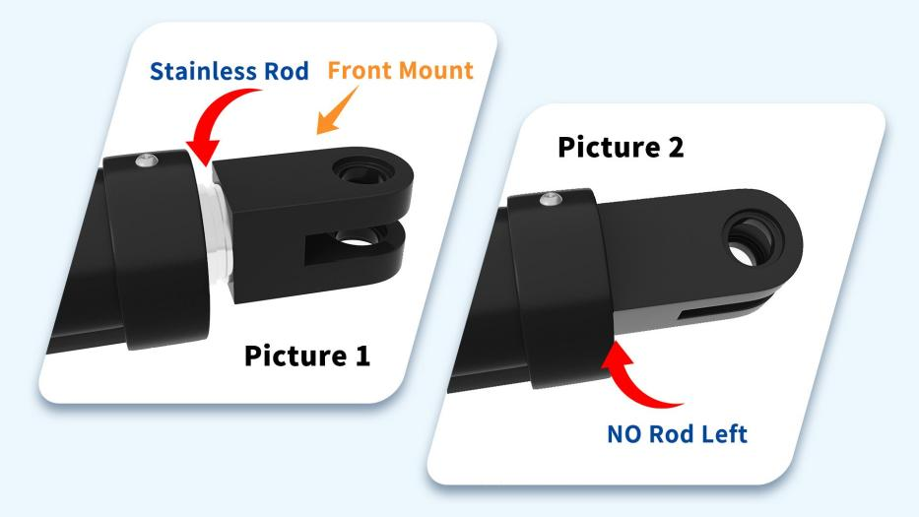
4 Please shoot some videos showing the working condition of the gates. You can directly send the video to my E-mail via the attachment. If the sending is not successful, please share the photo or video link through dropbox, icloud or google drive. Thanks for your understanding and cooperation.

不限位 Gate Does Not Stop at Limit Switch

开门不限位

拉开门安装 For pull-to-open installation
- 检查接线是否接好
- 检查开门位置是否安装正确
- 可以将限位A 往外移一点，看门机是不是可以提前停下来
- 还不行的话，拉耳转180度
- 可以换限位试试

- Ensure that the wires of the limit switch (BLUE, GREEN, and YELLOW wires of the arm) are not shorted. Confirm that each wire is properly inserted into its corresponding terminal and is not twisted with any other wire.

- Please reconfirm the open position of your gate. For Pull-to-Open Installation Mode, the open position is determined by the gate bracket. Please check if the moving rod is properly retracted as instructed in the picture below when your gate is at the desired open position. Adjust the gate bracket inward a little if necessary.
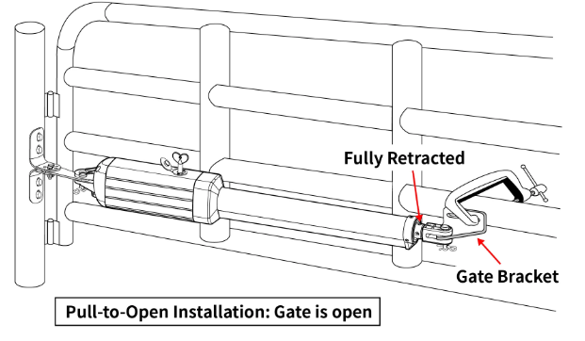
- If it does not work, please adjust Limit Switch A outward on the arm, then press the remote to open the gate and see if the open position changes. If not so, rotate the Front Mount 180° and test again.

- If there is still no luck, the limit switch might be defective.

推开门安装 For push-to-open installation
- 检查接线是否接好
- 检查开门位置是否安装正确, 将限位B往里移一点，多试几个位置
- 还不行的话，拉耳转180度
- 还不行，可以换限位试试

- Ensure that the wires of the limit switch (BLUE, GREEN, and YELLOW wires of the arm) are not shorted. Confirm that each wire is properly inserted into its corresponding terminal and is not twisted with any other wire.

- Please readjust the Open Position. The open position is adjusted by Limit Switch B (located far from the motor). Adjust Limit Switch B inward on the arm, then press the remote to open the gate and see if the open position changes. Repeat the operation several times to check if the arm consistently stops at the new position.
- If it changes, adjust Limit Switch B to the desired open position and tighten the screw.
- If the problem persists, rotate the Front Mount 180° and test again.

- If there is still no luck, the limit switch might be defective.

- 关门不限位

拉开门安装 For pull-to-open installation
- 检查接线是否接好
- 检查关门位置是否设置好，可以将限位B 往里一点，看门机是不是可以提前停下来；多换几个位置试试
- 还不行的话，拉耳转180度
- 可以换限位试试

- Ensure that the wires of the limit switch (BLUE, GREEN, and YELLOW wires of the arm) are not shorted. Confirm that each wire is properly inserted into its corresponding terminal and is not twisted with any other wire.

- Please readjust the Close Position. The close position is adjusted by Limit Switch B (located far from the motor). Adjust Limit Switch B inward on the arm, then press the remote to close the gate and see if the close position changes. Repeat the operation several times to check if the arm consistently stops at the new position.
- If it changes, adjust Limit Switch B to the desired close position and tighten the screw.
- If the problem persists, rotate the Front Mount 180° and test again.

- If there is still no luck, the limit switch might be defective.

推开门安装 For push-to-open installation
- 检查接线是否接好
- 检查关门位置是否安装正确
- 可以将限位A 往外移一点，看门机是不是可以提前停下来
- 还不行的话，拉耳转180度
- 可以换限位试试

- Ensure that the wires of the limit switch (BLUE, GREEN, and YELLOW wires of the arm) are not shorted. Confirm that each wire is properly inserted into its corresponding terminal and is not twisted with any other wire.

- Please reconfirm the close position of your gate. For Push-to-Open Installation Mode, the close position is determined by the gate bracket. Please check if the moving rod is properly retracted as instructed in the picture below when your gate is at the desired close position. Adjust the gate bracket inward a little if necessary.
- If it does not work, please adjust Limit Switch A a little outward on the arm, then press the remote to close the gate and see if the close position changes. If not so, rotate the Front Mount 180° and test again.

- If there is still no luck, the limit switch might be defective.

如果换了限位，还是不限位的话，可以拆开检查下磁环（新版注塑磁环几乎不会断）
还可以按照以下方法检查下控制板：
Check the Limit Switch: Disconnect the BLUE, GREEN, and YELLOW wires of the arm from the control board. Use two jumper wires to short the ULT, COM & DLT terminals to which the wires were connected, and then press the remote to see if the arm can extend and retract.
During this test, monitor the arm to ensure it doesn’t extend too far. Use the remote to reverse the direction if necessary. If the arm can move in both directions, release the COM terminal and check if the arm stops moving immediately. If the arm stops immediately, the control board is good and the limit switch might be faulty.

门机运行慢 Gate Operates Slowly
1 监测电压，看是不是有压降
2 增大遇阻力，缩小缓停止
3 打开离合手动推拉顺畅不。 顺畅的话，机臂拿下来，合上离合，握住拉耳，看看运行速度怎么样。
4 测电机，是否可以正常速度往两个方向运行
5 视频展示

1 Detect the voltage of the +BAT- terminals (11#, 12#) on the control board to see whether it can always stay above 22V when the opener is working. If the voltage is fine, please do the following steps. If the voltage is less than 22V, please disconnect all the wired accessories and test it again.

2 Please power off the system first (disconnect the power source from the +BAT- terminals). And turn the FORCE potentiometer all the way clockwise to increase the stall force, and turn the SOFT STOP potentiometer all the way counter-clockwise to decrease the soft stop period. Then turn on the power and operate the gate opener to run for a complete opening & closing cycle. See whether the gate will open and close all the way in the next opening and closing cycle.

3 If the problem still persists, please release the clutch on the arm and move the gate manually to see whether the gate can run smoothly in this case. If so, please engage the clutch and take down the arm from the gate. Then hold its front mount and press the remote to see if the arm can extend and retract at the normal speed. If not so, please check the motor as below.

4 Connect the red & black wires of the arm to the DC 24V power source directly, the motor should run, and then exchange the polarity of the wires, the motor should run in the opposite direction. If the motor runs in both directions at the normal speed, the motor itself is good.

5 Please let me know the result one by one. Videos showing the problem are much appreciated for further judgement. You can directly send the video to my E-mail via the attachment. If the sending is not successful, please share the photo or video link through dropbox, icloud or google drive. Thanks for your understanding and cooperation.

Note：以上都没解决的话，可按下遥控器，监测MOTOR端口的电压， 如果只有13-14V那就是缓停止的电压，可能缓停止错乱了。
如果有延长线的话，可能还会受延长线的影响，可以断开机臂延长线，将自带的线直接接到控制板看看。

十二、电机电流小导致走停 Motor Current Too Low Causes Stalling (The Gate Stops Immediately It Starts)
电机电流小导致的走停一般是电机开始启动一下然后就猛地停住，一般是开门有问题，或者关门有问题，这种一般机臂不带门，手握住拉耳，按遥控器机臂可以正常伸缩；
门突然启动时扯着机臂动导致电流小造成的，这种情况换控制板还不好用，只能并电阻，门的状态包括机臂电流是可能会波动的，如果只是偶尔这样，说明电流不是特别小，这个时候阻值大一点没关系，可以先试试50欧的电阻，电阻发热没那么严重，相对来说会更好一些。不行再25欧。
负载电阻没有规定电压，只有功率要求，20欧-100欧都可以，功率要大于1152除以电阻值。
电阻阻值变小发热会更厉害，电阻最好不要贴在盒子上安装。

手动反推排查
1 给门施加持续的相反的力，看看门是否可以开或者关到位
2 如果第一步起作用，那要检查门的铰链，托架螺栓是否紧固，连接处是否有明显磨损或者螺栓断裂的情况；
3 如果第二步没发现问题，那就需要加电阻，如果门只一个方向走停，还需要加二极管；电阻没极性，二极管有极性，二极管控制着哪个方向施加阻力，所以二极管的极性要接对（the direction of the diode polarity controls whether the resistor load is applied during open or closing and that if the diode is removed then the load is applied in both cases）

1 Push against (in the opposite direction of the gate moving) the gate during the gate is opening/closing, continuously add some load to the gate and see if the gate can open/close all the way properly. If it works, then the working current through the arm is so small that the opener could only extend and retract few inches. Please proceed to next steps.
2 If step 1 worked, please double check the gate's hinges and brackets for tightness, and inspect all connection points for significant wear or broken bolts.
3 If the problem persists, adding some load to the gate motor by connecting a resistor to the BLACK & RED wires of the arm in parallel to solve the problem. Regretfully, we do not have this resistor for sale in our store. Sorry for the inconvenience.
Below is the link to the resistor that will work.
https://www.amazon.com/dp/B08HYZV3DW
注意链接国家

拉开门开门不正常加二极管电阻 （推开门关门不正常）
Connect anode of the diode to “+Motor” (connect with the red wire of the motor in parallel), connect cathode of the diode to one side of the resistor, then connect the other side of the resistor to “Motor-” (connect with the black wire of the motor in parallel). Please refer to the diagram below. Here are the links for the resistor and diode from third parties that are compatible.
Resistor: https://www.amazon.com/dp/B08HYZV3DW
Diode: https://www.amazon.com/dp/B01HMSR2T4
注意链接国家
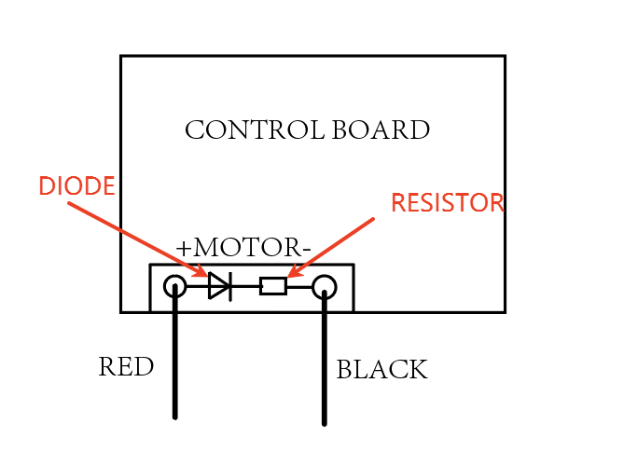

拉开门关门不正常加二极管电阻（推开门开门不正常）
Connect anode of the diode to “Motor-” terminal (connect with the black wire of the motor in parallel), connect cathode of the diode to one side of the resistor, then connect the other side of the resistor to +motor (connect with the red wire of the motor in parallel). Please refer to the diagram below. Here are the links for the resistor and diode from third parties that are compatible.
Resistor: https://www.amazon.co.uk/dp/B07H33917Z
Diode: https://www.amazon.co.uk/dp/B079KCC8P9
注意链接国家
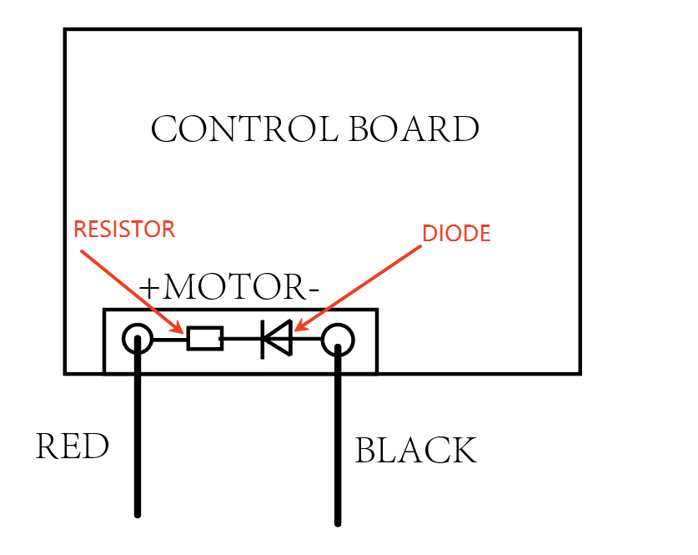

加了电阻之后，相当于增大了负载，需要加大遇阻力。
After adding the resistor, you need to increase the FORCE. Please power off the system first (disconnect the power source from the +BAT- terminals). And turn the FORCE potentiometer all the way clockwise to increase the stall force. Then turn on the power and operate the gate opener to run for a complete opening & closing cycle. See whether the gate will open and close all the way in the next opening and closing cycle.

电机电流小的原因
The operating current drawn by the gate arm motor is below the minimum detection threshold of the control board. This low current draw, which can occur with gates that are too light for the opener, causes the board to erroneously interpret the motor status and cut power prematurely, resulting in immediate stoppage.
Insufficient load (a gate that is too light) causes the motor current to fall below the control board's detection threshold, triggering an immediate safety shutdown.

信息补充：万用表测机臂电流
除了HJ4022的其他平开门机，机臂运行时候的电机电流应该大于0.5A 小于3A, 如果机器运行时候的电机电流大于3A，那说明负载过载或者电机有问题（可以机臂从门上拿下来排查）
测机臂空载电机电流 小于1A 是正常的 大于1A 说明电机有问题

Measuring DC Current going through the arm with a Multimeter like this. Switch ON the multimeter. Turn the knob to test DC current. Please connect the Multimeter pens in series with the power supply and the arm. The arm can only operate normally with the current lower than 3Ampere.

测工作电流详细步骤
1. Power off the opener system first.
2. Disconnect the red wire of the arm from the +motor terminal on the control board.
3. Connect the positive polarity (e.g. red pen) of the multimeter to the +motor terminal on the control board.
4. Connect the red wire of the arm with the negative polarity of the multimeter (e.g. black pen) together.
5. Turn the knob of the multimeter to test DC current.
6. Power on the opener system and press the remote to detect the value on the multimeter. The normal value should be lower than 3 Amps.
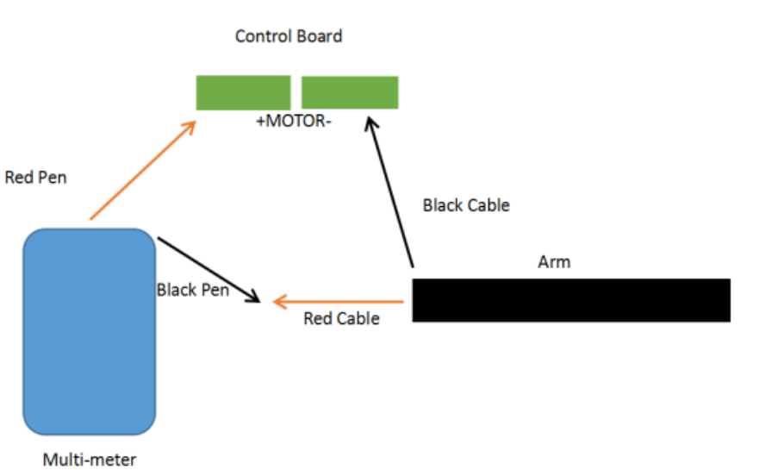

测机臂空载电流
Measuring DC Current going through the arm with a Multimeter like this. Switch ON the multimeter. Turn the knob to test DC current. Please connect the Multimeter in series with the batteries and the arm. The arm can only operate normally with the current lower than 1 Ampere.
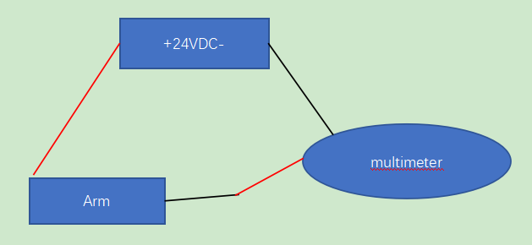

十三、电机转机臂不伸缩 Motor Runs But Gate Doesn't Move
博客文章链接：
https://topens.com/blogs/blog-posts/troubleshooting-guide-motor-operates-but-gate-opener-arm-fails-to-move

1 伸太过缩不回去的情况：
离合打开，将机臂推到中间位置再合上离合再试，如果已经伸太过离合打开缩不回了，可尝试离合合上，顺时针往里边推边旋转拉杆，如果OK则说明之前丝母与丝杆之间脱开了（最远端），可以让客户将远端限位开关再往回调一点点，限位螺丝拧紧；如果还不行，需要拆机臂的话这一步可直接加入之前伸太过缩不回去的排查文章链接，让客人参考；
2 拉杆在缩到底或部分伸出去的状态，电机转，机臂不伸缩：
如果机臂拉杆推到中间位置，合上离合，电机依然只转，机臂不伸缩，说明问题可能在于机臂内部，离合或电机. 可以先检查离合是正确合上（拧到位），离合正常合上还不行，打开机臂再用离合钥匙开关离合，观察离合部位是否能正常啮合，如果不能，手动转下拉耳使其正常啮合；检查丝杆和带轴承的离合件3是否正常连接，拉杆螺母是否磨损，以上都正常的话可能是电机减速箱内部齿轮破损导致打滑。

1 If the arm is stuck in the fully extended position and the moving-rod does not retract:
(1) Disengage the clutch and manually push the moving-rod to the middle position. Then, press the remote control to test for movement.
(2) If the arm still does not move, re-engage the clutch and detach the arm from the gate. While pushing the moving-rod inward, rotate the front mount clockwise. If the arm begins to move, the screw nut may have disengaged from the screw rod at the far end. Once the arm is back in the middle position, use the remote control to test operation again.

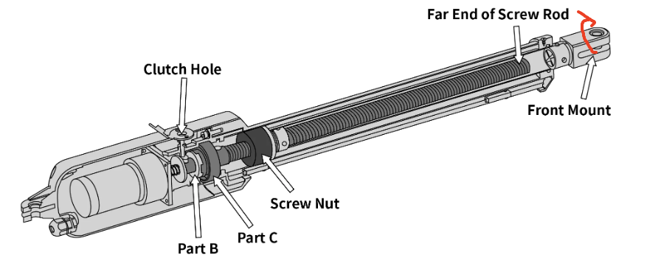
(3) Once the arm functions properly, use a screwdriver to loosen the screw on Limit Switch B. Slide the switch slightly inward and re-tighten the screw to prevent future over-extension.
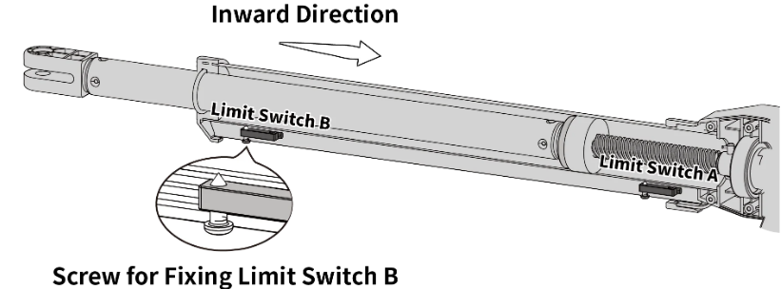
For additional guidance of the extended too much, please refer to this help article:
https://topens.com/blogs/blog-posts/how-to-retract-the-moving-rod-when-the-opener-arm-extends-too-much

2 If the opener arm is partially extended or fully retracted and the moving-rod does not move despite the motor activation:
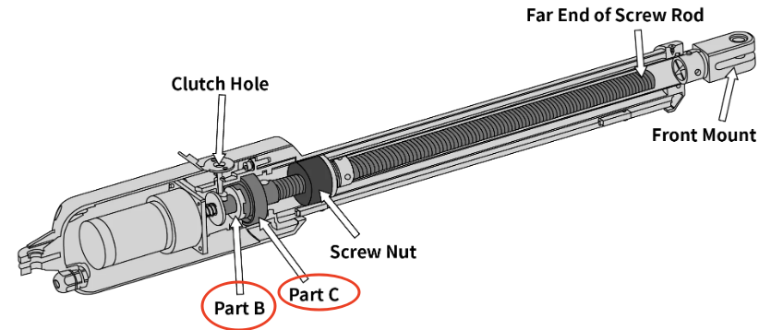
(1) Ensure that the clutch is fully and correctly engaged. If engagement appears normal, disassemble the opener arm and check whether clutch components (Part B and Part C) are properly aligned. If not, manually rotate the front mount until proper alignment is achieved.
(2 ) Verify the connection between the screw rod and the clutch component with bearing (Part C). Also inspect the moving-rod’s screw nut for signs of damage or excessive wear.
(3) If all visible components appear intact and operational, but abnormal or excessive noise is present in the motor area, the issue may lie within the motor’s reduction gearbox. Internal gear damage or slippage can prevent the arm from moving, even if the motor is running. In this case, please dismantle the gearbox of the motor and check the gears inside.

十四、机臂声音异常 Abnormal Noise From Arm
1. 打开离合，按遥控器，看是否还有异响？
无异响→做步骤2；
有异响→异响来自电机或离合，做步骤5；

- 保持离合打开，手动开关门，看是否还有异响？
无异响→异响很可能是由于电机负载过大产生；
有异响→做步骤3；

- 将机臂从门上取下，手动开关门，看是否还有异响？
无异响→异响来自机臂前端，继续步骤4；
有异响→问题在门（检查润滑门体、铰链等）

- 保持离合打开，手动推拉伸缩杆，看是否顺畅丝滑。
再合上离合，握住拉耳，按遥控器通电查看机臂是否有异响。
如若卡顿或有异响，请润滑丝杆、丝母、外管、伸缩杆&挡圈。

5.拆开外壳，保持主体完整，合上离合，按遥控器通电，确认异响来自哪里？
离合件凸轮刮擦产生的异响→在摩擦部位加润滑脂；
电机内部异响→齿轮箱的问题，更换齿轮箱。

- Release the clutch and press the remote to run the opener.
- If the noise disappears, please proceed to Step 2.
- If the noise remains, it likely comes from the motor or clutch. In this case, please go directly to Step 5.

- Keep the clutch released and try opening and closing the gate by hand.
- If the noise is gone, the issue is likely caused by excessive motor load when the gate is connected. Please check for gate obstructions and verify that the gate does not exceed the opener's rated capacity.
- If the noise persists, please move on to Step 3.

- Detach the actuator arm from the gate then manually open and close the gate again.
- If the noise stops, the problem is likely coming from the front part of the actuator arm. Please continue to Step 4.
- If the noise continues, the issue is with the gate itself. Please check and lubricate hinges of the gate to ensure smooth operation.

- Keep the clutch disengaged and the arm removed from the gate, manually push and pull the moving-rod. It should move smoothly without resistance.
Then engage the clutch, hold the front mount, and press the remote to power the actuator while listening carefully for any noise.
- If you feel sticking or hear unusual noise, please lubricate the arm.
- Spray WD40 or the ordinary engine oil on the stainless steel moving-rod
- Dismantle the arm and lubricate the inside including the screw rod, nut, and the outer tube.
How to lubricate inside of the arm
https://www.youtube.com/watch?v=IRIA5iaWHqE

- Engage the clutch, open the outer housing of the arm and inspect the internal components. Then press the remote to make the arm run again while listening carefully to locate the source of the noise.
- If the noise comes from the clutch cam scraping against other parts, apply grease to the friction area.
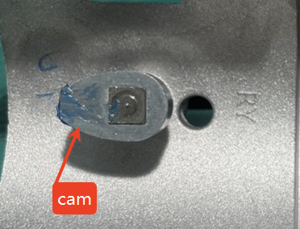

- If the noise comes from inside the motor, the gearbox may be faulty. In this case, please replace the gearbox.

The pictures of how removing the outer housing for your reference.
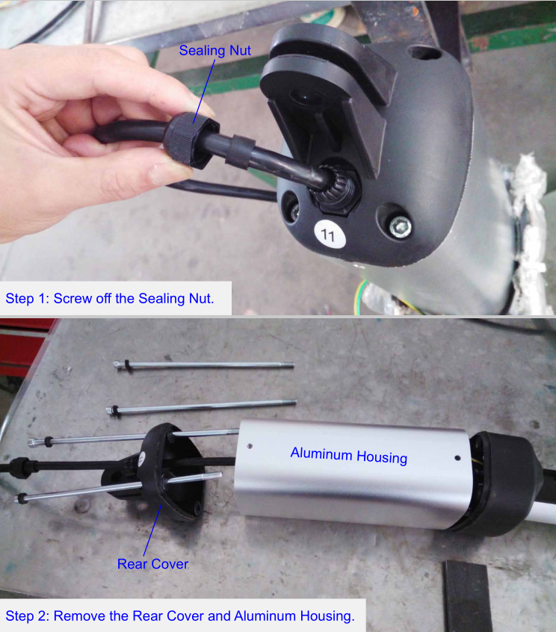

十五、离合打不开 Clutch Won't Release
1把机臂拿下来不带门的时候试试：先确定下离合拧不开的时候机臂是在什么状态下，看机臂是不是关门到位很紧的状态，这个时候拧离合钥匙是很难拧开的；如果不带门可以正常打开 需要重新调整开关门位置；
2 如果不带门也打不开，检查一下是不是伸太过，先手旋转拉杆往里推试试，看能不能拧进去，可以的话限位B往里调一点；如果不能旋进去，拆开看看，是不是里面卡住了。
3 如果不是伸太过的情况，用拆开机壳，离合钥匙插在离合小轴上，转动离合钥匙，看看离合件2和离合件3会不会分离，如果可以分离，但是机臂不能手动伸缩，要拆开检查丝母与铝管或不锈钢管内壁是不是卡住了，螺母有没有磨损；如果一切正常，可润滑看看。
1 Remove the arm from the gate first and try to disengage the clutch with the release key to see whether it can work. If you can disengage the clutch when the arm is not installed on the gate, then it is possible that the installation of the gate needs to be readjusted. Please try to reconfirm the open and close position point as instructed in the user manual.

2 If the clutch still cannot be released, please check if the arm is fully extended and can’t be retracted, if so, please refer to the steps and video link below to check whether the issue can be fixed.
Use the release key to engage the clutch and manually rotate clockwise and push the Front Mount inward, see screenshot below. When the arm is pushed to the middle position (half retracted), press the remote to see if the arm moves properly.
https://youtube.com/shorts/EeHaJdHqE-U?feature=share
- If you fail in the attempt above, please refer to the video link below (the arm in the video is not the same) to check whether it can help.
How to dismantle the moving-rod?: https://youtu.be/0dkm1sKYjzA
How to Install the moving rod for TOPENS swing gate opener:
https://youtu.be/5s1EQh2M_mo
- If arm can be retracted, please slide the limit switch B inwards a little bit to prevent the problem from happening again.

3 If it is note the case in the step 2, please kindly dismantle the arm with reference to the following instruction. The arm in the screenshots might be different from yours, but the procedures are the same.
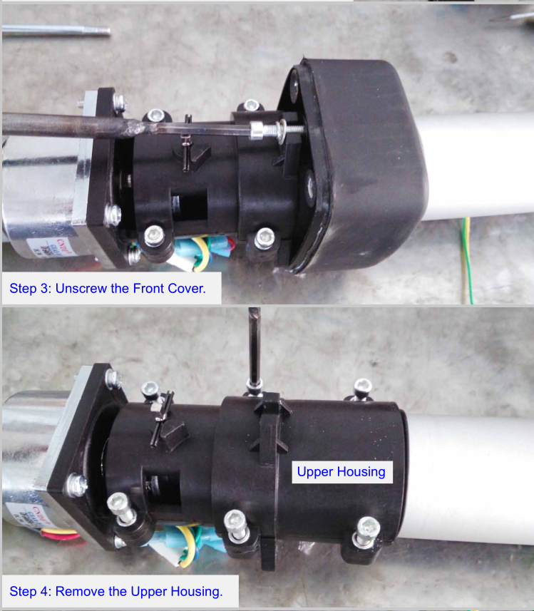
- Please use the release key to turn the clutch clockwise and counterclockwise to see whether the clutch can be engaged and released (the marked two parts can be separated when you release the clutch). If not, videos showing the problem are much appreciated for further assistance.
- If the clutch can be released but the arm cannot extend or retract by hand, please check if something inside is stuck . The lead screw and the nut or the nut and the outer aluminum tube? Has the nut been worn out? Moreover, are there any obvious deformations in the aluminum tube? Some pictures of the problem are much appreciated for further judgement.
How to dismantle the moving-rod?:
https://youtu.be/0dkm1sKYjzA
How to Install the moving rod for TOPENS swing gate opener:
https://youtu.be/5s1EQh2M_mo

4 If there is nothing abnormal in the tests above, please lubricate the inside of the aluminum tube and lead screw as well as the nut (as shown below) to see how it works. Grease capable of enduring the lowest local temperature is highly recommended.

How to lubricate inside of the arm
https://www.youtube.com/watch?v=IRIA5iaWHqE

风会把门吹开（或者外力能把门推开一点） There is Little Play When the Gate is Closed
1 检查托架是否紧固，门机运行时候是否会晃动，大门铰链最好不要太松
2观察门被风吹动的时候拉杆会不会伸缩。如果不会，解释大风吹的时候门体晃动是正常的，建议装电子锁
3 如果会动的话，取下来离合合上，手推拉，是不是可以伸缩，如果会发视频看看
1 Please verify that all post brackets and pivot brackets are securely fastened and remain completely rigid during operation. Additionally, ensure the gate hinges are properly tightened to eliminate excessive play or looseness.

2 If the brackets are fine, please observe whether the moving-rod will be extended/retracted by the wind. If not, it is the normal case that the gate will be blown open because of the strong wind. Please kindly note that the gate opener is more focused on the function of opening and closing the gate automatically and does not act as a lock. There can be a small opening more or less after gate is closed, especially in windy areas. To solve this issue, TOPENS ET24 electric lock is highly recommended.

3 If the moving-rod can be moved when the clutch is engaged, please remove the arm from the gate. Then pull/push the moving-rod by hand to see whether it will extend or retract by doing so. If so, please share us a video showing the problem for further assistance. You can directly send the video to my E-mail via the attachment. If the sending is not successful, please share the photo or video link through dropbox, icloud or google drive. Thanks for your understanding and cooperation.

十七、保养与润滑 Maintenance and Lubrication
日常保养润滑：
In cold climates where temperatures reach 1°C (30°F) or less, spray WD40 on the stainless steel moving-rod every 4~6 weeks to prevent freeze up.
For maintenance, please spray WD40 or the ordinary engine oil on the stainless steel moving-rod.

如果运行不顺畅等，可更进一步拆机臂润滑不锈钢管内壁，丝母内外侧，甚至丝杆
Besides, grease is needed to lubricate the inside of the stainless steel tube and lead screw as well as the nut (as shown below). When doing this, please take apart the actuator with reference to the steps as follows.
How to lubricate inside of the arm
https://www.youtube.com/watch?v=IRIA5iaWHqE

Below are the links of how to disassemble and reassemble the arm for your reference.
How to dismantle the moving-rod?
https://youtu.be/0dkm1sKYjzA
How to Install the moving rod for TOPENS swing gate opener?
https://youtu.be/5s1EQh2M_mo

1. Routine Maintenance
Spray WD40 or ordinary engine oil on the stainless steel moving rod.

In cold climates (1°C / 30°F or below):
Spray every 4–6 weeks to prevent freeze‑up.

2. Deep Lubrication (if movement is not smooth)
If the arm still does not run smoothly after routine maintenance, further lubricate:
·Inside of the stainless steel tube
·Nut (inside and outside)
·Lead screw
How to lubricate inside the arm:
https://www.youtube.com/watch?v=IRIA5iaWHqE

✅ Use grease that can withstand the lowest local temperature in your area.

3. Guide of maintainance for your reference:
·Essential Guide to Regular Maintenance and Care for Your Gate Opener
https://topens.com/blogs/blog-posts/essential-guide-to-regular-maintenance-and-care-for-your-gate-opener

·How Do You Keep the Gate Opener Arm from Freezing in Winter
https://topens.com/blogs/blog-posts/preventing-winter-freezing-of-automatic-gate-opener-arms

十八、其他产品知识讲解
控制板本身的遇阻功能：不论遇阻几次都是开门遇阻停止，关门遇阻反弹到位（反弹到开门位置）。
红外遇阻功能：控制板连接红外，红外功能开启，红外遇阻，开门不起作用，关门遇阻反弹到位（反弹到开门位置）

外接收器和有线面板接的电源端口一般都是长期有电的
用作保护的红外接节能型的平开门机，接线如说明书中那样接，待机是不耗电的，所以带S的机器可不用加大太阳能板功率和电池容量，如果用作开门，红外电源就要接到BAT端口，这个时候纯太阳能供电的机器需要考虑电池容量和太阳能板功率。

适配器插到BAT端口的话，POWER灯正常闪烁，FULL灯会常亮提示过压。输入电源插到适配器端口，CODE灯会微弱的常亮。只接适配器在adapter端口也是CODE灯微弱的亮

解释AB值
The "A" value is the horizontal distance from the gate hinge to the joint of the arm and the pivot bracket; while the "B" is vertical distance from the gate hinge to that joint.

解释XY值
The "X" value stands for the distance from gate hinge to the mounting surface of post brackets, while the "Y" value refers to the width of the mounting surface of post brackets.

限位原理

我们的平开门机限位都是常闭的，到限位之后会给控制板一个信号。然后近端限位和远端限位都短接之后就是相当于机器在运行中途，没有检测到开关门限位。这个时候正常机器就可以通过遥控器等来操控开停关。如果表现正常说明控制板是没问题的，如果接回限位开关，机器不正常就是限位开关出问题了，一般表现是只开不关，只关不开，或不工作。例如：只开不关，就说明关门限位有问题了，有可能是关门限位开关一直在给信号让门机以为一直是关到位的状态，一直给信号一般就跟限位开关内部零件出问题有关系了； 反之，只关不开就是开门限位出问题了。

Actually, the limit switch is triggered by a magnet. It is the case that the limit switches stay normally closed until they sense the magnet (hit the limit stop).
Our gate opener is equipped two electromagnetism limit switches (limit switch A and limit switch B) for limiting the open and closed positions. When the limit switches sense the magnet on the moving-rod, the gate will stop at the open/closed positions. Generally, the limit switch A is fixed at the factory and you are not allowed to adjust the limit switch A.

想调限位A
According to your description, I assume your gate is installed as pull-to-open (viewed from the inside of your property). If so, the opening position of the gate is confirmed by the position of the gate bracket and you can reconfirm the opening position through the following procedures.

Please have the moving-rod fully retracted and leave the gate at the desired opening position so as to confirm the position of the gate bracket.

Frankly, it is not suggested to adjust the limit switch A, which is fixed in the factory. If you still want to adjust the Limit switch A, you are allowed to adjust no more than 1.9 inch (5cm), in case the inner structure of the motor will be damaged. If the 1.9 inch cannot meet your requirements, you have to move the gate bracket inward. I do appreciate your kind understanding.

机臂进水
As for the problem that water went into the arm, please check whether the clutch port of the arm is properly covered and whether there is any damage in the sealing ring of the outer cover. Otherwise, water will penetrate into the arm.

断电和接线顺序提醒
When disconnecting the power source, please disconnect the solar panels from the solar controller first. When connecting, it is required to connect the batteries to the solar controller first.

电池推荐：
The batteries for this gate opener are NOT available at our Amazon store. Sorry for the inconvenience. You may order the batteries from other stores. Generally, a 24V 12Ah battery (or 2pcs 12V 12Ah batteries connected in series may function as 24V) is required to power the gate opener. Lead acid / GEL / AGM / flooded (deep cycle) batteries can be used. Kindly note that the regulator is not compatible with most lithium-ion batteries, except for LiFePO4 batteries. And the battery should be waterproof type, or be placed in waterproof circumstance.
Moreover, if you only use solar panel to charge the batteries, you’re required to increase the solar panels power and the batteries capacity when you add continuously electricity-consuming accessories such as exit sensor wand, wired keypad, external receiver, etc. Normally, if you add such an accessory, you need increase the solar panel by 30W and enlarge the battery capacity accordingly.

接耗电有线配件需要扩大太阳能板功率和电池容量
The capacity of the batteries and the power of the solar panel should be enlarged if you want to use some accessories that consume power in standby mode.

The connection of TEW3 Car Exit Wand will speed up battery drain. If batteries are chosen to be the main power source and to be charged only by solar panel in this case, the power of the solar panel should be up to 60W, and the battery needs to be 17Ah.

太阳能板串联的时候电压增加，并联的时候电压不变，电流变大。不管串联还是并联太阳能板的功率都会增加。电池是串联的时候电压增加，容量不变，并联的时候电压不变，容量增加。

太阳能板充电的问题
要看是多大功率太阳能板充多少AH电池，如果是20W太阳能板+7.2AH电池，那么平均日照6H的话差不多需要4天充满。如果是30W太阳能板+12AH电池，那么平均日照6H的话差不多需要5天充满。

平开门机（比如A8S）如果是7Ah没接配件一天开20个循环可以坚持4天，如果是12Ah电池一天20个循环可以坚持6天
If your area has beautiful sunshine and the gate opener does not have accessories, and the gate opener runs 10 cycles everyday, it takes 5 days to fully charge a 12AH battery.

如果适配器来充一个7AH刚欠压的电池，充满电差不多要16小时，如果充一个12AH刚欠压的电池，充满电差不多要28小时。12AH电池充满电机器每天工作20个循环（不接配件）坚持6天是没问题的

30W太阳能板对应最大20Ah的电池 60W太阳能板对应最大35Ah的电池

带太阳能组套的开门机的使用频次问题
It depends on the frequency of use and sunshine duration. Generally speaking, if you use 7.2Ah batteries, the average sunshine duration is more than 6 hours daily, and there aren't power-consuming accessories connected to the gate opener, the gate opener can run less than 10 open & close cycles per day. The kit comes with an adapter which can be plugged into AC outlet to charge the batteries. If there isn't much sunlight and the gate opener is used frequently daily, it is suggested to use batteries of higher capacity (like 12Ah or 17Ah) and the adapter to power the system together with solar.

别的牌子的太阳能板和控制器用于我们的开门机
待机电流小于10mA，然后确保是太阳能板和控制器额定电压都是24VDC

