ACTOR-FREE TD-LEWM · COMPLETE 7×3 CONTROLLED ABLATION

Results TD
  - swm/OGBCube-v0 | dataset quentinll/lewm-cube | training seed 3072 | planning seed 42
Locked protocol: all 7 methods completed 10 epochs / 127,960 optimizer updates; each method was evaluated with 3 scores, for 21 formal O50 runs. goal offset=50; common selection SHA-256=e46ea81cce2e….

Combined O50 ranking
Rank | Method | Family | Combined | Successes | Rate | Elapsed
1 | Hybrid | Successor | f_plus_g | 27/50 | 54% | 14:34.6
2 | Serial Decoupled | Successor | f_plus_g | 23/50 | 46% | 16:32.9
2 | Imaginary Hybrid | Successor | f_plus_g | 23/50 | 46% | 16:29.2
4 | Parallel Real | Successor | f_plus_g | 22/50 | 44% | 17:20.4
5 | Serial Coupled | Successor | f_plus_g | 20/50 | 40% | 17:55.9
6 | Goal Hybrid | Successor | f_plus_g | 19/50 | 38% | 18:56.5
6 | Direct Goal Critic Hybrid | Direct critic | f_plus_c | 19/50 | 38% | 18:47.4
Table 1. Ranking uses only the pre-specified combined column; equal success counts share a rank. The best of the three score columns is not selected post hoc.

7×3 inference-score matrix
Method | Tail type | F-only | G/C-only | F+G / F+C | Combined rank only
Serial Decoupled | Successor / G | 20/50 · 40% · 18:54.9 | 15/50 · 30% · 20:32.1 | 23/50 · 46% · 16:32.9 | #2 · G
Serial Coupled | Successor / G | 26/50 · 52% · 15:11.5 | 14/50 · 28% · 20:36.9 | 20/50 · 40% · 17:55.9 | #5 · G
Hybrid | Successor / G | 25/50 · 50% · 15:40.0 | 13/50 · 26% · 22:03.4 | 27/50 · 54% · 14:34.6 | #1 · G
Parallel Real | Successor / G | 17/50 · 34% · 19:33.0 | 13/50 · 26% · 20:48.1 | 22/50 · 44% · 17:20.4 | #4 · G
Goal Hybrid | Successor / G | 25/50 · 50% · 15:45.3 | 19/50 · 38% · 18:28.8 | 19/50 · 38% · 18:56.5 | #6 · G
Imaginary Hybrid | Successor / G | 24/50 · 48% · 16:13.8 | 13/50 · 26% · 21:09.9 | 23/50 · 46% · 16:29.2 | #2 · G
Direct Goal Critic Hybrid | Direct / C | 22/50 · 44% · 17:25.5 | 16/50 · 32% · 19:56.4 | 19/50 · 38% · 18:47.4 | #6 · C
Table 2. Each cell reports successes/episodes, success rate and elapsed time (h:mm:ss); F-only includes the final planning action.

TRAINING / VALIDATION · SUMMARY-DERIVED METRICS

Training convergence and checkpoints
  - 7 methods | 10 epochs | 127,960 optimizer updates per method
Comparison limit: auxiliary-loss counts and definitions differ. Total loss is only a within-method convergence check and cannot rank methods across structures.
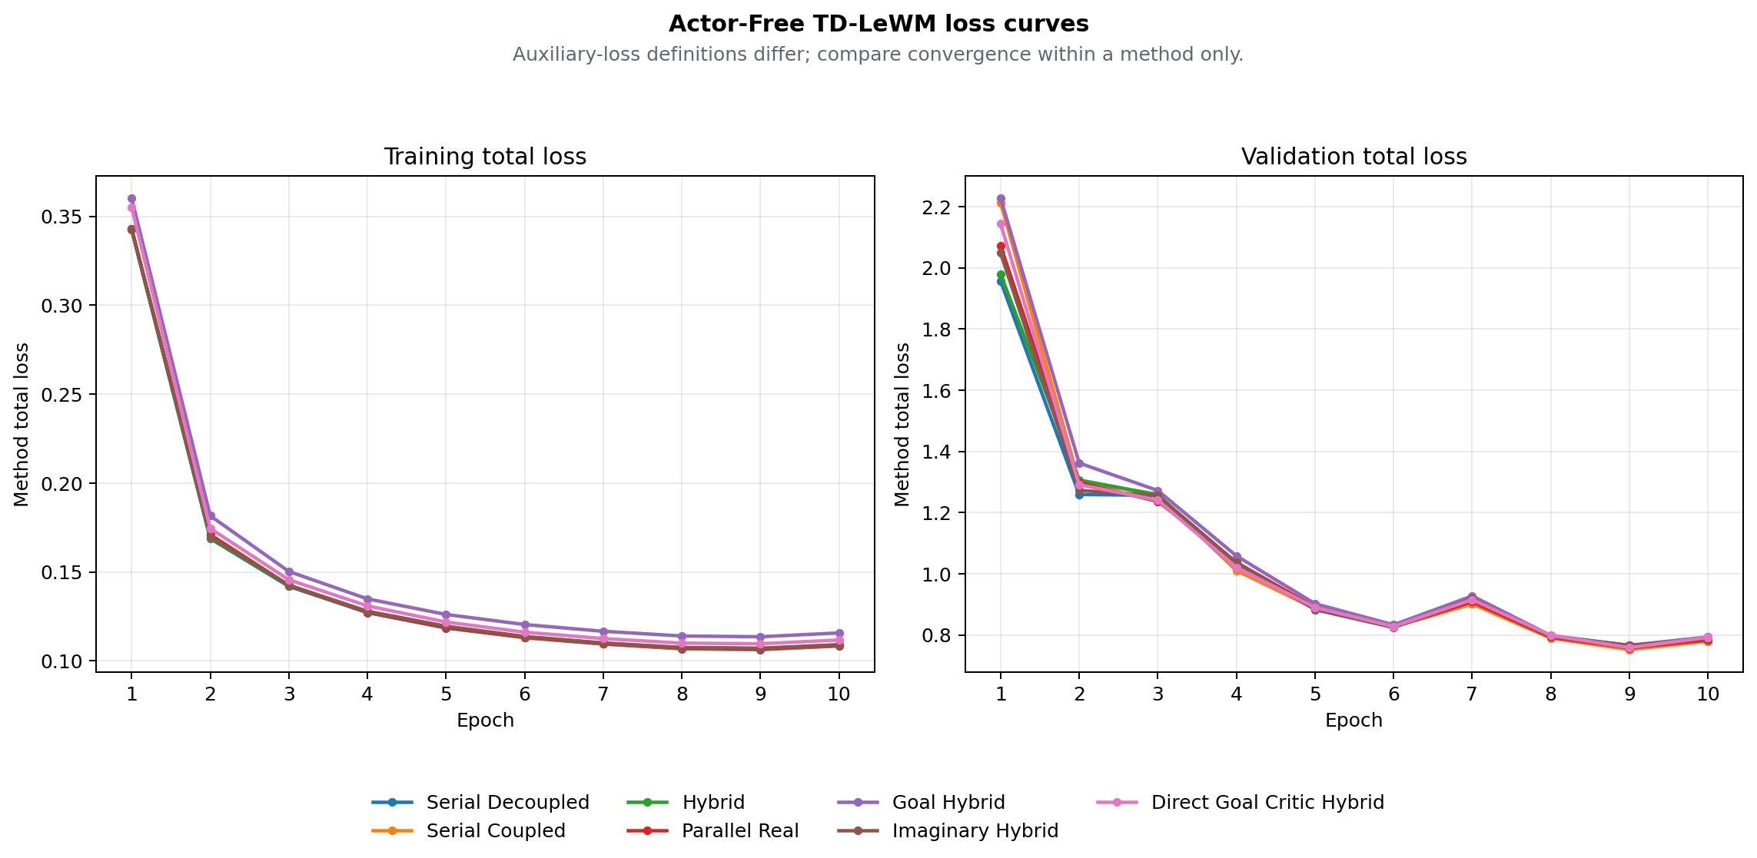
Figure 1. Training and validation total-loss curves derived by the archiver; cross-method ranking uses combined O50 on page 1.
Method | Final train | Final validation | Best validation | Checkpoint SHA | Training commit
Serial Decoupled | 0.108424 | 0.780097 | 0.754505 · E9 | cb8be3f9a851 | 8e667cb6a8e9
Serial Coupled | 0.108643 | 0.780158 | 0.752397 · E9 | 2fe3fd5bcb2c | 8e667cb6a8e9
Hybrid | 0.108973 | 0.784110 | 0.766112 · E9 | 299222acff78 | 8e667cb6a8e9
Parallel Real | 0.108762 | 0.784254 | 0.757853 · E9 | 61b5614a7b92 | e895637d8c7e
Goal Hybrid | 0.115752 | 0.793633 | 0.766048 · E9 | a746912bddd0 | 88ad2ec12c1d
Imaginary Hybrid | 0.109176 | 0.788777 | 0.766026 · E9 | e7656fed92a0 | ea82e8f2984f
Direct Goal Critic Hybrid | 0.111773 | 0.792399 | 0.759004 · E9 | b3345e9eefdb | a1d98a2d0881
Table 3. Final is epoch 10; Best validation is selected within each method's 10 epochs. Hashes and commits come from the archive summary.

METHOD REFERENCE · BASE STRUCTURAL ABLATIONS

Four base Actor-Free TD-LeWM structures
  - Shared LeWM encoder/predictor; differences are successor inputs, TD gradient paths and real/predicted branches.
Common objective: L_LeWM = L_pred + 0.09 L_SIGReg. The successor target uses the real EMA next latent, EMA head and dataset next action, with a stop-gradient target; every method is actor-free.
Method | Network | Training loss | Special design / gradient path | Inference
Serial Decoupled  serial_decoupled | LeWM + one successor-feature head on predicted latent history | L = L_LeWM + αᵤ L_TD^pred  G(sg(H̃ₜ), aₜ) → sg(yₜ^SF) | Predicted context is detached; TD updates the successor head only. | CEM with F-only, G-only, or F+G cost.
Serial Coupled  serial_coupled | LeWM + one successor-feature head on predicted latent history | L = L_LeWM + αᵤ L_TD^pred  G(H̃ₜ, aₜ) → sg(yₜ^SF) | Predicted context stays differentiable; TD also reaches LeWM. | CEM with F-only, G-only, or F+G cost.
Hybrid  hybrid | LeWM + one shared successor head for real and predicted histories | L = L_LeWM + αᵤ(L_TD^pred + L_TD^real)  The same G consumes predicted and real latent histories | The same head is trained on parallel-real and coupled-serial branches. | CEM with F-only, G-only, or F+G cost.
Parallel Real  parallel_real | LeWM predictor and successor head are parallel on encoder latents | L = L_LeWM + αᵤ L_TD^real  G(Hₜ^real, aₜ) is parallel to the LeWM predictor | TD uses real latent history and does not pass through the predictor. | CEM with F-only, G-only, or F+G cost.
Table 4. Method descriptions come from archive summary.method_spec; the equations are fixed definitions, not manually entered results.

Unified meaning of the three inference scores
Score mode | Candidate-action ranking signal
F-only | LeWM rolls and scores all H predicted states with the normalized discounted latent-goal cost.
G-only | LeWM still rolls the candidate to form tail context, but ranking uses only the successor G readout.
F+G | F prefix cost plus discounted successor G tail cost.
Control protocol: all structures use the same swm/OGBCube-v0, selection and planning seed 42. G-only still uses a LeWM rollout to build tail context, but excludes F cost from ranking.

METHOD REFERENCE · GOAL / IMAGINARY / DIRECT

Three extensions, target equations and audit sources
  - Side-by-side comparison of goal-readout TD, EMA imaginary bootstrap and a direct goal-conditioned critic.
Method | Network | Training loss | Special design / gradient path | Inference
Goal Hybrid  goal_hybrid | Hybrid successor head with fixed linear goal readout G^T w(g) | L = L_LeWM + αᵤ(L_SF-TD^real + L_SF-TD^pred + L_goal-TD^real + L_goal-TD^pred)  C_g(H,a) = G(H,a)ᵀw(z_g) | Goal readout is trained by hindsight goal-conditioned Bellman TD. | CEM with F-only, G-only, or F+G cost.
Imaginary Hybrid  imaginary_hybrid | Hybrid successor head with an EMA-LeWM imagined bootstrap state | L = L_LeWM + αᵤ(L_TD^real + L_TD^pred)  The bootstrap state is imagined one step by stop-gradient EMA-LeWM | The TD target bootstraps one step through the stopped EMA predictor. | CEM with F-only, G-only, or F+G cost.
Direct Goal Critic Hybrid  direct_goal_hybrid | LeWM + one scalar goal-conditioned critic for real/predicted histories | L = L_LeWM + αᵤ(L_C-TD^real + L_C-TD^pred)  C(H,a,z_g) directly outputs a goal-conditioned scalar cost | Goal latent enters the critic directly; there is no SF factorization. | CEM with F-only, C-only, or F+C cost.
Table 5. Direct uses C-only / F+C; successor methods use G-only / F+G. Training remains actor-free.

Target and planning equations
SF TD: yₜ^SF = (1−γ)χ(z̄ₜ₊₁) + γ(1−dₜ)Ḡ(next).
Goal TD: C_g(H,a)=G(H,a)ᵀw(z_g), yₜ^g=(1−γ)c(z̄ₜ₊₁,z_g)+γ(1−dₜ^g)C̄_g(next).
Imaginary: Ĥₜ₊₁=sg(P̄(Hₜ,aₜ)), then bootstrap from Ĥₜ₊₁; Direct: C(H,a,z_g) predicts scalar cost directly.
Planning: J_F=Σₖ₌₁ᴴγᵏ⁻¹c(z̃ₜ₊ₖ,z_g); combined adds the discounted G/C tail to the F prefix. CEM minimizes cost; it does not train an Actor to maximize a one-step dot product.
Combined conclusion: Hybrid ranks first at 27/50 (54%). This claim applies only to the combined score; F-only and G/C-only are inference ablations of the same checkpoint. Boundary: one training seed and one matched O50 planning selection. Rank only combined inference scores; this is not a multi-seed claim.

Provenance / checksums
Variant | Train commit | Eval commit(s) | Checkpoint SHA | Locked protocol SHA
serial_decoupled | 8e667cb6a8 | fa46ed99b/8e667cb6a | cb8be3f9a851 | 6eaaf266bc6e
serial_coupled | 8e667cb6a8 | fa46ed99b/8e667cb6a | 2fe3fd5bcb2c | e272feeb5081
hybrid | 8e667cb6a8 | fa46ed99b/8e667cb6a | 299222acff78 | bd0b207e2712
parallel_real | e895637d8c | fa46ed99b/e895637d8 | 61b5614a7b92 | f3d3ca31e1f1
goal_hybrid | 88ad2ec12c | fa46ed99b | a746912bddd0 | fdbf618cb45e
imaginary_hybrid | ea82e8f298 | fa46ed99b | e7656fed92a0 | 6e43c9f75351
direct_goal_hybrid | a1d98a2d08 | fa46ed99b | b3345e9eefdb | f9e2ee091aee
Input SHA-256: selection=e46ea81cce2e6a9a5df05ba04893b4181cbd8979340111a012c30f1efa2d7ee7; summary.json=9fa31a12476ff4a332e555505fc720964d81c5640c77cc394beb5df538ae2da6; training_loss_curves.png=4cce0d5891b8b51e5e3dc7481bd9582de85e69c9b01a9fcb6d025ed271957a60; paired_outcomes.csv=3047c9a419f066548b6e942e29c49b35d286670dc60e5db27fcd845897a6f2ae.
Score definitions: F-only — LeWM rolls and scores all H predicted states with the normalized discounted latent-goal cost. Combined — F prefix cost plus discounted successor G tail cost / discounted direct-critic C tail cost.

RESULTS TD / CONTROLLED C–G3 V0 → V1
Raw-action V0 vs shared-action-encoder V1
Same C/D/F/G1/G2/G3 losses · same 50 pairs · actor-free CEM planning
Version boundary: the first four pages preserve the earlier 7-method Actor-Free TD-LeWM ablation. This appendix records the later controlled C-G3 study; its raw-action V0 is a separate 6-by-3 experiment.

V0 / V1 definition
V0 sends the normalized raw 25D action block directly into G. V1 sends stopgrad(E_A(a)), the 192D embedding from the shared frozen LeWM Action Encoder. Both current and dataset next actions follow this rule; neither version contains an Actor or reward model. The six losses and planning definitions are unchanged, but predictor capacity is not matched: 336,320 parameters in V0 versus 379,072 in V1.

V0 formal O50 — raw 25D action
V0 has 18 completed formal evaluations: six methods × F-only/G-only/F+G. All rows use training seed 3072, planning seed 42, horizons 5/1/5 and the same 50 start–goal pairs used by V1.
V0 method | F-only | G-only | F+G | Δ vs F
C | 23/50 (46%) | 18/50 (36%) | 24/50 (48%) | +1/50
D | 23/50 (46%) | 20/50 (40%) | 21/50 (42%) | -2/50
F | 23/50 (46%) | 19/50 (38%) | 20/50 (40%) | -3/50
G1 | 23/50 (46%) | 16/50 (32%) | 25/50 (50%) | +2/50
G2 | 23/50 (46%) | 16/50 (32%) | 25/50 (50%) | +2/50
G3 | 23/50 (46%) | 18/50 (36%) | 23/50 (46%) | +0/50

V0 → V1 combined comparison
On this matched selection: F and G3 gain 8 pp; D and G2 are unchanged; C loses 4 pp; G1 loses 2 pp. V0 best is G1/G2 at 50%; V1 best is G3 at 54%.
Method | V0 F+G | V1 F+G | V1 - V0
C | 24/50 (48%) | 22/50 (44%) | -2/50
D | 21/50 (42%) | 21/50 (42%) | +0/50
F | 20/50 (40%) | 24/50 (48%) | +4/50
G1 | 25/50 (50%) | 24/50 (48%) | -1/50
G2 | 25/50 (50%) | 25/50 (50%) | +0/50
G3 | 23/50 (46%) | 27/50 (54%) | +4/50

RESULTS TD / ACTOR-FREE TD-JEPA V1 DETAILS
Cube O50 — six methods × three score modes
Shared frozen LeWM Action Encoder · actor-free CEM planning · seed 3072
Study: actor_free_td_lewm_v1_cube_seed3072_o50_6x3
Evaluation: 18 formal O50 runs on one matched set of 50 pairs
Training: 6 methods · 10 epochs · 127,960 updates per method
Training acceptance: PASS_WITH_WARNINGS
Selection SHA-256: e46ea81cce2e6a9a5df05ba04893b4181cbd8979340111a012c30f1efa2d7ee7
Interpretation boundary — one training seed and one planning selection. Use this report as a matched structural/score-mode ablation, not as a multi-seed claim of overall superiority.
Training provenance warning — launcher exit codes could not be recovered. Checkpoints, metrics, epochs, steps, and acceptance evidence passed the archive validator, but the missing exit-code provenance must not be represented as an unconditional PASS. Archived warning: c.process: PID 122116 was reaped without an exit marker; d.process: PID 122117 was reaped without an exit marker; f.process: PID 122118 was reaped without an exit marker; g1.process: PID 122119 was reaped without an exit marker; g2.process: PID 122120 was reaped without an exit marker; g3.process: PID 122121 was reaped without an exit marker

Combined ranking
Highest combined result: V1-G3 Prefix-Marginal Advantage, 27/50 (54%). Ties share the same success count; ordering is taken from the validated summary.
Rank | Method | ID | Score | O50
1 | V1-G3 Prefix-Marginal Advantage | G3 | F+G | 27/50 (54%)
2 | V1-G2 Prefix-Mean Advantage | G2 | F+G | 25/50 (50%)
3 | V1-F Same-Future / Different-Goal Advantage | F | F+G | 24/50 (48%)
3 | V1-G1 Neighbor Action Advantage | G1 | F+G | 24/50 (48%)
5 | V1-C Goal-Projected TD | C | F+G | 22/50 (44%)
6 | V1-D Goal-Value Weighted TD | D | F+G | 21/50 (42%)

Three inference scores
F-only uses the LeWM rollout score; G-only uses the learned successor readout; F+G uses the LeWM prefix with the successor tail. All three columns use the same checkpoint and the same 50 start–goal pairs within each method.
Method | F-only | G-only | F+G | Δ vs F
V1-C Goal-Projected TD | 23/50 (46%) | 18/50 (36%) | 22/50 (44%) | -1/50
V1-D Goal-Value Weighted TD | 23/50 (46%) | 22/50 (44%) | 21/50 (42%) | -2/50
V1-F Same-Future / Different-Goal Advantage | 23/50 (46%) | 23/50 (46%) | 24/50 (48%) | +1/50
V1-G1 Neighbor Action Advantage | 23/50 (46%) | 21/50 (42%) | 24/50 (48%) | +1/50
V1-G2 Prefix-Mean Advantage | 23/50 (46%) | 21/50 (42%) | 25/50 (50%) | +2/50
V1-G3 Prefix-Marginal Advantage | 23/50 (46%) | 19/50 (38%) | 27/50 (54%) | +4/50

Training curves
The left panel is each method's own training objective and is not cross-method comparable. The right panel is the common base TD validation objective used by all six methods.
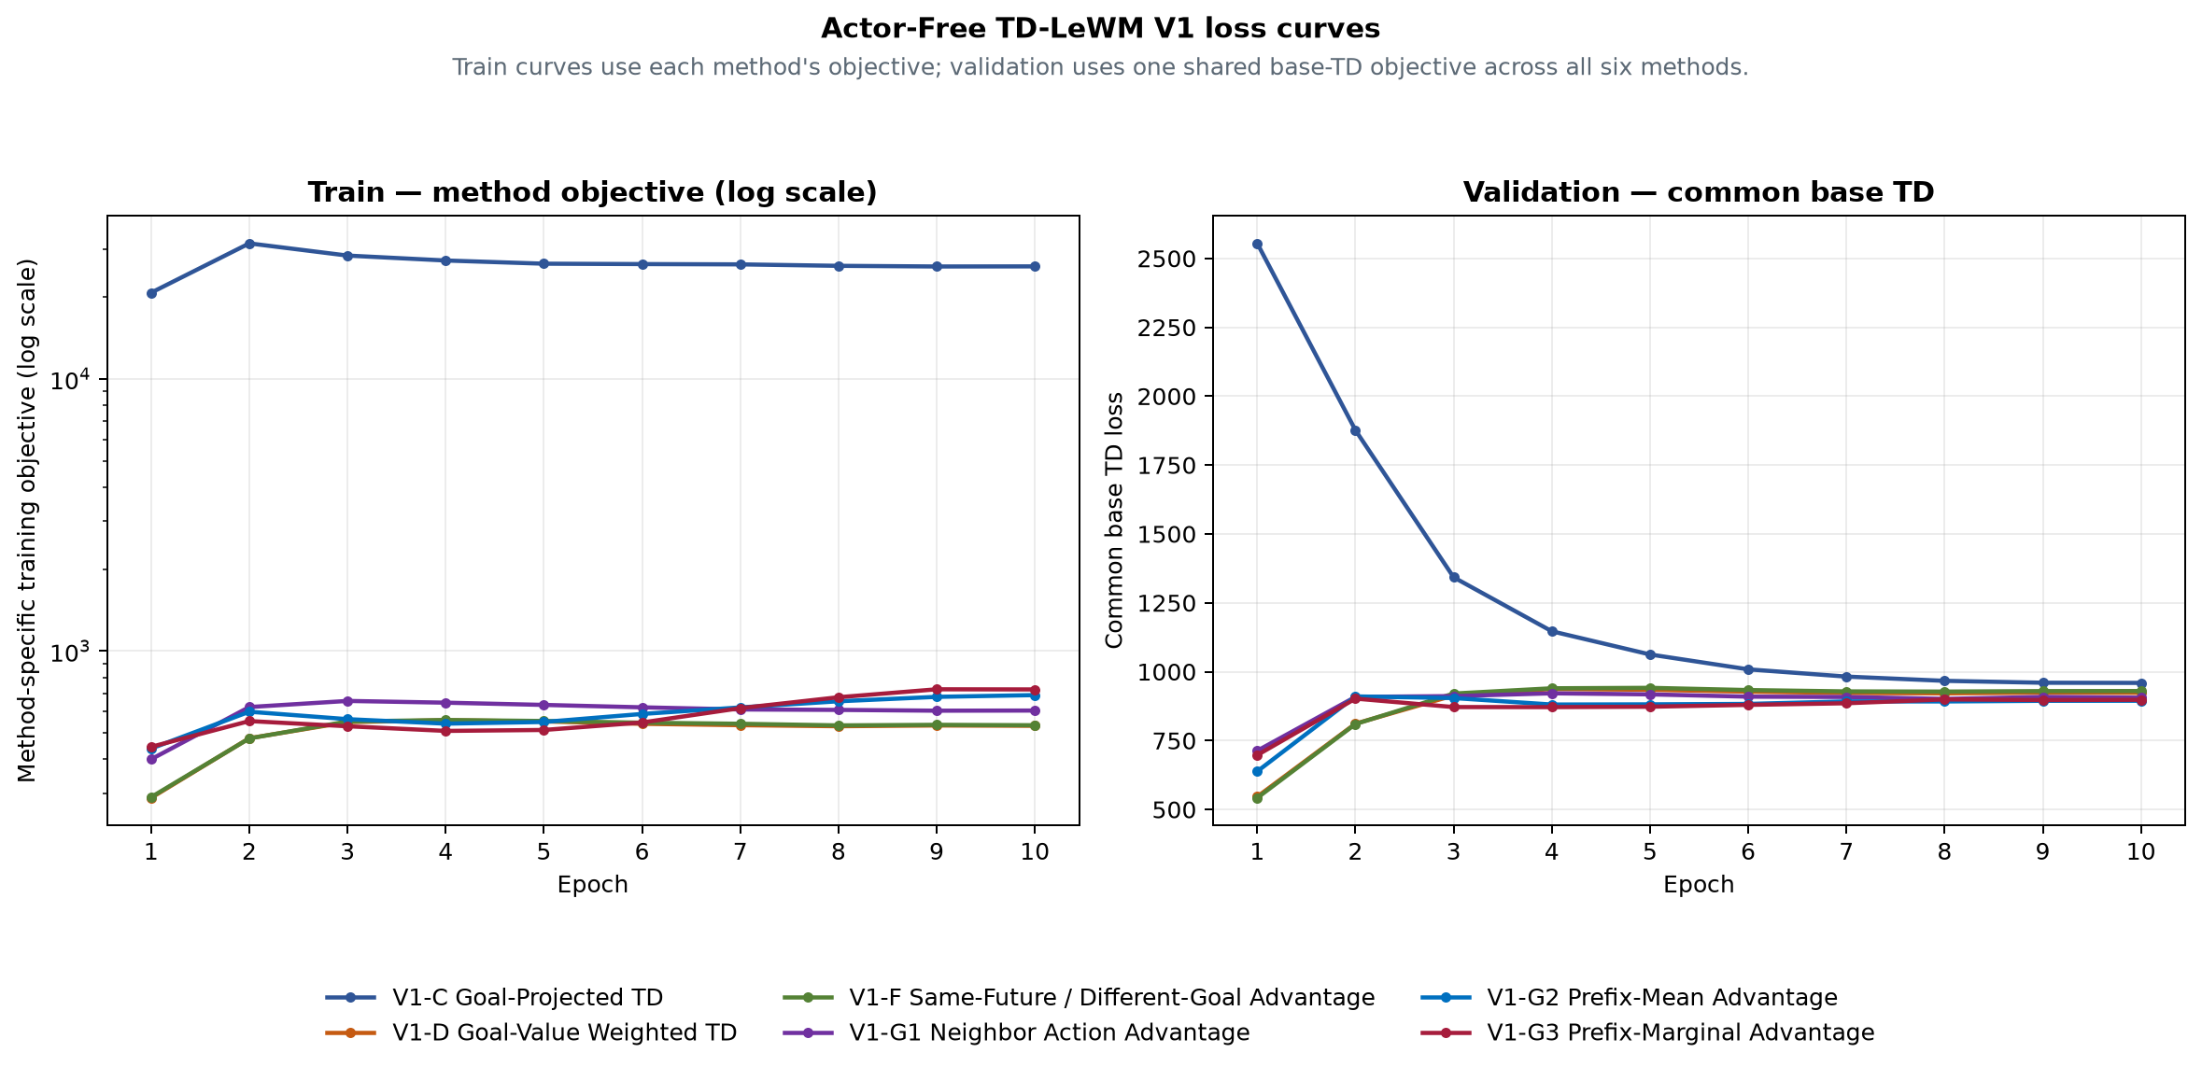
Figure 1. Train method objective (left) and validation common base TD (right).
Method | E10 train  method objective | E10 validation  common base TD | Best common  base TD
V1-C Goal-Projected TD | 25927.3 | 959.265 | 959.265 (E10)
V1-D Goal-Value Weighted TD | 531.178 | 923.235 | 546.341 (E1)
V1-F Same-Future / Different-Goal Advantage | 533.615 | 929.771 | 541.974 (E1)
V1-G1 Neighbor Action Advantage | 604.267 | 905.668 | 713.09 (E1)
V1-G2 Prefix-Mean Advantage | 688.673 | 894.455 | 638.227 (E1)
V1-G3 Prefix-Marginal Advantage | 722.493 | 897.862 | 697.315 (E1)

Method definitions

V1-C Goal-Projected TD (C)
Network: Frozen LeWM + frozen shared action encoder + one 379,072-parameter TD-JEPA predictor
Training loss: Common feature TD plus goal-projected TD residual on goal-derived tasks
Special design: Directly constrains the detached TD target and prediction after projection onto the matched goal
Inference: F-only: LeWM final predicted-latent goal cost, horizon 5; G-only: Negative goal projection of the V1 predictor, horizon 1; F+G: LeWM F prefix plus discounted terminal V1 G tail, horizon 5

V1-D Goal-Value Weighted TD (D)
Network: Frozen LeWM + frozen shared action encoder + one 379,072-parameter TD-JEPA predictor
Training loss: Detached target-goal scores reweight the common real-transition feature TD
Special design: Goal-subset softmax weights; random-task weight remains one; final weights have mean one
Inference: F-only: LeWM final predicted-latent goal cost, horizon 5; G-only: Negative goal projection of the V1 predictor, horizon 1; F+G: LeWM F prefix plus discounted terminal V1 G tail, horizon 5

V1-F Same-Future / Different-Goal Advantage (F)
Network: Frozen LeWM + frozen shared action encoder + one 379,072-parameter TD-JEPA predictor
Training loss: Same-future/different-goal detached advantage reweights common feature TD
Special design: Matching task score is contrasted with all goal-derived tasks in the batch
Inference: F-only: LeWM final predicted-latent goal cost, horizon 5; G-only: Negative goal projection of the V1 predictor, horizon 1; F+G: LeWM F prefix plus discounted terminal V1 G tail, horizon 5

V1-G1 Neighbor Action Advantage (G1)
Network: Frozen LeWM + frozen shared action encoder + one 379,072-parameter TD-JEPA predictor
Training loss: Neighbor-action detached advantage reweights common real-action feature TD
Special design: Other-episode KNN actions are comparison-only and never create candidate TD targets
Inference: F-only: LeWM final predicted-latent goal cost, horizon 5; G-only: Negative goal projection of the V1 predictor, horizon 1; F+G: LeWM F prefix plus discounted terminal V1 G tail, horizon 5

V1-G2 Prefix-Mean Advantage (G2)
Network: Frozen LeWM + frozen shared action encoder + one 379,072-parameter TD-JEPA predictor
Training loss: Full-prefix score minus mean prefix score reweights common feature TD
Special design: Zero-mean suffix prefixes are comparison-only; the real full action supplies the TD pair
Inference: F-only: LeWM final predicted-latent goal cost, horizon 5; G-only: Negative goal projection of the V1 predictor, horizon 1; F+G: LeWM F prefix plus discounted terminal V1 G tail, horizon 5

V1-G3 Prefix-Marginal Advantage (G3)
Network: Frozen LeWM + frozen shared action encoder + one 379,072-parameter TD-JEPA predictor
Training loss: Mean adjacent prefix-score improvement reweights common feature TD
Special design: Prefix marginal gains are detached comparison signals, not extra TD targets
Inference: F-only: LeWM final predicted-latent goal cost, horizon 5; G-only: Negative goal projection of the V1 predictor, horizon 1; F+G: LeWM F prefix plus discounted terminal V1 G tail, horizon 5

Paired-outcome audit
The paired archive contains exactly 50 rows and 18 Boolean outcome columns. Every pair uses goal_step − start_step = 50; the summary counts were recomputed from these columns before this document was written.
Audit field | Validated value
Training seed | 3072
Planning seed | 42
Episodes / mode | 50
Goal offset | 50
Selection SHA-256 | e46ea81cce2e6a9a5df05ba04893b4181cbd8979340111a012c30f1efa2d7ee7

Claim boundary
This report records one formal training seed and one shared O50 planning selection. It supports within-selection architecture and inference-score comparisons. It does not establish mean performance, variance, or statistical superiority across independent training seeds.

RESULTS TD / COMPLETE EXPERIMENT LEDGER
All methods, versions, checkpoints and scores
Cube · seed 3072 · 465 O50 cells · legacy + V0 + V1 + V2 + V2-EMA-SG
This is the consolidated ledger, not a new-score appendix. Every result uses the same 50 start-goal pairs. Best-epoch findings are explicitly post-hoc; all training uses one seed and no statistical-significance claim is made.

Decision summary
Question | Answer | Evidence | Decision
Best on prespecified F+G column | V1-G3 | 27/50 (54%) | Keep as primary baseline
Best fixed result overall | V1-C + First-Q | 28/50 (56%) | Primary new-readout baseline
Best V2-EMA training variant | F (Same-Future) | E10 five-score mean 38.4% | Retain this variant if joint training continues
Descriptive default test score | First-Q | 4-version mean 44.8% | Default readout; Mean-Q is an ablation
Leading failure hypothesis | Joint world-model drift | V1→V2 F-only 46%→26% | Restore F before optimizing G

Coverage map
Family/version | Methods | Epochs | Scores | Cells
Legacy structures | 7 | E10 | F / G(C) / combined | 21
V0 raw action | 6 | E10 | F / G / F+G / First-Q | 24
V1 action encoder | 6 | E10 | F / G / F+G / First-Q | 24
V2 joint | 6 | E3-E10 | 3 original + E10 First/Mean | 156
V2-EMA-SG | 6 | E3-E10 | All five | 240
TOTAL | - | - | Same O50 selection | 465

The legacy and V0/V1 method/network/loss definitions remain in the preceding locked pages. The following pages add the complete V2 and V2-EMA trajectories and the cross-version decision analysis.

V2 / V2-EMA network, target and loss
V2 jointly updates online LeWM, the shared 25D-to-192D Action Encoder and G. V2-EMA-SG uses an EMA world model, EMA Action Encoder and EMA G to form the fully stopped next-frame target. Neither version trains an Actor or reward model.
TD target Y_t = sg[zbar_(t+1) + gamma(1-d_t) Gbar(zbar_(t+1),ebar_(t+1),m_t)]
zbar comes from the real next frame; ebar comes from the known dataset next action. gamma=0.95.
Total L_total = L_pred + 0.09 L_SIGReg + rho(u)(L_method^real + L_method^pred)
The predicted branch is differentiable to online LeWM/Action Encoder; EMA modules only form targets.
For branch b in {real,pred}, the per-sample base residual is l_i^b = ||G_phi(s_i^b,e_i,m_i)-Y_i||^2. Here m_i is the goal/random task vector and rho(u) is the TD warm-up. C adds a scalar goal residual; D/F/G1/G2/G3 use stopped advantage signals to reweight l_i^b.
Method | Special signal | Per-branch loss | Role
C | q_i^b = G_phi(s_i^b,e_i,m_i)^T m_i; q_i^Y = Y_i^T m_i | L_C^b = mean(l_i^b) + lambda_C mean_goal[(q_i^b-q_i^Y)^2], lambda_C=1 | Only C adds a trainable scalar projection residual on goal-derived tasks.
D | A_i = sg(Y_i^T m_i) | L_D^b = mean_i[w_i(A) l_i^b] | Detached target goal value reweights TD; tau=0.5.
F | A_i = sg[Y_i^T m_i - mean_j(Y_i^T m_j)] | L_F^b = mean_i[w_i(A) l_i^b] | Matched future/task is contrasted with all goal tasks in the batch.
G1 | A_i = sg[q_i - sum_k softmax(-d_ik/tau_n) q_ik] | L_G1^b = mean_i[w_i(A) l_i^b] | K=8 other-episode latent-neighbour actions; candidates have no TD targets.
G2 | A_i = sg[q_i5 - (1/5) sum_{j=1}^5 q_ij] | L_G2^b = mean_i[w_i(A) l_i^b] | Five zero-suffix action prefixes; full-minus-prefix-mean signal.
G3 | A_i = sg[(1/4) sum_{j=1}^4(q_i,j+1-q_ij)] | L_G3^b = mean_i[w_i(A) l_i^b] | Five prefixes; mean adjacent marginal score gain.

Five inference scores
Score | Planner signal | G location | Main risk
F-only | Five-step terminal latent distance | None | World-model drift
G-only | -Q_G(z0,A1,g), H=1 | Real z0 / first action | Weak without F
F+G tail | F prefix + final G tail | Final imagined state | Tail OOD / interference
First-Q | F terminal cost - 0.25 Q_G(z0,A1,g) | Real z0 / first action | Q scale / alpha
Mean-Q | -(1/5) sum Q over F rollout | Five real/imagined predecessors | Accumulated drift / OOD

V0 fixed E10 — complete four-score matrix
Method | F-only | G-only | F+G | First-Q
C | 23/50 (46%) | 18/50 (36%) | 24/50 (48%) | 26/50 (52%)
D | 23/50 (46%) | 20/50 (40%) | 21/50 (42%) | 24/50 (48%)
F | 23/50 (46%) | 19/50 (38%) | 20/50 (40%) | 24/50 (48%)
G1 | 23/50 (46%) | 16/50 (32%) | 25/50 (50%) | 20/50 (40%)
G2 | 23/50 (46%) | 16/50 (32%) | 25/50 (50%) | 23/50 (46%)
G3 | 23/50 (46%) | 18/50 (36%) | 23/50 (46%) | 24/50 (48%)

V1 fixed E10 — complete four-score matrix
Method | F-only | G-only | F+G | First-Q
C | 23/50 (46%) | 18/50 (36%) | 22/50 (44%) | 28/50 (56%)
D | 23/50 (46%) | 22/50 (44%) | 21/50 (42%) | 25/50 (50%)
F | 23/50 (46%) | 23/50 (46%) | 24/50 (48%) | 26/50 (52%)
G1 | 23/50 (46%) | 21/50 (42%) | 24/50 (48%) | 26/50 (52%)
G2 | 23/50 (46%) | 21/50 (42%) | 25/50 (50%) | 25/50 (50%)
G3 | 23/50 (46%) | 19/50 (38%) | 27/50 (54%) | 26/50 (52%)

V2 fixed E10 — complete five-score matrix
Method | F-only | G-only | F+G | First-Q | Mean-Q
C | 13/50 (26%) | 20/50 (40%) | 16/50 (32%) | 19/50 (38%) | 10/50 (20%)
D | 16/50 (32%) | 18/50 (36%) | 16/50 (32%) | 21/50 (42%) | 24/50 (48%)
F | 15/50 (30%) | 19/50 (38%) | 13/50 (26%) | 21/50 (42%) | 22/50 (44%)
G1 | 12/50 (24%) | 17/50 (34%) | 13/50 (26%) | 19/50 (38%) | 17/50 (34%)
G2 | 12/50 (24%) | 18/50 (36%) | 13/50 (26%) | 20/50 (40%) | 13/50 (26%)
G3 | 10/50 (20%) | 14/50 (28%) | 11/50 (22%) | 19/50 (38%) | 17/50 (34%)

V2-EMA fixed E10 — complete five-score matrix
Method | F-only | G-only | F+G | First-Q | Mean-Q
C | 12/50 (24%) | 18/50 (36%) | 12/50 (24%) | 20/50 (40%) | 14/50 (28%)
D | 15/50 (30%) | 19/50 (38%) | 16/50 (32%) | 22/50 (44%) | 19/50 (38%)
F | 15/50 (30%) | 19/50 (38%) | 17/50 (34%) | 22/50 (44%) | 23/50 (46%)
G1 | 15/50 (30%) | 15/50 (30%) | 11/50 (22%) | 19/50 (38%) | 21/50 (42%)
G2 | 12/50 (24%) | 20/50 (40%) | 16/50 (32%) | 18/50 (36%) | 17/50 (34%)
G3 | 12/50 (24%) | 17/50 (34%) | 13/50 (26%) | 21/50 (42%) | 17/50 (34%)

V2 exact checkpoint trajectory
Every entry below is an exact O50 result. Together these tables contain 144 unique V2 cells.

F-only
Epoch | C | D | F | G1 | G2 | G3
E3 | 15/50 (30%) | 16/50 (32%) | 13/50 (26%) | 12/50 (24%) | 13/50 (26%) | 15/50 (30%)
E4 | 18/50 (36%) | 14/50 (28%) | 13/50 (26%) | 13/50 (26%) | 17/50 (34%) | 13/50 (26%)
E5 | 16/50 (32%) | 16/50 (32%) | 17/50 (34%) | 15/50 (30%) | 13/50 (26%) | 13/50 (26%)
E6 | 10/50 (20%) | 16/50 (32%) | 14/50 (28%) | 15/50 (30%) | 11/50 (22%) | 12/50 (24%)
E7 | 11/50 (22%) | 20/50 (40%) | 18/50 (36%) | 16/50 (32%) | 13/50 (26%) | 13/50 (26%)
E8 | 14/50 (28%) | 12/50 (24%) | 13/50 (26%) | 16/50 (32%) | 15/50 (30%) | 13/50 (26%)
E9 | 13/50 (26%) | 17/50 (34%) | 14/50 (28%) | 13/50 (26%) | 14/50 (28%) | 9/50 (18%)
E10 | 13/50 (26%) | 16/50 (32%) | 15/50 (30%) | 12/50 (24%) | 12/50 (24%) | 10/50 (20%)

G-only
Epoch | C | D | F | G1 | G2 | G3
E3 | 20/50 (40%) | 15/50 (30%) | 19/50 (38%) | 18/50 (36%) | 15/50 (30%) | 15/50 (30%)
E4 | 21/50 (42%) | 22/50 (44%) | 18/50 (36%) | 17/50 (34%) | 14/50 (28%) | 20/50 (40%)
E5 | 17/50 (34%) | 15/50 (30%) | 21/50 (42%) | 15/50 (30%) | 17/50 (34%) | 14/50 (28%)
E6 | 17/50 (34%) | 19/50 (38%) | 22/50 (44%) | 19/50 (38%) | 19/50 (38%) | 16/50 (32%)
E7 | 16/50 (32%) | 18/50 (36%) | 18/50 (36%) | 17/50 (34%) | 13/50 (26%) | 16/50 (32%)
E8 | 21/50 (42%) | 19/50 (38%) | 20/50 (40%) | 15/50 (30%) | 17/50 (34%) | 17/50 (34%)
E9 | 20/50 (40%) | 17/50 (34%) | 20/50 (40%) | 15/50 (30%) | 20/50 (40%) | 14/50 (28%)
E10 | 20/50 (40%) | 18/50 (36%) | 19/50 (38%) | 17/50 (34%) | 18/50 (36%) | 14/50 (28%)

F+G tail
Epoch | C | D | F | G1 | G2 | G3
E3 | 16/50 (32%) | 20/50 (40%) | 14/50 (28%) | 11/50 (22%) | 13/50 (26%) | 15/50 (30%)
E4 | 20/50 (40%) | 18/50 (36%) | 20/50 (40%) | 16/50 (32%) | 16/50 (32%) | 18/50 (36%)
E5 | 17/50 (34%) | 15/50 (30%) | 15/50 (30%) | 14/50 (28%) | 15/50 (30%) | 15/50 (30%)
E6 | 15/50 (30%) | 17/50 (34%) | 18/50 (36%) | 12/50 (24%) | 16/50 (32%) | 17/50 (34%)
E7 | 14/50 (28%) | 23/50 (46%) | 19/50 (38%) | 13/50 (26%) | 14/50 (28%) | 16/50 (32%)
E8 | 14/50 (28%) | 16/50 (32%) | 19/50 (38%) | 11/50 (22%) | 13/50 (26%) | 10/50 (20%)
E9 | 14/50 (28%) | 14/50 (28%) | 12/50 (24%) | 10/50 (20%) | 12/50 (24%) | 11/50 (22%)
E10 | 16/50 (32%) | 16/50 (32%) | 13/50 (26%) | 13/50 (26%) | 13/50 (26%) | 11/50 (22%)

V2-EMA exact checkpoint trajectory
Every entry below is an exact O50 result. Together these tables contain 240 unique V2-EMA cells.

F-only
Epoch | C | D | F | G1 | G2 | G3
E3 | 15/50 (30%) | 16/50 (32%) | 19/50 (38%) | 13/50 (26%) | 16/50 (32%) | 16/50 (32%)
E4 | 15/50 (30%) | 15/50 (30%) | 18/50 (36%) | 16/50 (32%) | 13/50 (26%) | 14/50 (28%)
E5 | 17/50 (34%) | 18/50 (36%) | 14/50 (28%) | 11/50 (22%) | 13/50 (26%) | 16/50 (32%)
E6 | 13/50 (26%) | 15/50 (30%) | 19/50 (38%) | 15/50 (30%) | 12/50 (24%) | 14/50 (28%)
E7 | 8/50 (16%) | 15/50 (30%) | 20/50 (40%) | 10/50 (20%) | 16/50 (32%) | 11/50 (22%)
E8 | 14/50 (28%) | 18/50 (36%) | 12/50 (24%) | 15/50 (30%) | 11/50 (22%) | 11/50 (22%)
E9 | 14/50 (28%) | 16/50 (32%) | 16/50 (32%) | 12/50 (24%) | 18/50 (36%) | 14/50 (28%)
E10 | 12/50 (24%) | 15/50 (30%) | 15/50 (30%) | 15/50 (30%) | 12/50 (24%) | 12/50 (24%)

G-only
Epoch | C | D | F | G1 | G2 | G3
E3 | 18/50 (36%) | 15/50 (30%) | 19/50 (38%) | 16/50 (32%) | 16/50 (32%) | 17/50 (34%)
E4 | 15/50 (30%) | 19/50 (38%) | 17/50 (34%) | 14/50 (28%) | 16/50 (32%) | 19/50 (38%)
E5 | 17/50 (34%) | 14/50 (28%) | 19/50 (38%) | 9/50 (18%) | 19/50 (38%) | 13/50 (26%)
E6 | 19/50 (38%) | 16/50 (32%) | 19/50 (38%) | 15/50 (30%) | 17/50 (34%) | 20/50 (40%)
E7 | 15/50 (30%) | 14/50 (28%) | 14/50 (28%) | 12/50 (24%) | 15/50 (30%) | 14/50 (28%)
E8 | 21/50 (42%) | 15/50 (30%) | 19/50 (38%) | 13/50 (26%) | 18/50 (36%) | 17/50 (34%)
E9 | 17/50 (34%) | 19/50 (38%) | 20/50 (40%) | 18/50 (36%) | 15/50 (30%) | 15/50 (30%)
E10 | 18/50 (36%) | 19/50 (38%) | 19/50 (38%) | 15/50 (30%) | 20/50 (40%) | 17/50 (34%)

F+G tail
Epoch | C | D | F | G1 | G2 | G3
E3 | 16/50 (32%) | 22/50 (44%) | 20/50 (40%) | 13/50 (26%) | 16/50 (32%) | 18/50 (36%)
E4 | 14/50 (28%) | 19/50 (38%) | 17/50 (34%) | 15/50 (30%) | 15/50 (30%) | 20/50 (40%)
E5 | 14/50 (28%) | 18/50 (36%) | 15/50 (30%) | 14/50 (28%) | 12/50 (24%) | 15/50 (30%)
E6 | 12/50 (24%) | 19/50 (38%) | 17/50 (34%) | 16/50 (32%) | 15/50 (30%) | 14/50 (28%)
E7 | 15/50 (30%) | 19/50 (38%) | 20/50 (40%) | 15/50 (30%) | 13/50 (26%) | 13/50 (26%)
E8 | 14/50 (28%) | 18/50 (36%) | 17/50 (34%) | 10/50 (20%) | 16/50 (32%) | 14/50 (28%)
E9 | 14/50 (28%) | 14/50 (28%) | 16/50 (32%) | 13/50 (26%) | 14/50 (28%) | 11/50 (22%)
E10 | 12/50 (24%) | 16/50 (32%) | 17/50 (34%) | 11/50 (22%) | 16/50 (32%) | 13/50 (26%)

F + first-Q
Epoch | C | D | F | G1 | G2 | G3
E3 | 17/50 (34%) | 22/50 (44%) | 20/50 (40%) | 18/50 (36%) | 21/50 (42%) | 23/50 (46%)
E4 | 16/50 (32%) | 18/50 (36%) | 22/50 (44%) | 15/50 (30%) | 21/50 (42%) | 20/50 (40%)
E5 | 24/50 (48%) | 17/50 (34%) | 18/50 (36%) | 18/50 (36%) | 18/50 (36%) | 17/50 (34%)
E6 | 20/50 (40%) | 16/50 (32%) | 21/50 (42%) | 15/50 (30%) | 19/50 (38%) | 20/50 (40%)
E7 | 19/50 (38%) | 20/50 (40%) | 17/50 (34%) | 13/50 (26%) | 22/50 (44%) | 19/50 (38%)
E8 | 22/50 (44%) | 23/50 (46%) | 20/50 (40%) | 17/50 (34%) | 20/50 (40%) | 16/50 (32%)
E9 | 21/50 (42%) | 22/50 (44%) | 23/50 (46%) | 16/50 (32%) | 20/50 (40%) | 22/50 (44%)
E10 | 20/50 (40%) | 22/50 (44%) | 22/50 (44%) | 19/50 (38%) | 18/50 (36%) | 21/50 (42%)

Mean-Q rollout
Epoch | C | D | F | G1 | G2 | G3
E3 | 21/50 (42%) | 19/50 (38%) | 24/50 (48%) | 18/50 (36%) | 17/50 (34%) | 19/50 (38%)
E4 | 20/50 (40%) | 23/50 (46%) | 25/50 (50%) | 16/50 (32%) | 16/50 (32%) | 23/50 (46%)
E5 | 14/50 (28%) | 21/50 (42%) | 19/50 (38%) | 15/50 (30%) | 16/50 (32%) | 17/50 (34%)
E6 | 17/50 (34%) | 20/50 (40%) | 22/50 (44%) | 18/50 (36%) | 21/50 (42%) | 22/50 (44%)
E7 | 18/50 (36%) | 20/50 (40%) | 23/50 (46%) | 18/50 (36%) | 15/50 (30%) | 19/50 (38%)
E8 | 14/50 (28%) | 17/50 (34%) | 21/50 (42%) | 17/50 (34%) | 14/50 (28%) | 18/50 (36%)
E9 | 9/50 (18%) | 19/50 (38%) | 22/50 (44%) | 17/50 (34%) | 20/50 (40%) | 16/50 (32%)
E10 | 14/50 (28%) | 19/50 (38%) | 23/50 (46%) | 21/50 (42%) | 17/50 (34%) | 17/50 (34%)

Training / validation trajectories
Training totals are method-specific and cannot be ranked by absolute height. Use them only as within-method convergence diagnostics. The locked opening pages contain the legacy and V1 curves; the following charts add V0, V2 and V2-EMA. All numeric rows are retained in the reconciled CSV archives.
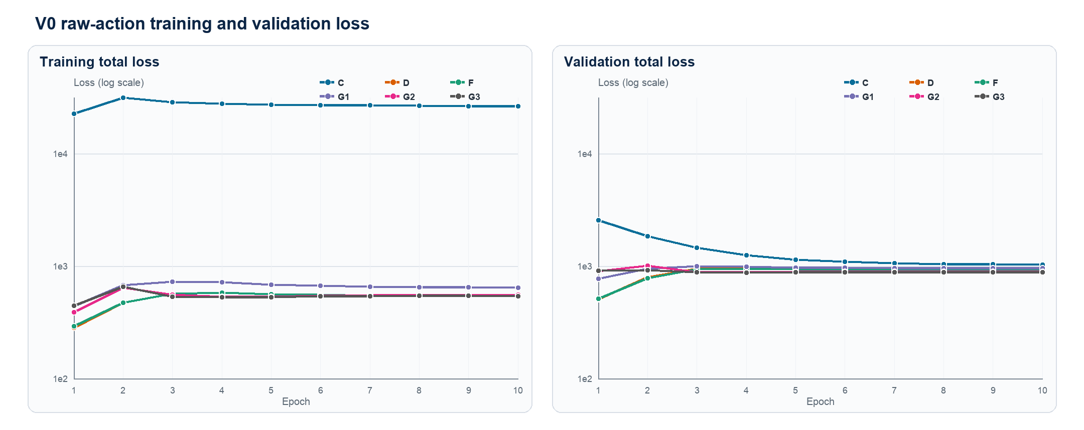
Figure 1. V0 training and validation total loss (E1-E10)
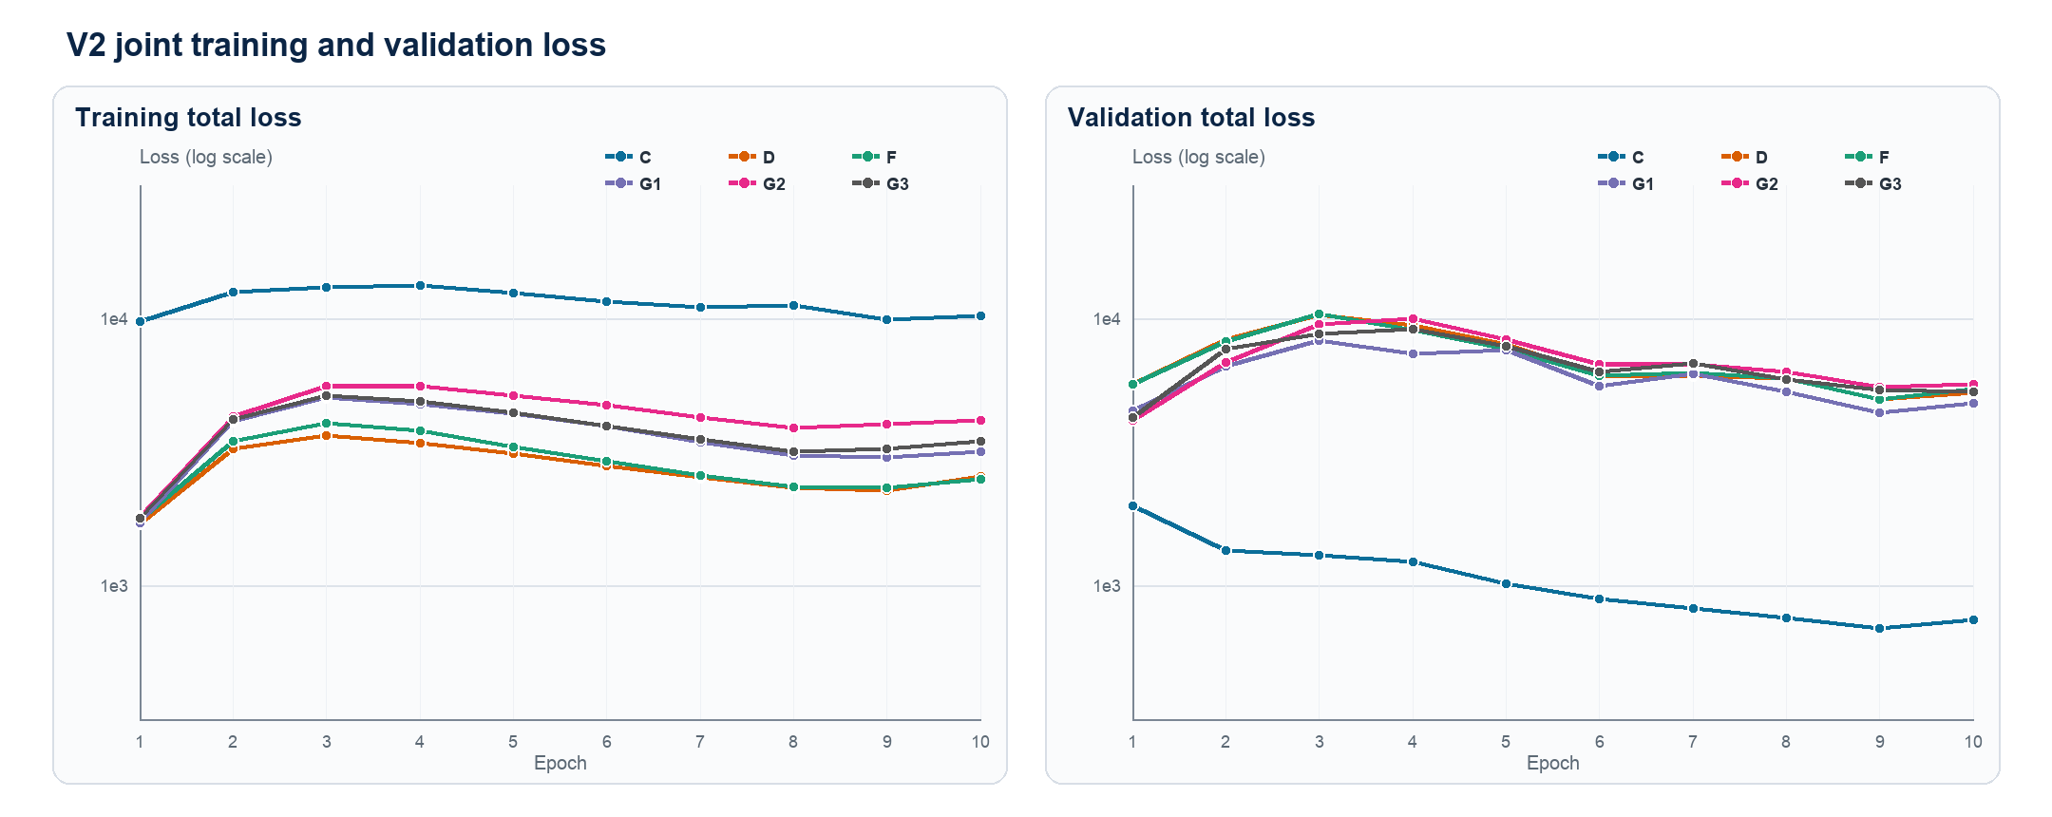
Figure 2. V2 joint training and validation total loss (E1-E10)
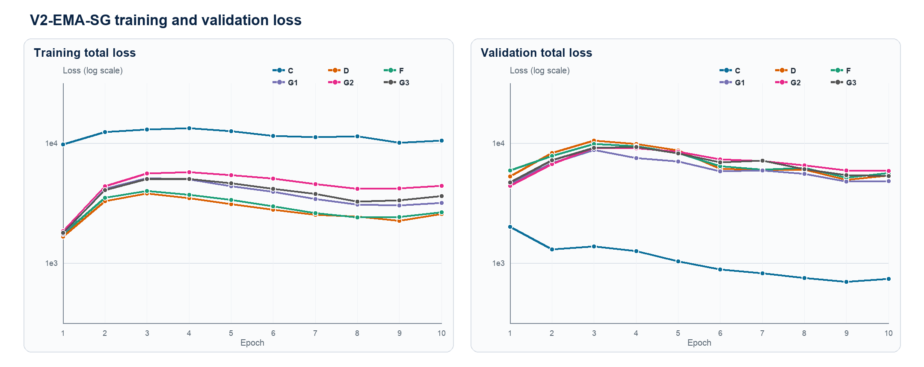
Figure 3. V2-EMA-SG training and validation loss (E1-E10)
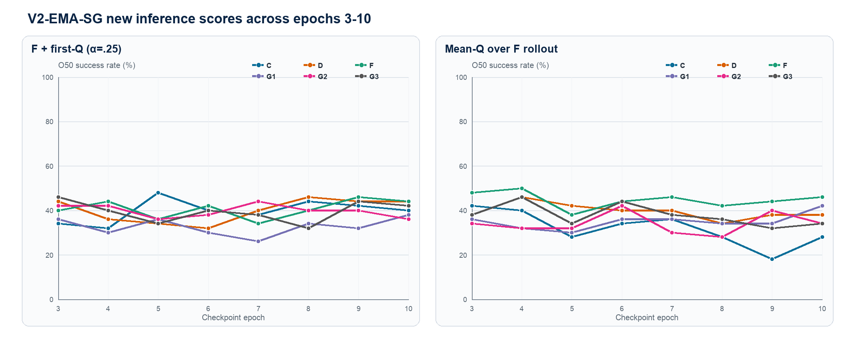
Figure 4. V2-EMA new-score trajectories (E3-E10)

Post-hoc checkpoint diagnosis
WARNING: maxima below were selected after observing E3-E10 on the same O50 pairs. They are selection-biased trajectory diagnostics and do not replace the fixed E10 results.
Version | Score | Post-hoc best | Best | Best at E10
V2 | F-only | D-E7 | 20/50 (40%) | 16/50 (32%)
V2 | G-only | D-E4, F-E6 | 22/50 (44%) | 20/50 (40%)
V2 | F+G tail | D-E7 | 23/50 (46%) | 16/50 (32%)
V2-EMA | F-only | F-E7 | 20/50 (40%) | 15/50 (30%)
V2-EMA | G-only | C-E8 | 21/50 (42%) | 20/50 (40%)
V2-EMA | F+G tail | D-E3 | 22/50 (44%) | 17/50 (34%)
V2-EMA | F + first-Q | C-E5 | 24/50 (48%) | 22/50 (44%)
V2-EMA | Mean-Q rollout | F-E4 | 25/50 (50%) | 23/50 (46%)

V2-EMA new-score stability
Method | Score | Mean | Sigma pp | Best | E10
C | F + first-Q | 39.8% | 4.8 | E5 / 48% | 40%
C | Mean-Q rollout | 31.8% | 7.3 | E3 / 42% | 28%
D | F + first-Q | 40.0% | 5.0 | E8 / 46% | 44%
D | Mean-Q rollout | 39.5% | 3.3 | E4 / 46% | 38%
F | F + first-Q | 40.8% | 3.9 | E9 / 46% | 44%
F | Mean-Q rollout | 44.8% | 3.5 | E4 / 50% | 46%
G1 | F + first-Q | 32.8% | 3.7 | E10 / 38% | 38%
G1 | Mean-Q rollout | 35.0% | 3.3 | E10 / 42% | 42%
G2 | F + first-Q | 39.8% | 2.7 | E7 / 44% | 36%
G2 | Mean-Q rollout | 34.0% | 4.5 | E6 / 42% | 34%
G3 | F + first-Q | 39.5% | 4.4 | E3 / 46% | 42%
G3 | Mean-Q rollout | 37.8% | 4.6 | E4 / 46% | 34%

Interpretation and next objectives

Fixed E10 version means
Training version | F-only | G-only | F+G | First-Q | Mean-Q | Common-4 mean
V0 raw action | 46.0% | 35.7% | 46.0% | 47.0% | — | 43.7%
V1 action encoder | 46.0% | 41.3% | 47.7% | 52.0% | — | 46.8%
V2 joint fine-tune | 26.0% | 35.3% | 27.3% | 39.7% | 34.3% | 32.1%
V2-EMA-SG | 27.0% | 36.0% | 28.3% | 40.7% | 37.0% | 33.0%

Fixed-score comparison
Score | Versions | Cells | Version mean | Best fixed cell
F-only | V0/V1/V2/V2-EMA | 24 | 36.2% | V0-C, V0-D, V0-F, V0-G1, V0-G2, V0-G3, V1-C, V1-D, V1-F, V1-G1, V1-G2, V1-G3: 23/50 (46%)
G-only | V0/V1/V2/V2-EMA | 24 | 37.1% | V1-F: 23/50 (46%)
F+G tail | V0/V1/V2/V2-EMA | 24 | 37.3% | V1-G3: 27/50 (54%)
F + first-Q | V0/V1/V2/V2-EMA | 24 | 44.8% | V1-C: 28/50 (56%)
Mean-Q rollout | V2/V2-EMA | 12 | 35.7% | V2-D: 24/50 (48%)

V2-EMA training variants
Training variant | Five-score mean | Best readout | Best rate
C | 30.4% | F + first-Q | 40%
D | 36.4% | F + first-Q | 44%
F | 38.4% | Mean-Q rollout | 46%
G1 | 32.4% | Mean-Q rollout | 42%
G2 | 33.2% | G-only | 40%
G3 | 32.0% | F + first-Q | 42%

There is no readout-independent training winner: V1-G3 leads the prespecified F+G column, whereas V1-C leads First-Q. These are descriptive single-seed results, not statistical superiority claims.
Finding | Evidence | Interpretation | Next objective
Action embedding helps G | V0→V1 G-only 35.7→41.3%; First-Q 47→52% | Semantic action representation improves critic readout | Keep shared V1 Action Encoder
Joint tuning damages F | V1→V2 F-only 46→26% | Consistent with TD-gradient representation drift | Restore F-only mean to >=46%
EMA is insufficient | Only ~1–3 pp recovery | Target stabilization does not undo online drift | Freeze/low-LR then staged unfreeze
First-Q leads descriptively | 4-version mean 44.8% | Real-state/first-action readout may limit rollout OOD | Default test score; calibrate alpha on dev
Mean-Q is method-specific | F=46%; V2-C=20% | Repeated imagined-state readout compounds error | Keep only as registered ablation
Single-seed boundary | All training seed 3072 | No population-level claim | >=3 seeds + paired statistics

Recommended next experiment: freeze the V1 encoder/world model, compare V1-C + First-Q against V1-G3 + F+G on independent development pairs, pre-register epoch/alpha, then run at least three training seeds. If joint training is retained, use a much smaller TD learning rate, latent/prediction anchors to V1 and conservative calibration on CEM candidate actions.
Audit field | Locked value
Verified O50 cells | 465 / 465
Episode selection | e46ea81cce2e6a9a5df05ba04893b4181cbd8979340111a012c30f1efa2d7ee7
Fixed valid-row-ranks hash | 88c204c83daf2157334d4ce9ecf7f18dcd11f778fbb80c310e31f322bfe5aed7
Action normalization | 57f4d3c252e1805f4af1f614d20d1d1a064fa0d1d463ed5eb8ecf9dfc2b1a723
Training / planning seed | 3072 / 42
EMA E3 retry | G1/F+G and G2/F-only use isolated attempt_02
Claim boundary | One training seed; post-hoc epoch maxima are diagnostic only

