ACTOR-FREE TD-LEWM · COMPLETE 7×3 CONTROLLED ABLATION

Results TD
  - swm/OGBCube-v0 | dataset quentinll/lewm-cube | training seed 3072 | planning seed 42
Locked protocol: all 7 methods completed 10 epochs / 127,960 optimizer updates; each method was evaluated with 3 scores, for 21 formal O50 runs. goal offset=50; common selection SHA-256=e46ea81cce2e…. The complete seven-score cross-version section follows the preserved Legacy and V0/V1 reference pages.

Combined O50 ranking
Rank | Method | Family | Combined | Successes | Rate | Elapsed
1 | Hybrid | Successor | f_plus_g | 27/50 | 54% | 14:34.6
2 | Serial Decoupled | Successor | f_plus_g | 23/50 | 46% | 16:32.9
2 | Imaginary Hybrid | Successor | f_plus_g | 23/50 | 46% | 16:29.2
4 | Parallel Real | Successor | f_plus_g | 22/50 | 44% | 17:20.4
5 | Serial Coupled | Successor | f_plus_g | 20/50 | 40% | 17:55.9
6 | Goal Hybrid | Successor | f_plus_g | 19/50 | 38% | 18:56.5
6 | Direct Goal Critic Hybrid | Direct critic | f_plus_c | 19/50 | 38% | 18:47.4
Table 1. Ranking uses only the pre-specified combined column; equal success counts share a rank. The best of the three score columns is not selected post hoc.

7×3 inference-score matrix
Method | Tail type | F-only | G/C-only | F+G / F+C | Combined rank only
Serial Decoupled | Successor / G | 20/50 · 40% · 18:54.9 | 15/50 · 30% · 20:32.1 | 23/50 · 46% · 16:32.9 | #2 · G
Serial Coupled | Successor / G | 26/50 · 52% · 15:11.5 | 14/50 · 28% · 20:36.9 | 20/50 · 40% · 17:55.9 | #5 · G
Hybrid | Successor / G | 25/50 · 50% · 15:40.0 | 13/50 · 26% · 22:03.4 | 27/50 · 54% · 14:34.6 | #1 · G
Parallel Real | Successor / G | 17/50 · 34% · 19:33.0 | 13/50 · 26% · 20:48.1 | 22/50 · 44% · 17:20.4 | #4 · G
Goal Hybrid | Successor / G | 25/50 · 50% · 15:45.3 | 19/50 · 38% · 18:28.8 | 19/50 · 38% · 18:56.5 | #6 · G
Imaginary Hybrid | Successor / G | 24/50 · 48% · 16:13.8 | 13/50 · 26% · 21:09.9 | 23/50 · 46% · 16:29.2 | #2 · G
Direct Goal Critic Hybrid | Direct / C | 22/50 · 44% · 17:25.5 | 16/50 · 32% · 19:56.4 | 19/50 · 38% · 18:47.4 | #6 · C
Table 2. Each cell reports successes/episodes, success rate and elapsed time (h:mm:ss); F-only includes the final planning action.

TRAINING / VALIDATION · SUMMARY-DERIVED METRICS

Training convergence and checkpoints
  - 7 methods | 10 epochs | 127,960 optimizer updates per method
Comparison limit: auxiliary-loss counts and definitions differ. Total loss is only a within-method convergence check and cannot rank methods across structures.
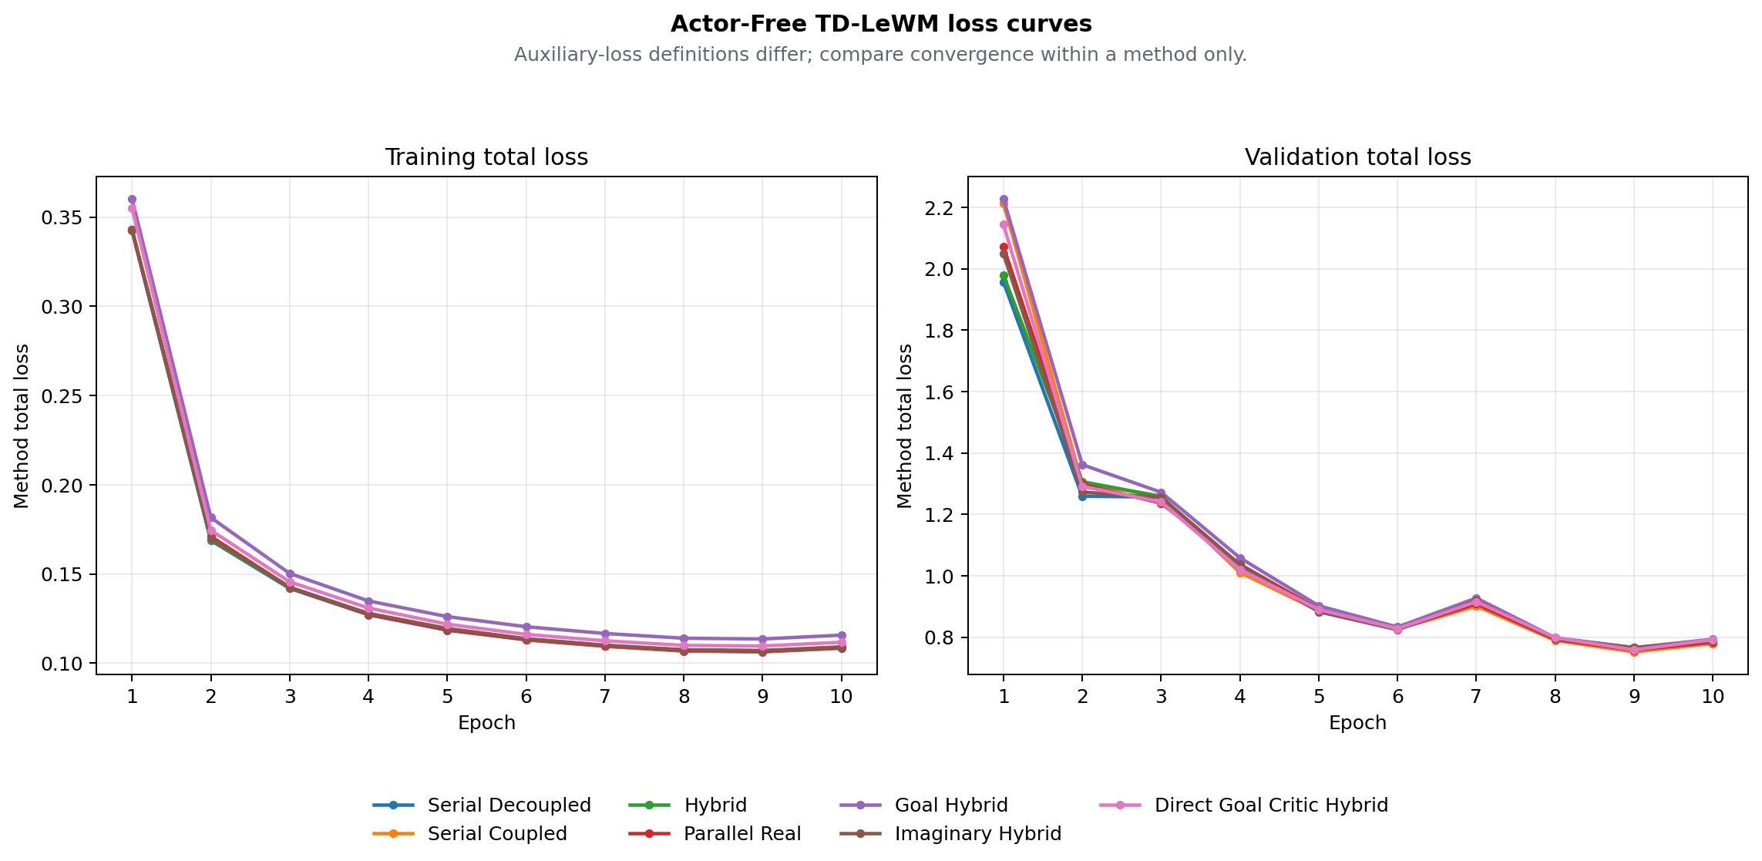
Figure 1. Training and validation total-loss curves derived by the archiver; cross-method ranking uses combined O50 on page 1.
Method | Final train | Final validation | Best validation | Checkpoint SHA | Training commit
Serial Decoupled | 0.108424 | 0.780097 | 0.754505 · E9 | cb8be3f9a851 | 8e667cb6a8e9
Serial Coupled | 0.108643 | 0.780158 | 0.752397 · E9 | 2fe3fd5bcb2c | 8e667cb6a8e9
Hybrid | 0.108973 | 0.784110 | 0.766112 · E9 | 299222acff78 | 8e667cb6a8e9
Parallel Real | 0.108762 | 0.784254 | 0.757853 · E9 | 61b5614a7b92 | e895637d8c7e
Goal Hybrid | 0.115752 | 0.793633 | 0.766048 · E9 | a746912bddd0 | 88ad2ec12c1d
Imaginary Hybrid | 0.109176 | 0.788777 | 0.766026 · E9 | e7656fed92a0 | ea82e8f2984f
Direct Goal Critic Hybrid | 0.111773 | 0.792399 | 0.759004 · E9 | b3345e9eefdb | a1d98a2d0881
Table 3. Final is epoch 10; Best validation is selected within each method's 10 epochs. Hashes and commits come from the archive summary.

METHOD REFERENCE · BASE STRUCTURAL ABLATIONS

Four base Actor-Free TD-LeWM structures
  - Shared LeWM encoder/predictor; differences are successor inputs, TD gradient paths and real/predicted branches.
Common objective: L_LeWM = L_pred + 0.09 L_SIGReg. The successor target uses the real EMA next latent, EMA head and dataset next action, with a stop-gradient target; every method is actor-free.
Method | Network | Training loss | Special design / gradient path | Inference
Serial Decoupled  serial_decoupled | LeWM + one successor-feature head on predicted latent history | L = L_LeWM + αᵤ L_TD^pred  G(sg(H̃ₜ), aₜ) → sg(yₜ^SF) | Predicted context is detached; TD updates the successor head only. | CEM with F-only, G-only, or F+G cost.
Serial Coupled  serial_coupled | LeWM + one successor-feature head on predicted latent history | L = L_LeWM + αᵤ L_TD^pred  G(H̃ₜ, aₜ) → sg(yₜ^SF) | Predicted context stays differentiable; TD also reaches LeWM. | CEM with F-only, G-only, or F+G cost.
Hybrid  hybrid | LeWM + one shared successor head for real and predicted histories | L = L_LeWM + αᵤ(L_TD^pred + L_TD^real)  The same G consumes predicted and real latent histories | The same head is trained on parallel-real and coupled-serial branches. | CEM with F-only, G-only, or F+G cost.
Parallel Real  parallel_real | LeWM predictor and successor head are parallel on encoder latents | L = L_LeWM + αᵤ L_TD^real  G(Hₜ^real, aₜ) is parallel to the LeWM predictor | TD uses real latent history and does not pass through the predictor. | CEM with F-only, G-only, or F+G cost.
Table 4. Method descriptions come from archive summary.method_spec; the equations are fixed definitions, not manually entered results.

Unified meaning of the three inference scores
Score mode | Candidate-action ranking signal
F-only | LeWM rolls and scores all H predicted states with the normalized discounted latent-goal cost.
G-only | LeWM still rolls the candidate to form tail context, but ranking uses only the successor G readout.
F+G | F prefix cost plus discounted successor G tail cost.
Control protocol: all structures use the same swm/OGBCube-v0, selection and planning seed 42. G-only still uses a LeWM rollout to build tail context, but excludes F cost from ranking.

METHOD REFERENCE · GOAL / IMAGINARY / DIRECT

Three extensions, target equations and audit sources
  - Side-by-side comparison of goal-readout TD, EMA imaginary bootstrap and a direct goal-conditioned critic.
Method | Network | Training loss | Special design / gradient path | Inference
Goal Hybrid  goal_hybrid | Hybrid successor head with fixed linear goal readout G^T w(g) | L = L_LeWM + αᵤ(L_SF-TD^real + L_SF-TD^pred + L_goal-TD^real + L_goal-TD^pred)  C_g(H,a) = G(H,a)ᵀw(z_g) | Goal readout is trained by hindsight goal-conditioned Bellman TD. | CEM with F-only, G-only, or F+G cost.
Imaginary Hybrid  imaginary_hybrid | Hybrid successor head with an EMA-LeWM imagined bootstrap state | L = L_LeWM + αᵤ(L_TD^real + L_TD^pred)  The bootstrap state is imagined one step by stop-gradient EMA-LeWM | The TD target bootstraps one step through the stopped EMA predictor. | CEM with F-only, G-only, or F+G cost.
Direct Goal Critic Hybrid  direct_goal_hybrid | LeWM + one scalar goal-conditioned critic for real/predicted histories | L = L_LeWM + αᵤ(L_C-TD^real + L_C-TD^pred)  C(H,a,z_g) directly outputs a goal-conditioned scalar cost | Goal latent enters the critic directly; there is no SF factorization. | CEM with F-only, C-only, or F+C cost.
Table 5. Direct uses C-only / F+C; successor methods use G-only / F+G. Training remains actor-free.

Target and planning equations
SF TD: yₜ^SF = (1−γ)χ(z̄ₜ₊₁) + γ(1−dₜ)Ḡ(next).
Goal TD: C_g(H,a)=G(H,a)ᵀw(z_g), yₜ^g=(1−γ)c(z̄ₜ₊₁,z_g)+γ(1−dₜ^g)C̄_g(next).
Imaginary: Ĥₜ₊₁=sg(P̄(Hₜ,aₜ)), then bootstrap from Ĥₜ₊₁; Direct: C(H,a,z_g) predicts scalar cost directly.
Planning: J_F=Σₖ₌₁ᴴγᵏ⁻¹c(z̃ₜ₊ₖ,z_g); combined adds the discounted G/C tail to the F prefix. CEM minimizes cost; it does not train an Actor to maximize a one-step dot product.
Combined conclusion: Hybrid ranks first at 27/50 (54%). This claim applies only to the combined score; F-only and G/C-only are inference ablations of the same checkpoint. Boundary: one training seed and one matched O50 planning selection. Rank only combined inference scores; this is not a multi-seed claim.

Provenance / checksums
Variant | Train commit | Eval commit(s) | Checkpoint SHA | Locked protocol SHA
serial_decoupled | 8e667cb6a8 | fa46ed99b/8e667cb6a | cb8be3f9a851 | 6eaaf266bc6e
serial_coupled | 8e667cb6a8 | fa46ed99b/8e667cb6a | 2fe3fd5bcb2c | e272feeb5081
hybrid | 8e667cb6a8 | fa46ed99b/8e667cb6a | 299222acff78 | bd0b207e2712
parallel_real | e895637d8c | fa46ed99b/e895637d8 | 61b5614a7b92 | f3d3ca31e1f1
goal_hybrid | 88ad2ec12c | fa46ed99b | a746912bddd0 | fdbf618cb45e
imaginary_hybrid | ea82e8f298 | fa46ed99b | e7656fed92a0 | 6e43c9f75351
direct_goal_hybrid | a1d98a2d08 | fa46ed99b | b3345e9eefdb | f9e2ee091aee
Input SHA-256: selection=e46ea81cce2e6a9a5df05ba04893b4181cbd8979340111a012c30f1efa2d7ee7; summary.json=9fa31a12476ff4a332e555505fc720964d81c5640c77cc394beb5df538ae2da6; training_loss_curves.png=4cce0d5891b8b51e5e3dc7481bd9582de85e69c9b01a9fcb6d025ed271957a60; paired_outcomes.csv=3047c9a419f066548b6e942e29c49b35d286670dc60e5db27fcd845897a6f2ae.
Score definitions: F-only — LeWM rolls and scores all H predicted states with the normalized discounted latent-goal cost. Combined — F prefix cost plus discounted successor G tail cost / discounted direct-critic C tail cost.

RESULTS TD / CONTROLLED C–G3 V0 → V1
Raw-action V0 vs shared-action-encoder V1
Same C/D/F/G1/G2/G3 losses · same 50 pairs · actor-free CEM planning
Version boundary: the first four pages preserve the earlier 7-method Actor-Free TD-LeWM ablation. This appendix records the later controlled C-G3 study; its raw-action V0 is a separate 6-by-3 experiment.

V0 / V1 definition
V0 sends the normalized raw 25D action block directly into G. V1 sends stopgrad(E_A(a)), the 192D embedding from the shared frozen LeWM Action Encoder. Both current and dataset next actions follow this rule; neither version contains an Actor or reward model. The six losses and planning definitions are unchanged, but predictor capacity is not matched: 336,320 parameters in V0 versus 379,072 in V1.

V0 formal O50 — raw 25D action
V0 has 18 completed formal evaluations: six methods × F-only/G-only/F+G. All rows use training seed 3072, planning seed 42, horizons 5/1/5 and the same 50 start–goal pairs used by V1.
V0 method | F-only | G-only | F+G | Δ vs F
C | 23/50 (46%) | 18/50 (36%) | 24/50 (48%) | +1/50
D | 23/50 (46%) | 20/50 (40%) | 21/50 (42%) | -2/50
F | 23/50 (46%) | 19/50 (38%) | 20/50 (40%) | -3/50
G1 | 23/50 (46%) | 16/50 (32%) | 25/50 (50%) | +2/50
G2 | 23/50 (46%) | 16/50 (32%) | 25/50 (50%) | +2/50
G3 | 23/50 (46%) | 18/50 (36%) | 23/50 (46%) | +0/50

V0 → V1 combined comparison
On this matched selection: F and G3 gain 8 pp; D and G2 are unchanged; C loses 4 pp; G1 loses 2 pp. V0 best is G1/G2 at 50%; V1 best is G3 at 54%.
Method | V0 F+G | V1 F+G | V1 - V0
C | 24/50 (48%) | 22/50 (44%) | -2/50
D | 21/50 (42%) | 21/50 (42%) | +0/50
F | 20/50 (40%) | 24/50 (48%) | +4/50
G1 | 25/50 (50%) | 24/50 (48%) | -1/50
G2 | 25/50 (50%) | 25/50 (50%) | +0/50
G3 | 23/50 (46%) | 27/50 (54%) | +4/50

RESULTS TD / ACTOR-FREE TD-JEPA V1 DETAILS
Cube O50 — six methods × three score modes
Shared frozen LeWM Action Encoder · actor-free CEM planning · seed 3072
Study: actor_free_td_lewm_v1_cube_seed3072_o50_6x3
Evaluation: 18 formal O50 runs on one matched set of 50 pairs
Training: 6 methods · 10 epochs · 127,960 updates per method
Training acceptance: PASS_WITH_WARNINGS
Selection SHA-256: e46ea81cce2e6a9a5df05ba04893b4181cbd8979340111a012c30f1efa2d7ee7
Interpretation boundary — one training seed and one planning selection. Use this report as a matched structural/score-mode ablation, not as a multi-seed claim of overall superiority.
Training provenance warning — launcher exit codes could not be recovered. Checkpoints, metrics, epochs, steps, and acceptance evidence passed the archive validator, but the missing exit-code provenance must not be represented as an unconditional PASS. Archived warning: c.process: PID 122116 was reaped without an exit marker; d.process: PID 122117 was reaped without an exit marker; f.process: PID 122118 was reaped without an exit marker; g1.process: PID 122119 was reaped without an exit marker; g2.process: PID 122120 was reaped without an exit marker; g3.process: PID 122121 was reaped without an exit marker

Combined ranking
Highest combined result: V1-G3 Prefix-Marginal Advantage, 27/50 (54%). Ties share the same success count; ordering is taken from the validated summary.
Rank | Method | ID | Score | O50
1 | V1-G3 Prefix-Marginal Advantage | G3 | F+G | 27/50 (54%)
2 | V1-G2 Prefix-Mean Advantage | G2 | F+G | 25/50 (50%)
3 | V1-F Same-Future / Different-Goal Advantage | F | F+G | 24/50 (48%)
3 | V1-G1 Neighbor Action Advantage | G1 | F+G | 24/50 (48%)
5 | V1-C Goal-Projected TD | C | F+G | 22/50 (44%)
6 | V1-D Goal-Value Weighted TD | D | F+G | 21/50 (42%)

Three inference scores
F-only uses the LeWM rollout score; G-only uses the learned successor readout; F+G uses the LeWM prefix with the successor tail. All three columns use the same checkpoint and the same 50 start–goal pairs within each method.
Method | F-only | G-only | F+G | Δ vs F
V1-C Goal-Projected TD | 23/50 (46%) | 18/50 (36%) | 22/50 (44%) | -1/50
V1-D Goal-Value Weighted TD | 23/50 (46%) | 22/50 (44%) | 21/50 (42%) | -2/50
V1-F Same-Future / Different-Goal Advantage | 23/50 (46%) | 23/50 (46%) | 24/50 (48%) | +1/50
V1-G1 Neighbor Action Advantage | 23/50 (46%) | 21/50 (42%) | 24/50 (48%) | +1/50
V1-G2 Prefix-Mean Advantage | 23/50 (46%) | 21/50 (42%) | 25/50 (50%) | +2/50
V1-G3 Prefix-Marginal Advantage | 23/50 (46%) | 19/50 (38%) | 27/50 (54%) | +4/50

Training curves
The left panel is each method's own training objective and is not cross-method comparable. The right panel is the common base TD validation objective used by all six methods.
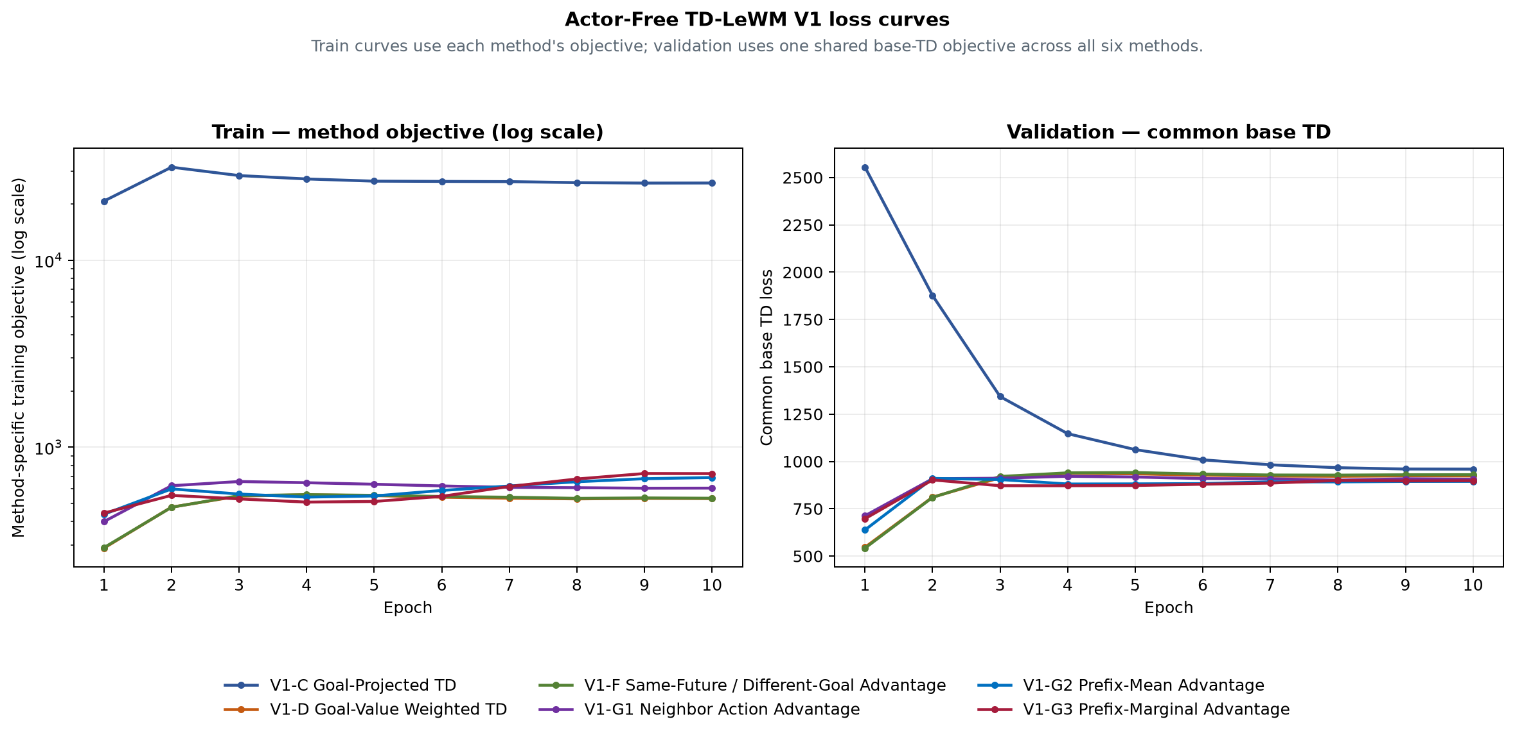
Figure 1. Train method objective (left) and validation common base TD (right).
Method | E10 train  method objective | E10 validation  common base TD | Best common  base TD
V1-C Goal-Projected TD | 25927.3 | 959.265 | 959.265 (E10)
V1-D Goal-Value Weighted TD | 531.178 | 923.235 | 546.341 (E1)
V1-F Same-Future / Different-Goal Advantage | 533.615 | 929.771 | 541.974 (E1)
V1-G1 Neighbor Action Advantage | 604.267 | 905.668 | 713.09 (E1)
V1-G2 Prefix-Mean Advantage | 688.673 | 894.455 | 638.227 (E1)
V1-G3 Prefix-Marginal Advantage | 722.493 | 897.862 | 697.315 (E1)

Method definitions

V1-C Goal-Projected TD (C)
Network: Frozen LeWM + frozen shared action encoder + one 379,072-parameter TD-JEPA predictor
Training loss: Common feature TD plus goal-projected TD residual on goal-derived tasks
Special design: Directly constrains the detached TD target and prediction after projection onto the matched goal
Inference: F-only: LeWM final predicted-latent goal cost, horizon 5; G-only: Negative goal projection of the V1 predictor, horizon 1; F+G: LeWM F prefix plus discounted terminal V1 G tail, horizon 5

V1-D Goal-Value Weighted TD (D)
Network: Frozen LeWM + frozen shared action encoder + one 379,072-parameter TD-JEPA predictor
Training loss: Detached target-goal scores reweight the common real-transition feature TD
Special design: Goal-subset softmax weights; random-task weight remains one; final weights have mean one
Inference: F-only: LeWM final predicted-latent goal cost, horizon 5; G-only: Negative goal projection of the V1 predictor, horizon 1; F+G: LeWM F prefix plus discounted terminal V1 G tail, horizon 5

V1-F Same-Future / Different-Goal Advantage (F)
Network: Frozen LeWM + frozen shared action encoder + one 379,072-parameter TD-JEPA predictor
Training loss: Same-future/different-goal detached advantage reweights common feature TD
Special design: Matching task score is contrasted with all goal-derived tasks in the batch
Inference: F-only: LeWM final predicted-latent goal cost, horizon 5; G-only: Negative goal projection of the V1 predictor, horizon 1; F+G: LeWM F prefix plus discounted terminal V1 G tail, horizon 5

V1-G1 Neighbor Action Advantage (G1)
Network: Frozen LeWM + frozen shared action encoder + one 379,072-parameter TD-JEPA predictor
Training loss: Neighbor-action detached advantage reweights common real-action feature TD
Special design: Other-episode KNN actions are comparison-only and never create candidate TD targets
Inference: F-only: LeWM final predicted-latent goal cost, horizon 5; G-only: Negative goal projection of the V1 predictor, horizon 1; F+G: LeWM F prefix plus discounted terminal V1 G tail, horizon 5

V1-G2 Prefix-Mean Advantage (G2)
Network: Frozen LeWM + frozen shared action encoder + one 379,072-parameter TD-JEPA predictor
Training loss: Full-prefix score minus mean prefix score reweights common feature TD
Special design: Zero-mean suffix prefixes are comparison-only; the real full action supplies the TD pair
Inference: F-only: LeWM final predicted-latent goal cost, horizon 5; G-only: Negative goal projection of the V1 predictor, horizon 1; F+G: LeWM F prefix plus discounted terminal V1 G tail, horizon 5

V1-G3 Prefix-Marginal Advantage (G3)
Network: Frozen LeWM + frozen shared action encoder + one 379,072-parameter TD-JEPA predictor
Training loss: Mean adjacent prefix-score improvement reweights common feature TD
Special design: Prefix marginal gains are detached comparison signals, not extra TD targets
Inference: F-only: LeWM final predicted-latent goal cost, horizon 5; G-only: Negative goal projection of the V1 predictor, horizon 1; F+G: LeWM F prefix plus discounted terminal V1 G tail, horizon 5

Paired-outcome audit
The paired archive contains exactly 50 rows and 18 Boolean outcome columns. Every pair uses goal_step − start_step = 50; the summary counts were recomputed from these columns before this document was written.
Audit field | Validated value
Training seed | 3072
Planning seed | 42
Episodes / mode | 50
Goal offset | 50
Selection SHA-256 | e46ea81cce2e6a9a5df05ba04893b4181cbd8979340111a012c30f1efa2d7ee7

Claim boundary
This report records one formal training seed and one shared O50 planning selection. It supports within-selection architecture and inference-score comparisons. It does not establish mean performance, variance, or statistical superiority across independent training seeds.

RESULTS TD / COMPLETE EXPERIMENT LEDGER
Complete 26-method, seven-score results and analysis
Cube · seed 3072 · 477 base + 8 endpoints + 20 alpha-sweep cells = 505 O50 cells
The preceding pages preserve the detailed Legacy and V0/V1 method reference. This section now integrates the complete 477-cell base audit, eight strict C2-E10/C3-E12 endpoint cells, and all 20 First-Q alpha-sweep cells in one master matrix. Every result uses the same 50 start-goal pairs; the three audited components retain 25,250 Boolean outcomes. All training uses one seed, and alpha was selected on the same O50 set, so the 62% sweep peak is exploratory rather than an unbiased formal endpoint.

Decision summary
Question | Answer | Evidence | Decision
Best on prespecified F+G column | V1-G3 | 27/50 (54%) | Keep as primary baseline
Best fixed result overall | V1-C + F + first-Q | 28/50 (56%) | Primary fixed-E10 baseline
Highest tuned observation | V1-C3 Z-score First-Q2, alpha=0.1 | 31/50 (62%); paired p=0.125 vs C3 State-V | Exploratory only; confirm on disjoint dev/test pairs
Best equal-weight training average | V1-F, V1-G3 | Five-score mean 48.8% | Treat as candidates, not a seed-robust winner
Best V2-EMA training variant | F | E10 five-score mean 38.4% | Retain this variant if joint training continues
Descriptive default test score | F + first-Q | 24-configuration mean 44.8% | Default readout candidate; confirm on dev pairs
Leading failure hypothesis | Joint world-model drift | V1→V2 F-only 46.0%→26.0% | Restore F toward the V1 mean (46.0%)

Complete companion ledgers
Artifact | Coverage | Repository-relative path | SHA-256
CSV scalar ledger | 477 O50 cells | reports/artifacts/actor_free_td_lewm_complete_cube_seed3072/all_o50_results.csv | 0e5b541bdb11cf6d647fc1e679499a02c3aa430d64e37c8819d02c44e1dcb900
JSON reconciliation ledger | 477 x 50 = 23,850 outcomes | reports/artifacts/actor_free_td_lewm_complete_cube_seed3072/reconciliation_ledger.json | 2f1985d5703e795f48bd8b850d470f76e35c998447112c86065e8bdcbbe1372b
First-Q alpha scalar ledger | 20 O50 cells | reports/artifacts/actor_free_td_lewm_first_q_alpha_sweep_023e8f8_20260906/alpha_sweep_results.csv | ce6c7e99a1acbce2148fb26f14e824ddb08455672e22e694c58717e30b97f848
First-Q alpha validation ledger | 20 x 50 = 1,000 outcomes | reports/artifacts/actor_free_td_lewm_first_q_alpha_sweep_023e8f8_20260906/posthoc_validation.json | bbdfe687179e7edd941159d60c1105d35173ae86119ad625f88f882e3293dc9d

The original fixed-E10 analysis remains unchanged in its 477-cell base ledger. The table above now also indexes the 20-cell alpha-sweep scalar and validation ledgers; together with eight strict C2/C3 endpoint cells, the complete document covers 505 O50 cells and 25,250 pair-level outcomes.

How the seven evaluation methods are run
This section defines the seven score families in the 26-method matrix. z0 is the latent of the current real observation, z_g is the supplied goal-image latent, and z_k^F is the imagined latent after k LeWM steps. The affected V1-C and V1-C3 cells list every tested alpha directly in the same score column. The goal readout is w(g)=sqrt(192) z_g/||z_g||_2 and Q_G(z,A,g)=G(z,e,w(g))^T w(g).
Common protocol field | Fixed setting
Environment | swm/OGBCube-v0
Formal pairs | The same 50 same-episode start-goal pairs; goal offset 50
CEM | 300 candidates, 30 iterations, 30 elites, planning seed 42, warm start
Execution | Minimize candidate cost, execute only the first action block A1, then observe and replan
Episode success | Object-to-goal distance <= 0.04 m within 100 environment steps
Checkpoint | Base rows use fixed E10; C2 uses final E10; C3 uses final E12. No score-specific retraining

Action input differs only by training version: V0 passes the normalized 25D action block directly to G; V1, V1-C2, V2 and V2-EMA use e=E_A(A) from the shared Action Encoder. V1-C3 State-V has no action input after F produces z5. Every A_k is one 25D block of five consecutive 5D primitive actions.
Score | Actual F and G path | Cost minimized by CEM | What is used
F-only | F rolls A1...A5 from real z0 and produces imagined z1^F...z5^F; G is not called. | J_F = ||z5^F - z_g||_2^2 | Uses terminal goal distance at z5; no Q and no gamma.
G-only | H=1. G scores the real z0 and first candidate action A1; F is not rolled out. | J_G = -Q_G(z0,A1,g) | No explicit goal distance and no gamma; minimizing -Q maximizes Q.
F+G tail | F rolls only A1...A4 to z4^F; G evaluates the fifth transition from z4^F with A5. | J_tail = ||z4^F - z_g||_2^2 - gamma^4 Q_G(z4^F,A5,g) | Uses z4 goal distance and the deepest imagined-state Q; gamma=0.95.
F + first-Q | F completes the five-step rollout; G is read only once at the real z0 with A1. | J_first = ||z5^F - z_g||_2^2 - alpha Q_G(z0,A1,g) | No gamma^4. Fixed-table default alpha=0.25; the integrated sweep also tests 0.1, 0.5, 1 and 2.
Mean-Q rollout | F generates predecessors z0,z1^F,...,z4^F; G scores each aligned pair (z{k-1}^F,Ak). | J_mean = -(1/5) sum[k=1..5] Q_G(z{k-1}^F,Ak,g) | No terminal goal distance; z5 is not read by G and gamma is unused.
First-Q2 | F completes the five-step rollout; G is read once at real z0 with A1. Each candidate set normalizes F-cost and first-Q separately. | J_first2 = zscore_candidates(J_F) - alpha zscore_candidates(Q_G(z0,A1,g)) | No gamma. Candidate statistics are recomputed each iteration; C3 tests alpha=0.025, 0.05, 0.075, 0.1, 0.15, 0.2, 0.25, 0.5, 1 and 2.
State-V terminal | Frozen F completes all five blocks to z5^F; only the EMA State-V critic reads (z5^F,z_g). G is not called. | J_V = V_bar(z5^F,z_g) | No terminal latent L2, G term, actor or gamma factor is added at inference; CEM minimizes predicted temporal cost-to-go.

V2-EMA still deploys the online F, online Action Encoder and online G. The EMA modules construct the stopped training target and are checked when loading the checkpoint, but they do not score CEM candidates. The Legacy G/C-only column is different: its older adapter first uses F to construct an H-1 tail state; only Direct Goal Critic Hybrid replaces G with a scalar C.

26-method, seven-score master comparison with the integrated alpha sweep
Read across a row to compare all available scores for one training method; read down a column only inside one version block. V1 includes C2/C3 beside C, followed inside the same master table by a dedicated alpha submatrix containing all 20 newly executed tests plus three reused alpha=0 anchors. Yellow marks a row best, blue a sweep-column best, and teal both; all ties are retained. Fixed-score and exploratory-sweep winners are kept as separate comparison scopes.
Marker | Meaning | Comparison scope
Yellow fill | Best available value in this row | Seven score columns; neutral missing cells are ignored; all ties are marked
Blue fill | Best available value in this column | Methods inside the same dynamic version band only; all ties are marked
Teal fill | Both winner conditions | Best in the row and best in the version-specific column
Version band | Version boundary | Separates V0, V1, V2 and V2-EMA; it does not encode performance
Alpha-sweep block | Twenty executed tests plus three reused alpha=0 anchors | Embedded in the V1 band; its row/column winners are separate from the fixed-score colors

The Training loss column shows the method-specific G objective: l_i is the per-sample successor TD residual; qY = Y^T m; and w_i(.) is the normalized sample weight formed from a stopped signal. V0/V1 use the real branch. V2/V2-EMA optimize L_pred + 0.09 L_SIGReg + rho(L_method^real + L_method^pred). Exact C-G3 signals and weighting rules appear in V2 / V2-EMA network, target and loss.
V1-C2 initializes every parameter from V1-C E10, freezes LeWM and its Action Encoder, and fine-tunes only G with L_C2=L_C+CE(p_F,p_Q): p_F is the softmax of negative candidate-normalized frozen-F terminal cost, while p_Q is the softmax of candidate-normalized Q_G(z0,A1,g). V1-C3 freezes the complete V1-C parent, including both G copies, and trains only an EMA-targeted MRN State-V critic with expectile-Huber TD (tau=0.03, gamma=0.98, n<=50 primitive steps).

One 26 by 7 master matrix with all 20 alpha-sweep cells
Version | Method | Training loss | F-only | G-only | F+G tail | First-Q | Mean-Q | First-Q2 | State-V
V0 | C | L_C=mean(l)+mean_goal(q-qY)^2 | 23/50 (46%) | 18/50 (36%) | 24/50 (48%) | 26/50 (52%) | 22/50 (44%) | — | —
 | D | L_D=mean_i w_i[sg(qY)]l_i | 23/50 (46%) | 20/50 (40%) | 21/50 (42%) | 24/50 (48%) | 26/50 (52%) | — | —
 | F | L_F=mean_i w_i(A_goal)l_i | 23/50 (46%) | 19/50 (38%) | 20/50 (40%) | 24/50 (48%) | 24/50 (48%) | — | —
 | G1 | L_G1=mean_i w_i(A_neighbor)l_i | 23/50 (46%) | 16/50 (32%) | 25/50 (50%) | 20/50 (40%) | 20/50 (40%) | — | —
 | G2 | L_G2=mean_i w_i(A_prefix-mean)l_i | 23/50 (46%) | 16/50 (32%) | 25/50 (50%) | 23/50 (46%) | 23/50 (46%) | — | —
 | G3 | L_G3=mean_i w_i(A_prefix-gain)l_i | 23/50 (46%) | 18/50 (36%) | 23/50 (46%) | 24/50 (48%) | 24/50 (48%) | — | —
V1 | C | L_C=mean(l)+mean_goal(q-qY)^2 | 23/50 (46%) | 18/50 (36%) | 22/50 (44%) | 28/50 (56%) | 21/50 (42%) | 26/50 (52%) | —
 | C2 | L_C2=L_C+CE(p_F,p_Qfirst) | 23/50 (46%) | 18/50 (36%) | 23/50 (46%) | 26/50 (52%) | 22/50 (44%) | 26/50 (52%) | —
 | C3 | L_C3=mean_i omega_tau(r_i)Huber_1(r_i) | — | — | — | — | — | — | 26/50 (52%)
 | D | L_D=mean_i w_i[sg(qY)]l_i | 23/50 (46%) | 22/50 (44%) | 21/50 (42%) | 25/50 (50%) | 26/50 (52%) | — | —
 | F | L_F=mean_i w_i(A_goal)l_i | 23/50 (46%) | 23/50 (46%) | 24/50 (48%) | 26/50 (52%) | 26/50 (52%) | — | —
 | G1 | L_G1=mean_i w_i(A_neighbor)l_i | 23/50 (46%) | 21/50 (42%) | 24/50 (48%) | 26/50 (52%) | 25/50 (50%) | — | —
 | G2 | L_G2=mean_i w_i(A_prefix-mean)l_i | 23/50 (46%) | 21/50 (42%) | 25/50 (50%) | 25/50 (50%) | 24/50 (48%) | — | —
 | G3 | L_G3=mean_i w_i(A_prefix-gain)l_i | 23/50 (46%) | 19/50 (38%) | 27/50 (54%) | 26/50 (52%) | 27/50 (54%) | — | —
V1 inference alpha sweep — 20 newly executed O50 cells; alpha=0 values are reused comparison anchors
Checkpoint and score | Training loss | alpha=0 | .025 | .05 | .075 | .10 | .15 | .20 | .25 | .50 | 1 | 2
V1-C3 Raw  State-V + First-Q | L_C3  unchanged | 26/50  52% | - | - | - | 26/50  52% | - | - | 22/50  44% | 21/50  42% | 21/50  42% | 22/50  44%
V1-C3 Z-score  State-V + First-Q2 | L_C3  unchanged | 26/50  52% | 25/50  50% | 28/50  56% | 27/50  54% | 31/50  62% | 23/50  46% | 28/50  56% | 26/50  52% | 24/50  48% | 24/50  48% | 25/50  50%
V1-C Original  First-Q | L_C  unchanged | 23/50  46% | - | - | - | 24/50  48% | - | - | 28/50  56% | 27/50  54% | 28/50  56% | 25/50  50%

V2 | C | L_C=mean(l)+mean_goal(q-qY)^2 | 13/50 (26%) | 20/50 (40%) | 16/50 (32%) | 19/50 (38%) | 10/50 (20%) | — | —
 | D | L_D=mean_i w_i[sg(qY)]l_i | 16/50 (32%) | 18/50 (36%) | 16/50 (32%) | 21/50 (42%) | 24/50 (48%) | — | —
 | F | L_F=mean_i w_i(A_goal)l_i | 15/50 (30%) | 19/50 (38%) | 13/50 (26%) | 21/50 (42%) | 22/50 (44%) | — | —
 | G1 | L_G1=mean_i w_i(A_neighbor)l_i | 12/50 (24%) | 17/50 (34%) | 13/50 (26%) | 19/50 (38%) | 17/50 (34%) | — | —
 | G2 | L_G2=mean_i w_i(A_prefix-mean)l_i | 12/50 (24%) | 18/50 (36%) | 13/50 (26%) | 20/50 (40%) | 13/50 (26%) | — | —
 | G3 | L_G3=mean_i w_i(A_prefix-gain)l_i | 10/50 (20%) | 14/50 (28%) | 11/50 (22%) | 19/50 (38%) | 17/50 (34%) | — | —
V2-EMA | C | L_C=mean(l)+mean_goal(q-qY)^2 | 12/50 (24%) | 18/50 (36%) | 12/50 (24%) | 20/50 (40%) | 14/50 (28%) | — | —
 | D | L_D=mean_i w_i[sg(qY)]l_i | 15/50 (30%) | 19/50 (38%) | 16/50 (32%) | 22/50 (44%) | 19/50 (38%) | — | —
 | F | L_F=mean_i w_i(A_goal)l_i | 15/50 (30%) | 19/50 (38%) | 17/50 (34%) | 22/50 (44%) | 23/50 (46%) | — | —
 | G1 | L_G1=mean_i w_i(A_neighbor)l_i | 15/50 (30%) | 15/50 (30%) | 11/50 (22%) | 19/50 (38%) | 21/50 (42%) | — | —
 | G2 | L_G2=mean_i w_i(A_prefix-mean)l_i | 12/50 (24%) | 20/50 (40%) | 16/50 (32%) | 18/50 (36%) | 17/50 (34%) | — | —
 | G3 | L_G3=mean_i w_i(A_prefix-gain)l_i | 12/50 (24%) | 17/50 (34%) | 13/50 (26%) | 21/50 (42%) | 17/50 (34%) | — | —

Best training method and evaluation score
There is no evaluation-independent training winner. The prespecified F+G leader remains V1-G3 at 27/50 (54%), and the highest fixed cell remains V1-C First-Q at 28/50 (56%). After integrating all 20 weight tests, the highest observed cell is V1-C3 Z-score First-Q2 at alpha=0.1, 31/50 (62%). Because alpha was chosen on the same O50 pairs and paired p=0.125 versus C3 State-V, this is an exploratory peak that must be confirmed on disjoint development and test pairs.

Within-version column winners
Version | F-only | G-only | F+G tail | First-Q | Mean-Q | First-Q2 | State-V
V0 | C/D/F/G1/G2/G3 23/50 | D 20/50 | G1/G2 25/50 | C 26/50 | D 26/50 | — | —
V1 | C/C2/D/F/G1/G2/G3 23/50 | F 23/50 | G3 27/50 | C 28/50 | G3 27/50 | C/C2 26/50 | C3 26/50
V1 alpha sweep | - | - | - | C alpha=.25/1 28/50 | - | C3 Z-score alpha=.10 31/50 | C3 alpha=0 anchor 26/50
V2 | D 16/50 | C 20/50 | C/D 16/50 | D/F 21/50 | D 24/50 | — | —
V2-EMA | D/F/G1 15/50 | G2 20/50 | F 17/50 | D/F 22/50 | F 23/50 | — | —

This table is the textual counterpart of the winner fills in the master matrix. The first four rows retain the fixed-score version comparisons; the additional V1 sweep row separately reports the exploratory alpha winners so post-hoc tuning does not overwrite fixed endpoint colors.

V1-C2/C3 endpoint evidence
Shared score | V1-C parent | V1-C2 | C2-parent
F-only | 23/50 | 23/50 | +0 pp
G-only | 18/50 | 18/50 | +0 pp
F+G tail | 22/50 | 23/50 | +2 pp
F + first-Q | 28/50 | 26/50 | -4 pp
Mean-Q rollout | 21/50 | 22/50 | +2 pp
First-Q2 | 26/50 | 26/50 | +0 pp

Across the six comparable scores, C2 is 2 up / 3 tied / 1 down; mean delta +0.0 pp. C3 State-V is 26/50 (52%).
On the identical 50 pairs, the C3 early diagnostic is E3 28/50 (56%) versus the final E12 endpoint 26/50 (52%). Paired outcomes: both success 24, E3 only 4, E12 only 2, both failure 20; exact two-sided McNemar p=0.6875. E3 is diagnostic only and is excluded from the eight-cell master table.

Endpoint interpretation and next steps
C2 is mixed across the six shared scores: 2 up, 3 tied and 1 down, with mean delta +0.0 pp. First-Q changes -4 pp and First-Q2 changes +0 pp. This single-seed evidence does not establish a robust cross-readout ranking gain.
Final C3 State-V changes +6 pp versus V1-C F-only and -4 pp versus V1-C First-Q. Train State-V next on a controlled mixture of real latents and stopped-gradient F-imagined terminal latents to reduce the train/inference OOD gap.
The paired E3/E12 exact McNemar p-value is 0.6875. It is not significant at 0.05, so E3 must not replace the final endpoint post hoc. Select epochs on held-out development pairs or pre-register the early-stop rule.
All endpoint comparisons are descriptive: one training seed and the same 50 formal pairs do not establish multi-seed superiority or causality.

Fixed E10 means by training version
Training version | F-only | G-only | F+G | First-Q | Mean-Q | Five-score mean
V0 raw action | 46.0% | 35.7% | 46.0% | 47.0% | 46.3% | 44.2%
V1 action encoder | 46.0% | 41.3% | 47.7% | 52.0% | 49.7% | 47.3%
V2 joint fine-tune | 26.0% | 35.3% | 27.3% | 39.7% | 34.3% | 32.5%
V2-EMA-SG | 27.0% | 36.0% | 28.3% | 40.7% | 37.0% | 33.8%

Fixed E10 means by evaluation score
Score | Versions | Cells | Four-version mean | Best fixed cell
F-only | V0/V1/V2/V2-EMA | 24 | 36.2% | 12 tied: V0-C, V0-D, V0-F, …: 23/50 (46%)
G-only | V0/V1/V2/V2-EMA | 24 | 37.1% | V1-F: 23/50 (46%)
F+G tail | V0/V1/V2/V2-EMA | 24 | 37.3% | V1-G3: 27/50 (54%)
F + first-Q | V0/V1/V2/V2-EMA | 24 | 44.8% | V1-C: 28/50 (56%)
Mean-Q rollout | V0/V1/V2/V2-EMA | 24 | 41.8% | V1-G3: 27/50 (54%)

Causes and next objectives
Finding | Evidence | Interpretation | Next objective
Action embedding helps G | V0→V1 G-only 35.7→41.3%; First-Q 47.0→52.0% | Association is consistent with a better critic readout | Keep shared V1 Action Encoder
Joint tuning damages F | V1→V2 F-only 46.0→26.0% | Consistent with TD-gradient representation drift | Restore F-only mean to >=46.0%
EMA is insufficient | Five-score mean delta +1.3 pp | Target stabilization does not undo online drift | Freeze/low-LR then staged unfreeze
F + first-Q leads descriptively | 24-configuration mean 44.8% | Readout exposure to rollout OOD remains a testable hypothesis | Use as default candidate; tune score parameters on dev
Tail effect is heterogeneous | F+G vs F-only: 15 up / 3 tied / 6 down; mean +1.1 pp | Final imagined-state G can help or add OOD/scale error | Gate/calibrate the tail on independent dev pairs
Mean-Q complete coverage | Mean 41.8%; V1-G3: 27/50 (54%) | All four versions now contribute equally to the comparison | Use the complete result to decide primary versus ablation status
Single-seed boundary | All training seed 3072 | No population-level claim | >=3 seeds + paired statistics

Reasoning from the fixed matrix
First, V0 and V1 share the same F-only result for all six methods, while the version mean falls from 46.0% in V1 to 26.0% in V2. Because F-only does not call G at inference, the drop cannot be explained by a bad G readout alone. It is consistent with joint TD fine-tuning changing the deployed world-model representation or prediction quality.
Second, replacing raw actions with the shared Action Encoder raises the version mean from 35.7% to 41.3% for G-only and from 47.0% to 52.0% for First-Q. This supports keeping the semantic action embedding, although one training seed does not establish causality.
Third, F+G tail improves 15 of 24 fixed configurations, ties 3, and hurts 6; its mean change from F-only is +1.1 pp. The tail reads G at the deepest imagined state, so rollout distribution shift and Q scale can either help or interfere. First-Q keeps Q on the real z0 and therefore avoids that specific source of error.
Finally, Mean-Q averages five Q values but four of them use imagined predecessor states. Its 24-configuration mean is 41.8%. Averaging reduces dependence on one tail state, but it also repeats exposure to imagined-state error. The per-version and per-method results therefore matter more than the name of the aggregation rule.
Recommended next experiment: freeze the V1 encoder/world model, compare V1-C + F + first-Q against V1-G3 + F+G tail on independent development pairs, pre-register epoch/alpha, then run at least three training seeds. If joint training is retained, use a much smaller TD learning rate, latent/prediction anchors to V1 and conservative calibration on CEM candidate actions.

Coverage map
Family/version | Methods | Epochs | Scores | Cells
Legacy structures | 7 | E10 | F / G(C) / combined | 21
V0 raw action | 6 | E10 | All five | 30
V1 action encoder | 6 | E10 | All five | 30
V2 joint | 6 | E3-E10 | 3 original + E10 First/Mean | 156
V2-EMA-SG | 6 | E3-E10 | All five | 240
V1-C2/C3 endpoints | 2 | C2 E10 / C3 E12 | First-Q2 + State-V integrated in master | 8
First-Q alpha sweep | V1-C / V1-C3 | C E10 / C3 E12 | 5 original + 5 C3 Raw + 10 C3 Z-score | 20
TOTAL | - | - | Same locked O50 selection | 505

The original 24-row comparison deliberately uses fixed E10; C2 uses final E10 and C3 uses final E12. The full V2 and V2-EMA E3-E10 trajectories are reproduced later as diagnostics and remain available in the audited companion ledgers.

V2 / V2-EMA network, target and loss
V2 jointly updates online LeWM, the shared 25D-to-192D Action Encoder and G. V2-EMA-SG uses an EMA world model, EMA Action Encoder and EMA G to form the fully stopped next-frame target. Neither version trains an Actor or reward model.
TD target Y_t = sg[zbar_(t+1) + gamma(1-d_t) Gbar(zbar_(t+1),ebar_(t+1),m_t)]
zbar comes from the real next frame; ebar comes from the known dataset next action. gamma=0.95.
Total L_total = L_pred + 0.09 L_SIGReg + rho(u)(L_method^real + L_method^pred)
The predicted branch is differentiable to online LeWM/Action Encoder; EMA modules only form targets.
For branch b in {real,pred}, the per-sample base residual is l_i^b = ||G_phi(s_i^b,e_i,m_i)-Y_i||^2. Here m_i is the goal/random task vector and rho(u) is the TD warm-up. C adds a scalar goal residual; D/F/G1/G2/G3 use stopped advantage signals to reweight l_i^b.
Method | Special signal | Per-branch loss | Role
C | q_i^b = G_phi(s_i^b,e_i,m_i)^T m_i; q_i^Y = Y_i^T m_i | L_C^b = mean(l_i^b) + lambda_C mean_goal[(q_i^b-q_i^Y)^2], lambda_C=1 | Only C adds a trainable scalar projection residual on goal-derived tasks.
D | A_i = sg(Y_i^T m_i) | L_D^b = mean_i[w_i(A) l_i^b] | Detached target goal value reweights TD; tau=0.5.
F | A_i = sg[Y_i^T m_i - mean_j(Y_i^T m_j)] | L_F^b = mean_i[w_i(A) l_i^b] | Matched future/task is contrasted with all goal tasks in the batch.
G1 | A_i = sg[q_i - sum_k softmax(-d_ik/tau_n) q_ik] | L_G1^b = mean_i[w_i(A) l_i^b] | K=8 other-episode latent-neighbour actions; candidates have no TD targets.
G2 | A_i = sg[q_i5 - (1/5) sum_{j=1}^5 q_ij] | L_G2^b = mean_i[w_i(A) l_i^b] | Five zero-suffix action prefixes; full-minus-prefix-mean signal.
G3 | A_i = sg[(1/4) sum_{j=1}^4(q_i,j+1-q_ij)] | L_G3^b = mean_i[w_i(A) l_i^b] | Five prefixes; mean adjacent marginal score gain.
C2 (V1 only) | Frozen-F candidate ranking teacher | L_C2=L_C+CE(softmax(-z(J_F)),softmax(z(Q_first))) | Fine-tune G only; align real-state First-Q with the five-block F planner
C3 (V1 only) | Same-episode primitive temporal cost | E[omega_tau(r)Huber_1(r)], r=V_psi-sg(y), tau=0.03 | Train only MRN State-V; frozen V1-C parent; EMA bootstrap

Seven inference scores
Score | Planner signal | G location | Main risk
F-only | Five-step terminal latent distance | None | World-model drift
G-only | -Q_G(z0,A1,g), H=1 | Real z0 / first action | Weak without F
F+G tail | F prefix + final G tail | Final imagined state | Tail OOD / interference
First-Q | F terminal cost - alpha Q_G(z0,A1,g) | Real z0 / first action | Q scale / alpha
Mean-Q | -(1/5) sum Q over F rollout | Five real/imagined predecessors | Accumulated drift / OOD
First-Q2 | z_cand(F terminal cost) - alpha z_cand(Q_G(z0,A1,g)) | Real z0 / first action | Candidate-set normalization / alpha
State-V | EMA V_bar(F^5(z0,A1:5),z_g) | G is not used | Temporal-value calibration / imagined terminal state

Training / validation trajectories
Training totals are method-specific and cannot be ranked by absolute height. Use them only as within-method convergence diagnostics. The following charts show V0, V2 and V2-EMA; the preserved opening pages contain the Legacy and V1 curves. When hash-bound endpoint training metrics are present, the final compact figure adds C2/C3 convergence and diagnostics.
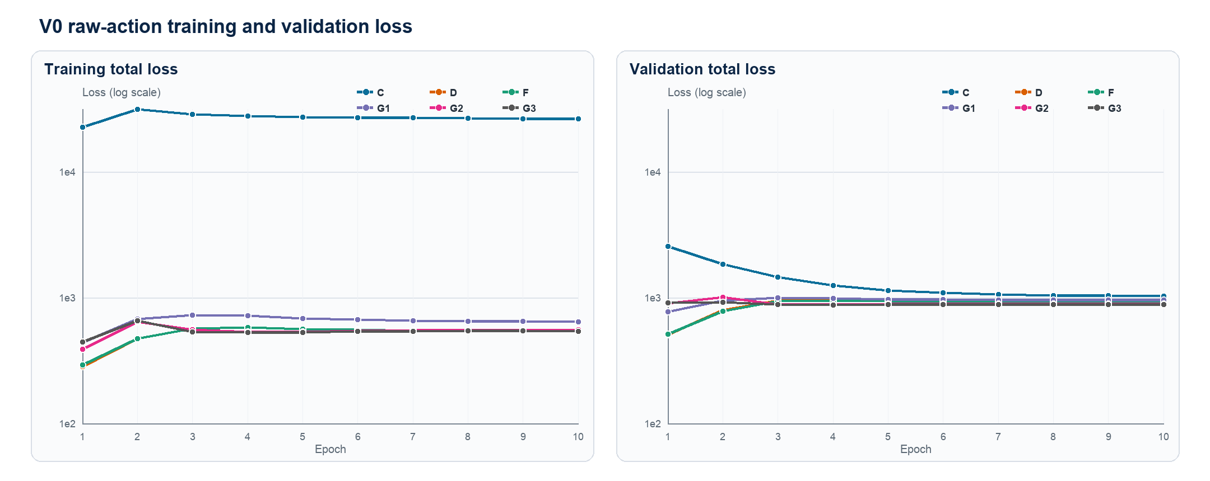
Figure 1. V0 training and validation total loss (E1-E10)
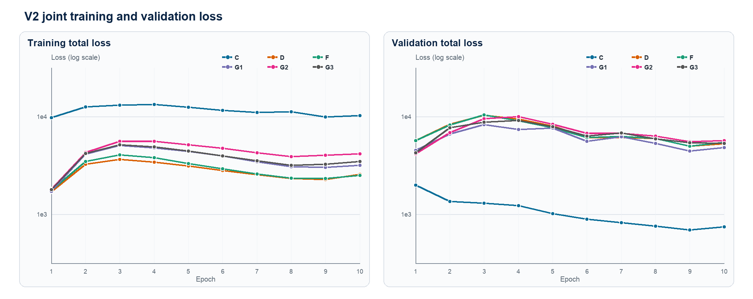
Figure 2. V2 joint training and validation total loss (E1-E10)
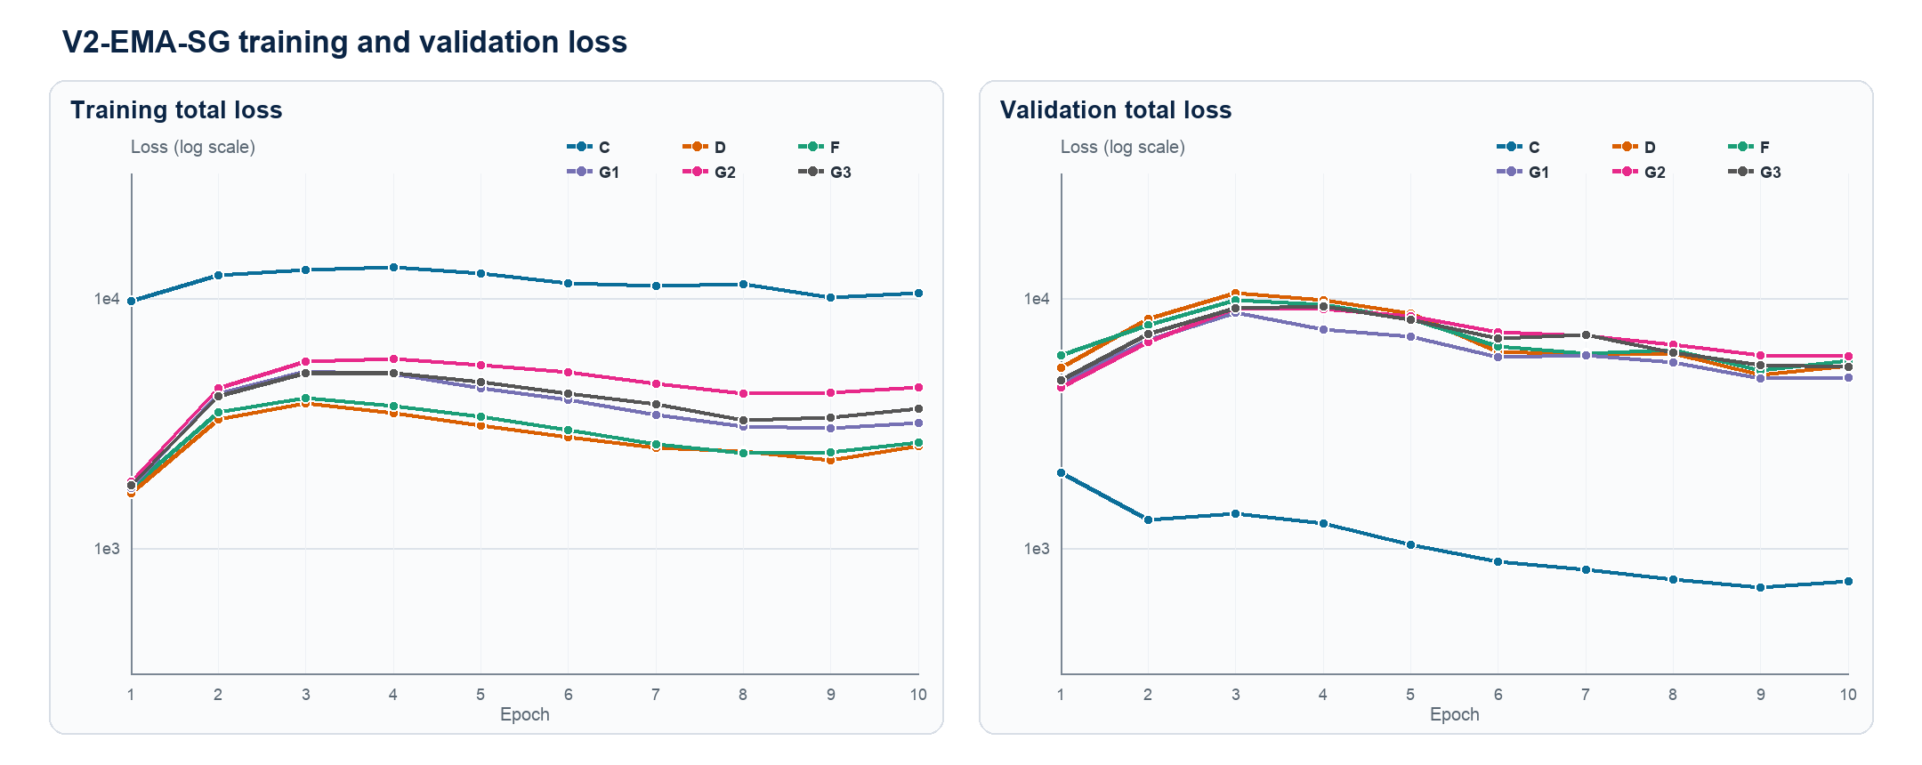
Figure 3. V2-EMA-SG training and validation loss (E1-E10)
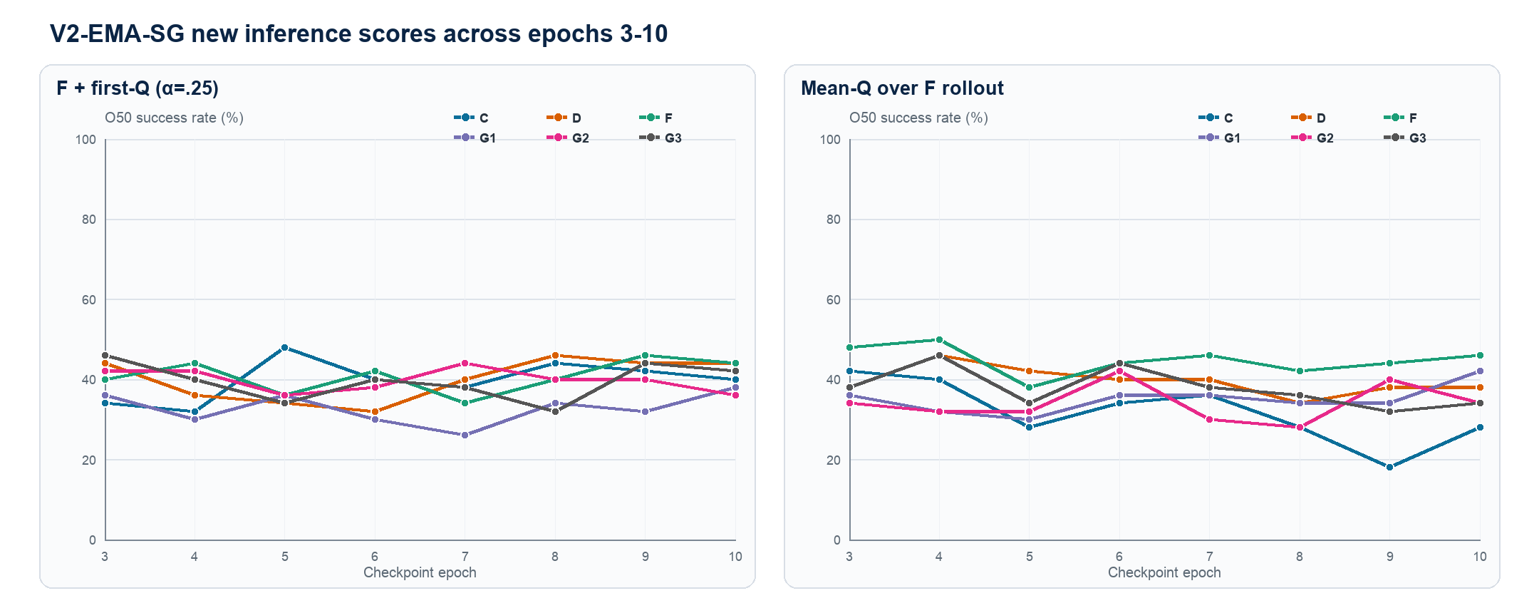
Figure 4. V2-EMA First-Q and Mean-Q trajectories (E3-E10)

V1-C2/C3 endpoint training evidence
Method | Metric | First epoch | Final epoch | Change
V1-C2 | Train total loss | 26033.77 | 25074.55 | -3.7%
V1-C2 | Validation base TD loss | 965.30 | 812.76 | -15.8%
V1-C2 | First-Q ranking CE | 3.1343 | 3.1317 | -0.1%
V1-C2 | First-Q top-1 agreement | 9.09 | 9.22 | +0.13 pp; random 6.25%
V1-C3 | Train TD loss | 0.3932 | 0.3459 | -12.0%
V1-C3 | Validation TD loss | 0.3203 | 0.2940 | -8.2%
V1-C3 | Validation MC MAE | 12.750 | 12.029 | -5.7%
V1-C3 | Validation TD residual MAE | 9.935 | 9.233 | -7.1%
V1-C3 | Validation Spearman | 0.6420 | 0.6455 | +0.0035

C2 ranking CE ends at 3.1317 versus train total 25074.55 (0.0125% by raw value), while top-1 agreement changes only from 9.09% to 9.22%. This does not prove a gradient-scale cause, but supports testing normalized losses and adaptive or gradient-balanced weighting instead of another fixed weight.
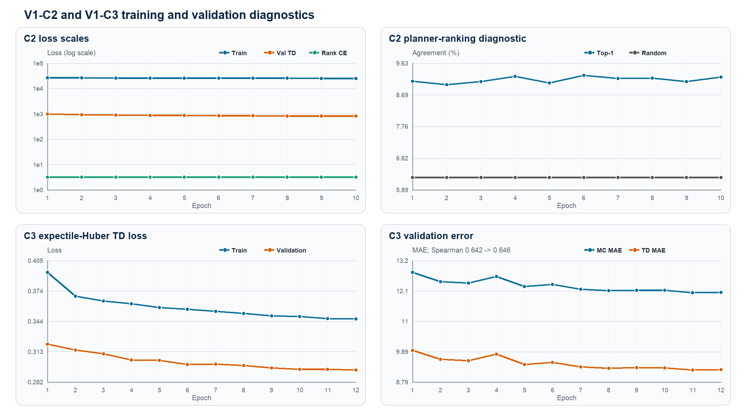
Figure 5. V1-C2 and V1-C3 training, validation and diagnostic trajectories

V2 exact checkpoint trajectories
These E3-E10 tables are diagnostic only. The main matrix remains fixed at E10, so no value below is substituted after looking at the formal O50 pairs.

F-only
Epoch | C | D | F | G1 | G2 | G3
E3 | 15/50 (30%) | 16/50 (32%) | 13/50 (26%) | 12/50 (24%) | 13/50 (26%) | 15/50 (30%)
E4 | 18/50 (36%) | 14/50 (28%) | 13/50 (26%) | 13/50 (26%) | 17/50 (34%) | 13/50 (26%)
E5 | 16/50 (32%) | 16/50 (32%) | 17/50 (34%) | 15/50 (30%) | 13/50 (26%) | 13/50 (26%)
E6 | 10/50 (20%) | 16/50 (32%) | 14/50 (28%) | 15/50 (30%) | 11/50 (22%) | 12/50 (24%)
E7 | 11/50 (22%) | 20/50 (40%) | 18/50 (36%) | 16/50 (32%) | 13/50 (26%) | 13/50 (26%)
E8 | 14/50 (28%) | 12/50 (24%) | 13/50 (26%) | 16/50 (32%) | 15/50 (30%) | 13/50 (26%)
E9 | 13/50 (26%) | 17/50 (34%) | 14/50 (28%) | 13/50 (26%) | 14/50 (28%) | 9/50 (18%)
E10 | 13/50 (26%) | 16/50 (32%) | 15/50 (30%) | 12/50 (24%) | 12/50 (24%) | 10/50 (20%)

G-only
Epoch | C | D | F | G1 | G2 | G3
E3 | 20/50 (40%) | 15/50 (30%) | 19/50 (38%) | 18/50 (36%) | 15/50 (30%) | 15/50 (30%)
E4 | 21/50 (42%) | 22/50 (44%) | 18/50 (36%) | 17/50 (34%) | 14/50 (28%) | 20/50 (40%)
E5 | 17/50 (34%) | 15/50 (30%) | 21/50 (42%) | 15/50 (30%) | 17/50 (34%) | 14/50 (28%)
E6 | 17/50 (34%) | 19/50 (38%) | 22/50 (44%) | 19/50 (38%) | 19/50 (38%) | 16/50 (32%)
E7 | 16/50 (32%) | 18/50 (36%) | 18/50 (36%) | 17/50 (34%) | 13/50 (26%) | 16/50 (32%)
E8 | 21/50 (42%) | 19/50 (38%) | 20/50 (40%) | 15/50 (30%) | 17/50 (34%) | 17/50 (34%)
E9 | 20/50 (40%) | 17/50 (34%) | 20/50 (40%) | 15/50 (30%) | 20/50 (40%) | 14/50 (28%)
E10 | 20/50 (40%) | 18/50 (36%) | 19/50 (38%) | 17/50 (34%) | 18/50 (36%) | 14/50 (28%)

F and G tail
Epoch | C | D | F | G1 | G2 | G3
E3 | 16/50 (32%) | 20/50 (40%) | 14/50 (28%) | 11/50 (22%) | 13/50 (26%) | 15/50 (30%)
E4 | 20/50 (40%) | 18/50 (36%) | 20/50 (40%) | 16/50 (32%) | 16/50 (32%) | 18/50 (36%)
E5 | 17/50 (34%) | 15/50 (30%) | 15/50 (30%) | 14/50 (28%) | 15/50 (30%) | 15/50 (30%)
E6 | 15/50 (30%) | 17/50 (34%) | 18/50 (36%) | 12/50 (24%) | 16/50 (32%) | 17/50 (34%)
E7 | 14/50 (28%) | 23/50 (46%) | 19/50 (38%) | 13/50 (26%) | 14/50 (28%) | 16/50 (32%)
E8 | 14/50 (28%) | 16/50 (32%) | 19/50 (38%) | 11/50 (22%) | 13/50 (26%) | 10/50 (20%)
E9 | 14/50 (28%) | 14/50 (28%) | 12/50 (24%) | 10/50 (20%) | 12/50 (24%) | 11/50 (22%)
E10 | 16/50 (32%) | 16/50 (32%) | 13/50 (26%) | 13/50 (26%) | 13/50 (26%) | 11/50 (22%)

V2-EMA exact checkpoint trajectories
These E3-E10 tables are diagnostic only. The main matrix remains fixed at E10, so no value below is substituted after looking at the formal O50 pairs.

F-only
Epoch | C | D | F | G1 | G2 | G3
E3 | 15/50 (30%) | 16/50 (32%) | 19/50 (38%) | 13/50 (26%) | 16/50 (32%) | 16/50 (32%)
E4 | 15/50 (30%) | 15/50 (30%) | 18/50 (36%) | 16/50 (32%) | 13/50 (26%) | 14/50 (28%)
E5 | 17/50 (34%) | 18/50 (36%) | 14/50 (28%) | 11/50 (22%) | 13/50 (26%) | 16/50 (32%)
E6 | 13/50 (26%) | 15/50 (30%) | 19/50 (38%) | 15/50 (30%) | 12/50 (24%) | 14/50 (28%)
E7 | 8/50 (16%) | 15/50 (30%) | 20/50 (40%) | 10/50 (20%) | 16/50 (32%) | 11/50 (22%)
E8 | 14/50 (28%) | 18/50 (36%) | 12/50 (24%) | 15/50 (30%) | 11/50 (22%) | 11/50 (22%)
E9 | 14/50 (28%) | 16/50 (32%) | 16/50 (32%) | 12/50 (24%) | 18/50 (36%) | 14/50 (28%)
E10 | 12/50 (24%) | 15/50 (30%) | 15/50 (30%) | 15/50 (30%) | 12/50 (24%) | 12/50 (24%)

G-only
Epoch | C | D | F | G1 | G2 | G3
E3 | 18/50 (36%) | 15/50 (30%) | 19/50 (38%) | 16/50 (32%) | 16/50 (32%) | 17/50 (34%)
E4 | 15/50 (30%) | 19/50 (38%) | 17/50 (34%) | 14/50 (28%) | 16/50 (32%) | 19/50 (38%)
E5 | 17/50 (34%) | 14/50 (28%) | 19/50 (38%) | 9/50 (18%) | 19/50 (38%) | 13/50 (26%)
E6 | 19/50 (38%) | 16/50 (32%) | 19/50 (38%) | 15/50 (30%) | 17/50 (34%) | 20/50 (40%)
E7 | 15/50 (30%) | 14/50 (28%) | 14/50 (28%) | 12/50 (24%) | 15/50 (30%) | 14/50 (28%)
E8 | 21/50 (42%) | 15/50 (30%) | 19/50 (38%) | 13/50 (26%) | 18/50 (36%) | 17/50 (34%)
E9 | 17/50 (34%) | 19/50 (38%) | 20/50 (40%) | 18/50 (36%) | 15/50 (30%) | 15/50 (30%)
E10 | 18/50 (36%) | 19/50 (38%) | 19/50 (38%) | 15/50 (30%) | 20/50 (40%) | 17/50 (34%)

F and G tail
Epoch | C | D | F | G1 | G2 | G3
E3 | 16/50 (32%) | 22/50 (44%) | 20/50 (40%) | 13/50 (26%) | 16/50 (32%) | 18/50 (36%)
E4 | 14/50 (28%) | 19/50 (38%) | 17/50 (34%) | 15/50 (30%) | 15/50 (30%) | 20/50 (40%)
E5 | 14/50 (28%) | 18/50 (36%) | 15/50 (30%) | 14/50 (28%) | 12/50 (24%) | 15/50 (30%)
E6 | 12/50 (24%) | 19/50 (38%) | 17/50 (34%) | 16/50 (32%) | 15/50 (30%) | 14/50 (28%)
E7 | 15/50 (30%) | 19/50 (38%) | 20/50 (40%) | 15/50 (30%) | 13/50 (26%) | 13/50 (26%)
E8 | 14/50 (28%) | 18/50 (36%) | 17/50 (34%) | 10/50 (20%) | 16/50 (32%) | 14/50 (28%)
E9 | 14/50 (28%) | 14/50 (28%) | 16/50 (32%) | 13/50 (26%) | 14/50 (28%) | 11/50 (22%)
E10 | 12/50 (24%) | 16/50 (32%) | 17/50 (34%) | 11/50 (22%) | 16/50 (32%) | 13/50 (26%)

F with first-Q
Epoch | C | D | F | G1 | G2 | G3
E3 | 17/50 (34%) | 22/50 (44%) | 20/50 (40%) | 18/50 (36%) | 21/50 (42%) | 23/50 (46%)
E4 | 16/50 (32%) | 18/50 (36%) | 22/50 (44%) | 15/50 (30%) | 21/50 (42%) | 20/50 (40%)
E5 | 24/50 (48%) | 17/50 (34%) | 18/50 (36%) | 18/50 (36%) | 18/50 (36%) | 17/50 (34%)
E6 | 20/50 (40%) | 16/50 (32%) | 21/50 (42%) | 15/50 (30%) | 19/50 (38%) | 20/50 (40%)
E7 | 19/50 (38%) | 20/50 (40%) | 17/50 (34%) | 13/50 (26%) | 22/50 (44%) | 19/50 (38%)
E8 | 22/50 (44%) | 23/50 (46%) | 20/50 (40%) | 17/50 (34%) | 20/50 (40%) | 16/50 (32%)
E9 | 21/50 (42%) | 22/50 (44%) | 23/50 (46%) | 16/50 (32%) | 20/50 (40%) | 22/50 (44%)
E10 | 20/50 (40%) | 22/50 (44%) | 22/50 (44%) | 19/50 (38%) | 18/50 (36%) | 21/50 (42%)

Mean-Q rollout
Epoch | C | D | F | G1 | G2 | G3
E3 | 21/50 (42%) | 19/50 (38%) | 24/50 (48%) | 18/50 (36%) | 17/50 (34%) | 19/50 (38%)
E4 | 20/50 (40%) | 23/50 (46%) | 25/50 (50%) | 16/50 (32%) | 16/50 (32%) | 23/50 (46%)
E5 | 14/50 (28%) | 21/50 (42%) | 19/50 (38%) | 15/50 (30%) | 16/50 (32%) | 17/50 (34%)
E6 | 17/50 (34%) | 20/50 (40%) | 22/50 (44%) | 18/50 (36%) | 21/50 (42%) | 22/50 (44%)
E7 | 18/50 (36%) | 20/50 (40%) | 23/50 (46%) | 18/50 (36%) | 15/50 (30%) | 19/50 (38%)
E8 | 14/50 (28%) | 17/50 (34%) | 21/50 (42%) | 17/50 (34%) | 14/50 (28%) | 18/50 (36%)
E9 | 9/50 (18%) | 19/50 (38%) | 22/50 (44%) | 17/50 (34%) | 20/50 (40%) | 16/50 (32%)
E10 | 14/50 (28%) | 19/50 (38%) | 23/50 (46%) | 21/50 (42%) | 17/50 (34%) | 17/50 (34%)

Post-hoc checkpoint diagnosis
The maxima in this section were selected after observing E3-E10 on the same O50 pairs. They describe instability and selection risk; they are not formal replacements for the fixed E10 results.
Version | Score | Post-hoc best | Best | Best at E10
V2 | F-only | D-E7 | 20/50 (40%) | 16/50 (32%)
V2 | G-only | D-E4, F-E6 | 22/50 (44%) | 20/50 (40%)
V2 | F+G tail | D-E7 | 23/50 (46%) | 16/50 (32%)
V2-EMA | F-only | F-E7 | 20/50 (40%) | 15/50 (30%)
V2-EMA | G-only | C-E8 | 21/50 (42%) | 20/50 (40%)
V2-EMA | F+G tail | D-E3 | 22/50 (44%) | 17/50 (34%)
V2-EMA | F + first-Q | C-E5 | 24/50 (48%) | 22/50 (44%)
V2-EMA | Mean-Q rollout | F-E4 | 25/50 (50%) | 23/50 (46%)

V2-EMA new-score stability
Method | Score | Mean | Sigma pp | Best | E10
C | F + first-Q | 39.8% | 4.8 | E5 / 48% | 40%
C | Mean-Q rollout | 31.8% | 7.3 | E3 / 42% | 28%
D | F + first-Q | 40.0% | 5.0 | E8 / 46% | 44%
D | Mean-Q rollout | 39.5% | 3.3 | E4 / 46% | 38%
F | F + first-Q | 40.8% | 3.9 | E9 / 46% | 44%
F | Mean-Q rollout | 44.8% | 3.5 | E4 / 50% | 46%
G1 | F + first-Q | 32.8% | 3.7 | E10 / 38% | 38%
G1 | Mean-Q rollout | 35.0% | 3.3 | E10 / 42% | 42%
G2 | F + first-Q | 39.8% | 2.7 | E7 / 44% | 36%
G2 | Mean-Q rollout | 34.0% | 4.5 | E6 / 42% | 34%
G3 | F + first-Q | 39.5% | 4.4 | E3 / 46% | 42%
G3 | Mean-Q rollout | 37.8% | 4.6 | E4 / 46% | 34%

V2-EMA training variants
Training variant | Five-score mean | Best readout | Best rate
C | 30.4% | F + first-Q | 40%
D | 36.4% | F + first-Q | 44%
F | 38.4% | Mean-Q rollout | 46%
G1 | 32.4% | Mean-Q rollout | 42%
G2 | 33.2% | G-only | 40%
G3 | 32.0% | F + first-Q | 42%

Audit boundary
Audit field | Locked value
Verified O50 cells | 505 / 505 = 477 base + 8 C2/C3 endpoints + 20 alpha-sweep cells
Scalar CSV path | reports/artifacts/actor_free_td_lewm_complete_cube_seed3072/all_o50_results.csv
Scalar CSV SHA-256 | 0e5b541bdb11cf6d647fc1e679499a02c3aa430d64e37c8819d02c44e1dcb900
Reconciliation JSON path | reports/artifacts/actor_free_td_lewm_complete_cube_seed3072/reconciliation_ledger.json
Reconciliation JSON SHA-256 | 2f1985d5703e795f48bd8b850d470f76e35c998447112c86065e8bdcbbe1372b
Per-pair Boolean outcomes | 25,250 / 25,250 = 23,850 base + 400 endpoints + 1,000 alpha-sweep outcomes
Fixed E10 Mean-Q cells | 24 / 24
C2/C3 endpoint extension | 8 / 8 strict cells
First-Q alpha sweep | 20 / 20 strict cells; 1,000 pair-level outcomes
Alpha-sweep evidence | CSV SHA-256 ce6c7e99a1acbce2148fb26f14e824ddb08455672e22e694c58717e30b97f848; validation SHA-256 bbdfe687179e7edd941159d60c1105d35173ae86119ad625f88f882e3293dc9d
Grand total | 505 O50 cells; 25,250 pair-level Boolean outcomes
Episode selection | e46ea81cce2e6a9a5df05ba04893b4181cbd8979340111a012c30f1efa2d7ee7
Fixed valid-row-ranks hash | 88c204770f33c0b0220057d45b187766e3cfc54912e3f5ca49f2aa93d16437e9
Action normalization | 57f4d3c252e1805f4af1f614d20d1d1a064fa0d1d463ed5eb8ecf9dfc2b1a723
Training / planning seed | 3072 / 42
EMA E3 retry | G1/F+G and G2/F-only use isolated attempt_02
Claim boundary | One training seed; base rules fixed, C2 E10 and C3 E12 fixed; alpha chosen on this O50 is exploratory

First Q alpha sensitivity
This section compares First-Q fusion weights on fixed checkpoints. The highest observed result is V1-C3 Z-score First-Q2 at alpha=0.1: 31/50 (62%). Because alpha was selected on the same O50 pairs, this is an exploratory tuning result, not a replacement for a pre-registered endpoint.

Score paths and fixed training objectives
No model was retrained in this sweep. Both C3 scores use the V1-C3 E12 checkpoint and retain training loss L_C3. Original First-Q uses the V1-C E10 checkpoint and retains training loss L_C. Only the CEM inference cost changes.
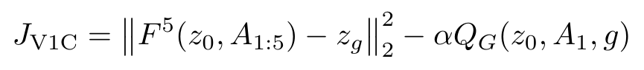
Score | Fixed checkpoint and loss | Input path | CEM minimized objective
C3 Raw First-Q | V1-C3 E12  L_C3 unchanged | EMA State-V reads the F five-step terminal latent; retained online G reads real z0 and A1. | Raw State-V cost minus α times raw First-Q.
C3 Z-score First-Q2 | V1-C3 E12  L_C3 unchanged | The same State-V and First-Q paths; each is population-z-scored inside the current CEM candidate set. | Normalized State-V cost minus α times normalized First-Q.
Original V1-C First-Q | V1-C E10  L_C unchanged | F rolls five blocks to z5; retained online G reads real z0 and A1. | Terminal latent goal distance minus α times raw First-Q.

Unified O50 alpha-result matrix
Every cell uses the same 50 start-goal pairs. Alpha=0 was not rerun: for C3 it equals the existing State-V result, and for V1-C it equals the existing F-only result. Yellow marks each row best, blue marks each column best, and cyan marks a cell that is both; all ties are retained.
Fixed checkpoint and score | Training loss | α=0 | 0.025 | 0.05 | 0.075 | 0.1 | 0.15 | 0.2 | 0.25 | 0.5 | 1 | 2
V1-C3 Raw  State-V + First-Q | L_C3 | 26/50  52% | — | — | — | 26/50  52% | — | — | 22/50  44% | 21/50  42% | 21/50  42% | 22/50  44%
V1-C3 Z-score  State-V + First-Q2 | L_C3 | 26/50  52% | 25/50  50% | 28/50  56% | 27/50  54% | 31/50  62% | 23/50  46% | 28/50  56% | 26/50  52% | 24/50  48% | 24/50  48% | 25/50  50%
V1-C Original  First-Q | L_C | 23/50  46% | — | — | — | 24/50  48% | — | — | 28/50  56% | 27/50  54% | 28/50  56% | 25/50  50%

Paired analysis
Comparison | Success-count change | New-only successes | Reference-only successes | Exact McNemar p
C3 Z-score α=0.1 vs C3 State-V α=0 | 26 → 31  +10 pp | 6 | 1 | 0.125
C3 Z-score α=0.1 vs V1-C First-Q α=0.25 | 28 → 31  +6 pp | 4 | 1 | 0.375
C3 Z-score α=0.1 vs Legacy Hybrid F+G | 27 → 31  +8 pp | 8 | 4 | 0.3877

Interpretation and next step
Highest observed result. C3 Z-score alpha=0.1 reaches 31/50 (62%), five more successful pairs than C3 State-V. However, paired p=0.125 and the weight was selected on the same O50 set, so this is not an unbiased formal optimum.
Scale calibration is decisive. C3 Raw at alpha=0.1 only ties State-V, and alpha>=0.25 falls to 42%-44%. After candidate-wise z-scoring, a small First-Q weight can contribute complementary first-step reachability information.
The optimum is sharp. Alpha=0.075, 0.1 and 0.15 yield 54%, 62% and 46%, respectively. CEM elite ranking is sensitive to small weight changes; alpha=0.1 is not yet a demonstrated stable plateau.
Original First-Q is more tolerant. V1-C reaches 28/50 (56%) at alpha=0.25 and alpha=1, and 27/50 (54%) at alpha=0.5, but it does not match the best observed C3 Z-score result in this sweep.
Reproduction boundary. Historical C3 Z-score alpha=0.25 was 27/50, versus 26/50 here. Three pairs flipped, for a net difference of one; changes of one or two episodes should not be overinterpreted.
Next: choose alpha on disjoint development pairs, then confirm it on untouched test pairs and multiple planning seeds. If C3 is extended, calibrate State-V and First-Q so fusion no longer has a sharp alpha sensitivity.
Evidence: 20 new O50 cells and 1,000 pair-level outcomes; fixed selection SHA-256 e46ea81cce2e6a9a5df05ba04893b4181cbd8979340111a012c30f1efa2d7ee7.

RESULTS TD / O25 PAIRED EXTENSION

Cube O25 paired audit for V1-C and V1-C3
Retention, rescue and regression on one fixed set of 50 start-goal pairs
On 50 fixed O25 pairs, F-only is 37/50 (74%) and the C3 combo is 38/50 (76%). The first six rows are the earlier V1-C E10 supplement; the final row reuses, without retraining, the exact C3 scorer that reached 31/50 (62%) on O50. C3 rescues six F failures but loses five F successes. Label-oracle unions are 43/50 (86%) for F+C3 and 44/50 (88%) across all scores; they are not deployable results.

Methods by inference score, relative to F-only
Each row is one trained method/checkpoint. Every score column is followed by one adjacent New / Lost / F+New column. A dash means not evaluated.
The adjacent column contains counts only: newly successful pairs / lost F successes / total if all F successes are retained and New is added.
Method / checkpoint | F-only  baseline | G-only | New / Lost / F+New | F+G tail | New / Lost / F+New | First-Q  alpha=.25 | New / Lost / F+New | Mean-Q | New / Lost / F+New | First-Q2  alpha=.25 | New / Lost / F+New | C3 State-V + First-Q2  alpha=.10 | New / Lost / F+New
V1-C E10 | 37/50 (74%) | 29/50 (58%) | 3/11/40 | 35/50 (70%) | 6/8/43 | 36/50 (72%) | 2/3/39 | 30/50 (60%) | 1/8/38 | 35/50 (70%) | 2/4/39 | — | —
V1-C3 E12 | 37/50 (74%)* | — | — | — | — | — | — | — | — | — | — | 38/50 (76%) | 6/5/43
* C3 freezes and reuses V1-C's F. Its F-only cell is therefore the same 37/50 baseline reference, not a separate C3 F-only rerun. Exact pair-level records remain in the audit CSV rather than a second results table.

Conclusions and the next gating objective
- C3 is the best standalone O25 score at 38/50 (76%), a net gain of only one success over F-only. It rescues P01, P02, P08, P20, P23, P25, but loses P10, P13, P24, P27, P34.
- C3 versus F-only has six new-only and five reference-only successes; the two-sided exact McNemar p-value is 1.0. This single-seed result does not establish statistically significant superiority over F.
- The F+C3 oracle is 43/50 (86%). The oracle across F and all alternatives is 44/50 (88%), with rescue union P01, P02, P08, P20, P23, P25, P32. P25 is unique to C3 and P32 is unique to F+G tail. Every score fails on P07, P12, P15, P18, P28, P39.
- Next, train or calibrate a gate on separate development pairs: first choose between F and C3, then test whether an F+G-tail third route covers P32-like cases. Lock the rule before evaluation on unseen test pairs and multiple planning seeds. Formal O25 success labels must not be used to implement the oracle.
- Boundary: one training seed and one planning seed. C3 alpha=.10 was selected exploratorily on the same O50 set. O25 and O50 differ in offset, difficulty and execution protocol, so percentage differences are not cross-protocol improvements.

相关工作 Cube 结果比较
口径：O25 等表示 goal offset；主表 SR 均为原始 success rate。RP1 Hard 仅为扣除 no-op floor 后的归一化值，写在注释列。— 表示论文未报告。
方法 | O25 SR | O50 SR | O75 SR | O100 SR | O125 SR | O150 SR | 执行预算/目标距离 | 评测重复 | 是否相同 Episode | 配置差异／注释
LeWM 原论文 | 74% | — | — | — | — | — | 2× | 50 episodes | 未公开配对 manifest | O25、执行 50 步；Cube 的 CEM 为 300 候选 × 10 轮，即 3,000 rollouts。原论文未测试 O100。
本项目 LeWM（V1-C E10 的 F-only） | 74% | 46% | — | 50% | — | — | 2× | O25：1×50；O50：1×50；O100：1×50 | 每个 offset 内固定同一组 50 个 pair；不同 offset 是不同任务 | V1 阶段冻结 LeWM 与 Action Encoder；F-only 不调用 G，只用 LeWM 五步 rollout 的终点 latent L2。O25 为 37/50；Prior O50 为 23/50；O100 为 25/50；training seed 3072、planning seed 42。
LeWM+CEM+L2（RP1 重测） | 74.0% | — | — | 58.0% | — | — | 2× | 3 eval seeds × 50 | RP1 论文内使用相同 3 组任务 | 方法结构仍是 LeWM rollout + 终点 latent L2 + CEM；RP1 改用 300×30，即 9,000 rollouts。Hard：O25 40.9%；O100 23.2%。
RP1：LeWM+CEM+critic | 84.0% | — | — | 76.7% | — | — | 2× | 3 eval seeds × 50 | 与上行相同 | 冻结 LeWM，只把终点 L2 换成 state critic；Hard：63.6% / 57.4%。
RP1 | 89.1% | — | — | 82.4% | — | — | 2× | 3 eval × 3 train seeds × 50 | 同一 3 组评测任务；增加 3 个 planner seeds | Critic + learned refiner；Hard：75.2% / 67.8%。
RP1-Dyna | 94.4% | — | — | 84.7% | — | — | 2× | 3 eval × 3 train seeds × 50 | 使用相同评测协议 | world model 已用失败轨迹微调；Hard：87.3% / 72.0%。
Traj-LeWM：Endpoint-only | 80% | — | — | — | — | — | 2× | 3 eval seeds × 50 | 三种 Traj 评分使用相同评测 seeds | 已进行 trajectory-preference 训练，但测试时不用 LTC。
Traj-LeWM：LTC-only | 69% | — | — | — | — | — | 2× | 3 eval seeds × 50 | 与相邻 Traj 行相同 | 只使用完整路径 cost。
Traj-LeWM：Endpoint+LTC | 88.0±4.0% | — | — | — | — | — | 2× | 3 eval seeds × 50 | 与相邻 Traj 行相同 | 完整方法；表中 LeWM 74% 是论文参照，未证明与 88% 逐 episode 配对。
ProWorld：复现 LeWM | 71.33±3.06% | — | — | — | — | — | 2× | 3 training seeds | 统一协议，未公开逐 episode manifest | O25、执行 50 步；CEM 300×30。训练 seeds 为 42、1337、3407，evaluation 使用对应的同号 seed。
ProWorld：Terminal-only | 62% | — | — | — | — | — | 2× | 规划消融 | 同一 ProWorld 模型的消融 | 仅保留终点距离；这是 Cube-S 的单项消融结果，不是 3-seed 主结果。
ProWorld：完整方法 | 77.33±1.15% | — | — | — | — | — | 2× | 3 training seeds | 与其 LeWM 复现使用统一设置 | ProWorld 世界模型 + 完整路径评分；规划 cost 为终点 + 最好中间状态 + 平均路径进展。论文另报规划器消融的 Full planner 为 78%。
SAGE：复现 LeWM | 66.7% | — | — | 57.3% | — | 26.7% | 1× | 3 manifests × 50 | 与 SAGE 使用完全相同的固定 manifests | 同一冻结 LeWM、CEM 300×30；但 O25 只执行 25 步，所以不是原 LeWM 的 O25/B50 协议。
SAGE：Generator-only | 91.3±1.2% | 63.3±5.0% | 76.0±4.0% | 70.7±13.3% | 59.3±11.7% | 51.3±4.2% | 1× | 3 manifests × 50 | 与完整 SAGE 相同 | 生成 subgoal，但仍从普通高斯初始化 CEM。
SAGE：完整方法 | 98.7±1.2% | 76.0±5.3% | 86.0±4.0% | 85.3±1.2% | 77.3±3.1% | 67.3±3.1% | 1× | 3 manifests × 50 | 与 SAGE baseline 完全相同 | 生成 subgoal + action proposal + 冻结 LeWM + CEM。
LeFlow：LeWM+CEM | 73.3±9.0% | — | — | — | — | — | 2× | 3 eval seeds × 50 | 与 LeFlow 不完全相同 | baseline 只有 3 次重复，LeFlow 有 5 次；论文未证明两者完整 aggregate 逐 episode 配对。
LeFlow | 100.0±0.0% | — | — | — | — | — | 2× | 5 eval seeds × 50 | 不完全相同 | seeds 42–46；冻结 LeWM；rectified-flow 生成 latent 路径。

RESULTS TD / O100 V1-C C3 PAIRED EXTENSION

Cube O100 paired evaluation: V1-C and V1-C3
One fixed set of 50 start-goal pairs: score, New, Lost and complementary successes
All columns use the same O100 pairs, planning seed 42, CEM 300 x 30 and budget 200. V1-C uses E10 and V1-C3 uses E12. The best standalone score is First-Q alpha=.25 at 32/50 (64%): seven New and zero Lost relative to F-only at 25/50 (50%).

O100 method-by-inference-score matrix
Every score is followed by New / Lost / F+New counts. New means the scorer succeeds where F-only fails; Lost means an F-only success becomes a failure; F+New is the post-hoc upper bound that keeps every F success and adds all New. The C3 F-only cell is the same frozen-F baseline, not another evaluation run.
Method / checkpoint | F-only  baseline | G-only | New / Lost / F+New | F+G tail | New / Lost / F+New | First-Q  alpha=.25 | New / Lost / F+New | Mean-Q | New / Lost / F+New | First-Q2  alpha=.25 | New / Lost / F+New | C3 State-V + First-Q2  alpha=.10 | New / Lost / F+New
V1-C E10 | 25/50 (50%) | 24/50 (48%) | 4 / 5 / 29 | 22/50 (44%) | 3 / 6 / 28 | 32/50 (64%) | 7 / 0 / 32 | 25/50 (50%) | 3 / 3 / 28 | 26/50 (52%) | 4 / 3 / 29 | — | —
V1-C3 E12 | 25/50 (50%)* | — | — | — | — | — | — | — | — | — | — | 25/50 (50%) | 3 / 3 / 28

Cyan marks the best standalone O100 result; it also preserves every F-only success.

First-Q's seven New pairs and complementary rescues
- First-Q has seven New pairs: P09, P22, P28, P29, P31, P40, P41. Lost=0, so its observed 32/50 equals its F+New upper bound.
- Other scores do rescue four distinct pairs outside those seven: P13 only by F+G tail; P25 only by G-only; P42 only by First-Q2; and P48 by both F+G tail and Mean-Q.
- The post-hoc union of F-only, First-Q and every complementary rescue is 36/50 (72%). This is an oracle selected with true success labels, not a deployable result.
- C3's three New pairs (P29, P31 and P40) are already included in First-Q's seven; C3 contributes no rescue outside First-Q.
- The next target is a conservative gate around First-Q: retain First-Q by default, and switch to tail, G-only or First-Q2 only when a separate development set can reliably identify P13-, P25-, P42- or P48-like cases. Lock the rule before testing unseen pairs and multiple planning seeds.
- Scope: one training seed, one planning seed and one fixed set of 50 formal O100 pairs. The 36/50 (72%) oracle is not an implemented controller result.
Evidence: seven scores x 50 pair-level outcomes; shared selection SHA-256 8a87815e8e1816ccb5021af81a5e2307a5b342d094eec3edf221a0e24851d10c。

