ACTOR-FREE TD-LEWM · COMPLETE 7×3 CONTROLLED ABLATION

Results TD
  - swm/OGBCube-v0 | dataset quentinll/lewm-cube | training seed 3072 | planning seed 42
Locked protocol: all 7 methods completed 10 epochs / 127,960 optimizer updates; each method was evaluated with 3 scores, for 21 formal O50 runs. goal offset=50; common selection SHA-256=e46ea81cce2e….

Combined O50 ranking
Rank | Method | Family | Combined | Successes | Rate | Elapsed
1 | Hybrid | Successor | f_plus_g | 27/50 | 54% | 14:34.6
2 | Serial Decoupled | Successor | f_plus_g | 23/50 | 46% | 16:32.9
2 | Imaginary Hybrid | Successor | f_plus_g | 23/50 | 46% | 16:29.2
4 | Parallel Real | Successor | f_plus_g | 22/50 | 44% | 17:20.4
5 | Serial Coupled | Successor | f_plus_g | 20/50 | 40% | 17:55.9
6 | Goal Hybrid | Successor | f_plus_g | 19/50 | 38% | 18:56.5
6 | Direct Goal Critic Hybrid | Direct critic | f_plus_c | 19/50 | 38% | 18:47.4
Table 1. Ranking uses only the pre-specified combined column; equal success counts share a rank. The best of the three score columns is not selected post hoc.

7×3 inference-score matrix
Method | Tail type | F-only | G/C-only | F+G / F+C | Combined rank only
Serial Decoupled | Successor / G | 20/50 · 40% · 18:54.9 | 15/50 · 30% · 20:32.1 | 23/50 · 46% · 16:32.9 | #2 · G
Serial Coupled | Successor / G | 26/50 · 52% · 15:11.5 | 14/50 · 28% · 20:36.9 | 20/50 · 40% · 17:55.9 | #5 · G
Hybrid | Successor / G | 25/50 · 50% · 15:40.0 | 13/50 · 26% · 22:03.4 | 27/50 · 54% · 14:34.6 | #1 · G
Parallel Real | Successor / G | 17/50 · 34% · 19:33.0 | 13/50 · 26% · 20:48.1 | 22/50 · 44% · 17:20.4 | #4 · G
Goal Hybrid | Successor / G | 25/50 · 50% · 15:45.3 | 19/50 · 38% · 18:28.8 | 19/50 · 38% · 18:56.5 | #6 · G
Imaginary Hybrid | Successor / G | 24/50 · 48% · 16:13.8 | 13/50 · 26% · 21:09.9 | 23/50 · 46% · 16:29.2 | #2 · G
Direct Goal Critic Hybrid | Direct / C | 22/50 · 44% · 17:25.5 | 16/50 · 32% · 19:56.4 | 19/50 · 38% · 18:47.4 | #6 · C
Table 2. Each cell reports successes/episodes, success rate and elapsed time (h:mm:ss); F-only includes the final planning action.

TRAINING / VALIDATION · SUMMARY-DERIVED METRICS

Training convergence and checkpoints
  - 7 methods | 10 epochs | 127,960 optimizer updates per method
Comparison limit: auxiliary-loss counts and definitions differ. Total loss is only a within-method convergence check and cannot rank methods across structures.
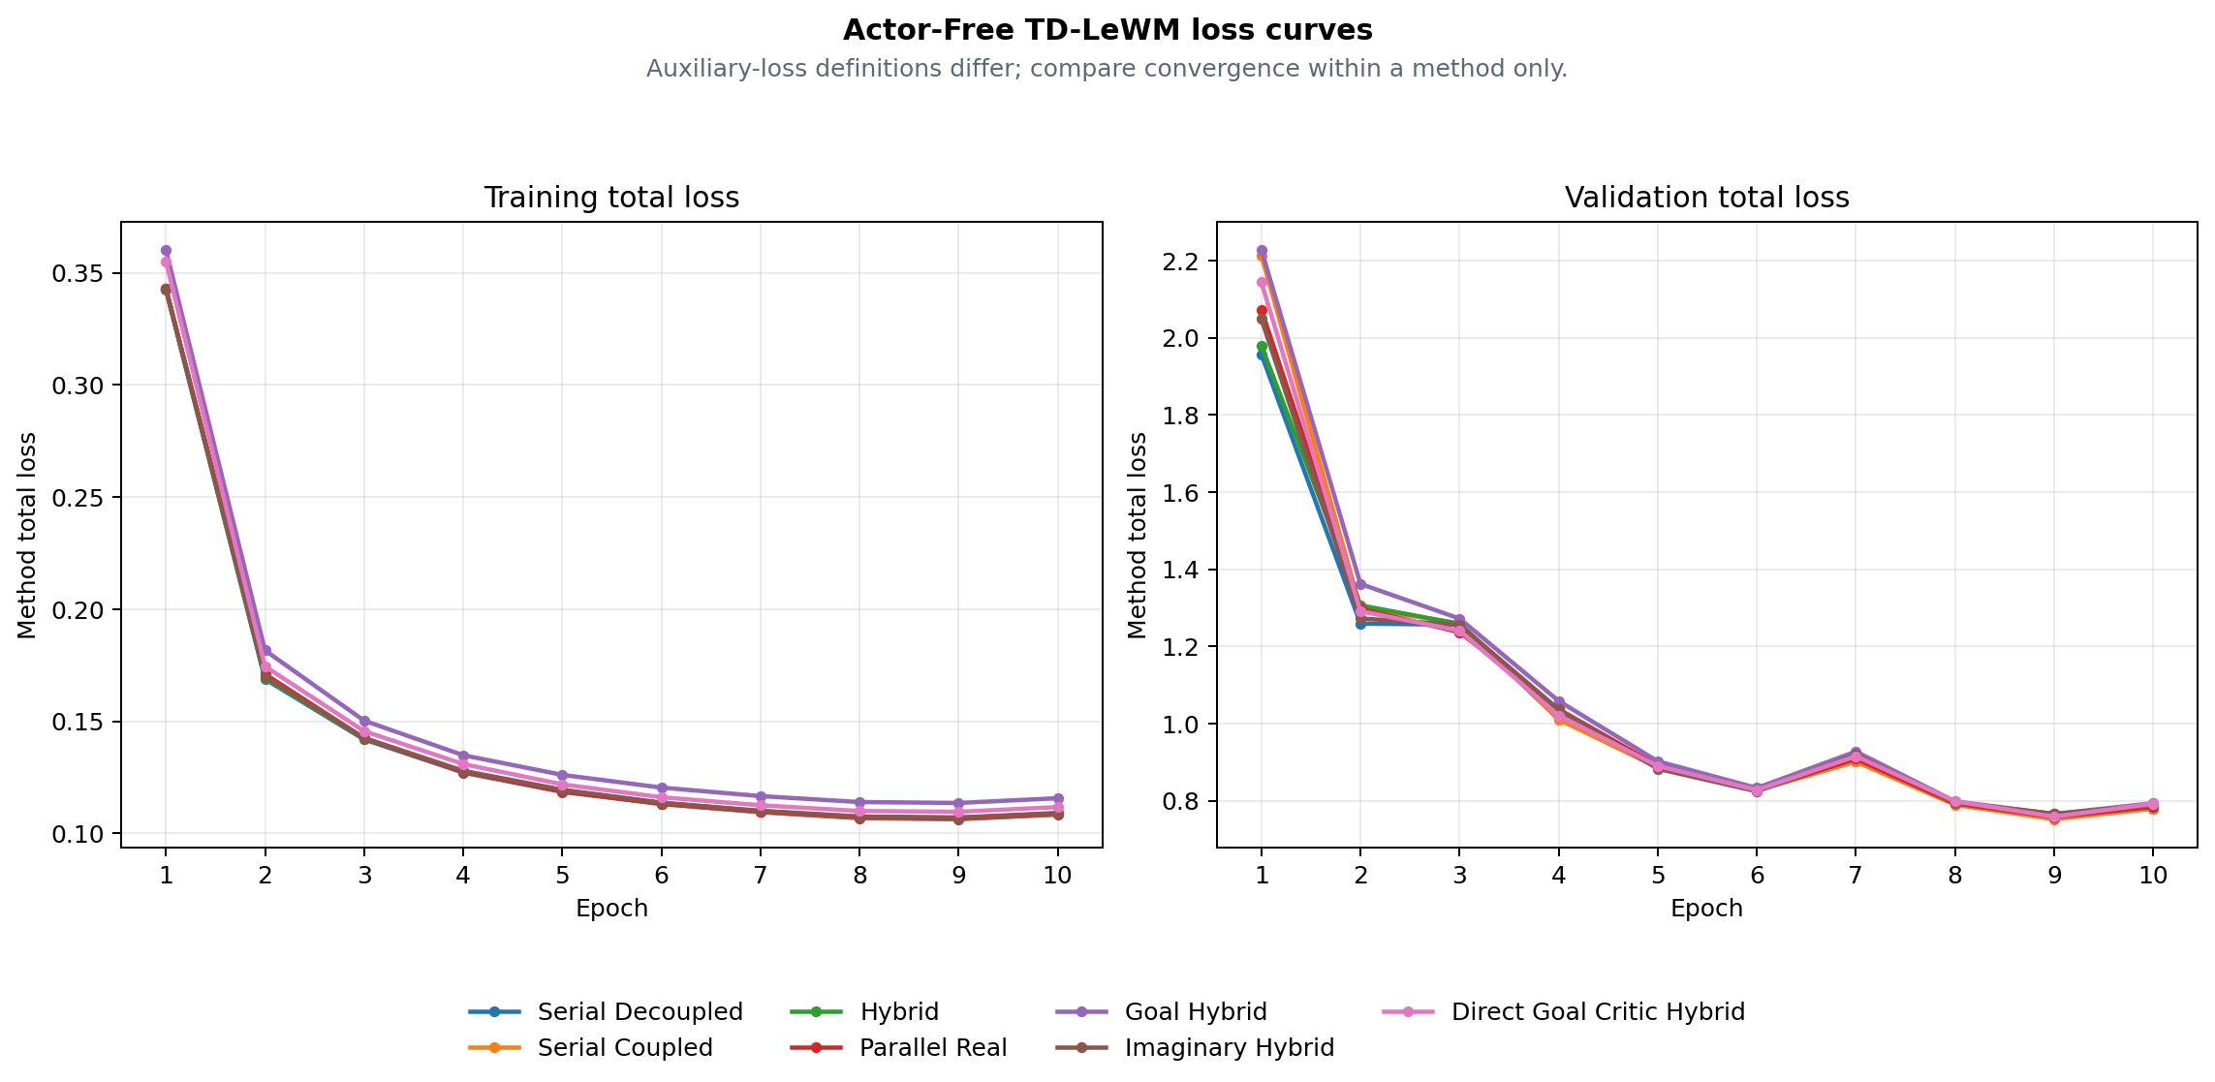
Figure 1. Training and validation total-loss curves derived by the archiver; cross-method ranking uses combined O50 on page 1.
Method | Final train | Final validation | Best validation | Checkpoint SHA | Training commit
Serial Decoupled | 0.108424 | 0.780097 | 0.754505 · E9 | cb8be3f9a851 | 8e667cb6a8e9
Serial Coupled | 0.108643 | 0.780158 | 0.752397 · E9 | 2fe3fd5bcb2c | 8e667cb6a8e9
Hybrid | 0.108973 | 0.784110 | 0.766112 · E9 | 299222acff78 | 8e667cb6a8e9
Parallel Real | 0.108762 | 0.784254 | 0.757853 · E9 | 61b5614a7b92 | e895637d8c7e
Goal Hybrid | 0.115752 | 0.793633 | 0.766048 · E9 | a746912bddd0 | 88ad2ec12c1d
Imaginary Hybrid | 0.109176 | 0.788777 | 0.766026 · E9 | e7656fed92a0 | ea82e8f2984f
Direct Goal Critic Hybrid | 0.111773 | 0.792399 | 0.759004 · E9 | b3345e9eefdb | a1d98a2d0881
Table 3. Final is epoch 10; Best validation is selected within each method's 10 epochs. Hashes and commits come from the archive summary.

METHOD REFERENCE · BASE STRUCTURAL ABLATIONS

Four base Actor-Free TD-LeWM structures
  - Shared LeWM encoder/predictor; differences are successor inputs, TD gradient paths and real/predicted branches.
Common objective: L_LeWM = L_pred + 0.09 L_SIGReg. The successor target uses the real EMA next latent, EMA head and dataset next action, with a stop-gradient target; every method is actor-free.
Method | Network | Training loss | Special design / gradient path | Inference
Serial Decoupled  serial_decoupled | LeWM + one successor-feature head on predicted latent history | L = L_LeWM + αᵤ L_TD^pred  G(sg(H̃ₜ), aₜ) → sg(yₜ^SF) | Predicted context is detached; TD updates the successor head only. | CEM with F-only, G-only, or F+G cost.
Serial Coupled  serial_coupled | LeWM + one successor-feature head on predicted latent history | L = L_LeWM + αᵤ L_TD^pred  G(H̃ₜ, aₜ) → sg(yₜ^SF) | Predicted context stays differentiable; TD also reaches LeWM. | CEM with F-only, G-only, or F+G cost.
Hybrid  hybrid | LeWM + one shared successor head for real and predicted histories | L = L_LeWM + αᵤ(L_TD^pred + L_TD^real)  The same G consumes predicted and real latent histories | The same head is trained on parallel-real and coupled-serial branches. | CEM with F-only, G-only, or F+G cost.
Parallel Real  parallel_real | LeWM predictor and successor head are parallel on encoder latents | L = L_LeWM + αᵤ L_TD^real  G(Hₜ^real, aₜ) is parallel to the LeWM predictor | TD uses real latent history and does not pass through the predictor. | CEM with F-only, G-only, or F+G cost.
Table 4. Method descriptions come from archive summary.method_spec; the equations are fixed definitions, not manually entered results.

Unified meaning of the three inference scores
Score mode | Candidate-action ranking signal
F-only | LeWM rolls and scores all H predicted states with the normalized discounted latent-goal cost.
G-only | LeWM still rolls the candidate to form tail context, but ranking uses only the successor G readout.
F+G | F prefix cost plus discounted successor G tail cost.
Control protocol: all structures use the same swm/OGBCube-v0, selection and planning seed 42. G-only still uses a LeWM rollout to build tail context, but excludes F cost from ranking.

METHOD REFERENCE · GOAL / IMAGINARY / DIRECT

Three extensions, target equations and audit sources
  - Side-by-side comparison of goal-readout TD, EMA imaginary bootstrap and a direct goal-conditioned critic.
Method | Network | Training loss | Special design / gradient path | Inference
Goal Hybrid  goal_hybrid | Hybrid successor head with fixed linear goal readout G^T w(g) | L = L_LeWM + αᵤ(L_SF-TD^real + L_SF-TD^pred + L_goal-TD^real + L_goal-TD^pred)  C_g(H,a) = G(H,a)ᵀw(z_g) | Goal readout is trained by hindsight goal-conditioned Bellman TD. | CEM with F-only, G-only, or F+G cost.
Imaginary Hybrid  imaginary_hybrid | Hybrid successor head with an EMA-LeWM imagined bootstrap state | L = L_LeWM + αᵤ(L_TD^real + L_TD^pred)  The bootstrap state is imagined one step by stop-gradient EMA-LeWM | The TD target bootstraps one step through the stopped EMA predictor. | CEM with F-only, G-only, or F+G cost.
Direct Goal Critic Hybrid  direct_goal_hybrid | LeWM + one scalar goal-conditioned critic for real/predicted histories | L = L_LeWM + αᵤ(L_C-TD^real + L_C-TD^pred)  C(H,a,z_g) directly outputs a goal-conditioned scalar cost | Goal latent enters the critic directly; there is no SF factorization. | CEM with F-only, C-only, or F+C cost.
Table 5. Direct uses C-only / F+C; successor methods use G-only / F+G. Training remains actor-free.

Target and planning equations
SF TD: yₜ^SF = (1−γ)χ(z̄ₜ₊₁) + γ(1−dₜ)Ḡ(next).
Goal TD: C_g(H,a)=G(H,a)ᵀw(z_g), yₜ^g=(1−γ)c(z̄ₜ₊₁,z_g)+γ(1−dₜ^g)C̄_g(next).
Imaginary: Ĥₜ₊₁=sg(P̄(Hₜ,aₜ)), then bootstrap from Ĥₜ₊₁; Direct: C(H,a,z_g) predicts scalar cost directly.
Planning: J_F=Σₖ₌₁ᴴγᵏ⁻¹c(z̃ₜ₊ₖ,z_g); combined adds the discounted G/C tail to the F prefix. CEM minimizes cost; it does not train an Actor to maximize a one-step dot product.
Combined conclusion: Hybrid ranks first at 27/50 (54%). This claim applies only to the combined score; F-only and G/C-only are inference ablations of the same checkpoint. Boundary: one training seed and one matched O50 planning selection. Rank only combined inference scores; this is not a multi-seed claim.

Provenance / checksums
Variant | Train commit | Eval commit(s) | Checkpoint SHA | Locked protocol SHA
serial_decoupled | 8e667cb6a8 | fa46ed99b/8e667cb6a | cb8be3f9a851 | 6eaaf266bc6e
serial_coupled | 8e667cb6a8 | fa46ed99b/8e667cb6a | 2fe3fd5bcb2c | e272feeb5081
hybrid | 8e667cb6a8 | fa46ed99b/8e667cb6a | 299222acff78 | bd0b207e2712
parallel_real | e895637d8c | fa46ed99b/e895637d8 | 61b5614a7b92 | f3d3ca31e1f1
goal_hybrid | 88ad2ec12c | fa46ed99b | a746912bddd0 | fdbf618cb45e
imaginary_hybrid | ea82e8f298 | fa46ed99b | e7656fed92a0 | 6e43c9f75351
direct_goal_hybrid | a1d98a2d08 | fa46ed99b | b3345e9eefdb | f9e2ee091aee
Input SHA-256: selection=e46ea81cce2e6a9a5df05ba04893b4181cbd8979340111a012c30f1efa2d7ee7; summary.json=9fa31a12476ff4a332e555505fc720964d81c5640c77cc394beb5df538ae2da6; training_loss_curves.png=4cce0d5891b8b51e5e3dc7481bd9582de85e69c9b01a9fcb6d025ed271957a60; paired_outcomes.csv=3047c9a419f066548b6e942e29c49b35d286670dc60e5db27fcd845897a6f2ae.
Score definitions: F-only — LeWM rolls and scores all H predicted states with the normalized discounted latent-goal cost. Combined — F prefix cost plus discounted successor G tail cost / discounted direct-critic C tail cost.

RESULTS TD / CONTROLLED C–G3 V0 → V1
Raw-action V0 vs shared-action-encoder V1
Same C/D/F/G1/G2/G3 losses · same 50 pairs · actor-free CEM planning
Version boundary: the first four pages preserve the earlier 7-method Actor-Free TD-LeWM ablation. This appendix records the later controlled C-G3 study; its raw-action V0 is a separate 6-by-3 experiment.

V0 / V1 definition
V0 sends the normalized raw 25D action block directly into G. V1 sends stopgrad(E_A(a)), the 192D embedding from the shared frozen LeWM Action Encoder. Both current and dataset next actions follow this rule; neither version contains an Actor or reward model. The six losses and planning definitions are unchanged, but predictor capacity is not matched: 336,320 parameters in V0 versus 379,072 in V1.

V0 formal O50 — raw 25D action
V0 has 18 completed formal evaluations: six methods × F-only/G-only/F+G. All rows use training seed 3072, planning seed 42, horizons 5/1/5 and the same 50 start–goal pairs used by V1.
V0 method | F-only | G-only | F+G | Δ vs F
C | 23/50 (46%) | 18/50 (36%) | 24/50 (48%) | +1/50
D | 23/50 (46%) | 20/50 (40%) | 21/50 (42%) | -2/50
F | 23/50 (46%) | 19/50 (38%) | 20/50 (40%) | -3/50
G1 | 23/50 (46%) | 16/50 (32%) | 25/50 (50%) | +2/50
G2 | 23/50 (46%) | 16/50 (32%) | 25/50 (50%) | +2/50
G3 | 23/50 (46%) | 18/50 (36%) | 23/50 (46%) | +0/50

V0 → V1 combined comparison
On this matched selection: F and G3 gain 8 pp; D and G2 are unchanged; C loses 4 pp; G1 loses 2 pp. V0 best is G1/G2 at 50%; V1 best is G3 at 54%.
Method | V0 F+G | V1 F+G | V1 - V0
C | 24/50 (48%) | 22/50 (44%) | -2/50
D | 21/50 (42%) | 21/50 (42%) | +0/50
F | 20/50 (40%) | 24/50 (48%) | +4/50
G1 | 25/50 (50%) | 24/50 (48%) | -1/50
G2 | 25/50 (50%) | 25/50 (50%) | +0/50
G3 | 23/50 (46%) | 27/50 (54%) | +4/50

RESULTS TD / ACTOR-FREE TD-JEPA V1 DETAILS
Cube O50 — six methods × three score modes
Shared frozen LeWM Action Encoder · actor-free CEM planning · seed 3072
Study: actor_free_td_lewm_v1_cube_seed3072_o50_6x3
Evaluation: 18 formal O50 runs on one matched set of 50 pairs
Training: 6 methods · 10 epochs · 127,960 updates per method
Training acceptance: PASS_WITH_WARNINGS
Selection SHA-256: e46ea81cce2e6a9a5df05ba04893b4181cbd8979340111a012c30f1efa2d7ee7
Interpretation boundary — one training seed and one planning selection. Use this report as a matched structural/score-mode ablation, not as a multi-seed claim of overall superiority.
Training provenance warning — launcher exit codes could not be recovered. Checkpoints, metrics, epochs, steps, and acceptance evidence passed the archive validator, but the missing exit-code provenance must not be represented as an unconditional PASS. Archived warning: c.process: PID 122116 was reaped without an exit marker; d.process: PID 122117 was reaped without an exit marker; f.process: PID 122118 was reaped without an exit marker; g1.process: PID 122119 was reaped without an exit marker; g2.process: PID 122120 was reaped without an exit marker; g3.process: PID 122121 was reaped without an exit marker

Combined ranking
Highest combined result: V1-G3 Prefix-Marginal Advantage, 27/50 (54%). Ties share the same success count; ordering is taken from the validated summary.
Rank | Method | ID | Score | O50
1 | V1-G3 Prefix-Marginal Advantage | G3 | F+G | 27/50 (54%)
2 | V1-G2 Prefix-Mean Advantage | G2 | F+G | 25/50 (50%)
3 | V1-F Same-Future / Different-Goal Advantage | F | F+G | 24/50 (48%)
3 | V1-G1 Neighbor Action Advantage | G1 | F+G | 24/50 (48%)
5 | V1-C Goal-Projected TD | C | F+G | 22/50 (44%)
6 | V1-D Goal-Value Weighted TD | D | F+G | 21/50 (42%)

Three inference scores
F-only uses the LeWM rollout score; G-only uses the learned successor readout; F+G uses the LeWM prefix with the successor tail. All three columns use the same checkpoint and the same 50 start–goal pairs within each method.
Method | F-only | G-only | F+G | Δ vs F
V1-C Goal-Projected TD | 23/50 (46%) | 18/50 (36%) | 22/50 (44%) | -1/50
V1-D Goal-Value Weighted TD | 23/50 (46%) | 22/50 (44%) | 21/50 (42%) | -2/50
V1-F Same-Future / Different-Goal Advantage | 23/50 (46%) | 23/50 (46%) | 24/50 (48%) | +1/50
V1-G1 Neighbor Action Advantage | 23/50 (46%) | 21/50 (42%) | 24/50 (48%) | +1/50
V1-G2 Prefix-Mean Advantage | 23/50 (46%) | 21/50 (42%) | 25/50 (50%) | +2/50
V1-G3 Prefix-Marginal Advantage | 23/50 (46%) | 19/50 (38%) | 27/50 (54%) | +4/50

Training curves
The left panel is each method's own training objective and is not cross-method comparable. The right panel is the common base TD validation objective used by all six methods.
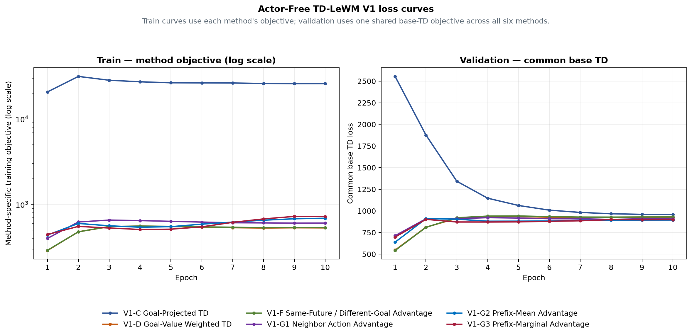
Figure 1. Train method objective (left) and validation common base TD (right).
Method | E10 train  method objective | E10 validation  common base TD | Best common  base TD
V1-C Goal-Projected TD | 25927.3 | 959.265 | 959.265 (E10)
V1-D Goal-Value Weighted TD | 531.178 | 923.235 | 546.341 (E1)
V1-F Same-Future / Different-Goal Advantage | 533.615 | 929.771 | 541.974 (E1)
V1-G1 Neighbor Action Advantage | 604.267 | 905.668 | 713.09 (E1)
V1-G2 Prefix-Mean Advantage | 688.673 | 894.455 | 638.227 (E1)
V1-G3 Prefix-Marginal Advantage | 722.493 | 897.862 | 697.315 (E1)

Method definitions

V1-C Goal-Projected TD (C)
Network: Frozen LeWM + frozen shared action encoder + one 379,072-parameter TD-JEPA predictor
Training loss: Common feature TD plus goal-projected TD residual on goal-derived tasks
Special design: Directly constrains the detached TD target and prediction after projection onto the matched goal
Inference: F-only: LeWM final predicted-latent goal cost, horizon 5; G-only: Negative goal projection of the V1 predictor, horizon 1; F+G: LeWM F prefix plus discounted terminal V1 G tail, horizon 5

V1-D Goal-Value Weighted TD (D)
Network: Frozen LeWM + frozen shared action encoder + one 379,072-parameter TD-JEPA predictor
Training loss: Detached target-goal scores reweight the common real-transition feature TD
Special design: Goal-subset softmax weights; random-task weight remains one; final weights have mean one
Inference: F-only: LeWM final predicted-latent goal cost, horizon 5; G-only: Negative goal projection of the V1 predictor, horizon 1; F+G: LeWM F prefix plus discounted terminal V1 G tail, horizon 5

V1-F Same-Future / Different-Goal Advantage (F)
Network: Frozen LeWM + frozen shared action encoder + one 379,072-parameter TD-JEPA predictor
Training loss: Same-future/different-goal detached advantage reweights common feature TD
Special design: Matching task score is contrasted with all goal-derived tasks in the batch
Inference: F-only: LeWM final predicted-latent goal cost, horizon 5; G-only: Negative goal projection of the V1 predictor, horizon 1; F+G: LeWM F prefix plus discounted terminal V1 G tail, horizon 5

V1-G1 Neighbor Action Advantage (G1)
Network: Frozen LeWM + frozen shared action encoder + one 379,072-parameter TD-JEPA predictor
Training loss: Neighbor-action detached advantage reweights common real-action feature TD
Special design: Other-episode KNN actions are comparison-only and never create candidate TD targets
Inference: F-only: LeWM final predicted-latent goal cost, horizon 5; G-only: Negative goal projection of the V1 predictor, horizon 1; F+G: LeWM F prefix plus discounted terminal V1 G tail, horizon 5

V1-G2 Prefix-Mean Advantage (G2)
Network: Frozen LeWM + frozen shared action encoder + one 379,072-parameter TD-JEPA predictor
Training loss: Full-prefix score minus mean prefix score reweights common feature TD
Special design: Zero-mean suffix prefixes are comparison-only; the real full action supplies the TD pair
Inference: F-only: LeWM final predicted-latent goal cost, horizon 5; G-only: Negative goal projection of the V1 predictor, horizon 1; F+G: LeWM F prefix plus discounted terminal V1 G tail, horizon 5

V1-G3 Prefix-Marginal Advantage (G3)
Network: Frozen LeWM + frozen shared action encoder + one 379,072-parameter TD-JEPA predictor
Training loss: Mean adjacent prefix-score improvement reweights common feature TD
Special design: Prefix marginal gains are detached comparison signals, not extra TD targets
Inference: F-only: LeWM final predicted-latent goal cost, horizon 5; G-only: Negative goal projection of the V1 predictor, horizon 1; F+G: LeWM F prefix plus discounted terminal V1 G tail, horizon 5

Paired-outcome audit
The paired archive contains exactly 50 rows and 18 Boolean outcome columns. Every pair uses goal_step − start_step = 50; the summary counts were recomputed from these columns before this document was written.
Audit field | Validated value
Training seed | 3072
Planning seed | 42
Episodes / mode | 50
Goal offset | 50
Selection SHA-256 | e46ea81cce2e6a9a5df05ba04893b4181cbd8979340111a012c30f1efa2d7ee7

Claim boundary
This report records one formal training seed and one shared O50 planning selection. It supports within-selection architecture and inference-score comparisons. It does not establish mean performance, variance, or statistical superiority across independent training seeds.

