ACTOR-FREE TD-LEWM · COMPLETE 7×3 CONTROLLED ABLATION

Results TD
  - swm/OGBCube-v0 | dataset quentinll/lewm-cube | training seed 3072 | planning seed 42
Locked protocol: all 7 methods completed 10 epochs / 127,960 optimizer updates; each method was evaluated with 3 scores, for 21 formal O50 runs. goal offset=50; common selection SHA-256=e46ea81cce2e….

Combined O50 ranking
Rank | Method | Family | Combined | Successes | Rate | Elapsed
1 | Hybrid | Successor | f_plus_g | 27/50 | 54% | 14:34.6
2 | Serial Decoupled | Successor | f_plus_g | 23/50 | 46% | 16:32.9
2 | Imaginary Hybrid | Successor | f_plus_g | 23/50 | 46% | 16:29.2
4 | Parallel Real | Successor | f_plus_g | 22/50 | 44% | 17:20.4
5 | Serial Coupled | Successor | f_plus_g | 20/50 | 40% | 17:55.9
6 | Goal Hybrid | Successor | f_plus_g | 19/50 | 38% | 18:56.5
6 | Direct Goal Critic Hybrid | Direct critic | f_plus_c | 19/50 | 38% | 18:47.4
Table 1. Ranking uses only the pre-specified combined column; equal success counts share a rank. The best of the three score columns is not selected post hoc.

7×3 inference-score matrix
Method | Tail type | F-only | G/C-only | F+G / F+C | Combined rank only
Serial Decoupled | Successor / G | 20/50 · 40% · 18:54.9 | 15/50 · 30% · 20:32.1 | 23/50 · 46% · 16:32.9 | #2 · G
Serial Coupled | Successor / G | 26/50 · 52% · 15:11.5 | 14/50 · 28% · 20:36.9 | 20/50 · 40% · 17:55.9 | #5 · G
Hybrid | Successor / G | 25/50 · 50% · 15:40.0 | 13/50 · 26% · 22:03.4 | 27/50 · 54% · 14:34.6 | #1 · G
Parallel Real | Successor / G | 17/50 · 34% · 19:33.0 | 13/50 · 26% · 20:48.1 | 22/50 · 44% · 17:20.4 | #4 · G
Goal Hybrid | Successor / G | 25/50 · 50% · 15:45.3 | 19/50 · 38% · 18:28.8 | 19/50 · 38% · 18:56.5 | #6 · G
Imaginary Hybrid | Successor / G | 24/50 · 48% · 16:13.8 | 13/50 · 26% · 21:09.9 | 23/50 · 46% · 16:29.2 | #2 · G
Direct Goal Critic Hybrid | Direct / C | 22/50 · 44% · 17:25.5 | 16/50 · 32% · 19:56.4 | 19/50 · 38% · 18:47.4 | #6 · C
Table 2. Each cell reports successes/episodes, success rate and elapsed time (h:mm:ss); F-only includes the final planning action.

TRAINING / VALIDATION · SUMMARY-DERIVED METRICS

Training convergence and checkpoints
  - 7 methods | 10 epochs | 127,960 optimizer updates per method
Comparison limit: auxiliary-loss counts and definitions differ. Total loss is only a within-method convergence check and cannot rank methods across structures.
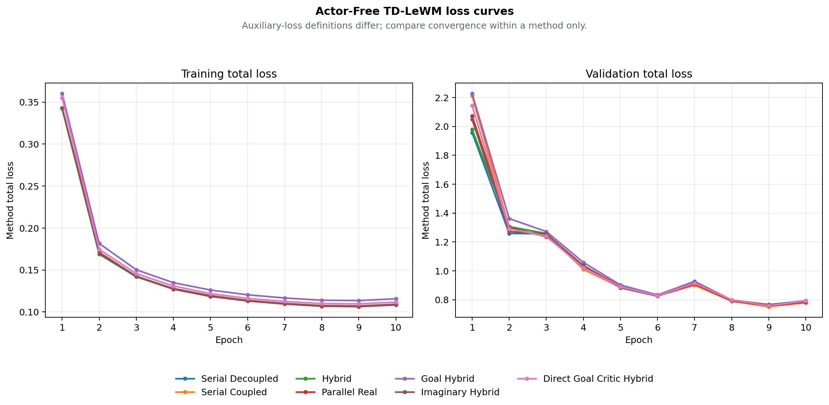
Figure 1. Training and validation total-loss curves derived by the archiver; cross-method ranking uses combined O50 on page 1.
Method | Final train | Final validation | Best validation | Checkpoint SHA | Training commit
Serial Decoupled | 0.108424 | 0.780097 | 0.754505 · E9 | cb8be3f9a851 | 8e667cb6a8e9
Serial Coupled | 0.108643 | 0.780158 | 0.752397 · E9 | 2fe3fd5bcb2c | 8e667cb6a8e9
Hybrid | 0.108973 | 0.784110 | 0.766112 · E9 | 299222acff78 | 8e667cb6a8e9
Parallel Real | 0.108762 | 0.784254 | 0.757853 · E9 | 61b5614a7b92 | e895637d8c7e
Goal Hybrid | 0.115752 | 0.793633 | 0.766048 · E9 | a746912bddd0 | 88ad2ec12c1d
Imaginary Hybrid | 0.109176 | 0.788777 | 0.766026 · E9 | e7656fed92a0 | ea82e8f2984f
Direct Goal Critic Hybrid | 0.111773 | 0.792399 | 0.759004 · E9 | b3345e9eefdb | a1d98a2d0881
Table 3. Final is epoch 10; Best validation is selected within each method's 10 epochs. Hashes and commits come from the archive summary.

METHOD REFERENCE · BASE STRUCTURAL ABLATIONS

Four base Actor-Free TD-LeWM structures
  - Shared LeWM encoder/predictor; differences are successor inputs, TD gradient paths and real/predicted branches.
Common objective: L_LeWM = L_pred + 0.09 L_SIGReg. The successor target uses the real EMA next latent, EMA head and dataset next action, with a stop-gradient target; every method is actor-free.
Method | Network | Training loss | Special design / gradient path | Inference
Serial Decoupled  serial_decoupled | LeWM + one successor-feature head on predicted latent history | L = L_LeWM + αᵤ L_TD^pred  G(sg(H̃ₜ), aₜ) → sg(yₜ^SF) | Predicted context is detached; TD updates the successor head only. | CEM with F-only, G-only, or F+G cost.
Serial Coupled  serial_coupled | LeWM + one successor-feature head on predicted latent history | L = L_LeWM + αᵤ L_TD^pred  G(H̃ₜ, aₜ) → sg(yₜ^SF) | Predicted context stays differentiable; TD also reaches LeWM. | CEM with F-only, G-only, or F+G cost.
Hybrid  hybrid | LeWM + one shared successor head for real and predicted histories | L = L_LeWM + αᵤ(L_TD^pred + L_TD^real)  The same G consumes predicted and real latent histories | The same head is trained on parallel-real and coupled-serial branches. | CEM with F-only, G-only, or F+G cost.
Parallel Real  parallel_real | LeWM predictor and successor head are parallel on encoder latents | L = L_LeWM + αᵤ L_TD^real  G(Hₜ^real, aₜ) is parallel to the LeWM predictor | TD uses real latent history and does not pass through the predictor. | CEM with F-only, G-only, or F+G cost.
Table 4. Method descriptions come from archive summary.method_spec; the equations are fixed definitions, not manually entered results.

Unified meaning of the three inference scores
Score mode | Candidate-action ranking signal
F-only | LeWM rolls and scores all H predicted states with the normalized discounted latent-goal cost.
G-only | LeWM still rolls the candidate to form tail context, but ranking uses only the successor G readout.
F+G | F prefix cost plus discounted successor G tail cost.
Control protocol: all structures use the same swm/OGBCube-v0, selection and planning seed 42. G-only still uses a LeWM rollout to build tail context, but excludes F cost from ranking.

METHOD REFERENCE · GOAL / IMAGINARY / DIRECT

Three extensions, target equations and audit sources
  - Side-by-side comparison of goal-readout TD, EMA imaginary bootstrap and a direct goal-conditioned critic.
Method | Network | Training loss | Special design / gradient path | Inference
Goal Hybrid  goal_hybrid | Hybrid successor head with fixed linear goal readout G^T w(g) | L = L_LeWM + αᵤ(L_SF-TD^real + L_SF-TD^pred + L_goal-TD^real + L_goal-TD^pred)  C_g(H,a) = G(H,a)ᵀw(z_g) | Goal readout is trained by hindsight goal-conditioned Bellman TD. | CEM with F-only, G-only, or F+G cost.
Imaginary Hybrid  imaginary_hybrid | Hybrid successor head with an EMA-LeWM imagined bootstrap state | L = L_LeWM + αᵤ(L_TD^real + L_TD^pred)  The bootstrap state is imagined one step by stop-gradient EMA-LeWM | The TD target bootstraps one step through the stopped EMA predictor. | CEM with F-only, G-only, or F+G cost.
Direct Goal Critic Hybrid  direct_goal_hybrid | LeWM + one scalar goal-conditioned critic for real/predicted histories | L = L_LeWM + αᵤ(L_C-TD^real + L_C-TD^pred)  C(H,a,z_g) directly outputs a goal-conditioned scalar cost | Goal latent enters the critic directly; there is no SF factorization. | CEM with F-only, C-only, or F+C cost.
Table 5. Direct uses C-only / F+C; successor methods use G-only / F+G. Training remains actor-free.

Target and planning equations
SF TD: yₜ^SF = (1−γ)χ(z̄ₜ₊₁) + γ(1−dₜ)Ḡ(next).
Goal TD: C_g(H,a)=G(H,a)ᵀw(z_g), yₜ^g=(1−γ)c(z̄ₜ₊₁,z_g)+γ(1−dₜ^g)C̄_g(next).
Imaginary: Ĥₜ₊₁=sg(P̄(Hₜ,aₜ)), then bootstrap from Ĥₜ₊₁; Direct: C(H,a,z_g) predicts scalar cost directly.
Planning: J_F=Σₖ₌₁ᴴγᵏ⁻¹c(z̃ₜ₊ₖ,z_g); combined adds the discounted G/C tail to the F prefix. CEM minimizes cost; it does not train an Actor to maximize a one-step dot product.
Combined conclusion: Hybrid ranks first at 27/50 (54%). This claim applies only to the combined score; F-only and G/C-only are inference ablations of the same checkpoint. Boundary: one training seed and one matched O50 planning selection. Rank only combined inference scores; this is not a multi-seed claim.

Provenance / checksums
Variant | Train commit | Eval commit(s) | Checkpoint SHA | Locked protocol SHA
serial_decoupled | 8e667cb6a8 | fa46ed99b/8e667cb6a | cb8be3f9a851 | 6eaaf266bc6e
serial_coupled | 8e667cb6a8 | fa46ed99b/8e667cb6a | 2fe3fd5bcb2c | e272feeb5081
hybrid | 8e667cb6a8 | fa46ed99b/8e667cb6a | 299222acff78 | bd0b207e2712
parallel_real | e895637d8c | fa46ed99b/e895637d8 | 61b5614a7b92 | f3d3ca31e1f1
goal_hybrid | 88ad2ec12c | fa46ed99b | a746912bddd0 | fdbf618cb45e
imaginary_hybrid | ea82e8f298 | fa46ed99b | e7656fed92a0 | 6e43c9f75351
direct_goal_hybrid | a1d98a2d08 | fa46ed99b | b3345e9eefdb | f9e2ee091aee
Input SHA-256: selection=e46ea81cce2e6a9a5df05ba04893b4181cbd8979340111a012c30f1efa2d7ee7; summary.json=9fa31a12476ff4a332e555505fc720964d81c5640c77cc394beb5df538ae2da6; training_loss_curves.png=4cce0d5891b8b51e5e3dc7481bd9582de85e69c9b01a9fcb6d025ed271957a60; paired_outcomes.csv=3047c9a419f066548b6e942e29c49b35d286670dc60e5db27fcd845897a6f2ae.
Score definitions: F-only — LeWM rolls and scores all H predicted states with the normalized discounted latent-goal cost. Combined — F prefix cost plus discounted successor G tail cost / discounted direct-critic C tail cost.

RESULTS TD / CONTROLLED C–G3 V0 → V1
Raw-action V0 vs shared-action-encoder V1
Same C/D/F/G1/G2/G3 losses · same 50 pairs · actor-free CEM planning
Version boundary: the first four pages preserve the earlier 7-method Actor-Free TD-LeWM ablation. This appendix records the later controlled C-G3 study; its raw-action V0 is a separate 6-by-3 experiment.

V0 / V1 definition
V0 sends the normalized raw 25D action block directly into G. V1 sends stopgrad(E_A(a)), the 192D embedding from the shared frozen LeWM Action Encoder. Both current and dataset next actions follow this rule; neither version contains an Actor or reward model. The six losses and planning definitions are unchanged, but predictor capacity is not matched: 336,320 parameters in V0 versus 379,072 in V1.

V0 formal O50 — raw 25D action
V0 has 18 completed formal evaluations: six methods × F-only/G-only/F+G. All rows use training seed 3072, planning seed 42, horizons 5/1/5 and the same 50 start–goal pairs used by V1.
V0 method | F-only | G-only | F+G | Δ vs F
C | 23/50 (46%) | 18/50 (36%) | 24/50 (48%) | +1/50
D | 23/50 (46%) | 20/50 (40%) | 21/50 (42%) | -2/50
F | 23/50 (46%) | 19/50 (38%) | 20/50 (40%) | -3/50
G1 | 23/50 (46%) | 16/50 (32%) | 25/50 (50%) | +2/50
G2 | 23/50 (46%) | 16/50 (32%) | 25/50 (50%) | +2/50
G3 | 23/50 (46%) | 18/50 (36%) | 23/50 (46%) | +0/50

V0 → V1 combined comparison
On this matched selection: F and G3 gain 8 pp; D and G2 are unchanged; C loses 4 pp; G1 loses 2 pp. V0 best is G1/G2 at 50%; V1 best is G3 at 54%.
Method | V0 F+G | V1 F+G | V1 - V0
C | 24/50 (48%) | 22/50 (44%) | -2/50
D | 21/50 (42%) | 21/50 (42%) | +0/50
F | 20/50 (40%) | 24/50 (48%) | +4/50
G1 | 25/50 (50%) | 24/50 (48%) | -1/50
G2 | 25/50 (50%) | 25/50 (50%) | +0/50
G3 | 23/50 (46%) | 27/50 (54%) | +4/50

RESULTS TD / ACTOR-FREE TD-JEPA V1 DETAILS
Cube O50 — six methods × three score modes
Shared frozen LeWM Action Encoder · actor-free CEM planning · seed 3072
Study: actor_free_td_lewm_v1_cube_seed3072_o50_6x3
Evaluation: 18 formal O50 runs on one matched set of 50 pairs
Training: 6 methods · 10 epochs · 127,960 updates per method
Training acceptance: PASS_WITH_WARNINGS
Selection SHA-256: e46ea81cce2e6a9a5df05ba04893b4181cbd8979340111a012c30f1efa2d7ee7
Interpretation boundary — one training seed and one planning selection. Use this report as a matched structural/score-mode ablation, not as a multi-seed claim of overall superiority.
Training provenance warning — launcher exit codes could not be recovered. Checkpoints, metrics, epochs, steps, and acceptance evidence passed the archive validator, but the missing exit-code provenance must not be represented as an unconditional PASS. Archived warning: c.process: PID 122116 was reaped without an exit marker; d.process: PID 122117 was reaped without an exit marker; f.process: PID 122118 was reaped without an exit marker; g1.process: PID 122119 was reaped without an exit marker; g2.process: PID 122120 was reaped without an exit marker; g3.process: PID 122121 was reaped without an exit marker

Combined ranking
Highest combined result: V1-G3 Prefix-Marginal Advantage, 27/50 (54%). Ties share the same success count; ordering is taken from the validated summary.
Rank | Method | ID | Score | O50
1 | V1-G3 Prefix-Marginal Advantage | G3 | F+G | 27/50 (54%)
2 | V1-G2 Prefix-Mean Advantage | G2 | F+G | 25/50 (50%)
3 | V1-F Same-Future / Different-Goal Advantage | F | F+G | 24/50 (48%)
3 | V1-G1 Neighbor Action Advantage | G1 | F+G | 24/50 (48%)
5 | V1-C Goal-Projected TD | C | F+G | 22/50 (44%)
6 | V1-D Goal-Value Weighted TD | D | F+G | 21/50 (42%)

Three inference scores
F-only uses the LeWM rollout score; G-only uses the learned successor readout; F+G uses the LeWM prefix with the successor tail. All three columns use the same checkpoint and the same 50 start–goal pairs within each method.
Method | F-only | G-only | F+G | Δ vs F
V1-C Goal-Projected TD | 23/50 (46%) | 18/50 (36%) | 22/50 (44%) | -1/50
V1-D Goal-Value Weighted TD | 23/50 (46%) | 22/50 (44%) | 21/50 (42%) | -2/50
V1-F Same-Future / Different-Goal Advantage | 23/50 (46%) | 23/50 (46%) | 24/50 (48%) | +1/50
V1-G1 Neighbor Action Advantage | 23/50 (46%) | 21/50 (42%) | 24/50 (48%) | +1/50
V1-G2 Prefix-Mean Advantage | 23/50 (46%) | 21/50 (42%) | 25/50 (50%) | +2/50
V1-G3 Prefix-Marginal Advantage | 23/50 (46%) | 19/50 (38%) | 27/50 (54%) | +4/50

Training curves
The left panel is each method's own training objective and is not cross-method comparable. The right panel is the common base TD validation objective used by all six methods.
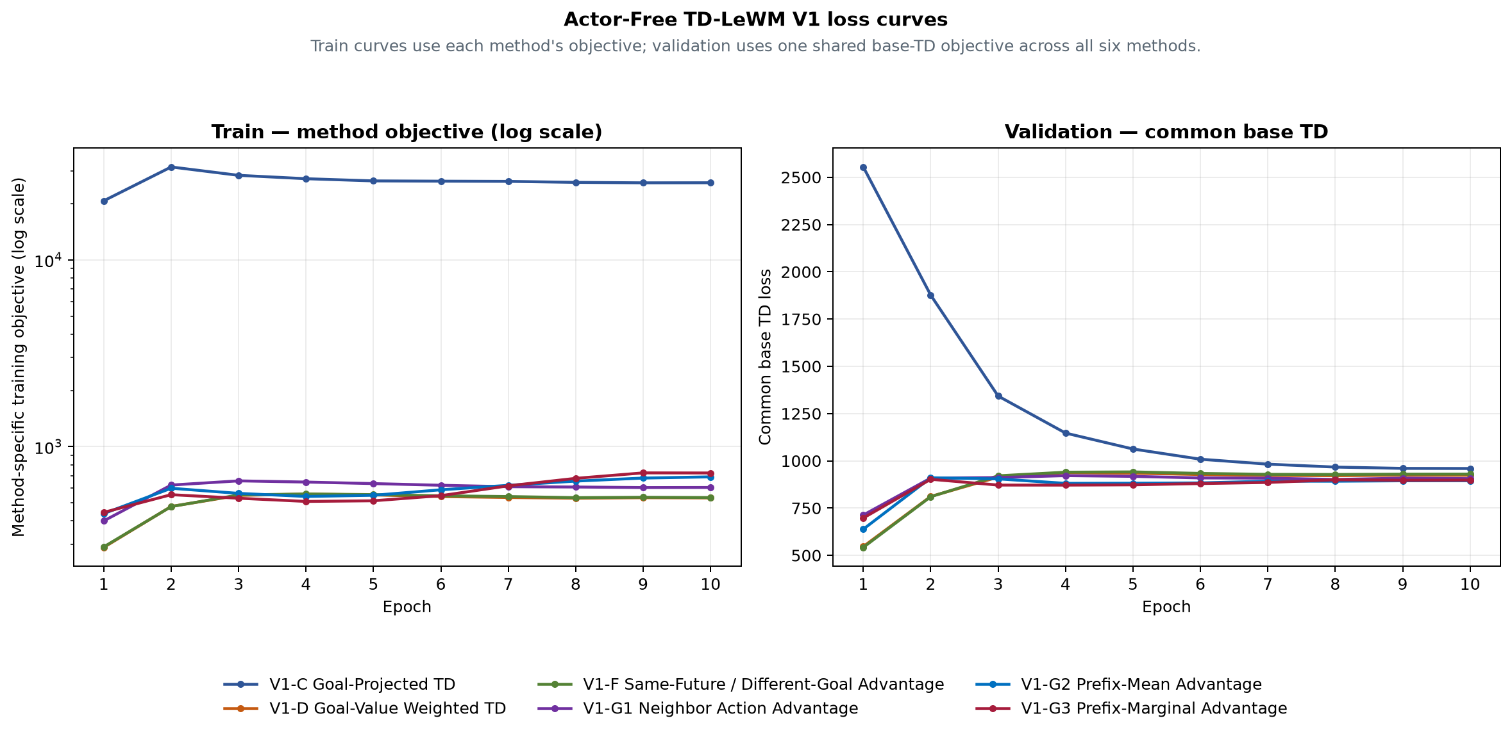
Figure 1. Train method objective (left) and validation common base TD (right).
Method | E10 train  method objective | E10 validation  common base TD | Best common  base TD
V1-C Goal-Projected TD | 25927.3 | 959.265 | 959.265 (E10)
V1-D Goal-Value Weighted TD | 531.178 | 923.235 | 546.341 (E1)
V1-F Same-Future / Different-Goal Advantage | 533.615 | 929.771 | 541.974 (E1)
V1-G1 Neighbor Action Advantage | 604.267 | 905.668 | 713.09 (E1)
V1-G2 Prefix-Mean Advantage | 688.673 | 894.455 | 638.227 (E1)
V1-G3 Prefix-Marginal Advantage | 722.493 | 897.862 | 697.315 (E1)

Method definitions

V1-C Goal-Projected TD (C)
Network: Frozen LeWM + frozen shared action encoder + one 379,072-parameter TD-JEPA predictor
Training loss: Common feature TD plus goal-projected TD residual on goal-derived tasks
Special design: Directly constrains the detached TD target and prediction after projection onto the matched goal
Inference: F-only: LeWM final predicted-latent goal cost, horizon 5; G-only: Negative goal projection of the V1 predictor, horizon 1; F+G: LeWM F prefix plus discounted terminal V1 G tail, horizon 5

V1-D Goal-Value Weighted TD (D)
Network: Frozen LeWM + frozen shared action encoder + one 379,072-parameter TD-JEPA predictor
Training loss: Detached target-goal scores reweight the common real-transition feature TD
Special design: Goal-subset softmax weights; random-task weight remains one; final weights have mean one
Inference: F-only: LeWM final predicted-latent goal cost, horizon 5; G-only: Negative goal projection of the V1 predictor, horizon 1; F+G: LeWM F prefix plus discounted terminal V1 G tail, horizon 5

V1-F Same-Future / Different-Goal Advantage (F)
Network: Frozen LeWM + frozen shared action encoder + one 379,072-parameter TD-JEPA predictor
Training loss: Same-future/different-goal detached advantage reweights common feature TD
Special design: Matching task score is contrasted with all goal-derived tasks in the batch
Inference: F-only: LeWM final predicted-latent goal cost, horizon 5; G-only: Negative goal projection of the V1 predictor, horizon 1; F+G: LeWM F prefix plus discounted terminal V1 G tail, horizon 5

V1-G1 Neighbor Action Advantage (G1)
Network: Frozen LeWM + frozen shared action encoder + one 379,072-parameter TD-JEPA predictor
Training loss: Neighbor-action detached advantage reweights common real-action feature TD
Special design: Other-episode KNN actions are comparison-only and never create candidate TD targets
Inference: F-only: LeWM final predicted-latent goal cost, horizon 5; G-only: Negative goal projection of the V1 predictor, horizon 1; F+G: LeWM F prefix plus discounted terminal V1 G tail, horizon 5

V1-G2 Prefix-Mean Advantage (G2)
Network: Frozen LeWM + frozen shared action encoder + one 379,072-parameter TD-JEPA predictor
Training loss: Full-prefix score minus mean prefix score reweights common feature TD
Special design: Zero-mean suffix prefixes are comparison-only; the real full action supplies the TD pair
Inference: F-only: LeWM final predicted-latent goal cost, horizon 5; G-only: Negative goal projection of the V1 predictor, horizon 1; F+G: LeWM F prefix plus discounted terminal V1 G tail, horizon 5

V1-G3 Prefix-Marginal Advantage (G3)
Network: Frozen LeWM + frozen shared action encoder + one 379,072-parameter TD-JEPA predictor
Training loss: Mean adjacent prefix-score improvement reweights common feature TD
Special design: Prefix marginal gains are detached comparison signals, not extra TD targets
Inference: F-only: LeWM final predicted-latent goal cost, horizon 5; G-only: Negative goal projection of the V1 predictor, horizon 1; F+G: LeWM F prefix plus discounted terminal V1 G tail, horizon 5

Paired-outcome audit
The paired archive contains exactly 50 rows and 18 Boolean outcome columns. Every pair uses goal_step − start_step = 50; the summary counts were recomputed from these columns before this document was written.
Audit field | Validated value
Training seed | 3072
Planning seed | 42
Episodes / mode | 50
Goal offset | 50
Selection SHA-256 | e46ea81cce2e6a9a5df05ba04893b4181cbd8979340111a012c30f1efa2d7ee7

Claim boundary
This report records one formal training seed and one shared O50 planning selection. It supports within-selection architecture and inference-score comparisons. It does not establish mean performance, variance, or statistical superiority across independent training seeds.

RESULTS TD / V2-EMA-SG NEW INFERENCE SCORES
V2-EMA-SG new scores and checkpoint trajectory
Cube · seed 3072 · actor-free CEM · 96 EMA cells + 24 fixed-checkpoint cells
Interpretation boundary: one training seed; the EMA sweep and fixed-checkpoint study share one O50 episode selection. Best epoch is a post-hoc trajectory analysis, not an unbiased final-performance estimate; this report does not claim pairwise statistical significance.

Network, TD target and total loss
Online LeWM supplies the real latent z_t and a differentiable predicted latent z-hat_t. One G_phi is trained on both real and predicted branches. The unique shared, trainable LeWM Action Encoder maps each raw 25D action block to 192D. There is no Actor, reward model or action loss.
TD target Y_t = sg[z-bar_(t+1) + gamma(1-d_t) G-bar(z-bar_(t+1), e-bar_(t+1), m_t)], gamma=0.95
z-bar_(t+1) comes from the real next frame through the EMA encoder; e-bar_(t+1) comes from the known dataset next action through the EMA Action Encoder.
Branch TD l_(t,b) = ||G_phi(s_t^b,e_t,m_t)-Y_t||_2^2, b in {real,pred}
s_real=z_t and s_pred=z-hat_t. The predicted branch retains gradients to the online LeWM predictor and shared Action Encoder.
Total L_total = L_pred + 0.09 L_SIGReg + rho(u)[L_method^real + L_method^pred]
L_pred uses the real next-frame EMA latent as a stop-gradient target; rho rises linearly from 0 to 1 over the first 5% of optimizer updates.

C / D / F / G1 / G2 / G3 training terms
D/F/G1/G2/G3 use detached signals only to reweight per-sample TD error. Goal-subset weights use tau=0.5 softmax and mean-one normalization. C also fits a goal-projection residual. Every method shares the same EMA Bellman target.
Method | Special signal A / q | Per-branch loss | Training role
C | q_i^b = G_phi(s_i^b,e_i,m_i)^T m_i; q_i^Y = Y_i^T m_i | L_C^b = mean(l_i^b) + lambda_C mean_goal[(q_i^b-q_i^Y)^2], lambda_C=1 | Only C adds a trainable scalar projection residual on goal-derived tasks.
D | A_i = sg(Y_i^T m_i) | L_D^b = mean_i[w_i(A) l_i^b] | Detached target goal value reweights TD; tau=0.5.
F | A_i = sg[Y_i^T m_i - mean_j(Y_i^T m_j)] | L_F^b = mean_i[w_i(A) l_i^b] | Matched future/task is contrasted with all goal tasks in the batch.
G1 | A_i = sg[q_i - sum_k softmax(-d_ik/tau_n) q_ik] | L_G1^b = mean_i[w_i(A) l_i^b] | K=8 other-episode latent-neighbour actions; candidates have no TD targets.
G2 | A_i = sg[q_i5 - (1/5) sum_{j=1}^5 q_ij] | L_G2^b = mean_i[w_i(A) l_i^b] | Five zero-suffix action prefixes; full-minus-prefix-mean signal.
G3 | A_i = sg[(1/4) sum_{j=1}^4(q_i,j+1-q_ij)] | L_G3^b = mean_i[w_i(A) l_i^b] | Five prefixes; mean adjacent marginal score gain.

Two new inference scores
Q_G(z,A,g)=G(z,E_A(A),w(g))^T w(g). CEM minimizes the cost below, executes only A1, then replans. No Actor is trained.
F + first-Q J_first(A_1:5)=||z-hat_5-z_g||_2^2 - 0.25 Q_G(z_0,A_1,g)
F performs the complete five-block rollout. first-Q has no gamma^4 tail discount and evaluates only real z_0 with the first candidate block A1.
Mean-Q rollout J_mean(A_1:5)=-(1/5) sum_(k=1)^5 Q_G(z_(k-1)^F,A_k,g)
z_0 is the online encoder state; z_1 through z_4 come from the F rollout. F only generates imagined states; neither terminal goal distance nor gamma enters this score.

Epoch 10: five inference scores
All five columns bind the same V2-EMA epoch-10 checkpoint and shared formal episode selection (e46ea81c...). The first three columns come from the original formal archive; the last two come from the 96-cell sweep.
Method | F-only | G-only | F+G tail | F + first-Q | Mean-Q rollout
C | 12/50 (24%) | 18/50 (36%) | 12/50 (24%) | 20/50 (40%) | 14/50 (28%)
D | 15/50 (30%) | 19/50 (38%) | 16/50 (32%) | 22/50 (44%) | 19/50 (38%)
F | 15/50 (30%) | 19/50 (38%) | 17/50 (34%) | 22/50 (44%) | 23/50 (46%)
G1 | 15/50 (30%) | 15/50 (30%) | 11/50 (22%) | 19/50 (38%) | 21/50 (42%)
G2 | 12/50 (24%) | 20/50 (40%) | 16/50 (32%) | 18/50 (36%) | 17/50 (34%)
G3 | 12/50 (24%) | 17/50 (34%) | 13/50 (26%) | 21/50 (42%) | 17/50 (34%)

Fixed V0/V1/V2 checkpoints: all 24 cells
This table and the EMA sweep use the same episode-selection.json (e46ea81c...), so success rates are comparable on one O50 pair set. 88c20477... is only the fixed launcher's canonical valid-row-ranks digest. The report input does not include per-cell outcome vectors, so no paired significance test is claimed. V0/V1 support first-Q only; Mean-Q is V2-only.
Method | V0 first-Q | V1 first-Q | V2 first-Q | V2 Mean-Q
C | 26/50 (52%) | 28/50 (56%) | 19/50 (38%) | 10/50 (20%)
D | 24/50 (48%) | 25/50 (50%) | 21/50 (42%) | 24/50 (48%)
F | 24/50 (48%) | 26/50 (52%) | 21/50 (42%) | 22/50 (44%)
G1 | 20/50 (40%) | 26/50 (52%) | 19/50 (38%) | 17/50 (34%)
G2 | 23/50 (46%) | 25/50 (50%) | 20/50 (40%) | 13/50 (26%)
G3 | 24/50 (48%) | 26/50 (52%) | 19/50 (38%) | 17/50 (34%)

Best epoch by method and score (post-hoc)
Warning: each epoch-3-to-10 maximum was selected after observing the same O50 selection and is therefore selection-biased. Use it only to understand training trajectories or define a preregistered rule for the next study; epoch 10 remains the separately reported formal checkpoint.
Method | Score | Best epoch | Best O50 | Epoch 10 | Best-E10
C | F + first-Q (α=.25) | E5 | 24/50 (48%) | 20/50 (40%) | +4/50
C | Mean-Q over F rollout | E3 | 21/50 (42%) | 14/50 (28%) | +7/50
D | F + first-Q (α=.25) | E8 | 23/50 (46%) | 22/50 (44%) | +1/50
D | Mean-Q over F rollout | E4 | 23/50 (46%) | 19/50 (38%) | +4/50
F | F + first-Q (α=.25) | E9 | 23/50 (46%) | 22/50 (44%) | +1/50
F | Mean-Q over F rollout | E4 | 25/50 (50%) | 23/50 (46%) | +2/50
G1 | F + first-Q (α=.25) | E10 | 19/50 (38%) | 19/50 (38%) | +0/50
G1 | Mean-Q over F rollout | E10 | 21/50 (42%) | 21/50 (42%) | +0/50
G2 | F + first-Q (α=.25) | E7 | 22/50 (44%) | 18/50 (36%) | +4/50
G2 | Mean-Q over F rollout | E6 | 21/50 (42%) | 17/50 (34%) | +4/50
G3 | F + first-Q (α=.25) | E3 | 23/50 (46%) | 21/50 (42%) | +2/50
G3 | Mean-Q over F rollout | E4 | 23/50 (46%) | 17/50 (34%) | +6/50

Training and validation loss
Training total loss is method-specific. Validation uses the shared base Hybrid TD objective, although total loss still includes prediction/SIGReg. Use the curves to inspect within-method trajectories, not to rank methods by absolute loss height.
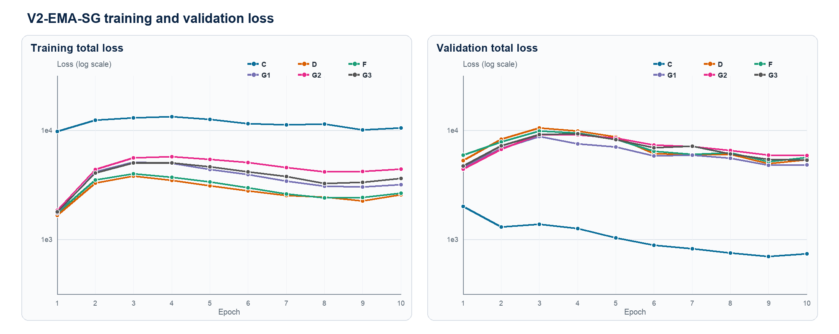
Figure 1. V2-EMA-SG training / validation total loss (epochs 1-10)

New-score trajectories across epochs
Every point is a complete O50 evaluation for epochs 3-10. The shared selection makes checkpoint trajectories comparable, but repeatedly inspecting the same 50 pairs is exactly why best-epoch selection is biased.
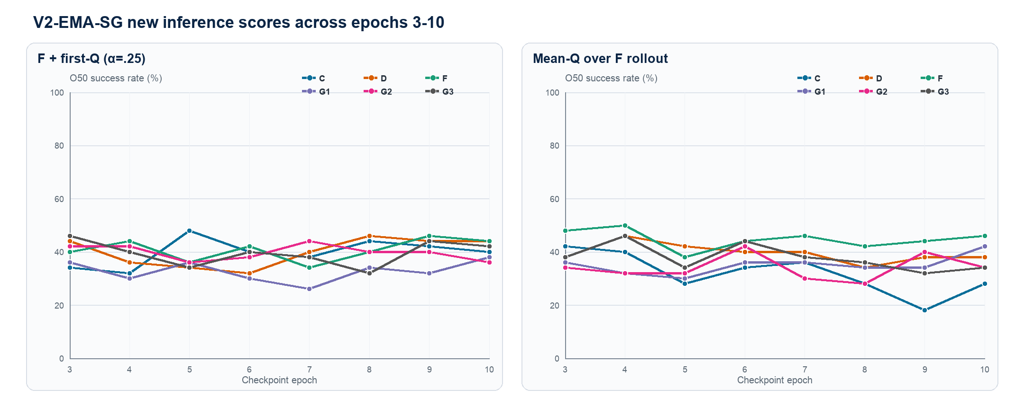
Figure 2. O50 success rate for the two new scores (epochs 3-10)

Key conclusions and audit boundary
1. Epoch 10 first-Q winner: D/F, 22/50 (44%).
2. Epoch 10 Mean-Q winner: F, 23/50 (46%).
3. Across six methods, epoch-10 means are 40.7% first-Q and 37.0% Mean-Q; fixed first-Q means are V0 47.0%, V1 52.0% and V2 39.7%.
4. Fixed V2 first-Q winner: D/F, 21/50 (42%); it shares the EMA table's O50 pair set.
5. C/D/F/G1/G2/G3 differ only in training-time TD loss or detached weights; their inference formulas are shared, while each checkpoint learns a different G.
6. One training seed and one planning selection are available. These results do not establish multi-seed superiority or statistical significance.
Audit field | Locked value
Training commit | 18cd574d522515f20f4103509b1e660b2fc89ea6
Evaluation commit | 5456f3d18116812d078d4ec2e85ba1f83d89c7c7
Shared 120-cell episode selection | e46ea81cce2e6a9a5df05ba04893b4181cbd8979340111a012c30f1efa2d7ee7
Fixed launcher valid-row-ranks | 88c204770f33c0b0220057d45b187766e3cfc54912e3f5ca49f2aa93d16437e9
Action normalization | 57f4d3c252e1805f4af1f614d20d1d1a064fa0d1d463ed5eb8ecf9dfc2b1a723
Grid | 96 = 8 epochs × 6 variants × 2 modes; fixed = 24

