ACTOR-FREE TD-LEWM · COMPLETE 7×3 CONTROLLED ABLATION

Results TD
  - swm/OGBCube-v0 | dataset quentinll/lewm-cube | training seed 3072 | planning seed 42
锁定协议：7 个方法均完成 10 epochs / 127,960 optimizer updates；每种方法评测 3 种分数，共 21 个 formal O50。goal offset=50；共同 selection SHA-256=e46ea81cce2e….

Combined O50 排名
排名 | 方法 | 族 | Combined | 成功 | 率 | 耗时
1 | Hybrid | Successor | f_plus_g | 27/50 | 54% | 14:34.6
2 | Serial Decoupled | Successor | f_plus_g | 23/50 | 46% | 16:32.9
2 | Imaginary Hybrid | Successor | f_plus_g | 23/50 | 46% | 16:29.2
4 | Parallel Real | Successor | f_plus_g | 22/50 | 44% | 17:20.4
5 | Serial Coupled | Successor | f_plus_g | 20/50 | 40% | 17:55.9
6 | Goal Hybrid | Successor | f_plus_g | 19/50 | 38% | 18:56.5
6 | Direct Goal Critic Hybrid | Direct critic | f_plus_c | 19/50 | 38% | 18:47.4
表 1. 排名只使用预先定义的 combined 列；相同成功数共享名次，不按三列中的最佳值重新排序。

7×3 推理分数矩阵
方法 | 尾部类型 | F-only | G/C-only | F+G / F+C | 仅 Combined 排名
Serial Decoupled | Successor / G | 20/50 · 40% · 18:54.9 | 15/50 · 30% · 20:32.1 | 23/50 · 46% · 16:32.9 | #2 · G
Serial Coupled | Successor / G | 26/50 · 52% · 15:11.5 | 14/50 · 28% · 20:36.9 | 20/50 · 40% · 17:55.9 | #5 · G
Hybrid | Successor / G | 25/50 · 50% · 15:40.0 | 13/50 · 26% · 22:03.4 | 27/50 · 54% · 14:34.6 | #1 · G
Parallel Real | Successor / G | 17/50 · 34% · 19:33.0 | 13/50 · 26% · 20:48.1 | 22/50 · 44% · 17:20.4 | #4 · G
Goal Hybrid | Successor / G | 25/50 · 50% · 15:45.3 | 19/50 · 38% · 18:28.8 | 19/50 · 38% · 18:56.5 | #6 · G
Imaginary Hybrid | Successor / G | 24/50 · 48% · 16:13.8 | 13/50 · 26% · 21:09.9 | 23/50 · 46% · 16:29.2 | #2 · G
Direct Goal Critic Hybrid | Direct / C | 22/50 · 44% · 17:25.5 | 16/50 · 32% · 19:56.4 | 19/50 · 38% · 18:47.4 | #6 · C
表 2. 每格依次给出 successes/episodes、success rate 和 elapsed time（时:分:秒）；F-only 不忽略最后一个规划动作。

TRAINING / VALIDATION · SUMMARY-DERIVED METRICS

训练收敛与 checkpoint
  - 7 methods | 10 epochs | 127,960 optimizer updates per method
比较限制：不同方法的 auxiliary loss 数量和定义不同；total loss 只用于判断各方法自身是否收敛，不能按曲线高低做跨方法性能排序。
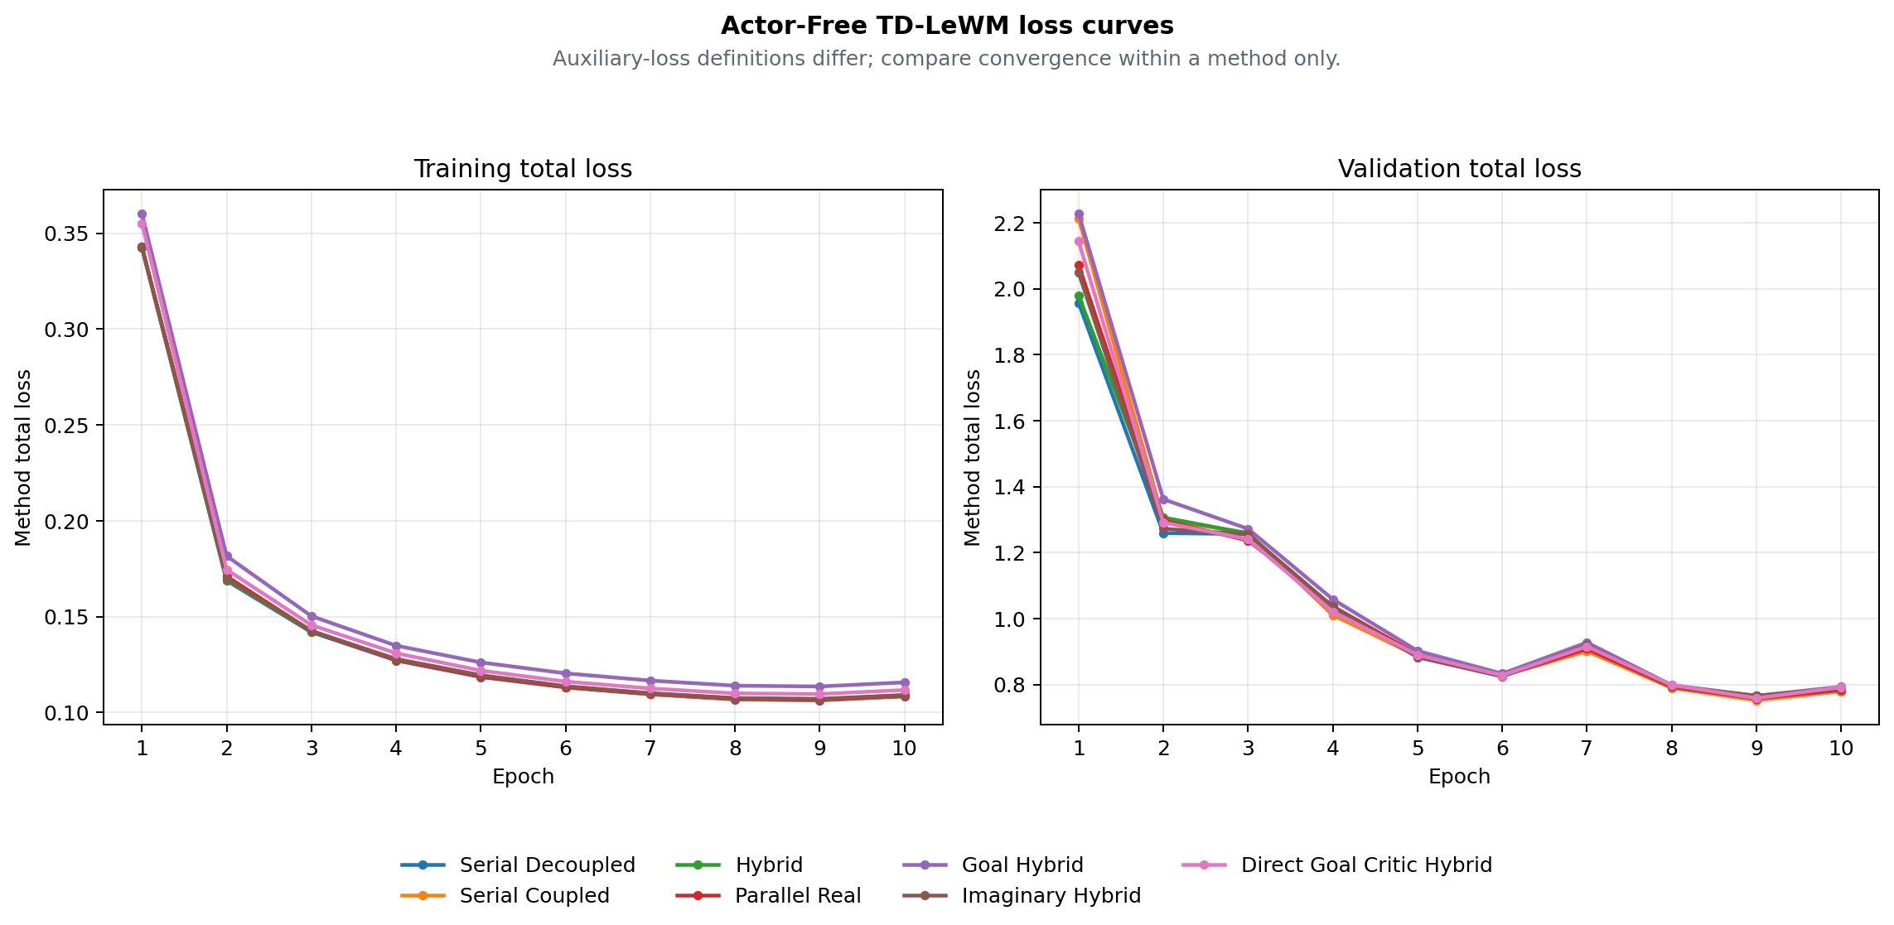
图 1. 归档器派生的训练与 validation total-loss 曲线；横向结果排名使用第 1 页的 combined O50。
方法 | Final train | Final validation | Best validation | Checkpoint SHA | Training commit
Serial Decoupled | 0.108424 | 0.780097 | 0.754505 · E9 | cb8be3f9a851 | 8e667cb6a8e9
Serial Coupled | 0.108643 | 0.780158 | 0.752397 · E9 | 2fe3fd5bcb2c | 8e667cb6a8e9
Hybrid | 0.108973 | 0.784110 | 0.766112 · E9 | 299222acff78 | 8e667cb6a8e9
Parallel Real | 0.108762 | 0.784254 | 0.757853 · E9 | 61b5614a7b92 | e895637d8c7e
Goal Hybrid | 0.115752 | 0.793633 | 0.766048 · E9 | a746912bddd0 | 88ad2ec12c1d
Imaginary Hybrid | 0.109176 | 0.788777 | 0.766026 · E9 | e7656fed92a0 | ea82e8f2984f
Direct Goal Critic Hybrid | 0.111773 | 0.792399 | 0.759004 · E9 | b3345e9eefdb | a1d98a2d0881
表 3. Final 指 epoch 10；Best validation 在各自 10 个 epoch 内选择。哈希和 commit 均来自归档摘要。

METHOD REFERENCE · BASE STRUCTURAL ABLATIONS

四个基础 Actor-Free TD-LeWM 结构
  - 共享 LeWM encoder/predictor；差异集中在 successor 输入、TD 梯度路径和 real/predicted 分支。
共同目标：L_LeWM = L_pred + 0.09 L_SIGReg。Successor 目标使用真实 EMA next latent、EMA head 和数据集 next action，并对 target stop-gradient；所有方法均无 Actor。
方法 | 网络结构 | 训练损失 | 特殊设计 / 梯度路径 | 推理
Serial Decoupled  serial_decoupled | LeWM + one successor-feature head on predicted latent history | L = L_LeWM + αᵤ L_TD^pred  G(sg(H̃ₜ), aₜ) → sg(yₜ^SF) | Predicted context is detached; TD updates the successor head only. | CEM with F-only, G-only, or F+G cost.
Serial Coupled  serial_coupled | LeWM + one successor-feature head on predicted latent history | L = L_LeWM + αᵤ L_TD^pred  G(H̃ₜ, aₜ) → sg(yₜ^SF) | Predicted context stays differentiable; TD also reaches LeWM. | CEM with F-only, G-only, or F+G cost.
Hybrid  hybrid | LeWM + one shared successor head for real and predicted histories | L = L_LeWM + αᵤ(L_TD^pred + L_TD^real)  同一 G 同时接收预测与真实 latent history | The same head is trained on parallel-real and coupled-serial branches. | CEM with F-only, G-only, or F+G cost.
Parallel Real  parallel_real | LeWM predictor and successor head are parallel on encoder latents | L = L_LeWM + αᵤ L_TD^real  G(Hₜ^real, aₜ) 与 LeWM predictor 平行 | TD uses real latent history and does not pass through the predictor. | CEM with F-only, G-only, or F+G cost.
表 4. 方法描述取自归档 summary.method_spec；公式是固定方法定义，不包含手填实验结果。

三种推理分数的统一含义
Score mode | 候选动作排序信号
F-only | LeWM rolls and scores all H predicted states with the normalized discounted latent-goal cost.
G-only | LeWM still rolls the candidate to form tail context, but ranking uses only the successor G readout.
F+G | F prefix cost plus discounted successor G tail cost.
控制口径：全部结构在同一 swm/OGBCube-v0、同一 selection、同一 planning seed 42 下比较；G-only 仍使用 LeWM rollout 构造 tail context，只是不把 F cost 加入排序。

METHOD REFERENCE · GOAL / IMAGINARY / DIRECT

三种扩展、目标公式与审计来源
  - Goal readout TD、EMA imaginary bootstrap，以及直接 goal-conditioned critic 的并列对照。
方法 | 网络结构 | 训练损失 | 特殊设计 / 梯度路径 | 推理
Goal Hybrid  goal_hybrid | Hybrid successor head with fixed linear goal readout G^T w(g) | L = L_LeWM + αᵤ(L_SF-TD^real + L_SF-TD^pred + L_goal-TD^real + L_goal-TD^pred)  C_g(H,a) = G(H,a)ᵀw(z_g) | Goal readout is trained by hindsight goal-conditioned Bellman TD. | CEM with F-only, G-only, or F+G cost.
Imaginary Hybrid  imaginary_hybrid | Hybrid successor head with an EMA-LeWM imagined bootstrap state | L = L_LeWM + αᵤ(L_TD^real + L_TD^pred)  bootstrap state 由 stop-gradient EMA-LeWM 想象一步 | The TD target bootstraps one step through the stopped EMA predictor. | CEM with F-only, G-only, or F+G cost.
Direct Goal Critic Hybrid  direct_goal_hybrid | LeWM + one scalar goal-conditioned critic for real/predicted histories | L = L_LeWM + αᵤ(L_C-TD^real + L_C-TD^pred)  C(H,a,z_g) 直接输出 goal-conditioned scalar cost | Goal latent enters the critic directly; there is no SF factorization. | CEM with F-only, C-only, or F+C cost.
表 5. Direct 方法用 C-only / F+C；其余 successor 方法用 G-only / F+G。训练仍然不引入 Actor。

目标与规划公式
SF TD： yₜ^SF = (1−γ)χ(z̄ₜ₊₁) + γ(1−dₜ)Ḡ(next)。
Goal TD： C_g(H,a)=G(H,a)ᵀw(z_g)，yₜ^g=(1−γ)c(z̄ₜ₊₁,z_g)+γ(1−dₜ^g)C̄_g(next)。
Imaginary： Ĥₜ₊₁=sg(P̄(Hₜ,aₜ))，再从 Ĥₜ₊₁ bootstrap；Direct：C(H,a,z_g) 直接预测 scalar cost。
规划：J_F=Σₖ₌₁ᴴγᵏ⁻¹c(z̃ₜ₊ₖ,z_g)；combined 为 F prefix 加 γᴴ⁻¹ 的 G/C tail。CEM 最小化 cost，并非训练 Actor 去最大化单步点积。
Combined 结论：本次首位为 Hybrid 27/50 (54%)。该结论仅对应 combined score；F-only 与 G/C-only 是同一 checkpoint 的推理消融。边界：One training seed and one matched O50 planning selection. Rank only combined inference scores; this is not a multi-seed claim.

Provenance / checksums
Variant | Train commit | Eval commit(s) | Checkpoint SHA | Locked protocol SHA
serial_decoupled | 8e667cb6a8 | fa46ed99b/8e667cb6a | cb8be3f9a851 | 6eaaf266bc6e
serial_coupled | 8e667cb6a8 | fa46ed99b/8e667cb6a | 2fe3fd5bcb2c | e272feeb5081
hybrid | 8e667cb6a8 | fa46ed99b/8e667cb6a | 299222acff78 | bd0b207e2712
parallel_real | e895637d8c | fa46ed99b/e895637d8 | 61b5614a7b92 | f3d3ca31e1f1
goal_hybrid | 88ad2ec12c | fa46ed99b | a746912bddd0 | fdbf618cb45e
imaginary_hybrid | ea82e8f298 | fa46ed99b | e7656fed92a0 | 6e43c9f75351
direct_goal_hybrid | a1d98a2d08 | fa46ed99b | b3345e9eefdb | f9e2ee091aee
输入文件 SHA-256：selection=e46ea81cce2e6a9a5df05ba04893b4181cbd8979340111a012c30f1efa2d7ee7；summary.json=9fa31a12476ff4a332e555505fc720964d81c5640c77cc394beb5df538ae2da6；training_loss_curves.png=4cce0d5891b8b51e5e3dc7481bd9582de85e69c9b01a9fcb6d025ed271957a60；paired_outcomes.csv=3047c9a419f066548b6e942e29c49b35d286670dc60e5db27fcd845897a6f2ae。
Score 定义来源：F-only — LeWM rolls and scores all H predicted states with the normalized discounted latent-goal cost. Combined — F prefix cost plus discounted successor G tail cost. / F prefix cost plus discounted direct critic C tail cost.

