User’s Guide

BSMART Graphical User Interface (GUI)

Contents

Contents 1
Download BSMART software package 2
Start BSMART 2
Recommended procedure of using BSMART 3
BSMART menus overview 4
How to use BSMART 5
1 To Convert Data 5
1.1 To Import data 5
1.2 To Export data 5
2 To Preprocess Data 6
2.1 To normalize data 6
2.2 To do FFT analysis 7
3 To Create Autoregressive Model 8
3.1 To estimate model order 8
3.2 To create AR model 9
3.3 To test Autoregressive Model 13
4 To Compute Spectral Quantities 17
4.1 To compute spectral power from multivariate AR models 17
4.2 To compute spectral power from bivariate AR models 18
4.3 To compute spectral coherence from multivariate AR model 19
4.4 To compute spectral coherence from bivariate AR model 20
4.5 To compute Granger causality using Bivariate AR model 21
4.6 To do coherence network analysis 22
4.7 To do Granger causality network analysis 23
4.8 How to write the location file 24
5 To Plot Data 25
5.1 To View Data 25
5.2 To View Coherence 27
5.3 To View Power 28
5.4 To View Granger Causality 29

Download BSMART software package

- Browse to BSMART GitHub repository at: https://github.com/jiecui/b-smart
- Download the package of BSMART according to the instructions provided on the website.
- The software is in a compressed ZIP file. Extract the package into a user defined directory. Throughout this manual, the root directory of BSMART is assumed to be at C:\bsmart.

Start BSMART

- Start Matlab.
- Add the root directory C:\bsmart and all its subdirectories into Matlab Search Path:
  - Type pathtool on Matlab command line
  - On the “Set Path” dialog, click “Add with Subfolders…”
  - Navigate to BSMART root directory
  - Click “OK”
  - Click “Close” to close “Set Path” dialog
- On Matlab command line, type bsmart to start BSMART

Recommended procedure of using BSMART

Begin
Data import/export
Data preprocessing
Data view
OK?
AMAR Data Modeling
Order estimation
Model estimation
Model validation
OK?
Spectral Quantity Analysis
Power spectrum
Coherence spectrum
Granger causality influence
N
Y
Plots
OK?
N
Y
Decide coordinated channels
Network Analysis
Coherence network
Granger causality network
Display networks
OK?
End
N
Y
N
Y
①
②
③
④
① Neural time series importing and preprocessing

② AMAR data modeling and validation

③ Spectral quantity analysis

④ Network analysis

BSMART menus overview

BSMART
Start GUI
File
Data format conversion
Tools
Preprocessing and FFT
Analysis
Power, coherence and causality influence
Model
Estimation and validation
Plots
Signal waveform and network map
Help
Documentation
File
Import data
From binary data to matlab format data
Export data
From matlab format data to binary data
Model
AIC order estimation
AIC measure as function of model order
Fixed window
Model estimation in a fixed window (bivariate and multivariate)
Moving window
Model estimation in a sliding window (bivariate and multivariate)
Whiteness test
Test assumption of white residuals
Stability test
Test if model generated process is stationary and convergent
Consistency test
Quantify portions of variance in the data captured by the model
Help
How to use BSMART
HTML/PDF introduction to BSMART suite and concepts
Function reference
M-File descriptions
About BSMART
Version information, credits and history
Tools
Preprocessing
Different methods of normalization and signal average removal
FFT
Power spectrum by FFT
Analysis
Power
Auto power and partial power spectra
Coherence
Ordinary and partial coherence spectra
Granger causality
Pairwise Granger causality influence
Coherence network
Topographic maps of channels where coherence strength above threshold
Granger causality network
Topographic maps showing direction and strength of causal influence flow
Plots
Data view
Multi-trial, multi-channel signals shown in chart view or grid view
Power view
Power density between specified channels (spectrum, time-frequency representation)

Coherence view
Pairwise and multivariate based coherence spectrum
Granger causality view
Causal influence between specified two channels (pairwise analysis)

How to use BSMART

To Convert Data

To Import data
- File menu ► Import Data

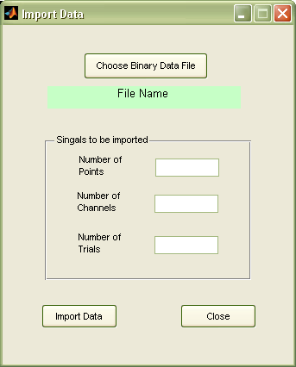

This window allows the user to convert a data file from binary format to MATLAB (.mat) format for use in BSMART.A sample data file, called 'test71.bin', is provided for testing in bsmart\data. This file contains a data set having 15 channels, 137 trials, 18 points and 200 points/sec as the sampling rate. The following instructions use the test71 data set as an example.

- Click the Choose Binary Data File (.bin) button.
- Navigate to C:\bsmart\data in the Pick a file window.
- Open ‘test71.bin’. The path C:\bsmart\data\test71.bin appears in the File path pane. Enter “18” in the Number of Points pane. Enter “15” in the Number of Channels pane. Enter “137” in the Number of Trials pane.
- Click the Import Data button.
- In the Save Workspace Variables window, save the MATLAB format data file as test71.mat in C:\bsmart\test.
- Click the Close button.

Your data file is now in the format that BSMART requires. (You may verify that bsmart\test\test71.mat exists.) Then you can use Plot ► View data to visualize the data.

To Export data
- File menu ► Export Data

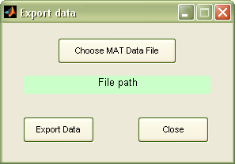

This window allows the user to convert a data file from MATLAB format (.mat) to binary format. This is sometimes desirable to save disk space.

To Preprocess Data

To normalize data
- Tools menu ► Preprocessing

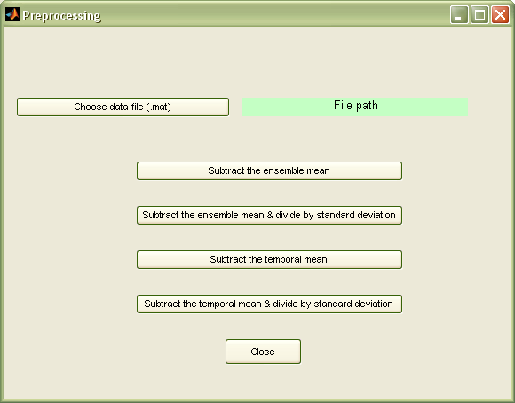

This window allows the user to preprocess a data set in MATLAB format.The following instructions use the test71 data set as an example.

- Click the Choose data file (.mat) button.
- Navigate to bsmart\test in the Pick a file window.
- Open ‘test71.mat’. The path C:\bsmart\test\test71.mat appears in the File path pane.
- Four preprocessing steps are available:
  - Click the Subtract the ensemble mean button to subtract the ensemble mean from each trial in the data set.
  - Click the Subtract the ensemble mean & divide by ensemble standard deviation button to subtract the ensemble mean and divide by the ensemble standard deviation for each trial in the data set.
  - Click the Subtract the temporal mean button to subtract from each trial in the data set its temporal mean.
  - Click the Subtract the temporal mean & divide by standard deviation button to subtract from each trial in the data set the temporal mean and divide by the temporal standard deviation.
- In the Save Workspace Variables window, save the preprocessed MATLAB format data file in bsmart\test. You can either save to a new file, e.g. bsmart\test\test71_pre.mat, or overwrite the same file, i.e. bsmart\test\test71.mat.
- Click the Close button. Then you can use Plot ► View data to visualize the data.

To do FFT analysis
- Tools menu ► FFT

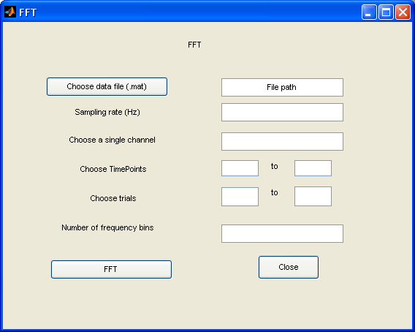

This window allows the user to do FFT analysis from a data set in MATLAB format. The following instructions use the test71_pre data set as an example.

- Click the Choose data file (.mat) button.
- Navigate to bsmart\test in the Pick a file window.
- Open ‘test71_pre.mat’. The path C:\bsmart\test\test71_pre.mat appears in the File path pane.
- Enter desired sampling rate (e.g.200) in the Sampling rate pane.
- Enter desired channel (e.g. 9) in the Choose a single channel pane.
- Enter desired starting position (e.g. 1) and ending position (e.g. 15) in the Choose TimePoints pane.
- Enter desired starting trial (e. g. 1) and ending trial (e.g. 100) in the Choose trial pane.
- Enter desired number of frequency bins (e.g. 100) in the number of frequency bins pane.
- Click the FFT button.
- Click the Close button.
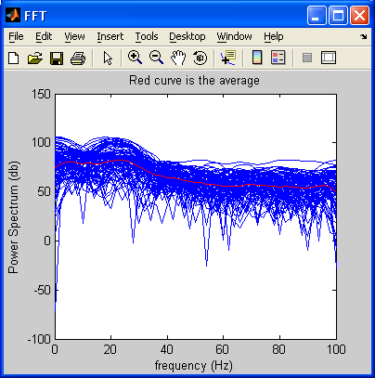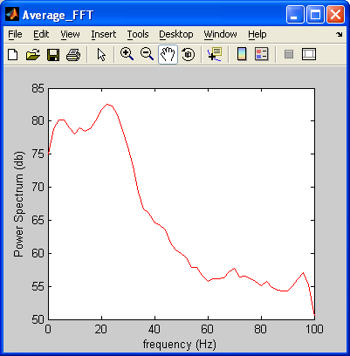

To Create Autoregressive Model

To estimate model order
- Model menu ► AIC Model Order Estimation

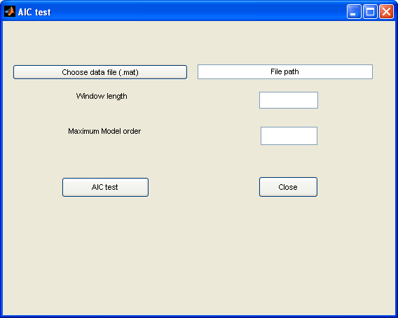

This window allows the user to do AIC test from a data set in MATLAB format. The following instructions use the test71_pre data set as an example.

- Click the Choose data file (.mat) button.
- Navigate to bsmart\test in the Pick a file window.
- Open ‘test71_pre.mat’. The path C:\bsmart\test\test71_pre.mat appears in the File path pane.
- Enter desired window (e.g. 12) in the Window length pane.
- Enter desired maximum model order (e.g. 10) in the Maximum model order pane.
- Click the AIC test button.
- In the Save as window, save the result as bsmart\test\AIC.
- In the AIC order window, enter desired window (e.g. 2) in the Window pane.
- Click the Plot button.
- Click the Close button.
- Click the Close button in Aic test window.

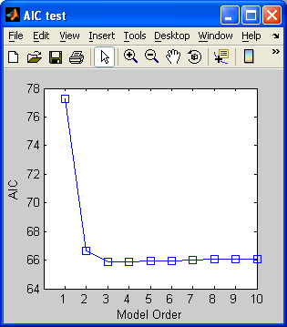

Note: The Akaike Information Criterion (AIC) as a function of model order. Using the AIC to determine the model order which makes the AIC reaches the minimum. In the above figure, model order 5 is sufficient since there is very little change in the AIC beyond that value. And the shape of the curve is similar for all other window.

To create AR model
There are four ways to create AR model: (1) Fixed window (multivariate model) (section 3.2.1), (2) Fixed window (bivariate model) (section 3.2.2), (3) Moving window (multivariate models) (section 3.2.3), and (4) Moving window (bivariate models) (section 3.2.4).

3.1 To Create a Multivariate Autoregressive Model from One Time Window

- Model menu ► Fixed window (multivariate model)
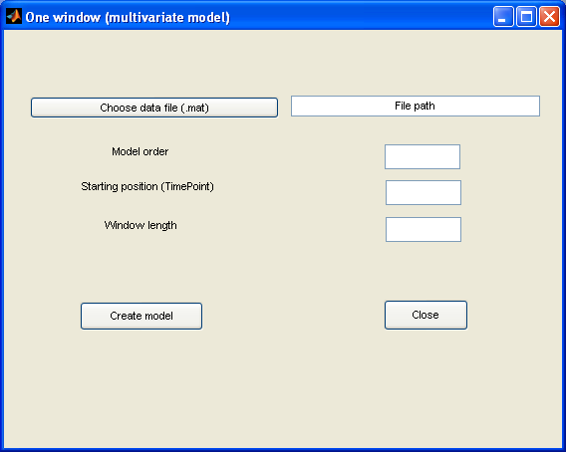

This window allows the user to create a Multivariate (for multiple channels) Autoregressive Model from a data set in MATLAB format for one time window. The following instructions use the test71_pre data set as an example.

- Click the Choose data file (.mat) button.
- Navigate to bsmart\test in the Pick a file window.
- Open ‘test71_pre.mat’. The path C:\bsmart\test\test71_pre.mat appears in the File path pane.
- Enter desired model order (e.g. 5) in the Model order pane.
- Enter desired starting position (e.g. 1) in the Starting position pane.
- Enter desired window length (e.g. 10) in the Window length pane.
- Click the Create model button.
- In the Save as window, save the autoregressive model coefficients as bsmart\test\AR_coefficient, and the noise coefficients as bsmart\test\AR_noise.
- Click the Close button. Then you can use Analysis ► Power (multivariate model), Coherence (multivariate model), and Granger causality (multivariate model) to analyze the data.

To Create a Bivariate Autoregressive Model from One Time Window

- Model menu ► One window (bivariate model)

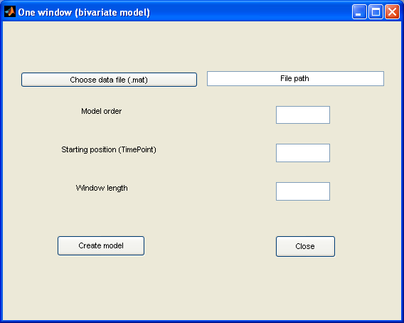

This window allows the user to create a Bivariate (for two channels) Autoregressive Model from a data set in MATLAB format for one time window. The following instructions use the test71_pre data set as an example.

- Click the Choose data file (.mat) button.
- Navigate to bsmart\test in the Pick a file window.
- Open ‘test71_pre.mat’. The path C:\bsmart\test\test71_pre.mat appears in the File path pane.
- Enter desired model order (e.g. 5) in the Model order pane.
- Enter desired starting position (e.g. 1) in the Starting position pane.
- Enter desired window length (e.g. 10) in the Window length pane.
- Click the Create model button.
- The autoregressive model coefficients will be saved as AR_C* files, and the noise coefficients as AR_N* files, in the C:\bsmart\Onewindow_Coefficient directory.
- Click the Close button.

Important Note: Please do not delete the ‘Onewindow_Coefficient’ directory, or rename the files in this directory. You may delete the files in this directory. Every time you click the Create model button, BSMART first deletes all files existing in the ‘Onewindow_Coefficient’ directory, and then generates new files there.

Then you can use Analysis ► Power (bivariate model), Coherence (bivariate model), and Granger causality (bivariate model) to analyze the data.

To Create a series of Multivariate Autoregressive Models from a Moving Time Window
- Tools menu ► Moving window (multivariate models)

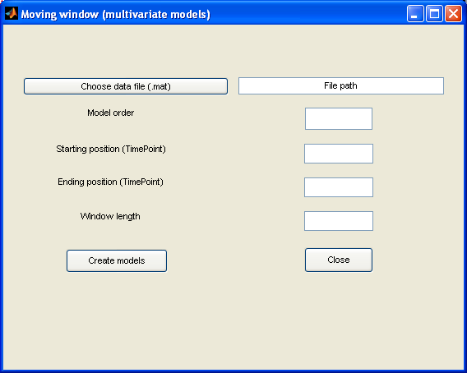

This window allows the user to create Multivariate (for multiple channels) Autoregressive Models from a data set in MATLAB format from a moving time window. The following instructions use the test71_pre data set as an example.

- Click the Choose data file (.mat) button.
- Navigate to bsmart\test in the Pick a file window.
- Open ‘test71_pre.mat’. The path C:\bsmart\test\test71_pre.mat appears in the File path pane.
- Enter desired model order (e.g. 5) in the Model order pane.
- Enter desired position of the first window (e.g. 1) in the Starting position (TimePoint) pane.
- Enter desired position of the last window (e.g. 15) in the Ending position (TimePoint) pane.
- Enter desired window length (e.g. 10) in the Window length pane.
- Click the Create models button.
- In the Save as window, save the autoregressive model coefficients as bsmart\test\AR_coefficientm, and the noise coefficients as bsmart\test\AR_noisem.
- Click the Close button.

Then you can use Analysis ► Power (multivariate model), Coherence (multivariate model), and Granger causality (multivariate model) to analyze the data.

To Create a series of Bivariate Autoregressive Models from a Moving Time Window
- Tools menu ► Moving window (bivariate models)

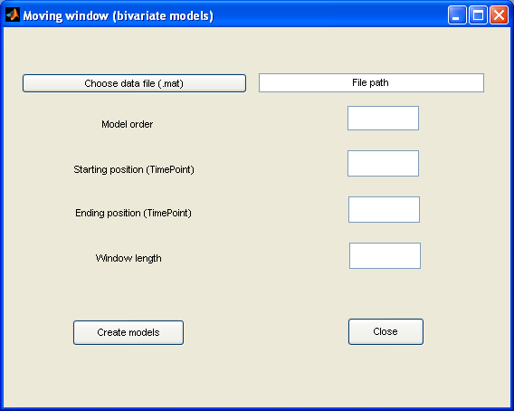

This window allows the user to create Bivariate (for two channels) Autoregressive Models from a data set in MATLAB format from a moving time window. The following instructions use the test71_pre data set as an example.

- Click the Choose data file (.mat) button.
- Navigate to bsmart\test in the Pick a file window.
- Open ‘test71_pre.mat’. The path C:\bsmart\test\test71_pre.mat appears in the File path pane.
- Enter desired model order (e.g. 5) in the Model order pane.
- Enter desired position of the first window (e.g. 1) in the Starting position (TimePoint) pane.
- Enter desired position of the last window (e.g. 15) in the Ending position (TimePoint) pane.
- Enter desired window length (e.g. 10) in the Window length pane.
- Click the Create models button.
- The autoregressive model coefficients will be saved as AR_C* files, and the noise coefficients as AR_N* files, in the C:\bsmart\Movingwindow_Coefficient directory.
- Click the Close button.

Important Note: Please do not delete the ‘Movingwindow_Coefficient’ directory, or rename the files in this directory. You may delete the files in this directory. Every time you click the Create models button, BSMART first deletes all files existing in the ‘Movingwindow_Coefficient’ directory, and then generates new files there.

Then you can use Analysis ►Power (bivariate model), Coherence (bivariate model), and Granger causality (bivariate model) to analyze the data.

To test Autoregressive Model
There are three tests (1) Whiteness test (Section 3.3.1), (2) Consistency test (Section 3.3.2) and (3) Stability test (Section 3.3.3) to test Autoregressive model.

To Do Whiteness Test
- Test menu ► Whiteness test
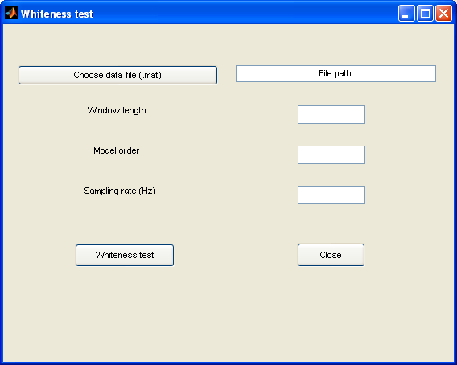

This window allows the user to do whiteness test from a data set in MATLAB format. The following instructions use the test71_pre data set as an example.

- Click the Choose data file (.mat) button.
- Navigate to bsmart\test in the Pick a file window.
- Open ‘test71_pre.mat’. The path C:\bsmart\test\test71_pre.mat appears in the File path pane.
- Enter desired window (e.g. 10) in the Window length pane.
- Enter desired model order (e.g. 5) in the Model order pane.
- Enter desired sampling rate (e.g.200) in the Sampling rate pane.
- Click the Whiteness test button.
- In the Save as window, save the result as bsmart\test\resid.out.
- Click the Close button.

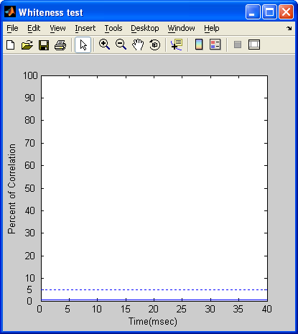

Note: Above figure shows that the percentage of auto- and cross-correlation coefficients that are outside the 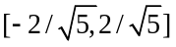 is below 5%, which means the residual noise is white and the data set could be represented as AR process.

To Do Consistency Test
- Model menu ► Consistency test

This window allows the user to do consistency test from AR coefficient file, AR noise file and the data set in MATLAB format.

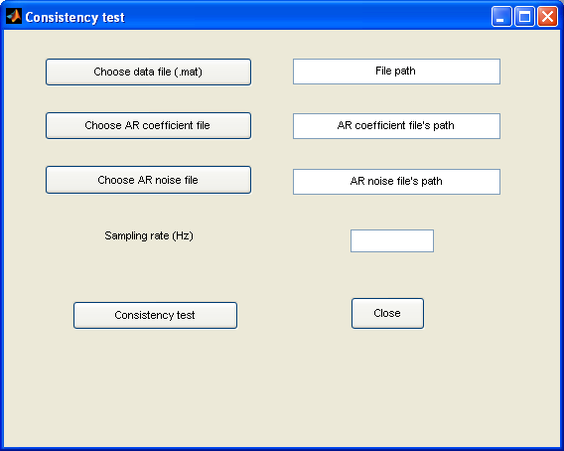

The following instructions use the AR_coeffecientm, AR_noisem and test71_pre data set as an example.

- Click the Choose data file (.mat) button.
- Navigate to bsmart\test in the Pick a file window.
- Open ‘test71_pre.mat’. The path C:\bsmart\test\test71_pre.mat appears in the File path pane.
- Click the Choose AR coefficient file button.
- Navigate to bsmart\test in the Pick a file window.
- Open ‘AR_coefficientm’. The path C:\bsmart\test\AR_coefficientm appears in the AR coefficient file pane.
- Click the Choose AR noise file button.
- Navigate to bsmart\test in the Pick a file window.
- Open ‘AR_noisem’. The path C:\bsmart\test\AR_noisem appears in the AR noise file pane.
- Enter desired sampling rate (e.g.200) in the Sampling rate pane.
- Click the Consistency test button.
- In the Save Workspace Variables window, save the result as bsmart\test\ratio.
- Click the Close button.
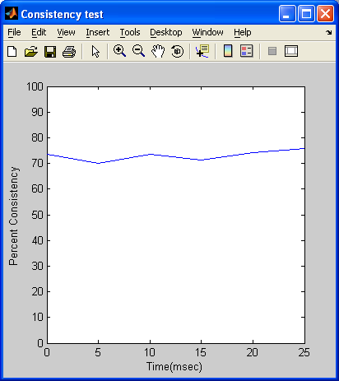

Note: Percent consistency as a function of time, indicating the similarity between the correlation structure of the real data and Autoregressive Model simulated data. In the above figure, this measure is near 80% which means a high consistency.

To Do Stability Test
- Model menu ► Stability test

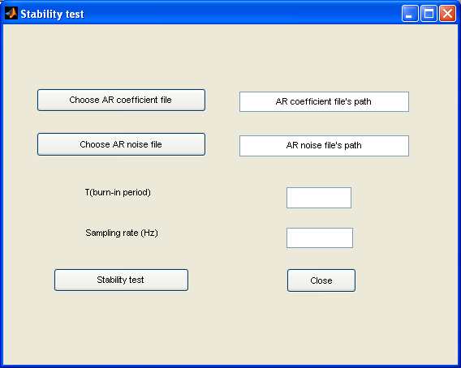

This window allows the user to do stability test from AR coefficient file and AR noise file. The following instructions use the AR_coeffecientm and AR_noisem and test71_pre data set as an example.

- Click the Choose AR coefficient file button.
- Navigate to bsmart\test in the Pick a file window.
- Open ‘AR_coefficientm’. The path C:\bsmart\test\AR_coefficientm appears in the data file pane.
- Click the Choose AR noise file button.
- Navigate to bsmart\test in the Pick a file window.
- Open ‘AR_noisem’. The path C:\bsmart\test\AR_noisem appears in the data file pane.
- Enter desired burn-in period (e. g. 100) in T (burn-in period) pane.
- Enter desired sampling rate (e.g.200) in the Sampling rate pane.
- Click the Stability test button.
- In the Save Workspace Variables window, save the result as bsmart\test\le.
- Click the Close button.

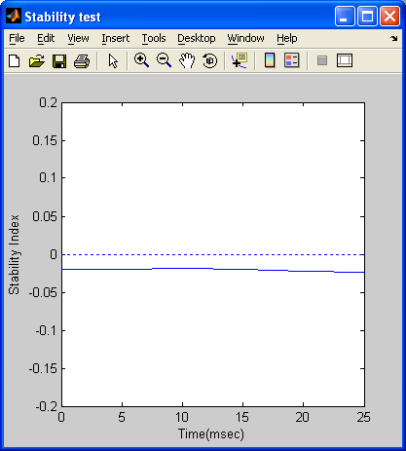

Note: The Stability Index as a function of time. In the above figure, all the values of Stability Index are negative, indicating that all of the fitted models are stable.

To Compute Spectral Quantities

To compute spectral power from multivariate AR models
- Analysis menu ► Power (multivariate model)

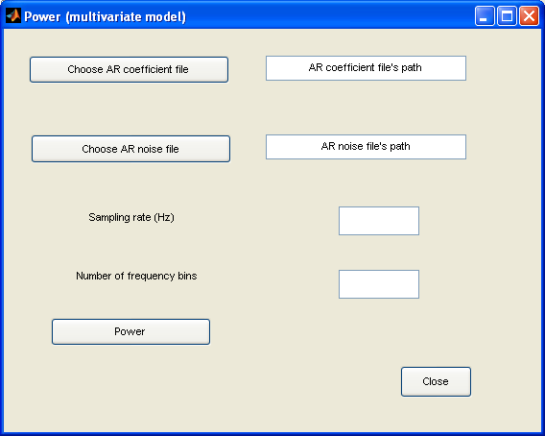

This window allows the user to compute spectral power from Multivariate Autoregressive Models from one or a series of time windows by specifying the AR coefficient and AR noise files. The following instructions use the AR_coefficient and AR_noise files generated on Page 4 to compute the spectral power from a Multivariate Autoregressive Model in one window.

- Click the Choose AR coefficient file button.
- Navigate to bsmart\test in the Pick a file window.
- Open ‘AR_coefficient’. The path C:\bsmart\test\AR_coefficient appears in the AR coefficient file pane.
- Click the Choose AR noise file button.
- Navigate to bsmart\test in the Pick a file window.
- Open ‘AR_noise’. The path C:\bsmart\test\AR_noise appears in the AR noise file pane.
- Enter desired sampling rate (e.g. 200) in the Sampling rate (Hz) pane.
- Enter desired number of frequency bins (e.g. 100) in the Number of frequency bins pane.
- Click the Power button.
- In the Save Workspace Variables window, save the spectral power as bsmart\test\power_one.
- Click the Close button.

Note: You may also use AR_coefficientm and AR_noisem files generated on Page 6 as an example to compute the spectral power from a series of Multivariate Autoregressive Models in the Power (multivariate model) window. Using the same parameter as above, the result is saved as bsmart\test\power_mov.

Then you can use Plot ► Power view to visualize data.

To compute spectral power from bivariate AR models
- Analysis menu ► Power (bivariate model)

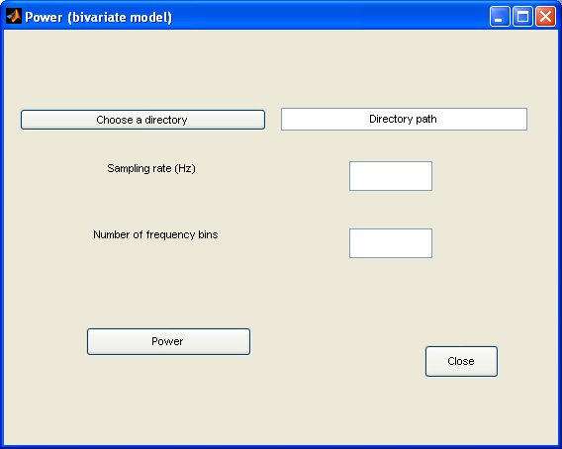

This window allows the user to compute spectral power from Bivariate Autoregressive Models from one or a series of time windows by specifying the AR coefficient and AR noise directory. The following instructions use the files in the C:\bsmart\Onewindow_Coefficient directory generated on Page 5 to compute the spectral power from a Bivariate Autoregressive Model in one window.

- Click the Choose a directory button.
- Navigate to C:\mar\bsmart\ in the Browse for Folder window.
- Select the C:\mar\bsmart\Onewindow_Coefficient directory. Click the OK button.
- The path C:\bsmart\test\Onewindow_Coefficient appears in the Directory path pane.
- Enter desired sampling rate (e.g. 200) in the Sampling rate (Hz) pane.
- Enter desired number of frequency bins (e.g. 100) in the Number of frequency bins pane.
- Click the Power button.
- In the Save Workspace Variables window, save the spectral power as bsmart\test\power_one_bi.
- Click the Close button.

Note: You may also use directory path C:\bsmart\Movingwindow_Coefficient mentioned in Page 7 as an example to compute the spectral power from a series of Bivariate Autoregressive Models in Power (bivariate model) window. Using the same parameter as above, the result is saved as bsmart\test\power_mov_bi.

Then you can use Plot ►Power view to visualize data.

To compute spectral coherence from multivariate AR model
- Analysis menu ► Coherence (multivariate model)

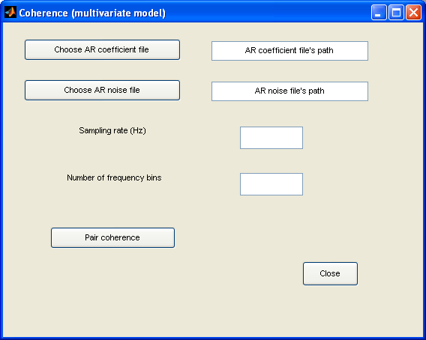

This window allows the user to compute spectral coherence from one or a series of Multivariate Autoregressive Models by specifying the AR coefficient and AR noise files. The following instructions use the AR_coefficient and AR_noise generated in Page 4 as an example to compute the spectral coherence from a Multivariate Autoregressive Model.

- Click the Choose AR coefficient file button.
- Navigate to bsmart\test in the Pick a file window.
- Open ‘AR_coefficient’. The path C:\bsmart\test\AR_coefficient appears in the AR coefficient file pane.
- Click the Choose AR noise file button.
- Navigate to bsmart\test in the Pick a file window.
- Open ‘AR_noise’. The path C:\bsmart\test\AR_noise appears in the AR noise file pane.
- Enter desired sampling rate (e.g.200) in the Sampling rate pane.
- Enter desired number of frequency bins (e.g.100) in the Number of frequency bins pane.
- Click the Pair coherence button.
- In the Save Workspace Variables window, save the coherence as bsmart\test\ coherence_one.
- Click the Close button.

Note: You can also use AR_coefficientm and AR_noisem generated in Page 6 as an example to compute the spectral coherence from a series of Multivariate Autoregressive Models in Coherence (multivariate model) window. Using the same parameter as above, the result is saved as bsmart\test\coherence_mov.

Then you can use Plot ►Coherence view to visualize data.

To compute spectral coherence from bivariate AR model
- Analysis menu ► Coherence (bivariate model)

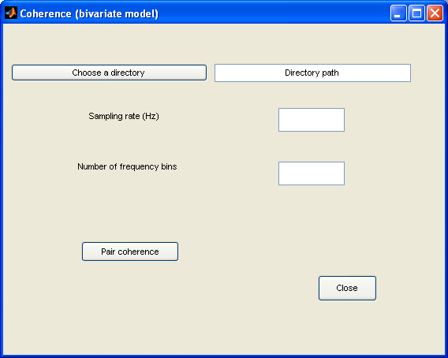

This window allows the user to compute spectral coherence from one or a series of Bivariate Autoregressive Models by specifying the AR coefficient and AR noise directory. The following instructions use the C:\bsmart\Onewindow_Coefficient generated in Page 5 as an example to compute the spectral coherence from a Bivariate Autoregressive Model.

- Click the Choose a directory button.
- Navigate to C:\mar\bsmart\ in the Browse for Folder window.
- Select the C:\mar\bsmart\Onewindow_Coefficient directory. Click the OK button.
- The path C:\bsmart\test\Onewindow_Coefficient appears in the Directory path pane.
- Enter desired sampling rate (e.g.200) in the Sampling rate pane.
- Enter desired number of frequency bins (e.g.100) in the number of frequency bins pane.
- Click the Pair coherence button.
- In the Save Workspace Variables window, save the spectral power as bsmart\test\coherence_one_bi.
- Click the Close button.

Note: You can also use directory path C:\bsmart\Movingwindow_Coefficient mentioned in Page 7 as an example to compute the spectral coherence from a series of Bivariate Autoregressive Models in Coherence (bivariate model) window. Using the same parameter as above, the result is saved as bsmart\test\coherence_mov_bi.

Then you can use Plot ► Coherence view to visualize data.

To compute Granger causality using Bivariate AR model
- Analysis menu ► Granger causality (bivariate model)

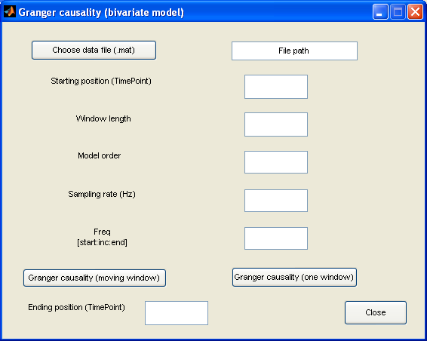

This window allows the user to compute granger causality from a data set in MATLAB format using Bivariate Autoregressive Model method. The following instructions use the test71_pre data set as an example.

- Click the Choose data file (.mat) button.
- Navigate to bsmart\test in the Pick a file window.
- Open ‘test71_pre.mat’. The path C:\bsmart\test\test71_pre.mat appears in the File path pane.
- Enter desired starting position (e.g. 1) in the Starting position pane.
- Enter desired window (e.g. 10) in the Window length pane.
- Enter desired model order (e.g. 5) in the Model order pane.
- Enter desired sampling rate (e.g.200) in the Sampling rate pane.
- Enter desired frequency range (e.g. 1:100) in the Freq pane.
- Click the Granger causality (one window) button.
- In the Save Workspace Variables window, save the granger causality as bsmart\test\Fx2y_one_bi, and bsmart\test\Fy2x_one_bi.
- Enter desired ending position (e.g. 15) in the Ending position pane.
- Click the Granger causality (moving window) button.
- In the Save Workspace Variables window, save the granger causality as bsmart\test\Fxy_mov_bi, and bsmart\test\Fyx_mov_bi.
- Click the Close button.

Then you can use Plot ► Granger causality view to visualize data.

To do coherence network analysis
- Analysis menu ► Coherence network

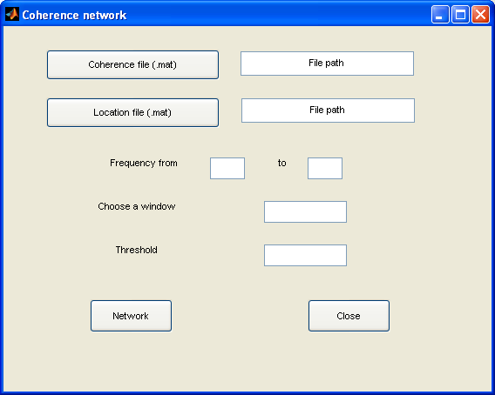

This window allows the user to view coherence network from the data sets in MATLAB format. The following instructions use the coherence_mov, location data sets as an example.

- Click the Coherence file (.mat) button.
- Navigate to bsmart\test in the Pick a file window.
- Open ‘coherence_mov.mat’. The path C:\bsmart\test\coherence_mov.mat appears in the File path pane.
- Click the Location file (.mat) button.
- Navigate to bsmart\test in the Pick a file window.
- Open ‘location.mat’. The path C:\bsmart\test\location.mat appears in the File path pane.
- Enter desired starting frequency (e.g. 1) and ending frequency (e.g. 80) in the Frequency pane.
- Enter desired time (e.g. 2) in the Choose a window pane.
- Enter desired threshold (e. g. 0.25) in the Threshold Pane.
- Click Network button in the bottom.
- Click Close button.

Note: Section 4.8 talks about more information about location file.

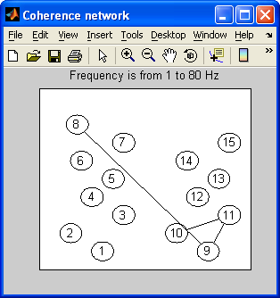

To do Granger causality network analysis
- Analysis menu ► Granger causality network

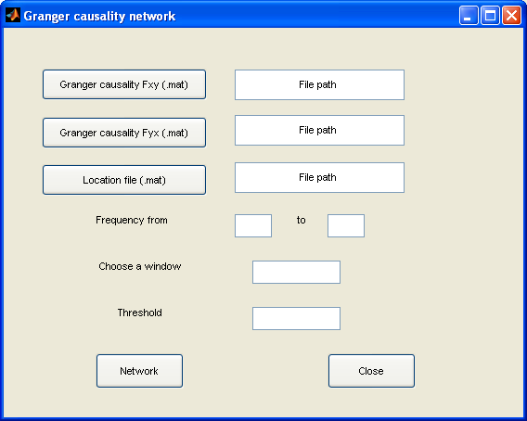

This window allows the user to view granger causality network from the data sets in MATLAB format. The following instructions use the Fxy_mov, Fyx_mov, location data sets as an example.

- Click the Granger causality Fxy (.mat) button.
- Navigate to bsmart\test in the Pick a file window.
- Open ‘Fxy_mov.mat’. The path C:\bsmart\test\Fxy_mov.mat appears in the File path pane.
- Click the Granger causality Fyx (.mat) button.
- Navigate to bsmart\test in the Pick a file window.
- Open ‘Fyx_mov.mat’. The path C:\bsmart\test\Fyx_mov.mat appears in the File path pane.
- Click the Location file (.mat) button.
- Navigate to bsmart\test in the Pick a file window.
- Open ‘location.mat’. The path C:\bsmart\test\location.mat appears in the data file pane.
- Enter desired starting frequency (e.g. 1) and ending frequency (e.g. 80) in the Frequency pane.
- Enter desired time (e.g. 2) in the Choose a window pane.
- Enter desired threshold (e. g. 0.16) in the Threshold Pane.
- Click Network button in the bottom. (Figure shows in Page 22).
- Click Close button.

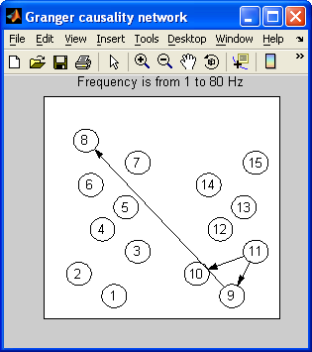

For, coherence network and granger causality network, refer to Graph Layout Generation Package (Ver 1.0, 08-May-2000) by Ali Taylan Cemgil (cemgil@mbfys.kun.nl)

How to write the location file

The location file is a matrix in MATLAB format. The matrix has two rows. The first row is the X coordinate and the second row is the Y coordinate on the unit square. Every column which has one X coordinate and one Y coordinate indicates the location of one site.

In the location file which can be found in C:\bsmart\test

Columns 1 through 8
0.3000 0.1500 0.4000 0.2500 0.3500 0.2000 0.4000 0.1800
0.1000 0.2000 0.3000 0.4000 0.5000 0.6000 0.7000 0.8000

Columns 9 through 15

0.8000 0.6500 0.9000 0.7500 0.8500 0.7000 0.9000
0.1000 0.2000 0.3000 0.4000 0.5000 0.6000 0.7000

It has 15 columns which mean locations for 15 sites. If you would like to change the location file, do the following steps. In MATLAB command window, type “location=[x coordinates; y coordinates]”. For example, in order to get the above location file, type below in the command line:

location = [0.3000 0.1500 0.4000 0.2500 0.3500 0.2000 0.4000 0.1800 0.8000 0.6500 0.9000 0.7500 0.8500 0.7000 0.9000; 0.1000 0.2000 0.3000 0.4000 0.5000 0.6000 0.7000 0.8000 0.1000 0.2000 0.3000 0.4000 0.5000 0.6000 0.7000]

Save “location” in a file at C:\bsmart.
In MATLAB command window, type “save location location”.

To Plot Data
This section explains the Data view (Section 5.1), Coherence view (Section 5.2), power view (Section 5.3) and granger causality view (Section 5.4).

To View Data
- Plot menu ► Data view

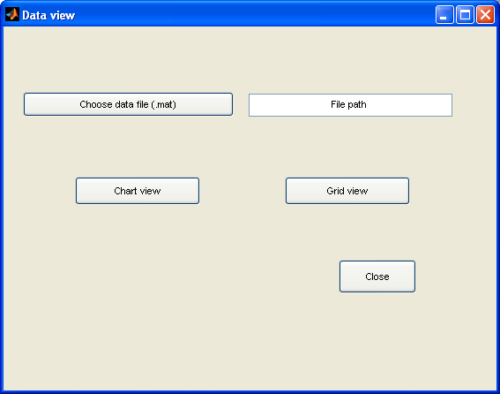
This window allows the user to view data in two ways from a data set in MATLAB format. The following instructions use the test71_pre data set as an example.

- Click the Choose data file (.mat) button.
- Navigate to bsmart\test in the Pick a file window.
- Open ‘test71_pre.mat’. The path C:\bsmart\test\test71_pre.mat appears in the File path pane.
- Click the Chart view button.

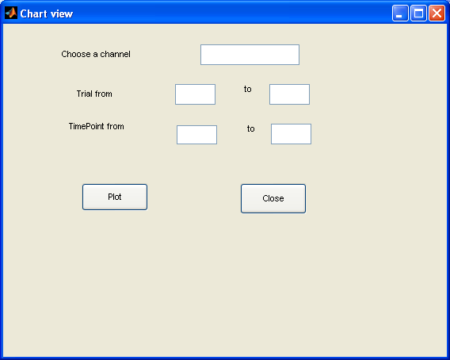

- Enter desired channel (e.g. 8) in the Choose a channel pane.
- Enter desired starting trial (e.g. 1) and ending trial (e.g. 5) in the Trial pane.
- Enter desired starting point (e.g. 1) and ending point (e.g. 15) in the TimePoint pane.
- Click Plot button.
- Click the Close button.
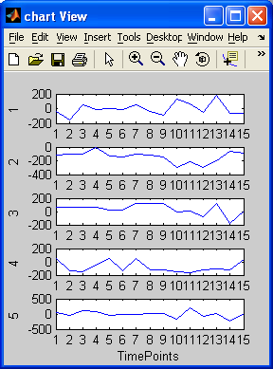

- Click the Grid view button.
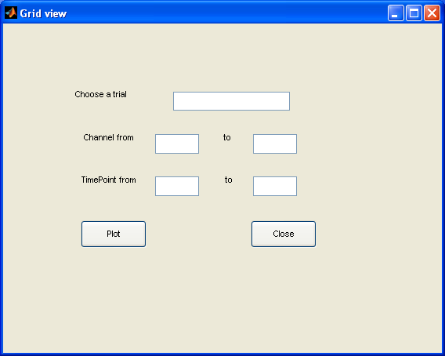

- Enter desired trial (e.g. 8) in the Choose a trial pane.
- Enter desired starting channel (e.g. 1) and ending channel (e.g. 5) in the Channel pane.
- Enter desired starting point (e.g. 1) and ending point (e.g. 15) in the TimePoint pane.
- Click Plot button.
- Click Close button.
- Click Close button in the View data window.

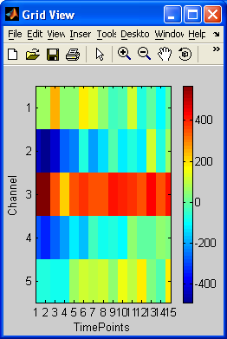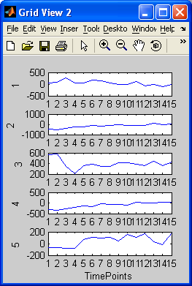

To View Coherence
- Plot menu ► Coherence view

This window allows the user to view coherence from a data set in MATLAB format.

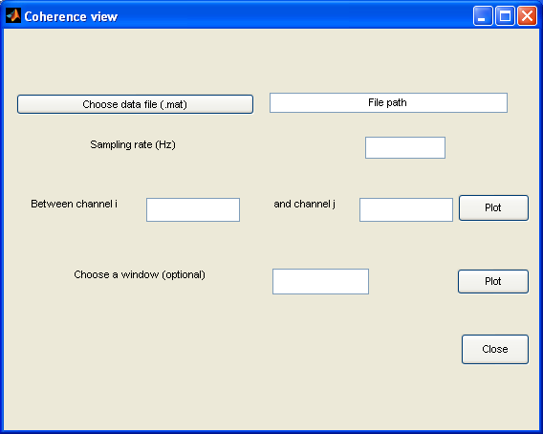

The following instructions use the coherence_mov data set as an example.

- Click the Choose data file (.mat) button.
- Navigate to bsmart\test in the Pick a file window.
- Open ‘coherence_mov.mat’. The path C:\bsmart\test\coherence_mov.mat appears in the File path pane.
- Enter desired sampling rate (e.g.200) in the Sampling rate pane.
- Enter desired channel i (e.g. 9) in the channel i pane and channel j (e.g. 10) in the Channel j pane.
- Click Plot button on the right side. (Figure1)
- Enter time (e.g. 5) in the Choose a window pane.
- Click Plot button on the right side. (Figure 2)
- Click Close button.

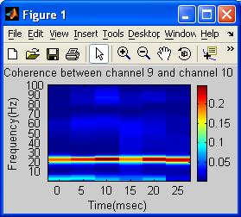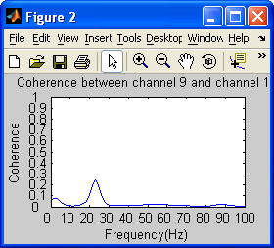

To View Power
- Plot menu ► Power view

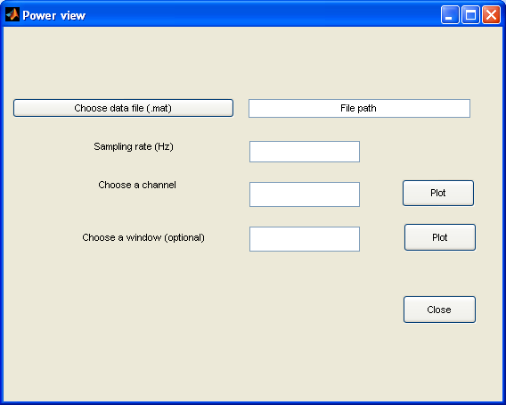

This window allows the user to view power from a data set in MATLAB format. The following instructions use the power_mov data set as an example.

- Click the Choose data file (.mat) button.
- Navigate to bsmart\test in the Pick a file window.
- Open ‘power_mov.mat’. The path C:\bsmart\test\power_mov.mat appears in the File path pane.
- Enter desired sampling rate (e.g.200) in the Sampling rate pane.
- Enter desired channel (e.g. 9) in the channel pane.
- Click Plot button on the right side.
- Enter time (e.g. 5) in the Choose a window pane.
- Click Plot button on the right side.
- Click Close button.

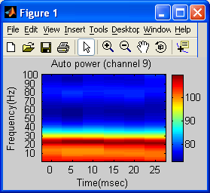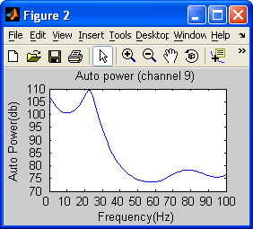

To View Granger Causality
- Plot menu ► Granger causality view

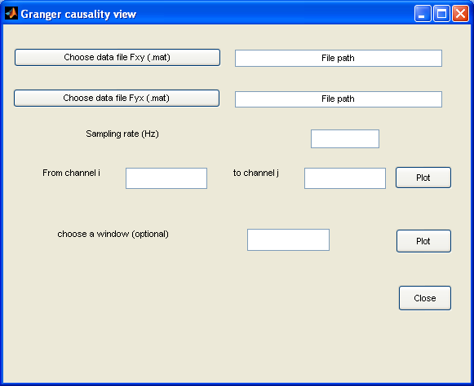

This window allows the user to view granger causality from the data sets in MATLAB format. The following instructions use the Fxy_mov,Fyx_mov data set as an example.

- Click the Choose data file Fxy(.mat) button.
- Navigate to bsmart\test in the Pick a file window.
- Open ‘Fxy_mov.mat’. The path C:\bsmart\test\Fxy_mov.mat appears in the File path pane.
- Click the Choose data file Fyx(.mat) button.
- Navigate to bsmart\test in the Pick a file window.
- Open ‘Fyx_mov.mat’. The path C:\bsmart\test\Fyx_mov.mat appears in the File path pane.
- Enter desired sampling rate (e.g.200) in the Sampling rate pane.
- Enter desired channel i (e.g. 9) in the channel i pane and channel j (e.g. 10) in the Channel j pane.
- Click Plot button on the right side. (Figure 1)
- Enter time (e.g. 5) in the Choose a window pane.
- Click Plot button on the right side. (Figure 3)
- Click Close button.
- Enter desired channel i (e.g. 10) in the channel i pane and channel j (e.g. 9) in the Channel j pane.
- Click Plot button on the right side. (Figure 2)
- Enter time (e.g. 5) in the Choose a window pane.
- Click Plot button on the right side. (Figure 4)
- Click Close button.

