**Reinforcement Learning HW-1**

**Name:** Li, Jieda

**NetID:** jlg7773

Problem 1: Please see plots for problem 1(a), 1(b) and 1(c) below.

[Reference Code](https://github.com/jiedali/reinforcement_learning/blob/master/shuttle_dispatch/hw1_q1.py)

1(a) Value function at Time 0 (from enumeration method with T=500)

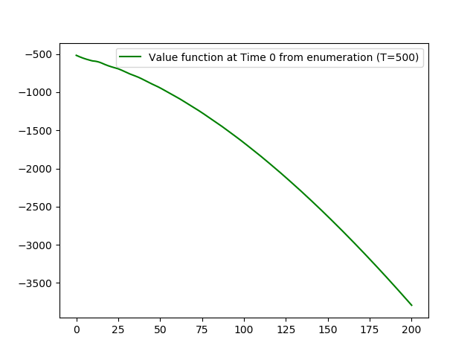

1(b) Value function from value iteration

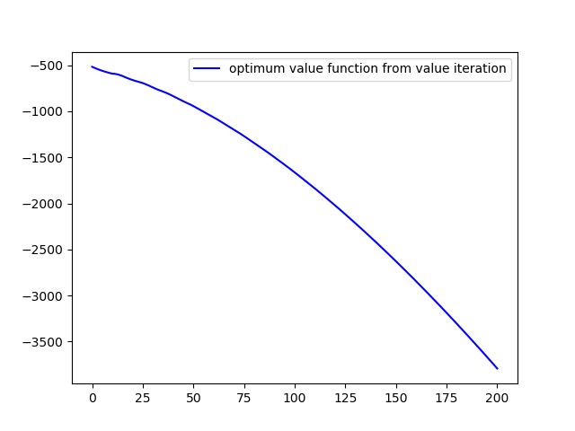

1(c) Optimum policy from policy iteration

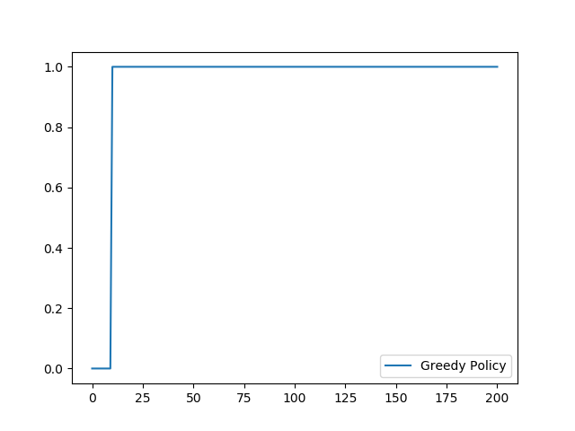

Problem 2:

[Reference Code](https://github.com/jiedali/reinforcement_learning/blob/master/shuttle_dispatch/hw1_q2.py)

**Modeling details / assumptions:**

* State is now defined as a matrix, shape 101 *5
* Value function is defined as a vector, length is 101**5 = 10,510,100,501
* Total number of states are 101**5 = 10,510,100,501
* Each unique state is represented by a vector of 5; Such as, S = [10 5 6 67 25]
* At one time point, arriving customer is represented by a vector of 5, such as [1 5 3 4 2]
* **When a bus is dispatched, it will always take 6 people from each class; If a class has less than 6 people, it will just take whatever number of customers in that class.**

For example, current state S = [10 5 6 67 25], when a shuttle is dispatched, next state will be [10 5 6 67 25] – [6 5 6 6 6] 🡪 [4 0 0 61 19]

* Each column of the value function matrix corresponds to a specific customer type
* Maximum number of customers per class type waiting is 100
* Capacity of shuttle is 30
* Cost of each remaining customer is ch = {1 1.5 2 2.5 3}

**Mathematical approximations used to reduce computation load:**

* Calculation of expected total future rewards per action (expectation over next states) is replaced by sampling of next state (one sample).

**Computation technique used:**

* Python multiprocessing

**Experiment Record:**

* **Attempt 1:**

Run with max number of customer waiting = 100, total states = 10,510,100,501

Result: **Ipython killed the process reporting “kill 9”.** (consuming too much memory)

* **Attempt 2:**

Run with reduced state space, reduce max customer waiting from 100 to 20, total states = 4,084,101

Result: show below the value function from enumeration for 5 class of customers

X: number of customers in each class (max=20)

2(a) Value function from enumeration T=100