Question 1(b): Natural Cubic Spline Graduation
Australia, total population, 2005 | Ages 20–59

1. Data and fitting approach
The crude central death rates are calculated as m_x = D_x / E_x^c using Australian total-population deaths and central exposures for 2005. The data cover 40 ages, from 20 to 59 inclusive. As checks, D_20 = 164.01 and E_20^c = 283,502.35; D_59 = 1,184.14 and E_59^c = 225,403.60.
The spline coefficients are obtained by solving interpolation equations, following the equation-solving approach in Unit 3 Exercise 3.8. No minimum chi-squared objective or smoothing penalty is introduced. Exercise 3.8 is an interpolation example rather than a statistical fitting criterion; this distinction is retained here.
Explicit implementation assumption: the interpolation anchors are age 20, every interior knot, and age 59. The assignment specifies the knot locations but does not explicitly prescribe these interpolation anchors. The upper boundary knot at 60 is used only to define the natural boundary; no age-60 observation is included. All plotted rates and goodness-of-fit calculations cover ages 20–59.
Model | Interior knots | Parameters | Chi-square df
S1 | 28, 36, 44, 52 | 6 | 34
S2 | 24, 28, 32, 36, 40, 44, 48, 52, 56 | 11 | 29
S3 | 22, 24, 26, 28, 30, 32, 34, 36, 38, 40, 42, 44, 46, 48, 50, 52, 54, 56, 58 | 21 | 19

2. Spline construction and calculation steps
Let k_0 = 20 < k_1 < … < k_n = 60 be the complete knot sequence. Define the truncated cubic functions φ_j(x) = MAX(x − k_j, 0)^3.
For j = 0, …, n−2, construct F_j(x) = φ_j(x) − [(60 − k_j)/(60 − k_(n−1))]φ_(n−1)(x) + [(k_(n−1) − k_j)/(60 − k_(n−1))]φ_n(x).
The natural cubic spline is s(x) = a_0 + a_1 x + Σ_(j=0)^(n−2) b_j F_j(x). These basis functions give a continuous spline with continuous first and second derivatives, with s″(20) = s″(60) = 0 and linear continuation outside the boundary knots.
At each anchor age z_i, impose a_0 + a_1 z_i + Σ_j b_j F_j(z_i) = m_(z_i). This produces a square linear system Aθ = y, with each row of A equal to [1, z_i, F_0(z_i), …, F_(n−2)(z_i)]. There are 6, 11 and 21 equations and coefficients for S1, S2 and S3, respectively.
Excel implementation: calculate φ_j with MAX(age−knot,0)^3, calculate the F_j columns, then solve the linear equations. Solver can set the first equation residual to zero, constrain all remaining residuals to zero, and change all coefficients using Simplex LP. Coefficients must be unrestricted in sign. Alternatively, the same linear system can be evaluated by MMULT(MINVERSE(A),y); this is the same interpolation calculation, not a different fitting objective.
Finally evaluate s(x) for each integer age from 20 to 59. All evaluated graduated rates in these corrected models are positive. Interpolation residuals and the natural boundary conditions were checked independently.

3. Goodness of fit and smoothness
Under the usual Poisson approximation, expected deaths are μ_x = E_x^c s(x). The Pearson statistic is X² = Σ_(x=20)^59 (D_x − μ_x)² / μ_x. Following the Unit 3 convention, subtract one degree of freedom per estimated parameter: df = 40 − p. At the 5% level, reject when X² exceeds the upper 5% chi-square critical value. The chi-square statistic is used only for assessment after interpolation.
Barnett’s third-order condition is 7³|Δ³s(x)| < s(x), where Δ³s(x) = s(x+3) − 3s(x+2) + 3s(x+1) − s(x). It is evaluated for ages 20–56, giving 37 testable ages. Ages 57–59 are excluded because the necessary later graduated rates lie outside the specified age range. Part (b) does not impose the 85% selection threshold used in Part (a).
Model | X² | df | 5% critical | p-value | Decision | Barnett
S1 | 48.0886 | 34 | 48.6024 | 0.05530 | Do not reject | 36/37 (97.30%)
S2 | 52.5200 | 29 | 42.5570 | 0.00477 | Reject | 13/37 (35.14%)
S3 | 35.1973 | 19 | 30.1435 | 0.01322 | Reject | 1/37 (2.70%)

S1
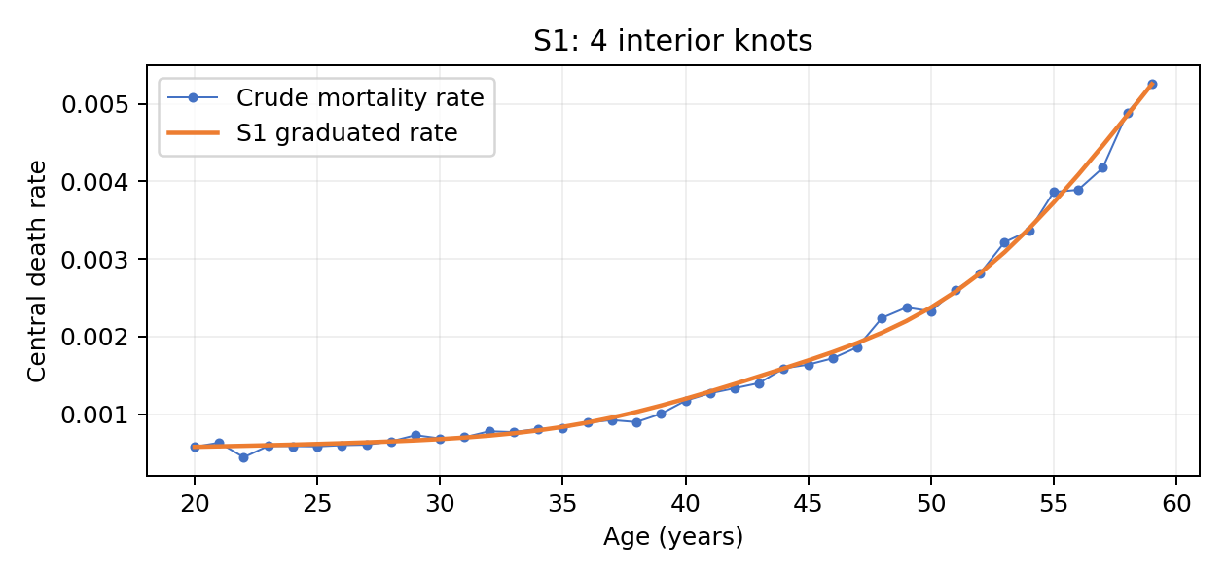
For S1, X² = 48.0886 with 34 degrees of freedom and p = 0.05530. The test does not reject the goodness-of-fit hypothesis at 5%. Barnett’s criterion holds at 36 of 37 ages (97.30%).
The p-value is only slightly above 0.05, so the result is marginal and should not be interpreted as strong evidence of a good fit. The only age failing the third-order smoothness criterion is 44.

S2
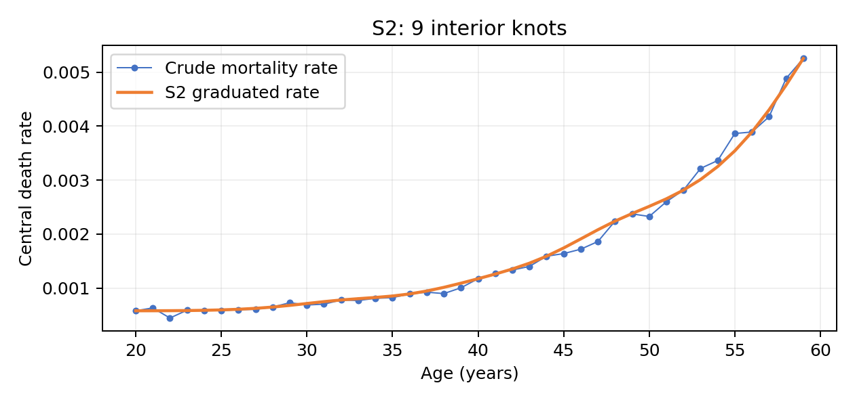
For S2, X² = 52.5200 with 29 degrees of freedom and p = 0.00477. The test rejects the goodness-of-fit hypothesis at 5%. Barnett’s criterion holds at 13 of 37 ages (35.14%).

S3
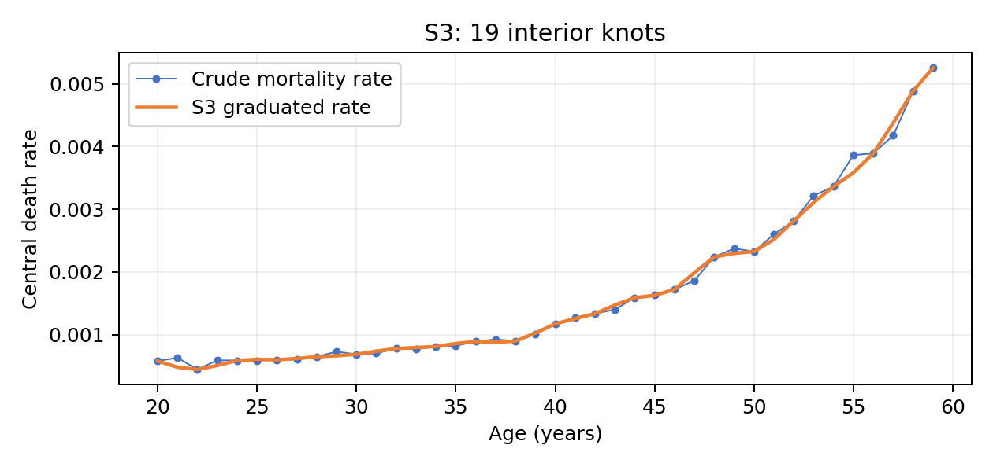
For S3, X² = 35.1973 with 19 degrees of freedom and p = 0.01322. The test rejects the goodness-of-fit hypothesis at 5%. Barnett’s criterion holds at 1 of 37 ages (2.70%).

4. Effect of increasing the number of knots
Increasing the number of interior knots increases the number of free coefficients and the flexibility of the fitted curve. Under the chosen interpolation method, each additional interior knot also adds an age at which the spline must exactly match the crude rate. This strengthens adherence at the selected anchors but can transmit sampling fluctuations into the fitted curve.
Overall Pearson fit is not monotonic: X² changes from 48.0886 for S1 to 52.5200 for S2, then falls to 35.1973 for S3. Exact interpolation at more selected ages does not minimise the statistic across all 40 ages. In addition, increasing the parameter count reduces the chi-square degrees of freedom from 34 to 29 and 19. Consequently, although S3 has the smallest unadjusted statistic, both S2 and S3 are rejected at 5%, while S1 is not rejected.
Smoothness deteriorates markedly: the Barnett pass proportion falls from 97.30% to 35.14% and then 2.70%. Thus, continuity of the spline and its first two derivatives does not guarantee small third differences on the annual age grid. Among these three interpolated models, S1 provides the most favourable observed balance between the reported goodness-of-fit test and third-order smoothness; this comparison does not involve an additional optimisation or knot-selection procedure.

References and workbook consistency
ACTL90007 Assignment 2 (2026), Question 1(b); Unit 3 notes, Exercise 3.8 and the sections on chi-squared degrees of freedom and Barnett smoothness; Unit Three Exercise 3.8.xls.
These results correspond to the corrected interpolation calculations, not the erroneous S2 values in the latest uploaded workbook. Before submission, correct the workbook references and equations and ensure its results match this table. No claim is made that the unspecified anchor convention is required by the assignment.

