Question 3: Mortality Models
Australia and United Kingdom | Total population | Ages 40–90 | 1961–2005

(a) Lee–Carter models and evidence of a cohort effect
The analysis uses the Total (both sexes) columns of the supplied HMD Deaths_1x1 and Exposures_1x1 files. Rows represent ages 40–90 inclusive and columns represent years 1961–2005 inclusive, giving 51 × 45 = 2,295 observations per population. The selected observations are complete and have positive deaths and central exposures. The original text files and the earlier workbook agree exactly over this window.
Following the lecturer’s LC_APC.R example, the Lee–Carter model is fitted with StMoMo using lc(link="log") and fit(). The statistical model is D_(x,t) ~ Poisson(E_(x,t)^c m_(x,t)), with log m_(x,t) = a_x + b_x k_t. The parameters are estimated from deaths and exposures, rather than by replacing the supplied likelihood-based method with an unweighted SVD fit to log rates. The LC identifiability constraints are Σ_x b_x = 1 and Σ_t k_t = 0.
Here a_x describes the baseline age profile of log mortality, b_x measures the sensitivity of mortality at age x to the period index, and k_t captures the common temporal trend. Both fitted models converged.
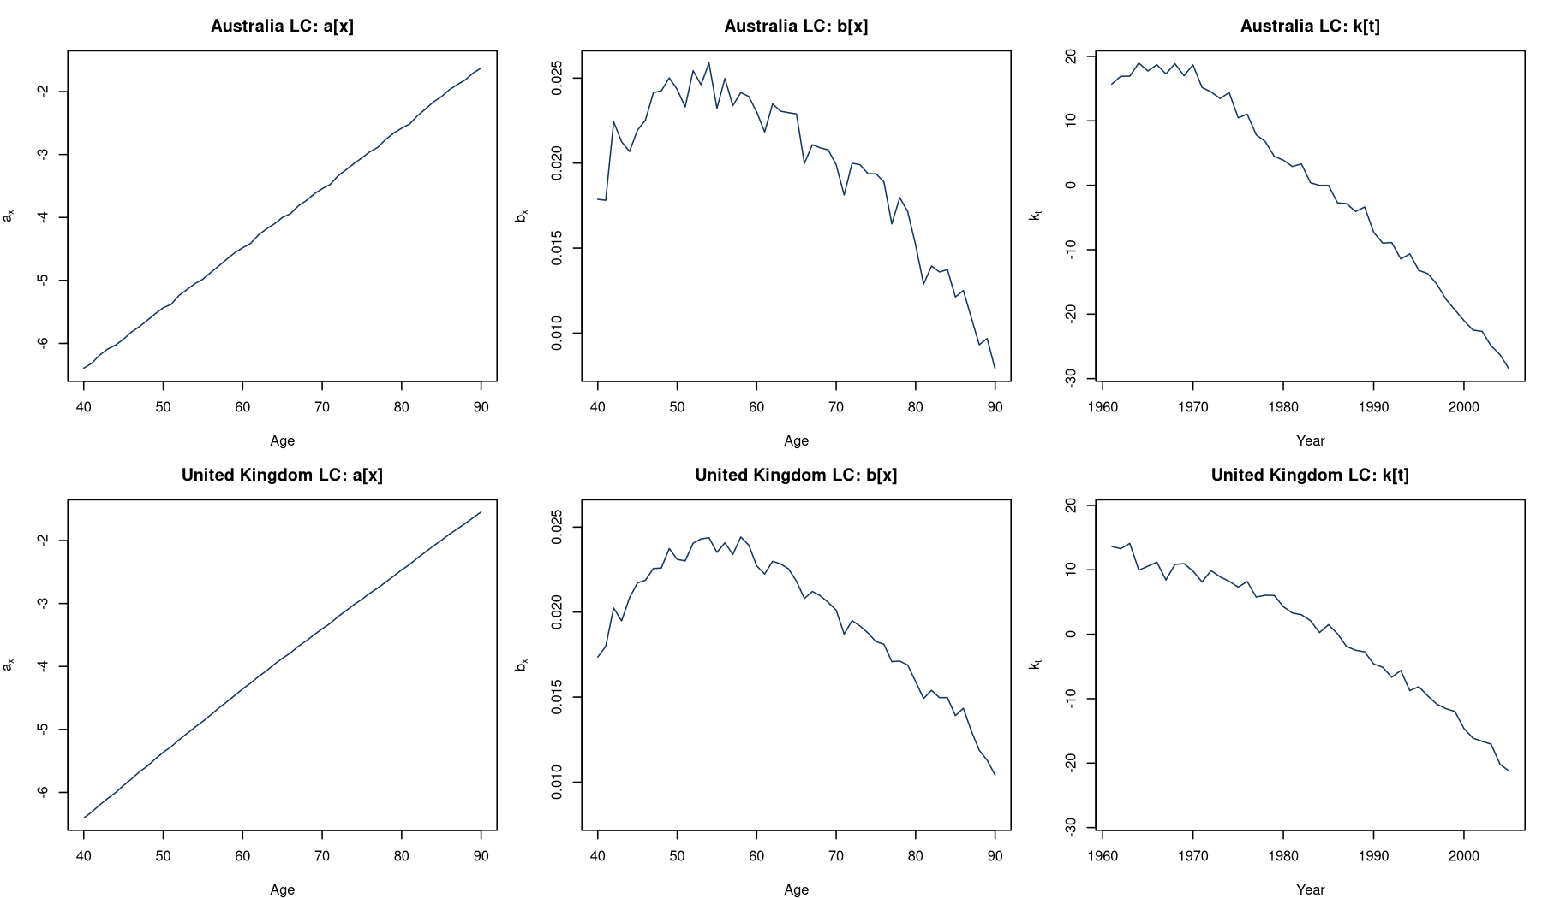
Figure 1. Estimated LC parameters for Australia (top) and the United Kingdom (bottom). Matching axis limits are used within each parameter column.
In both populations, a_x increases strongly with age, reflecting higher mortality at older ages. It rises from approximately −6.39 to −1.63 in Australia and −6.41 to −1.55 in the UK between ages 40 and 90. The estimated b_x values are positive throughout the selected range; they are generally largest in middle age and decline towards age 90. Their maxima occur at ages 54 and 58 for Australia and the UK, respectively. Thus mortality changes associated with the period index are proportionally stronger at these middle ages than at the oldest ages.
The period indices generally decline over time. Australia’s k_t falls from approximately 15.70 in 1961 to −28.52 in 2005, with a relatively flat or fluctuating period during the 1960s followed by a clearer decline. The UK index falls from approximately 13.64 to −21.23. Because b_x is positive, these declining indices indicate broad mortality improvement. Their numerical magnitudes are model-specific and should not be treated as direct mortality-rate differences between countries.

Residual visualisation and identification of the population
To examine cohort structure, age–year heatmaps and sign maps of unscaled Poisson deviance residuals are used. For fitted deaths μ_(x,t) = E_(x,t)^c m̂_(x,t), the residual is r_(x,t) = sign(D_(x,t)−μ_(x,t)) × sqrt{2[D_(x,t) log(D_(x,t)/μ_(x,t)) − (D_(x,t)−μ_(x,t))]}. In R, these are obtained from residuals(fit, scale=FALSE). StMoMo adds a negligible 0.00001 internally when forming its deviance residuals; the death data used for fitting are not altered.
Calendar year is on the horizontal axis and age is on the vertical axis. A fixed birth cohort c=t−x therefore follows an upward-sloping diagonal. Positive residuals, shown in red, mean observed deaths exceed fitted deaths; negative residuals, shown in blue, mean observed deaths are below fitted deaths. Common colour limits are used for each comparison, and the sign maps provide a comparison that does not depend on the relative magnitudes of exposures.
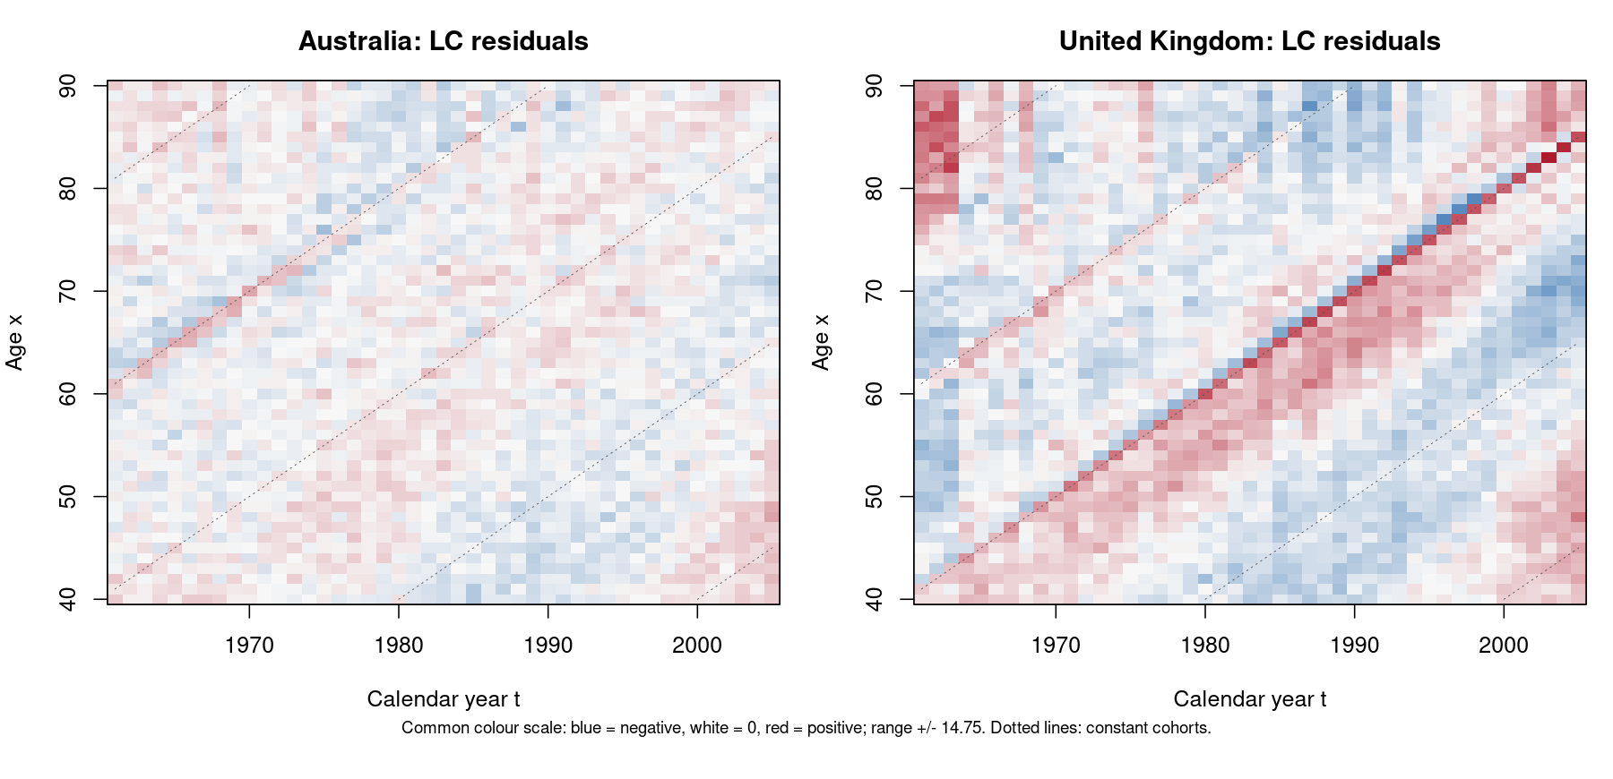
Figure 2. LC deviance residual heatmaps on a common colour scale. Dotted lines indicate selected constant-birth-cohort paths.
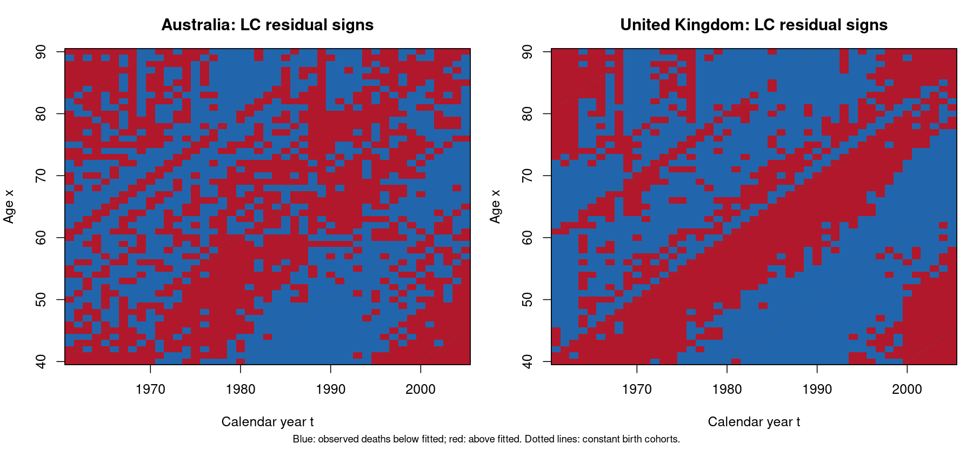
Figure 3. LC residual signs: red indicates positive residuals and blue indicates negative residuals.
The UK shows stronger evidence of a cohort effect. Its LC residuals contain pronounced, persistent diagonal bands with the same sign, including a narrow positive diagonal around the 1919 birth cohort and broader neighbouring bands. Australia also has some diagonal structure, but its residual pattern is generally weaker and more fragmented. The conclusion is based on the coherence of the diagonal patterns, not simply on the larger absolute residuals or total deviance in the UK, since larger exposures affect residual magnitudes.

(b) A cohort model for the United Kingdom
For the UK, the lecturer’s Renshaw–Haberman model is fitted using rh(link="log", cohortAgeFun="NP", approxConst=TRUE). It extends LC by adding an age-modulated birth-cohort effect:
log m_(x,t) = a_x + b_x k_t + c_x h_(t−x).
The cohort factor h_(t−x) represents systematic mortality differences by year of birth, while c_x determines how strongly that cohort effect operates at each age. Identifiability is handled by the supplied StMoMo model and its constraint routine, as in the teaching example. The same UK deaths, exposures, years and ages are used for LC and RH; no data are omitted to improve the comparison. The RH fit converged.
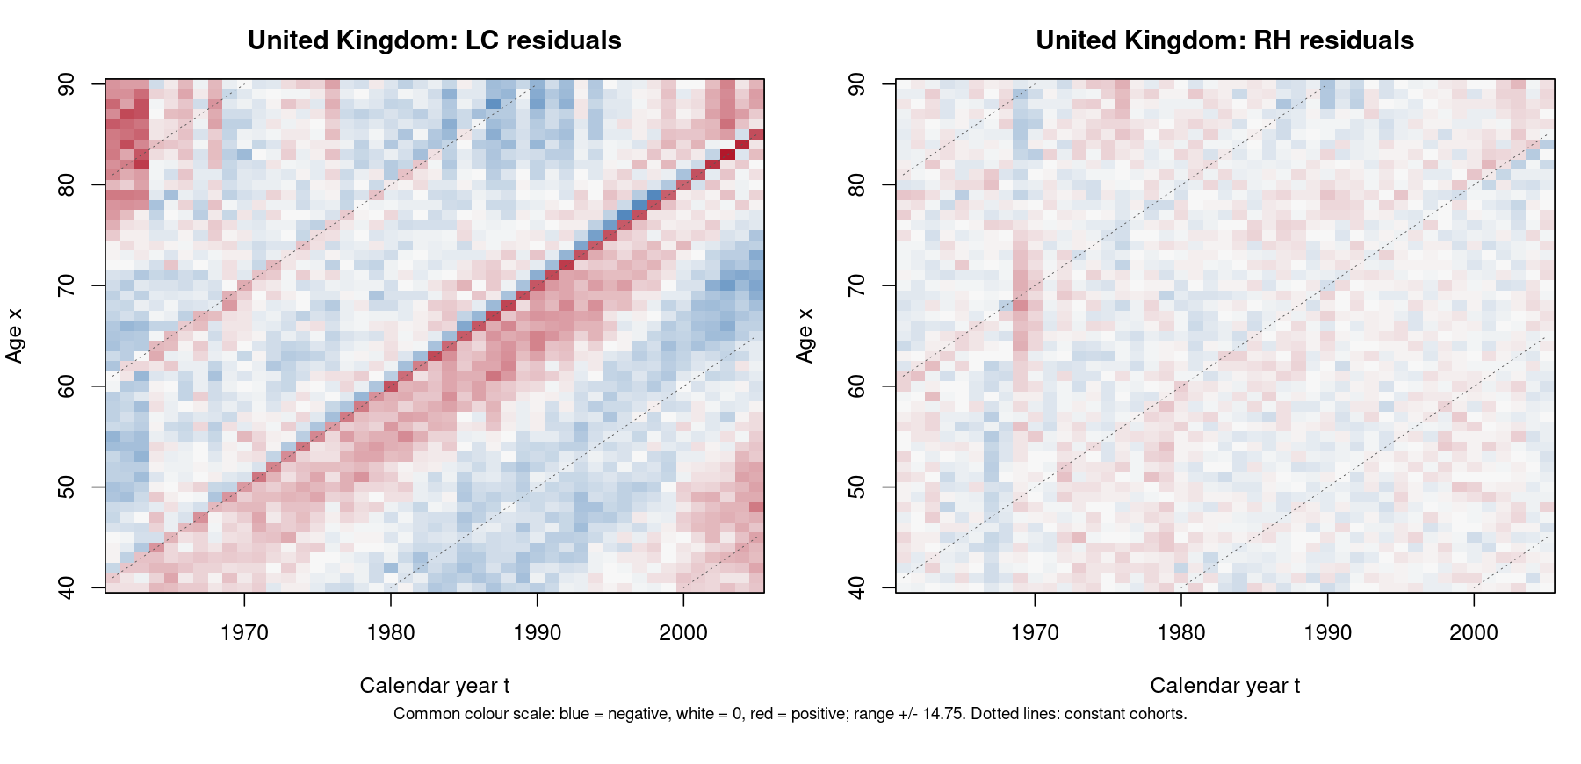
Figure 4. UK LC and RH residual heatmaps using the same definition, axes and colour limits.
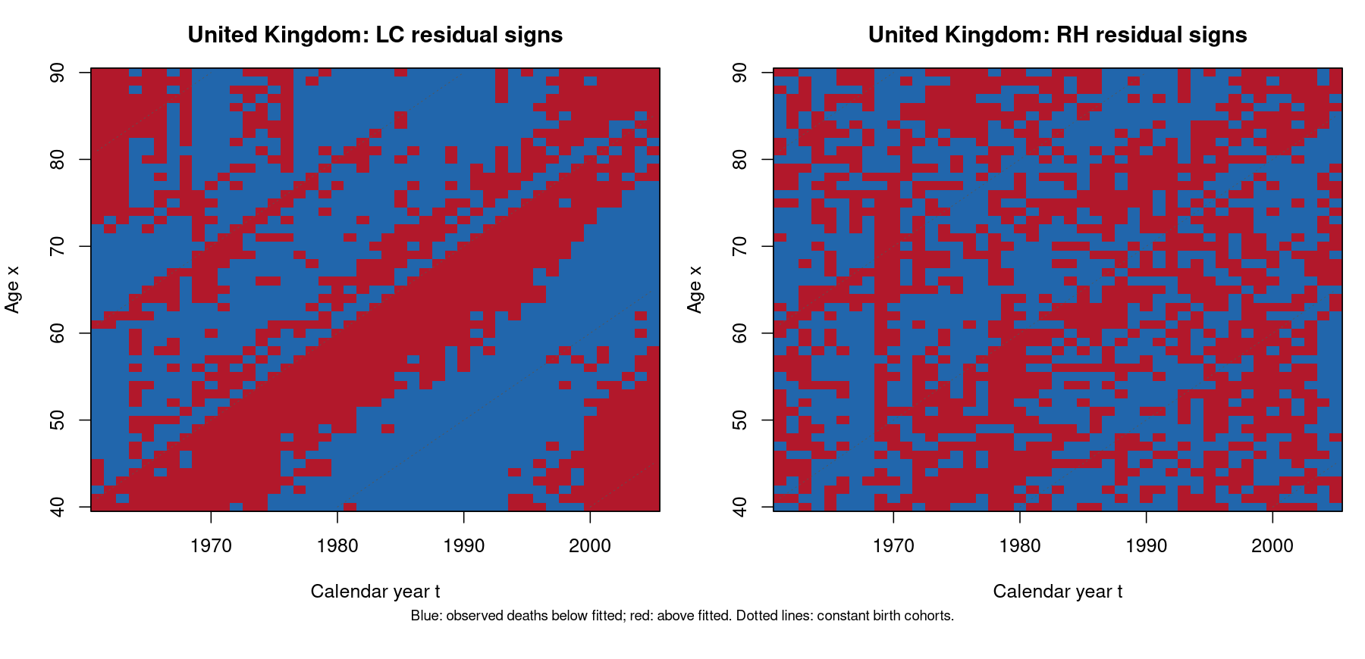
Figure 5. UK residual signs before and after including the cohort term.
The prominent same-sign diagonal bands in the UK LC residuals are substantially weakened by RH. The RH heatmap is generally closer to zero, while the sign map is more mixed and less dominated by coherent diagonal strips. Some local structure remains, so the cohort effect should be described as reduced rather than completely eliminated.
UK model | Cells | Parameters¹ | Poisson deviance | Log-rate RMSE
LC | 2295 | 145 | 25,591.761 | 0.04200
RH | 2295 | 288 | 4,278.376 | 0.01773
¹ Parameter counts reported by StMoMo for these fitted model specifications.
The UK Poisson deviance decreases from 25,591.761 to 4,278.376, a reduction of approximately 83.3%. The log-rate RMSE decreases from 0.04200 to 0.01773. These are descriptive in-sample measures, not a formal likelihood-ratio test or evidence that future forecasts must improve. The model has more parameters, so the key evidence for addressing the cohort effect is the reduction of the diagonal residual structure using the same visualisation.
RH improves the fit because its cohort term can represent deviations shared by people born in the same year across different ages and calendar years. The single LC period factor cannot fully reproduce this pattern. The additional term therefore addresses the specific residual feature identified in part (a), while retaining the age and period components taught in class. Cohort estimates near the edges rely on fewer observed age–year cells and should be interpreted cautiously.

Reproducibility and references
The accompanying Q3_analysis.R reads the four original text files, checks the data, fits both LC models and the UK RH model, and exports the parameter plots, residual plots, fitted rates, parameter tables and diagnostics. It sets a reproducible random seed and records sessionInfo(). Forecasting blocks in the classroom example are not used because Q3 does not request projections.
References: ACTL90007 Assignment 2 (2026), Q3; Unit 4 notes, LC and cohort-model sections, particularly pp.50–58; lecturer’s LC_APC.R. Week 10 covers LC estimation, but the supplied R example’s StMoMo method is used here as required by Q3. The original teaching script is preserved separately; its final undefined RH.simple.fit reference is corrected to RH.fit in the assignment implementation.

