This is the result of case 5 (0.5,0.5,5,0.5)
std=0.2
Theta = 0.5
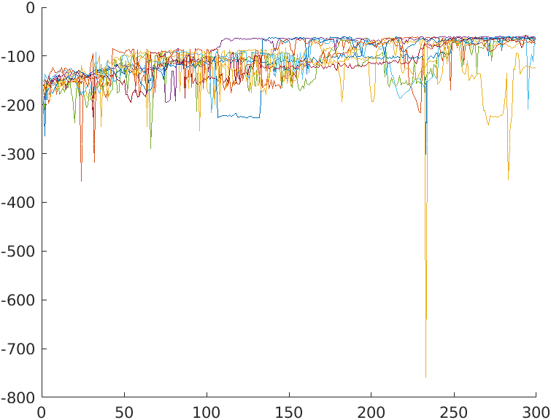

theta = 0.15
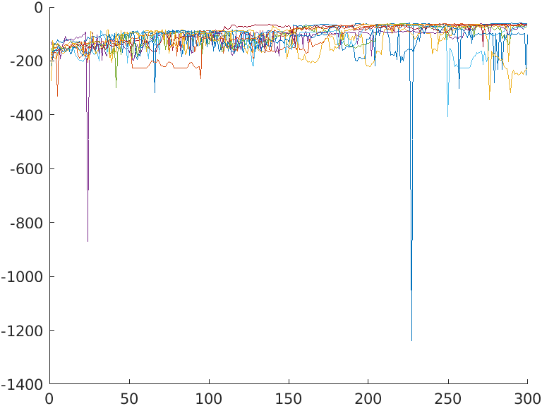

theta = 0.05

