My Doll will **simulate 7 basic emotions** basic on the feelings of human, it contain joy, anger, sadness, fear, love, disliking and liking performing on the LED eyes and month, its’s sound and shake.

The concept of "basic" or "primary" emotions dates back at least to the Book of Rites, a first-century Chinese encyclopedia that identifies seven ‘feelings of men’: joy, [anger](https://www.psychologytoday.com/us/basics/anger), sadness, [fear](https://www.psychologytoday.com/us/basics/fear), love, disliking, and liking.

<https://www.psychologytoday.com/us/blog/hide-and-seek/201601/what-are-basic-emotions>

Joy-

[](https://www.google.com/url?sa=i&rct=j&q=&esrc=s&source=images&cd=&cad=rja&uact=8&ved=2ahUKEwiUzJXV3YXiAhXGvJ4KHSmEDQgQjRx6BAgBEAU&url=https%3A%2F%2Fwww.dreamstime.com%2Fjoy-emotion-gracious-beautiful-girl-straight-white-hair-portrait-joy-emotion-gracious-image107972407&psig=AOvVaw23liVQKwl2nEJCajs7Cros&ust=1557191801982496) [](https://www.google.com/url?sa=i&rct=j&q=&esrc=s&source=images&cd=&cad=rja&uact=8&ved=2ahUKEwiLnfvj3YXiAhVRrJ4KHT41DyoQjRx6BAgBEAU&url=https%3A%2F%2Fwww.123rf.com%2Fphoto_36912290_stock-vector-smiley-emotion-of-joy.html&psig=AOvVaw23liVQKwl2nEJCajs7Cros&ust=1557191801982496)

Anger-

[](https://www.google.com/url?sa=i&rct=j&q=&esrc=s&source=images&cd=&cad=rja&uact=8&ved=2ahUKEwiZi5z03YXiAhUWnZ4KHc1PAcIQjRx6BAgBEAU&url=https%3A%2F%2Fwww.churchtimes.co.uk%2Farticles%2F2014%2F2-may%2Ffeatures%2Ffeatures%2Fanger-the-problem-emotion&psig=AOvVaw1N21-qsRGvHcygHIyXwDif&ust=1557191863880316) [](https://www.google.com/url?sa=i&rct=j&q=&esrc=s&source=images&cd=&cad=rja&uact=8&ved=2ahUKEwj7-5v73YXiAhVJnJ4KHQ2kDAMQjRx6BAgBEAU&url=https%3A%2F%2Fwww.workshopsaz.org%2Fpowerful-emotion-422016%2F&psig=AOvVaw1N21-qsRGvHcygHIyXwDif&ust=1557191863880316)

Sadness-

[](https://www.google.com/url?sa=i&rct=j&q=&esrc=s&source=images&cd=&cad=rja&uact=8&ved=2ahUKEwik-6GR3oXiAhWQvp4KHeAOBoIQjRx6BAgBEAU&url=https%3A%2F%2Fdepositphotos.com%2F142395310%2Fstock-photo-devastated-depressed-woman-crying-sad.html&psig=AOvVaw0fJfgqquFi9Q5bt-YWwwWa&ust=1557191910287239)[](https://www.google.com/url?sa=i&rct=j&q=&esrc=s&source=images&cd=&cad=rja&uact=8&ved=2ahUKEwikhJOb3oXiAhVHjp4KHer3AVEQjRx6BAgBEAU&url=https%3A%2F%2Fwww.iconfinder.com%2Ficons%2F2814478%2Femotion_sad_sadness_icon&psig=AOvVaw0fJfgqquFi9Q5bt-YWwwWa&ust=1557191910287239)

Fear-

[](https://www.google.com/url?sa=i&rct=j&q=&esrc=s&source=images&cd=&cad=rja&uact=8&ved=&url=http%3A%2F%2Fsocialpsychonline.com%2F2016%2F08%2Ffear-appeals-persuasion-psychology%2F&psig=AOvVaw1_I10BGd8zLEYeDbVAfqU-&ust=1557191974858179)[](https://www.google.com/url?sa=i&rct=j&q=&esrc=s&source=images&cd=&cad=rja&uact=8&ved=&url=http%3A%2F%2Fchunky-emo.blogspot.com%2F2010%2F12%2Ffear-emotion.html&psig=AOvVaw1_I10BGd8zLEYeDbVAfqU-&ust=1557191974858179)

Love-

[](https://www.google.com/url?sa=i&rct=j&q=&esrc=s&source=images&cd=&cad=rja&uact=8&ved=2ahUKEwijm7bM3oXiAhUEvJ4KHfOgBnsQjRx6BAgBEAU&url=https%3A%2F%2Fwww.123rf.com%2Fphoto_18349365_an-in-love-young-couple-in-romantic-emotion-with-similar-red-dress.html&psig=AOvVaw2BWnjRm_GK7l8yejXeAt8J&ust=1557192040357431) [](https://www.google.com/url?sa=i&rct=j&q=&esrc=s&source=images&cd=&cad=rja&uact=8&ved=2ahUKEwj2-_LU3oXiAhXXpZ4KHS3RAKAQjRx6BAgBEAU&url=https%3A%2F%2Fwww.vectorstock.com%2Froyalty-free-vector%2Flove-emoji-face-love-emotion-icon-vector-15705719&psig=AOvVaw2BWnjRm_GK7l8yejXeAt8J&ust=1557192040357431)

Disliking-

[](https://www.google.com/url?sa=i&rct=j&q=&esrc=s&source=images&cd=&cad=rja&uact=8&ved=2ahUKEwjLiaf53oXiAhWIpp4KHRSWBeIQjRx6BAgBEAU&url=https%3A%2F%2Fdepositphotos.com%2F152846576%2Fstock-photo-i-am-sick-of-this.html&psig=AOvVaw1iqU26NDYSMTEadp2cG3Rm&ust=1557192144228337)

Liking-

[](https://www.google.com/url?sa=i&rct=j&q=&esrc=s&source=images&cd=&cad=rja&uact=8&ved=2ahUKEwj6wKqH34XiAhVCqZ4KHVrBBHcQjRx6BAgBEAU&url=https%3A%2F%2Fpositivepsychologyprogram.com%2Fpositive-emotions-list-examples-definition-psychology%2F&psig=AOvVaw30qFyBy3LyHWWBhJHOL_ns&ust=1557192169514081)

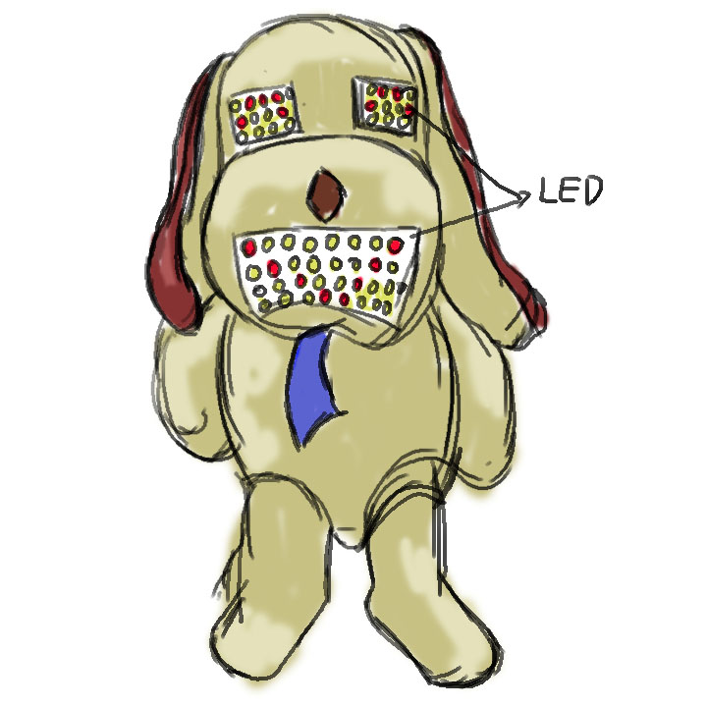

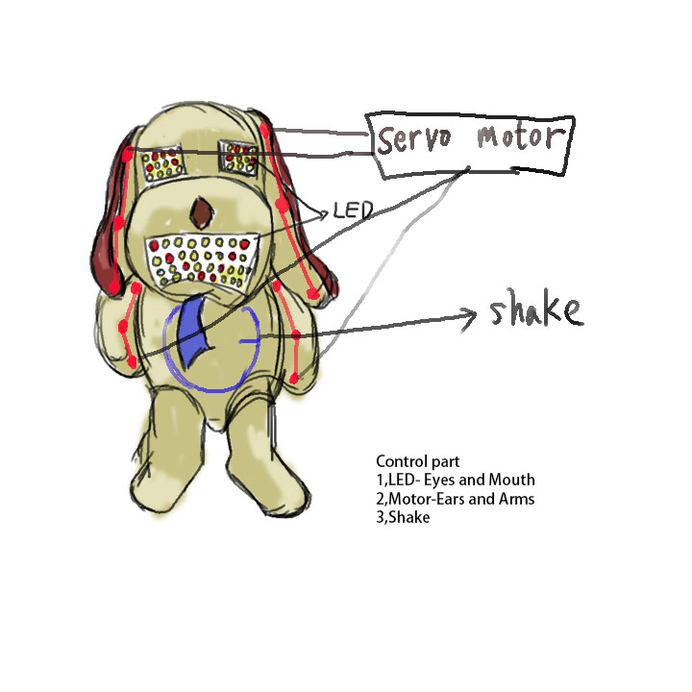**When they will perform different emotion?**

**What game can be play in AR?**