NRT Hot Topics: Agentic AI, 2026
Week 1 Tutorial: VS Code, Jupyter, and Claude Code
Hands-on setup and first coding workflow
Goal for today
Leave the session able to open a project folder in VS Code, run and debug Python locally, work with a Jupyter notebook, and use Claude Code to review or edit code when access is available.

By the end, you should be able to...
1. Open a project as a VS Code workspace.
2. Select the Python interpreter / notebook kernel you intend to use.
3. Run a Python script and use a breakpoint.
4. Run notebook cells inside VS Code.
5. Ask Claude Code to inspect code, propose a change, and verify the result yourself.

Warm-up: Create your workspace
- Launch VS Code. If it is not installed, install it from the official VS Code site at official tutorial.
- Create a folder named ‘NRTAgentLab’ on your Desktop. If you love terminal, try following command
mkdir ~/Desktop/NRTAgentLab

No command line required
You can create the NRTAgentLab folder using your computer's normal file browser. Terminal commands are optional for this tutorial.

- In VS Code, choose File → Open Folder… and select NRTAgentLab.
Why open a folder instead of only a file?
Claude Code, Python tools, notebooks, terminals, and debuggers work more reliably when VS Code knows the whole project workspace.


Checkpoint
☐ VS Code is open.
☐ NRTAgentLab is open as the current folder/workspace.

Part 1 — Install the essential VS Code extensions
Open the Extensions view from the left Activity Bar.
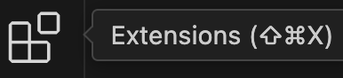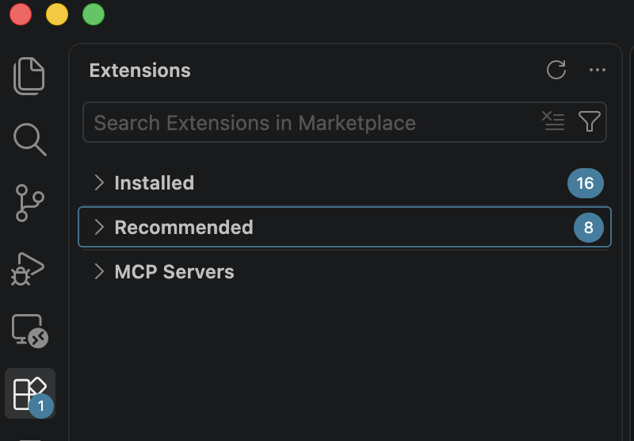

Recommended extensions
Extension | Why you need it
Python | Interpreter selection, IntelliSense, running scripts, and debugging.
Jupyter | Notebook editing, kernels, cell execution, and notebook outputs.
Claude Code for VS Code | AI coding assistant integrated into the IDE.
Claude Terminal (optional) | Alternative way to open Claude CLI in the editor area if your workflow uses it.

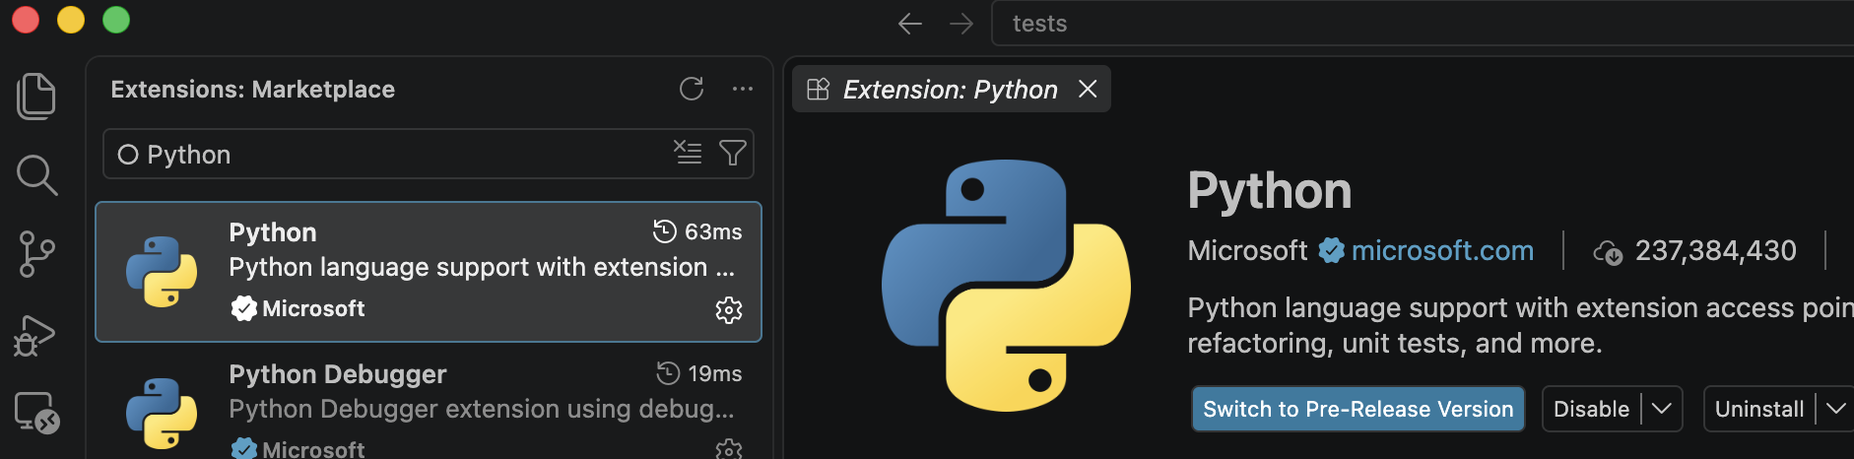
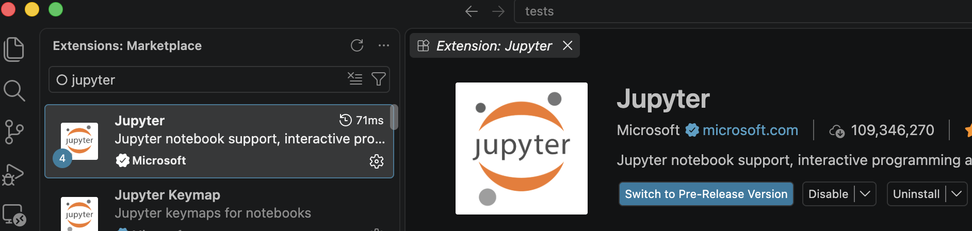
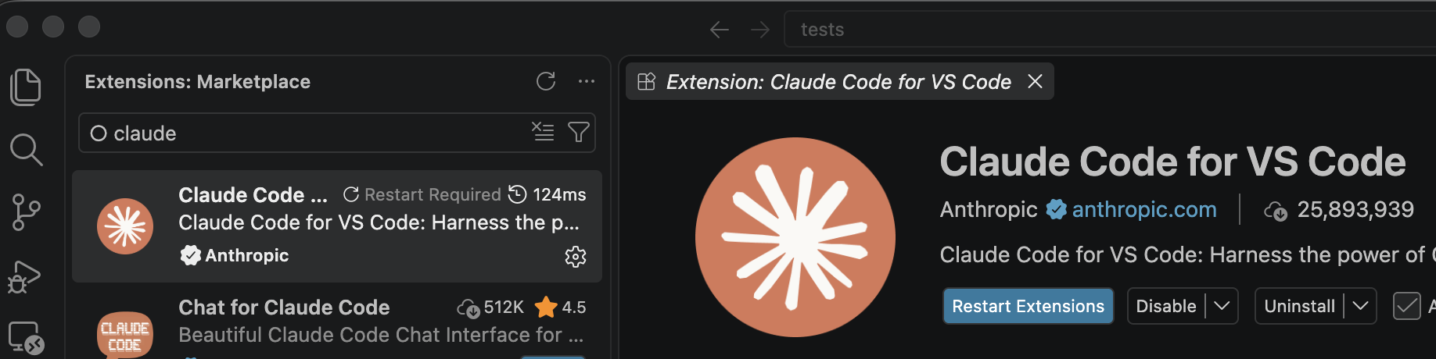
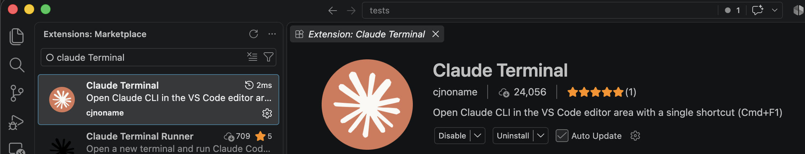
Tip
- If more than one extension has a similar name, confirm the publisher and description before installing.
- The Python extension teaches VS Code how to work with Python. The Python interpreter is the software that actually runs Python code. In Part 2, we install Anaconda to provide Python and common data-science packages.

Checkpoint
☐ Python extension installed.
☐ Jupyter extension installed.
☐ Claude Code extension installed if you have access.

Part 2 — Set up Python and verify the interpreter
Why Anaconda for this workshop?
Anaconda provides Python, Jupyter, and many commonly used data-science packages in one installation. For today's tutorial, you do not need to create a virtual environment or use conda commands.

2.1 Install Anaconda
1. Download the current Anaconda Distribution for your operating system from the official Anaconda website: https://www.anaconda.com/download
2. Follow Anaconda's normal installation instructions for Windows, macOS, or Linux.
3. When installation finishes, restart VS Code if it was already open.
No terminal setup required today
You do not need to open Anaconda Prompt or Terminal, and you do not need to run conda create or conda activate for this tutorial.

2.2 Let VS Code find Anaconda's Python
1. Create or open hello.py inside your NRTAgentLab folder.
2. Look at the Python interpreter shown in the VS Code status bar.
a. In VS Code versions, the selected Python interpreter is usually shown in the bottom-right area of the status bar when a Python file such as hello.py is open.
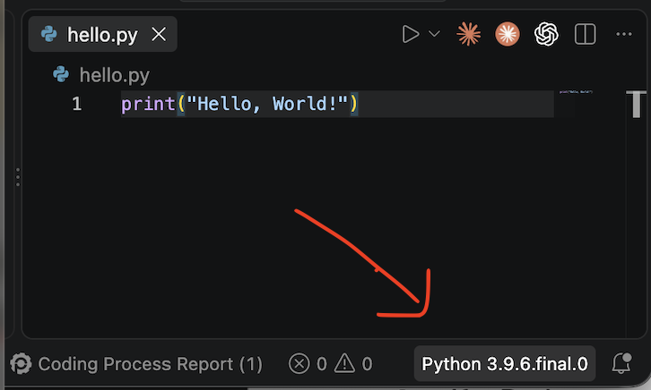
b. If you do not see it, the easiest method is:
- Open hello.py in VS Code.
- Press Ctrl+Shift+P on Windows/Linux or Cmd+Shift+P on macOS.
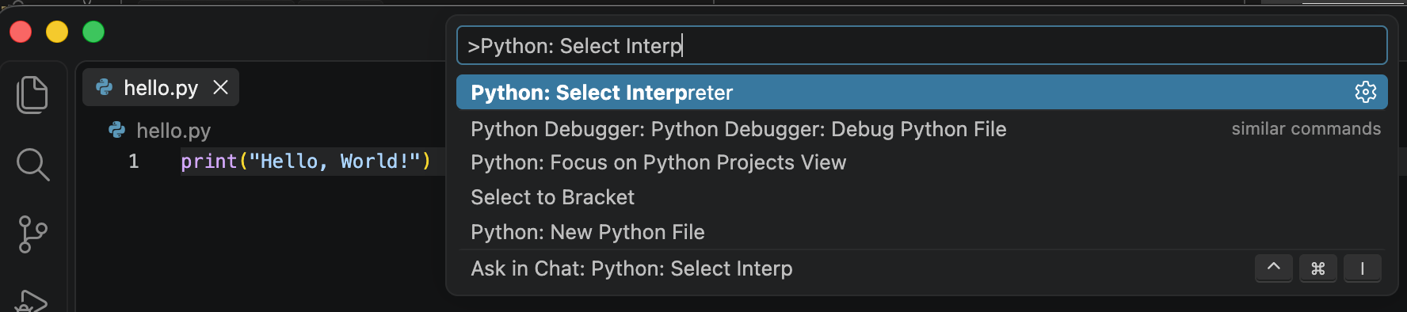
- Type Python: Select Interpreter.
- Choose one of the listed Python interpreters, preferably the one associated with Anaconda or conda.
- After selection, VS Code should use that Python for the file.
3. If a Python version is already selected, continue to Part 3.
4. If VS Code asks you to select an interpreter, choose an available Python 3 interpreter associated with Anaconda or conda.
5. If no Python interpreter appears, ask an instructor for help before continuing.
What should you see?
A Python 3.x interpreter should be selected in VS Code. The exact version may differ across computers.

Checkpoint
☐ Anaconda is installed.
☐ VS Code shows a Python 3 interpreter.
☐ No command-line environment setup was required.

Part 3 — Run and debug a Python script
  - Create hello.py inside NRTAgentLab.
  - Enter the following code:
def greet(name):
message = f"Hello, {name}!"
return message
student_name = "NRT"
print(greet(student_name))

  - Run the file using the Run button.
  - Set a breakpoint on the line that creates message, then start the debugger.
  - Use Step Over and inspect name and message in the Variables panel.
Checkpoint
☐ hello.py runs.
☐ You stopped at a breakpoint.
☐ You inspected at least one variable while debugging.

Part 4 — Jupyter notebooks inside VS Code
  - Create first_notebook.ipynb inside NRTAgentLab.
  - When VS Code asks you to choose a kernel, select the available Python/Anaconda environment.
  - Run this first cell:
print('Notebook is running in VS Code')

  - Create another code cell and try a small Python calculation:
values = [2, 4, 6, 8]
mean_value = sum(values) / len(values)
mean_value

What to practice
Run one cell at a time.
Edit a cell and rerun it.
Inspect output directly below a cell.
Save, close, and reopen the notebook.
Know where to change the notebook kernel if VS Code asks you to choose one.

Checkpoint
☐ first_notebook.ipynb runs inside VS Code.
☐ A Python kernel is selected.
☐ You can edit, rerun, save, and reopen the notebook.

If something does not run
What you see | What to try
No Python option appears | Restart VS Code after installing Anaconda, then select the Python interpreter again.
Notebook asks for a kernel | Choose the available Python/Anaconda kernel.
You are unsure which option to choose | Ask an instructor rather than changing environment settings or using terminal commands.

Part 5 — Claude Code inside VS Code
Access note
Complete this section if you already have Claude Code access through an eligible subscription or account. If not, you can skip this section today and return to it when access is provided.

5.1 Open Claude Code
Open hello.py. With the Claude Code extension installed, use the Claude Code control in VS Code.
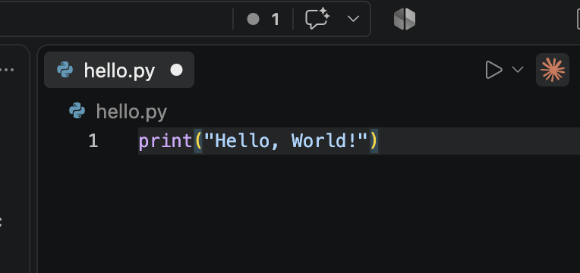

5.2 Sign in
Follow the sign-in flow shown by the extension.
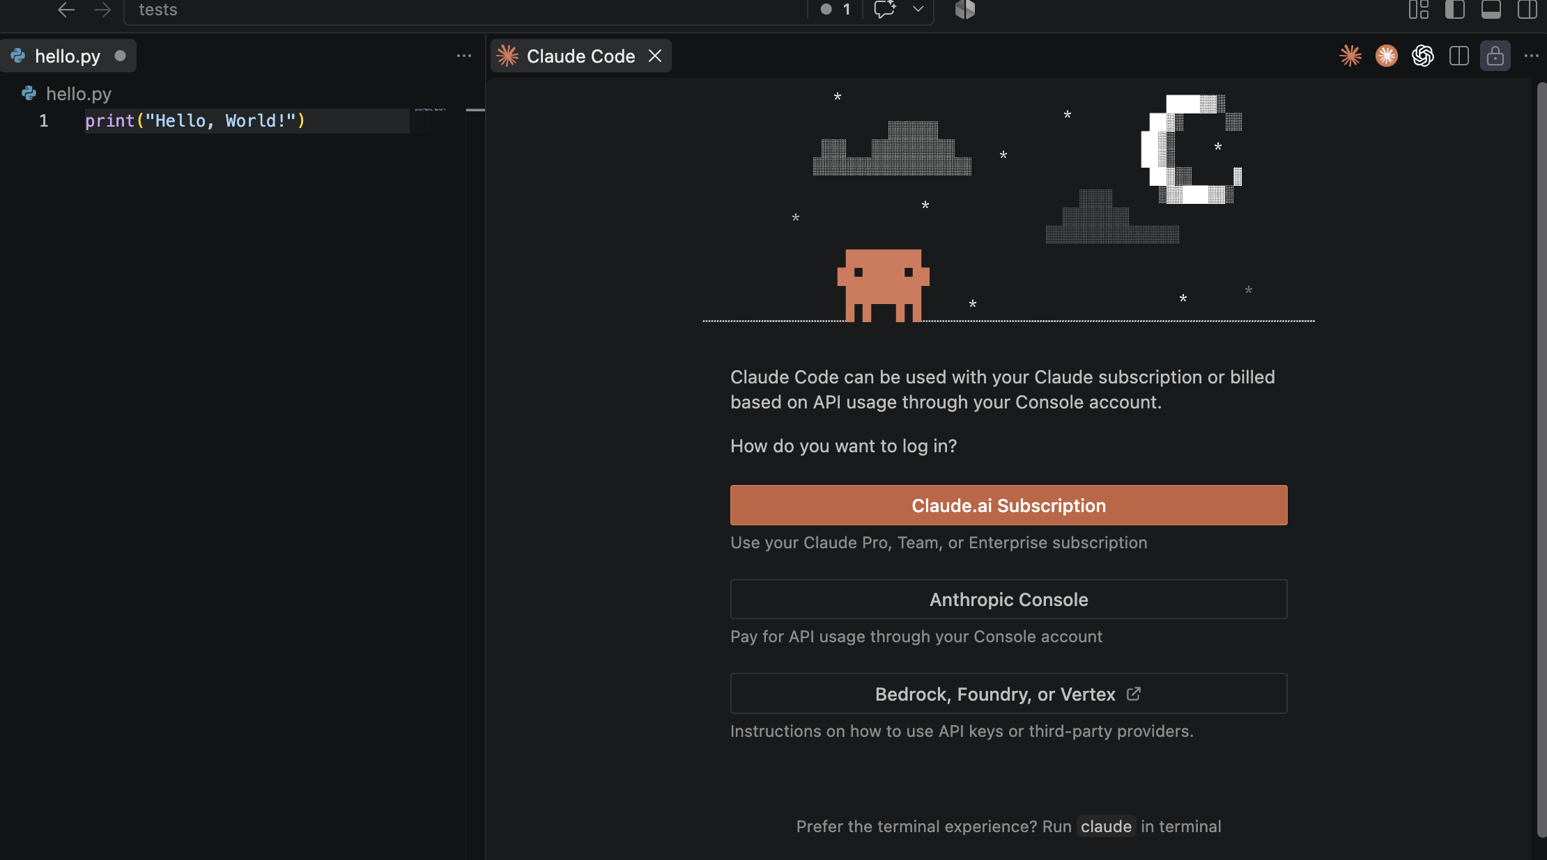
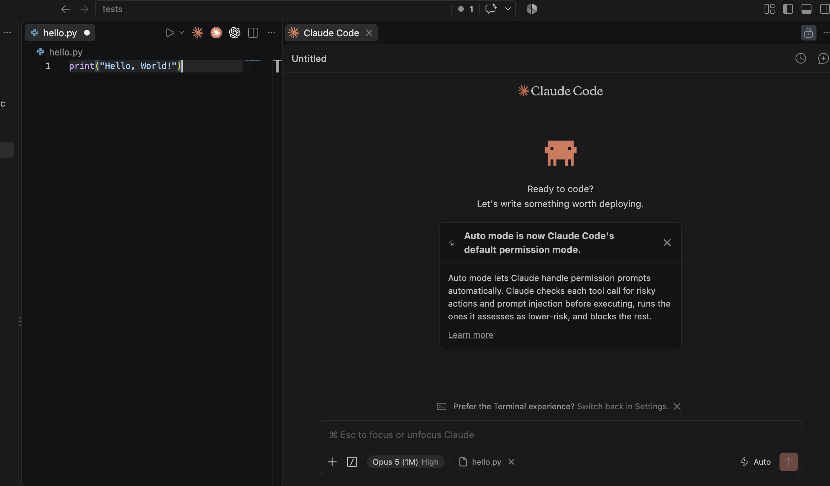

5.3 Practice a review-first workflow
Start by asking Claude to inspect the file without changing it:
Review hello.py. Explain what the code does and suggest one small improvement. Do not modify the file yet.

Read the explanation. Then, if the suggestion is reasonable, ask:
Implement the improvement you proposed. Keep the program simple, and tell me exactly what you changed.

Review the proposed edit before accepting it. Then rerun hello.py yourself.
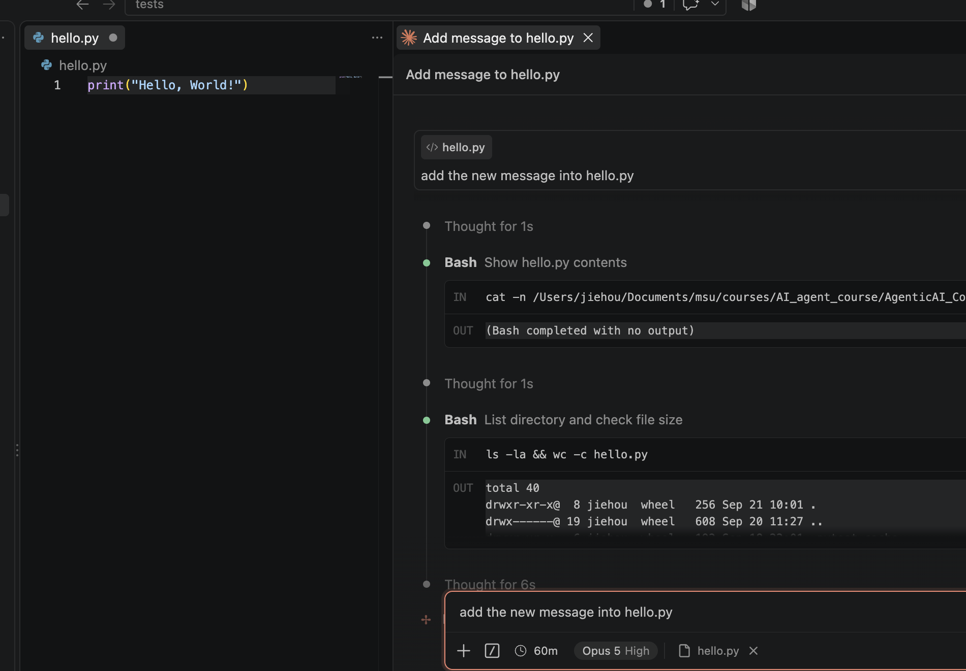

Part 6 — Good practice when using Claude Code
Four habits to build now
1. Give context. Open the project folder and tell Claude which file or task to inspect.
2. Separate review from editing. Ask for an explanation or plan before accepting a code change.
3. Verify everything. Run the code, inspect outputs, and use the debugger when needed.
4. Protect sensitive information. Do not paste passwords, API keys, private credentials, or restricted data into prompts or source files.

Mini challenge
Complete the following sequence with hello.py:
- Ask Claude to explain the current file without editing it.
- Ask Claude to modify greet() so it can greet two names.
- Review the edit before accepting it.
- Run the file yourself.
- Set a breakpoint and confirm that the updated variables contain the values you expect.
- If something is wrong, describe the observed behavior to Claude rather than simply asking it to 'fix everything.'

Wrap-up checklist
☐ I can open a project folder in VS Code.
☐ I know which Python interpreter VS Code is using.
☐ I can run and debug a .py file.
☐ I can run a Jupyter notebook and identify its kernel.
☐ I can ask Claude Code to review or modify a file when access is available.
☐ I know that AI-generated code still needs my review and testing.
Next session
We will build on this setup and move toward deeper Claude Code use and agent-oriented development workflows.

