**Git Commands**

**git config**

Usage: git config –global user.name [name]

Usage: git config –global user.email [email address]

This command sets the author name and email address respectively to be used with your commits.

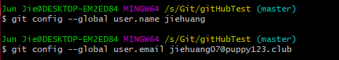

**git init**

Usage: git init [repository name]

This command is used to start a new repository.



**git status**

Usage: git status

This command lists all the files that have to be committed.

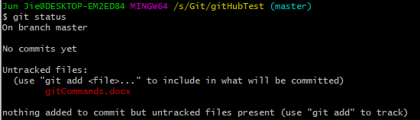

**git add**

Usage: git add [file]

This command adds a file to the staging area.

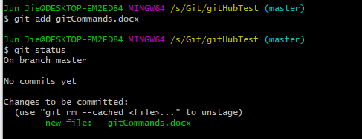

**git commit**

Usage: git commit -m “[Type in the commit message]”  [file]

Or git commit [file]

This command records or snapshots the file permanently in the version history. After committing all files, working tree is clean and nothing to commit.

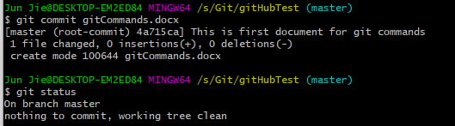

**git diff**

Usage: git diff

This command shows the file differences which are not yet staged.

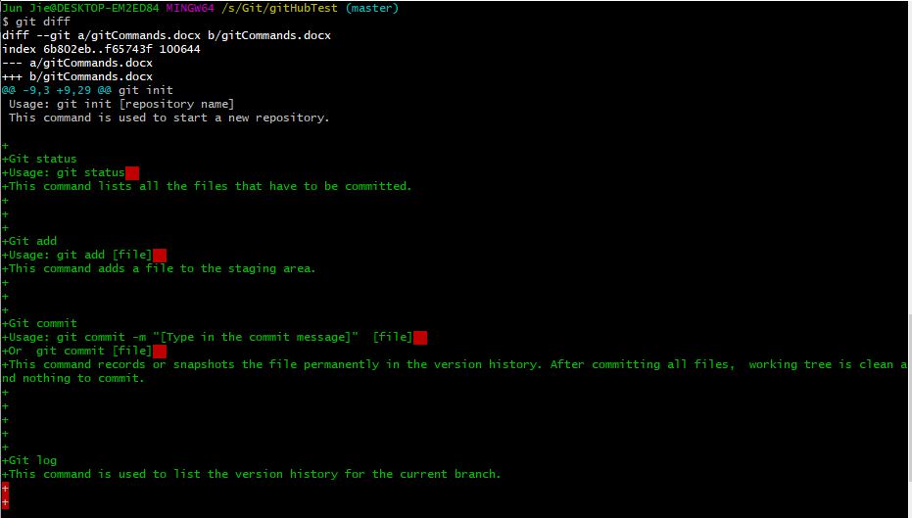

**git log**

Usage: git log

This command is used to list the version history for the current branch.

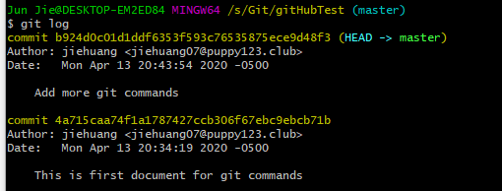

**git log --oneline**

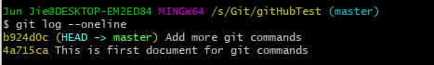

**git reflog**



**git reset**

Usage: git reset –hard [commit]

This command discards all history and goes back to the specified commit.



**git remote**

Usage: git remote add [variable name] [Remote Server Link]

This command is used to connect your local repository to the remote server.

