
Assignment
Programme | : | Diploma in Computer Science
Subject Code | : | PROG2114
Subject Name | : | Adv Java Programming
Lecturer Name | : | So Yong Quay
Academic Session | : | 2026C
Detail:
Assignment Title: | Assignment - Individual
Names: | Siow Yong Hui
Student ID: | D250110B
Phone No: | 016 6751876
Email: | Avr7581@gmail.com
Due Date: | 13 Nov 2026

Assessment:
MARK: | Comments:
This cover sheet must be completed and firmly attached to the front of the submission. All works must be submitted by the due date.
Please note that it is the student’s responsibility to retain a copy of his / her own assignment.

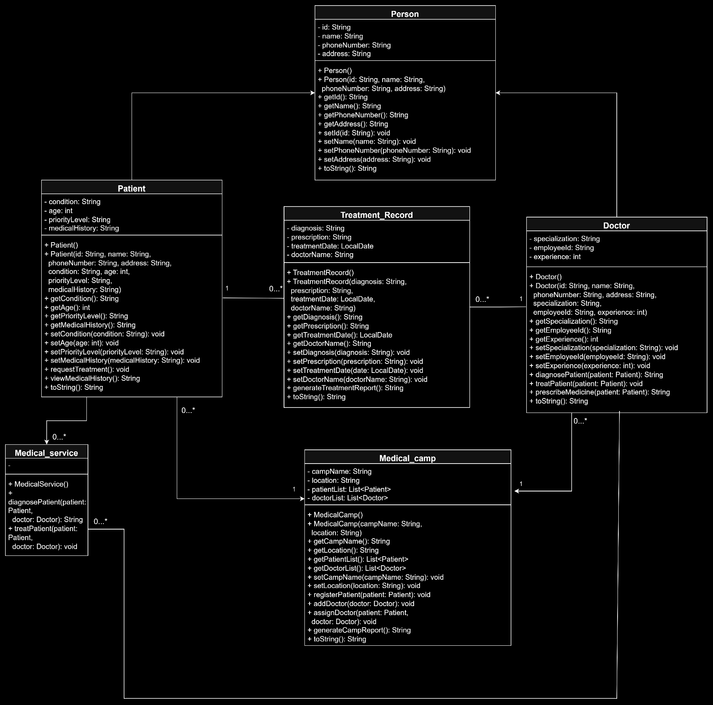
- UML class diagram

2.0 Brief Report
Introduction
A system to manage patients, doctors and treatment records in the time of emergency is known as Medical Camp Management System. It is based on Object Orientated Programming (OOP) concepts for improving system organization, reusability and maintainability.

Encapsulation
Encapsulation means to hide the data which in this case means declaring attributes as private (-) and having public (+) getter and setter. An example of this is the class Patient, which includes getAge() and setAge() methods for getting and setting the patient's age.

Inheritance
Classes may inherit attributes and methods of other classes. Common information between the classes Person and Patient (like ID, name, phone number, address) are kept in the Person class; this can be shared without duplication.

Polymorphism
In some classes, the same method may have different behaviors; this is called polymorphism. For instance, Patient and Doctor can override the toString( ) inherited from Person to print their own information.

Abstraction
Abstraction abstracts out complex operations, and displays only the essential ones. Methods in the MedicalService class are called without revealing the implementation details, like diagnosePatient() and treatPatient().

Class Relationships
Adheres to Person, Patient and Doctor's Inheritance Relationship. Aggregation links MedicalCamp to Patient & Doctor and associations link TreatmentRecord to Patient & Doctor. MedicalService communicates with the Patient and the Doctor to carry out medical services.

4.0 Conclusion
Additionally, by implementing the OOP concepts, the Medical Camp Management System becomes more structured, reusable, safe, and maintainable.

