

MULTIMEDIA UNIVERSITY®

TSE2101

(Software Engineering Fundamentals)

Employee Training Management System

Prepared by



LEE XI JIE 1161204459

TEO MING ZE 1161204548

EU JUN HONG 1151205564

MUHAMMED ALIMRAN 1161203939

TABLE CONTENT

Page

Software Requirements Specifications 3-6

Problem Statement 7

User Stories 8

Use Case Diagram 9

Use Case Diagram Table 10-24

Business Rule 25

Entity Relational Diagram 27

Class Diagram 28

Sequence Diagram 29-32

Process Model Chosen 33

Flowchart 34-37

Part 1 : Requirements Engineering

**Purpose**

The purpose of this document is to build an employee training management system to manage the training courses and assign to the company trainee.

**Intended Audience and Reading Suggestions**

This project is a prototype for the training management system and it is used within the company. This is implemented under the guidance of HR Staff and also Admin. This system is useful for the training management as well as to the college.

**Project Scope**

The purpose of the employee training management system is to ease the college to create a convenient application for trainer and also trainee. The system is based on a relational database with its training management and application functions. The aim of us is to provide a comfortable user experience to use the system.

**Operating Environment**

Operating environment for the training management system is as listed below

* Distributed database
* Client/Server system
* Operating System : Windows
* Database : SQL Database
* Platform : PHP/JAVASCRIPT/HTML/CSS

**User Interfaces**

Front-end software : PHP

Back-end software : SQL+

**Hardware Interfaces**

Windows

A browser which supports HTML, Javascript, PHP, CSS

**Communication Interfaces**

This project supports many types of web browsers, we are using simple form to organize a training course.

The system <FUXION> SHALL able to allow Admin to manage the training courses and assign it to trainer and provide to trainee.

The system <FUXION> SHALL able to allow Admin to has the full access of all user accounts details to provide more convenience change of data by admin

The system <FUXION> SHALL able to allow Admin to manage the resources’ availability in order to provide efficient booking reservation room for training.

The system <FUXION> WILL able to allow Admin to receive feedback from trainees/trainer in order to provide more efficient of the training courses.

The system <FUXION> WILL able to allow Admin to receive request joining training from trainees/trainer in order to provide more efficient of the training courses.

The system <FUXION> SHALL able to allow HR Staff to create/edit a training course and assign it to trainer and also trainee to join

The system <FUXION> SHALL able to allow HR Staff to create/edit user’s account details such as the department of the users (trainee,trainer) to avoid conflict of the department role

The system <FUXION> SHALL able to allow HR Staff to view the description of the training courses such as the list of the trainee joined and also conducted by which trainer

The system <FUXION> WILL allow Trainer to upload assignment to the training courses’ announcements for the trainee in order to enhance the trainee’s problem solving skills

The system <FUXION> WILL allow Trainer to create/edit announcement on dashboard and provide it to be visible for particular users (trainee,trainer)

The system <FUXION> SHALL allow Admin/HR Staff to upload the certificate and provide to user to download it.

 The system <FUXION> SHALL allow Trainer to view the description of the training courses which assigned by HR Staff so Trainer can prepare materials for it.

 The system <FUXION> SHALL allow Trainer to submit feedback form to the admin/hr.

The system <FUXION> SHALL allow trainer to submit request form in order to joining training.

The system <FUXION> SHALL allow Trainee to view information of the training courses which provided to them so they can be prepared for it.

The system <FUXION> SHALL allow Trainee to view announcements which posted by the trainer in order to get ready what to do for next.

The system <FUXION> SHALL allow Trainee to self-apply for joining courses which they have interested on it and want more implements for it in order to make their skills better

 The system <FUXION> SHALL allow Trainee to submit feedback form to the admin/hr.

The system <FUXION> SHALL allow Trainee to submit request form in order to joining training.

The system <FUXION> SHALL allow all the user to edit their personal data in the system so that they can update their profile.

**Problem Statement**

-Admin and HR Staff are able to create, edit or delete a training course and assign to trainer and participant by trainee.

-Trainees are able to request for joining a training course that they are interested in or they wanted to improve themselves through the training courses.

-Trainer are able to upload assignment to the particular training courses in order to ensure the trainee can catch up the training courses.

**User Story**

|  |  |  |
| --- | --- | --- |
| As a/an | I want to | So that I can |
| Admin | Manges training courses | Organize the training courses and assign it to trainer and also trainee |
| Admin | Manges user accounts | Add, edit and delete some redundancy data of the users. |
| Admin | Manages resources | Set the availability of the resources for training to avoid clashing |
| Admin | Receive feedback from trainer | Enhance the quality or performance of my company |
| Admin | Receive request from trainer and trainee | Receive request from trainer and trainee |
| HR Staff | Create, edit training courses | Organize training courses and assign it to trainer and trainee |
| HR Staff | Create, edit user accounts | Reduce the burden of the admin |
| HR Staff | Receive request from trainer and trainee | Receive request from trainer and trainee |
| Trainer | Create, edit announcement board | Reach the information to my trainee |
| Trainer | Create, edit assignment and attach in announcement | I can ensure that my trainee skills and help them to improve their performance |
| Trainer | Able view details of the training courses | Conduct the training course efficiently |
| Trainer | Able to give feedback to admin | I can evaluate about the training courses to admin |
| Trainee | Able view information of the training courses | Request for joining the training course |
| Trainee | Able view announcements posted by the Trainer | Receives the information they wan to reach us |
| Trainee | View the assignments and download the certificate for the training course | Submit my task to the trainer and has a prove |
| Trainee | Allow to request joining training courses | I can apply myself. |
| Trainee | Able to give feedback to admin | I can evaluate about the training courses to admin |

**Use Case Diagram**

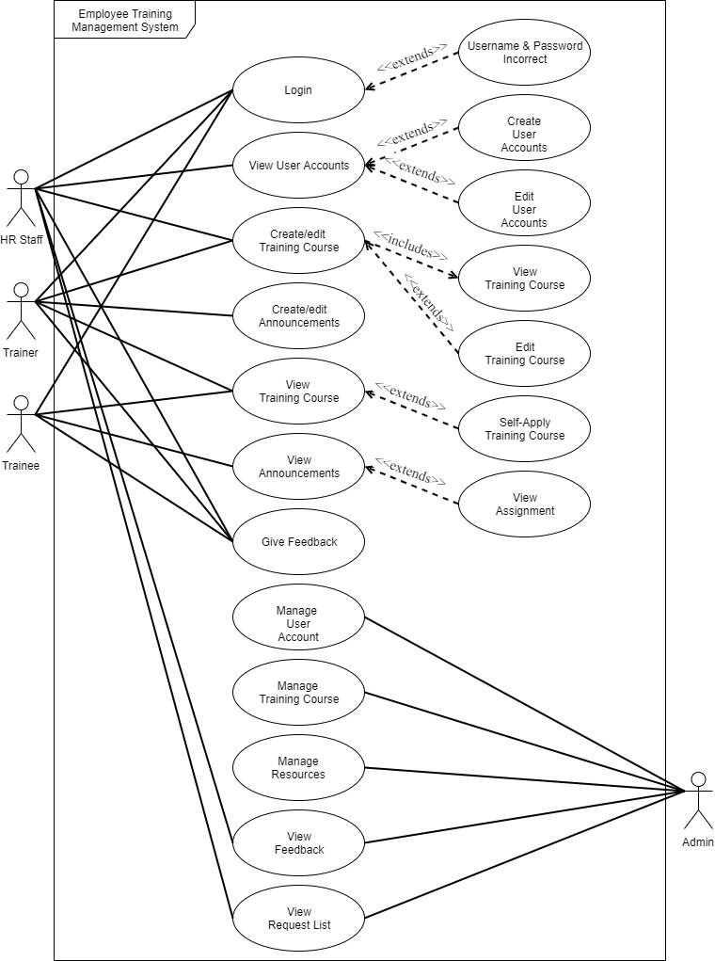

**UCDT**

**Admin**

|  |  |
| --- | --- |
|  | LOGIN |
| Precondition | Username must exist and the password must match the username’s password |
| Postcondition | Logged into the system & redirect to dashboard page |
| Main Flow | 1. User select login page 2. System determine the user’s username and password 3. System validates the user’s details 4. System verify the user’s access right |
| Alternate Flow |  |
| Exception Flow | 1. Error message if username and password does not match 2. A sentence of error will appear in the bottom part of the input field |

|  |  |
| --- | --- |
|  | MANAGE USER ACCOUNT |
| Precondition | User must have the access right to the manage user account page |
| Postcondition | Refresh the user account’s list page |
| Main Flow | 1. System check the user’s whether is it admin 2. System display all the user account’s list if he is admin and has the access right to manage 3. System display all the user account in list from database 4. Admin has the access right to manage (add,edit,delete) the user’s information 5. Admin confirm and send the updated information to database 6. System update and redirect to user account’s list page |
| Alternate Flow |  |
| Exception Flow | 1. System update information 2. For some of the filed that are not optional cannot be empty else the error message will be appear in the bottom part of the input field |

|  |  |
| --- | --- |
|  | MANAGE TRAINING COURSE |
| Precondition | User must have the access right to the manage training course page |
| Postcondition | Refresh the training course’s list page |
| Main Flow | 1. System check the user’s whether is it admin 2. System display all the training course’s list if he is admin and has the access right to manage 3. System display all the training course in list from database 4. Admin has the access right to manage (add,edit,delete) the training courses’ information 5. Admin confirm and send the updated information to database 6. System update and redirect to training courses’ list page |
| Alternate Flow |  |
| Exception Flow | 1. System update information 2. If the start date is later than the end date 3. System show error message in the bottom part of the input field 4. If the trainer is empty 5. System show error message in the bottom part of the input field |

|  |  |
| --- | --- |
|  | MANAGE RESOURCES |
| Precondition | User must have the access right to the manage resources pages. |
| Postcondition | Refresh the resources’ page |
| Main Flow | 1. System check the user’s whether is it admin 2. System display all the resources’ list if is an admin access right 3. Admin has the access right to manage (add,edit,delete) the resources’ information 4. Admin confirm and send the updated information to database 5. System update and redirect to resources’ list page |
| Alternate Flow |  |
| Exception Flow | 1. System update information 2. For some of the filed that are not optional cannot be empty else the error message will be appear in the bottom part of the input field 3. For example, the room venue cannot be empty |

|  |  |
| --- | --- |
|  | Assign Training Course |
| Precondition | User must have the access right to the assign page. |
| Postcondition | Refresh the assign’ page |
| Main Flow | 1. System check the user’s whether is it admin 2. System display all the assign’ list if is an admin access right 3. Admin has the access right to manage (add,edit,delete) the assign information 4. Admin confirm and send the updated information to database 5. System update and redirect to assign page |
| Alternate Flow |  |
| Exception Flow | 1. System update information 2. If the user Is taken other training course it will not show in the user list |

|  |  |
| --- | --- |
|  | View Feedback |
| Precondition | User must have the access right to the feedback page |
| Postcondition | Refresh the feedback page |
| Main Flow | 1. System check the user’s whether is it admin 2. System display all the feedback list if is an admin access right 3. Admin has the access right to view the description of the feedback |
| Alternate Flow |  |
| Exception Flow | 1. If the User_Type != admin/hr it not able to see the feedback list |

**HR STAFF**

|  |  |
| --- | --- |
|  | CREATE/EDIT USER ACCOUNT |
| Precondition | The HR Staff must have login credentials to the system |
| Postcondition | The HR Staff is granted access to the system. |
| Main Flow | 1. System check the user’s whether is he has the access right 2. System display all the user account list from database 3. HR Staff has the access right to view, create and edit some information of the user account 4. HR Staff confirm and send the updated information to database 5. System update and redirect to user account’s list page |
| Alternate Flow |  |
| Exception Flow | 1. System update information 2. For some of the filed that are not optional cannot be empty else the error message will be appear in the bottom part of the input field |

|  |  |
| --- | --- |
|  | CREATEEDIT TRAINING COURSE |
| Precondition | User must have the access right to the create training course page |
| Postcondition | Refresh the training course’s list page |
| Main Flow | 1. System check the user’s whether is it admin 2. System display all the training course’s list if he is HR Staff and has the access right to create and assign to trainer and trainee 3. System display all the training course in list from database 4. HR Staff has the access right to create and edit the training courses’ information 5. HR Staff confirm and send the updated information to database 6. System update and redirect to training courses’ list page |
| Alternate Flow |  |
| Exception Flow | 1. System update information 2. If the start date is later than the end date 3. System show error message in the bottom part of the input field 4. If the trainer is empty 5. System show error message in the bottom part of the input field |

|  |  |
| --- | --- |
|  | CREATE/EDIT RESOURCES |
| Precondition | User must have the access right to the manage resources pages. |
| Postcondition | Refresh the resources’ page |
| Main Flow | 1. System check the user’s whether is it HR 2. System display all the resources’ list if is an admin access right 3. Admin has the access right to manage (add,edit,delete) the resources’ information 4. Admin confirm and send the updated information to database 5. System update and redirect to resources’ list page |
| Alternate Flow |  |
| Exception Flow | 1. System update information 2. For some of the filed that are not optional cannot be empty else the error message will be appear in the bottom part of the input field 3. For example, the room venue cannot be empty |

|  |  |
| --- | --- |
|  | Assign Training Course |
| Precondition | User must have the access right to the assign page. |
| Postcondition | Refresh the assign’ page |
| Main Flow | 1. System check the user’s whether is it HR 2. System display all the assign’ list if is an admin access right 3. Admin has the access right to manage (add,edit,delete) the assign information 4. Admin confirm and send the updated information to database 5. System update and redirect to assign page |
| Alternate Flow |  |
| Exception Flow | 1. System update information 2. If the user Is taken other training course it will not show in the user list |

|  |  |
| --- | --- |
|  | View Feedback |
| Precondition | User must have the access right to the feedback page |
| Postcondition | Refresh the feedback page |
| Main Flow | 1. System check the user’s whether is it HR 2. System display all the feedback list if is an HR access right 3. HR has the access right to view the description of the feedback |
| Alternate Flow |  |
| Exception Flow | 1. If the User_Type != admin/hr it not able to see the feedback list |

**TRAINER**

|  |  |
| --- | --- |
|  | LOGIN |
| Precondition | Username must exist and the password must match the username’s password |
| Postcondition | Logged into the system & redirect to dashboard page |
| Main Flow | 1. User select login page 2. System determine the user’s username and password 3. System validates the user’s details 4. System verify the user’s access right |
| Alternate Flow |  |
| Exception Flow | 1. Error message if username and password does not match 2. A sentence of error will appear in the bottom part of the input field |

|  |  |
| --- | --- |
|  | GIVE FEEDBACK |
| Precondition | The trainer involved in training course |
| Postcondition | The trainer will be able to give feedback to admin |
| Main Flow | 1. System check the user’s access right 2. System display the feedback form for trainer in order to give suggestion to the training courses 3. System update and redirect to assignment upload page |
| Alternate Flow |  |
| Exception Flow | 1. If empty description, the bottom part of input field will appear an error message |

|  |  |
| --- | --- |
|  | REQUEST TO JOIN A TRAINING COURSE |
| Precondition | Login as User_Type Trainer |
| Postcondition | The trainre request will be sent to HR Staff/Admi |
| Main Flow | 1. System check the user’s access right 2. System display form request 3. Trainer are able to request for joining only one training courses 4. Trainee send request to HR Staff 5. System update and redirect to training courses page |
| Alternate Flow | HR Staff and Trainer can assign the trainee to join a particular training course |
| Exception Flow | 1. System update information 2. System determine the availability of the trainee 3. If trainee is taking one training course, system alert trainee that he/she cant request for more training 4. System show error message in the bottom part of input field |

|  |  |
| --- | --- |
|  | CREATE ANNOUNCEMENTS |
| Precondition | User must have the access right to view dashboard page and the trainer must has at least one valid training course |
| Postcondition | This announcement will be posted in the dashboard in order to let the trainee know |
| Main Flow | 1. System check the user’s whether is he has the access right 2. System display all the announcement that posted by that particular Trainer 3. Trainer has the access right to view, create and edit announcements of the training courses 4. Trainer specifies the settings, for example details of the announcements 5. System saves the announcements in the database. 6. System update and redirect to the dashboard page |
| Alternate Flow |  |
| Exception Flow | System update information  For some of the filed that are not optional cannot be empty else the error message will be appear in the bottom part of the input field  For example, if the announcement details is empty  System show error message in the bottom part of the input field |

|  |  |
| --- | --- |
|  | VIEW TRAINING COURSES THAT CURRENTLY TAKING |
| Precondition | The trainer must has joined into a training courses that assigned by admin/hr |
| Postcondition | The trainer will be able to view the details of training courses |
| Main Flow | 1. System check the user’s access right 2. The system fetches the details of training courses from databases. 3. System display the training courses’ details for trainee |
| Alternate Flow |  |
| Exception Flow |  |

**TRAINEE**

|  |  |
| --- | --- |
|  | LOGIN |
| Precondition | Username must exist and the password must match the username’s password |
| Postcondition | Logged into the system & redirect to dashboard page |
| Main Flow | 1. User select login page 2. System determine the user’s username and password 3. System validates the user’s details 4. System verify the user’s access right |
| Alternate Flow |  |
| Exception Flow | 1. Error message if username and password does not match 2. A sentence of error will appear in the bottom part of the input field |

|  |  |
| --- | --- |
|  | REQUEST TO JOIN A TRAINING COURSE |
| Precondition | The trainee must has no joining any training courses before trainee request |
| Postcondition | The trainee request will be sent to HR Staff |
| Main Flow | 1. System check the user’s access right 2. System display all the available training courses list from database 3. Trainee are able to request for joining only one training courses 4. System validate the trainee availability 5. Trainee send request to HR Staff 6. System update and redirect to training courses page |
| Alternate Flow | HR Staff and Trainer can assign the trainee to join a particular training course |
| Exception Flow | 1. System update information 2. System determine the availability of the trainee 3. If trainee is taking one training course, system alert trainee that he/she cant request for more training 4. System show error message in the bottom part of input field |

|  |  |
| --- | --- |
|  | VIEW ANNOUNCEMENT |
| Precondition | The trainee must has joined into a training courses that organized by trainer |
| Postcondition | The trainee will be able to view the assignment |
| Main Flow | 1. System check the user’s access right 2. System display the announcement and followed by the training courses that the trainee taken 3. System update and redirect to dashboard page |
| Alternate Flow |  |
| Exception Flow | 1. If the trainee no taken any of the training courses, it will show nothing in the dashboard |

|  |  |
| --- | --- |
|  | VIEW ASSIGNMENT |
| Precondition | The trainee must has joined into a training courses that organized by trainer |
| Postcondition | The trainee will be able to view the assignment |
| Main Flow | 1. System check the user’s access right 2. System display the announcement which attach the assignment and allow trainee to view the assignment 3. System update and redirect to dashboard page |
| Alternate Flow |  |
| Exception Flow |  |

|  |  |
| --- | --- |
|  | GIVE FEEDBACK |
| Precondition | The trainee must has joined into a training courses that organized by trainer |
| Postcondition | The trainee will be able to give feedback to admin |
| Main Flow | 1. System check the user’s access right 2. System display the feedback form for trainee in order to give suggestion to the training courses 3. System update and redirect to assignment upload page |
| Alternate Flow |  |
| Exception Flow | 1. If empty description, the bottom part of input field will appear an error message |

|  |  |
| --- | --- |
|  | VIEW TRAINING COURSES THAT CURRENTLY TAKING |
| Precondition | The trainee must has joined into a training courses that organized by trainer |
| Postcondition | The trainee will be able to view the details of training courses |
| Main Flow | 1. System check the user’s access right 2. The system fetches the details of training courses from databases. 3. System display the training courses’ details for trainee |
| Alternate Flow |  |
| Exception Flow |  |

**Business Rule**

1. A training course may consist many announcements. Each announcements is consisted in a training course.
2. A training course may receive many feedbacks. Each feedback is received from a training course.
3. A training course is needed to rent a resource. A resource is being rented in order to conduct a training course.
4. A training course may consist many attendees. Each attendee attends a training course.
5. A user may be many attendees. Each attendee is to be a user.
6. A user may send many feedbacks Each feedback is sent by a user.
7. An admin can handle many resources. Each resource is handled by an admin.
8. An admin may manage many training courses. Each training course Is managed by an admin.
9. An admin may manage many announcements in dashboard. Each announcement is managed by an admin.
10. An admin can manage many user accounts that are not admin or HR role. Each user account is managed by an admin.
11. A user can only be an Admin, HR Staff, Trainer or Trainee. An Admin, HR Staff, Trainer or trainee is a user.
12. A HR Staff may create a many training courses. Each training courses are to be created by a HR Staff.
13. A HR Staff can create many user accounts that are not Admin or HR role. Each user account can be created by a HR Staff.
14. A trainer may create many announcements. Each announcement is created by a trainer.
15. A trainee may request to join a training course. Each training course can be joined by many trainees.
16. An admin can assign trainer and trainee into one training course. Many users can assign into one training courses.
17. A HR Staff can assign trainer and trainee into one training course. Many users can assign into one training courses.

**CONCEPTUAL ERD**

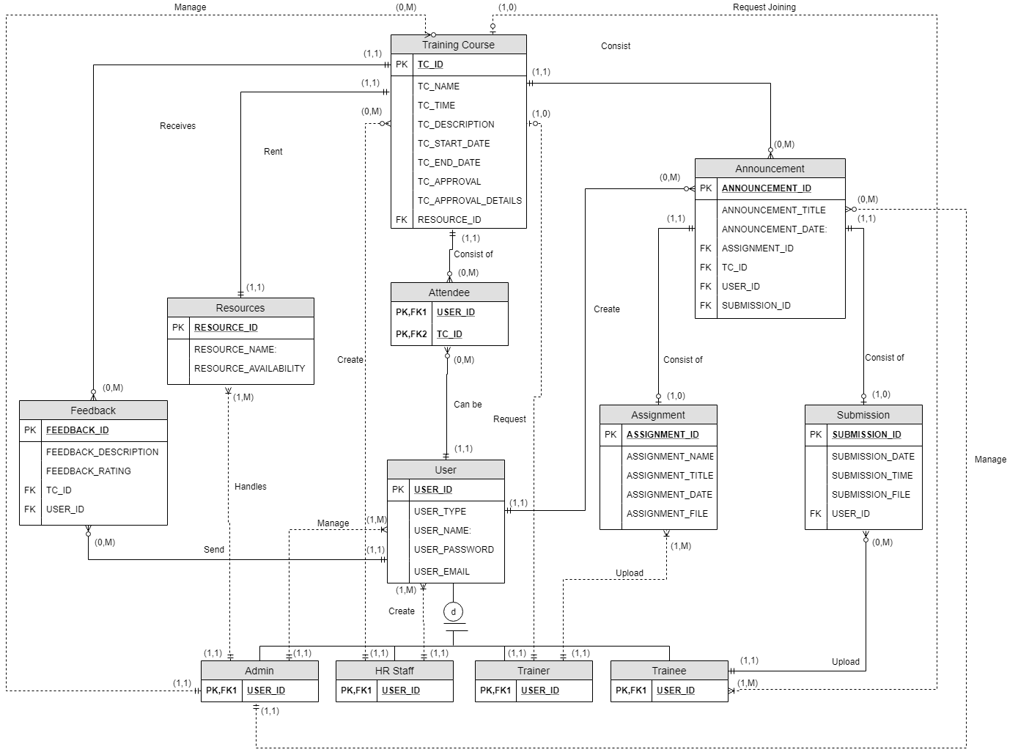

**CLASS DIAGRAM**

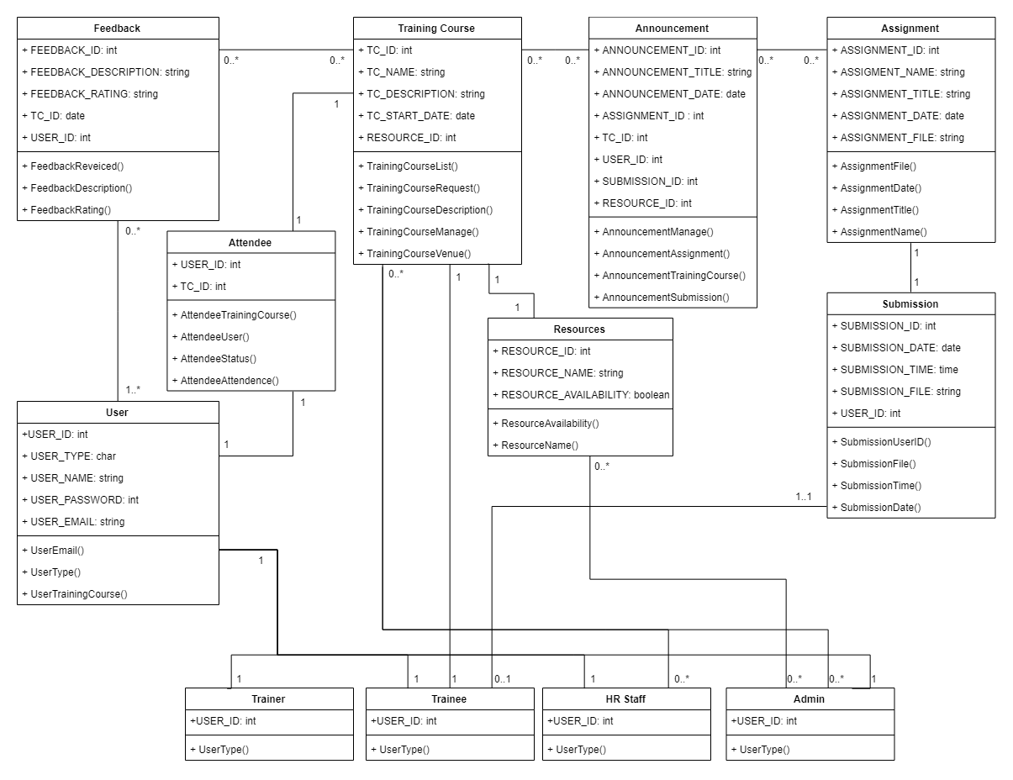

**SEQUENCE DIAGRAM ADMIN**

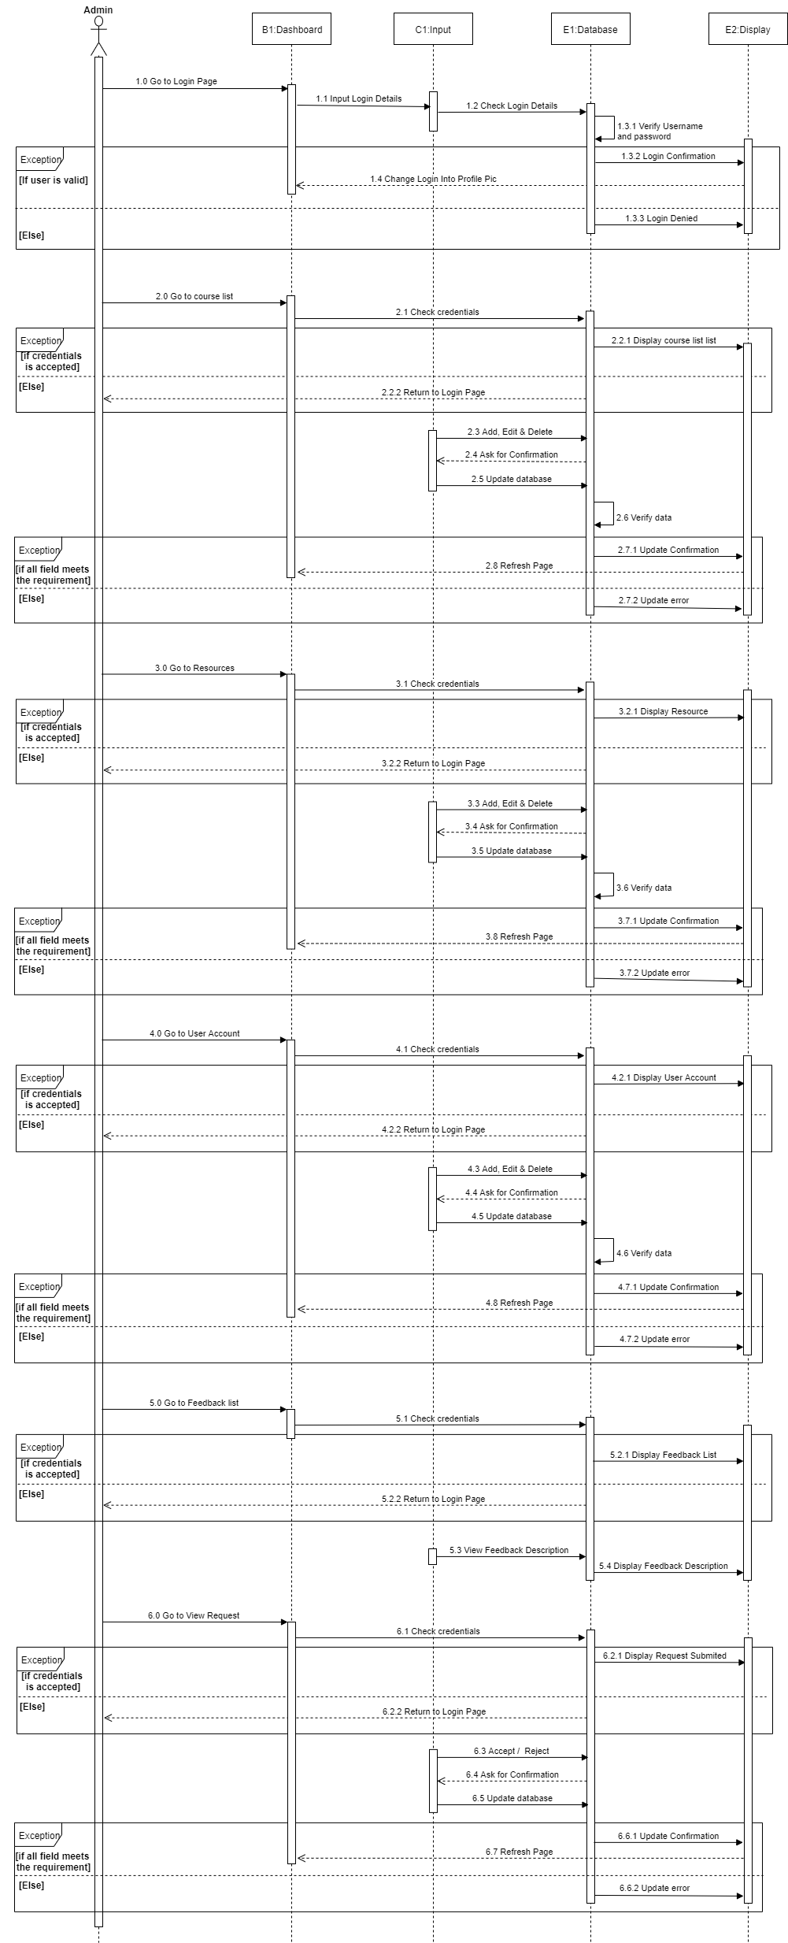

**SEQUENCE DIAGRAM HR STAFF**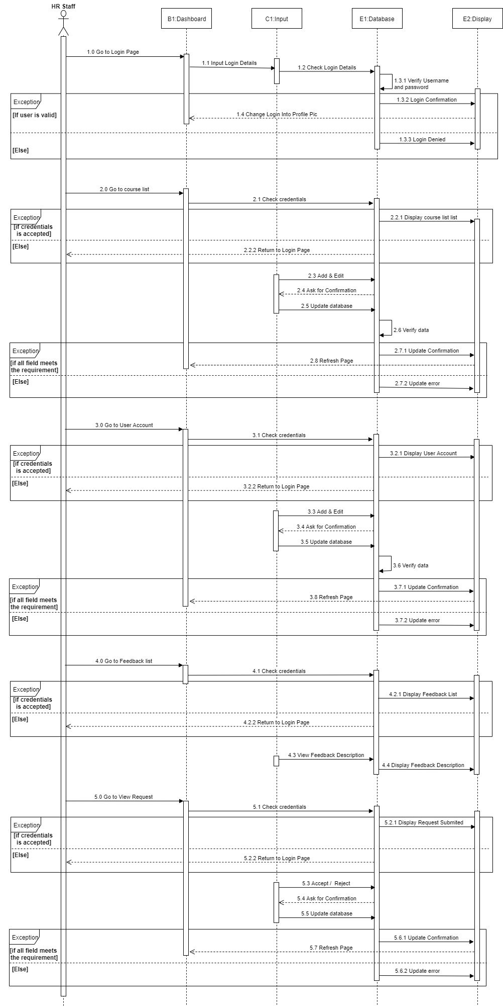

**SEQUENCE DIAGRAM TRAINER** 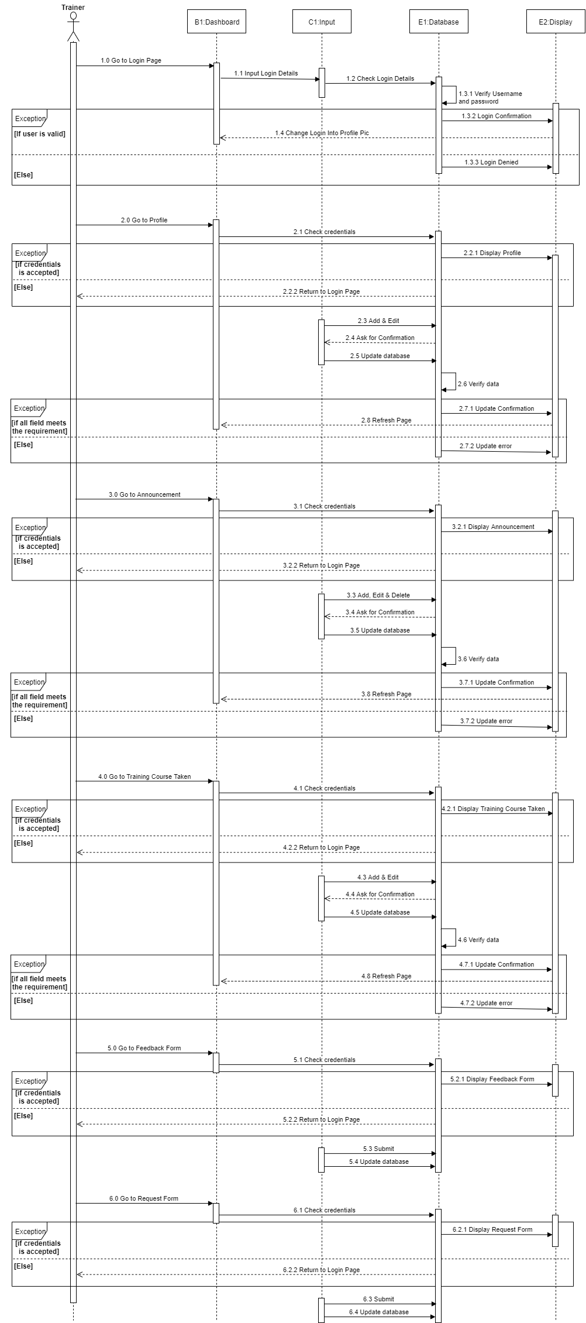

**SEQUENCE DIAGRAM TRAINEE**

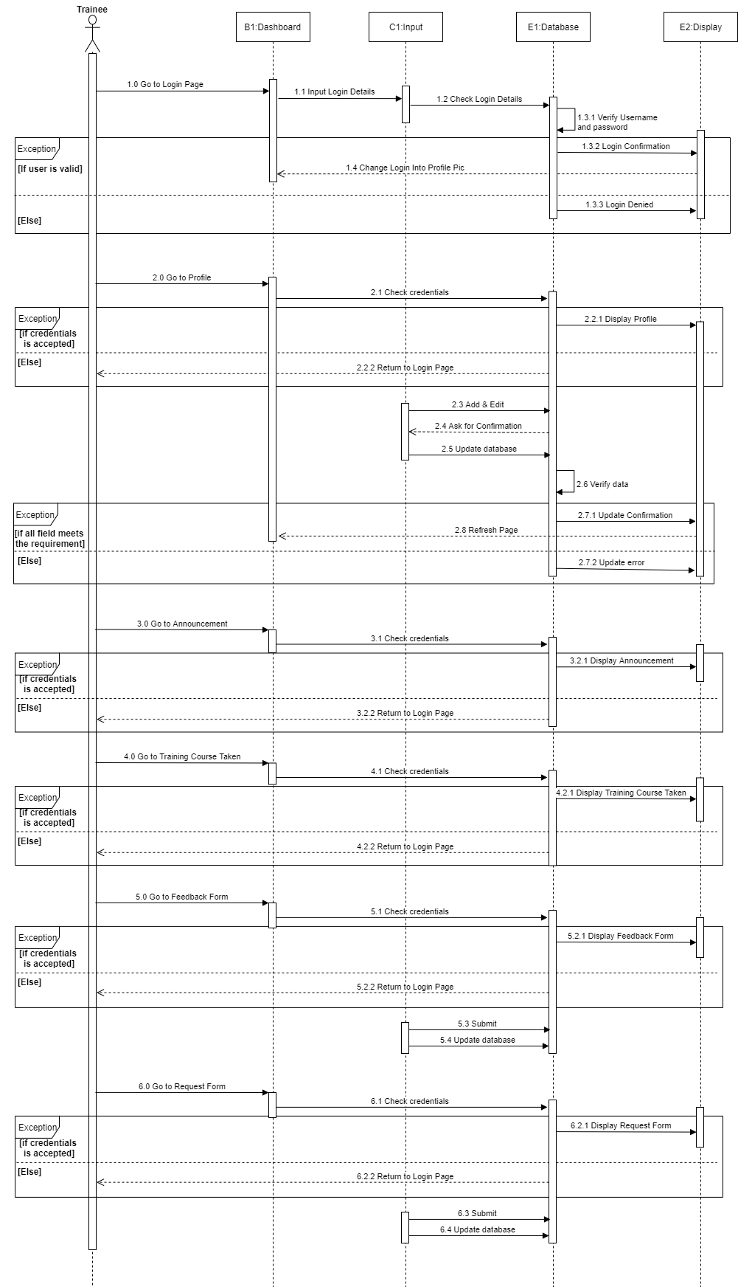

**PROCESS MODEL CHOSEN**

**Increment process model.**

**-Increment 1**

The reason why we choose increment process model for our project, software engineering team are not very well skilled or trained and such methodology is more in use for web application. In the increment 2 we will be evaluated and upgrading through out our project.

**FLOWCHART ADMIN & HR STAFF  
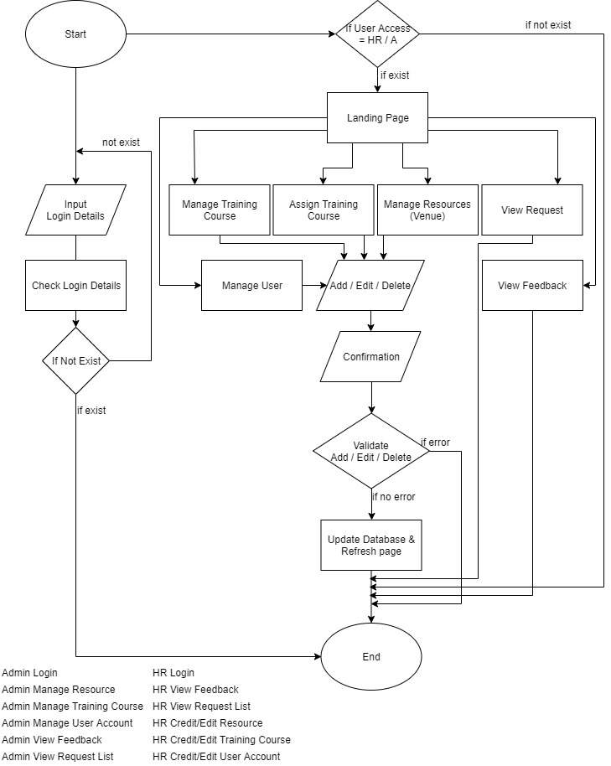**

**FLOWCHART TRAINER & TRAINEE**

