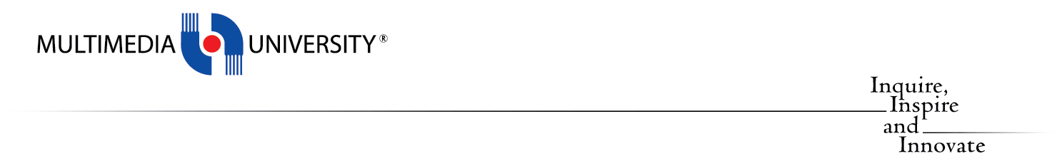

MULTIMEDIA UNIVERSITY®

TSE2101

(Software Engineering Fundamentals)

Employee Training Management System

FUXION

Prepared by



LEE XI JIE 1161204459

TEO MING ZE 1161204548

EU JUN HONG 1151205564

MUHAMMED ALIMRAN 1161203939

**TABLE CONTENT**

Page

Introduction

Software Design 3

Part II : Software Design

Entity-Relational Diagram 4

Data Dictionary 5-9

Class Diagram 10

System Architectural Diagram 11

Application Architectural Diagram 12

Component Diagram 13

Deployment Diagram 14

Interface Design 15-21

Software and Presentation Quality 22

**Introduction**

This is the part II documentation for Software Engineering Fundamentals project, where we will do our continue with the design planning before implement the project in part III.

In the part II, we are understanding of what a good software design is really look like, which encompass the following which conducted in our lecture 5 of software engineering fundamentals class.

* Firmness: A program should not have any bugs that inhibit its function.
* Commodity: A program should be suitable for the purposes for which it was intended.
* Delight: The experience of using the program should be pleasurable one.

**Part II : Software Design**

**Entity-Relational Diagram**

The Entity-Relational Diagram (ERD) below highlights the relationship between the models.

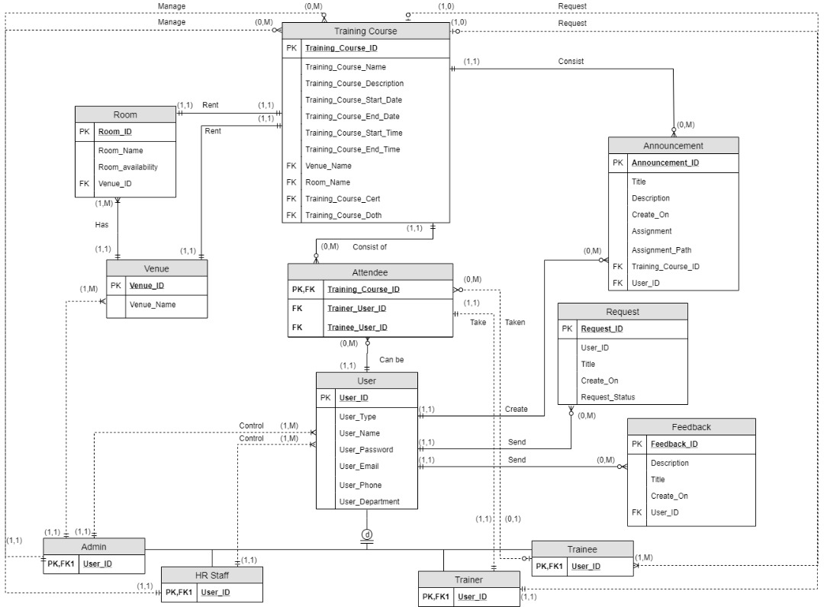

**Data Dictionary**

As part of data design, we include for the metadata for each of the field.

|  |  |  |  |  |  |  |  |
| --- | --- | --- | --- | --- | --- | --- | --- |
| ***Entity Name*** | ***Entity Description*** | ***Column Name*** | ***Column Description*** | ***Data Type*** | ***Length*** | ***Primary Key*** | ***Unique*** |
| User | User details, role will be store here in order to verification and validation | User_ID | For the unique identification of the user | Integer | 11 | True | True |
|  |  | User_Name | Name of the user | Varchar | 255 | False | False |
|  |  | User_Password | Password of the user accounts | Varchar | 255 | False | False |
|  |  | User_Type | Role of the user accounts | Varchar | 10 | False | False |
|  |  | User_Email | Email of the user accounts during registered the password and username will send the particular email accounts | Varchar | 255 | False | False |
|  |  | User_Phone | Phone of the user accounts | Varchar | 12 | False | False |
|  |  | User_Department | Department of the user | Varchar | 5 | False | False |

|  |  |  |  |  |  |  |  |
| --- | --- | --- | --- | --- | --- | --- | --- |
| ***Entity Name*** | ***Entity Description*** | ***Column Name*** | ***Column Description*** | ***Data Type*** | ***Length*** | ***Primary Key*** | ***Unique*** |
| Training Courses | All the list of the training courses will be stored in this entity with the description | Training_Course_ID | Unique ID for each of the training courses | Integer | 10 | True | True |
|  |  | Training_Course_Name | Naming for the training courses | Varchar | 255 | False | False |
|  |  | Training_Course_Description | Description for the training courses | Varchar | 255 | False | False |
|  |  | Training_Course_Start_Time | Time duration for the training courses | Varchar | 10 | False | False |
|  |  | Training_Course_End_Time | Time duration for the training courses | Varchar | 10 | False | False |
|  |  | Training­_Course_Start_Date | Date for the training courses | Date |  | False | False |
|  |  | Training_Course_End_Date | Date for the training courses | Date |  | False | False |
|  |  | Venue_Name | Reference for the training courses where will it held on | Varchar | 10 | False | False |
|  |  | Room_Name | Reference for the training courses where will it held on | Varchar | 10 | False | False |
|  |  | Training_Course_Cert | Name of the certificate of the training courses | Varchar | 100 | False | False |
|  |  | Training_Course_Cert_Path | Location of the cert will be save for backend | Text |  | False | False |

|  |  |  |  |  |  |  |  |
| --- | --- | --- | --- | --- | --- | --- | --- |
| ***Entity Name*** | ***Entity Description*** | ***Column Name*** | ***Column Description*** | ***Data Type*** | ***Length*** | ***Primary Key*** | ***Unique*** |
| Venue | All the venue will be stored in this entity and has link to venue | Venue_ID | Unique ID for the venue | Integer | 10 | True | True |
|  |  | Venue_Name | Name of the venue | Varchar | 255 | False | False |

|  |  |  |  |  |  |  |  |
| --- | --- | --- | --- | --- | --- | --- | --- |
| ***Entity Name*** | ***Entity Description*** | ***Column Name*** | ***Column Description*** | ***Data Type*** | ***Length*** | ***Primary Key*** | ***Unique*** |
| Room | All the resources room will be stored in here and the availability of the resource will be updated here as well. | Room_ID | Unique ID for the room | Integer | 10 | True | True |
|  |  | Room_Name | Name of the room | Varchar | 255 | False | False |
|  |  | Room_Availability | Availability of the room | Boolean | 1 | False | False |
|  |  | Venue_ID | Reference of the venue | Integer | 10 | Foreign Key | True |

|  |  |  |  |  |  |  |  |
| --- | --- | --- | --- | --- | --- | --- | --- |
| ***Entity Name*** | ***Entity Description*** | ***Column Name*** | ***Column Description*** | ***Data Type*** | ***Length*** | ***Primary Key*** | ***Unique*** |
| Attendee | The attendee and the training courses will be stored in here | Attendee_ID | The unique ID for the attendee | Integer | 10 | True | True |
|  |  | Trainer_User_ID | The ID, who join the training courses | Integer | 10 | Foreign Key | True |
|  |  | Training_Course_ID | The ID, which the training courses that the user join | Integer | 10 | Foreign Key | True |
|  |  | Trainee_User_ID | The ID, who join the training courses | Integer | 11 | Foreign Key | True |

|  |  |  |  |  |  |  |  |
| --- | --- | --- | --- | --- | --- | --- | --- |
| ***Entity Name*** | ***Entity Desciption*** | ***Column Name*** | ***Column Description*** | ***Data Type*** | ***Length*** | ***Primary Key*** | ***Unique*** |
| Announcement | List of announcements’ details will be stored in here | Announcement_ID | Unique ID for the announcement list | Integer | 10 | True | True |
|  |  | Title | Title for the announcement | Varchar | 255 | False | False |
|  |  | Description | Description for the announcement | Varchar | 500 | False | False |
|  |  | Created_on | Timestamp for the announcement | Datetime |  | False | False |
|  |  | Assignment | Name for the assignment where attach in the announcement | Varchar | 255 | False | False |
|  |  | Assignment_path | Location of the assignment saved for the backend purpose | Text |  | False | False |
|  |  | Training_Course_ID | Reference for which training course to attach the announcement | Int | 11 | True | True |

|  |  |  |  |  |  |  |  |
| --- | --- | --- | --- | --- | --- | --- | --- |
| ***Entity Name*** | ***Entity Description*** | ***Column Name*** | ***Column Description*** | ***Data Type*** | ***Length*** | ***Primary Key*** | ***Unique*** |
| Feedback | All of the feedback will stored in this entity | Feedback_ID | Unique ID for the feedback | Integer | 11 | True | True |
|  |  | User_ID | Reference for which user send the feedback | Int | 11 | Foreign Key | True |
|  |  | Title | Tile for the feedback | Varchar | 100 | False | False |
|  |  | Description | Description for the | Timestamp |  | False | False |
|  |  | Created_on | Timestamp for the feedback when it submitted | Datetime |  | False | False |

|  |  |  |  |  |  |  |  |
| --- | --- | --- | --- | --- | --- | --- | --- |
| ***Entity Name*** | ***Entity Description*** | ***Column Name*** | ***Column Description*** | ***Data Type*** | ***Length*** | ***Primary Key*** | ***Unique*** |
| Attendee_Request | All the request will store in this entity | Attendee_ID | Unique ID for the attendee_request | Integer | 11 | True | True |
|  |  | User_ID | Reference for which user send the request | Int | 11 | Foreign Key | True |
|  |  | Title | Tile for the feedback | Varchar | 100 | False | False |
|  |  | Description | Description for the | Timestamp |  | False | False |
|  |  | Created_on | Timestamp for the feedback when it submitted | Datetime |  | False | False |
|  |  | Status_request | Boolean for the approval that response by admin/hr | Varchar | 10 | False | False |

**Class Diagram**

The Class Diagram below highlights the relationship between the models.

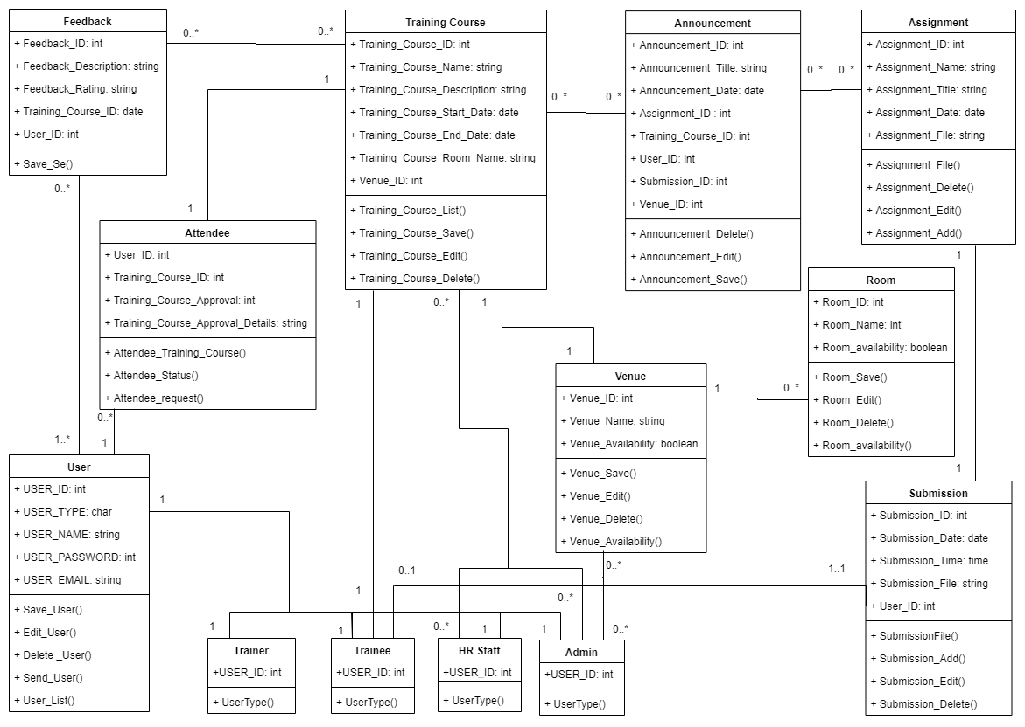

The purpose of class diagram is to model the static view of an application. It is also the diagram which directly mapped with object-oriented languages and widely used at the time of construction.

**System Architectural Diagram**

The architectural design diagram below defines the relationship between the major software structural elements.

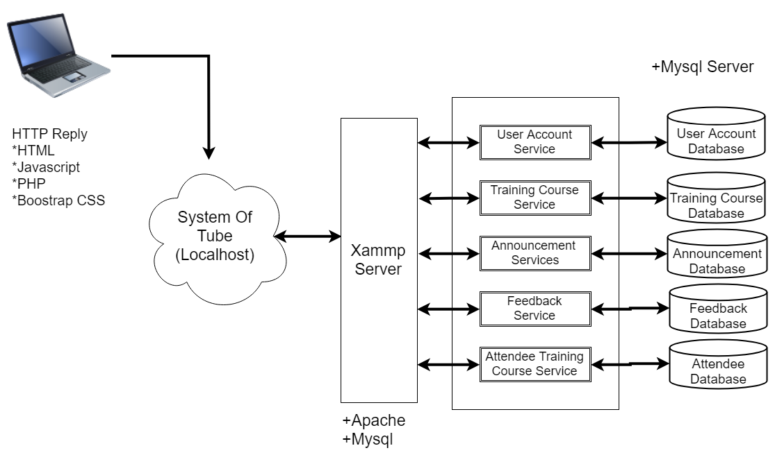

The architecture diagram above show how client side devices communicate with the server. When a function is being triggered by user, a request will send to the server which the server we used is mysql database. The server will validate the request for processing. If processing required data from our mysql database, communication is take place for data exchange. Hence, there will be a communication take place between user and the back-end in order to proceed their request/specific task.

**Application Architectural Diagram**

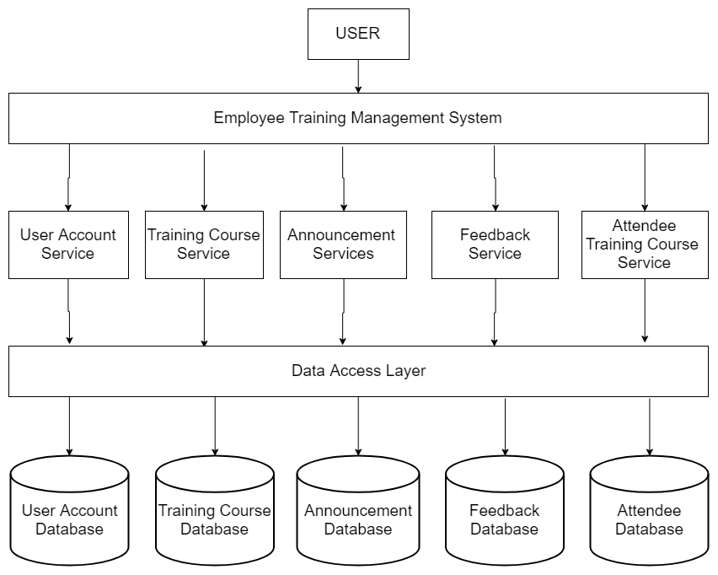

Each service has a narrow, focused a set of responsibility, and are independently expose in the form. An employee training management system could have separate microservice for user accounts, training courses, announcement, feedback and also the attendee databases.

**Component Diagram**

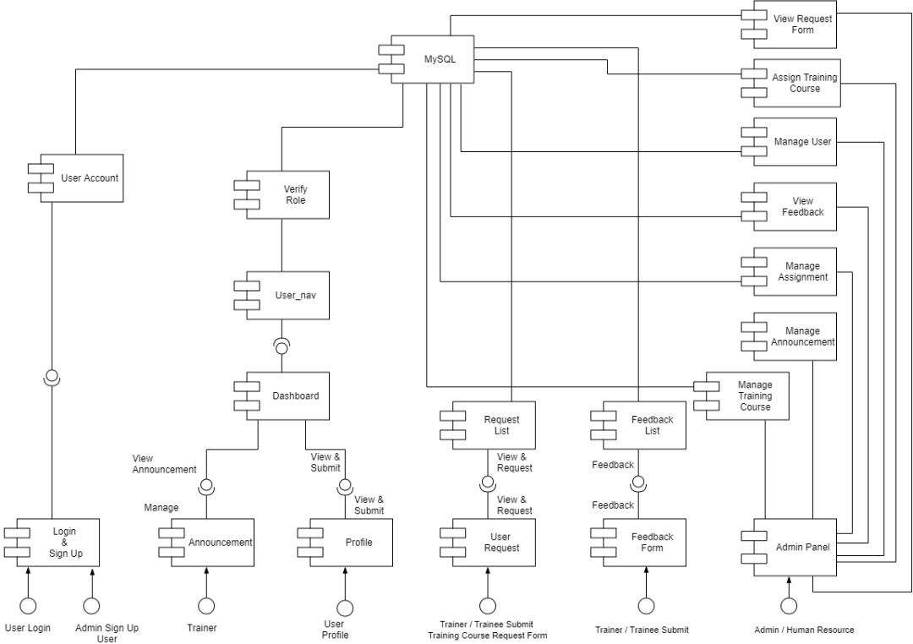

The component diagram above shows the provided interfaces to the users, and how the system components interface interact between each other. The components are mainly partitioned for user login, request training courses, assignment/submission, training courses, feedback and admin panel which are mange users, manage venue, manage training courses and etc. The components then interfaces with the database provided by mysql.

**Deployment Diagram**

The deployment design diagram highlights the hardware system’s topology, which, also provides one of the highest level of abstraction to the development team, by viewing the system from the hardware’s perspective.

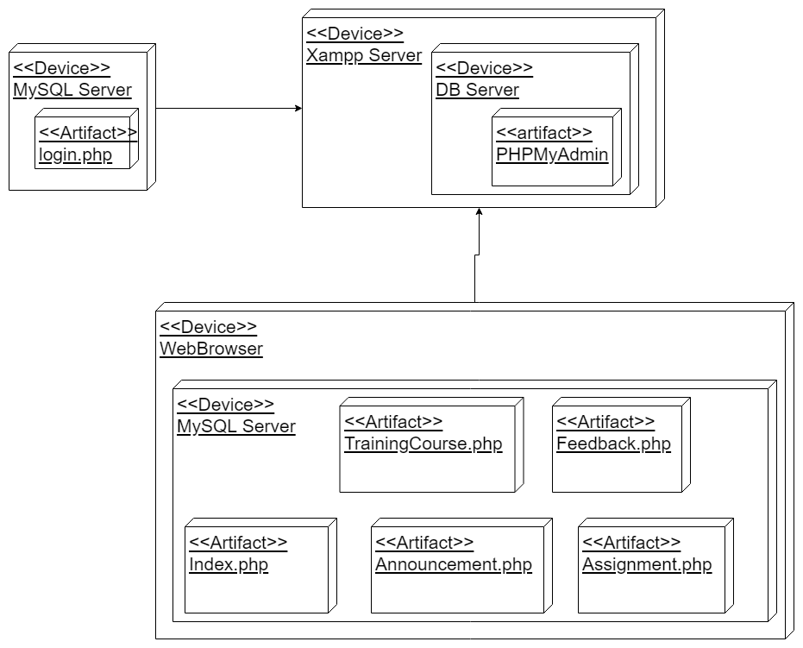

The deployment diagram shows the physical hardware components and the artifacts generated by the hardware. We partition it into user device, mysql databse. In this diagram, it shows how the components interact between each other.

**Interface Design**

Our team follow the principle, given our own experience in order to design a friendly-user web application.

**Login**

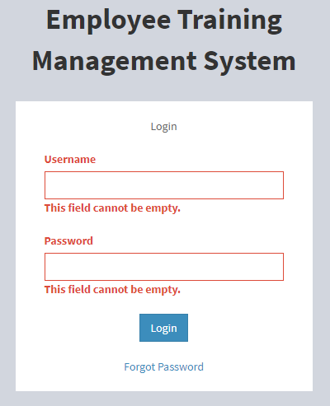 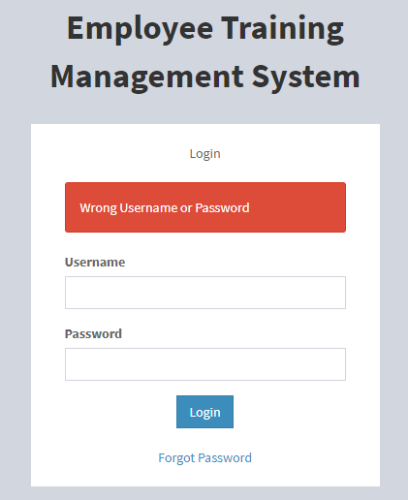

The login interface contain the web application system name, which is employee training managemnet system. User can login their ID once the admin registered their accounts.

**User Interface Layout**

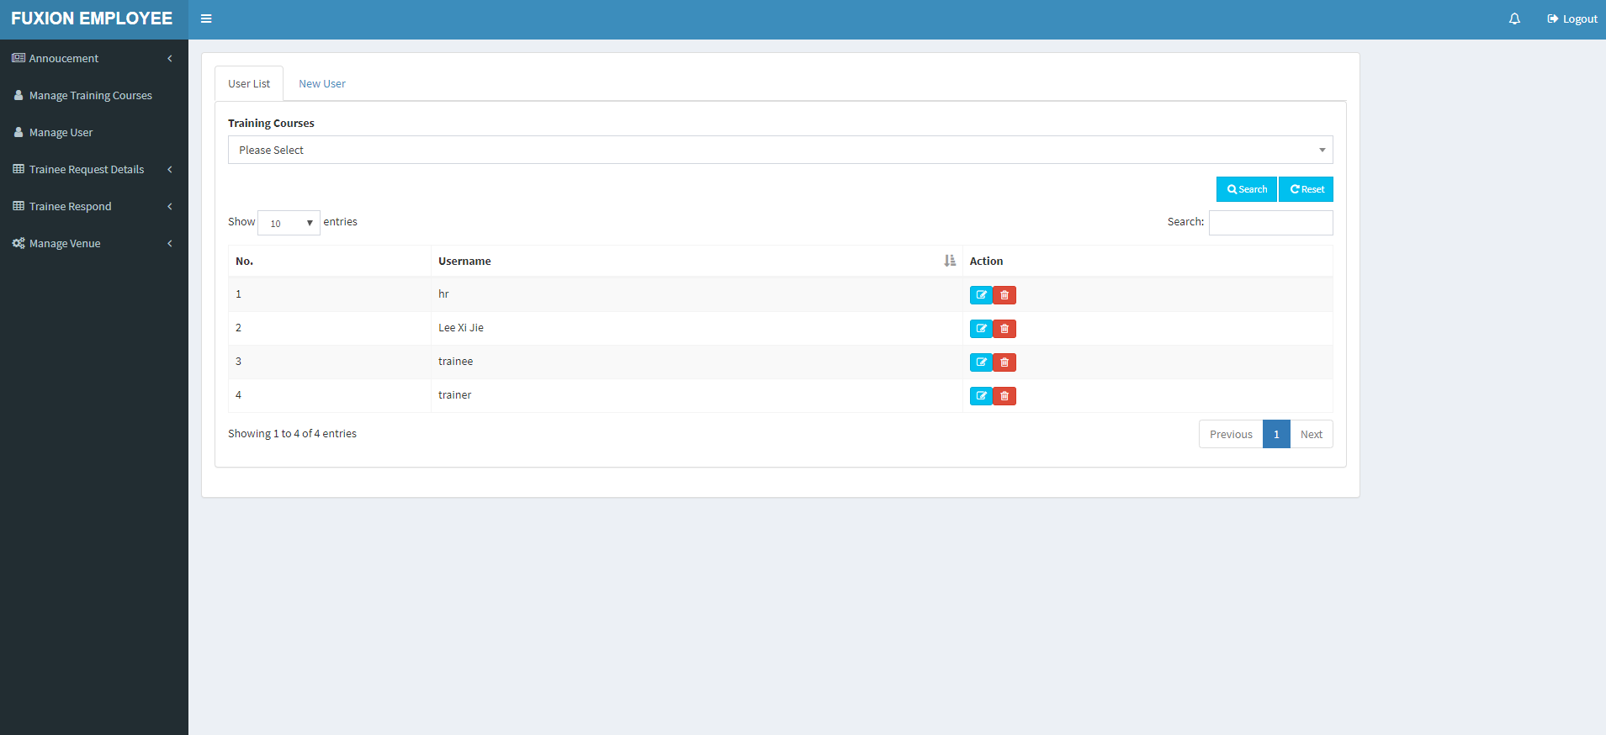

This is the design we set for the user which all the navigational bar will be in the left hand sided and the content will be keep update with the user input.

**User List**

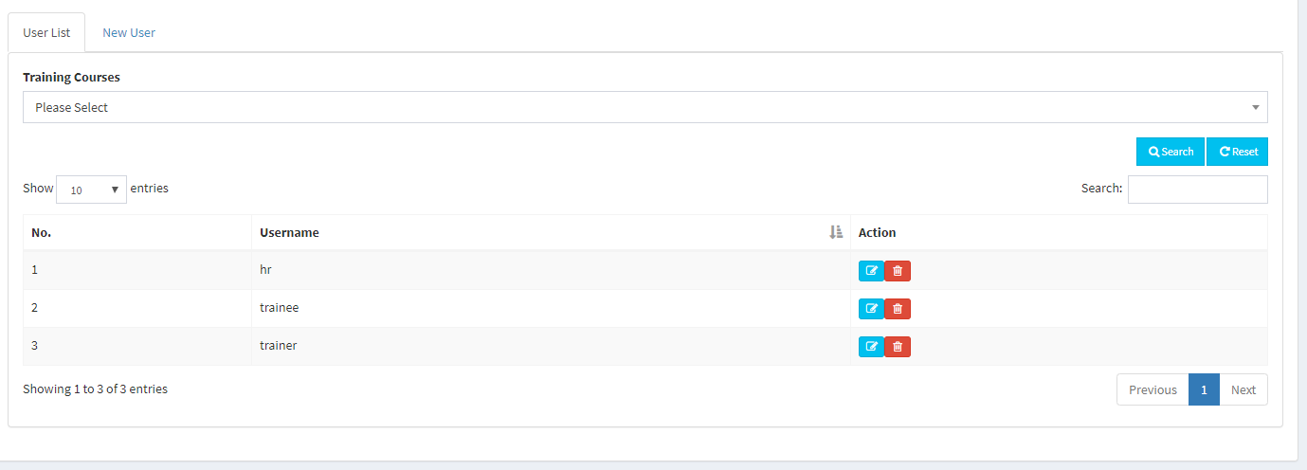

Here is all the user data will be stored in and only able to view by admin and also hr staff. They can create the user account through the tap “New User”.

**User Add**

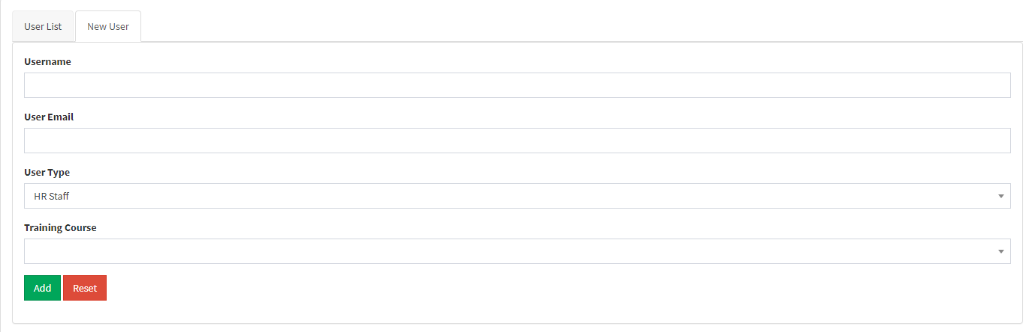 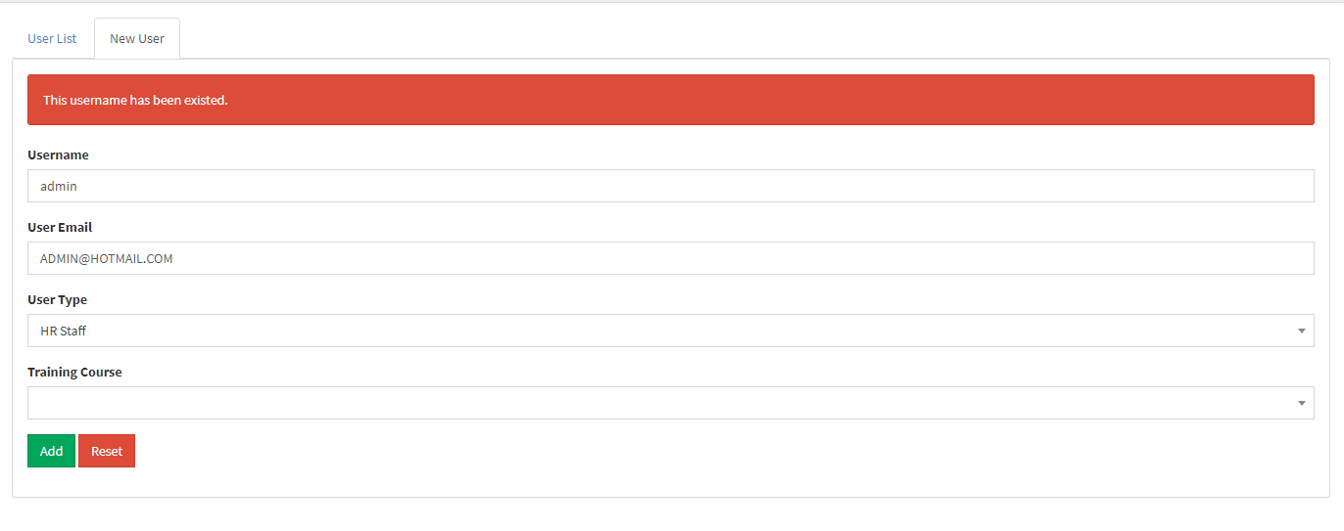

User Add we got verification and validate the role of the users and also check the username whether is it already existed in database or not. The user email is used to send the username and the password in order login to the system.

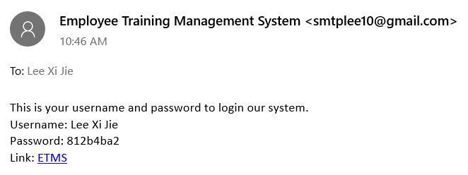

Reference of the email invitation that has been send to the user.

**Training Courses List**

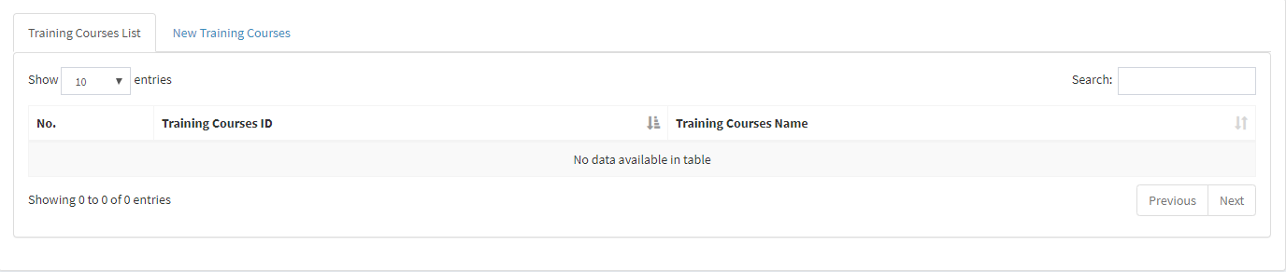

Here will be showing all the training courses list with the action delete button and also edit button.

**Training Courses Add**

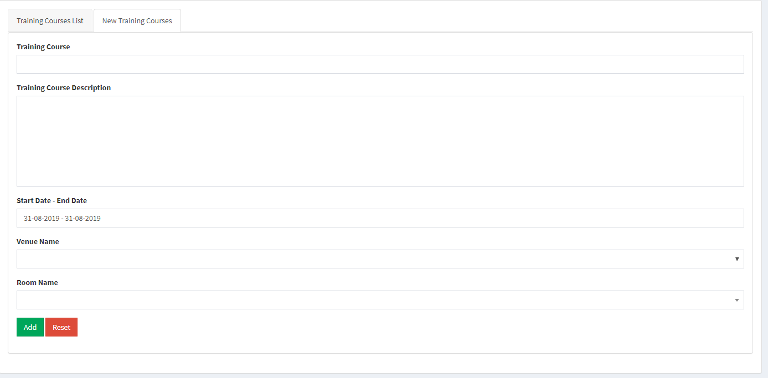

This is the training courses add form in order to let the admin and the HR staff to create their training for the trainer and also trainee.

**Venue and Room List**

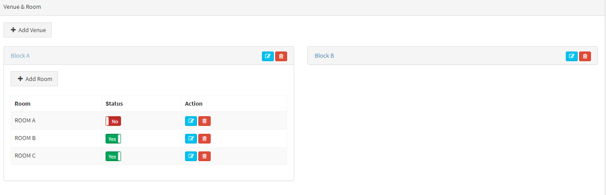

Here is to allow the admin to create or edit the new venue or the room to organize the training courses. Besides, the availability can be set also to avoid the clashing of the venue.

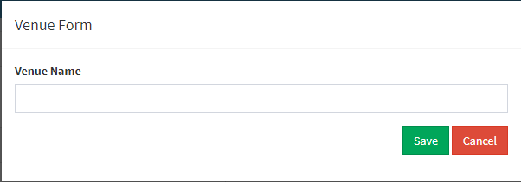

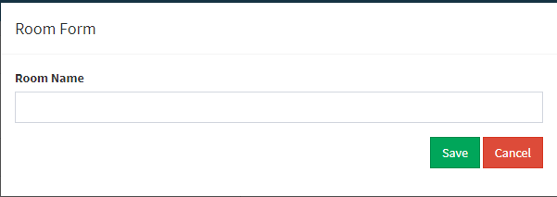

These two form is to allow the admin to create a new venue/room for the training course purpose.

**Requested List to join Training**

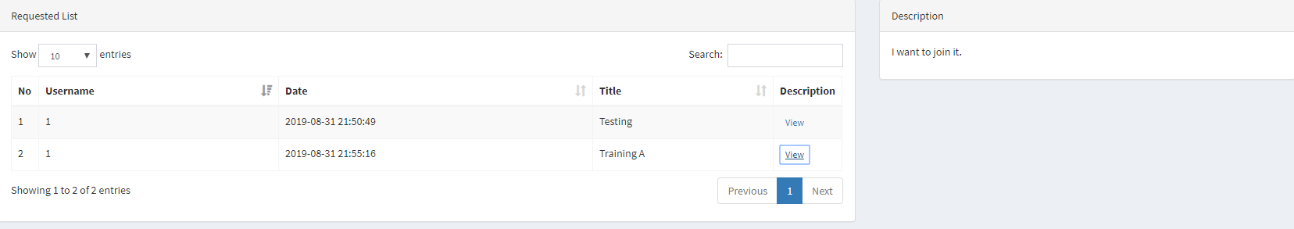

This will show the requested form list to admin where the user submit it with the description at the right hand side.

**Request Form**

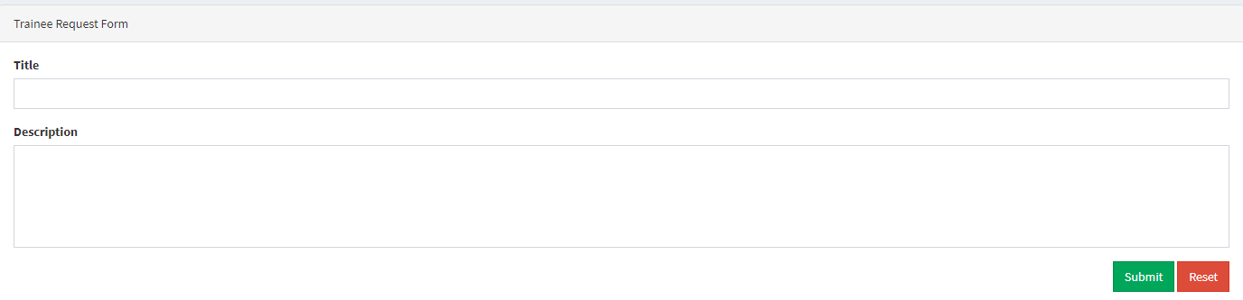

This form is allow the user fill and submit in order they wan request for joining the training courses.

**Announcement List**

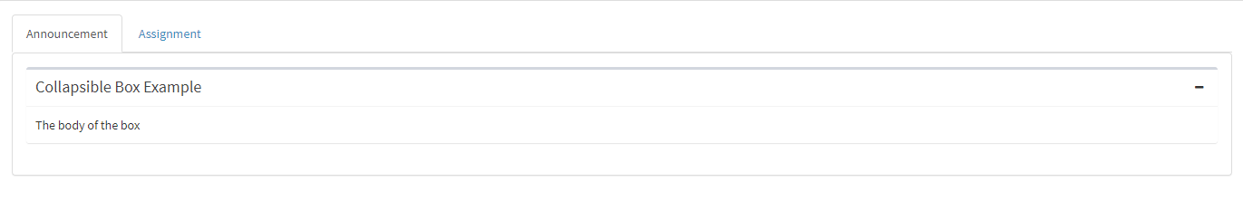

Announcement page, all the announcement will be showed in this pages. Besides, the assignment is optional to attach to the announcement.

**Create Announcement Form**

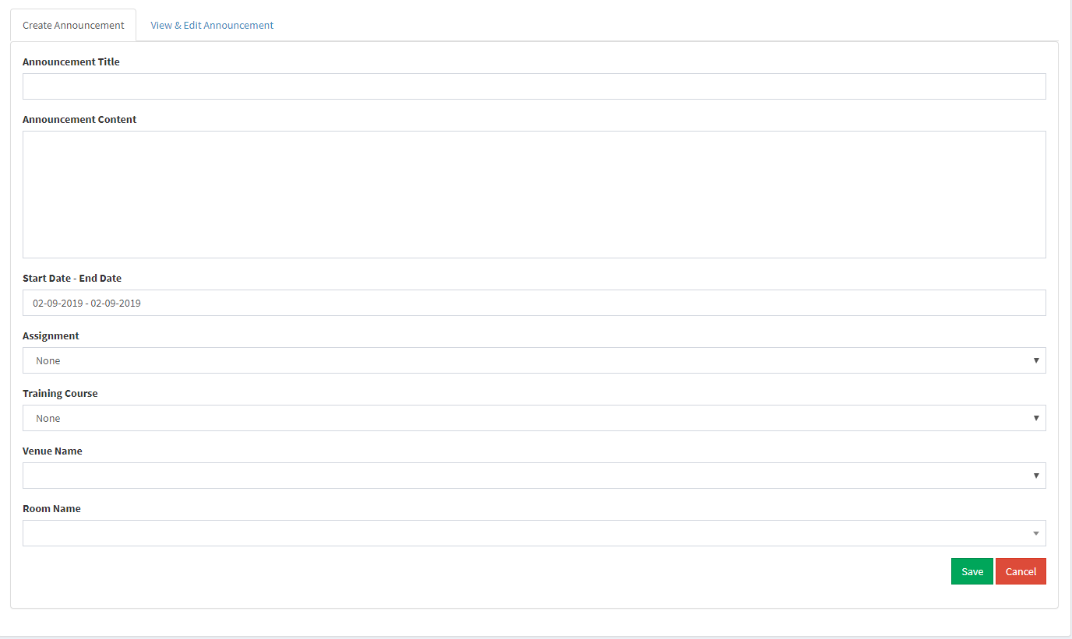

This is the form to allow the user to add announcement to the particular training courses.

|  |  |
| --- | --- |
| Software Quality | Presentation Quality |
| A software application is firmness and easy for the user to use it (User-Friendly). | Open for all the students to ask the question to our employee training management system. |