

MULTIMEDIA UNIVERSITY®

TSE2101

(Software Engineering Fundamentals)

Employee Training Management System

FUXION

Prepared by



LEE XI JIE 1161204459

TEO MING ZE 1161204548

EU JUN HONG 1151205564

MUHAMMED ALIMRAN 1161203939

**Table Content**

**Introduction**

In the part II, we are understanding of what a good software design is really look like, which encompass the following which conducted in our lecture 5 of software engineering fundamentals class.

* Firmness: A program should not have any bugs that inhibit its function.
* Commodity: A program should be suitable for the purposes for which it was intended.
* Delight: The experience of using the program should be pleasurable one.

This project part III we translate previous design and analysis models into implementation, with a user interface. Working among our group we has plan on how the team members can collaborate between each other to the this project.

In this report, we have attached the revised version of the part I and part II documentation.

**Project Scope**

The purpose of the employee training management system is to ease the college to create a convenient application for trainer and also trainee. The system is based on a relational database with its training management and application functions. The aim of us is to provide a comfortable user experience to use the system.

**Operating Environment**

Operating environment for the training management system is as listed below

* Distributed database
* Client/Server system
* Operating System : Windows
* Database : SQL Database
* Platform : PHP/JAVASCRIPT/HTML/CSS

**User Interfaces**

Front-end software : PHP

Back-end software : SQL+

**Hardware Interfaces**

Windows

A browser which supports HTML, Javascript, PHP, CSS

**Problem Statement**

-Admin and HR Staff are able to create, edit or delete a training course and assign to trainer and participant by trainee.

-Trainees are able to request for joining a training course that they are interested in or they wanted to improve themselves through the training courses.

-Trainer are able to upload assignment to the particular training courses in order to ensure the trainee can catch up the training courses.

The system <FUXION> SHALL able to allow Admin to manage the training courses and assign it to trainer and provide to trainee.

The system <FUXION> SHALL able to allow Admin to has the full access of all user accounts details to provide more convenience change of data by admin

The system <FUXION> SHALL able to allow Admin to manage the resources’ availability in order to provide efficient booking reservation room for training.

The system <FUXION> WILL able to allow Admin to receive feedback from trainees/trainer in order to provide more efficient of the training courses.

The system <FUXION> WILL able to allow Admin to receive request joining training from trainees/trainer in order to provide more efficient of the training courses.

The system <FUXION> SHALL allow Admin to upload the documents and certification to clarify any information for trainee.

The system <FUXION> SHALL able to allow HR Staff to create/edit a training course and assign it to trainer and also trainee to join

The system <FUXION> SHALL able to allow HR Staff to create/edit user’s account details such as the department of the users (trainee, trainer) to avoid conflict of the department role

The system <FUXION> SHALL able to allow HR Staff to view the description of the training courses such as the list of the trainee joined and also conducted by which trainer

The system <FUXION> SHALL allow HR Staff to provide any missing information that the trainee ask for.

The system <FUXION> WILL allow Trainer to create/edit announcement on dashboard and provide it to be visible for particular users (trainee, trainer)

The system <FUXION> WILL allow Trainer to upload assignment to the training courses’ announcements for the trainee in order to enhance the trainee’s problem-solving skills

 The system <FUXION> SHALL allow Trainer to view the description of the training courses which assigned by HR Staff so Trainer can prepare materials for it.

 The system <FUXION> SHALL allow Trainer to submit feedback form to the admin/hr.

The system <FUXION> SHALL allow Trainer to submit request form in order to joining training.

The system <FUXION> SHALL allow Trainee to view information of the training courses which provided to them so they can be prepared for it.

The system <FUXION> SHALL allow Trainee to view announcements which posted by the trainer in order to get ready what to do for next.

The system <FUXION> SHALL allow Trainee to self-apply for joining courses which they have interested on it and want more implements for it in order to make their skills better

 The system <FUXION> SHALL allow Trainee to submit feedback form in order to help better improve the training course.

**User Story**

|  |  |  |
| --- | --- | --- |
| As a/an | I want to | So that I can |
| Admin | Manges training courses | Organize the training courses and assign it to trainer and also trainee |
| Admin | Manges user accounts | Add, edit and delete some redundancy data of the users. |
| Admin | Manages resources | Set the availability of the resources for training to avoid clashing |
| Admin | Receive feedback from trainer | Enhance the quality or performance of my company |
| Admin | Receive request from trainer and trainee | Make the decision to approve or reject the request |
| Admin | Be able to Update document for training course | Provide document which could answer some question |
| HR Staff | Create, edit training courses | Organize training courses and assign it to trainer and trainee |
| HR Staff | Create, edit user accounts | Reduce the burden of the admin |
| HR Staff | View the description regarding training course | Monitor and help Trainer on managing the training course |
| HR Staff | Upload information and document | Give information on the training course |
| Trainer | Create, edit announcement | Reach the information to my trainee |
| Trainer | Create, edit assignment and attach in announcement | I can ensure that my trainee skills and help them to improve their performance |
| Trainer | Be able view description of the training courses | Conduct the training course following the course structure |
| Trainer | Be able to give feedback to admin | I can evaluate about the course structure to admin |
| Trainer | Able to submit request to be assign to the correct course | Teach in a course structure that the trainer also has interest in. |
| Trainee | Able view information of the training courses | Request for joining the chosen training course |
| Trainee | Able view announcements posted by the Trainer | Receives the updates on the latest announcements from their trainer |
| Trainee | Submit request for joining the chosen course | Have a choice in what course to take first. |
| Trainee | Able to give feedback to improve the training course | Help development and improve the training course in order to better training future participant |

**Use Case Diagram**

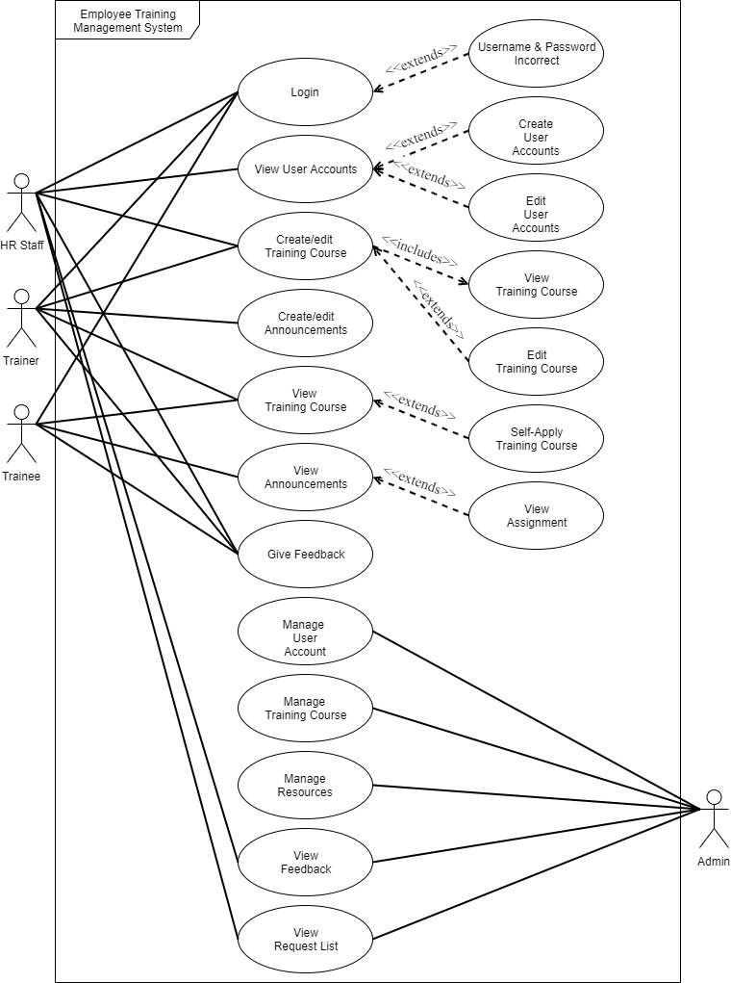

**UCDT**

**Admin**

|  |  |
| --- | --- |
|  | LOGIN |
| Precondition | Username must exist and the password must match the username’s password |
| Postcondition | Logged into the system & redirect to dashboard page |
| Main Flow | 1. User select login page 2. System determine the user’s username and password 3. System validates the user’s details 4. System verify the user’s access right |
| Alternate Flow |  |
| Exception Flow | 1. Error message if username and password does not match 2. A sentence of error will appear in the bottom part of the input field |

|  |  |
| --- | --- |
|  | MANAGE USER ACCOUNT |
| Precondition | User must have the access right to the manage user account page |
| Postcondition | Refresh the user account’s list page |
| Main Flow | 1. System check the user’s whether is it admin 2. System display all the user account’s list if he is admin and has the access right to manage 3. System display all the user account in list from database 4. Admin has the access right to manage (add,edit,delete) the user’s information 5. Admin confirm and send the updated information to database 6. System update and redirect to user account’s list page |
| Alternate Flow |  |
| Exception Flow | 1. System update information 2. For some of the filed that are not optional cannot be empty else the error message will be appear in the bottom part of the input field |

|  |  |
| --- | --- |
|  | MANAGE TRAINING COURSE |
| Precondition | User must have the access right to the manage training course page |
| Postcondition | Refresh the training course’s list page |
| Main Flow | 1. System check the user’s whether is it admin 2. System display all the training course’s list if he is admin and has the access right to manage 3. System display all the training course in list from database 4. Admin has the access right to manage (add,edit,delete) the training courses’ information 5. Admin confirm and send the updated information to database 6. System update and redirect to training courses’ list page |
| Alternate Flow |  |
| Exception Flow | 1. System update information 2. If the start date is later than the end date 3. System show error message in the bottom part of the input field 4. If the trainer is empty 5. System show error message in the bottom part of the input field |

|  |  |
| --- | --- |
|  | MANAGE RESOURCES |
| Precondition | User must have the access right to the manage resources pages. |
| Postcondition | Refresh the resources’ page |
| Main Flow | 1. System check the user’s whether is it admin 2. System display all the resources’ list if is an admin access right 3. Admin has the access right to manage (add,edit,delete) the resources’ information 4. Admin confirm and send the updated information to database 5. System update and redirect to resources’ list page |
| Alternate Flow |  |
| Exception Flow | 1. System update information 2. For some of the filed that are not optional cannot be empty else the error message will be appear in the bottom part of the input field 3. For example, the room venue cannot be empty |

|  |  |
| --- | --- |
|  | Assign Training Course |
| Precondition | User must have the access right to the assign page. |
| Postcondition | Refresh the assign’ page |
| Main Flow | 1. System check the user’s whether is it admin 2. System display all the assign’ list if is an admin access right 3. Admin has the access right to manage (add,edit,delete) the assign information 4. Admin confirm and send the updated information to database 5. System update and redirect to assign page |
| Alternate Flow |  |
| Exception Flow | 1. System update information 2. If the user Is taken other training course it will not show in the user list |

|  |  |
| --- | --- |
|  | View Feedback |
| Precondition | User must have the access right to the feedback page |
| Postcondition | Refresh the feedback page |
| Main Flow | 1. System check the user’s whether is it admin 2. System display all the feedback list if is an admin access right 3. Admin has the access right to view the description of the feedback |
| Alternate Flow |  |
| Exception Flow | 1. If the User_Type != admin/hr it not able to see the feedback list |

**HR STAFF**

|  |  |
| --- | --- |
|  | CREATE/EDIT USER ACCOUNT |
| Precondition | The HR Staff must have login credentials to the system |
| Postcondition | The HR Staff is granted access to the system. |
| Main Flow | 1. System check the user’s whether is he has the access right 2. System display all the user account list from database 3. HR Staff has the access right to view, create and edit some information of the user account 4. HR Staff confirm and send the updated information to database 5. System update and redirect to user account’s list page |
| Alternate Flow |  |
| Exception Flow | 1. System update information 2. For some of the filed that are not optional cannot be empty else the error message will be appear in the bottom part of the input field |

|  |  |
| --- | --- |
|  | CREATEEDIT TRAINING COURSE |
| Precondition | User must have the access right to the create training course page |
| Postcondition | Refresh the training course’s list page |
| Main Flow | 1. System check the user’s whether is it admin 2. System display all the training course’s list if he is HR Staff and has the access right to create and assign to trainer and trainee 3. System display all the training course in list from database 4. HR Staff has the access right to create and edit the training courses’ information 5. HR Staff confirm and send the updated information to database 6. System update and redirect to training courses’ list page |
| Alternate Flow |  |
| Exception Flow | 1. System update information 2. If the start date is later than the end date 3. System show error message in the bottom part of the input field 4. If the trainer is empty 5. System show error message in the bottom part of the input field |

|  |  |
| --- | --- |
|  | CREATE/EDIT RESOURCES |
| Precondition | User must have the access right to the manage resources pages. |
| Postcondition | Refresh the resources’ page |
| Main Flow | 1. System check the user’s whether is it HR 2. System display all the resources’ list if is an admin access right 3. Admin has the access right to manage (add,edit,delete) the resources’ information 4. Admin confirm and send the updated information to database 5. System update and redirect to resources’ list page |
| Alternate Flow |  |
| Exception Flow | 1. System update information 2. For some of the filed that are not optional cannot be empty else the error message will be appear in the bottom part of the input field 3. For example, the room venue cannot be empty |

|  |  |
| --- | --- |
|  | Assign Training Course |
| Precondition | User must have the access right to the assign page. |
| Postcondition | Refresh the assign’ page |
| Main Flow | 1. System check the user’s whether is it HR 2. System display all the assign’ list if is an admin access right 3. Admin has the access right to manage (add,edit,delete) the assign information 4. Admin confirm and send the updated information to database 5. System update and redirect to assign page |
| Alternate Flow |  |
| Exception Flow | 1. System update information 2. If the user Is taken other training course it will not show in the user list |

|  |  |
| --- | --- |
|  | View Feedback |
| Precondition | User must have the access right to the feedback page |
| Postcondition | Refresh the feedback page |
| Main Flow | 1. System check the user’s whether is it HR 2. System display all the feedback list if is an HR access right 3. HR has the access right to view the description of the feedback |
| Alternate Flow |  |
| Exception Flow | 1. If the User_Type != admin/hr it not able to see the feedback list |

**TRAINER**

|  |  |
| --- | --- |
|  | LOGIN |
| Precondition | Username must exist and the password must match the username’s password |
| Postcondition | Logged into the system & redirect to dashboard page |
| Main Flow | 1. User select login page 2. System determine the user’s username and password 3. System validates the user’s details 4. System verify the user’s access right |
| Alternate Flow |  |
| Exception Flow | 1. Error message if username and password does not match 2. A sentence of error will appear in the bottom part of the input field |

|  |  |
| --- | --- |
|  | GIVE FEEDBACK |
| Precondition | The trainer involved in training course |
| Postcondition | The trainer will be able to give feedback to admin |
| Main Flow | 1. System check the user’s access right 2. System display the feedback form for trainer in order to give suggestion to the training courses 3. System update and redirect to assignment upload page |
| Alternate Flow |  |
| Exception Flow | 1. If empty description, the bottom part of input field will appear an error message |

|  |  |
| --- | --- |
|  | REQUEST TO JOIN A TRAINING COURSE |
| Precondition | Login as User_Type Trainer |
| Postcondition | The trainre request will be sent to HR Staff/Admi |
| Main Flow | 1. System check the user’s access right 2. System display form request 3. Trainer are able to request for joining only one training courses 4. Trainee send request to HR Staff 5. System update and redirect to training courses page |
| Alternate Flow | HR Staff and Trainer can assign the trainee to join a particular training course |
| Exception Flow | 1. System update information 2. System determine the availability of the trainee 3. If trainee is taking one training course, system alert trainee that he/she cant request for more training 4. System show error message in the bottom part of input field |

|  |  |
| --- | --- |
|  | CREATE ANNOUNCEMENTS |
| Precondition | User must have the access right to view dashboard page and the trainer must has at least one valid training course |
| Postcondition | This announcement will be posted in the dashboard in order to let the trainee know |
| Main Flow | 1. System check the user’s whether is he has the access right 2. System display all the announcement that posted by that particular Trainer 3. Trainer has the access right to view, create and edit announcements of the training courses 4. Trainer specifies the settings, for example details of the announcements 5. System saves the announcements in the database. 6. System update and redirect to the dashboard page |
| Alternate Flow |  |
| Exception Flow | System update information  For some of the filed that are not optional cannot be empty else the error message will be appear in the bottom part of the input field  For example, if the announcement details is empty  System show error message in the bottom part of the input field |

|  |  |
| --- | --- |
|  | VIEW TRAINING COURSES THAT CURRENTLY TAKING |
| Precondition | The trainer must has joined into a training courses that assigned by admin/hr |
| Postcondition | The trainer will be able to view the details of training courses |
| Main Flow | 1. System check the user’s access right 2. The system fetches the details of training courses from databases. 3. System display the training courses’ details for trainee |
| Alternate Flow |  |
| Exception Flow |  |

**TRAINEE**

|  |  |
| --- | --- |
|  | LOGIN |
| Precondition | Username must exist and the password must match the username’s password |
| Postcondition | Logged into the system & redirect to dashboard page |
| Main Flow | 1. User select login page 2. System determine the user’s username and password 3. System validates the user’s details 4. System verify the user’s access right |
| Alternate Flow |  |
| Exception Flow | 1. Error message if username and password does not match 2. A sentence of error will appear in the bottom part of the input field |

|  |  |
| --- | --- |
|  | REQUEST TO JOIN A TRAINING COURSE |
| Precondition | The trainee must has no joining any training courses before trainee request |
| Postcondition | The trainee request will be sent to HR Staff |
| Main Flow | 1. System check the user’s access right 2. System display all the available training courses list from database 3. Trainee are able to request for joining only one training courses 4. System validate the trainee availability 5. Trainee send request to HR Staff 6. System update and redirect to training courses page |
| Alternate Flow | HR Staff and Trainer can assign the trainee to join a particular training course |
| Exception Flow | 1. System update information 2. System determine the availability of the trainee 3. If trainee is taking one training course, system alert trainee that he/she cant request for more training 4. System show error message in the bottom part of input field |

|  |  |
| --- | --- |
|  | VIEW ANNOUNCEMENT |
| Precondition | The trainee must has joined into a training courses that organized by trainer |
| Postcondition | The trainee will be able to view the assignment |
| Main Flow | 1. System check the user’s access right 2. System display the announcement and followed by the training courses that the trainee taken 3. System update and redirect to dashboard page |
| Alternate Flow |  |
| Exception Flow | 1. If the trainee no taken any of the training courses, it will show nothing in the dashboard |

|  |  |
| --- | --- |
|  | VIEW ASSIGNMENT |
| Precondition | The trainee must has joined into a training courses that organized by trainer |
| Postcondition | The trainee will be able to view the assignment |
| Main Flow | 1. System check the user’s access right 2. System display the announcement which attach the assignment and allow trainee to view the assignment 3. System update and redirect to dashboard page |
| Alternate Flow |  |
| Exception Flow |  |

|  |  |
| --- | --- |
|  | GIVE FEEDBACK |
| Precondition | The trainee must has joined into a training courses that organized by trainer |
| Postcondition | The trainee will be able to give feedback to admin |
| Main Flow | 1. System check the user’s access right 2. System display the feedback form for trainee in order to give suggestion to the training courses 3. System update and redirect to assignment upload page |
| Alternate Flow |  |
| Exception Flow | 1. If empty description, the bottom part of input field will appear an error message |

|  |  |
| --- | --- |
|  | VIEW TRAINING COURSES THAT CURRENTLY TAKING |
| Precondition | The trainee must has joined into a training courses that organized by trainer |
| Postcondition | The trainee will be able to view the details of training courses |
| Main Flow | 1. System check the user’s access right 2. The system fetches the details of training courses from databases. 3. System display the training courses’ details for trainee |
| Alternate Flow |  |
| Exception Flow |  |

**Business Rule**

1. A training course may consist many announcements. Each announcements is consisted in a training course.
2. A training course may receive many feedbacks. Each feedback is received from a training course.
3. A training course is needed to rent a resource. A resource is being rented in order to conduct a training course.
4. A training course may consist many attendees. Each attendee attends a training course.
5. A user may be many attendees. Each attendee is to be a user.
6. A user may send many feedbacks Each feedback is sent by a user.
7. An admin can handle many resources. Each resource is handled by an admin.
8. An admin may manage many training courses. Each training course Is managed by an admin.
9. An admin may manage many announcements in dashboard. Each announcement is managed by an admin.
10. An admin can manage many user accounts that are not admin or HR role. Each user account is managed by an admin.
11. A user can only be an Admin, HR Staff, Trainer or Trainee. An Admin, HR Staff, Trainer or trainee is a user.
12. A HR Staff may create a many training courses. Each training courses are to be created by a HR Staff.
13. A HR Staff can create many user accounts that are not Admin or HR role. Each user account can be created by a HR Staff.
14. A trainer may create many announcements. Each announcement is created by a trainer.
15. A trainee may request to join a training course. Each training course can be joined by many trainees.
16. An admin can assign trainer and trainee into one training course. Many users can assign into one training courses.
17. A HR Staff can assign trainer and trainee into one training course. Many users can assign into one training courses.

**SEQUENCE DIAGRAM ADMIN**

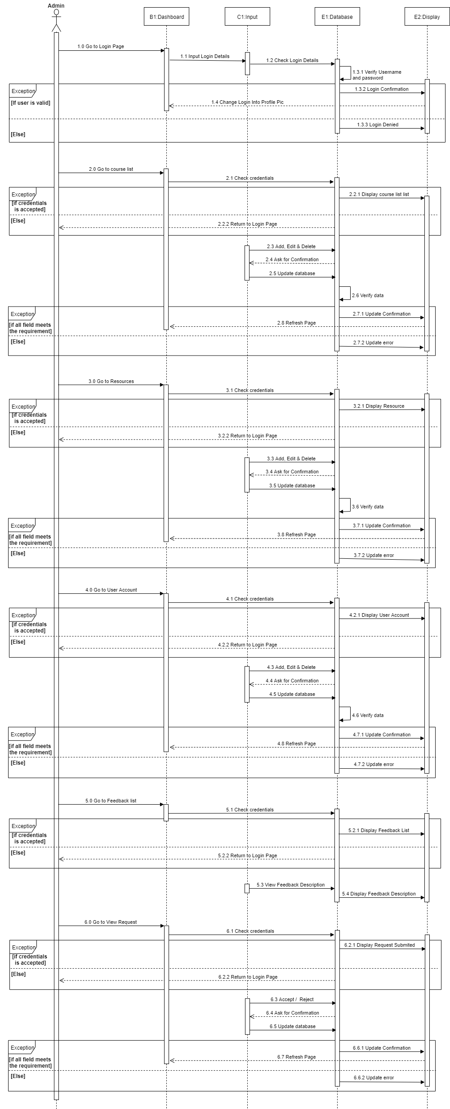

**SEQUENCE DIAGRAM HR STAFF**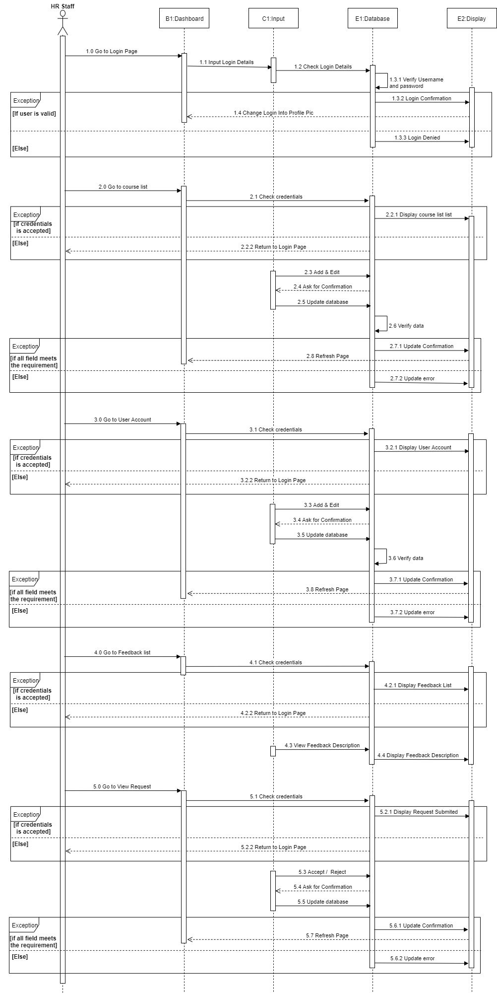

**SEQUENCE DIAGRAM TRAINER** 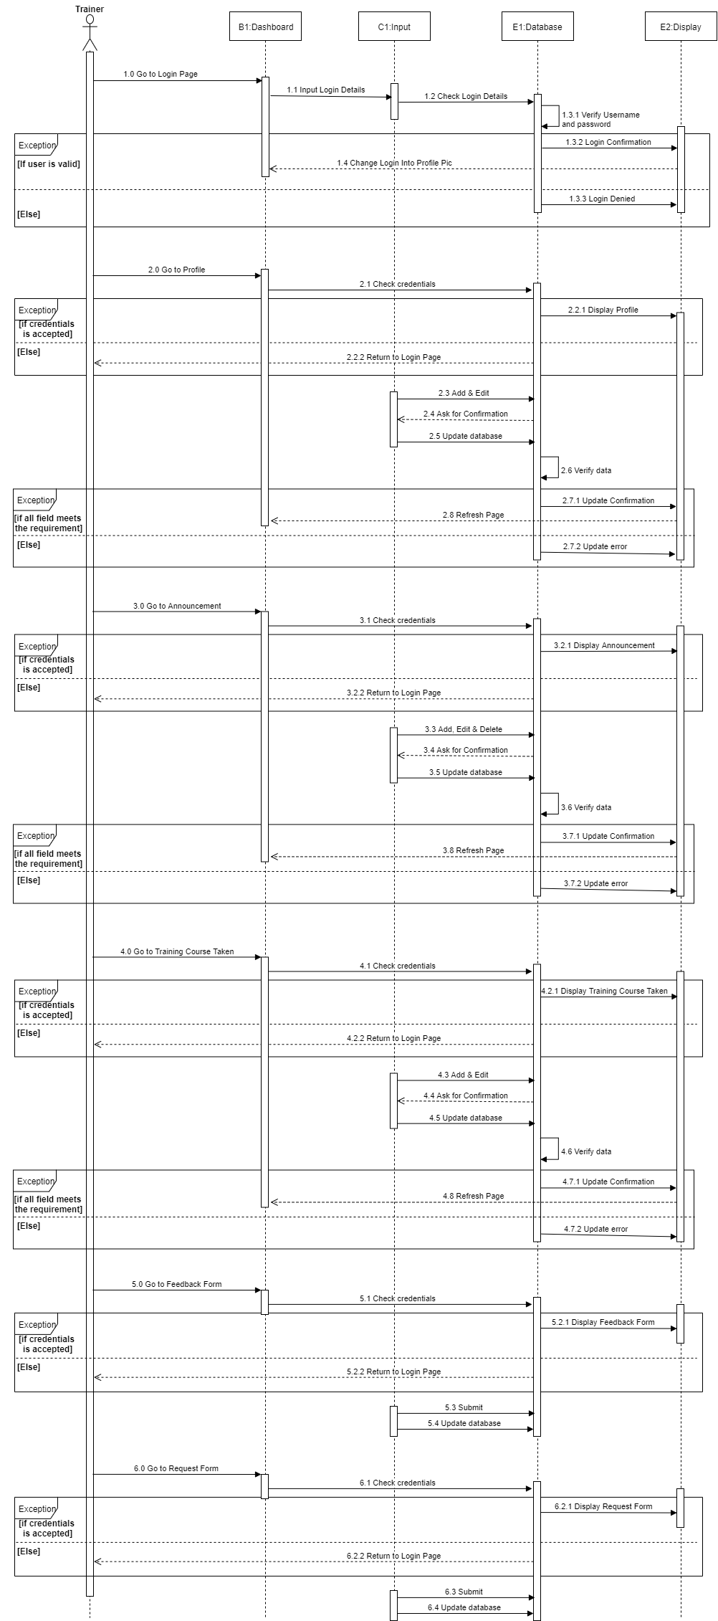

**SEQUENCE DIAGRAM TRAINEE**

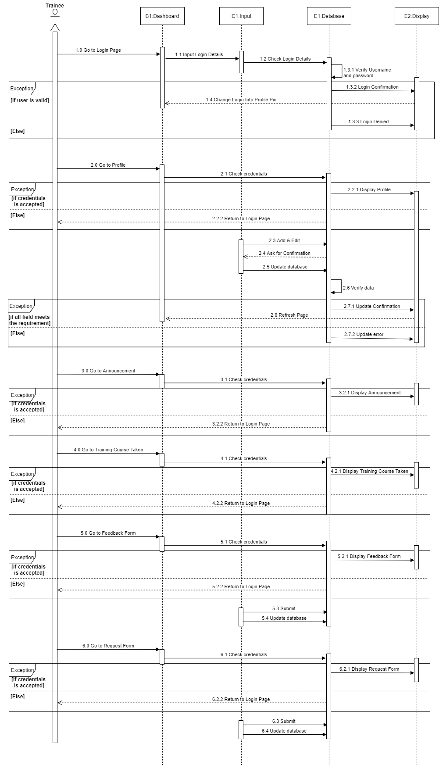

**FLOWCHART ADMIN & HR STAFF**

This Flowchart has mentioned that how a User_Type == Admin / HR Staff work between this system. 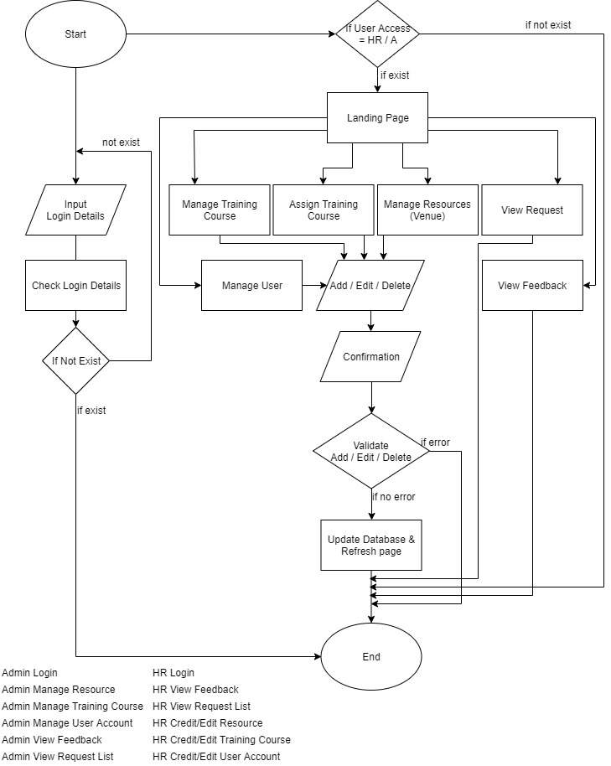

**FLOWCHART TRAINER & TRAINEE**

This Flowchart has mentioned that how a User_Type == Trainer / Trainee work between this system.

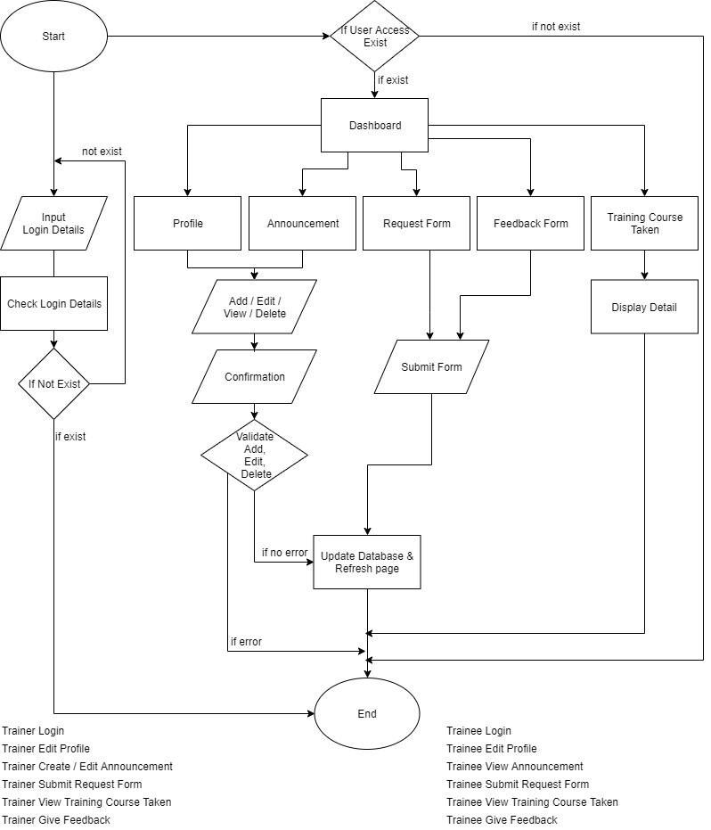

**Entity-Relational Diagram**

The Entity-Relational Diagram (ERD) below highlights the relationship between the models.

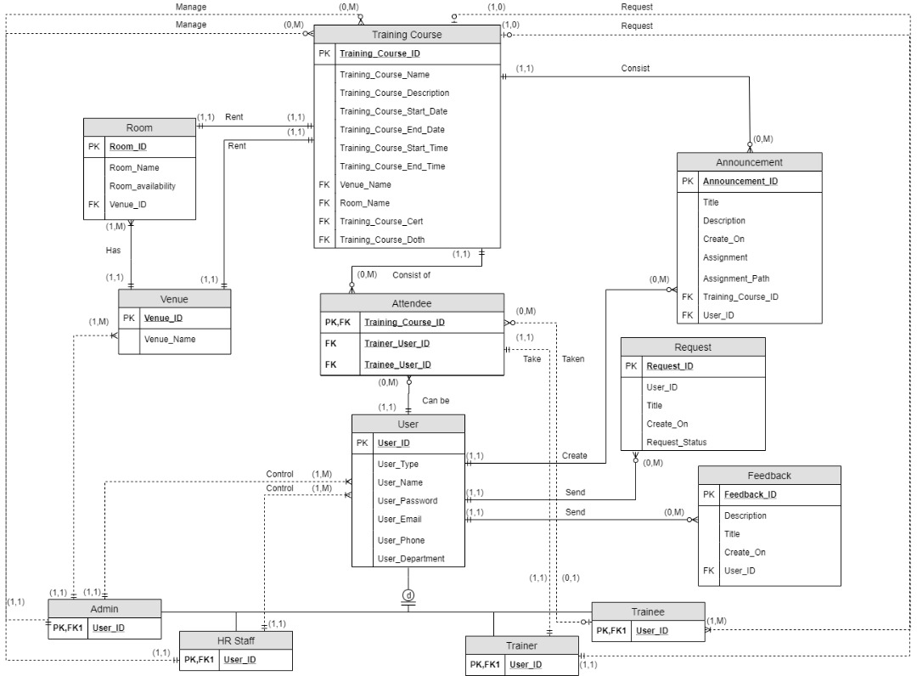

**Data Dictionary**

As part of data design, we include for the metadata for each of the field.

|  |  |  |  |  |  |  |  |
| --- | --- | --- | --- | --- | --- | --- | --- |
| ***Entity Name*** | ***Entity Description*** | ***Column Name*** | ***Column Description*** | ***Data Type*** | ***Length*** | ***Primary Key*** | ***Unique*** |
| User | User details, role will be store here in order to verification and validation | User_ID | For the unique identification of the user | Integer | 11 | True | True |
|  |  | User_Name | Name of the user | Varchar | 255 | False | False |
|  |  | User_Password | Password of the user accounts | Varchar | 255 | False | False |
|  |  | User_Type | Role of the user accounts | Varchar | 10 | False | False |
|  |  | User_Email | Email of the user accounts during registered the password and username will send the particular email accounts | Varchar | 255 | False | False |
|  |  | User_Phone | Phone of the user accounts | Varchar | 12 | False | False |
|  |  | User_Department | Department of the user | Varchar | 5 | False | False |

|  |  |  |  |  |  |  |  |
| --- | --- | --- | --- | --- | --- | --- | --- |
| ***Entity Name*** | ***Entity Description*** | ***Column Name*** | ***Column Description*** | ***Data Type*** | ***Length*** | ***Primary Key*** | ***Unique*** |
| Training Courses | All the list of the training courses will be stored in this entity with the description | Training_Course_ID | Unique ID for each of the training courses | Integer | 10 | True | True |
|  |  | Training_Course_Name | Naming for the training courses | Varchar | 255 | False | False |
|  |  | Training_Course_Description | Description for the training courses | Varchar | 255 | False | False |
|  |  | Training_Course_Start_Time | Time duration for the training courses | Varchar | 10 | False | False |
|  |  | Training_Course_End_Time | Time duration for the training courses | Varchar | 10 | False | False |
|  |  | Training­_Course_Start_Date | Date for the training courses | Date |  | False | False |
|  |  | Training_Course_End_Date | Date for the training courses | Date |  | False | False |
|  |  | Venue_Name | Reference for the training courses where will it held on | Varchar | 10 | False | False |
|  |  | Room_Name | Reference for the training courses where will it held on | Varchar | 10 | False | False |
|  |  | Training_Course_Cert | Name of the certificate of the training courses | Varchar | 100 | False | False |
|  |  | Training_Course_Cert_Path | Location of the cert will be save for backend | Text |  | False | False |

|  |  |  |  |  |  |  |  |
| --- | --- | --- | --- | --- | --- | --- | --- |
| ***Entity Name*** | ***Entity Description*** | ***Column Name*** | ***Column Description*** | ***Data Type*** | ***Length*** | ***Primary Key*** | ***Unique*** |
| Venue | All the venue will be stored in this entity and has link to venue | Venue_ID | Unique ID for the venue | Integer | 10 | True | True |
|  |  | Venue_Name | Name of the venue | Varchar | 255 | False | False |

|  |  |  |  |  |  |  |  |
| --- | --- | --- | --- | --- | --- | --- | --- |
| ***Entity Name*** | ***Entity Description*** | ***Column Name*** | ***Column Description*** | ***Data Type*** | ***Length*** | ***Primary Key*** | ***Unique*** |
| Room | All the resources room will be stored in here and the availability of the resource will be updated here as well. | Room_ID | Unique ID for the room | Integer | 10 | True | True |
|  |  | Room_Name | Name of the room | Varchar | 255 | False | False |
|  |  | Room_Availability | Availability of the room | Boolean | 1 | False | False |
|  |  | Venue_ID | Reference of the venue | Integer | 10 | Foreign Key | True |

|  |  |  |  |  |  |  |  |
| --- | --- | --- | --- | --- | --- | --- | --- |
| ***Entity Name*** | ***Entity Description*** | ***Column Name*** | ***Column Description*** | ***Data Type*** | ***Length*** | ***Primary Key*** | ***Unique*** |
| Attendee | The attendee and the training courses will be stored in here | Attendee_ID | The unique ID for the attendee | Integer | 10 | True | True |
|  |  | Trainer_User_ID | The ID, who join the training courses | Integer | 10 | Foreign Key | True |
|  |  | Training_Course_ID | The ID, which the training courses that the user join | Integer | 10 | Foreign Key | True |
|  |  | Trainee_User_ID | The ID, who join the training courses | Integer | 11 | Foreign Key | True |

|  |  |  |  |  |  |  |  |
| --- | --- | --- | --- | --- | --- | --- | --- |
| ***Entity Name*** | ***Entity Desciption*** | ***Column Name*** | ***Column Description*** | ***Data Type*** | ***Length*** | ***Primary Key*** | ***Unique*** |
| Announcement | List of announcements’ details will be stored in here | Announcement_ID | Unique ID for the announcement list | Integer | 10 | True | True |
|  |  | Title | Title for the announcement | Varchar | 255 | False | False |
|  |  | Description | Description for the announcement | Varchar | 500 | False | False |
|  |  | Created_on | Timestamp for the announcement | Datetime |  | False | False |
|  |  | Assignment | Name for the assignment where attach in the announcement | Varchar | 255 | False | False |
|  |  | Assignment_path | Location of the assignment saved for the backend purpose | Text |  | False | False |
|  |  | Training_Course_ID | Reference for which training course to attach the announcement | Int | 11 | True | True |

|  |  |  |  |  |  |  |  |
| --- | --- | --- | --- | --- | --- | --- | --- |
| ***Entity Name*** | ***Entity Description*** | ***Column Name*** | ***Column Description*** | ***Data Type*** | ***Length*** | ***Primary Key*** | ***Unique*** |
| Feedback | All of the feedback will stored in this entity | Feedback_ID | Unique ID for the feedback | Integer | 11 | True | True |
|  |  | User_ID | Reference for which user send the feedback | Int | 11 | Foreign Key | True |
|  |  | Title | Tile for the feedback | Varchar | 100 | False | False |
|  |  | Description | Description for the | Timestamp |  | False | False |
|  |  | Created_on | Timestamp for the feedback when it submitted | Datetime |  | False | False |

|  |  |  |  |  |  |  |  |
| --- | --- | --- | --- | --- | --- | --- | --- |
| ***Entity Name*** | ***Entity Description*** | ***Column Name*** | ***Column Description*** | ***Data Type*** | ***Length*** | ***Primary Key*** | ***Unique*** |
| Attendee_Request | All the request will store in this entity | Attendee_ID | Unique ID for the attendee_request | Integer | 11 | True | True |
|  |  | User_ID | Reference for which user send the request | Int | 11 | Foreign Key | True |
|  |  | Title | Tile for the feedback | Varchar | 100 | False | False |
|  |  | Description | Description for the | Timestamp |  | False | False |
|  |  | Created_on | Timestamp for the feedback when it submitted | Datetime |  | False | False |
|  |  | Status_request | Boolean for the approval that response by admin/hr | Varchar | 10 | False | False |

**Class Diagram**

**System Architectural Diagram**

The architectural design diagram below defines the relationship between the major software structural elements.

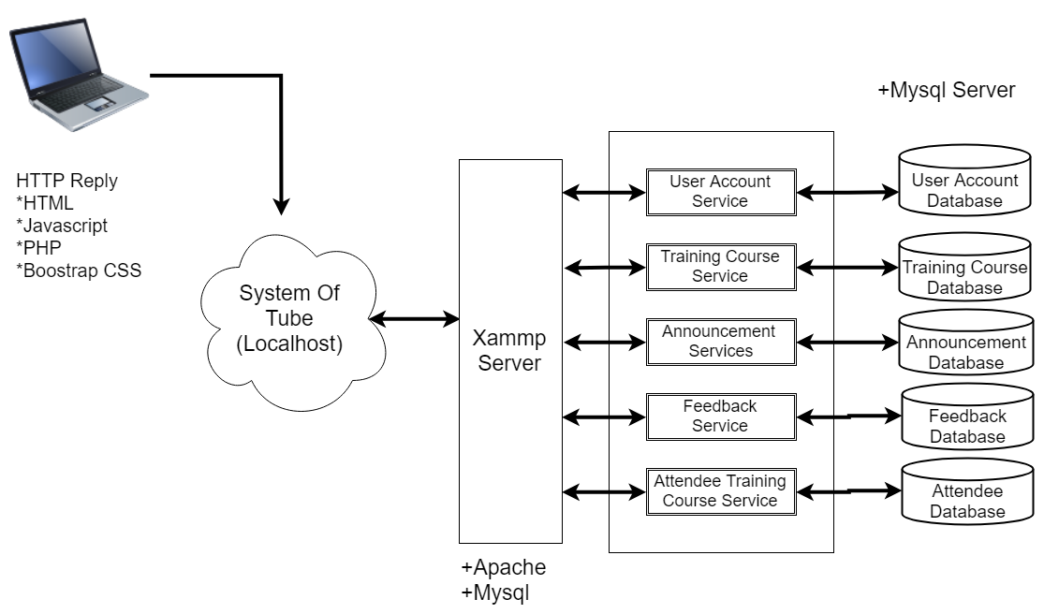

The architecture diagram above show how client side devices communicate with the server. When a function is being triggered by user, a request will send to the server which the server we used is mysql database. The server will validate the request for processing. If processing required data from our mysql database, communication is take place for data exchange. Hence, there will be a communication take place between user and the back-end in order to proceed their request/specific task.

**Application Architectural Diagram**

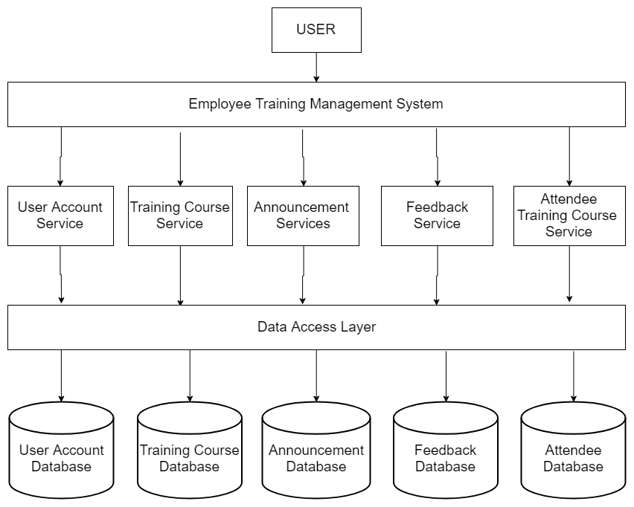

Each service has a narrow, focused a set of responsibility, and are independently expose in the form. An employee training management system could have separate microservice for user accounts, training courses, announcement, feedback and also the attendee databases.

**Component Diagram**

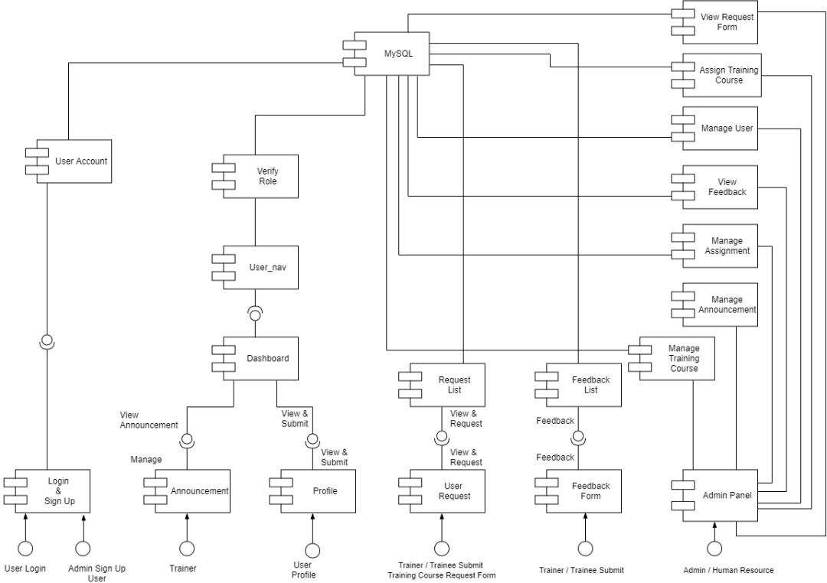

The component diagram above shows the provided interfaces to the users, and how the system components interface interact between each other. The components are mainly partitioned for user login, request training courses, assignment/submission, training courses, feedback and admin panel which are mange users, manage venue, manage training courses and etc. The components then interfaces with the database provided by mysql.

**Deployment Diagram**

The deployment design diagram highlights the hardware system’s topology, which, also provides one of the highest level of abstraction to the development team, by viewing the system from the hardware’s perspective.

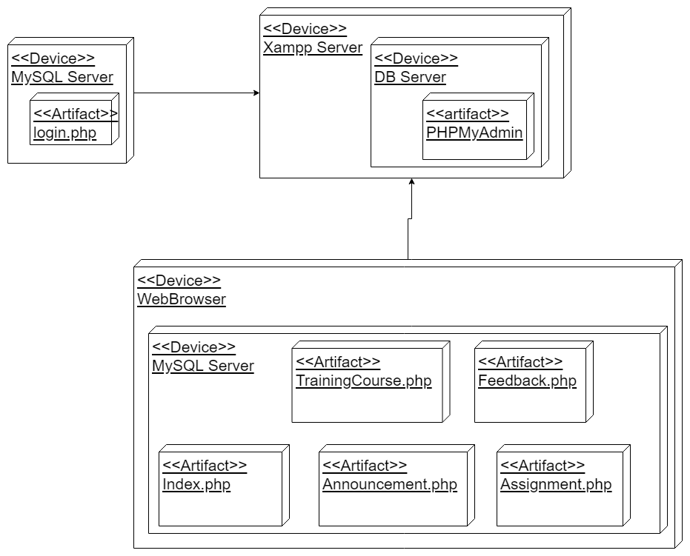

The deployment diagram shows the physical hardware components and the artifacts generated by the hardware. We partition it into user device, mysql databse. In this diagram, it shows how the components interact between each other.

**Test Case**

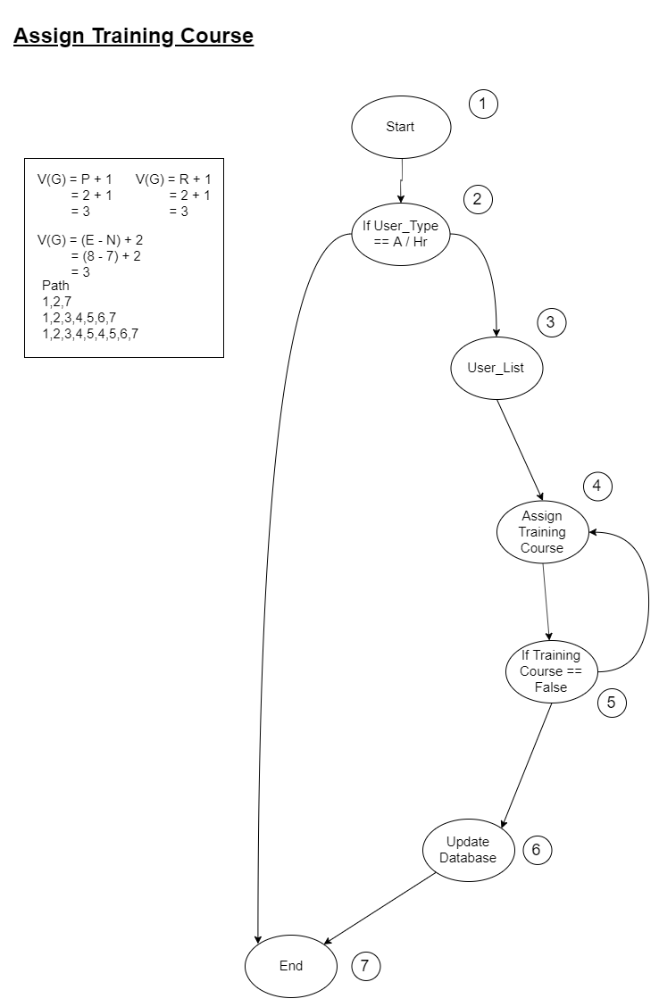

Test case for Admin & HR to assign the training course to trainer/trainee.

|  |  |  |  |  |  |  |
| --- | --- | --- | --- | --- | --- | --- |
| No | Action | Input | Expected Output | Actual Output | P/F | Remarks |
| 1 | Login as User_Type != Admin/HR | 1. Username, password | Redirect to admin_nav | Redirect to user_nav | F | It has no the access right to redirect admin_nav |
| 2 | Login as User_Type == Admin/HR | 1. Username, password 2. Redirect to assign training courses 3. Assign training course to trainer and trainees | Redirect to admin_nav and able to assign | Redirect to admin_nav and able to assign | P | It has the access right to do the assign training course |
| 3 | Login as User_Type == Admin/HR | 1. Username, password 2. Redirect to assign training course 3. No training courses are availability | Redirect to admin_nav and able to assign the training course to trainer and trainees | Redirect to admin_nav but not able to assign due to availability of the training courses | F | One training course, trainer and trainee can only involved in one. |

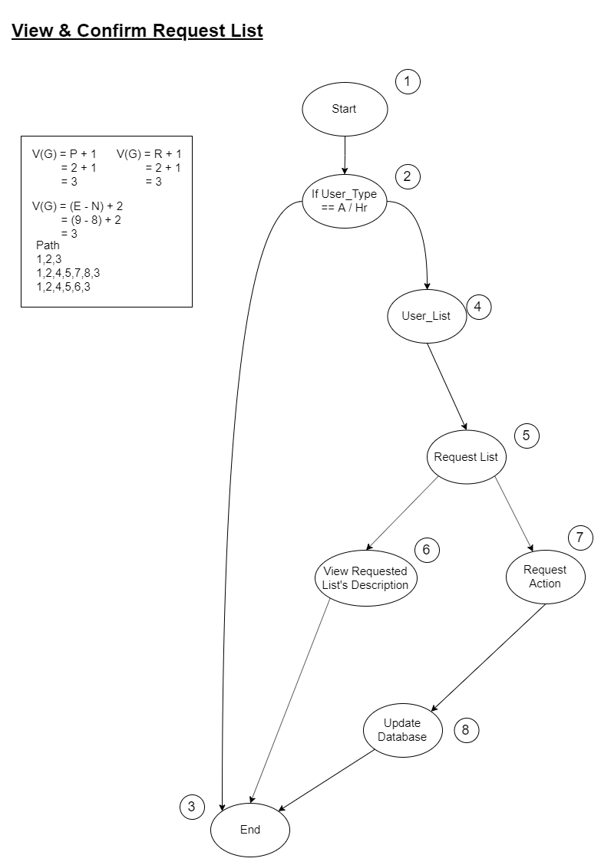Test case for Admin & HR to view and confirm requested list that submitted by trainer/trainee.

|  |  |  |  |  |  |  |
| --- | --- | --- | --- | --- | --- | --- |
| No | Action | Input | Expected Output | Actual Output | P/F | Remarks |
| 1 | Login as User_Type != Admin/HR | 1. Username, password | Redirect to admin_nav | Redirect to user_nav | F | It has no the access right to redirect admin_nav |
| 2 | Login as User_Type == Admin/HR | 1. Username, password 2. Redirect to view and confirm requested list 3. True/False input for requested form | Redirect to view and confirm requested list and able to do the true false statement for request form | Redirect to view and confirm requested list and able to do the true false statement for request form | P | It has the access right to view and confirm status to the requested list |
| 3. | Login as User_Type == Admin/HR | 1. Username, password 2. Redirect to view and confirm requested list | Redirect to view and confirm requested list and able to view the description which submitted by user | Redirect to view and confirm requested list and able to view the description which submitted by user | P | It has the access right to view the description |

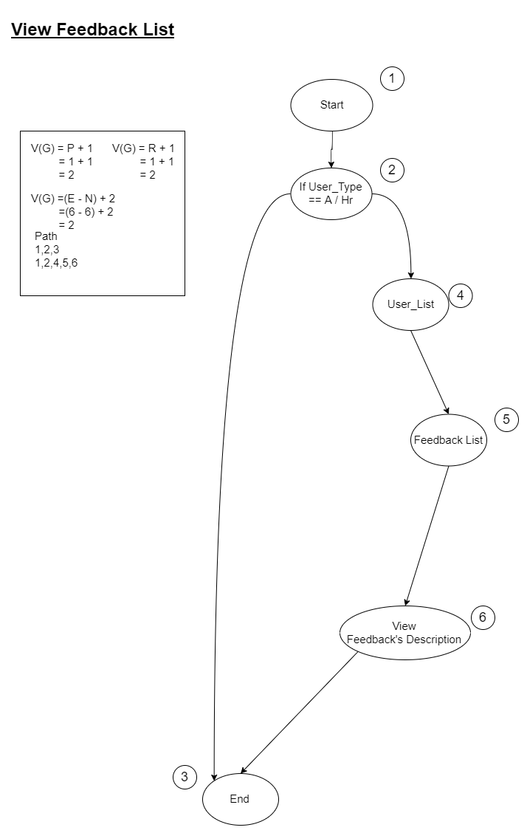

Test case for Admin & HR to view feedback list that submitted by trainer/trainee.

|  |  |  |  |  |  |  |
| --- | --- | --- | --- | --- | --- | --- |
| No | Action | Input | Expected Output | Actual Output | P/F | Remarks |
| 1 | Login as User_Type != Admin/HR | 1. Username, password | Redirect to admin_nav | Redirect to user_nav | F | It has no the access right to redirect admin_nav |
| 2 | Login as User_Type == Admin/HR | 1. Username, password 2. Redirect to view feedback | Redirect to view feedback list | Redirect to view feedback list and the description | P | It has the access right to view the list |

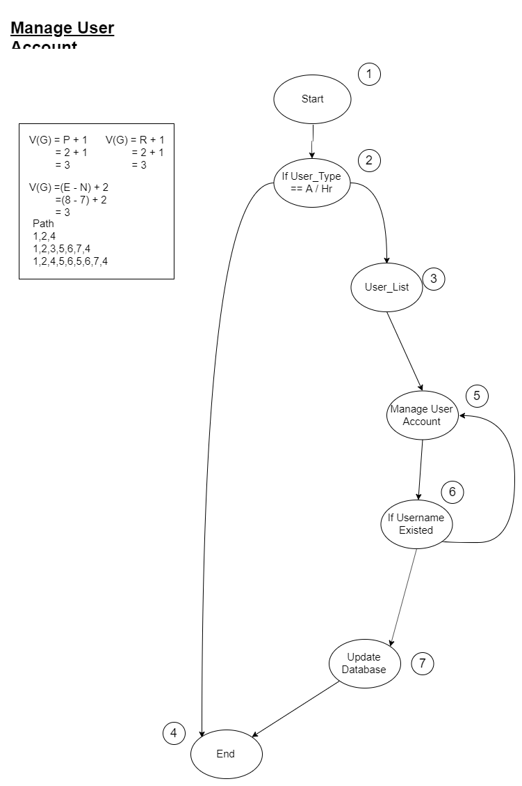

Test case for admin to add/edit or delete user accounts.

|  |  |  |  |  |  |  |
| --- | --- | --- | --- | --- | --- | --- |
| No | Action | Input | Expected Output | Actual Output | P/F | Remarks |
| 1 | Login with User_Type != Admin/HR | 1. Username, password | Redirect to admin_nav | Redirect to user_nav | F | It has no the access right to admin_nav |
| 2 | Login with User_Type == Admin/HR | 1. Username, password 2. Redirect to user list 3. Details of users | Redirect to user list page and able to add,edit/delete the user accounts | Redirect to user list page and able to add,edit/delete the user accounts | P | It has the access right to admin_nav and able to do manage the user accounts |
| 3 | Login with User_Type == Admin/HR | 1. Username, password 2. Redirect to user list 3. Details of users | Redirect to user list page and able to add,edit/delete the user accounts | Exception handling occurred, username existed in system | F | Username is unique for each of the employee in order to log in to the system |

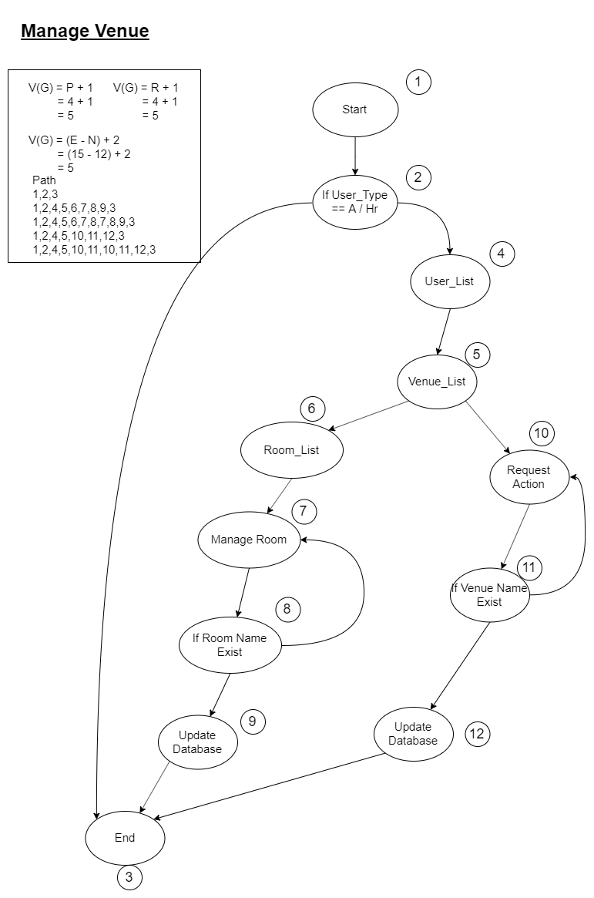

Test case for the Admin & HR to add/edit or delete the venue and room included the availability.

|  |  |  |  |  |  |  |
| --- | --- | --- | --- | --- | --- | --- |
| No | Action | Input | Expected Output | Actual Output | P/F | Remarks |
| 1 | Login with User_Type != Admin/HR | 1. Username, password | Redirect to admin_nav | Redirect to user_nav | F | It has no the access right to admin_nav |
| 2 | Login with User_Type == Admin/HR | 1. Username and password 2. Venue list 3. Room list 4. Manage room details 5. Room details | Able to save room name and update in database | Able to save room name and update in database | P |  |
| 3 | Login with User_Type == Admin/HR | 1. Username and password 2. Venue List 3. Room list 4. Manage room details 5. Room details | Able to save room name and update in database | Not Able to save room name | F | Exception handling occur, roon name existed |
| 4 | Login with User_Type == Admin/HR | 1. Username and password 2. Venue list      1. Manage venue details 2. Venue details | Able to save venue name and update in database | Able to save room name and update in database | P |  |
| 5 | Login with User_Type == Admin/HR | 1. Username and password 2. Venue list      1. Manage venue details 2. Venue details | Able to save venue name and update in database | Not able to save venue name and details | F | Exception handling occur, roon name existed |

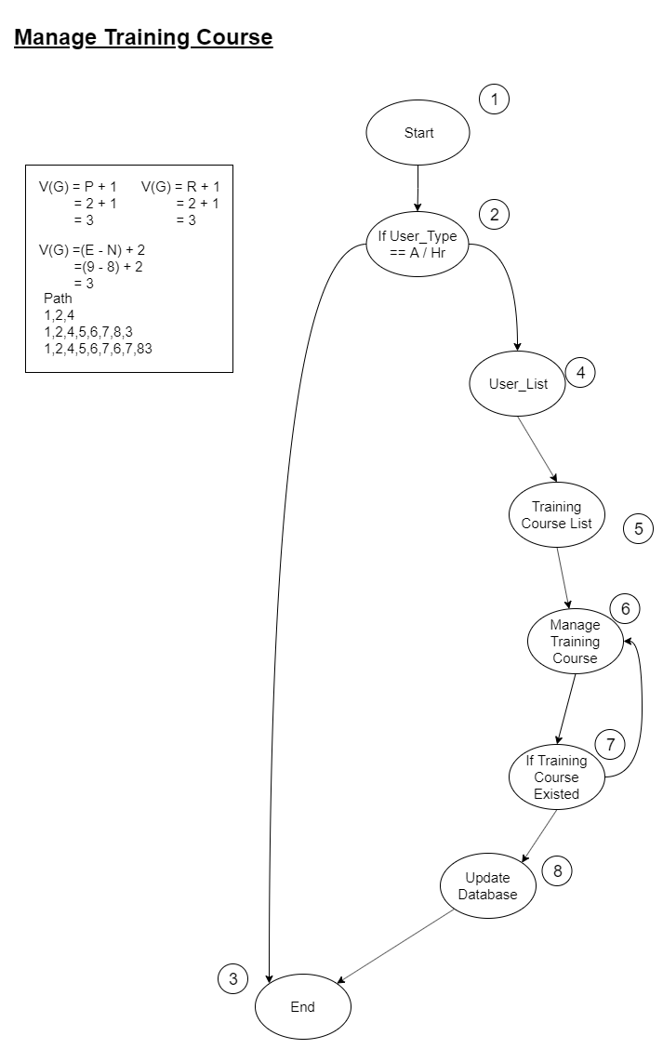

Test case for Admin & HR to add/edit or delete training course in the system.

|  |  |  |  |  |  |  |
| --- | --- | --- | --- | --- | --- | --- |
| No | Action | Input | Expected Output | Actual Output | P/F | Remarks |
| 1 | Login with User_Type != Admin/HR | 1. Username, password | Redirect to admin_nav | Redirect to user_nav | F | It has no the access right to admin_nav |
| 2 | Login with User_Type == Admin/HR | 1. Username, password 2. Redirect to training course list 3. Details of training course | Redirect to training course list page and able to add,edit/delete the training course | Redirect to training course list page and able to add,edit/delete the training course | P | It has the access right to admin_nav and able to do manage training course |
| 3 | Login with User_Type == Admin/HR | 1. Username, password 2. Redirect to training course list 3. Details of training course | Redirect to training course list page and able to add,edit/delete the training course | Exception handling occurred, training courses name existed in system | F | training course name is unique for the system |

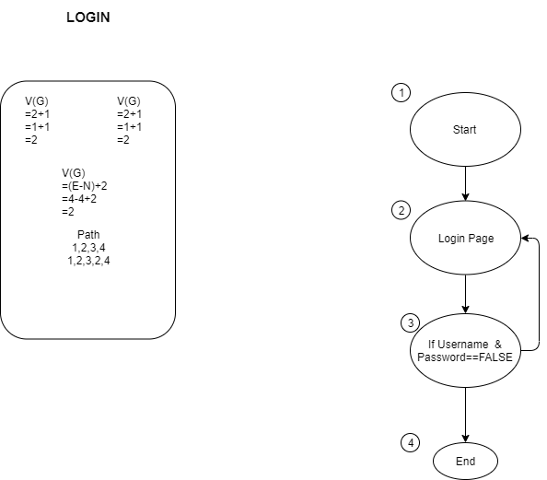

Test case for all the user login to the system.

|  |  |  |  |  |  |  |
| --- | --- | --- | --- | --- | --- | --- |
| No | Action | Input | Expected Output | Actual Output | P/F | Remarks |
| 1 | Login to the system from the index | 1. Username and password 2. Login Button | Redirect to the navigation based on the User_Type | Redirect to the navigation based on the User_Type | P | Username and password matched in the system |
| 2 | Login to the system from the index | 1. Username and password 2. Login button | Redirect to the navigation based on the User_Type | Not able login to the system, exception handling occur | F | Username and password do not matched in the system |

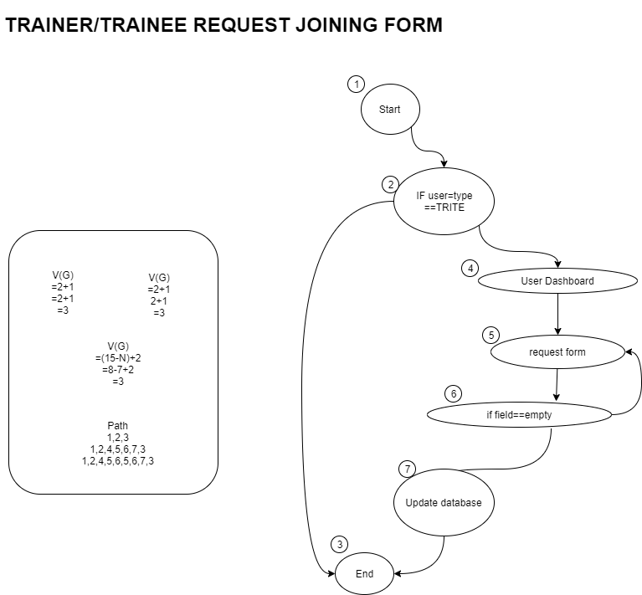

Test case for Trainer/Trainee to submit the request form to joining training course.

|  |  |  |  |  |  |  |
| --- | --- | --- | --- | --- | --- | --- |
| No | Action | Input | Expected Output | Actual Output | P/F | Remarks |
| 1 | Login to the system with User_Type != TR/TE | 1. Username and password | Able to view the request form | Not able to view due to the User_Type | F | Does not has the access right to the form |
| 2 | Login to the system with User_Type == TR/TR and surf to the request form | 1. Title 2. Description 3. Submit Button | Able to send the request for joining to Admin/HR Staff and update the record in database | Able to send the request and able update the status by Admin/HR | P | Has the access right to the request form. |
| 3 | Login to the system with User_Type == TR/TE and surf to the request form | 1. Title 2. Submit Button 3. Description 4. Submit Button | Able to submit the form to the database | Not able to submit due to blank of the field | F | Exception handling occur, field cannot be empty |

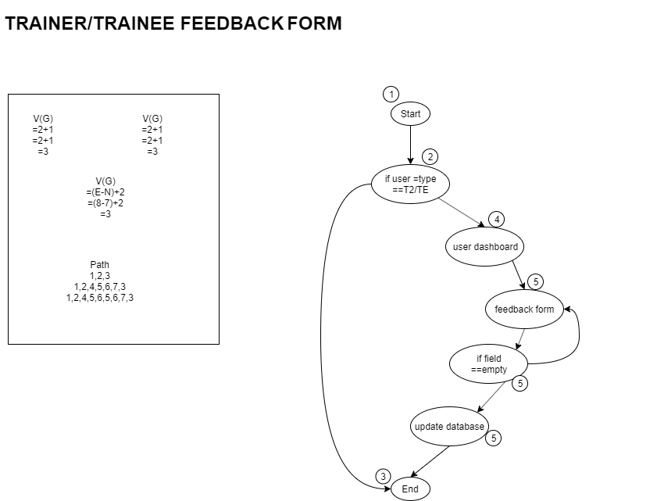

Test case for Trainer/Trainee to submit the feedback form.

|  |  |  |  |  |  |  |
| --- | --- | --- | --- | --- | --- | --- |
| No | Action | Input | Expected Output | Actual Output | P/F | Remarks |
| 1 | Login to the system with User_Type != TR/TE | 1. Username and password | Able to view the feedback form | Not able to view due to the User_Type | F | Does not has the access right to the form |
| 2 | Login to the system with User_Type == TR/TR and surf to the feedback form | 1. Title 2. Description 3. Submit Button | Able to send the feedback of the training to Admin/HR Staff | Able to send the feedback | P | Has the access right to the feedback form. |
| 3 | Login to the system with User_Type == TR/TE and surf to the feedback form | 1. Title 2. Submit Button 3. Description 4. Submit Button | Able to submit the form to the database | Not able to submit due to blank of the field | F | Exception handling occur, field cannot be empty |

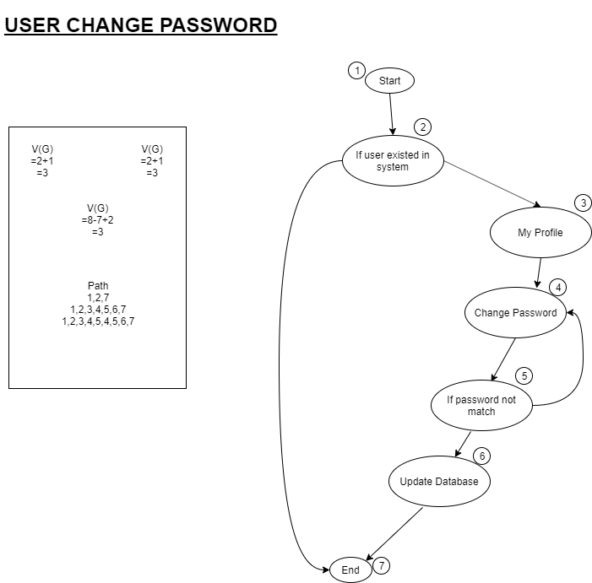

Test case for all the user to change their password.

|  |  |  |  |  |  |  |
| --- | --- | --- | --- | --- | --- | --- |
| No | Action | Input | Expected Output | Actual Output | P/F | Remarks |
| 1 | Log in to the system | 1. Username and password 2. Login Button | Redirect to the system and able to view profile and edit for the password. | Not able enter to the system | F | User does not exist |
| 2 | Able log in to the system | 1. Username and password 2. Login Button 3. Edit Profile 4. Change password 5. Old password and new password | Redirect to the system and able to view profile and edit for the password and update successfully | Redirect to the system and able to view profile and edit for the password and update successfully in the system | P |  |
| 3 | Able log in to the system | 1. Username and password 2. Login button 3. Edit Profile 4. Change Password 5. Old and new password | Redirect to the system and able to view profile and edit for the password and update successfully | Not able to update which the password does not match with the database | F | Exception handling occur |

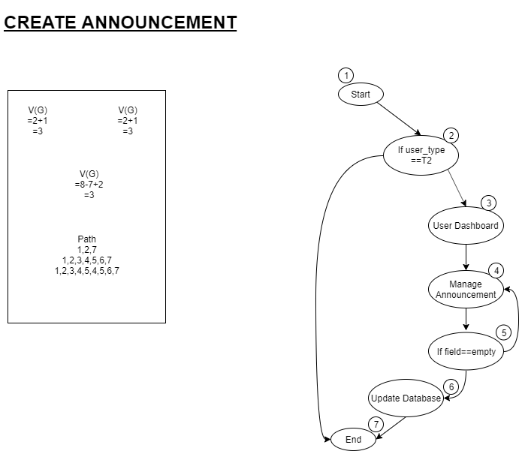

Test case for Trainer to create announcement to the training course.

|  |  |  |  |  |  |  |
| --- | --- | --- | --- | --- | --- | --- |
| No | Action | Input | Expected Output | Actual Output | P/F | Remarks |
| 1 | Login to the system with User_Type == TR | 1. Username and password | Able to view the manage announcement form | Not able to view due to the User_Type | F | Does not has the access right to the form |
| 2 | Login to the system with User_Type == TR | 1. Username and password 2. Login Button 3. Announcement details 4. Submit Button | Able to submit the announcement to the database and shown to trainee | Able to submit the announcement to the database and shown to trainee | P | Has the access right to the form |
| 3 | Able log in to the system | 1. Username and password 2. Login button 3. Announcement details 4. Submit Button | Able to submit the announcement to the database and shown to trainee | Not able to submit the announcement which some of the input field is empty | F | Exception handling occur |

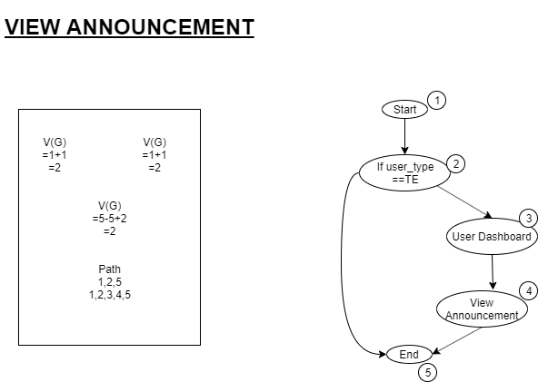

Test case for the trainee to view the announcement if he/she joined a training courses.

|  |  |  |  |  |  |  |
| --- | --- | --- | --- | --- | --- | --- |
| No | Action | Input | Expected Output | Actual Output | P/F | Remarks |
| 1 | Login to the system with User_Type == TE | 1. Username and password | Able to view the announcement | Not able to view due to the User_Type | F | Does not has the access right to the form |
| 2 | Login to the system with User_Type == TE | 1. Username and password 2. Login Button 3. Announcement details | Able to view the announcement from the database | Able to view the announcement from the database | P | Has the access right to the form |

**Interface Design**