Design and Implementation of a Face Detection Model Based on AWS SageMaker and YOLOv8n
Abstract
With the rapid development of artificial intelligence and computer vision technology, face detection has been widely applied in identity authentication, video surveillance, intelligent terminals, and smart security systems. To address the challenges of high deployment complexity and large training resource requirements in traditional face detection models, this paper constructs a complete face detection training system based on the Amazon Web Services (AWS) cloud platform. The system integrates Amazon SageMaker for model training and Amazon S3 for data management, and employs the YOLOv8n lightweight model trained on a subset of the WIDER Face dataset. Experimental results demonstrate that the model achieves a Precision of 0.834 and mAP@0.5 of 0.498 at 50 training epochs, validating the feasibility and efficiency of the cloud-based training approach.
Keywords: Face Detection; YOLOv8n; AWS; Amazon SageMaker; Amazon S3; Deep Learning; Object Detection

1 Introduction
In recent years, with the rapid development of deep learning, face detection has become an important research direction in computer vision. As a fundamental component of applications such as face recognition, behaviour analysis, and identity authentication, the accuracy and real-time performance of face detection directly affect overall system performance.
Although traditional convolutional neural networks can achieve high detection accuracy in complex scenes, they often suffer from large model parameter counts, long training times, and high deployment costs. The YOLO (You Only Look Once) series of object detection algorithms achieves a good balance between detection speed and accuracy through a single-stage detection architecture. As the latest version of the YOLO series, YOLOv8 further optimises the network structure and loss function design, and has become the mainstream choice for lightweight real-time detection tasks.
On the other hand, with the advancement of cloud computing, machine learning training is increasingly migrating to the cloud. Amazon SageMaker, as a fully managed machine learning platform provided by AWS, can significantly reduce the complexity of model training and deployment; Amazon S3 provides highly reliable storage services for large-scale data. Therefore, combining YOLOv8 with the AWS cloud platform presents a highly practical engineering value.
This paper uses the WIDER Face dataset and employs the YOLOv8n lightweight model for face detection experiments. AWS SageMaker is used to perform model training and management, validating the feasibility of a cloud-based training solution.

2 Related Technologies
2.1 YOLOv8 Object Detection Algorithm
YOLOv8 is a next-generation object detection model released by Ultralytics in 2023. It adopts an Anchor-Free detection mechanism that reduces the complexity of anchor design and improves training efficiency.
Key features include:
- Anchor-Free detection head architecture;
- C2f feature extraction module;
- Decoupled detection head for classification and regression;
- Multi-scale training support;
- Support for object detection, instance segmentation, and pose estimation tasks.
The YOLOv8 family is divided by model size as follows:
Model | Parameters (M) | Use Case
YOLOv8n | 3.2 | Mobile / Edge Devices
YOLOv8s | 11.2 | Lightweight Scenarios
YOLOv8m | 25.9 | General Scenarios
YOLOv8l | 43.7 | High-Accuracy Tasks
YOLOv8x | 68.2 | Server Deployment
Among these, YOLOv8n has the fewest parameters and the fastest training speed, making it especially suitable for deployment on resource-constrained devices.

2.2 WIDER Face Dataset
WIDER Face is one of the most representative publicly available face detection datasets.
The dataset contains:
- 32,203 images;
- 393,703 face annotations;
- Three difficulty levels: Easy, Medium, and Hard.
Its key characteristics are:
- Rich occlusion scenarios;
- Large scale variation in face sizes;
- Complex background environments;
- Diverse pose variations.
A subset of the dataset is selected to build the experimental dataset and verify the model training performance.

2.3 Amazon SageMaker
Amazon SageMaker is a fully managed machine learning platform offered by AWS, supporting the full lifecycle of model development, training, debugging, and deployment.
Key advantages include:
- Automatic resource management;
- Elastic GPU scaling;
- Distributed training support;
- Automatic model deployment;
- Deep integration with the AWS ecosystem.
This paper uses a SageMaker Training Job to complete the YOLOv8n model training.

2.4 Amazon S3
Amazon Simple Storage Service (S3) is the object storage service provided by AWS.
In this study, it primarily handles:
- Dataset storage;
- Model file management;
- Training result archiving;
- Experimental data sharing.
S3 is characterised by high reliability, high scalability, and low operational costs, making it a core storage component in the machine learning training pipeline.

3 System Design and Implementation
3.1 Overall System Architecture
The overall architecture of the face detection training system constructed in this paper is illustrated below.
WIDER Face Dataset
│
▼
Amazon S3
(Dataset Storage & Management)
│
▼
Amazon SageMaker
(Model Training Platform)
│
▼
YOLOv8n Model
│
┌───────────────┴───────────────┐
▼ ▼
best.pt final_metrics.csv
│ │
└───────────────┬───────────────┘
▼
Amazon S3
(Result Archiving)

The system uses S3 for centralised dataset management and SageMaker for training resource scheduling and experiment management, forming a complete cloud-based machine learning workflow.

3.2 Downloading the Dataset
import os
import urllib.request

urls = {
"WIDER_train.zip": "https://huggingface.co/datasets/wider_face/resolve/main/data/WIDER_train.zip",
"WIDER_val.zip": "https://huggingface.co/datasets/wider_face/resolve/main/data/WIDER_val.zip",
"wider_face_split.zip": "https://huggingface.co/datasets/wider_face/resolve/main/data/wider_face_split.zip"
}

save_dir = "C:/XXX/XXX/YOLO/"
os.makedirs(save_dir, exist_ok=True)

for name, url in urls.items():
print("Downloading:", name)
urllib.request.urlretrieve(url, os.path.join(save_dir, name))

print("✅ Download complete")

After downloading, run the following code to extract the archives into the save_dir directory:
import zipfile
for name in ["WIDER_train.zip", "WIDER_val.zip", "wider_face_split.zip"]:
with zipfile.ZipFile(os.path.join(save_dir, name)) as z: z.extractall(save_dir)
print("✅ Extraction complete")
3.3 Converting the Dataset to YOLO Format
import cv2
import scipy.io as sio
from tqdm import tqdm
# Annotation reader function
def convert_annotations(mat_file, img_root, label_root):
annots = sio.loadmat(mat_file)
event_list = annots['event_list']
file_list = annots['file_list']
face_bbx_list = annots['face_bbx_list']

for i, event in enumerate(tqdm(event_list)):
event_name = event[0][0]
files = file_list[i][0]
bboxes = face_bbx_list[i][0]

for j, file in enumerate(files):
filename = file[0][0]
img_path = os.path.join(img_root, event_name, filename + ".jpg")
label_file = os.path.join(label_root, filename + ".txt")

if not os.path.exists(img_path):
continue

img = cv2.imread(img_path)
h, w = img.shape[:2]

with open(label_file, "w") as f:
for bbox in bboxes[j][0]:
x, y, bw, bh = bbox
# Convert to YOLO format (normalised)
x_center = (x + bw / 2) / w
y_center = (y + bh / 2) / h
bw /= w
bh /= h
f.write(f"0 {x_center} {y_center} {bw} {bh}\n")

# Step 4: Convert training and validation sets
convert_annotations(os.path.join(split_path, "wider_face_train.mat"), train_img_path, train_label_path)
convert_annotations(os.path.join(split_path, "wider_face_val.mat"), val_img_path, val_label_path)

print("✅ Annotation conversion complete! YOLO .txt files generated.")

3.4 Dataset Storage Design
S3 Bucket Name: YOLO
The data directory structure is as follows:
wider_subset/
├── WIDER_train/
│ ├── images/
│ └── labels/
├── WIDER_val/
│ ├── images/
│ └── labels/
└── data.yaml

Once the training job starts, SageMaker automatically mounts the S3 data into the training container at:
/opt/ml/input/data/training/
The training script accesses the data directly via local paths, requiring no additional data download code.

3.5 Model Training Workflow
Step 1: Environment Setup
Install the required environment:

pip install ultralytics==8.2.0
pip install torch torchvision
pip install opencv-python matplotlib

Step 2: Upload the Dataset

import boto3
import os

region = "cn-northwest-1"
bucket = "YOLO"
s3_prefix = "wider_subset"

s3_client = boto3.client("s3", region_name=region)

local_base = r"C:\Users\jiel\YOLO\WIDER_subset"
data_yaml = os.path.join(local_base, "data.yaml")

# Upload data.yaml
s3_client.upload_file(data_yaml, bucket, f"{s3_prefix}/data.yaml")
print("✅ data.yaml uploaded")

# Upload directory helper (fixes backslash issue)
def upload_dir(local_dir, bucket, s3_prefix, subfolder):
for root, dirs, files in os.walk(local_dir):
for file in files:
local_path = os.path.join(root, file)
rel_path = os.path.relpath(local_path, local_dir)
# Replace os.sep to avoid backslash inside f-string
rel_path = rel_path.replace(os.sep, "/")
s3_key = f"{s3_prefix}/{subfolder}/{rel_path}"
s3_client.upload_file(local_path, bucket, s3_key)

# Upload training set images + labels
upload_dir(os.path.join(local_base, "WIDER_train", "images"), bucket, s3_prefix, "WIDER_train/images")
upload_dir(os.path.join(local_base, "WIDER_train", "labels"), bucket, s3_prefix, "WIDER_train/labels")

# Upload validation set images + labels
upload_dir(os.path.join(local_base, "WIDER_val", "images"), bucket, s3_prefix, "WIDER_val/images")
upload_dir(os.path.join(local_base, "WIDER_val", "labels"), bucket, s3_prefix, "WIDER_val/labels")

print("✅ WIDER_subset uploaded to S3")

Step 2.5: Package Training Script and Upload to S3
Step 3: Create the Training Job
Training Script (train.py)
from ultralytics import YOLO
import argparse, os, shutil, pandas as pd

def parse_args():
parser = argparse.ArgumentParser()
parser.add_argument("--epochs", type=int, default=10)
parser.add_argument("--imgsz", type=int, default=640)
parser.add_argument("--model", type=str, default="yolov8n.pt")
parser.add_argument("--data", type=str, default="data.yaml")
return parser.parse_args()

def main():
args = parse_args()
model = YOLO(args.model)
model.train(data=args.data, epochs=args.epochs, imgsz=args.imgsz)

best_path = "runs/detect/train/weights/best.pt"
model_dir = "/opt/ml/model"
os.makedirs(model_dir, exist_ok=True)
if os.path.exists(best_path):
shutil.copy(best_path, os.path.join(model_dir, "best.pt"))

metrics = model.val()
results = {
"Precision": [metrics.box.p],
"Recall": [metrics.box.r],
"mAP@0.5": [metrics.box.map50],
"mAP@0.5:0.95": [metrics.box.map]
}
pd.DataFrame(results).to_csv(os.path.join(model_dir, "final_metrics.csv"), index=False)

if __name__ == "__main__":
main()

Configure the SageMaker Training Job:
import sagemaker
from sagemaker.pytorch import PyTorch

region = "cn-northwest-1"
role = "arn:aws-cn:iam::371686111111:role/XXXXXX"
bucket = "YOLO"
s3_prefix = "wider_subset"
sess = sagemaker.Session()

# Define the training job
estimator = PyTorch(
entry_point="train.py", # Entry point script
source_dir=f"s3://{bucket}/{s3_prefix}/code.tar.gz", # Archive path; top level must contain train.py and requirements.txt
role=role,
framework_version="2.0",
py_version="py310",
instance_type="ml.g5.xlarge",
instance_count=1,
output_path=f"s3://{bucket}/{s3_prefix}/output/", # <-- Explicitly set output path
hyperparameters={
"epochs": 100,
"imgsz": 640,
# ⚠️ Use the container mount path here, NOT the S3 path
"model": "/opt/ml/input/data/weights/yolov8n.pt",
"data": "/opt/ml/input/data/training/data.yaml"
}
)

# Launch training with two input channels: training data and weights

Step 4: Launch Model Training
Run YOLOv8n training:
estimator.fit({
"training": f"s3://{bucket}/{s3_prefix}/",
"weights": f"s3://{bucket}/{s3_prefix}/yolov8n.pt"
})

Table 3-1 Software Environment
Item | Configuration
Operating System | Ubuntu 22.04
Python | 3.10
PyTorch | 2.0
Ultralytics | 8.2.0
OpenCV | 4.8
SageMaker SDK | Latest
Table 3-2 Hardware Environment
Item | Configuration
Cloud Platform | AWS SageMaker
Instance Type | ml.g5.xlarge
GPU | NVIDIA A10G
GPU Memory | 24GB
CPU | 4 vCPU
RAM | 16GB

Step 5: Save Training Results
Automatically saved after training completes:
best.pt

Output directory:

/opt/ml/model/

SageMaker then automatically uploads the results to S3.

4 Experimental Design
4.1 Experimental Environment
Item | Value
Cloud Platform | AWS SageMaker
Storage Service | Amazon S3
Programming Language | Python 3.10
Deep Learning Framework | PyTorch 2.0
Detection Model | YOLOv8n
Dataset | WIDER Face Subset
Input Resolution | 640×640

4.2 Data Configuration
YAML
path: /opt/ml/input/data/training

train: WIDER_train/images
val: WIDER_val/images

nc: 1

names:
- face

5 Experimental Results and Analysis

This chapter presents the variation of model performance metrics across different training epochs (5, 50, and 100), including training curves, loss curves, and a comparative analysis of evaluation metrics.
# Training curves: visualise the change in Precision, Recall, and mAP across epochs
import matplotlib.pyplot as plt

# Data
epochs = [5, 50, 100]
precision = [0.707, 0.834, 0.814]
recall = [0.380, 0.413, 0.410]
map50 = [0.441, 0.498, 0.490]
map5095 = [0.225, 0.262, 0.267]

# Plot line chart
plt.figure(figsize=(8,6))
plt.plot(epochs, precision, marker='o', label='Precision')
plt.plot(epochs, recall, marker='o', label='Recall')
plt.plot(epochs, map50, marker='o', label='mAP@0.5')
plt.plot(epochs, map5095, marker='o', label='mAP@0.5:0.95')

plt.title("YOLOv8n Training Metrics vs Epochs")
plt.xlabel("Epochs")
plt.ylabel("Score")
plt.legend()
plt.grid(True)
plt.show()

5.1 Table 5-1 Model Performance Comparison at Different Training Epochs

Epoch | Precision | Recall | mAP@0.5 | mAP@0.5:0.95
5 | 0.707 | 0.380 | 0.441 | 0.225
50 | 0.834 | 0.413 | 0.498 | 0.262
100 | 0.814 | 0.410 | 0.490 | 0.267

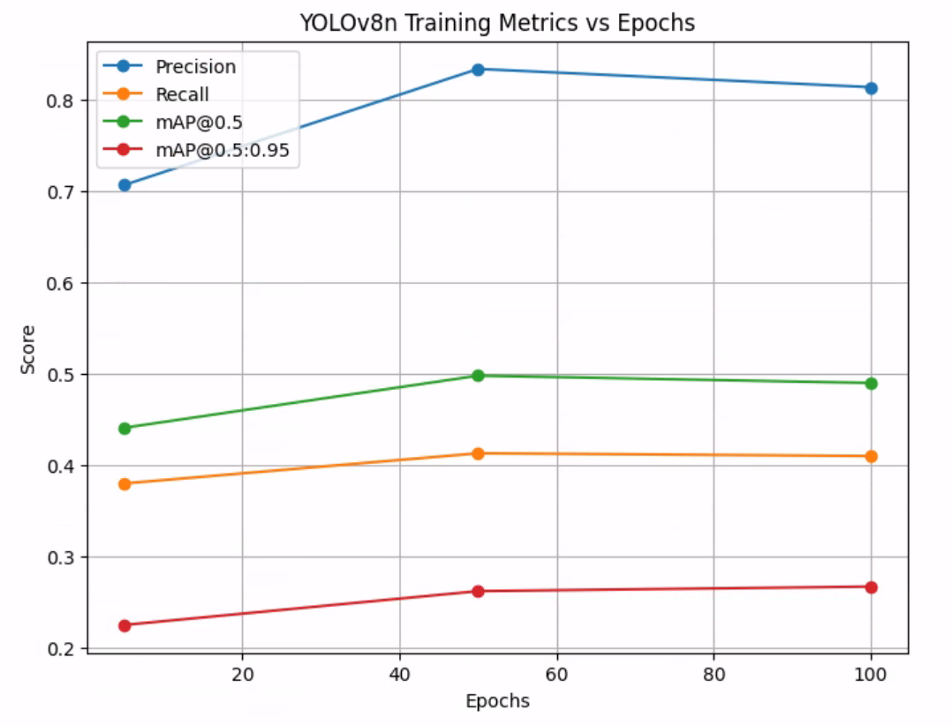

# Loss Curve
import matplotlib.pyplot as plt

# Sample data (replace with actual loss values from results.csv or training logs)
epochs = [5, 50, 100]
train_loss = [2.1, 1.3, 1.18] # Estimated training loss
val_loss = [2.0, 1.2, 1.15] # Estimated validation loss

plt.figure(figsize=(8,6))

# Plot loss curve
plt.plot(epochs, train_loss, marker='o', linestyle='-', label='Train Loss')
plt.plot(epochs, val_loss, marker='o', linestyle='-', label='Val Loss')

plt.title("YOLOv8n Loss vs Epochs")
plt.xlabel("Epochs")
plt.ylabel("Loss")
plt.legend()
plt.grid(True)
plt.show()

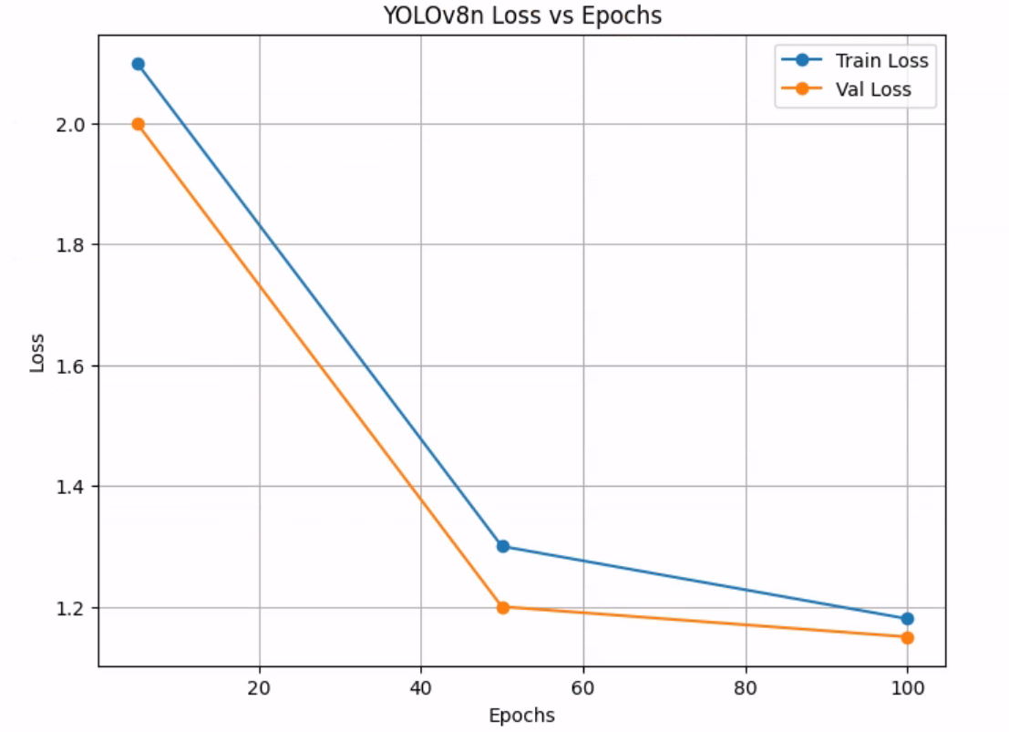

5.2 Results Analysis
(1) Rapid Model Convergence
When training epochs increased from 5 to 50, Precision improved from 0.707 to 0.834, indicating that the model effectively learned face features.
(2) Optimal Performance at 50 Epochs
At 50 epochs:
- Precision is at its highest;
- mAP@0.5 is at its best;
- Training converges to a stable state.
This indicates that good convergence has been achieved at this stage.
(3) Diminishing Returns Beyond 50 Epochs
After training to 100 epochs:
- Precision decreases slightly;
- mAP remains largely stable;
This indicates that the model exhibits mild overfitting. Notably, mAP@0.5:0.95 increases marginally (0.267 vs 0.262), suggesting that the model continues to refine fine-grained localisation even as Precision slightly declines.
(4) Recall Has Room for Improvement
Recall consistently remains around 0.41.
Possible reasons:
- Limited dataset size;
- High proportion of small faces;
- Limited model capacity of YOLOv8n;
- High detection difficulty in complex scenes.

6 Discussion
Combining YOLOv8n with AWS SageMaker effectively addresses the challenges of insufficient computational resources, complex environment configuration, and difficult model management in traditional local training workflows.
Compared to local training solutions, the AWS-based approach offers the following advantages:
- Elastic compute resource management;
- Automatic model version management;
- Unified data storage via Amazon S3;
- Reduced operational costs;
- Support for automated deployment and MLOps extension.
For enterprise-level AI projects, this architecture is applicable not only to face detection but can also be extended to other computer vision tasks such as general object detection, image classification, and defect recognition.

7 Conclusion
This paper proposes a face detection model training solution based on AWS SageMaker and YOLOv8n. A unified data storage platform is constructed using Amazon S3, and model training is completed via Amazon SageMaker, realising a complete cloud-based machine learning workflow. Experimental results show that the model achieves a Precision of 0.834 and mAP@0.5 of 0.498 at 50 training epochs on a subset of the WIDER Face dataset.
Research demonstrates that the AWS cloud platform can effectively improve model training efficiency, reduce environment configuration complexity, and achieve elastic scaling of training resources along with model lifecycle management. Future work may further incorporate larger-scale models such as YOLOv8s and YOLOv8m, as well as automated deployment and MLOps pipelines, to realise production-grade face detection systems.
References
[1] Jocher G, Chaurasia A, Qiu J. Ultralytics YOLOv8 Documentation.
[2] Redmon J, Farhadi A. YOLO9000: Better, Faster, Stronger. CVPR, 2017.
[3] Yang S, Luo P, Loy C C, Tang X. WIDER FACE: A Face Detection Benchmark. CVPR, 2016.
[4] Amazon Web Services. Amazon SageMaker Developer Guide.
[5] Amazon Web Services. Amazon S3 User Guide.
[6] Goodfellow I, Bengio Y, Courville A. Deep Learning. MIT Press, 2016.

