自动化实现定时关闭虚拟机

前提条件：Controller机器上必须安装Microsoft Azure PowerShell，并且要在PowerShell里登录一次Azure

配好Azure PowerShell以后，就可以用下面这个脚本创建定时关机任务：

把下面的代码另存为一个PowerShell脚本，比如叫“Stop-AzureVMsOnSchedule.ps1”

<*#*

.Synopsis

Creates scheduled tasks to stop Virtual Machines.

.DESCRIPTION

Creates scheduled tasks to stop a single Virtual Machine **or** a set of Virtual Machines (using

wildcard pattern syntax **for** the Virtual Machine name).

.EXAMPLE

Stop-AzureVMsOnSchedule.ps1 -ServiceName "MyServiceName" -VMName "testmachine1" -TaskName "Stopt Test Machine 1" -At 5:30PM

Stop-AzureVMsOnSchedule.ps1 -ServiceName "MyServiceName" -VMName "test*" -TaskName "Stop All Test Machines" -At 5:30PM

*#>*

param(

*# The name of the VM(s) to start on schedule. Can be wildcard pattern.*

[Parameter(Mandatory = $true)]

[string]$VMName,

*# The service name that $VMName belongs to.*

[Parameter(Mandatory = $true)]

[string]$ServiceName,

*# The name of the scheduled task.*

[Parameter(Mandatory = $true)]

[string]$TaskName,

*# The name of the "Stop" scheduled tasks.*

[Parameter(Mandatory = $true)]

[DateTime]$At

)

*# The script has been tested on Powershell 3.0*

Set-StrictMode -Version 3

*# Following modifies the Write-Verbose behavior to turn the messages on globally for this session*

$VerbosePreference = "Continue"

*# Check if Windows Azure Powershell is avaiable*

**if** ((Get-Module -ListAvailable Azure) -eq $null)

{

**throw** "Windows Azure Powershell not found! Please install from http://www.windowsazure.com/en-us/downloads/#cmd-line-tools"

}

*# Define a scheduled task to stop the VM(s) on a schedule.*

$stopAzureVM = "Stop-AzureVM -Name " + $VMName + " -ServiceName " + $ServiceName + " -Force -Verbose"

$stopTaskTrigger = **New**-ScheduledTaskTrigger -Daily -At $At

$stopTaskAction = **New**-ScheduledTaskAction -Execute "PowerShell.exe" -Argument $stopAzureVM

$startTaskSettingsSet = **New**-ScheduledTaskSettingsSet -AllowStartIfOnBatteries

$stopScheduledTask = **New**-ScheduledTask -Action $stopTaskAction -Trigger $stopTaskTrigger -Settings $startTaskSettingsSet

*# Register the scheduled tasks to start and stop the VM(s).*

Register-ScheduledTask -TaskName $TaskName -InputObject $stopScheduledTask

还是和刚才一样，右键用PS运行，并输入必要的参数：

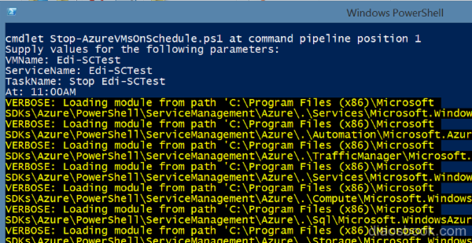

然后你的计划任务列表里也能刷出这个定时关机的任务了，可以测一下：

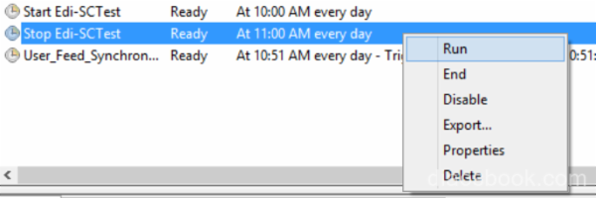

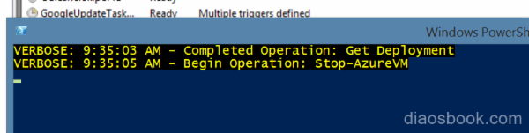

到Portal里验证一下，已经成功关机了：

