**Drinking Game Application**

Minyoung Kim

CIT - Purdue University  
2506 Redfree Dr.  
765-413-9571

kim2292@purdue.edu

Jieun You

CIT - Purdue University  
430 W Wood St.  
765-775-0540

you44@purdue.edu

Ge Chen

CIT - Purdue University  
101 Andrew Place.

765-418-7351

chen1934@purdue.edu

**ABSTRACT**

Our project is about developing an application that consists of various drinking games. There are many people who are taking risks from drinking outside with friends. These can lead to injuries, arrest, etc. This application provides joy and cheerful environment to users/drinkers with no risks.

**Keywords**

Android Application; Entertainment; Games;

# INTRODUCTION

This application is intended to entertain users providing 4 different types of mini games to play, especially when they are drinking. Often, when people gather together and drink, they often play games to change into a friendly atmosphere. Playing board games are good too but these days people tend to use more of their smartphones. By creating this application, users can play the game more conveniently by just launching the application.

# BACKGROUND

Android app is a mobile [software](https://www.webopedia.com/TERM/S/software.html) [application](https://www.webopedia.com/TERM/A/application.html) developed for use on devices powered by Google's [Android](https://www.webopedia.com/TERM/A/Android_platform.html) platform. Android apps are available in the [Google Play](https://www.webopedia.com/TERM/G/google_play.html) Store (formerly known as the [Android Market](https://www.webopedia.com/TERM/A/android_market.html)), in the [Amazon Appstore](https://www.webopedia.com/TERM/A/appstore.html) and on various Android App-focused sites, and the apps can run on Android [smartphones](https://www.webopedia.com/TERM/S/smartphone.html), [tablets](https://www.webopedia.com/TERM/T/tablet_PC.html), [Google TV](https://www.webopedia.com/TERM/G/google_tv.html) and other devices.

This app is developed using Android Studio. The features include Intent, Activity java file(button listener), XML file, Widgets, . The intent we are using to create multiple activities in order to let four games and main page connected. Activity java file is used to write actions for each activities and inside Activity java file, Button “Onclick” listener is used to make actions once user click a button and use this function to jump to different activities as well. XML files are used to design the app. Widgets such as ImageView, button, TextView are used to design the app.

# SKETCHES

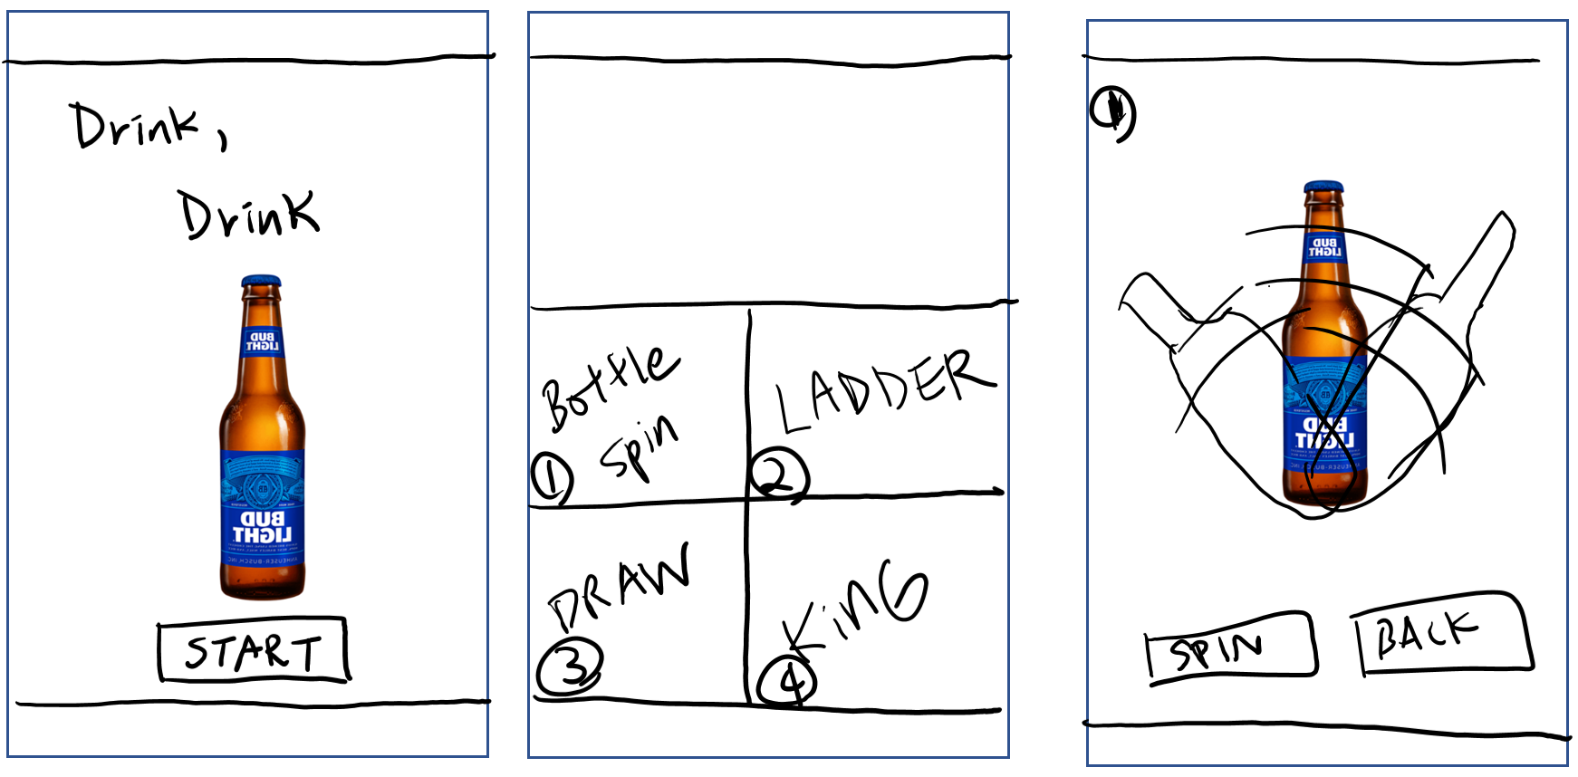

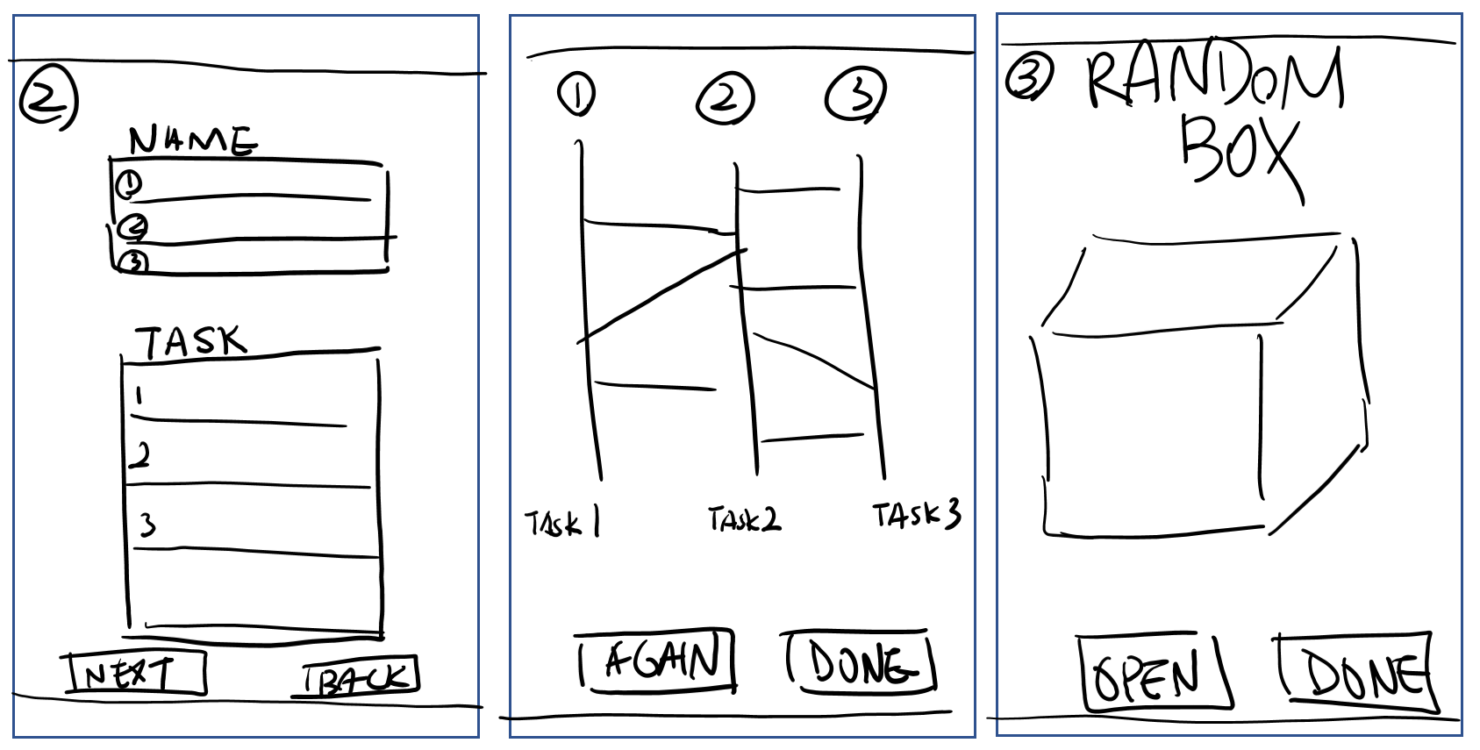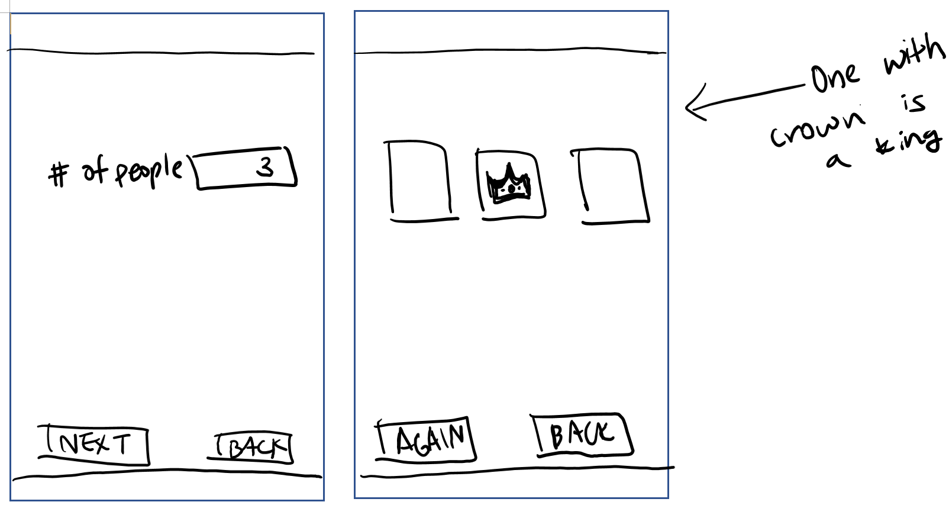

## 4. HOW TO USE

Open the application with a mobile device. On the Start screen, there are 4 selections of minigames you can choose from. Click on one of the games perfered. The game starts.

## 5. GAME DESCRIPTIONS

## 5.1 Bottle Spin

Bottle spin can be played by spinning a bottle that stops randomly at a direction. Person who get pointed drinks.

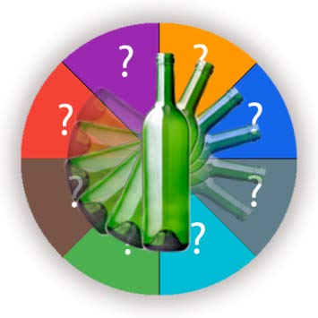

## 5.2 Ladder Game

Ladder game is one of the random games where each person can choose the start point and end point is shown when the game starts. Each endpoint have different tasks players must do. Such as “Drink 2 shots at once!”, “Hug person next to you!”.

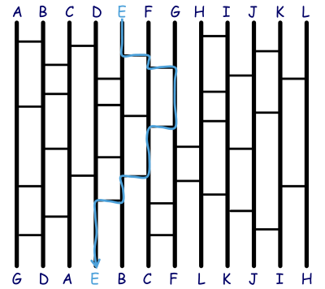

## 5.3 Radom Box

Random box game is drawing random tasks from the box. Player must do when they have drawn. If the player refuses to do the task, they must take shots.

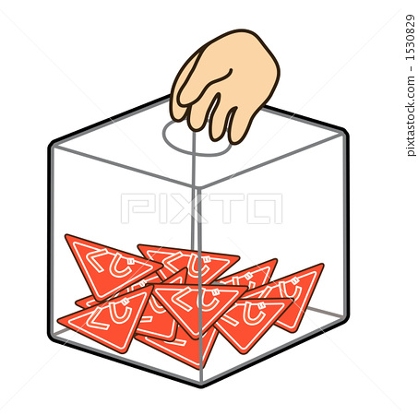

## 5.4 The Game of King

The game of king is a game that makes all the players to follow what King says. King can be chosen randomly in various ways. If players do not follow the King, they must be punished.

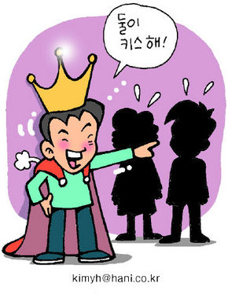

# 6. REFERENCES

1. Beal, V. (n.d.). Android app. (Oct.2019) DOI=https://www.webopedia.com/TERM/A/android_app.html.
2. Picture of Spin the Bottle, (n.d), Truth-Or-Dare (Oct. 2019)DOI=<https://www.amazon.com/Light-Creative-Labz-Truth-Dare/dp/B076HL68G6>
3. Picture of Ladder Game, (n.d), Amidakuji. Data Genetics (Oct. 2019) DOI=<http://datagenetics.com/blog/may42014/index.html>
4. Picture of Random Box, (n.d), 스톡일러스트 제비뽑기 (Oct. 2019) DOI=<https://kr.pixtastock.com/illustration/1530829>
5. Picture of King Game, 2005. **‘왕 게임’… 상처 주진 않는지 입장바꿔 생각해봅시다** (Oct. 2019) DOI=<http://www.hani.co.kr/arti/society/schooling/88484.html>