# MMC6936, Lab 2: Due January 13 (saturday), 2019

In this assignment you will have to demonstrate your understanding of network formats and representation. The tasks you will have to perform involve the following two small networks:

**Figure 1: Network 1** (actor-actor adjacency network)

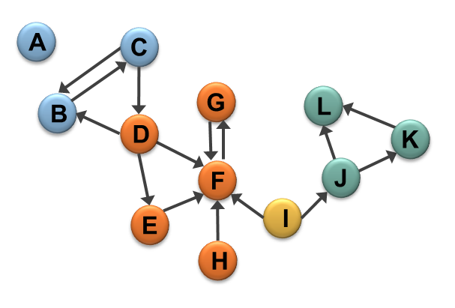

1. Describe **Network 1** in an edge list format:

|  |  |
| --- | --- |
| A | - |
| B |  |
| C |  |
| C |  |
| D |  |
| D |  |
| D |  |
| E |  |
| F |  |
| G |  |
| H |  |
| I |  |
| I |  |
| J |  |
| J |  |
| K |  |
| L | - |

1. Describe **Network 1** in a node list format:

|  |  |  |
| --- | --- | --- |
| A |  |  |
| B |  |  |
| C |  |  |
| D |  |  |
| E |  |  |
| F |  |  |
| G |  |  |
| H |  |  |
| I |  |  |
| J |  |  |
| K |  |  |
| L |  |  |

1. Describe **Network 1** in a matrix format:

|  |  |  |  |  |  |  |  |  |  |  |  |  |
| --- | --- | --- | --- | --- | --- | --- | --- | --- | --- | --- | --- | --- |
|  | A | B | C | D | E | F | G | H | I | J | K | L |
| A |  |  |  |  |  |  |  |  |  |  |  |  |
| B |  |  |  |  |  |  |  |  |  |  |  |  |
| C |  |  |  |  |  |  |  |  |  |  |  |  |
| D |  |  |  |  |  |  |  |  |  |  |  |  |
| E |  |  |  |  |  |  |  |  |  |  |  |  |
| F |  |  |  |  |  |  |  |  |  |  |  |  |
| G |  |  |  |  |  |  |  |  |  |  |  |  |
| H |  |  |  |  |  |  |  |  |  |  |  |  |
| I |  |  |  |  |  |  |  |  |  |  |  |  |
| J |  |  |  |  |  |  |  |  |  |  |  |  |
| K |  |  |  |  |  |  |  |  |  |  |  |  |
| L |  |  |  |  |  |  |  |  |  |  |  |  |

**Figure 2:** **Network 2** (actor-event affiliation network)

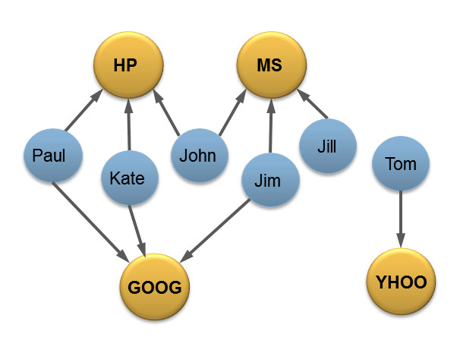

1. Describe **Network 2** in an edge list format:

|  |  |
| --- | --- |
| PAUL | HP |
|  |  |
|  |  |
|  |  |
|  |  |
|  |  |
|  |  |
|  |  |
|  |  |
|  |  |

1. Describe **Network 2** in a node list format:

|  |  |  |
| --- | --- | --- |
| PAUL |  |  |
|  |  |  |
| JOHN |  |  |
| JIM |  |  |
| JILL |  |  |
| TOM |  |  |

1. Describe **Network 2** in a matrix format:

|  |  |  |  |  |
| --- | --- | --- | --- | --- |
|  | HP | MS | GOOG | YHOO |
| PAUL |  |  |  |  |
| KATE |  |  |  |  |
| JOHN |  |  |  |  |
| JIM |  |  |  |  |
| JILL |  |  |  |  |
| TOM |  |  |  |  |

1. If the matrix representing Network 2 is called M, calculate the following:
   1. MT (M transposed)

|  |  |  |  |  |  |  |
| --- | --- | --- | --- | --- | --- | --- |
|  | PAUL | KATE | JOHN | JIM | JILL | TOM |
| HP |  |  |  |  |  |  |
| MS |  |  |  |  |  |  |
| GOOG |  |  |  |  |  |  |
| YHOO |  |  |  |  |  |  |

* 1. M x MT (matrix multiplication of M and M transposed)

|  |  |  |  |  |  |
| --- | --- | --- | --- | --- | --- |
|  |  |  |  |  |  |
|  |  |  |  |  |  |
|  |  |  |  |  |  |
|  |  |  |  |  |  |
|  |  |  |  |  |  |
|  |  |  |  |  |  |

* 1. MT x M (matrix multiplication of M transposed and M)

|  |  |  |  |
| --- | --- | --- | --- |
|  |  |  |  |
|  |  |  |  |
|  |  |  |  |
|  |  |  |  |