Table is stored as a file on disk -> file has multiple disk blocks/pages -> each page has multiple tuples/records -> the system (RDBMS) works on a page at a time in memory (the buffer)
Accessing a disk page -> {seek time, rotational delay, transfer time} reduce (I/O = rotation/seek)
When a page is requested -> {if requested page is not in the pool -> choose a frame for replacement, if frame is dirty write it to disk, read request page into the chosen frame} Else{pin the page and return its address}
Clock Algorithm
每个page在buffer pool中被引用过，refbit就会变成true，转盘指针经过的page的refbit都会变成false。1.如果被最近引用过/refbit被改变，就不会被replaced。2.如果refbit是false，then be replaced。如果dirty，就先writeback to the disk，then be replaced
Sequential flooding: Nasty situation caused by LRU + repeated sequential scans, # buffer frames < # pages in file means each page request causes an I/O. MRU much better in this situation (but not in all situations, of course).
Page Format – {Fixed length Records and Variable length records}
Using bitmap can move the record in the page without changing the rid
Record Format – fixed {information about field type same for all records in a file; stored in system catalog, delimited by special character $,} variable {array of field offset -> direct access but small overhead}
Null meaning: {many meaning in DB, eg. Representing “Not applicable”. “missing value”}
File organization: {Unordered/Heap file, hashed file, sorted file, B+ tree file}
heap file is not good for equality and range searches, must scan the entire file
hashed file is good for equality search, but not range search
sorted file is okay for both equality and range search, must do binary search to find the first value, is usually more expensive than B+ tree
B+ tree is good for both equality and range search, finding the first value tends to require no more than 3-4 page I/O, often is less than that because these pages are in the buffer
B+ Tree Insertion/Deletion – Equality and Range search Efficiently – is sorted file with a lot of pointers on top to direct search
Insertion: Find correct leaf L -> Put data entry onto L -> If (L has enough space, done!) Else (split L into two node -> redistribute entries evenly, copy up middle key)
Deletion: Start at root -> find leaf L where entry belongs -> remove the entry -> if (L is at least half-full, done!) Else (if L has only d-1 entries, try to re-distribute, borrowing from sibling node with the same parent as L) -> if re-distribution fails, merge L and sibling
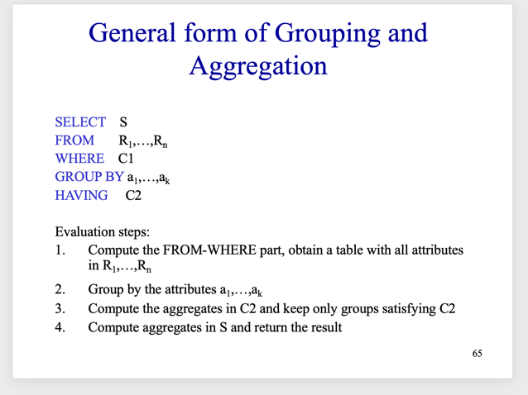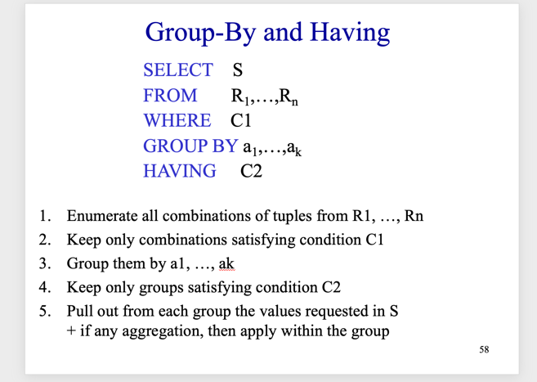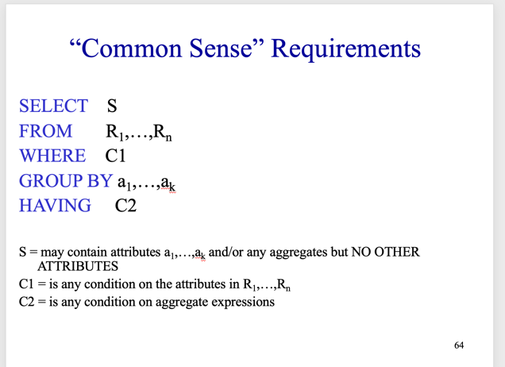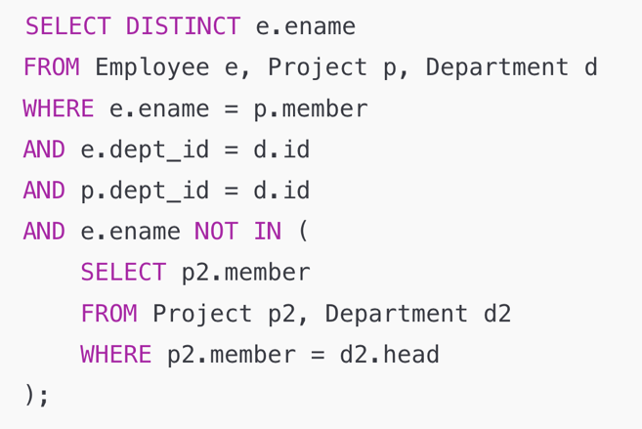
Business folks will ask you (the dev) to create a database for a business application (such as managing employees, keeping tracks of customers, etc.). You need to talk with them to understand the application requirements: what do they want to store in the database, what kinds of constraints, what kinds of queries they would often ask, etc.
Talking with business folks using a bunch of tables is hard. Better to talk using a language called ER.
Binary relationships (those between two entity sets) can be many-many, many-1, 1-many, 1-1. Many-1 between A and B means an entity in A is associated with AT MOST one entity in B. This is indicated using an arrow on the ER diagram. When translating this, the table for the relationship is folded into the table for the many side (that is, for A).
A relationship can be between 3 or more entity sets, such as a purchase relationship would be between person entity set, store entity set, and product entity set. The business folks will tell you if they want a relationship like this.
Consider a relationship R between three entity sets A, B, and C. When drawing an ER diagram for R, if you have an arrow going into C, that means an entity x from A and an entity y from B are associated with AT MOST one entity z from C. Unlike binary relationships, you cannot fold the table for R into the table for A, B, or C. In other words, you need a table for R, which will store the primary keys of A, B, and C, and the attributes of R, if any.

