A Maintenance–Reserve–Gating Framework for Modifier Effects in Hereditary Cerebellar Ataxia
Jieyang Chen
ORCID: 0009-0001-9247-2085
Independent Researcher, Hangzhou, China
Correspondence: 278404704@qq.com
Running title: Maintenance–reserve–gating framework in hereditary ataxia
Manuscript version 0.2.1; evidence cut-off 19 August 2026
Public repository/preprint package: https://github.com/jieyangxchen/cerebellar-maintenance-reserve-gating-hypothesis
This theoretical article reports no original human-participant or animal research.

Abstract
Pathogenic variants cause many spinocerebellar ataxias (SCAs), but they do not uniquely determine phenoconversion or progression. Established concepts of structural and functional cerebellar reserve explain how compensation can delay clinical expression; they do not specify whether an external exposure can first activate a high-demand state and only later supply enough useful input to sustain it. We therefore propose a nested, falsifiable framework rather than a newly discovered factor.
The observable layer separates measured exposure $\text{E}\text{(}\text{t}\text{)}$ from an outcome-blind, prospectively frozen score $\text{S}\text{=}\text{h}\text{(}\text{E}\text{;}\text{θ}\text{)}$ and asks whether $\text{S}$ shows a reproducible non-linear association with phenoconversion, biomarker trajectories, and genotype. The mechanistic extension posits a still-hypothetical input $\text{X}\text{(}\text{t}\text{)}$, activation and exchange, and dynamic reserve $\text{B}\text{(}\text{t}\text{)}$. A statistical hump would support only a non-linear environmental association. Gate-specific inference additionally requires independently measured activation, uptake/exchange, and reserve proxies in the predicted temporal order, followed by selective perturbation.
No human SCA study has demonstrated $\text{X}$, the gate, outward leakage, or the predicted low-input idle–intermediate depletion–high-input rebalance curve. Existing evidence supports only component premises: onset heterogeneity, selected premanifest biomarkers, cerebellar reserve, and model-specific multicellular causation or early reversibility. We outline an event-driven SCA3 test bed with SCA6 transport testing and target-specific early-intervention examples. Failure of external replication, temporal ordering, or improvement over known-mechanism models rejects the corresponding layer. The framework is a research programme, not a treatment recommendation.
Keywords: spinocerebellar ataxia; cerebellar reserve; environmental exposure; phenoconversion; biomarkers; disease modification

One-sentence thesis
Some hereditary cerebellar ataxias may contain a testable mismatch between genetic demand, externally conditioned activation, and dynamic reserve—but the unknown-input extension earns causal status only if it predicts new data and ordered mediators better than known-mechanism models.

Claim hierarchy
Throughout this new-idea review, claims are separated into four levels:
1. Established observation: directly supported in the cited population or model.
2. Supported analogy: demonstrates biological plausibility of one component, but not this model.
3. Testable inference: prospectively operationalized and capable of failure.
4. Speculation: motivates research but has no direct evidentiary support.
The complete claim-by-claim audit is available in the evidence appendix and machine-readable matrix.
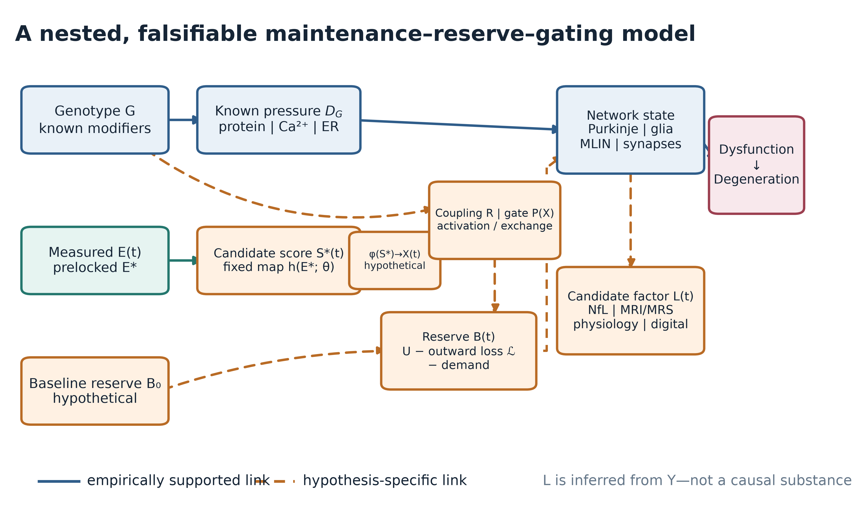
Figure 1. A nested, falsifiable maintenance–reserve–gating model. Solid edges summarize empirically supported relationships in at least one cited system; dashed edges are hypothesis-specific. $\text{E}\text{(}\text{t}\text{)}$ is measured exposure and $\text{S}\text{(}\text{t}\text{)}\text{=}\text{h}\text{\{}\text{E}\text{(}\text{t}\text{)}\text{;}\text{θ}\text{\}}$ is a derived score frozen without outcomes; the dashed $\text{φ}\text{:}\text{S}\text{→} \text{X}$ bridge is itself hypothetical. $\text{X}\text{(}\text{t}\text{)}$, $\text{B}\text{(}\text{t}\text{)}$, and the $\text{R}\text{/}\text{P}$ path are mechanistic hypotheses. $\text{L}\text{(}\text{t}\text{)}$ is a candidate factor measured by observed biomarkers, not a second causal substance. Evidence for an individual solid edge does not validate the complete path.

1. The unresolved timing problem
The minimal genetic model of an SCA is compelling:
$\text{G} \text{→} {\text{D}}_{\text{G}} \text{→} \text{neuronal} \text{dysfunction} \text{→} \text{degeneration}\text{,}$
where $\text{G}$ is the causal genotype and ${\text{D}}_{\text{G}}$ includes abnormal protein, RNA, ion-channel, transcriptional, calcium, proteostatic, or mitochondrial pressure. This model explains why the disease occurs. It does not, by itself, uniquely determine the individual timetable.
In a five-region cohort of 786 people with SCA3/MJD, expanded ATXN3 CAG length explained approximately 62% of age-at-onset variance [1]. That value is cohort-specific, not a universal constant. A 2026 study associated rare APOE ε4 homozygosity with onset about six years earlier in a Brazilian subgroup, but the signal was initial, subgroup-specific, and absent for common APOE contrasts [2]. In a four-family SCA6 series, two large families had stable 22- and 23-repeat expanded alleles, while the age at onset across affected participants was 24–63 years [3]. A study of only two monozygotic twin pairs—one SCA2 and one clinically diagnosed episodic ataxia type 2—reported quantitative discordance in eye movements, postural stability, severity, and regional involvement [4]. These observations justify looking for germline modifiers, somatic instability, stochastic biology, measurement error, and external influences. They do not identify a common environmental factor.
A broader causal description is therefore:
$\text{disease} \text{course}\text{=}\text{f}\text{(}\text{G}\text{,} {\text{G}}_{\text{modifier}}\text{,} \text{somatic} \text{change}\text{,} \text{age}\text{,} \text{environment}\text{,} \text{reserve}\text{,} \text{network} \text{state}\text{)}\text{.}$
The proposal here asks whether the last four terms can sometimes be represented by a parsimonious dynamic mismatch model. It is deliberately nested inside known molecular pathology and competes with simpler alternatives.

2. Relation to established concepts of cerebellar reserve
The term cerebellar reserve already has a defined scientific lineage. A consensus framework distinguishes structural reserve—the ability of spared cerebellar or extracerebellar systems to compensate for focal injury—from functional reserve within gradually affected cerebellar tissue [5]. It treats reserve as a moderator between pathology and clinical outcome and emphasizes plasticity, environmental enrichment, and the possibility of compensation or restoration while functional circuitry remains available. The related “Time Is Cerebellum” principle argues that treatment is most likely to preserve function before advanced cell loss [6].
The present framework builds on, rather than replaces, those concepts. Its proposed $\text{B}\text{(}\text{t}\text{)}$ is narrower and more speculative: a dynamic state whose trajectory is determined by known pathogenic pressure, ageing, activity-dependent demand, and candidate input-related fluxes. It is not a synonym for neuron count, cognitive reserve, synaptic plasticity, or an established biomarker. If observed biomarkers can be explained fully by existing structural or functional reserve without the proposed input-dependent dynamics, the new layer is unnecessary.
The distinctive claim is therefore not that reserve exists. It is that, for a prespecified input and susceptible genotype, activation and exchange could rise before useful supply, producing a directional non-monotonic prediction and an ordered mediator sequence. Those additional claims must fail independently of the broader cerebellar-reserve concept.

3. A two-layer operational framework
The phrase external maintenance factor is avoided because it suggests that a molecule or field has already been found. No such entity is known. The testable framework separates an observable modifier layer from an optional mechanistic extension.

3.1 Observable modifier layer: $\text{E}\text{(}\text{t}\text{)}$ and $\text{S}\text{(}\text{t}\text{)}$
$\text{E}\text{(}\text{t}\text{)}$ contains observable quantities: geocoded residential histories linked to independently curated environmental records, water source, occupation, diet, infection, medication, physical activity, social conditions, and other measured variables. A confirmatory analysis may use only a prespecified candidate ${\text{E}}^{\text{*}}$, fixed time window, and fixed measurement rule. Untargeted exposome discovery is exploratory.
If several measured components are combined, the derived score must be declared before outcome analysis:
$\text{S}\text{(}\text{t}\text{)}\text{=}\text{h}\text{\{}\text{E}\text{(}\text{t}\text{)}\text{;}\text{θ}\text{\}}\text{,}$
with fixed weights, lags, transformations, and missing-data rules. $\text{S}$ is observed or computable once the exposure data and mapping are frozen. The first layer tests only whether $\text{S}$ improves externally validated prediction or shows the prespecified association with phenoconversion and biomarker change. It does not require $\text{S}$ to be a nutrient, beneficial exposure, or direct measure of a maintenance substance.

3.2 Mechanistic extension: $\text{X}\text{(}\text{t}\text{)}$ and the $\text{S}\text{→} \text{X}$ bridge
The biological input $\text{X}$ remains hypothetical and distinct from $\text{S}$. Any bridge,
$\text{X}\text{(}\text{t}\text{)}\text{=}\text{φ}\text{\{}\text{S}\text{(}\text{t}\text{)}\text{;}\text{ψ}\text{\}}\text{,}$
must itself be prespecified, biologically calibrated, and tested independently of clinical outcomes. The illustrative convention $\text{X}\text{=}\text{S}$ used in Figure 2 is a model assumption, not an empirical finding. An unrestricted post-hoc $\text{S}$, $\text{X}$, $\text{φ}$, or $\text{ψ}$ can fit almost any pattern and is scientifically empty. Failure cannot be rescued by redefining them after seeing the outcome.

3.3 Coupling $\text{R}$
$\text{R}$ denotes a genotype- and physiology-dependent tendency to activate or maintain a candidate module. It may be a vector, $\text{R}\text{=}\text{(}{\text{R}}_{\text{1}}\text{,}\text{…}\text{,}{\text{R}}_{\text{m}}\text{)}$, but confirmatory work should begin with a low-dimensional, independently measured quantity. $\text{R}$ cannot be defined as “high in people who develop disease early”; that would make the model circular. Until a valid external measurement is available, the testable proxy is a prespecified genotype-by-exposure interaction, not an inferred personal “level.”

3.4 Dynamic reserve $\text{B}\text{(}\text{t}\text{)}$ and clinical transition
$\text{B}\text{(}\text{t}\text{)}$ is the only proposed mechanistic latent state. It represents the remaining capacity to absorb known pathogenic, ageing, and activity-dependent demands. It is not assumed to be one metabolite. To connect reserve dynamics to the cohort outcome, the simplest threshold observation model is:
${\text{T}}_{\text{conversion}}\text{=}\text{inf}\text{\{}\text{t}\text{:}\text{B}\text{(}\text{t}\text{)}\text{≤} {\text{B}}_{\text{c}}\text{\}}\text{.}$
A smoother alternative links lower reserve to higher instantaneous risk:
$\text{λ}\text{(}\text{t}\text{|} \text{B}\text{)}\text{=}{\text{λ}}_{\text{0}}\text{(}\text{t}\text{)}\text{exp}\text{[}\text{γ}\text{\{}{\text{B}}_{\text{c}}\text{-}\text{B}\text{(}\text{t}\text{)}{\text{\}}}_{\text{+}}\text{]}\text{,} \text{γ}\text{>}\text{0}\text{.}$
These are competing observation models, not established biology. They make explicit that a non-monotonic depletion rate does not automatically imply a non-monotonic clinical hazard: the result also depends on baseline reserve, exposure history, genetic burden, censoring, and survival. A registered analysis must simulate and distinguish those links before treating a clinical hump as a prediction of the reserve equation.

3.5 Biomarker state $\text{L}\text{(}\text{t}\text{)}$
$\text{L}\text{(}\text{t}\text{)}$ is a statistical measurement model:
$\text{Y}\text{(}\text{t}\text{)}\text{=}\text{Λ} \text{L}\text{(}\text{t}\text{)}\text{+}\text{ε}\text{(}\text{t}\text{)}\text{,}$
where $\text{Y}\text{(}\text{t}\text{)}$ may include NfL, genotype-specific MRI/MRS, eye movements, electrophysiology, and digital gait. $\text{L}$ is not a second causal fluid or field. It is useful only if the factor structure is invariant enough across time and site, predicts future outcomes in held-out cohorts, and adds information beyond its component biomarkers.
This reduction matters. Without it, $\text{S}$, $\text{X}$, $\text{R}$, $\text{B}$, and $\text{L}$ can substitute for one another and the model becomes non-identifiable.

4. Minimal dynamics and the gating extension
For a single illustrative biological input, reserve dynamics can be written as:
$\frac{\text{dB}}{\text{dt}}\text{=}\text{U}\text{\{}\text{X}\text{,}\text{P}\text{(}\text{X}\text{)}\text{\}}\text{-}\text{ℒ}\text{\{}\text{B}\text{,}\text{X}\text{,}\text{P}\text{(}\text{X}\text{)}\text{\}}\text{-}\text{M}\text{\{}\text{R}\text{,}\text{A}\text{(}\text{X}\text{)}\text{\}}\text{-}{\text{D}}_{\text{G}}\text{-}{\text{D}}_{\text{age}}\text{,}$
where $\text{U}$ is uptake, $\text{ℒ}$ is outward loss, $\text{M}$ is activity-dependent consumption, and the final terms represent known genetic and ageing burdens. One possible gate is:
$\text{P}\text{(}\text{X}\text{)}\text{=}\frac{{\text{X}}^{{\text{n}}_{\text{P}}}}{{\text{K}}_{\text{P}}^{{\text{n}}_{\text{P}}}\text{+}{\text{X}}^{{\text{n}}_{\text{P}}}}\text{,} \text{A}\text{(}\text{X}\text{)}\text{=}\frac{{\text{X}}^{{\text{n}}_{\text{A}}}}{{\text{K}}_{\text{A}}^{{\text{n}}_{\text{A}}}\text{+}{\text{X}}^{{\text{n}}_{\text{A}}}}\text{.}$
For multiple input classes $\text{q}$, uptake may depend on concentration ${\text{C}}_{\text{q}}$, uptake efficiency ${\text{η}}_{\text{q}}$, activation efficacy ${\text{a}}_{\text{iq}}$, and resource value ${\text{w}}_{\text{q}}$. The key theoretical condition is not a fixed “quality ratio,” but the possibility that activation rises faster than useful supply:
${\text{a}}_{\text{iq}}\text{≫} {\text{w}}_{\text{q}} \text{over} \text{part} \text{of} \text{the} \text{exposure} \text{range}\text{.}$
In the source code for Figure 2, one dimensionless example uses:
$\text{U}\text{=}\text{η} \text{PX}\text{,}$
$\text{ℒ}\text{=}\text{λ} \text{Pmax}\text{(}\text{B}\text{-}\text{κ} \text{X}\text{,}\text{0}\text{)}\text{,}$
$\text{M}\text{=}{\text{m}}_{\text{0}}\text{+}{\text{m}}_{\text{1A}}\text{(}\text{X}\text{)}\text{,}$
with a constant genetic/age drain. The parameters are chosen to display the hypothesized shape; they are not fitted to patients and have no dose interpretation. Figure 2 adopts $\text{X}\text{=}\text{S}$ solely to place the hypothetical dynamics on a visible standardized axis.
The proposed shape is not a generic consequence of a Hill gate. It requires at least three qualitative conditions over the comparison interval:
1. at low $\text{X}$, activation and exchange are sufficiently small that activation-linked demand and outward loss remain limited relative to the comparison states;
2. over an intermediate range, the increase in $\text{M}\text{+}\text{ℒ}$ exceeds the increase in useful uptake $\text{U}$; and
3. at high $\text{X}$, uptake eventually meets or exceeds combined activity-dependent demand, loss, and the genetic/ageing drain.
If the first condition fails, low input may be the most harmful state. If the second fails, no intermediate depletion maximum occurs. If the third fails, the curve remains monotonic or plateaus without rebalancing. Parameter sweeps and exposure-history simulations are therefore required before a candidate implementation can claim that a hump is robust rather than hand-selected.
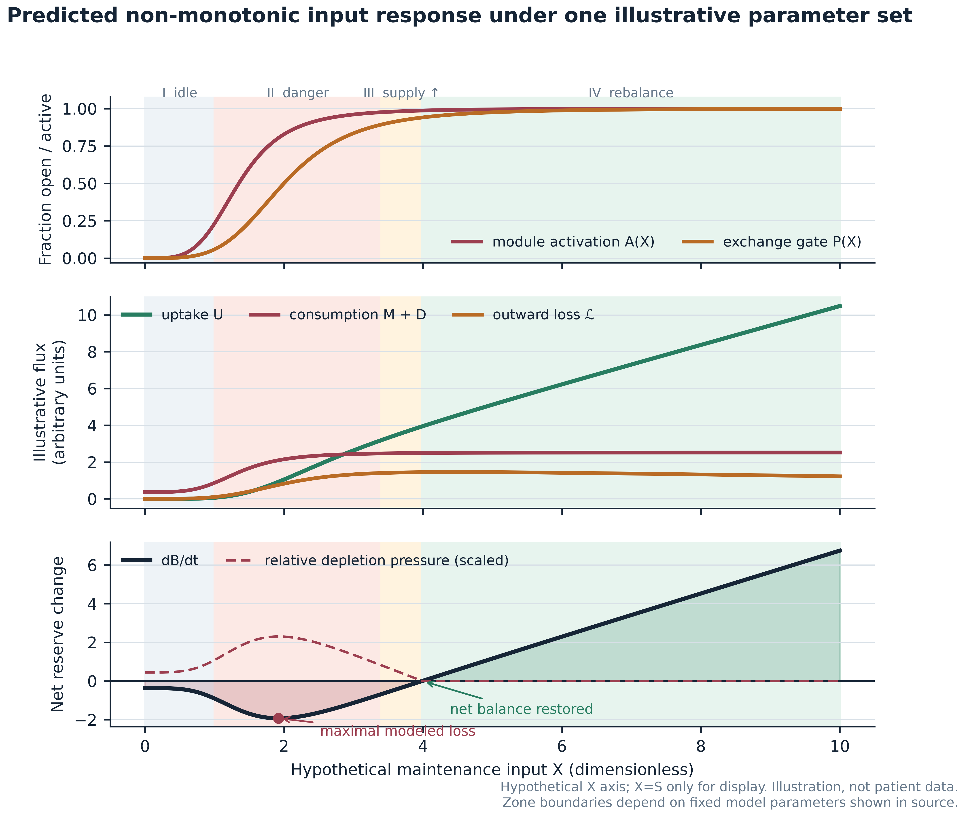
Figure 2. A predicted non-monotonic response under one illustrative parameter set. The horizontal axis is the hypothetical input $\text{X}$, and the plotted convention $\text{X}\text{=}\text{S}$ is used only for this illustration. At very low input, activation and exchange are small, producing an idle state with limited replenishment but limited activation-linked loss. At intermediate input, activation and outward loss can exceed uptake, creating maximal modeled depletion. At sufficiently high input, uptake dominates and net balance is restored. Every curve, boundary, and parameter is illustrative. No human SCA dataset currently demonstrates these four zones.

4.1 Four predicted regions
The gating extension predicts four qualitative regions:
• Zone I, low-input idle: $\text{A}\text{≈}\text{0}$, $\text{P}\text{≈}\text{0}$; there is little uptake but limited activation-linked loss.
• Zone II, activation–supply mismatch: activation and exchange increase before useful supply is sufficient; $\text{dB}\text{/}\text{dt}$ becomes most negative.
• Zone III, partial supply: uptake grows and depletion pressure falls, but reserve may still decline.
• Zone IV, rebalancing: uptake meets or exceeds aggregate loss; $\text{dB}\text{/}\text{dt}\text{≥}\text{0}$ in the illustrative system.
Under the threshold or hazard observation model, the observed disease-risk function can be hump-shaped, plateaued, monotonic, or, with multiple input classes, multimodal. A central-versus-extremes contrast is a disciplined first implementation, not proof that the biological peak must occur at the sample median. A mechanistically calibrated threshold would be preferable to quantile placement when a validated activation or uptake marker becomes available.

4.2 Identifiability and competing mechanisms
The same biomarker trajectory may result from low uptake, high consumption, high outward loss, or increasing ${\text{D}}_{\text{G}}$. Sparse observations cannot identify these processes separately. Identifiability requires perturbation, dense time series, external exposure calibration, or informative biological measurements. A statistical hump does not prove gating; it can arise from exposure misclassification, survivor selection, reverse causation, competing risks, mixtures of monotonic subgroups, or unmeasured confounding. These alternatives must be represented explicitly in a causal graph and sensitivity analyses.

4.3 What would distinguish gating from generic non-linearity?
The cohort's spline model can screen for a reproducible non-linear environmental association; it cannot by itself identify $\text{P}$, $\text{B}$, uptake, or leakage. A later gate-specific mechanistic substudy would need at least three independently measured axes: an activation marker $\text{A}$, an inward uptake or exchange proxy $\text{U}$, and a reserve/depletion proxy. The prespecified discriminating sequence is: intermediate $\text{S}$ first increases $\text{A}$ and exchange, $\text{U}$ fails to rise proportionally, and the reserve-proxy slope subsequently worsens before clinical change. A perturbation that selectively changes the proposed gate or activation process should then alter those ordered mediators and downstream biomarkers, with negative-control exposures and pathways remaining stable. Without this temporal and perturbational evidence, a hump plus genotype interaction supports only a non-linear environment model, not the proposed gate–leak mechanism.

5. What existing evidence does—and does not—support

5.1 Stage-dependent resilience is a plausible analogy
An SCA6 mouse study reported that ER/proteostasis stress and an HSP90-dependent unfolded-protein response preceded later hyperexcitability and motor impairment [7]. This is a useful analogy for early pathogenic pressure plus temporary resilience. It does not demonstrate a finite external reserve $\text{B}$. Moreover, the SCA6$\text{^}\text{84Q}\text{/}\text{+}$ model uses a repeat far longer than typical human SCA6 alleles, so translation requires caution.
In the Purkinje-cell-specific conditional SCA1[82Q] transgenic model, early suppression of mutant ATXN1 reversed measured pathology and motor impairment more fully than late suppression [8]. That establishes stage-dependent reversibility in that mouse model, not in human SCA generally.

5.2 Network and multicellular states can be causal
In Sca1 mice, molecular-layer interneuron hyperactivity preceded overt Purkinje neuron degeneration; chemogenetic suppression improved calcium signalling, delayed degeneration, and improved motor outcomes, whereas inducing related hyperactivity in healthy mice generated aspects of pathology [9]. This is the strongest experimental analogy for an early pathological “downshift.” The causal evidence is in mice, not in human cerebellar circuits.
Other experiments support a multicellular view. Bergmann-glia-specific disruption can produce non-cell-autonomous Purkinje-cell degeneration [10], and oligodendroglial mutant ATXN1 expression in mice can cause myelin abnormalities, Purkinje axonopathy, and motor impairment [11]. These findings make a systems-level state plausible; they do not imply that an external $\text{X}$ is required.

5.3 Excess signalling can be pathogenic, but direction is context-specific
A mouse model carrying the patient-associated GRM1 p.Y792C gain-of-function variant developed progressive motor and region-specific Purkinje-cell abnormalities [12]. A 2026 study of the moonwalker TRPC3 variant and the cerebellum-enriched Δ28 isoform found constitutive channel activity and calcium-dependent cell death in HEK293 cells; co-expression of Purkinje-enriched PMCA2 partly rescued survival in that cell system [13]. The latter was not an in-vivo Purkinje-cell rescue. Together, these studies show that “more activity” is not automatically beneficial. They do not establish a universal hyperactive subtype or justify blanket circuit inhibition.

5.4 Missing input can be restored in a defined knockout system
CBLN1–neurexin–GluD2 is a defined cerebellar synaptic-organizing system. Recombinant Cbln1 can rapidly restore aspects of parallel-fibre–Purkinje-cell synaptic organization in adult cbln1-null mice, and a later study reported transient improvement in selected gait measures [14,15]. This is a genuine missing-input rescue in a knockout model. It is not evidence for a common external factor in polyglutamine SCAs.
Likewise, purified human GluD2 reconstituted in artificial DPHPC lipid bilayers displayed D-serine- and GABA-gated currents [16]. Under 10 mM D-serine, reported open probability was $\text{8}\text{.}\text{85}\text{±}\text{1}\text{.}\text{02}\text{\%}$ at 37°C and $\text{1}\text{.}\text{03}\text{±}\text{0}\text{.}\text{14}\text{\%}$ at 22°C. Wild-type GluD2 currents remained difficult to observe in standard whole-cell expression conditions. This result demonstrates strong context dependence under a specific reductionist preparation; it neither validates $\text{X}$ nor makes every negative experiment uninformative.

5.5 Human biomarker readiness is uneven
NfL is elevated before manifest ataxia in SCA3 cohorts, including two multicentre cohorts in which abnormality was estimated several years before expected onset [17]. Longitudinal ESMI data in 291 carriers and 121 controls found stage-dependent changes in NfL and MRI, with pons volume showing high responsiveness across stages [18]. These results support trial enrichment and disease-activity measurement, but NfL and MRI are not established surrogate endpoints for clinical benefit.
A 2026 four-centre MRS study in 18 SCA2 participants, 25 SCA3 participants, and 29 controls found reproducible neurochemical differences over short retest intervals; estimates required site/vendor adjustment and differed by genotype [19]. It was not a presymptomatic longitudinal prediction study. MRS should therefore remain genotype-specific and generally secondary until responsiveness and clinical meaning are established.
A 2026 Ataxia Global Initiative consensus statement provided disease-specific recommendations for quantitative MRI endpoints in SCA1, SCA2, and SCA3 and emphasized their potential role in participant selection and monitoring for early trials [26]. This strengthens the rationale for a harmonized imaging core, but a consensus recommendation does not make MRI a validated surrogate for clinical benefit.

5.6 Environmental evidence is exploratory
An exploratory study of 188 SCA3/MJD participants from 109 families associated municipality-level rural proxies with approximately 1.8 years earlier residual age at onset [20]. The variables were 2010 ecological proxies—population density, rural population proportion, and untreated-well-water proportion—rather than individual lifetime exposures. They were correlated, median-dichotomized, and only marginally significant. The study did not measure $\text{S}$ or $\text{X}$, establish causality, or test a non-monotonic dose curve. It motivates better exposure measurement; it does not support the gating mechanism.

5.7 Human neuromodulation evidence argues for restraint
A randomized crossover study of 20 people with mixed neurodegenerative ataxias reported clinical and physiological improvements after a cerebellar-anodal/spinal-cathodal montage [21]. A separate randomized study in 20 people with SCA3 found that two weeks of cerebellar anodal tDCS did not improve SARA or cerebellar brain inhibition relative to sham [22]. Neither study selected a validated hyperactive subtype, and anodal tDCS cannot be equated with biological “downshifting.” This mixed record supports phenotype-first target validation, not immediate therapeutic generalization.

6. Six falsifiable predictions

Prediction 1: a preregistered non-monotonic contrast
For one independently measured and outcome-blind-derived ${\text{S}}^{\text{*}}$, the risk or disease-activity curve should show greater adverse association in a central exposure region than at both low and high reference regions. A significant quadratic term is insufficient. The confirmatory contrast is:
${\text{C}}_{\text{hump}}\text{=}\text{f}\text{(}{\text{S}}_{\text{50}}\text{)}\text{-}\frac{\text{f}\text{(}{\text{S}}_{\text{10}}\text{)}\text{+}\text{f}\text{(}{\text{S}}_{\text{90}}\text{)}}{\text{2}}\text{>}\text{0}\text{,}$
with both directional components, simultaneous confidence intervals, and a peak inside a prespecified central range.

Prediction 2: effect modification fixed before outcomes
The exposure association should differ between SCA3 and SCA6, or by an independently measured coupling variable. Until $\text{R}$ can be measured without outcomes, a genotype-by-${\text{S}}^{\text{*}}$ interaction is the confirmatory test. A post-hoc “high-$\text{R}$” group derived from onset is prohibited.

Prediction 3: temporal ordering after exposure change
Following a major migration or independently documented exposure shift, biomarker slopes should change before SARA. The design tests time-varying exposure with lags and negative-control windows; it does not assume immediate anatomical change.

Prediction 4: pathological activity precedes structural loss
A reproducible human activity signature must precede, not merely accompany, subsequent MRI or clinical deterioration after adjustment for baseline disease stage. This is a prerequisite for any circuit-downshift study.

Prediction 5: upstream intervention changes more than one axis
An intervention targeting a genuinely upstream module should produce coherent changes in target engagement, physiology, imaging or fluid disease activity, and later function. Improvement of one noisy endpoint alone is not sufficient.

Prediction 6: external prediction rather than retrospective explanation
The latent biomarker state and any coupling score must improve calibration and prediction in sites or cohorts not used for model construction. Failure of measurement invariance, calibration, or external prediction rejects that implementation.

7. Prospective validation programme
The complete protocol and statistical analysis plan are provided separately: prospective cohort and SAP.

7.1 Population and follow-up
The confirmatory natural-history programme is a five-year, multicentre, family-aware cohort of genetically confirmed SCA3 and SCA6 expansion carriers, including preataxic participants with $\text{SARA}\text{<}\text{3}$, early-manifest participants, and primarily expansion-negative relatives as controls. Clinical, NfL, ocular-motor, and digital measures occur every six months; remote gait sampling occurs every three months; structural/diffusion MRI is annual; genotype-specific MRS occurs at baseline, month 24, and month 60. Exposure history is collected independently from outcome assessors.
Phenoconversion is defined prospectively as the first visit with both $\text{SARA}\text{≥}\text{3}$ and a blinded expert rating of probable or definite manifest gait ataxia, confirmed at the next six-month visit. The primary time-to-event analysis uses age as the time scale, delayed entry, interval censoring, prespecified family/site structure, and competing-risk sensitivity analysis. Residual age at onset is descriptive only because it propagates error from a first-stage genetic prediction and can be distorted by ascertainment and survival.

7.2 SCA3 test bed, SCA6 transport test, and candidate exposure
SCA3 is the most defensible first test bed because the motivating rural-environment study was SCA3-specific and available phenoconversion information is stronger. SCA6 provides a deliberately difficult transport and heterogeneity test across a distinct channelopathy; it is not assumed to share the same coupling or exposure curve. Genotype-specific curves are therefore primary scientific objects. Any pooled contrast must justify its weights by a target population rather than inherit the planned recruitment ratio, and genotype interaction remains estimation-focused until its simulation-defined information target is reached.
Before outcome unblinding, an outcome-blind exposure panel applies a registered rubric to two rural-environment operationalizations—five-year-lagged residential agricultural pesticide intensity and five-year-lagged untreated-private-well residence—and selects one measured ${\text{E}}^{\text{*}}$. Its rank-preserving score ${\text{S}}^{\text{*}}\text{=}\text{h}\text{(}{\text{E}}^{\text{*}}\text{;}\text{θ}\text{)}$ is frozen from exposure-only data. These are candidate proxies motivated by one exploratory ecological association; neither is a maintenance resource, direct measure of $\text{X}$, or justification for exposure escalation. Outcome-blind reliability and common support are required for the statistical test, and a biological $\text{S}\text{→} \text{X}$ interpretation requires separate calibration. A lower observed risk at high pesticide or untreated-well exposure would demand bias analyses and could not be called beneficial rebalancing.
Restricted-cubic-spline and central-versus-extremes analyses remain locked. Internal–external validation leaves out sites or regions in turn, and a geographically separate SCA3 cohort is preferred for the first external replication. SCA6 then tests transport rather than serving as automatic pooled confirmation.

7.3 Sample-size logic
The cohort is event-driven. A simplified continuous-exposure benchmark gives about 108 events for a hazard ratio of 1.5 per standard deviation, 90% power, two-sided alpha 0.025, and covariate ${\text{R}}^{\text{2}}\text{=}\text{0}\text{.}\text{30}$. Five hundred preataxic SCA3 and 300 preataxic SCA6 carriers would yield only about 132 conversions under the protocol's conservative assumptions. That may support an SCA3-led exposure estimate if the exposure distribution is favourable; it is not robust power for a multi-degree-of-freedom genotype interaction. Recruitment weights do not define biological weights. Final sizing requires frozen simulation of interval censoring, family clustering, exposure error, site heterogeneity, and genotype-specific support; an underpowered interaction is inconclusive rather than negative.

7.4 Latent biomarker state
The candidate $\text{L}\text{(}\text{t}\text{)}$ is built without SARA to prevent circular prediction. A longitudinal factor model uses NfL, genotype-specific MRI/MRS, ocular-motor physiology, and digital measures; it tests site/genotype measurement invariance, uses cross-validation, and then predicts phenoconversion and functional decline. The model is abandoned if it is unstable, merely reproduces NfL, or does not improve external prediction. Predictive gain for $\text{L}$ would validate only the measurement model; it would not identify mechanistic reserve $\text{B}$.

8. Early-intervention implications of known biology
The trial concepts deliberately separate SCA3 and SCA6. They illustrate early modifiability of known targets; they neither test nor validate $\text{X}$, $\text{P}$, or the proposed reserve fluxes. There is no biologically defensible common drug intervention and no pooled primary efficacy test.
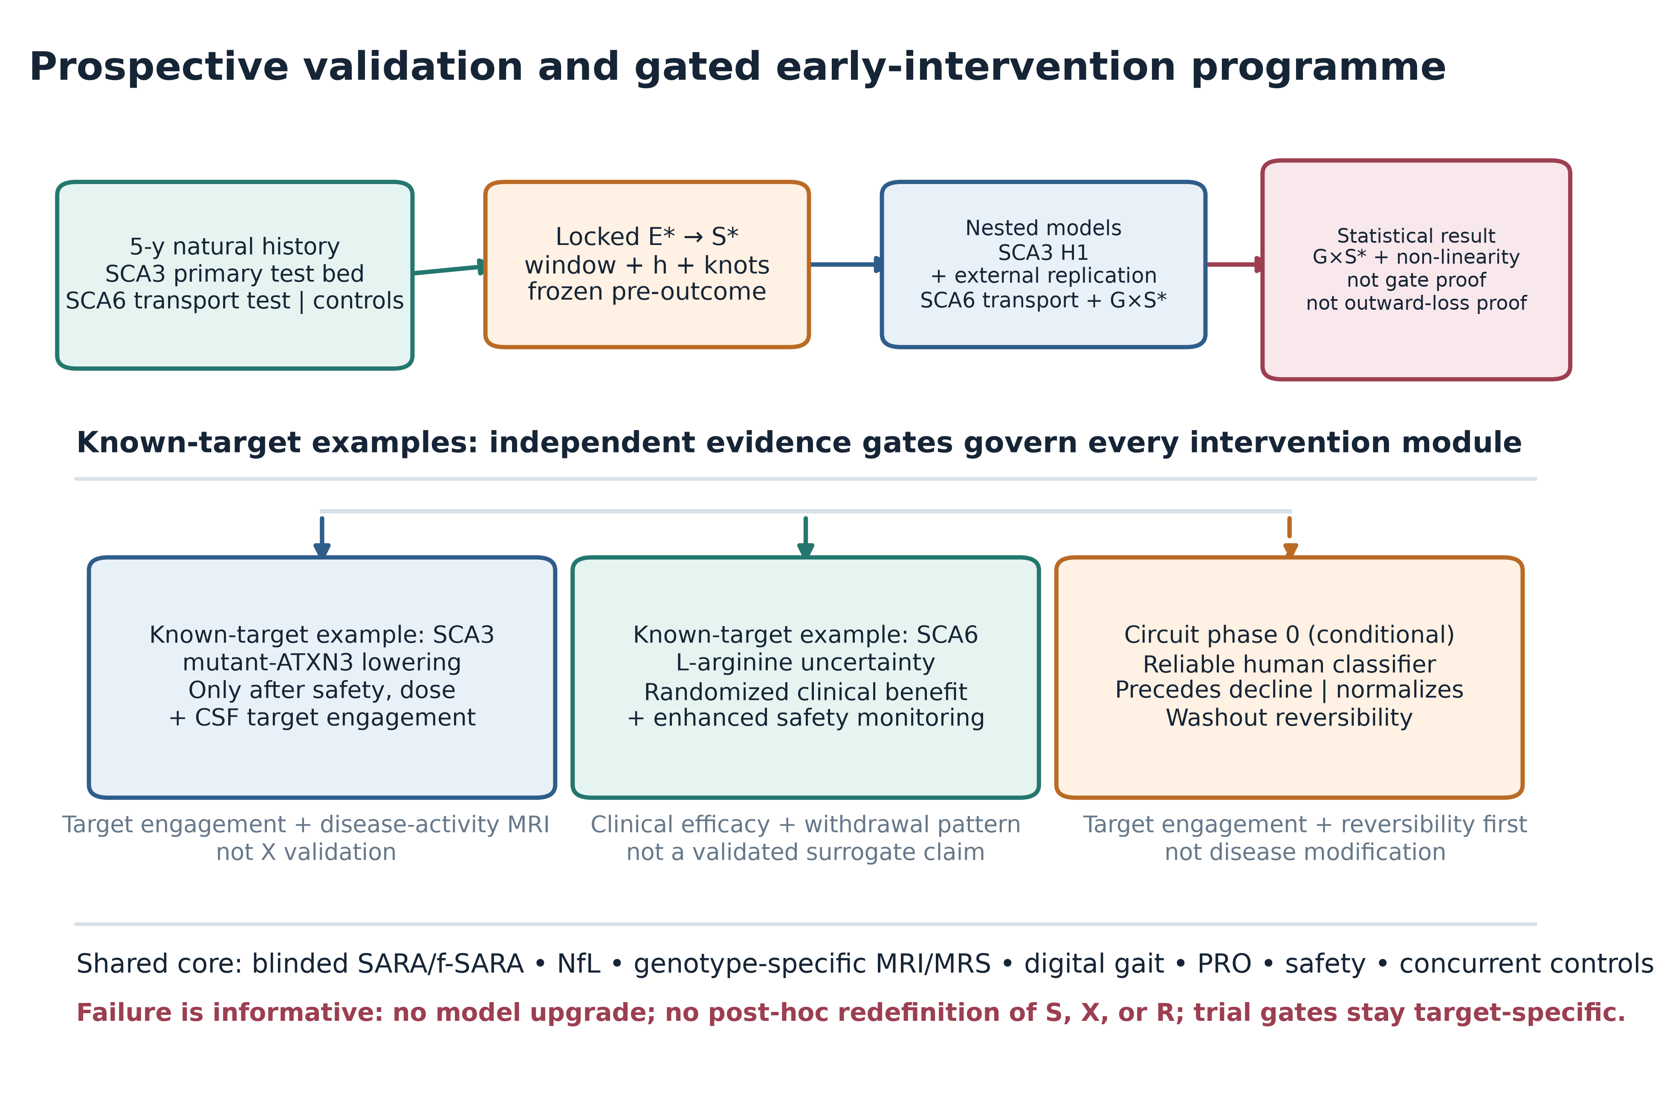
Figure 3. Prospective validation and gated early-intervention programme. A shared natural-history and measurement core feeds separate genotype- and target-specific examples. The SCA3 and SCA6 concepts test known targets, not the unknown input. The circuit module stays inactive until prospective human evidence meets four gates. A failed cohort signal stops model escalation and cannot be repaired by redefining $\text{S}$, $\text{X}$, or $\text{R}$.

8.1 Molecular lowering in SCA3
Allele-specific ASO proof-of-concept in SCA3 patient-derived neurons reduced mutant ataxin-3 for one linked-SNP strategy while largely preserving wild type [23]. A different CAG-repeat-targeting strategy, VO659, is registered in an open-label phase 1/2a study with no posted SCA efficacy result at the evidence cut-off [24]. These observations justify conditional, target-engagement-led development after agent-specific human safety and dose information; they do not establish clinical benefit. Intrathecal lowering is dose-adjustable but not rapidly reversible and should not be described as a circuit downshift.

8.2 Clinical uncertainty in SCA6
A 40-person phase 2 L-arginine trial in SCA6 estimated a 48-week SARA difference of −1.52 points, but the confidence interval included no effect and safety events require caution [25]. A confirmatory study would need concurrent randomized controls, conservative effect assumptions, staged entry into earlier disease, clinical rather than biomarker primary benefit, and enhanced hepatic, renal, metabolic, aspiration, and pneumonia monitoring. This example illustrates uncertainty in translating early intervention; it is not evidence for a shared maintenance input.

8.3 Circuit-targeted phase 0
A circuit study is not currently ready. It activates only when all four conditions hold:
1. the human hyperactivity classifier has test–retest reliability $\text{ICC}\text{≥}\text{0}\text{.}\text{75}$;
2. the classifier prospectively precedes decline after stage adjustment;
3. the intervention moves the signature toward a healthy reference rather than imposing blanket inhibition; and
4. the physiological effect returns toward baseline within a prespecified 2–4 week washout without persistent loss.
The first primary endpoint is target engagement and washout reversibility, not SARA or disease modification. “Downshift” always means selective, reversible, pathology-specific modulation; it never means structural injury or destruction.

9. Nested model comparison
The hypothesis is evaluated against three nested models:
• M0, known-mechanism model: causal genotype, repeat length, age, sex, ancestry, site, family, measured known modifiers, disease stage, and established exposures.
• M1, biomarker measurement model: M0 plus the frozen, cross-validated biomarker state $\text{L}\text{(}\text{t}\text{)}$.
• M2, non-linear environment model: M1 plus the locked non-linear ${\text{S}}^{\text{*}}$ term and genotype-by-${\text{S}}^{\text{*}}$ interaction.
M2 is retained only if it improves calibration and predictive performance in held-out sites or cohorts, reproduces the direction of the central-versus-extremes contrast, and survives exposure-error and selection-bias sensitivity analyses. A lower information criterion in the development data is not enough. M2 does not identify $\text{P}$, $\text{B}$, uptake, or leakage. Gate-specific language requires the independent activation–uptake–reserve sequence and perturbational evidence defined above.

10. Layer-specific falsification rules
Failure must be assigned to the layer actually tested:
1. Registered exposure/score implementation (${\text{E}}^{\text{*}}\text{/}{\text{S}}^{\text{*}}$): it is rejected if adequately informative data exclude the prespecified hump, temporal ordering is compatible with reverse causation, or the frozen shape fails external replication. This does not by itself exclude every environmental influence.
2. Coupling module ($\text{R}$): the proposed genotype-dependent coupling is rejected if the genotype-by-${\text{S}}^{\text{*}}$ interaction is adequately excluded and an independently defined $\text{R}$ adds no reproducible external information. A main environmental association could still remain.
3. Biomarker measurement module ($\text{L}$): the common factor is rejected if it fails longitudinal/genotype measurement invariance, calibration, or external prediction. This result neither proves nor disproves mechanistic reserve $\text{B}$.
4. Circuit-downshift module: it is rejected if a reproducible human high-activity signature never precedes deterioration, or if selective normalization produces target engagement but no downstream disease-activity signal in adequately powered studies. This does not decide the environmental model.
5. Gate–loss mechanism: it is rejected if independent activation, uptake/exchange, and reserve proxies do not show the registered temporal ordering, or if selective perturbation of the proposed gate fails to change those mediators despite adequate engagement. A statistical hump alone cannot rescue this mechanism.
6. Need for the external-input layer: the broader layer is rejected when externally validated models containing known DNA repair, somatic expansion, established cerebellar reserve, HSP90/UPR, calcium, mitochondrial, synaptic, glial, and behavioural mechanisms match or outperform it without $\text{S}\text{→} \text{X}$ assumptions.
The current programme permits at most two candidate families: the outcome-blind-selected primary candidate and, only after a new registration in a non-overlapping external cohort, one test of the remaining shortlist candidate. The secondary result in the original cohort cannot promote it. Two adequately informative external failures end confirmatory expansion of this external-input model class; new candidates would require a visibly new hypothesis and protocol, not a post-hoc repair of this one.

11. Ethical and clinical boundaries
The unknown input has no established identity, dose, delivery route, or safety profile. Clinicians and patients must not administer X, unvalidated electromagnetic fields, radiation, supplements, drugs, neural injury, or gene manipulation on the basis of this hypothesis. Observational exposure research should minimize disclosure risk from residential histories and avoid stigmatizing rural communities. Genetic-carrier recruitment requires counselling, privacy protection, and jurisdiction-specific handling of incidental and predictive findings.
Trial concepts in this repository are not ready-to-use clinical orders. Each requires agent ownership, manufacturing and toxicology data, regulatory authorization, independent ethics review, trial registration, data monitoring, site qualification, and participant-informed consent. Concurrent randomized controls are essential; historical natural-history data may inform design but should not replace the primary control group.

12. Limitations
First, the framework is underdetermined: several flux combinations can generate the same reserve trajectory. Second, a hand-selected parameter set can display a hump even when the shape is not robust; candidate-specific parameter sweeps and exposure-history simulations are still required. Third, the proposed input score may collapse biologically unrelated exposures, and the current rural proxies are not direct measures of a maintenance resource. Fourth, the link from reserve to clinical transition is itself a model choice. Fifth, onset measures are noisy and influenced by diagnosis, recall, and access to care, while migration and survival can induce time-varying confounding and selection. Sixth, biomarkers differ by genotype, site, platform, renal function, infection, trauma, and disease stage. Seventh, rare-disease recruitment may be insufficient for flexible interactions, especially in SCA6. Eighth, the drug examples test early intervention in known pathways, not the external-input mechanism. Finally, the framework may prove unnecessary if established modifier and cerebellar-reserve mechanisms provide equal or better explanation.

13. Conclusion
The maintenance–reserve–gating framework is best treated as a constrained model class nested within established cerebellar-reserve theory. Its value does not depend on asserting that a novel field or substance exists. It asks whether measured external exposures, genotype, and dynamic homeostatic capacity produce a prospectively predictable, non-linear transition before advanced structural degeneration.
Current evidence supports onset heterogeneity, established concepts of structural and functional cerebellar reserve, early biomarker abnormalities in selected human cohorts, and model-specific multicellular causation or stage-dependent reversibility. It does not support $\text{X}$, a gate, outward leakage, or a hump-shaped human risk curve. The decisive next step is therefore not speculative treatment. It is an SCA3-led, preregistered test of a reliable measured exposure, followed by external replication and SCA6 transport testing. Gate-specific language requires the independent activation–uptake–reserve sequence and perturbation. If those tests fail, existing reserve and known molecular mechanisms should replace the added layer.

Declarations

Data and code availability
This article contains no participant-level data. Figure source, deterministic sample-size scenarios, protocols, evidence audit, and repository checks are public in the repository identified on the title page. Trial concepts follow the logic of SPIRIT 2025, CONSORT 2025, and ICH E9(R1), but they are not substitutes for a sponsor-approved final protocol or SAP.

Ethics approval and consent
Not applicable. This article is a theoretical framework and critical review and reports no research involving human participants, animals, participant data, or biological material.

Author contribution
Jieyang Chen conceived the framework, performed the literature organization and claim audit, designed the proposed research programme, prepared the figures and reproducibility materials, and drafted and revised the manuscript.

Funding
This work received no external funding.

Competing interests
The author declares no competing interests. The author retains copyright in the associated public repository and may consider future commercial-licensing requests. No commercial funding or payment was received for this work.

AI-assisted tools
OpenAI Codex was used as an AI-assisted tool for literature organization, drafting and language editing, code generation for figures and repository checks, and internal consistency review. It is not an author. The named author remains responsible for source verification, scientific claims, analyses, disclosures, and the submitted version.

References
1. Akçimen F, et al. Genome-wide association study identifies genetic factors that modify age at onset in Machado-Joseph disease. Aging. 2020. doi:10.18632/aging.102825.
2. Meyer CC, et al. Association of rare apolipoprotein E ε4 homozygosity with an earlier age at onset in spinocerebellar ataxia type 3. Human Molecular Genetics. 2026. doi:10.1093/hmg/ddag016.
3. Gomez CM, et al. Spinocerebellar ataxia type 6: variable age of onset. Ann Neurol. 1997. doi:10.1002/ana.410420616.
4. Anderson JH, et al. Spinocerebellar ataxia in monozygotic twins. Arch Neurol. 2002. doi:10.1001/archneur.59.12.1945.
5. Mitoma H, et al. Consensus paper: cerebellar reserve from cerebellar physiology to cerebellar disorders. Cerebellum. 2020. doi:10.1007/s12311-019-01091-9.
6. Mitoma H, Manto M, Hampe CS. Time is cerebellum. Cerebellum. 2018. doi:10.1007/s12311-018-0925-6.
7. Huang H, et al. Resilience to ER stress mitigates late membrane hyperexcitability in a murine SCA6 model. Ann Neurol. 2026. doi:10.1002/ana.78042.
8. Zu T, et al. Recovery from polyglutamine-induced neurodegeneration in conditional SCA1 transgenic mice. J Neurosci. 2004. doi:10.1523/JNEUROSCI.2978-04.2004.
9. Pilotto F, et al. Early molecular layer interneuron hyperactivity triggers Purkinje neuron degeneration in SCA1. Neuron. 2023. doi:10.1016/j.neuron.2023.05.016.
10. Wang X, et al. Bergmann glia-specific loss of APC and non-cell-autonomous Purkinje-cell degeneration. Glia. 2011. doi:10.1002/glia.21154.
11. Lee C, et al. Oligodendrocyte dysfunction contributes to motor deficits and Purkinje cell axonopathy in SCA1. J Clin Invest. 2026. doi:10.1172/JCI195723.
12. Ibrahim MF, et al. Enhanced mGluR1 function causes motor deficits and region-specific Purkinje cell dysfunction. Brain. 2026. doi:10.1093/brain/awaf477.
13. Bell B, et al. Functional and structural basis of a hypermorphic TRPC3 variant. Sci Adv. 2026. doi:10.1126/sciadv.aec9284.
14. Ito-Ishida A, et al. Cbln1 regulates rapid formation and maintenance of excitatory synapses. J Neurosci. 2008. doi:10.1523/JNEUROSCI.1030-08.2008.
15. Takeuchi E, et al. Improvement of cerebellar ataxic gait by injecting Cbln1 into cbln1-null mice. Sci Rep. 2018. doi:10.1038/s41598-018-24490-0.
16. Wang H, et al. Delta-type glutamate receptors are ligand-gated ion channels. Nature. 2025. doi:10.1038/s41586-025-09610-x.
17. Wilke C, et al. Neurofilaments in SCA3 at preataxic and ataxic stages. EMBO Mol Med. 2020. doi:10.15252/emmm.201911803.
18. Berger M, et al. Progression of biological markers in SCA3: longitudinal ESMI data. Lancet Reg Health Eur. 2025. doi:10.1016/j.lanepe.2025.101339.
19. Joers JM, et al. Neurochemical endpoints for early-stage SCA2/SCA3 trials in a multisite setting. Ann Clin Transl Neurol. 2026. doi:10.1002/acn3.70443.
20. Martins AC, et al. Rural environment as a risk factor for age at onset of Machado-Joseph disease. Mov Disord Clin Pract. 2025. doi:10.1002/mdc3.14338.
21. Benussi A, et al. Cerebello-spinal tDCS in ataxia. Neurology. 2018. doi:10.1212/WNL.0000000000006210.
22. Maas RPPWM, et al. Cerebellar tDCS in SCA3: randomized sham-controlled trial. Neurotherapeutics. 2022. doi:10.1007/s13311-022-01231-w.
23. Hauser S, et al. Allele-specific targeting of mutant ataxin-3 in SCA3 iPSC-derived neurons. Mol Ther Nucleic Acids. 2022. doi:10.1016/j.omtn.2021.11.015.
24. ClinicalTrials.gov. NCT05822908: VO659 in SCA1, SCA3 and Huntington disease. Status checked 19 August 2026.
25. Ishihara T, et al. L-arginine in SCA6: multicentre randomized phase 2 trial. eClinicalMedicine. 2024. doi:10.1016/j.eclinm.2024.102952.
26. Öz G, et al.; Ataxia Global Initiative Working Group on MRI Biomarkers. MRI end-points for clinical trials in ataxias: recommendations from the Ataxia Global Initiative MRI Biomarkers Working Group. Nat Rev Neurol. 2026;22:439–456. doi:10.1038/s41582-026-01218-7.
The complete machine-readable bibliography is in references.bib.

