**Candidate number:** PQHG5

**Module code and name:** SECU0058: Crime Modelling and Simulation 24/25

**Word count:** 2328 words

**Measure of choice:** Electronic Article Surveillance (EAS)

### Introduction

Retailers suffer significant revenue losses due to shoplifting, while retail employees often face confrontational or unsafe situations when intervening in theft incidents (NBCC, 2024). Persistent and unchecked shoplifting can undermine community values by normalizing petty crime (UK Parliament, 2023). Additionally, shoplifting increases the workload of law enforcement and the justice system, diverting critical resources from addressing more serious crimes (NASP, 2006).

This report will explore the application of situational crime prevention principles to combat shoplifting. It will discuss the situational crime prevention measures highlighted in the Lasky et al. (2017) paper, analysing their strengths and limitations. The goal of this report is to implement and evaluate the effectiveness of Electronic Article Surveillance (EAS) within the NetLogo shoplifting simulation model and its broader implications.

### Section A: Overview of SCP-based crime reduction elements

Situational crime prevention principles aim to reduce opportunities for crime by modifying environmental and situational factors. In the context of shoplifting, all principles can be applied to deter shoplifting:

1. **Increasing Effort**: This involves making theft physically more challenging (Carmel-Gilfin, 2011). For instance, placing high-theft items in locked cabinets or behind checkout counters increases the effort required to steal.
2. **Increasing Risk**: Deploying surveillance measures such as employee presence, CCTV, electronic article surveillance, and public viewing monitors enhances the shoplifters’ perceived likelihood of detection, deterring theft attempts (Hayes et al., 2006).
3. **Reducing Provocation**: This strategy focuses on preventing situations that may lead to theft. For example, designing store layouts (Carmel-Gilfin, 2011) to minimize opportunities for theft and training staff to provide better customer service can reduce disputes and frustrating situations that might provoke shoplifting.
4. **Reducing Rewards:** Making stolen items less attractive, usable, or valuable can reduce the incentive for theft. For example, ink tags on clothing that spoil the items when tampered with effectively reduce the rewards for shoplifting by lowering the resale value or utility of stolen goods (DiLonardo & Clarke, 1996).
5. **Removing Excuses**: This involves creating a store environment that discourages rationalizing theft (Clarke, 2009). Implementing clear store policies, posting notices about surveillance, and highlighting penalties for shoplifting encourage ethical behaviour and deter rationalization of criminal activity.

### Overview of Lasky et al. (2017) Paper

Lasky et al. (2017) evaluated the effectiveness of various security measures from the perspective of shoplifters, highlighting their strengths and weaknesses. The study revealed that “Mirrors are not something I was really concentrating on. I was concentrating on the people most.” (p. 781) and Public Viewing Monitors (PVM) were largely ineffective, as “Displayed footage can be used in determining camera placement, which can assist with finding blind spots.” (p. 783) CCTV surveillance was moderately more effective, as it heightened the perceived risk of detection. However, its impact was often diminished by poor camera placement, lack of active monitoring, and “shoplifters have adapted their methods to account for the threat it poses.” (p. 782). Electronic Article Surveillance (EAS) proved highly effective in deterring the theft of tagged items as they “wouldn’t take anything with a tag on it.” (p. 784), although it shifted shoplifters’ focus to untagged products. Item packaging and item placement were also identified as strong deterrents, with shoplifters frequently avoiding items secured through these methods.

The study emphasized a significant challenge: shoplifters quickly adapt by exploiting design flaws in security measures and capitalizing on employee complacency (p. 789). Moreover, the effectiveness of all security measures increased substantially when combined with active employee engagement and regular updates to counter shoplifters’ evolving tactics.

### Approaches to Modelling SCP Principles:

Groff and Birks (2008) describe a general strategy for agent-based simulation modelling (ABSM) in crime reduction measures. This involves first defining a crime prevention objective, such as decreasing shoplifting, and then establishing measurable outcomes, such as the number of shoplifters caught, to evaluate the effectiveness of the intervention. The model incorporates diverse agent types to represent offenders, guardians, and customers (law-abiding civilians or potential targets). These agents are programmed with behavioural rules based on theories from various disciplines, including environmental criminology, cognitive science, behavioural geography, and ecology. Probabilistic elements are introduced into agent decision-making to account for the unpredictability of real-world behaviour. Simulations occur within a realistic spatial layout, referred to as the terrain, where agents interact with both the environment and other agents. The model is tested under extreme or unexpected conditions to identify weaknesses in the proposed intervention.

### Strengths and Limitations of ABSM

Agent-based simulation modelling (ABSM) enables the testing of various intervention strategies in simulation before implementation in the real world, saving time and resources (Groff and Birks 2008). Moreover, ABSM provides granular insights into how individual behaviours and interactions contribute to macro-level crime patterns. For instance, Brantingham et al. (2005) used ABSM to simulate burglary patterns based on offenders’ routine activities and spatial behaviours. This approach helped identify hot spots and potential preventive strategies. However, Maguire (2002) found that ABSM predictions varied significantly depending on the quality of input data, highlighting challenges in validation. Furthermore, “the dilemma is that we cannot reliably validate the results of a model that aims to simulate all crimes with official data that only represent an unknown subset of all crimes (i.e. recorded crime)” (Groff and Birks, 2008, p. 181).

### Section B: Selection and Implementation of Security Measures

Electronic article tagging (EAS) will be chosen out of the measures outlined in the study by Lasky et al. 2017. Shoplifters in the study noted they often avoid tagged items entirely, demonstrating the deterrence potential of this measure. EAS systems are considered a staple in shoplifting prevention as they are widely used across retail stores in the UK. EAS aligns closely with the Situational Crime Prevention principle of increased perceived effort via target hardening as it requires shoplifters to exert additional effort to remove or bypass these tags. It also increases the perceived risk as triggering the EAS sensors at the exits will alert employees, resulting in higher odds of detection.

### EAS Implementation Approaches

EAS can be implemented in different forms (Bamfield, 1994):

1. Hard tags, reusable electronic tags attached to high-value or frequently stolen items, typically removed at the point of sale. These tags are durable and reusable, making them cost-effective over time. Their visible presence acts as a deterrent to potential shoplifters. However, hard tags can slow down the checkout process as staff must remove them, and if left on by mistake, they can cause inconvenience for both customers and employees.
2. Soft tags, adhesive labels containing electronic circuits. They are low-cost and can be easily applied to a wide range of products during the packaging or stocking process. However, unlike hard tags, they are not reusable, which makes them more expensive in the long term. Additionally, they are easier for determined shoplifters to tamper with or remove, reducing their effectiveness compared to hard tags.
3. Source tagging, this involves embedding EAS tags directly into product packaging during the manufacturing process. This method ensures seamless integration, consistent tagging for all items of a specific type, and saves time and labour costs for retailers. Furthermore, embedding tags within the packaging makes them harder for shoplifters to detect and remove. However, source tagging may not be cost-effective for low-value items and can increase production costs for manufacturers.

### NetLogo Simulation Implementation Approach:

This section will briefly go over the NetLogo implementation, please refer to appendix and the code file *PQHG5_shoplifting.nlogo* and *PQHG5_CRAVED_method.nls* for further detail.

**Item Tagging**   
**Approach:** In the shoplifting model, source tags will not be implemented due to the time required for real-world adoption and the need for cooperation from manufacturers, making this approach unrealistic in the short term. Instead, hard tags and soft tags will be utilized because they are easier to implement in real-world settings. Hard tags will be applied to high-value items, based on the "Valuable" attribute of the CRAVED variable (Clarke 1999). Soft tags, on the other hand, will be used for other items that are easily concealable, based on the "Concealable" attribute of the CRAVED model.

**NetLogo Implementation:** First, initialise global variables “*threshold_hard_tag*” and “*threshold_soft_tag”* as sliders on the NetLogo interface. They are both set as integers ranging from 0 to 10. To implement tagging, a new patch-own variable “*tagtype*” is initialised, this is used to represent the type of tag used for the items in the patches that are shelves, the values of this variable ranges from: 2: hard tag, 1: soft tag, or 0: no tag. The method “*assign_CRAVED*” is renamed to “*assign_CRAVED_and_tag*” and changed to include the item tagging procedure: a new if-else statement is added to apply the tags on the shelf patches based on the C and V of the patch CRAVED attribute value.

**Shoplifter Behaviour: Stealing Tagged Items   
Approach:** Tagged items act as a deterrent for shoplifters; however, shoplifters tend to target items with less secure tagging. From their perspective of perceived risk and effort, items are ranked in desirability as follows: no tag, soft tag, and hard tag. Despite this, more securely tagged items are often of higher value. To model the behaviour of more determined shoplifters, a decision threshold can be implemented. According to the Rational Choice Perspective, these shoplifters will opt for more securely tagged items if the perceived reward outweighs the associated risks and effort (Carroll et al., 1986).

**Netlogo Implementation:** A new global constant, “*determination_threshold*”, is defined and initialized in the setup procedure to introduce stochastic behaviour in the shoplifter's decision-making process when choosing more securely tagged items. A new turtle-own variable “*list_of_tagged_products*” is defined and initialised as an empty list, when the turtle is created. Subsequently, the “*browsetosteal*” behaviour state is updated as follows: when a shoplifter decides to browse for an item to steal, they will examine items on the adjacent shelves. To account for more determined shoplifters, those who perceive the reward as greater than the risk (Carroll et al., 1986), the decision to steal a more securely tagged item will depend on the previously defined “*determination_threshold*” variable. When a shoplifter steals a tagged item, the tag type will be stored in a list called “*list_of_tagged_products*”. If the stolen item is untagged, the “*number_of_stolen_products*” variable will be incremented by 1.

**Shoplifter Behaviour: Bypassing Item Tags:  
Approach:** For the shoplifters, a new behaviour state will be implemented, if they are concealing a tagged item, based on another decision threshold, they will attempt to bypass the tag (Lasky et al, 2017), such as removing or wrapping the tag in a material so the alarm does not go off when they leave . If the tag is a hard tag, they will have an arbitrary probability threshold to bypass it, and if the tag is a soft tag, they will have a probability threshold s, lower than the prior, to remove it. Before the shoplifter decides to leave, they must bypass all tags from the stolen items. Hence, the measure’s increased risk effect is achieved by requiring the shoplifter to stay within the shop for a longer time, making them more likely to be caught.

**Netlogo Implementation:** Two new procedures are introduced: “*decide_bypass_item_tag*” and “*bypass_item_tag*”. The procedure “*decide_bypass_item_tag*” determines whether the shoplifter will attempt to bypass an item tag based on a new global variable, “*decide_bypass_item_tag_threshold*”. This procedure is invoked when the shoplifter is in the walking state and has one or more tagged products in their inventory. Depending on the type of tag, the shoplifter must meet the corresponding bypass tag threshold to attempt bypassing the tag. If the bypass is successful, the “*number_of_stolen_products*” variable is incremented by one, and the item is removed from the “*list_of_tagged_products*”.

### Results:

After implementing Electronic Article Surveillance (EAS) in NetLogo. We conducted an experiment using NetLogo's BehaviorSpace tool to evaluate the effect of tagging items with varying degrees of security and better trained guardians on the number of stolen products. In this experiment, the independent variables are the “*prob_guardian*”, “*threshold_hard_tag*” and “*threshold_soft_tag*”. Because we are interested in assessing the combined effect of non-complacent guardians and tagging products based on its Concealable and Valuable CRAVED attribute on the outcome variable of detecting the shoplifter.

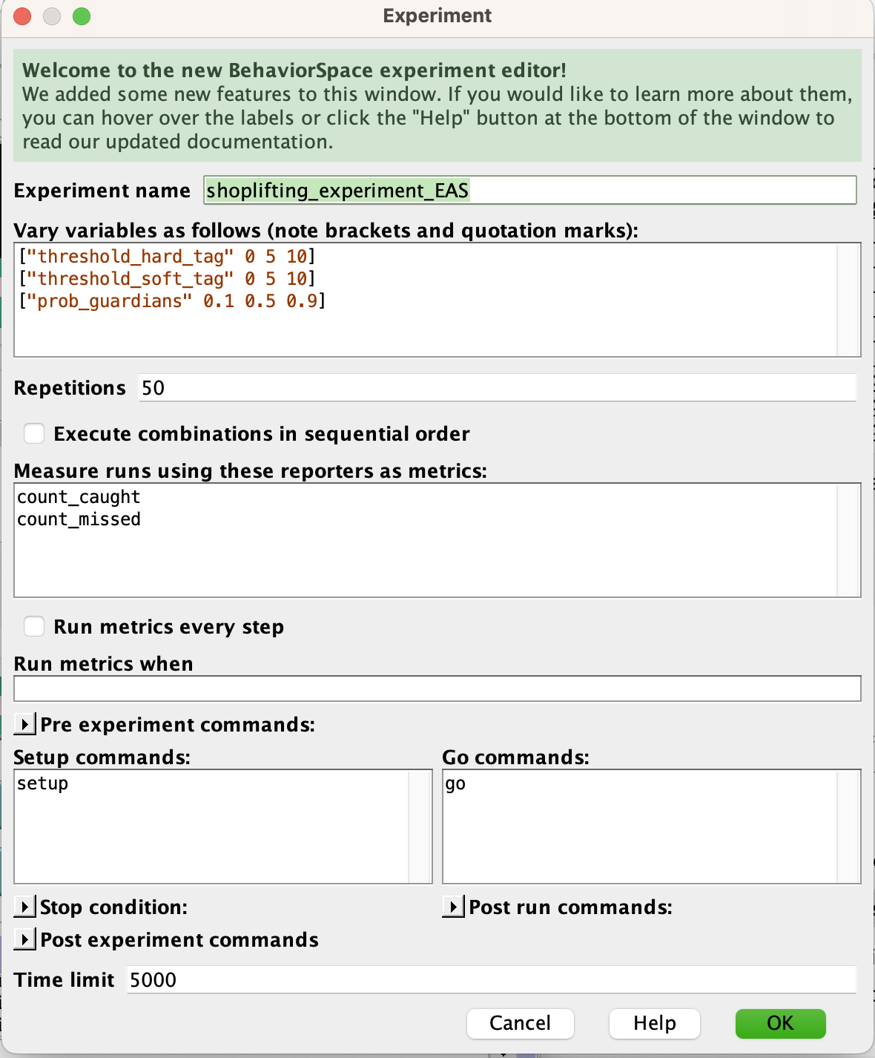  
Figure 1: Experiment Setup in the NetLogo Behaviour Tool

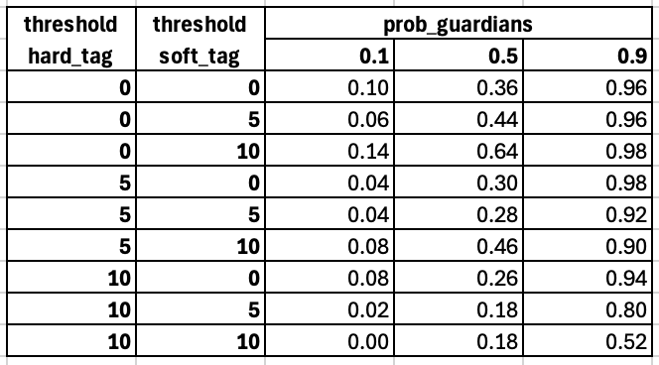  
Table 1: Proportion of Shoplifter Caught in 50 Runs Across Variable Configurations

Table 1 was created by aggregating results generated by the NetLogo BehaviorSpace tool in Microsoft Excel. The results indicate that, with EAS implemented, shoplifters were significantly more likely to be caught at any level of staff training compared to scenarios where no products were tagged (i.e., when the configuration was *{threshold_hard_tag = 10, threshold_soft_tag = 10})*. Furthermore, the proportion of shoplifters caught increased significantly across all tag threshold configurations when guardians were better trained. This underscores the critical role of employee involvement in enhancing the effectiveness of EAS systems, aligning with the findings of Bamfield (1994).

Even though our simulation model showed that implementing EAS significantly reduced shoplifting cases. One major limitation is the occurrence of non-theft alarms. Past studies indicate that 93–96% of alarm activations were non-theft related (Beck and Willis, 1994). This significantly reduces the effectiveness of EAS, as shoplifters can exploit the frequent false alarms to escape with stolen goods. Retailers may also become desensitized to alarm activations, often ignoring or downplaying them (Hayes and Blackwood, 2006). This, in turn, lowers the perceived risk associated with the system, making it less of a deterrent to potential shoplifters and undermining its overall impact. In addition, the employees in our model are assumed to maintain a consistent level of attentiveness and effectiveness based on their assigned training level “prob_guardian” throughout the simulation. However, this does not accurately reflect real-world scenarios, where factors such as fatigue, distractions, or loss of motivation can impact employee performance over time (Handford, 1994).

Despite these limitations, EAS can still be an effective shoplifting prevention measure. EAS implementation with strategic tagging based on high-risk items, combined with well-trained and engaged staff, can significantly enhance the system's effectiveness. Furthermore, layering EAS with complementary measures, such as CCTV surveillance, improved store layouts, and deterrent signage, establishes a comprehensive strategy that minimizes theft opportunities while heightening the perceived risk for shoplifters.

### Reference:

Bamfield, J. (1994). Electronic article surveillance: Management learning in curbing theft. In M. Gill (Ed.), *Crime at Work* (pp. 155–173). London: Perpetuity Press.

Beck, A., & Willis, A. (1994). Customer and staff perceptions of the role of closed circuit television in retail security. In M. Gill (Ed.), *Crime at Work* (pp. 186–202). London: Perpetuity Press.

Brantingham, P. L., Glasser, U., Kinney, B., Singh, K., & Vayihollahi, M. (2005). A computational model for simulating spatial aspects of crime in urban environments. Paper presented at the IEEE International Conference on Systems, Man, and Cybernetics, HI, USA.

Carmel-Gilfin, C. (2011). Bridging security and good design: Understanding perceptions of expert and novice shoplifters. *Security Journal, 26*(1), 80–105.

Carroll, J., & Weaver, F. (1986). Shoplifters’ perceptions of crime opportunities: A process-tracing study. In D. B. Cornish & R. V. Clarke (Eds.), *The Reasoning Criminal: Rational Choice Perspectives on Offending* (pp. 19–38). New York: Springer-Verlag.

Clarke, R. V. (1999). *Hot Products: Understanding, Anticipating, and Reducing the Demand for Stolen Goods*. London: Home Office Police and Reducing Crime Unit.

Clarke, R. V. (2009). Situational crime prevention: Theoretical background and current practice. In *Handbooks of Sociology and Social Research* (pp. 259–276).<https://doi.org/10.1007/978-1-4419-0245-0_14>

DiLonardo, R. L., Jr., & Clarke, R. V. (1996). Reducing the rewards of shoplifting: An evaluation of ink tags. In ELSEVIER, *Security Journal, 7*, 11–14. Retrieved from<https://popcenter.asu.edu/sites/default/files/60-dilonardo_clarke-reducing_the_rewards_of_shoplifting_a.pdf>

Elizabeth Groff & Dan Birks (2008). Simulating Crime Prevention Strategies: A Look at the Possibilities. Policing: A Journal of Policy and Practice, Volume 2, Issue 2, 2008, Pages 175–184. <https://doi.org/10.1093/police/pan020>

Handford, M. (1994). Electronic tagging in action: A case study in retailing. In M. Gill (Ed.), *Crime at Work* (pp. 174–184). London: Perpetuity Press.

Hayes, R., & Blackwood, R. (2006). Evaluating the effects of EAS on product sales and loss: Results of a large-scale field experiment. *Security Journal, 19*(4), 262–276.

Lasky, N. V., Fisher, B. S., & Jacques, S. (2015). ‘Thinking thief’ in the crime prevention arms race: Lessons learned from shoplifters. Security Journal, 30(3), 772–792. <https://doi.org/10.1057/sj.2015.21>

Maguire, M., Marguire, M., Morgan, R., & Reiner, R. (2002). Crime statistics: The ‘data explosion’ and its implications. In *The Oxford Handbook of Criminology* (3rd ed., pp. 322–375). Oxford: Oxford University Press.

National Association of Shoplifting. (2006). *Shoplifting statistics*. Retrieved from <https://www.shopliftingprevention.org/whatnas-poffers/NRC/PublicEducStats.htm>

UK Parliament. (2023). Unacceptable levels of shop theft causing serious harm to society. *House of Lords Committee Report*. Retrieved from<https://committees.parliament.uk/work/8463/tackling-shoplifting/news/203576/unacceptable-levels-of-shop-theft-causing-serious-harm-to-society/>

Gill, M. (2015). Electronic article surveillance: Management learning in curbing theft. Retrieved from<https://www.researchgate.net/publication/314614584_Electronic_Article_Surveillance_management_learning_in_curbing_theft>

UK National Business Crime Centre. (n.d.). Retrieved from<https://nbcc.police.uk/>

### Appendix:

**Item Tagging Code:**This can be found in the PQHG5_CRAVED_Method_nls file 

**Shoplifter Behaviour: Stealing Tagged Items Code:**  
This can found in the go procedure.

**Shoplifter Behaviour: Bypassing Item Tags:**Defining decide_bypass_item_tag and bypass_item_tag procedure:  
Calling decide_bypass_item_tag procedure in the go procedure.**