Baseline Automation Tool
User Guide

Author / Owner: JIEYUN CHEN
Revision level: 1.0
Revision date: Oct 16, 2014
Approval Date: N/A
Table of Contents
1 Introduction 4
1.1 Overview 4
1.2 Related Information 4
1.3 Instruction of automation tool 4
2 How to use automation tool 6
2.1 Run test bucket automatically 6
2.2 How to change test bucket 6

Revision History

Revision | Author | Date | Comments
1.0 | JIEYUN CHEN | Oct 16, 2014 | Initial draft

Introduction

Overview
This document introduces how to use baseline automation test tools. This tool was developed by baseline team member themselves and had begun to be used in daily test schedule.

Related Information
N/A

Instruction of automation tool
Our Automation tools was located on VEP server. Please use ID and password below to log on VEP server.
ID: baseline
Password: v3_p@ssw0rd
After you log on VEP server, please get into BAT directory.
Here comes the instruction of BAT directory:
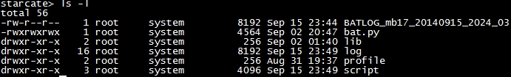
There were 4 directories in BAT.
We put all executed scripts in /scripts:
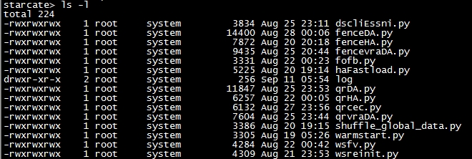

Put public interfaces in /lib:
All execution log will be created in /log:
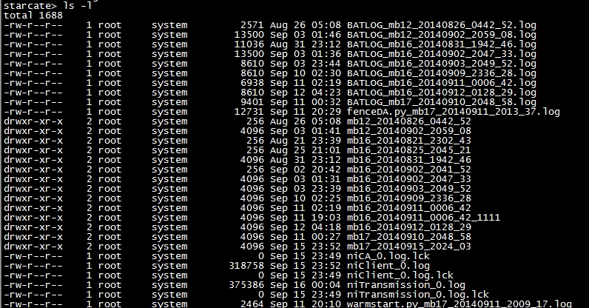

ATTENTION: DO NOT change anything in these three directories except you get permission first!!!
Machine profiles are in /profile
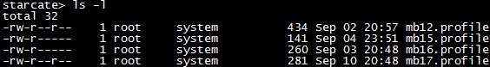
You can modify these profiles when you need to change your test bucket (Details come in next episode)

How to use automation tool

Run test bucket automatically

We usually use automation tool by this command:
Starcate> bat.py -t mbxx
mbxx can be instead of the box which you used. For example: mb12/mb16/mb15 and etc.
After you type this command, scripts will run itself and type execution log on your screen automatically, you just need to monitor it.
You can find these messages after each test case finish successfully. For example:
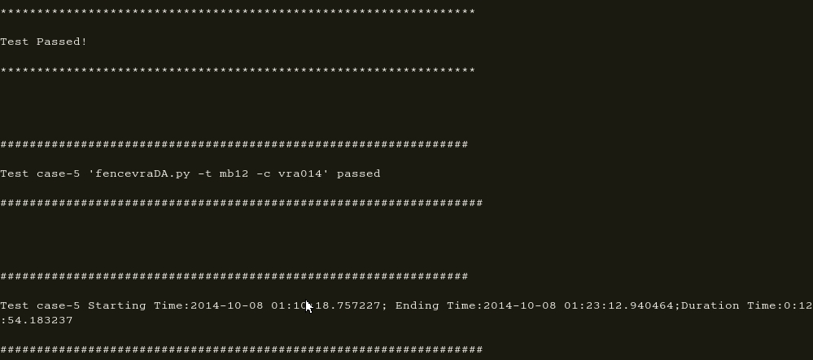
The first line of the log tells your test has been finished successfully. The second line indicates you that which test has been finished. The 3rd line will show you the start/end time and duration time of this test case.

If box hit issue during test execution (like “Single cluster mode” ), scripts will stop and quit. You will find some message like “Test Failed”. At this time, you need to check your box as soon as possible.

How to change test bucket

Test bucket always stable in baseline, but sometimes we still need to change them.
If you want to change test bucket, please get into /profile and edit it. Here comes the instruction of profile.
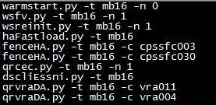
This profile contains a list of commands and each command instead of a script. You can delete or add any commands in profile.
You need to follow the format below to add case:
DSCLI/ESSNI: dscliEssni.py -t mbxx
Warmstart: warmstart.py -t mbxx -n x
Warmstart: wsfv.py -t mbxx -n x
Warmstart reinit: wsreinit.py -t mbxx -n x
HA fastload: haFastload.py -t mbxx
Fence/unfence HA: fenceHA.py -t mbxx -c cpssfcxxx
Quiesce/resume CEC: qrcec.py -t mbxx -n x
Quiesce/resume vraDA: qrvraDA.py -t mbxx -c vraxxx
Fence/unfence DA: fenceDA.py -t mbxx -c issxxx
Failover/failback: fofb.py -t mbxx -n x
Fence/unfence vraDA: fencevraDA.py -t mbxx -c vraxxx
Shuffle global data: shuffle_global_data.py -t mbxx

How to check your log
You need to check your test log after you finish test.
Type: “ls -lart” to list logs by time:
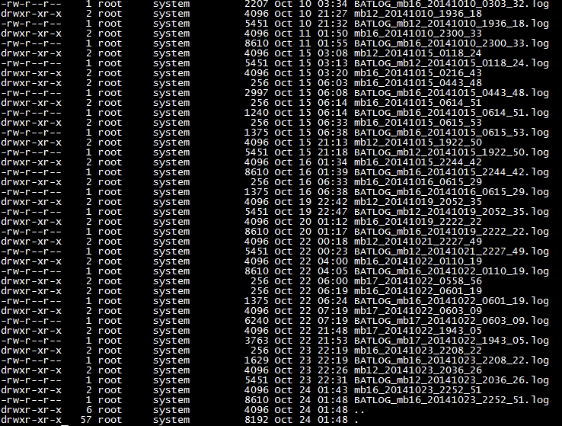
Find log name like “BATLOG_mbxx_xxxxxxxx.log”, this log will contain a summary of what you run and you can also find some useful information like below:
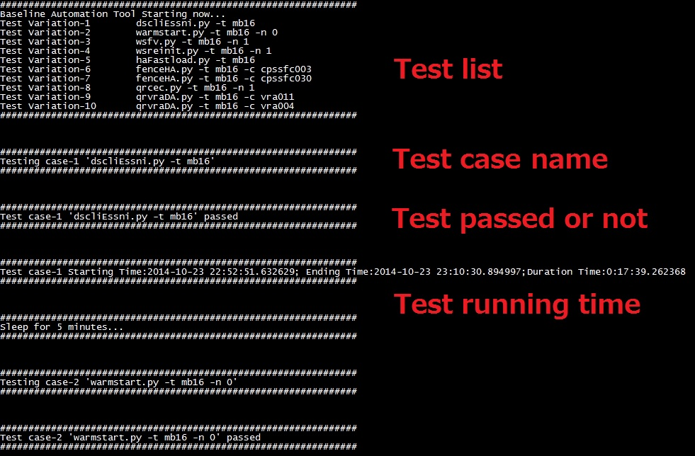
If you want to check detail log, please find directory named like “mbxx_xxxxx”, this directory will contain all test logs you run. You can view each test log in this directory.
