Animal Monitoring in the Backyard

Motivation:
Animal detection can benefit us in various ways. For example, lots of home gardeners have suffered from plant damage induced by wildlife such as rabbits. In addition, wild animals can present potential danger to pets and unpleasant smells, such as a skunk. Furthermore, for nature-lovers, animal detection would satisfy personal interest and enjoyment. Data of wildlife in people’s backyard could also facilitate the academic research to identify homeowners’ impact on local ecosystems.

System Description:
With the advances of IoT technology, now we can utilize cost-effective hardware and existing IoT infrastructure to build a smart backyard monitor system. I would like to achieve real-time animal capture, image analysis, and data sharing and storage with this platform, and details of implementation of feature is presented below.
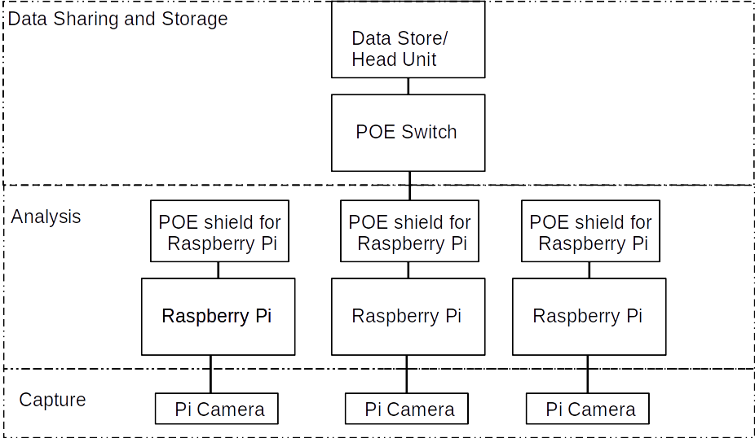

Animal Capture
I will utilize raspberry pi with picameras to continuously acquiring videos of the animals. Since that each picamera has a field-of-view (FOV) ~ 70 degree, and an illumination range ~ 20ft for night version, multiple picameras will be installed at different positions to cover the area of interest as shown below. Picameras are powered up by the raspberry.
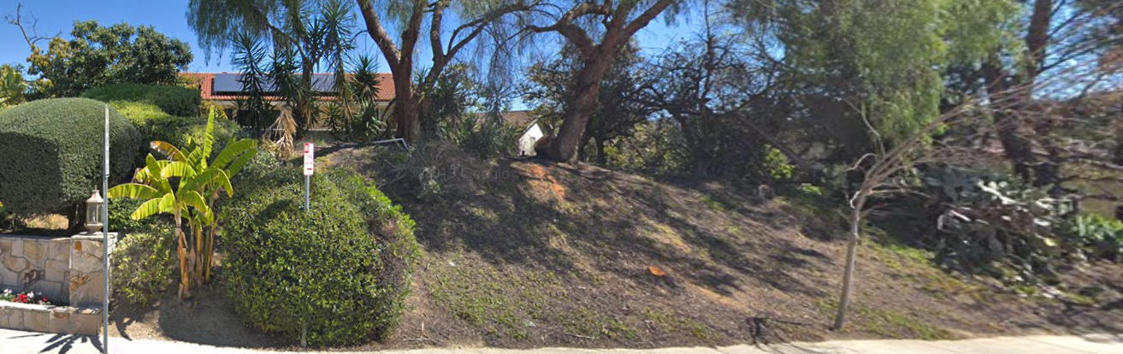
Image Analysis
Raspberry pi will provide on-site real-time process and analysis of videos via openCV and TensorFlow, respectively. Once an animal is identified in the video stream, timestamp, animal type, and a portion of the video containing the animals will be uploaded to the data warehouse. This “on-site” approach, i.e., analysis at the edge device directly, prevent sending meaningless information such as video without animals and wasting the bandwidth, as well as decreasing latency. Different frame rate will be investigated for satisfactory performance between frame rate and detection accuracy due to the limited computational capacitor of the Raspberry. Power Over Ethernet (POE) shield is utilized to power up each raspberry pi.

Data Sharing and Storage
To limit the scope of the project, wired Ethernet is employed for data transmitting between the edge device – Raspberry pi and the data store computer. A dashboard displaying real-time detection instances will be implemented in the data store computer. A gigabit Ethernet switch will be employed for network integration and power supply.

System Evaluation:
For testing the system, we will use per-recorded videos of animals to measure the detection accuracy under different situations. With human annotation and compare with the pre-trained model accuracy provided in the model’s documents. Assume the model is correct (such as the model has accuracy of xxx), confidence level (data may not be 100%).

Developed Model: Accuracy

Stretch Goals:
1. Power: Solar-powered system instead of POE
2. IoT deployment: Wireless data communication instead of wired Ethernet
3. Data Process:
3.1 Adaptive frame rate adjustment instead of fixed process frame rate for every Raspberry pi. Once an animal is detected, we can speed up the frame rate of all other Raspberry pi.
3.2 Once an animal is detected, automatically generate a picture of the animal and send to data house computer
4. Data storage: build a database and store the information on the cloud
5. Notification system: once an animal is classified as a threat, the system will text/email the home owner.

------improvements:
1. details about the goal:
such as what type of animals, details about the data: such as a time stamp, the kind of animal, a fraction of the video with animal inside

2. might add a servery about the achievable accuracy of the model with specific animal such as squirrel.

3. add kind of database and how to store: statics
Can store as local file,
For data statics, how I am going to store it in a laptop, such as Sql or Mongo (such as Json) ,
Which database is most appropriate under this situation: time+animal kind + video link → Sql
Schema mongodB: each animal has its own class, multiple fields/attributes.

