Dear editor,

Please find herewith the article “*Volcanic hazard exacerbated by global warming–driven increase in heavy rainfall*,” for consideration in *Nature Climate Change*.

The potential link between extreme rainfall events and secondary volcanic hazards (such as lahars or mass wasting events) is well-studied, and there also is mounting evidence for heavy rainfall as a trigger mechanism for primary volcanic activity. Numerous studies have suggested that Earth’s volcanism has increased throughout the Holocene as a function of abrupt changes in climate, with regional changes in humidity and precipitation being one of the proposed drivers of this increased activity.

In previous correspondence, you indicated that our article would benefit from more explicit demonstration of the links between heavy precipitation and volcanic hazard. In this light, we have created a new multi-panel Figure 1, demonstrating this linkage at multiple scales throughout the Pleistocene and Holocene. As I mentioned previously, there are data limitations due to poor preservation of both the written and geologic record. Nevertheless, I feel that these compiled examples (some reproduced after other authors, some presented for the first time here) ably demonstrate this hydrosphere—geosphere interaction. As well as this figure, the attendant discussion, and statistics provided as Extended Data, I have modified other paragraphs in light of our correspondence.

On a related note, Falk and I have a manuscript entitled “Rainfall-triggered volcanism,” currently under consideration elsewhere. That article makes use of spaceborne precipitation detection systems to investigate the link between rainfall and volcanic activity on a near-global scale. We introduce a novel probabilistic approach based on spectral analysis of satellite data and over 400 years of global eruption records, which reveals that rainfall-triggered volcanic activity is a widespread phenomenon: our results demonstrate that rainfall may be a modulator of eruptive behavior for as much as 1 out of every 7 volcanoes. Applying a simple model of pressure transfer to two case studies, we highlight that pressure fluctuations in line with previous theorised trigger stresses can be brought about by the infiltration of meteoric water, providing a feasible physical mechanism to explain our statistics-driven hypothesis. While the two manuscripts represent standalone studies, we could make a copy of it available for editors and/or reviewers if this would appropriate and useful.

We continue to believe that this interdisciplinary study will be of broad interest, and thank you for the insight you have provided so far. Potential reviewers are listed on the following page.

Thank you for your consideration.

Yours sincerely,

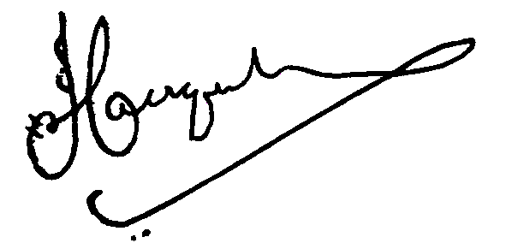

Jamie Farquharson and Falk Amelung.

Thomas Webb: t.l.webb@reading.ac.uk; a tropical meteorologist with a focus on volcanic regions;

Professor Bill McGuire: w.mcguire@ucl.ac.uk; an expert in climate forcing of geological hazards;

Jonathon Fink: jon.fink@pdx.edu; volcanologist with a focus on the impact of climate change on geologic hazards with climate change;

Idowu Ajibade: iajibade@pdx.edu; expert in mitigation and adaptation in response to climate change, with a recent focus on cascading environmental hazards;

Lucia Capra: lcapra@geociencias.unam.mx; volcanologist with previous experience investigating climate change—induced volcanic hazard;

Larry Mastin: lgmastin@usgs.gov; Expert in the dynamics of explosive volcanic eruptions, including the potential for rainfall to act as a trigger;

Graeme Swindles: G.Swindles@qub.ac.uk; Earth System Scientist with experience investigating climate controls on volcanism.