**Entity Relationship Diagram (Ver. 2- 6/24/20)**

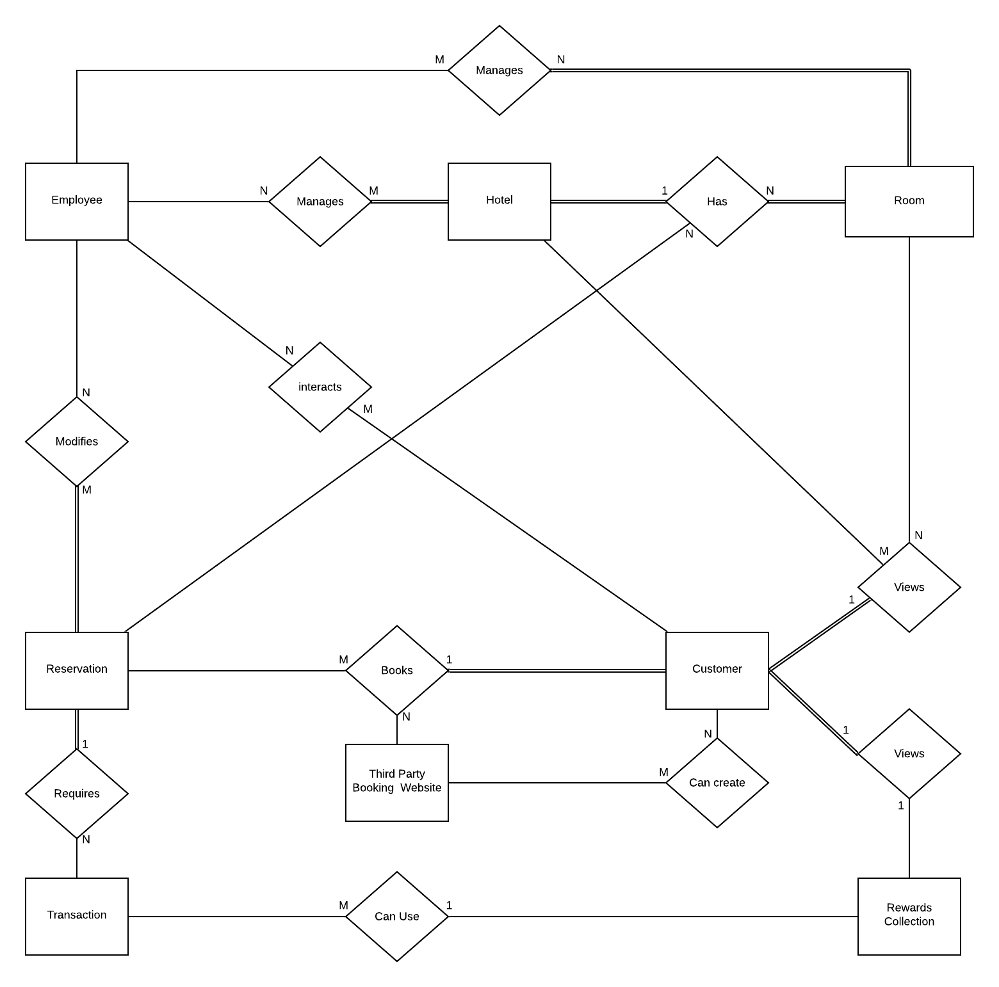

**ERD Attributes**

Room

* Reward Points Cost
* Room#
* Room Type
* Capacity
* # of beds
* Price per room (monetary & points)

Rewards Collection

* CustomerID#
* Amount of points
* History of rewards transactions
* Possible upgrades

Transaction

* transaction#
* Credit Card Information
* Date of transaction

Reservation

* Reservation#
* Start and End date
* Hotel Location
* Room#
* Room Type
* Balance?

Third Party Booking Site (file)

* Name
* Reservation Information
* Customer Information

Customer

* Name
* Location
* ID#
* password

Employee

* Name
* Location
* ID#
* password

Hotel

* Location
* Name
* ID#