

Used Car Listing SQL Project
Business Analysis Documentation

Overview
This project focuses on analysing used car listing data using SQL to understand market trends and overall business performance. The goal is to identify popular brands and models, analyse pricing patterns, and evaluate how fuel type, transmission, ownership, and location influence car prices.
The data is organized using a snowflake schema, with one fact table containing car details and multiple dimension tables for model, fuel, transmission, location, and owner. Additionally, a sub-dimension table for brand is connected to the model table, enabling more detailed brand-level analysis. This structure supports efficient querying and scalable data analysis.
The insights generated from this project help identify top-performing brands, understand customer preferences, and support data-driven decisions for pricing strategies, inventory management, and market analysis.

Problem Statement
The automotive market generates large volumes of car listing market data across different brands, models, fuel types, locations, and ownership categories. However, raw data alone does not provide meaningful insights unless it is properly structured and analysed using an efficient database design.
Key Challenges:
- Car data is distributed across multiple tables, making analysis complex without proper relationships
- Difficult to identify the most popular brands and models
- Hard to analyse pricing trends based on fuel type, transmission, location, and ownership
- No clear visibility into pricing distribution and market trends
- Challenging to compare vehicle performance across different dimensions such as brand, location, and year
Without a well-designed schema and structured SQL analysis, it is difficult to extract valuable insights and support data-driven decisions related to pricing, inventory planning, and market strategy.

What’s Happening?
- Car data is stored across multiple tables such as fact_car, dim_model, dim_brand, dim_fuel, dim_transmission, dim_location, and dim_owner
- Brand information is separated as a sub-dimension connected through the model table
- Important attributes like price, fuel type, transmission, and ownership are distributed across different tables
- Raw data does not directly show brand performance, market distribution, or pricing trends.
- Manual analysis would be time-consuming and inefficient

This makes it difficult to answer key business questions such as:

- Which brands and models have the highest number of listings and average prices?
- Which fuel type and transmission are most preferred?
- How does location influence car pricing and availability?
- Which ownership type is most common in the market?
- What are the overall pricing and vehicle usage trends?

Solution Goal
- Design and implement a snowflake schema to organize used car listing data efficiently
- Structure data into fact and dimension tables with proper relationships
- Use SQL queries to calculate count, average, rankings, and performance metrics
- Identify top-performing brands, models, and market segments
- Analyse pricing trends based on fuel type, location, and ownership
- Enable efficient data analysis to support business and market insights

Data Description
Project Title: Used car listing Data Analysis using SQL
Data Source: kaggle
Data Size: ~3,000+ records
Schema Type: Snowflake Schema
Data Types Used:
- INT (IDs, year, kilometre, seating capacity)
- VARCHAR (brand, model, fuel type, transmission, location, owner, engine)
- NUMERIC (price)

Key Tables and Fields
Fact Table
fact_car
- car_id – Unique identifier for each car
- model_id – References the car model
- fuel_id – References fuel type
- transmission_id – References transmission type
- location_id – References car location
- owner_id – References ownership type
- price – Selling listed price of the car
- year – Manufacturing year
- kilometre – Total kilometres driven
- engine – Engine specification
- seating_capacity – Number of seats
Dimension Tables
dim_model
- model_id – Unique identifier for each model
- model_name – Name of the car model
- brand_id – References the brand
dim_brand (Sub-dimension)
- brand_id – Unique identifier for each brand
- brand_name – Name of the brand
dim_fuel
- fuel_id – Unique identifier for fuel type
- fuel_type – Type of fuel (Petrol, Diesel, etc.)
dim_transmission
- transmission_id – Unique identifier for transmission type
- transmission_type – Manual or Automatic
dim_location
- location_id – Unique identifier for location
- location_name – City or region of listing
dim_owner
- owner_id – Unique identifier for ownership type
- owner_type – First owner, Second owner, etc.

Data Cleaning Steps
To ensure accurate analysis, the following data cleaning steps were performed:
- Removed missing values and duplicate records
- Trimmed spaces and standardized text fields (brand, model, fuel, transmission, location, owner)
- Converted price, year, kilometre, and seating capacity to correct numeric data types
- Assigned primary keys and established foreign key relationships
- Organized data into a snowflake schema to improve consistency and avoid duplication
SQL Approach
- Used JOINs to connect fact and dimension tables
- Applied aggregate functions (COUNT, AVG, MAX) for analysis
- Used GROUP BY and ORDER BY to identify trends and rankings
- Implemented window functions (ROW_NUMBER) for brand-wise price analysis
- Used LIMIT to retrieve Top N records for focused business insights
- Handled data cleaning and ensured proper relationships between tables

Snowflake Schema – Used Car listing Project
Fact table stores car details, and dimension tables store descriptive attributes

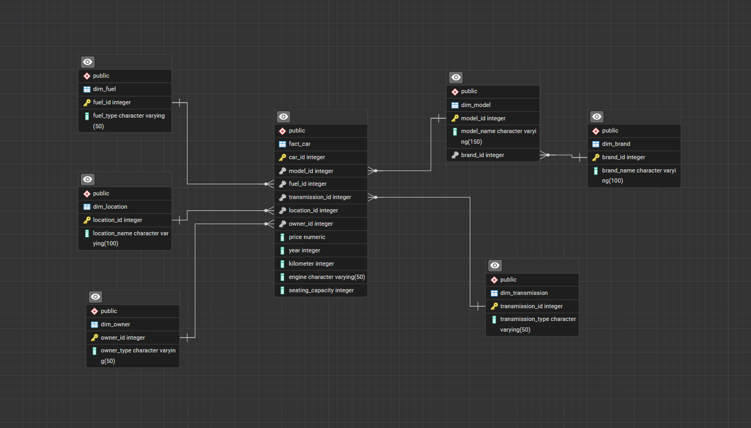

Total Listing value Analysis

1.Total listed price value
Syntax:
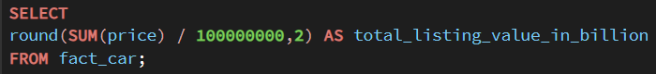

Data output:

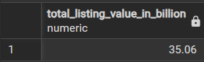

Insight:
Calculates the total aggregated listed price of all cars in the dataset.

What this tells us:
Shows the overall estimated market value based on listed prices in the dataset.

Brand Analysis

1. Top 5 brands with the highest number of cars
Syntax:
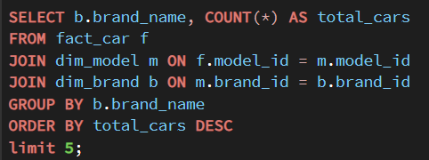

Data output:
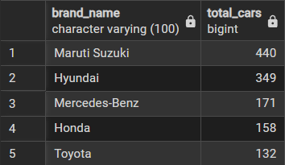

Insight:
Maruti Suzuki, Hyundai, and Mercedes-Benz have the highest number of car listings, followed by Honda and Toyota, indicating strong market presence in the used car segment.
What this tells us:
Shows that these top 5 brands dominate the dataset in terms of listing availability and overall market presence.

2. Top 10 brands by highest average car price
Syntax:
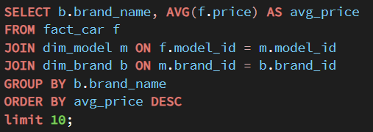
Data output:
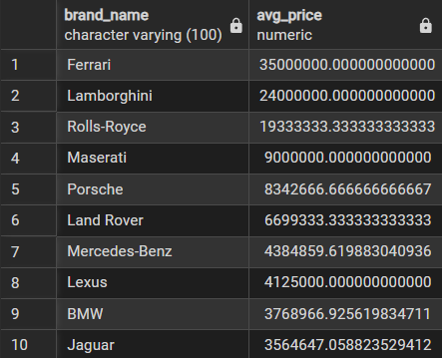

Insight
Ferrari, Lamborghini, and Rolls-Royce have the highest average car prices, followed by other luxury brands like Maserati, Porsche, and Land Rover, showing strong dominance of premium brands in the top 10.
What this tells us
Shows that luxury brands dominate the high-value segment, reflecting strong demand for premium vehicles, higher pricing power, and clear market segmentation between luxury and standard car brands.
Fuel Analysis

1.Which fuel type is most used
Syntax:
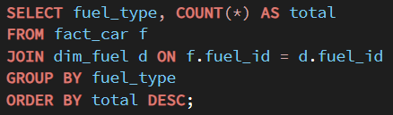

Data output:
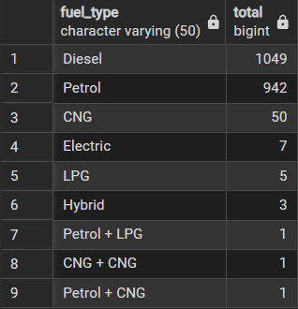

Insight:
Diesel is the most used fuel type with 1,049 cars, followed by Petrol with 942 cars, while alternative fuels like CNG, Electric, Hybrid, and LPG have significantly lower usage.
What this tells us:
Shows that Diesel and Petrol dominate the used car listing market, while alternative fuel types like CNG, Electric, Hybrid, and LPG have significantly lower representation in the dataset.
2. Average price by fuel type
Syntax:
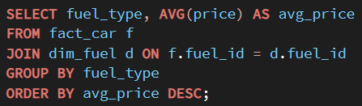
Data output:
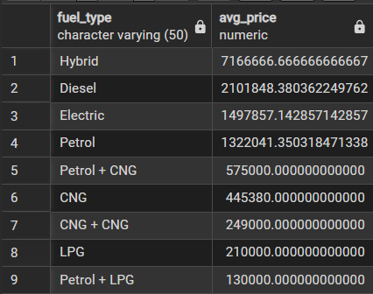

Insight:
Hybrid cars have the highest average price, followed by Diesel and Electric vehicles, while CNG and LPG cars have the lowest average prices.

What this tells us:
Shows that Hybrid, Diesel, and Electric vehicles are positioned as higher-value segments, while CNG and LPG vehicles fall into lower average price categories, indicating clear price segmentation across fuel types.
Transmission Analysis

1. Manual vs Automatic count
Syntax:
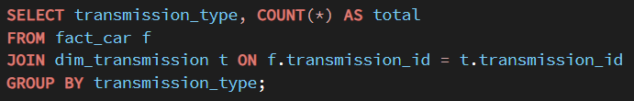

Data output:
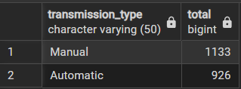

Insight:
Manual transmission cars are more common (1,133) compared to Automatic cars (926), indicating higher availability of manual vehicles in the dataset.

What this tells us:
Manual transmission vehicles have higher listing availability in the dataset, while automatic vehicles have slightly lower representation.

Location Analysis
1. Top 10 locations with most cars
Syntax:
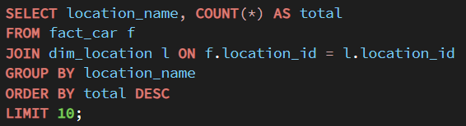
Data output:
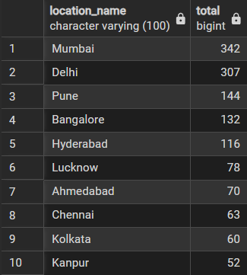

Insight:
Mumbai, Delhi, and Pune are the top three locations with the highest number of car listings, indicating the strongest market presence among all cities.
What this tells us:
Shows that major metropolitan cities have higher listing availability in the dataset, indicating stronger representation of used car listings in these locations.
2. Top 3 locations with the highest average car price
Syntax:
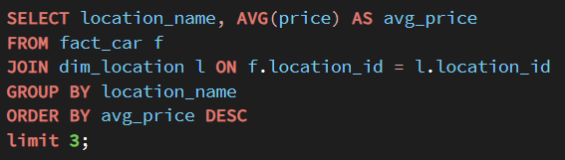

Data output:
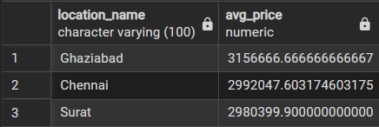

Insight:
Ghaziabad, Chennai, and Surat have the highest average car prices, indicating stronger presence of high-value vehicles in these locations.

What this tells us:
Shows that certain cities have higher average listing prices, indicating stronger presence of higher-value vehicles in those locations.

Owner Analysis

1. Which owner type sells most cars
Syntax:
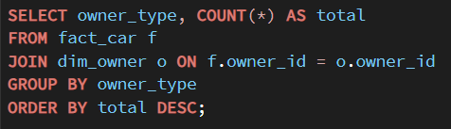

Data output:
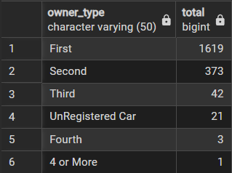

Insight:
First-owner cars have the highest count (1,619), followed by second-owner cars (373), while third-owner and older ownership cars are significantly fewer.

What this tells us:
Shows that first-owner vehicles have the highest listing availability in the dataset, while cars with multiple previous owners have lower representation.
Time Analysis
1. Top 5 years with the highest number of cars
Syntax:
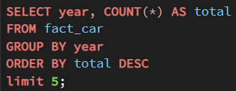
Data output:
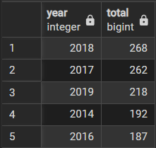

Insight:
The highest number of cars are from 2018, 2017, 2019, 2014, and 2016, showing strong presence of vehicles from these recent years.

What this tells us:
Shows that cars from recent manufacturing years have higher listing representation in the dataset, indicating stronger availability of relatively newer vehicles.

2.Top 10 years by highest average car price
Syntax:
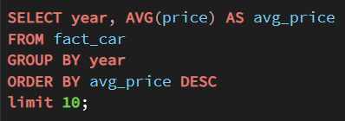
Data output:
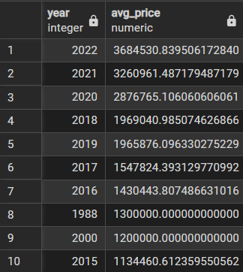

Insight
The highest average car prices are observed in recent years such as 2022, 2021, and 2020, while a few older years like 1988 and 2000 also show high averages due to limited listings of premium vehicles.
What this tells us
Shows that cars from recent manufacturing years generally have higher average listing prices in the dataset, while some older years may show higher averages due to a smaller number of high-priced listings.
Model Analysis

1. Top 10 most popular models
Syntax:
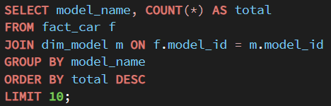
Data output:
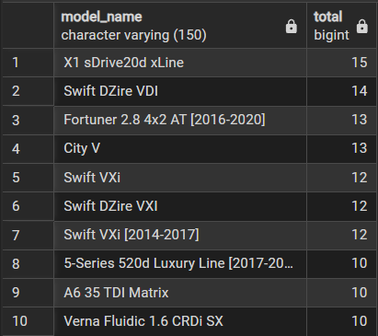

Insight:
BMW X1 sDrive20d xLine is the most popular model with the highest number of listings, followed by Swift DZire VDI and Toyota Fortuner, showing strong listing presence of both luxury and mid-range models in the dataset.

What this tells us:
Shows that both premium and affordable models have high listing representation in the dataset, indicating a diverse mix of vehicle segments available in the used car market.
Mileage / Usage Analysis

1. Average kilometres driven by fuel type
Syntax:
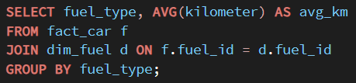
Data output:
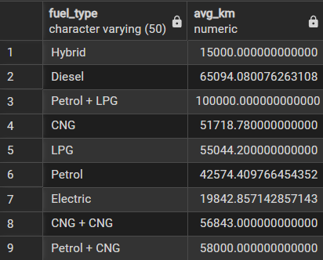

Insight:
Diesel cars show the highest average kilometres driven among major fuel types in the dataset, while Petrol and Electric cars have comparatively lower average kilometres.

What this tells us:
Shows that diesel vehicles in the dataset tend to have higher recorded usage compared to other fuel types, while petrol and electric vehicles show comparatively lower average kilometres.

Advanced Business
1. Top 5 most expensive brands
Syntax:
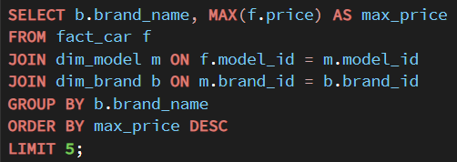

Data output:
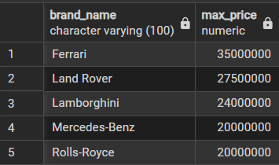

Insight:
Ferrari has the highest maximum listed car price in the dataset, followed by Land Rover, Lamborghini, Mercedes-Benz, and Rolls-Royce.

What this tells us:
Shows that these brands have the highest individual car listings in terms of price within the dataset, indicating strong presence in the high-price segment.

window function problem

1. Find the most expensive car in each brand
Syntax:
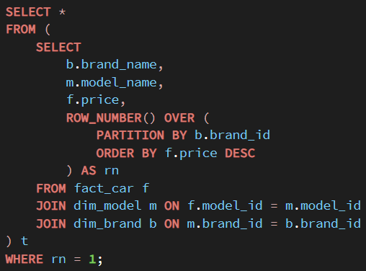

Data output:
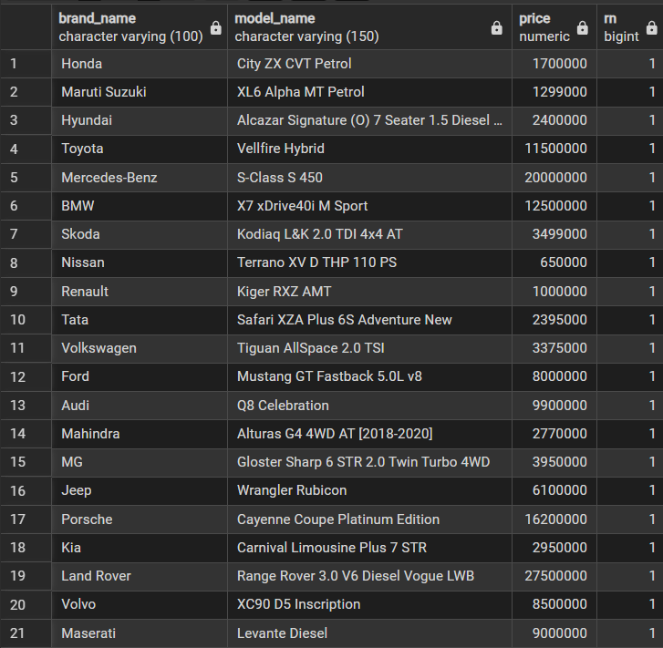

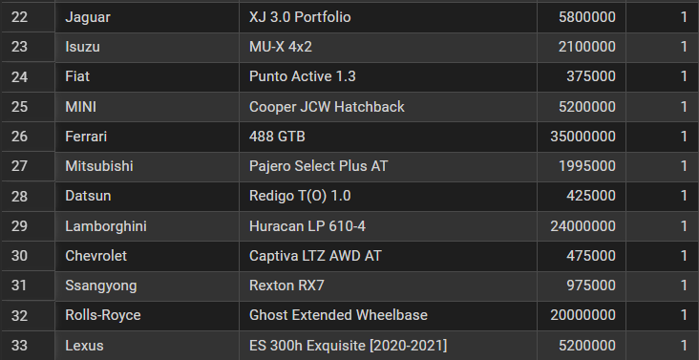

Insight:
Each brand has a highest-priced model in the dataset. Luxury brands such as Ferrari, Lamborghini, and Rolls-Royce show higher maximum listed prices compared to many mainstream brands.

What this tells us:
Shows variation in maximum listed prices across brands, highlighting the difference between premium and standard vehicle pricing within the dataset.

Overall Insights and Recommendations

1. Brand Performance

Insight:
- Brands like Maruti Suzuki and Hyundai have the highest number of listings in the dataset.
- Luxury brands such as Ferrari, Lamborghini, and Rolls-Royce show higher average or maximum listed prices.
- This highlights the difference between high-volume and high-value brands within the dataset.
Recommendations:
- Focus inventory on popular brands to maximize sales volume.
- Promote premium brands to increase overall revenue and profit margins.

2. Fuel and Transmission Trends

Insight:

- Diesel and Petrol cars have the highest number of listings in the dataset.

- Manual transmission cars are more common, while automatic cars also show significant representation.
Recommendations:

- Maintain strong availability of Diesel and Petrol vehicles.
- Increase focus on automatic vehicles as demand continues to grow.

3. Location-Based Market Trends

Insight:

- Major cities like Mumbai, Delhi, and Pune have the highest number of car listings.
- Some locations show higher average listed prices compared to others.
Recommendations:

- Focus marketing and inventory in high-demand cities.
- Target premium vehicle promotions in high-value locations.

4. Vehicle Age and Usage Patterns

Insight:

- Most listed cars are from recent years, indicating higher availability of newer vehicles in the dataset.
- Diesel cars have higher average kilometres driven, indicating heavy usage.

Recommendations:

- Prioritize newer vehicles to meet customer demand.
- Highlight low-usage cars to attract buyers seeking better condition vehicles.

Overall Business Performance

Insight:
- The analysis shows strong overall listing activity with a wide range of vehicle prices across brands and locations
- Higher listing volumes are observed for popular brands and major metropolitan locations.
- Premium brands contribute higher value per vehicle, while economy brands drive volume.
Recommendations:
- Focus on balancing high-volume and high-value vehicle inventory.
- Use brand, fuel, and location insights to optimize pricing and sales strategies.
- Leverage data-driven analysis to support informed business decisions.

