Software Define Network

Lab 3

Programming Data Plane Using P4

Name: Jigar Makwana

Email: [jigar_makwana@student.uml.edu](mailto:jigar_makwana@student.uml.edu)

ID: 01711370

Behavioral model version 1

Installing P4 repositories & dependencies for p4factory

* Make directory name “**p4lang**”
* Get file’s from GitHub repository in that directory.
  + - git clone [https://github.com/p4lang/behavioral-model.git bmv2](https://github.com/p4lang/behavioral-model.git%20bmv2)
    - git clone [https://github.com/p4lang/p4c-bm.git p4c-bmv2](https://github.com/p4lang/p4c-bm.git%20p4c-bmv2)
    - git clone <https://github.com/p4lang/p4factory.git>
* Go to “**p4factory**” directory in “**p4lang**” and
  + - git submodule update --init –recursive
    - sudo bash
    - ./install_deps.sh
    - /tools/veth_setup.sh
    - ./autogen.sh
    - ./configure
    - cd targets/simple_router
    - make bm

Now since the behavior model of the simple_router.p4 is build now run mininet

In a same directory targets/simple_router run “**./run_demo.bash**”. This will start the mininet environment with two hosts connected a switch (the one built from the simple_router.p4). When you do “h1 ping h2”, you will not see the ping going through.

Now in terminal 2 in the same directory run “**./run_add_demo_entries.bash**”

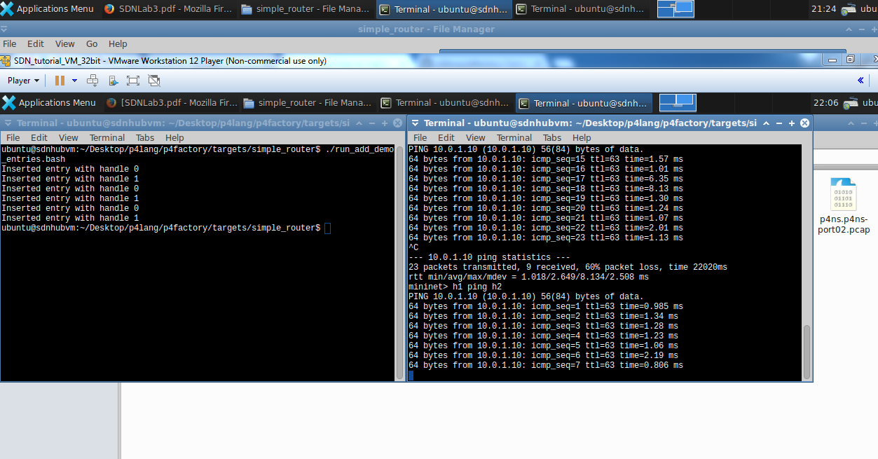

That will start ping going.

Because

Behavioral model version 2

* Go to the “/p4lang/p4c-bmv2” directory and

Sudo bash

pip install -r requirements.txtpip install scapy thrift networkx

* Now go to the “/p4lang/bmv2” directory and

./autogen.sh

./configure

Make

Now you will have the behavioral model version 2 and the compiler for it. To execute the simple_router P4 example under bmv2, you can do the following

* Cd p4lang/bmv2/mininet
* sudo python 1sw_demo.py --behavioral-exe ../targets/simple_router/simple_router -- json ../targets/simple_router/simple_router.json

Type "h1 ping h2" #you will see that the ping fails. Now open another terminal.

* cd p4lang/bmv2/targets/simple_router
* ./runtime_CLI < commands.txt

