**Program 1**

**Write a python program to import and export data using pandas library functions?**

**Code:**

**Import**

import pandas as pd

airbnb_data = pd.read_csv("listings (1).csv")

airbnb_data.head()

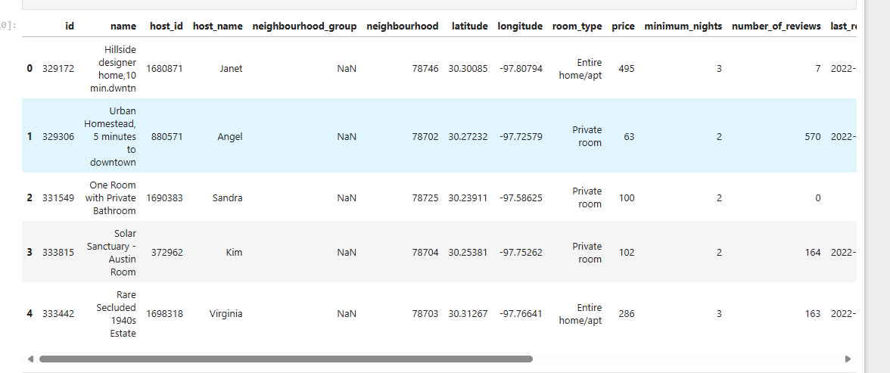

**Export**

airbnb_data.to_csv("list2.csv")

**Reading the file from the URL:**

url = "https://archive.ics.uci.edu/ml/machine-learning-databases/iris/iris.data"

col_names = ["sepal_length_in_cm",

"sepal_width_in_cm",

"petal_length_in_cm",

"petal_width_in_cm",

"class"]

iris_data = pd.read_csv(url, names=col_names)

iris_data.head()

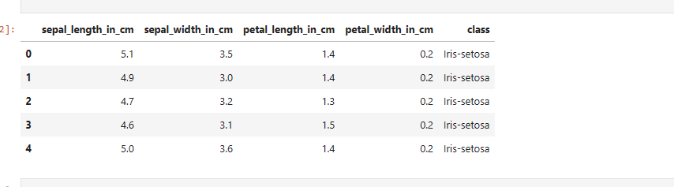

**Screenshot from the lab record:**

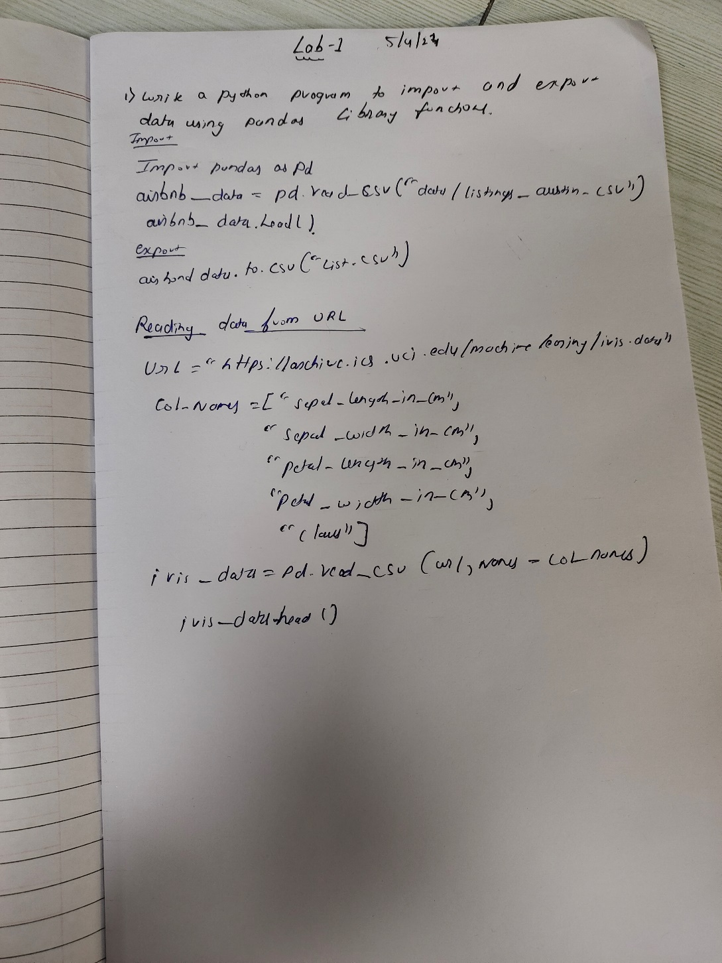

**Program 2**

Use an appropriate data set for building the decision tree (ID3) and apply this knowledge to classify a new sample.

1.importing database

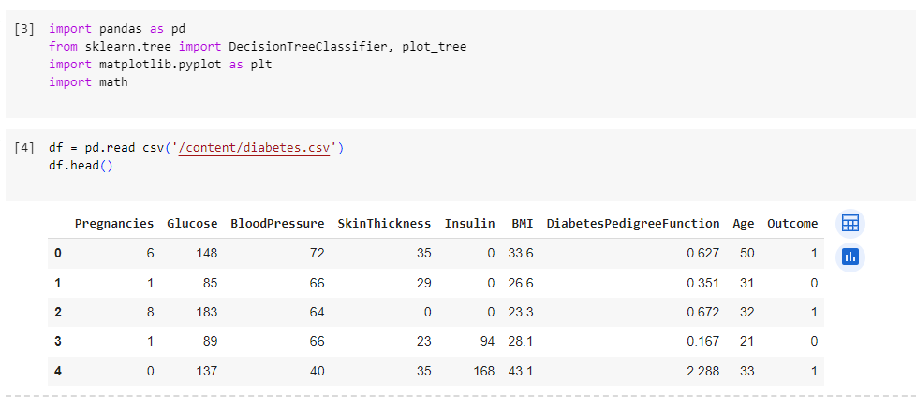

2.Calculating entropy and information gain.

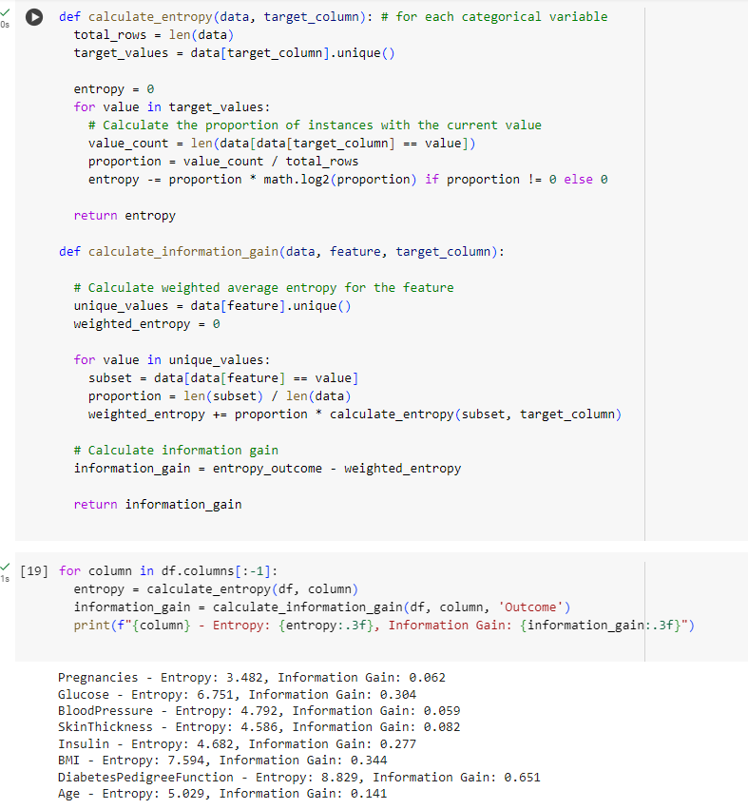

3.Making Decision tree.

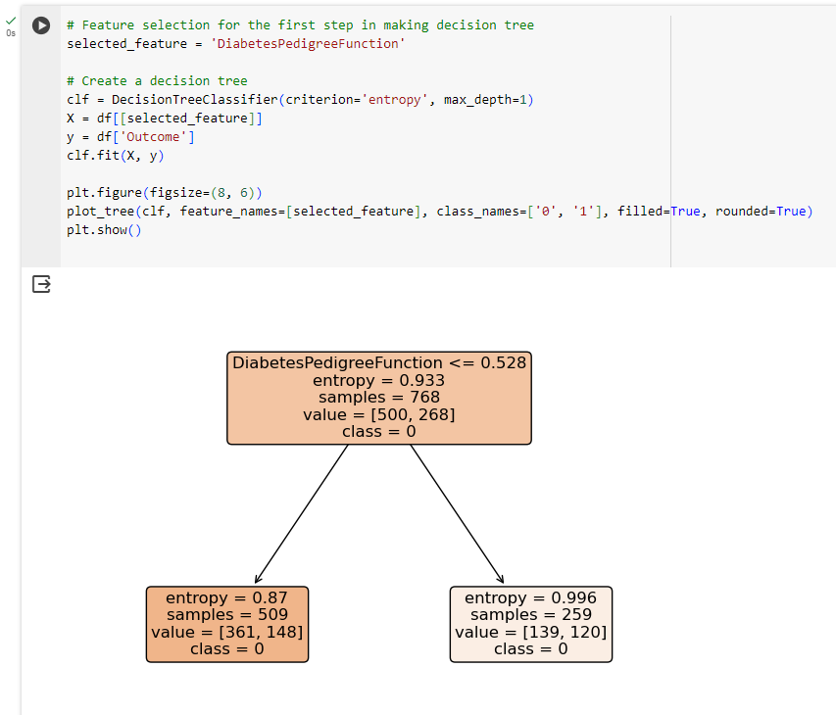

4.snapshot.