SmartKids

SmartKids is an application that is made with the children between the age of 4-5 years as the targeted audience.SmartKids aims at teaching the kids to write alphabets and to associate words with each alphabet. The sound that is played in the background helps the kids to better remember the pronunciation. The kids can also listen to poems and read them using this app.Thus, the kids will find the learning process interactive and interesting and will not feel as though they are being forced to do something but will learn taking keen interest in the whole process.

Features

1.Main Menu

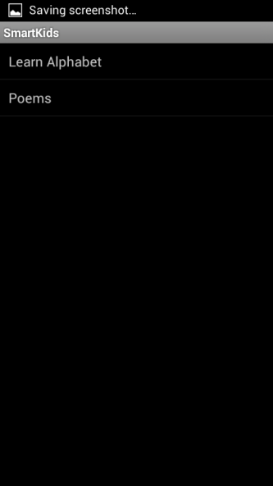

2. On Selecting Learn Alphabet option , you will get a Screen which shows Draw Alphabet , where you have draw any Alphabet from A to Z (Capital or cursive alphabets).

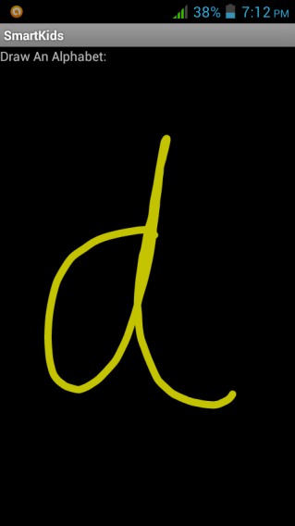 ==========🡺 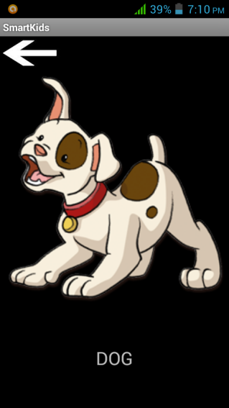

3. When you select the poem option , you will see a list of poems from which you can select any one. Selecting a poem, will take you to the corresponding poem and the poem will be played back in audio format in the background.

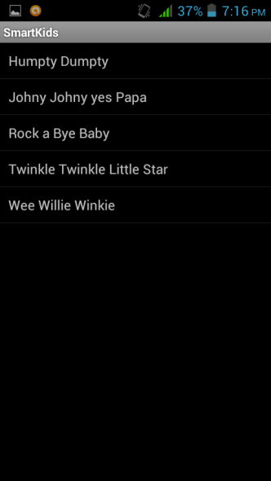 ==========🡺 

How to Install

1. Download the SMARTKIDS application from the website onto your Computer.

2. Connect the phone using USB Cable to your computer.

3. Turn on your USB storage / Mass Storage.

4. Now, copy the SmartKids.apk on to your memory card.

5. Disconnect the phone form the Computer.

6. Now, in your phone , go to settings -> security -> check the unknown sources checkbox.

7. Now,go to your phone explorer and click on the apk file and Install.

8.Follow the instructions on the phone.

9.After completion of the installation,you can run the application from the Menu.

Usage

Importing SmartKids as an [eclipse](http://www.eclipse.org/) project

* For setting up Android SDK and AVD in eclipse, please visit this [link](http://developer.android.com/sdk/index.html)
* With a single download, the ADT Bundle includes everything you need to begin developing apps:
  1. Eclipse + ADT plugin
  2. Android SDK Tools
  3. Android Platform-tools
  4. The latest Android platform
  5. The latest Android system image for the emulator

Start eclipse

* go-to File menu -> Import.
* from the Import dialog box, select Android.
* from Android section, select Existing Android Code Into Workspace and click Next button.
* you will be taken to Import Projects dialog box, click Browse button and select the repository where the source code is located.

Help, bugs and feedback

1. Users can mail their queries, feedback and suggestions at [jigar.1101@gmail.com](mailto:jigar.1101@gmail.com) , [patankarpranav@yahoo.co.in](mailto:patankarpranav@yahoo.co.in) or [oswaljignesh4@gmail.com](mailto:oswaljignesh4@gmail.com)
2. Developers/Contributor can raise issues at [issues](https://github.com/jigar1101/SmartKids/issues)
3. Pull requests are most welcome

License

GNU GPL Version 3, 29 June 2007.

Please refer this [link1](http://www.gnu.org/licenses/gpl-3.0.txt) or [link2](https://github.com/jigar1101/SmartKids/blob/master/LICENSE) for detailed description.