**Name: Jigar Siddhpura SAPID:** 60004200155

**DIV: C/C2** **Branch:** Computer Engineering

AI EXPERIMENT 5 - Genetic Algorithm

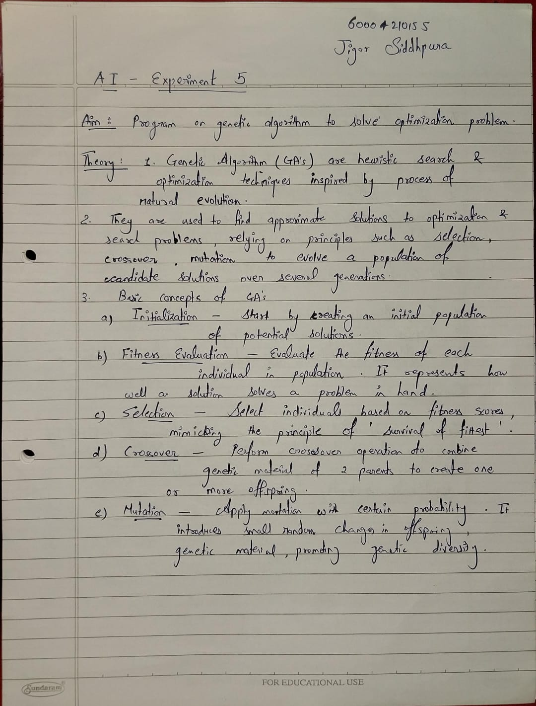

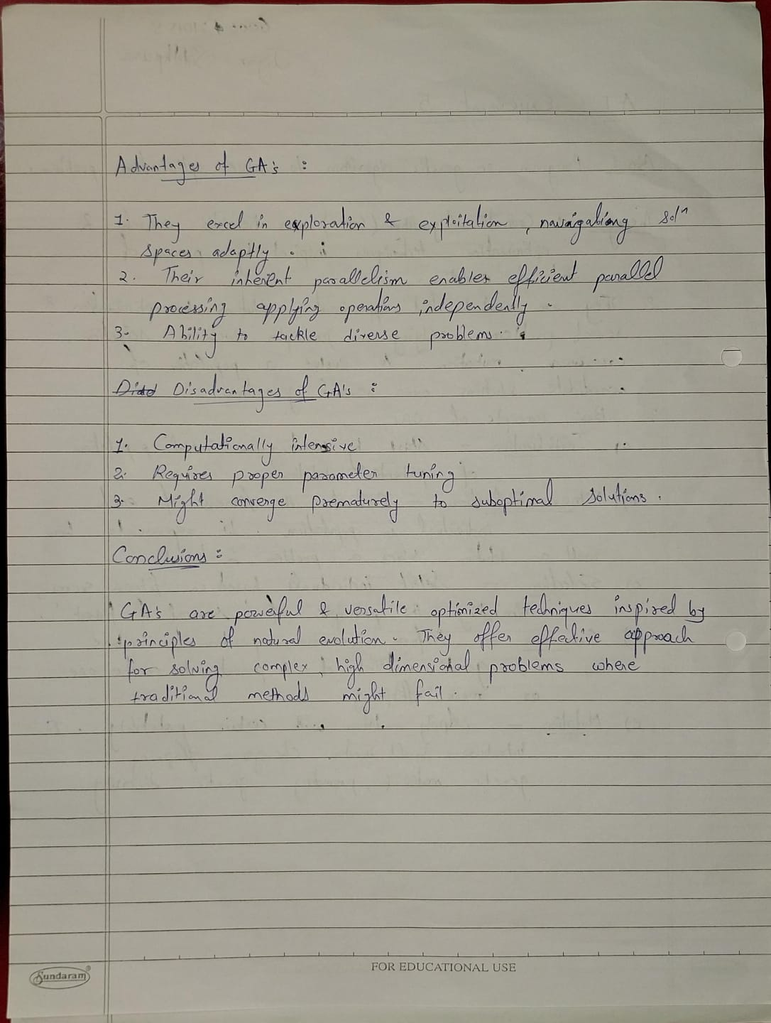

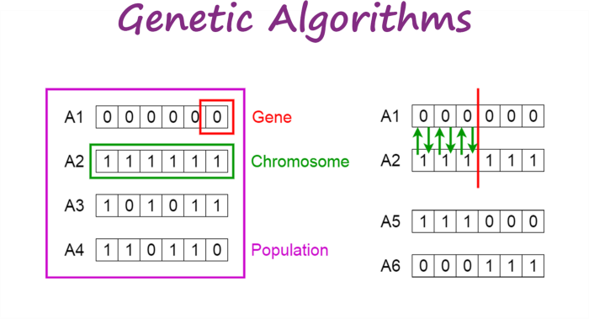

**Code :**

import random

gene = ['000000','111111','101011','110110']

def selection(gene):

    x = [int(x,2) for x in gene]

    fx = [int(x)*int(x) for x in x]

    fx_sum = sum(fx)

    fx_avg = fx_sum//len(fx)

    excepted_count = [round((i/fx_avg),4) for i in fx]

    actual_count = [round(i) for i in excepted_count]

    mate_pool = []

    for i,j in zip(actual_count,gene):

        if i:

            for c in range(i):

                mate_pool.append(j)

return x,fx, fx_sum,fx_avg,excepted_count,actual_count,mate_pool

def generate_mate(size,mate_element_size):

    if size % 2 != 0:

        return -1

    available_positions = list(range(size))

    random.shuffle(available_positions)

    mate = [-1] * size

    crossover =[-1] * size

    for i in range(size):

        if mate[i] == -1:

            j = random.choice(available_positions)

            while mate[j] != -1 or j == i:

                j = random.choice(available_positions)

            mate[i] = j

            mate[j] = i

            available_positions.remove(i)

            available_positions.remove(j)

    for i in mate:

        if crossover.count(-1) != 0:

            crossover[i] = crossover[mate[i]] = random.randint(1,mate_element_size-1)

    return mate,crossover

def crossover(mate_pool):

    mate, crossover_points = generate_mate(len(mate_pool),len(mate_pool[0]))

    new_poplu = [-1]*len(mate_pool)

    for i in mate:

        new_poplu[i] = mate_pool[i][:crossover_points[i]] + mate_pool[mate[i]][crossover_points[i]:]

    x = [int(x,2) for x in new_poplu]

    fx = [int(x)*int(x) for x in x]

    return mate_pool,new_poplu,mate,crossover_points,x, fx

def GA(gene,iter,n):

    if iter == 0:

        return

    x,fx, fx_sum,fx_avg,excepted_count,actual_count,mate_pool = selection(gene)

    if sum(actual_count)!=len(gene):

        print("Error dont know what to do at this situation ")

        return

    print(f"\n------------------------------------------------- GENERATION {n} --------------------------------------------------")

    print("Initial Population\tX Value\t\tFitness Value( f(x) )\tProbability(Expected Count)\tActual Count")

    print(f"-----------------------------------------------------------------------------------------------------------------")

    for i in range(len(gene)):

        print(f"{gene[i]}\t\t\t{x[i]}\t\t{fx[i]}\t\t\t{excepted_count[i]}\t\t\t\t{actual_count[i]}")

    mate_pool,new_poplu,mate,crossover_points,x, fx = crossover(mate_pool)

    print(f"\n----------------------------------------------- New Population {n} ------------------------------------------------")

    print("Mate Pool\tMate\t\tCrossover Points\tNew Population\t\tx value\t\tf(x)")

    print(f"-----------------------------------------------------------------------------------------------------------------")

    for i in range(len(gene)):

        print(f"{mate_pool[i]}\t\t{mate[i]}\t\t{crossover_points[i]}\t\t\t{new_poplu[i]}\t\t\t{x[i]}\t\t{fx[i]}")

    GA(new_poplu,iter-1,n+1)

GA(gene,4,0)

**Output :**

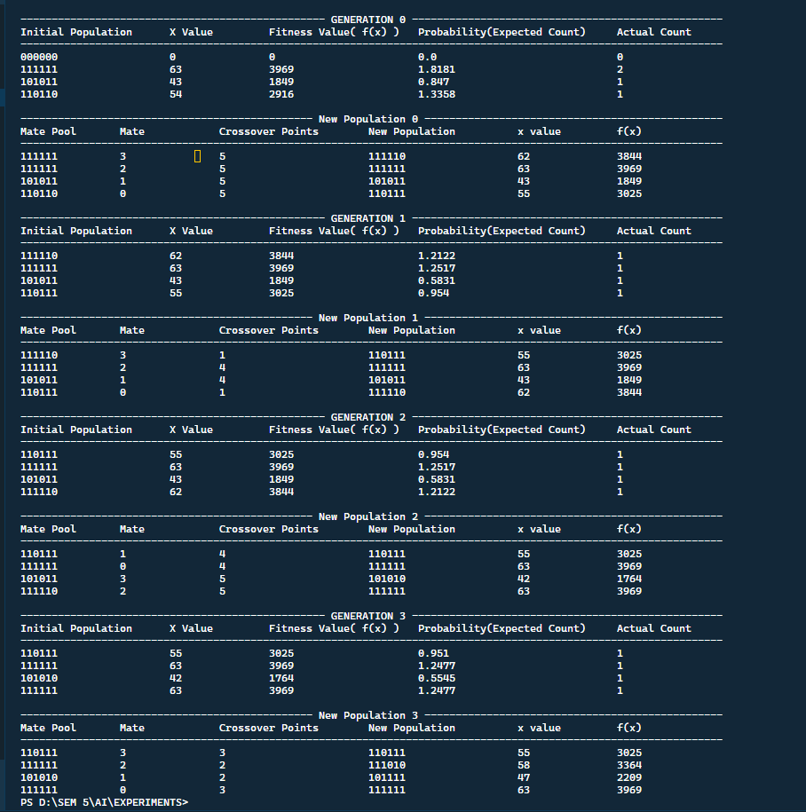

**Conclusion :**

Thus we successfully studied and applied Genetic Algorithm