**Name: Jigar Siddhpura SAPID:** 60004200155

**DIV: C/C2** **Branch:** Computer Engineering

AI EXPERIMENT 6 - Perceptron Learning

**Theory:**

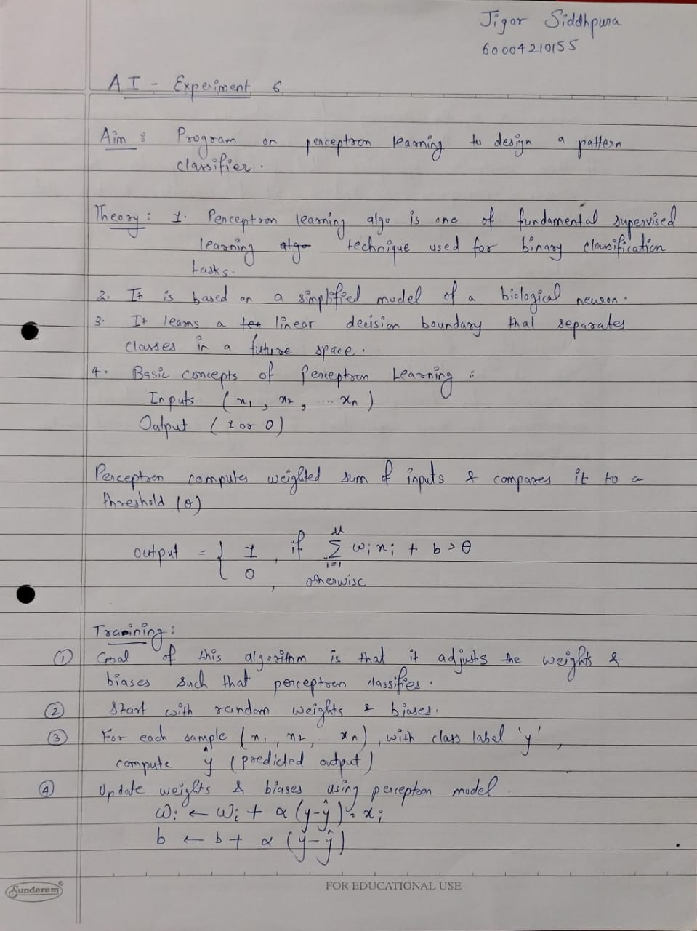

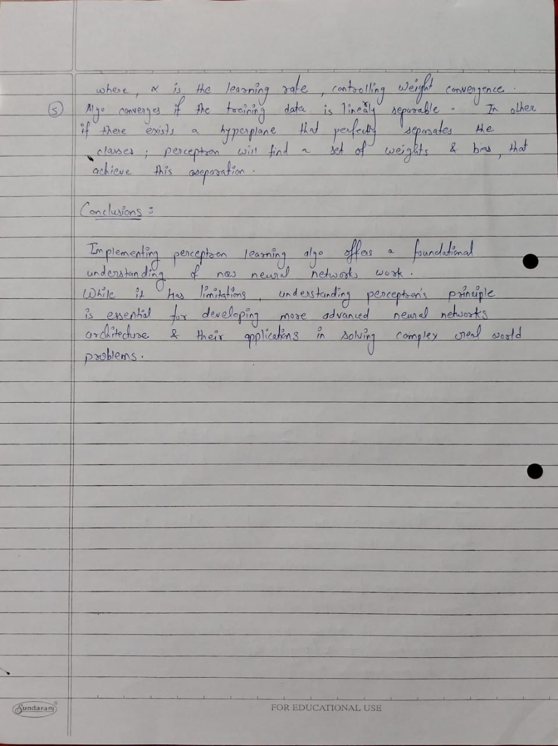

**Code :**

import numpy as np

*# Input features*

X = np.array([

    [1, 0, 1, 0, 0, 0, 1, 1, 1],

    [1, 0, 0, 1, 0, 0, 1, 1, 1],

    [1, 1, 0, 1, 0, 0, 1, 1, 1],

    [1, 0, 0, 1, 0, 0, 1, 1, 1],

    [1, 0, 0, 1, 0, 1, 1, 1, 1],

    [1, 0, 1, 0, 1, 1, 1, 0, 1],

    [1, 0, 1, 1, 1, 0, 1, 0, 1],

    [1, 0, 1, 1, 0, 1, 1, 0, 1],

    [1, 0, 0, 1, 1, 1, 1, 1, 1],

    [1, 1, 1, 1, 1, 1, 1, 0, 1]

])

*# Initial weights*

W = np.array([1, -1, 0, 0.5, 1, 1, 1, 0.5, 1])

*# Desired outputs*

d = np.array([0, 0, 0, 1, 0, 1, 1, 1, 1, 1])

*# Learning rate*

c = 1

*# Number of epochs*

epochs = 6

*# Training the perceptron*

for epoch in range(epochs):

    print("Iteration ", epoch + 1)

    for i in range(len(X)):

*# Compute the net input*

        net = np.dot(X[i], W)

*# Apply the step function*

        op = 1 if net > 0 else 0

*# Compute the error*

        error = d[i] - op

*# Update weights*

        dW = c * error * X[i]

        W += dW

        print("W", i, W)

print("\nW after ", epoch + 1, " epochs ", W)

print("Final W after ", epochs, "epochs:")

print(W)

*# Testing the perceptron with a new input*

test_input = [1, 0, 0, 1, 0, 0, 1, 1, 0]

net = np.dot(test_input, W)

*# Apply the step function to get the output*

output = 1 if net > 0 else 0

print("Output for test input:", output)

**Output :**

