**Name: Jigar Siddhpura SAPID:** 60004200155

**DIV: C/C2** **Branch:** Computer Engineering

AI - EXPERIMENT 7

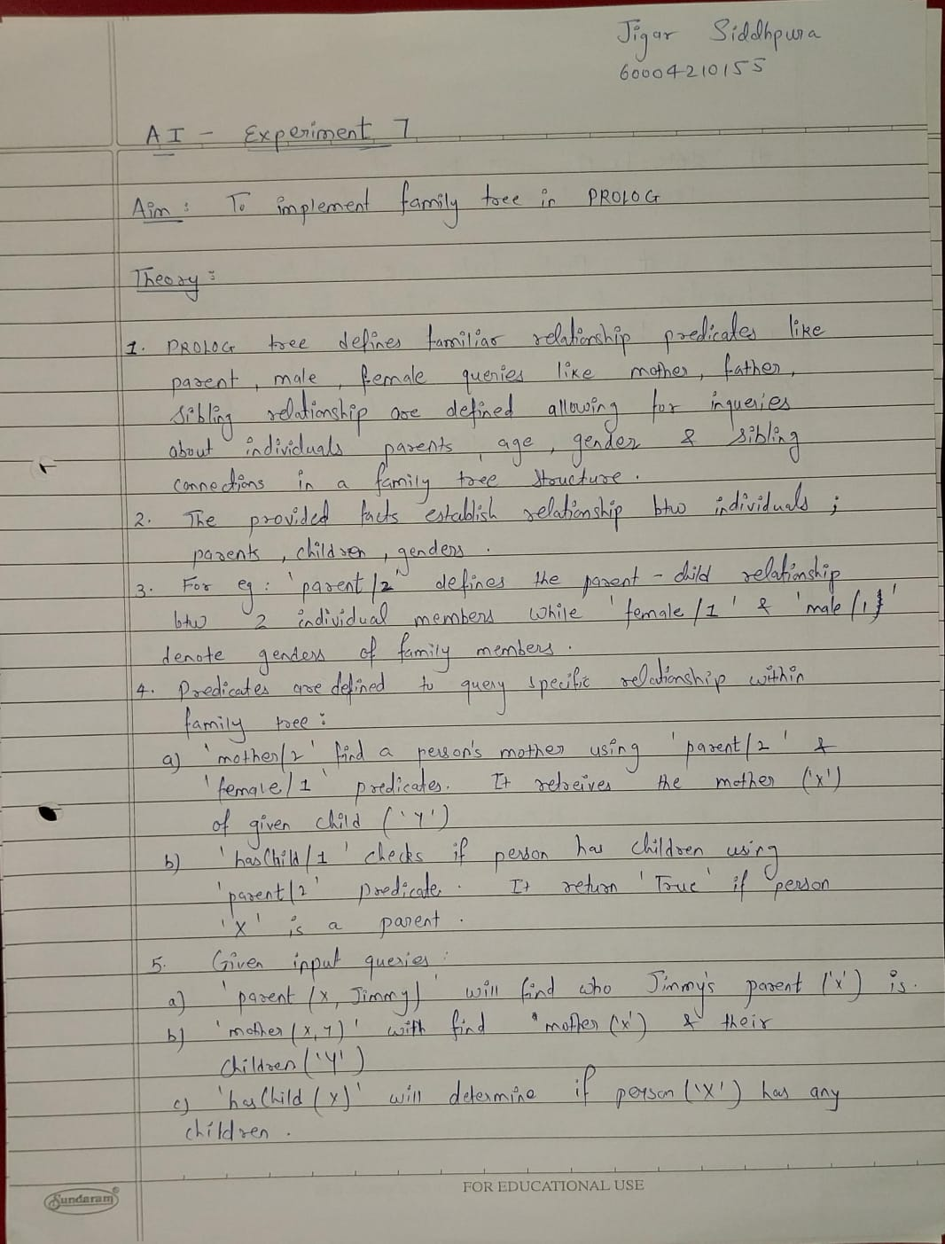

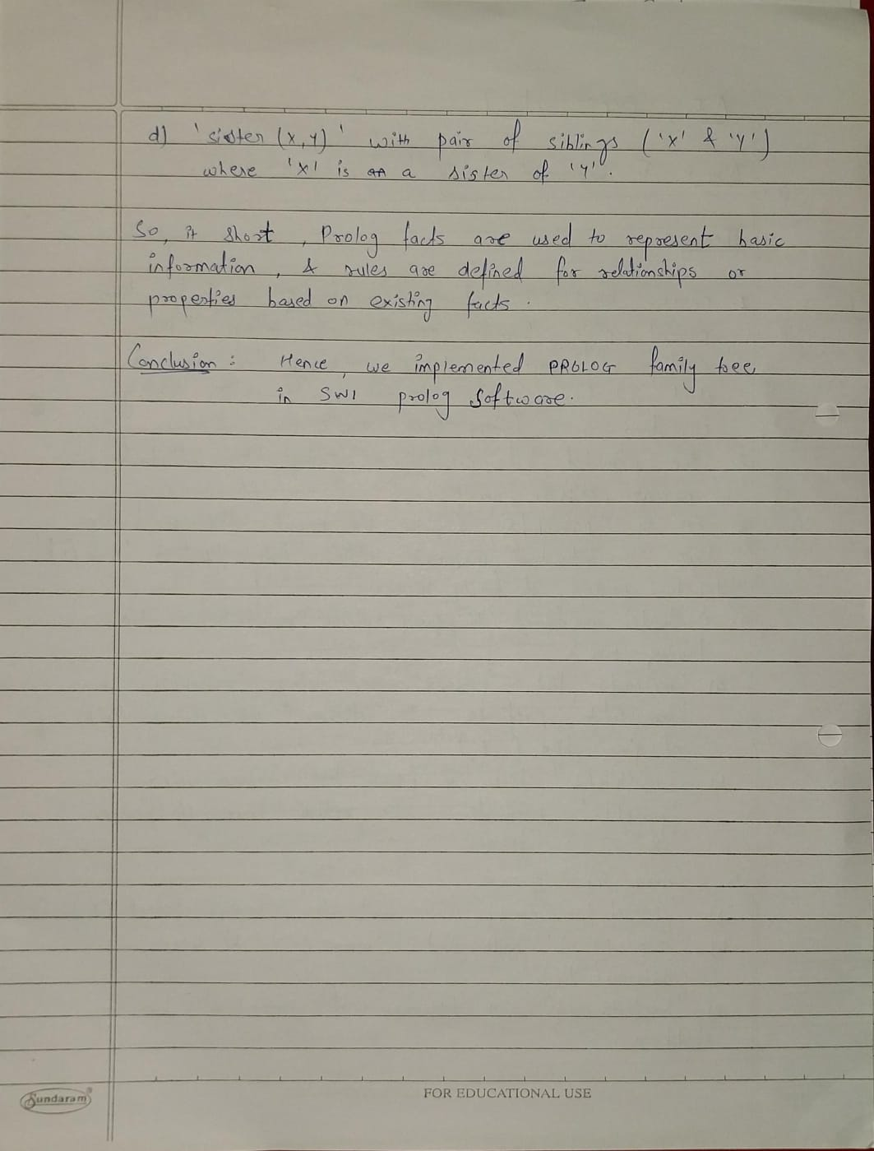

**Code :**

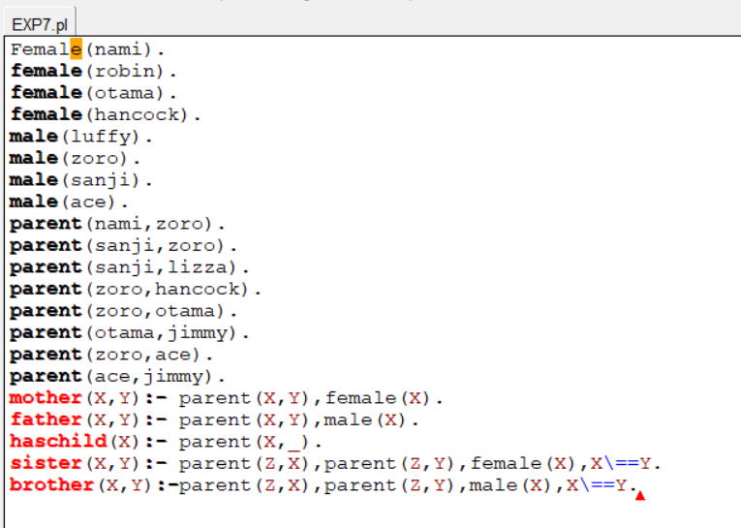

**Output :**

