**Name: Jigar Siddhpura SAPID:** 60004200155

**DIV: C/C2** **Branch:** Computer Engineering

AI EXPERIMENT 9

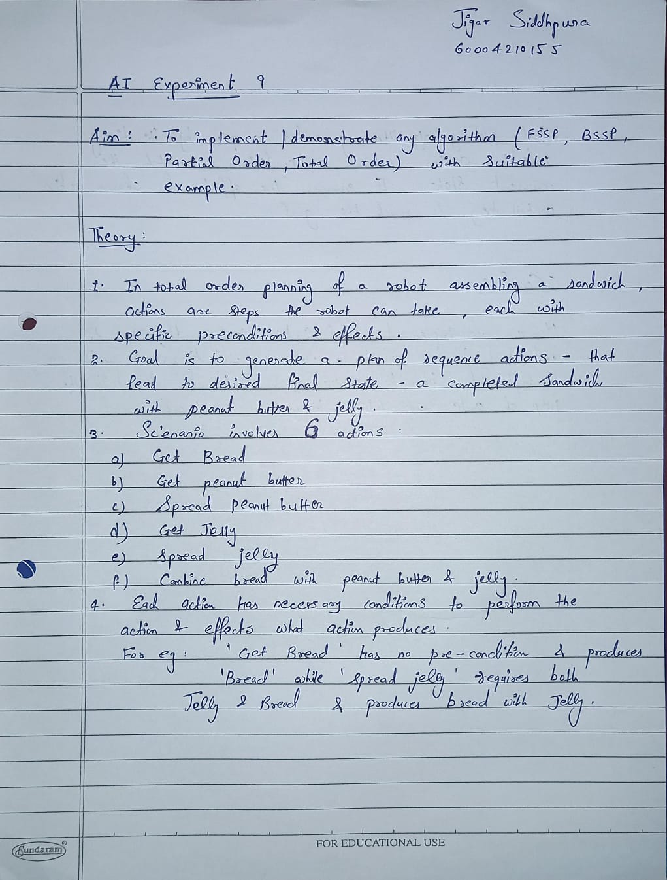

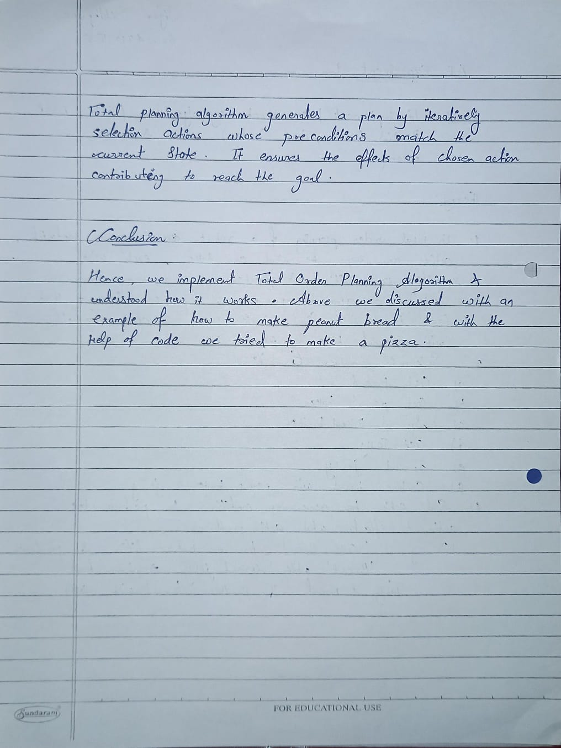

**Code :**

class Action:

    def __init__(self, name, preconditions, effects):

        self.name = name

        self.preconditions = preconditions

        self.effects = effects

def total_order_planning(actions, goal):

    plan = []

current_state = set()

    while not goal <= current_state:

        added = False

        for action in actions:

            if action not in plan and action.preconditions <= current_state:

                plan.append(action)

                current_state |= action.effects

                added = True

                Break

        if not added:

            print("Goal cannot be achieved.")

            return None

return plan

*# Define actions with their preconditions and effects for making pizza*

actions = [

    Action("Buy Pizza Dough", set(), {"Pizza Dough"}),

    Action("Preheat Oven", set(), {"Oven Preheated"}),

    Action("Roll Out Dough", {"Pizza Dough"}, {"Rolled Out Dough"}),

    Action("Spread Pizza Sauce", {"Rolled Out Dough"}, {"Dough with Sauce"}),

    Action("Grate Cheese", set(), {"Grated Cheese"}),

    Action("Add Cheese to Dough", {"Dough with Sauce", "Grated Cheese"}, {"Pizza with Cheese"}),

    Action("Chop Vegetables", set(), {"Chopped Vegetables"}),

    Action("Add Vegetables to Pizza", {"Pizza with Cheese", "Chopped Vegetables"}, {"Homemade Pizza"}),

    Action("Bake Pizza", {"Homemade Pizza", "Oven Preheated"}, {"Baked Pizza"})

]

pizza_goal = {"Baked Pizza"}

pizza_plan = total_order_planning(actions, pizza_goal)

if pizza_plan:

    print("\nTotal Order Plan for Homemade Pizza:")

    for action in pizza_plan:

        print(action.name)

print('\n')

**Output :**

