1. **Trends and Statistics**

**1.1 Introduction**

Vehicle theft is a serious problem in India, with over **4 lakh** vehicles stolen every year. The problem has been exacerbated in recent years by the increasing popularity of high-end vehicles and the growth of organized crime.

In 2022, there was a significant increase in vehicle theft in India. According to the National Crime Records Bureau (NCRB), over **4.2 lakh** vehicles were stolen in the country in 2022, up from **3.8 lakh** in 2021. This represents a year-on-year increase of over **10%.**

The NCRB report also revealed that two-wheelers are the most stolen vehicles in India, accounting for over **70%** of all vehicle thefts. Cars and SUVs account for the remaining **30%** of thefts.

**1.2 The most common vehicle theft methods in India**

**1.2.1 Towing:** Thieves tow away vehicles parked in isolated areas.

**1.2.2. Breaking and entering:** Thieves break into vehicles parked in public places and steal valuables, including the vehicle itself.

**1.2.3. Key duplication:** Thieves steal or duplicate vehicle keys and use them to steal vehicles.

Vehicle thefts are most common in major cities, such as Delhi, Mumbai, Bengaluru, and Chennai. However, they are also a problem in smaller cities and towns.

**1.3 Factors contributing to vehicle theft in India**

**1.3.1. Rapid urbanization:** The rapid urbanization of India has led to a significant increase in the number of vehicles on the road. This has made it easier for thieves to find and steal vehicles.

**1.3.2. Organized crime:** Organized crime groups are increasingly involved in vehicle theft in India. These groups have access to sophisticated tools and technology, and they are able to steal vehicles quickly and efficiently.

**1.3.3. Lack of security:** Many vehicles in India are parked in unsecured areas, such as roadside parking lots and apartment complexes. This makes it easier for thieves to steal vehicles.

**1.4 Preventive measures**

There are a number of things that vehicle owners can do to protect their vehicles from theft:

**1.4.1. Park in well-lit and secure areas:** Whenever possible, park your vehicle in a well-lit and secure area, such as a garage or a paid parking lot.

**1.4.2. Use a steering wheel lock:** A steering wheel lock is a visible deterrent to thieves.

**1.4.3. Install a security system:** A security system can alert you if someone is trying to break into or steal your vehicle.

**1.4.4. Keep your vehicle keys safe:** Do not leave your vehicle keys unattended. When you are not using your vehicle, keep the keys in a safe place, such as your purse or wallet.

If your vehicle is stolen, report it to the police immediately. You should also contact your insurance company to file a claim.

The Indian government is taking a number of steps to reduce vehicle theft. These steps include:

**1.4.5. Increasing police presence:** The government is increasing police presence in areas where vehicle theft is common.

**1.4.6. Installing CCTV cameras:** The government is installing CCTV cameras in public places to deter vehicle theft.

**1.4.7. Launching awareness campaigns:** The government is launching awareness campaigns to educate the public about vehicle theft prevention measures

**1.5 Use of GPS Tracker for vehicles**

**1.5.1. Real-time Tracking:**

Firstly, this feature enables the user to keep a watchful eye on the whereabouts of their vehicle. You get access to the exact location coordinates of your vehicle to your mobile application.

You also get a playback history of all the locations that have been visited by the vehicle so that any unauthorized activity is monitored and avoided. This also helps to give an estimate of the total distance covered by the vehicle.

**1.5.2. Instant Alerts:**

The main motive behind buying a GPS tracking device is to ensure the safety and security of your vehicle. One important function of any GPS system is to send instant alerts if it detects any unwanted activity.

The GPS devices give you the possibility of defining safe-zones or geofences and you get instant alerts on each and every entry or exit. Enhancing the safety factor around your vehicle, alerts will also be sent if your vehicle is forcibly entered or started and you can also remotely cut off the engine’s power via the phone application.

**1.5.3. Remote Engine Immobilization:**

This feature allows the user to cut off the fuel supply to the engine in case the user detects unauthorized access to their vehicle.As a result, the user can remotely access the fuel supply to the engine via the connected mobile application so that he can remotely control the vehicle’s ability to move.

**1.5.4. Geo-Fencing:**

It is a technology that permits the user to set up virtual perimeters in a real-world scenario. The user can define a particular radius area on the map. They will receive real-time updates on any entry or exit from that region.

As a result, Geo-fencing alerts the user with a pre-programmed prompt which can be in the form of text messages, push notifications or pop-up messages depending on the medium of use (browser or mobile application).

**1.6 Statistics**

**1.6.1. The following table shows the state-wise vehicle theft data for India in 2022:**

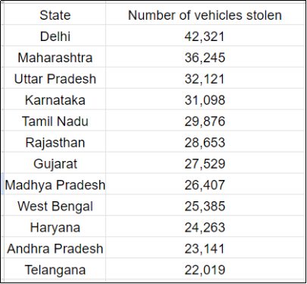

**1.6.2. The line graph shows thefts per thousand vehicles in four countries between 1990 and 1999.**

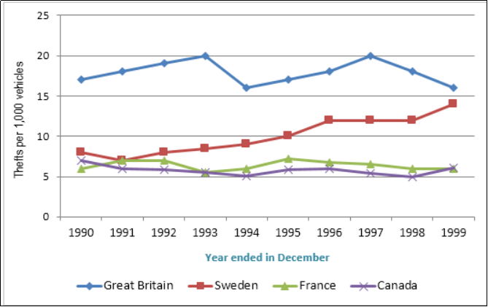

**1.7 Conclusion:**

Here we investigate the escalating issue of vehicle theft in India, revealing alarming statistics of over 4.2 lakh vehicles stolen in 2022. Two-wheelers constitute 70% of thefts, and major cities like Delhi and Mumbai are hotspots. Organized crime, urbanization, and lack of security contribute to the surge. The government's preventive measures include increased police presence, CCTV installations, and awareness campaigns. Additionally, the report discusses preventive measures for vehicle owners and introduces the convenience of GPS trackers for real-time tracking, instant alerts, remote engine immobilization, and geo-fencing. A state-wise theft data table and a line graph illustrating thefts per thousand vehicles are provided for comprehensive insights