**Name: Jigar Siddhpura SAPID:** 60004200155

**DIV: C/C2** **Branch:** Computer Engineering

POA EXPERIMENT 10

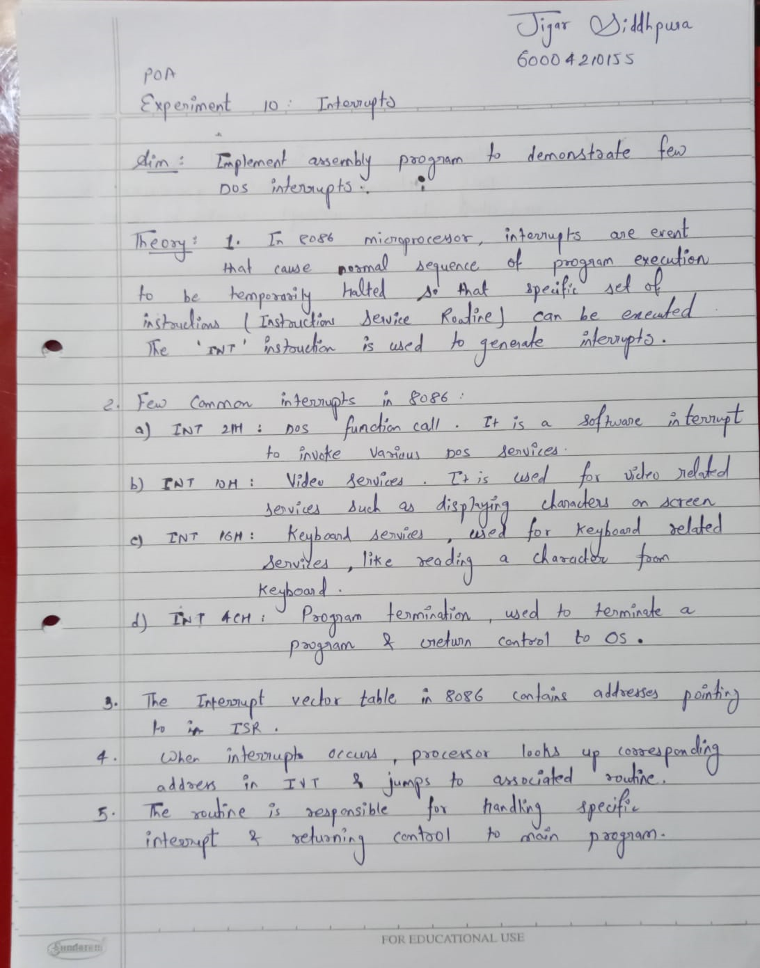

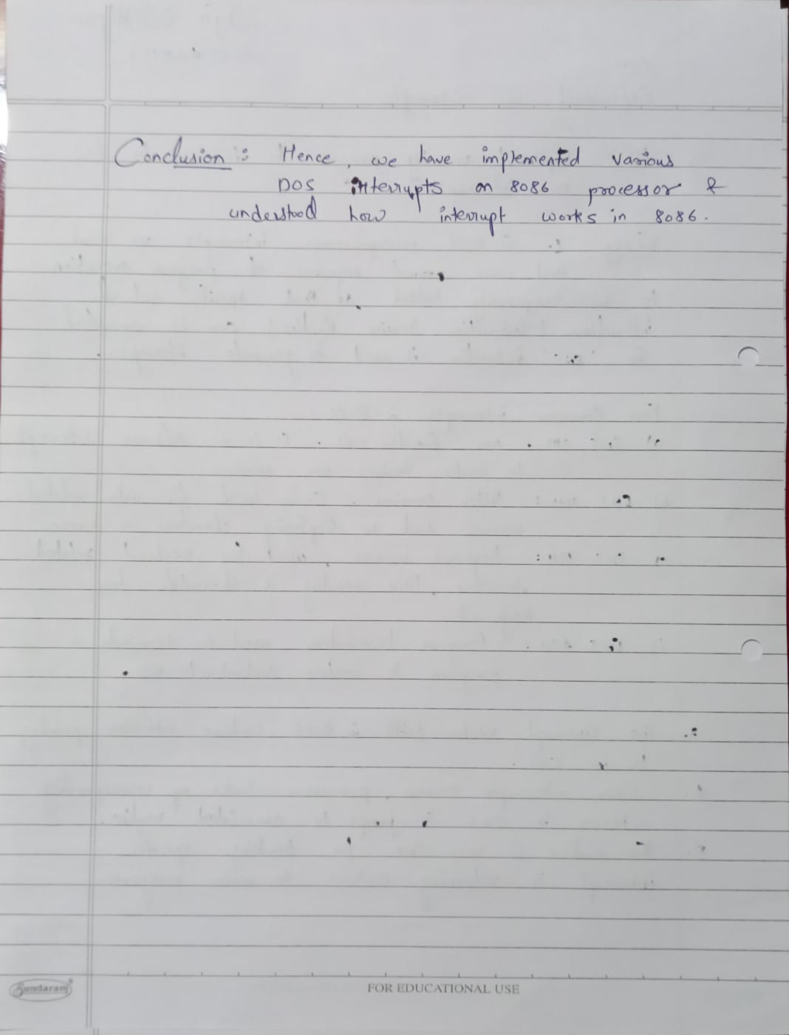

**Code :**

org 100h

DATA SEGMENT

MSG DB "Enter any Character : $"

DATA ENDS

CODE SEGMENT

START:

MOV AX,DATA

MOV DS,AX

LEA DX,MSG

MOV AH,09H

INT 21H

MOV AH,01

INT 21H

MOV DL,AL

MOV AH,02

INT 21H

MOV AH,4CH

INT 21H

CODE ENDS

END START

ret

Output:

