**Name: Jigar Siddhpura SAPID:** 60004200155

**DIV: C/C2 Branch:** Computer Engineering

ML - Experiment 8 - SVM

from google.colab import drive

drive.mount('/content/gdrive')

import numpy as np

import pandas as pd

from sklearn.preprocessing import StandardScaler

from sklearn.decomposition import PCA

from sklearn.svm import SVC

from sklearn.model_selection import train_test_split

from sklearn.metrics import accuracy_score, confusion_matrix, classification_report

import matplotlib.pyplot as plt

from sklearn.preprocessing import KBinsDiscretizer

***LINEAR***

**DATASET**

# Load the dataset

dataset_path = '/content/gdrive/MyDrive/ML/california.csv'

data = pd.read_csv(dataset_path)

data.head()

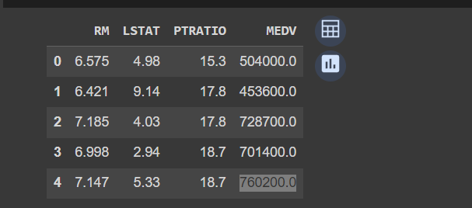

X = data.drop(columns=['medv'])  # Features

y = data['medv']  # Target variable

kbins = KBinsDiscretizer(n_bins=3, encode='ordinal', strategy='quantile')

y_discrete = kbins.fit_transform(y.values.reshape(-1, 1))

scaler = StandardScaler()

X_scaled = scaler.fit_transform(X)

pca = PCA(n_components=2)

X_pca = pca.fit_transform(X_scaled)

svm = SVC(kernel='linear')

svm.fit(X_pca, y_discrete)

plt.figure(figsize=(8, 6))

h = .02

x_min, x_max = X_pca[:, 0].min() - 1, X_pca[:, 0].max() + 1

y_min, y_max = X_pca[:, 1].min() - 1, X_pca[:, 1].max() + 1

xx, yy = np.meshgrid(np.arange(x_min, x_max, h), np.arange(y_min, y_max, h))

Z = svm.predict(np.c_[xx.ravel(), yy.ravel()])

Z = Z.reshape(xx.shape)

plt.contourf(xx, yy, Z, cmap='coolwarm', alpha=0.8)

plt.scatter(X_pca[:, 0], X_pca[:, 1], c=y_discrete, cmap='coolwarm', marker='o', edgecolors='k')

plt.xlabel('Principal Component 1')

plt.ylabel('Principal Component 2')

plt.colorbar(label='Target Value')

plt.show()

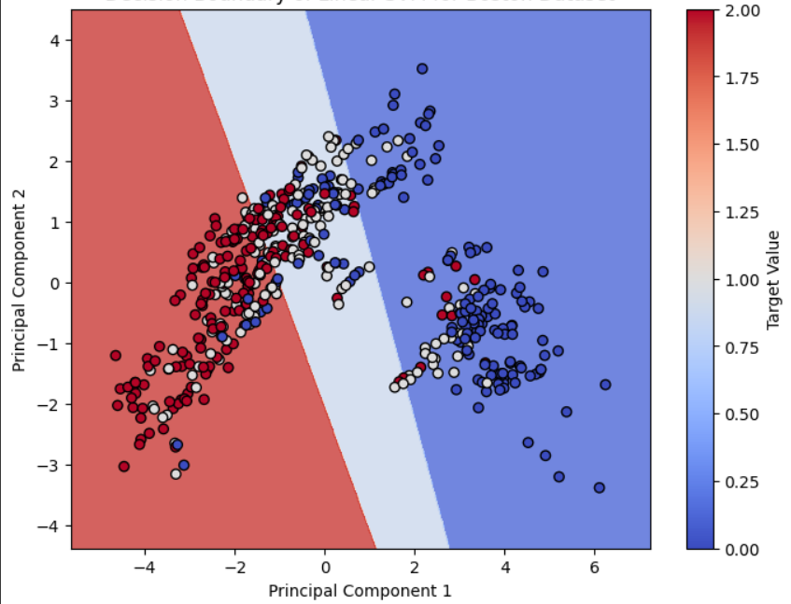

data = pd.read_csv('/content/gdrive/MyDrive/ML/california.csv')

bins = [0, 453600.0, 760200.0, float('inf')]

labels = ['low', 'medium', 'high']

data['medv_category'] = pd.cut(data['MEDV'], bins=bins, labels=labels)

X = data.drop(columns=['MEDV', 'medv_category'])

y = data['medv_category']

X_train, X_test, y_train, y_test = train_test_split(X, y, test_size=0.2, random_state=42)

kernels = ['linear', 'poly', 'rbf', 'sigmoid']

for kernel in kernels:

    svm = SVC(kernel=kernel)

    svm.fit(X_train, y_train)

    y_pred = svm.predict(X_test)

    accuracy = accuracy_score(y_test, y_pred)

    confusion_mat = confusion_matrix(y_test, y_pred)

    class_report = classification_report(y_test, y_pred)

    print(f"Kernel: {kernel}")

    print("Accuracy:", accuracy)

    print("Confusion Matrix:\n", confusion_mat)

    print("Classification Report:\n", class_report)

print()

**OUTPUT**

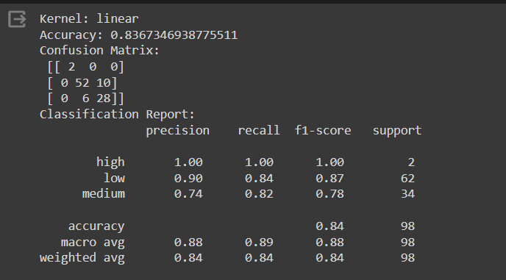

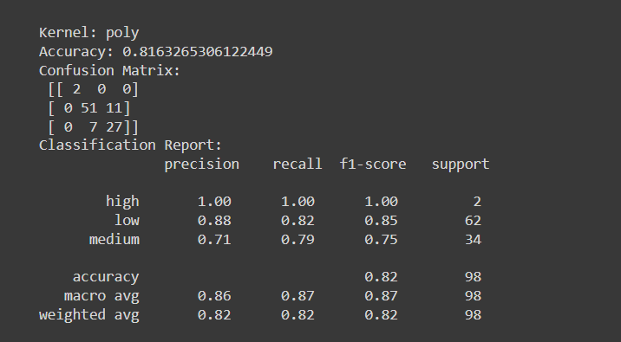

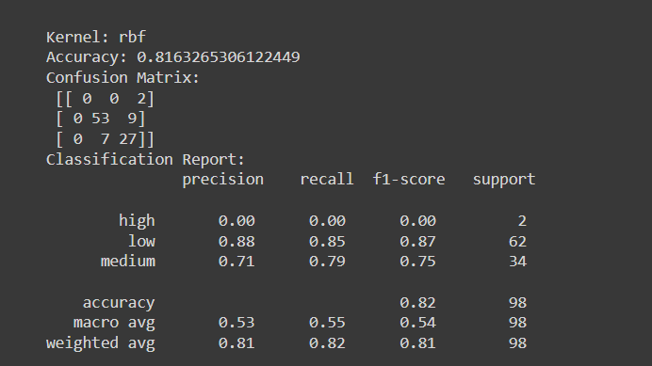

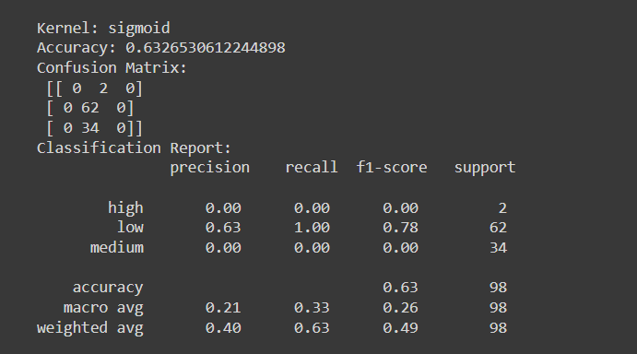

***NON - LINEAR***

**DATASET**

df = pd.read_csv('/content/gdrive/MyDrive/ML/heart.csv')

df.head()

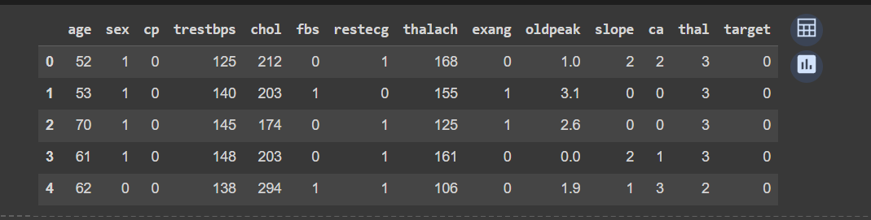

dataset_url = 'https://archive.ics.uci.edu/ml/machine-learning-databases/heart-disease/processed.cleveland.data'

names = ['age', 'sex', 'cp', 'trestbps', 'chol', 'fbs', 'restecg',

         'thalach', 'exang', 'oldpeak', 'slope', 'ca', 'thal', 'target']

data = pd.read_csv(dataset_url, names=names)

data.replace('?', np.nan, inplace=True)

data.dropna(inplace=True)

X = data.drop(columns=['target'])

y = data['target']

scaler = StandardScaler()

X_scaled = scaler.fit_transform(X)

pca = PCA(n_components=2)

X_pca = pca.fit_transform(X_scaled)

X_train, X_test, y_train, y_test = train_test_split(X_pca, y, test_size=0.2, random_state=42)

svm = SVC(kernel='rbf', gamma='scale')

svm.fit(X_train, y_train)

plt.figure(figsize=(8, 6))

h = .02  # step size in the mesh

x_min, x_max = X_pca[:, 0].min() - 1, X_pca[:, 0].max() + 1

y_min, y_max = X_pca[:, 1].min() - 1, X_pca[:, 1].max() + 1

xx, yy = np.meshgrid(np.arange(x_min, x_max, h), np.arange(y_min, y_max, h))

Z = svm.predict(np.c_[xx.ravel(), yy.ravel()])

Z = Z.reshape(xx.shape)

plt.contourf(xx, yy, Z, cmap='coolwarm', alpha=0.8)

plt.scatter(X_pca[:, 0], X_pca[:, 1], c=y, cmap='coolwarm', marker='o', edgecolors='k')

plt.title('Decision Boundary of Non-linear SVM for Heart Disease')

plt.xlabel('Principal Component 1')

plt.ylabel('Principal Component 2')

plt.colorbar(label='Target Value')

plt.show()

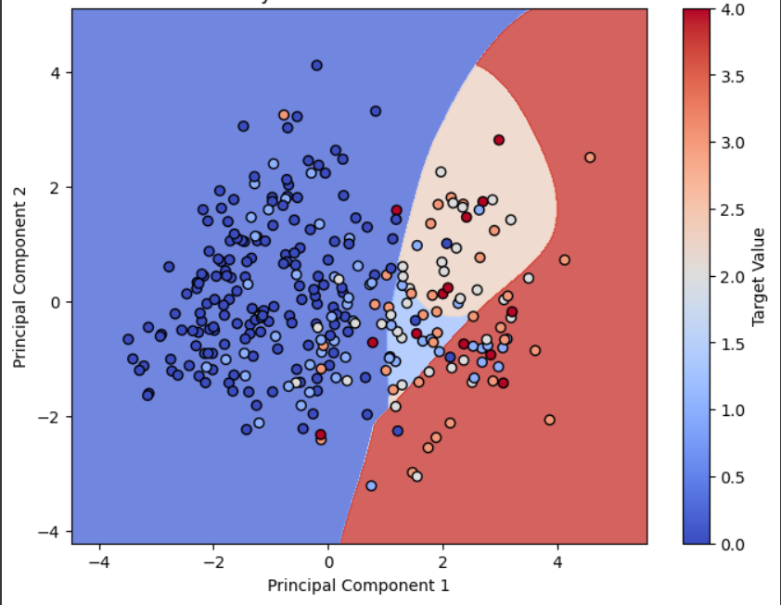

dataset_url = 'https://archive.ics.uci.edu/ml/machine-learning-databases/heart-disease/processed.cleveland.data'

names = ['age', 'sex', 'cp', 'trestbps', 'chol', 'fbs', 'restecg',

         'thalach', 'exang', 'oldpeak', 'slope', 'ca', 'thal', 'target']

data = pd.read_csv(dataset_url, names=names)

data.replace('?', np.nan, inplace=True)

data.dropna(inplace=True)

X = data.drop(columns=['target'])

y = data['target']

scaler = StandardScaler()

X_scaled = scaler.fit_transform(X)

pca = PCA(n_components=2)

X_pca = pca.fit_transform(X_scaled)

X_train, X_test, y_train, y_test = train_test_split(X_pca, y, test_size=0.2, random_state=42)

kernels = ['linear', 'poly', 'rbf', 'sigmoid']

results = {}

for kernel in kernels:

    svm = SVC(kernel=kernel, gamma='scale')

    svm.fit(X_train, y_train)

    y_pred = svm.predict(X_test)

    accuracy = accuracy_score(y_test, y_pred)

    cm = confusion_matrix(y_test, y_pred)

    report = classification_report(y_test, y_pred)

    results[kernel] = {'accuracy': accuracy, 'confusion_matrix': cm, 'classification_report': report}

for kernel, result in results.items():

    print(f"Kernel: {kernel}")

    print(f"Accuracy: {result['accuracy']}")

    print("Confusion Matrix:")

    print(result['confusion_matrix'])

    print("Classification Report:")

    print(result['classification_report'])

    print()

**OUTPUT**

