**Name: Jigar Siddhpura SAPID:** 60004200155

**DIV: C/C2 Branch:** Computer Engineering

ML - Experiment 9 - Bayesian Network

***CODE***

pip install pgmpy

from pgmpy.models import BayesianModel

from pgmpy.factors.discrete import TabularCPD

from pgmpy.inference import VariableElimination

# Define the structure of the Bayesian network

model = BayesianModel([('Earthquake', 'Alarm'), ('Burglary', 'Alarm'), ('Alarm', 'JohnCalls'), ('Alarm', 'MaryCalls')])

# Define the conditional probability distributions (CPDs)

cpd_earthquake = TabularCPD(variable='Earthquake', variable_card=2, values=[[0.99], [0.01]])

cpd_burglary = TabularCPD(variable='Burglary', variable_card=2, values=[[0.99], [0.01]])

cpd_alarm = TabularCPD(variable='Alarm', variable_card=2, values=[[0.999, 0.71, 0.06, 0.05], [0.001, 0.29, 0.94, 0.95]],

                        evidence=['Earthquake', 'Burglary'], evidence_card=[2, 2])

cpd_john_calls = TabularCPD(variable='JohnCalls', variable_card=2, values=[[0.95, 0.1], [0.05, 0.9]], evidence=['Alarm'], evidence_card=[2])

cpd_mary_calls = TabularCPD(variable='MaryCalls', variable_card=2, values=[[0.99, 0.3], [0.01, 0.7]], evidence=['Alarm'], evidence_card=[2])

# Add CPDs to the model

model.add_cpds(cpd_earthquake, cpd_burglary, cpd_alarm, cpd_john_calls, cpd_mary_calls)

model.check_model()

inference = VariableElimination(model)

# Query: P(Alarm = True | Earthquake = True, Burglary = True)

result = inference.query(variables=['Alarm'], evidence={'Earthquake': 1, 'Burglary': 1})

print(result)

# Query: P(JohnCalls = True, MaryCalls = True | Earthquake = True, Burglary = True)

result = inference.query(variables=['JohnCalls', 'MaryCalls'], evidence={'Earthquake': 1, 'Burglary': 1})

print(result)

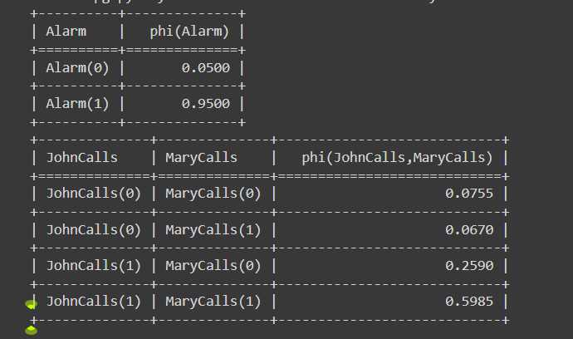

from pgmpy.models import BayesianModel

from pgmpy.factors.discrete import TabularCPD

from pgmpy.inference import VariableElimination

# Define the Bayesian Network structure

model = BayesianModel([('Burglary', 'Alarm'), ('Earthquake', 'Alarm'),

                       ('Alarm', 'JohnCalls'), ('Alarm', 'MaryCalls')])

# Define the Conditional Probability Tables (CPTs)

cpd_burglary = TabularCPD(variable='Burglary', variable_card=2, values=[[0.999], [0.001]])

cpd_earthquake = TabularCPD(variable='Earthquake', variable_card=2, values=[[0.998], [0.002]])

cpd_alarm = TabularCPD(variable='Alarm', variable_card=2,

                       values=[[0.999, 0.71, 0.06, 0.05],

                               [0.001, 0.29, 0.94, 0.95]],

                       evidence=['Burglary', 'Earthquake'],

                       evidence_card=[2, 2])

cpd_johncalls = TabularCPD(variable='JohnCalls', variable_card=2,

                           values=[[0.95, 0.1], [0.05, 0.9]],

                           evidence=['Alarm'], evidence_card=[2])

cpd_marycalls = TabularCPD(variable='MaryCalls', variable_card=2,

                           values=[[0.99, 0.3], [0.01, 0.7]],

                           evidence=['Alarm'], evidence_card=[2])

print()

print(cpd_burglary)

print()

print(cpd_earthquake)

print()

print(cpd_alarm)

print()

print(cpd_johncalls)

print()

print(cpd_marycalls)

print()

# Add CPTs to the model

model.add_cpds(cpd_burglary, cpd_earthquake, cpd_alarm, cpd_johncalls, cpd_marycalls)

# Check if the model is valid

print("Model is valid:", model.check_model())

# Initialize the Variable Elimination Inference object

infer = VariableElimination(model)

# Inputs

evidence_no_burglary_earthquake = {'Burglary': 0, 'Earthquake': 0}

# Perform inference to get the probability distributions for each query

# Query 1: Probability that John called and Mary called, given no Burglary and no Earthquake

query1 = infer.query(variables=['JohnCalls', 'MaryCalls','Alarm'], evidence=evidence_no_burglary_earthquake)

print("Query 1:")

print("Probability that John called and Mary called, given no Burglary and no Earthquake:")

print(query1)

# Query 2: Probability that John called

query2 = infer.query(variables=['JohnCalls'])

print("\nQuery 2:")

print("Probability that John called:")

print(query2)

# Query 3: Probability of Burglary given both John and Mary called

evidence_john_mary_called = {'JohnCalls': 1, 'MaryCalls': 1}

query3 = infer.query(variables=['Burglary'], evidence=evidence_john_mary_called)

print("\nQuery 3:")

print("Probability of Burglary given both John and Mary called:")

print(query3)

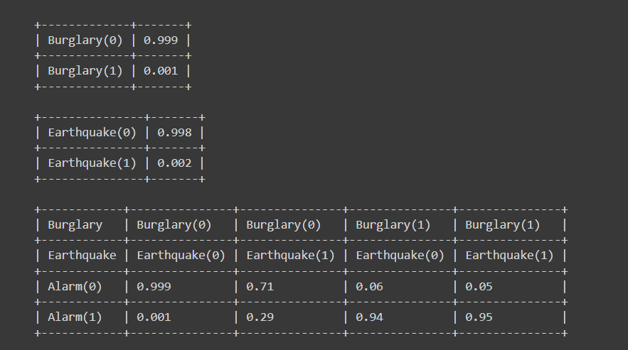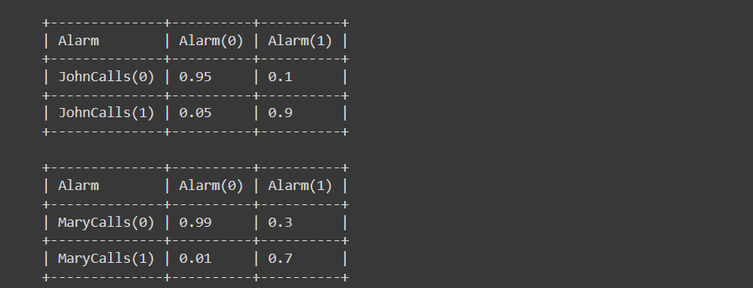

**QUERY OUTPUT**

