A Thesaurus Client & Server

Contents

1. System Requirements 1

2. Project Files 2

3. Steps to run the application 2

3.1 Compile and run ServerGUI.java 2

3.2 Compile and run ClientGUI.java 2

3.3 Search synonym 4

3.4 Server Response 4

3.5 Disconnect Client 5

3.6 Stop Server 6

4. Assumptions 6

5. Extra functionality 6

6. References 7

### System Requirements

Following are the system requirements of the project:

* Language: java
* Environment: Windows
* JDK version: 1.8 and above

## Project Files

* Server.java
* ServerGUI.java
* Client.java
* ClientGUI.java
* Synonyms.txt

## Steps to run the application

Open command prompt and go to directory where project files are located

### Compile and run ServerGUI.java

* To run enter following commands

Javac ServerGUI.java

Java ServerGUI

* Server application will start and will look like follows: Port number used for connection is 1234 with localhost.

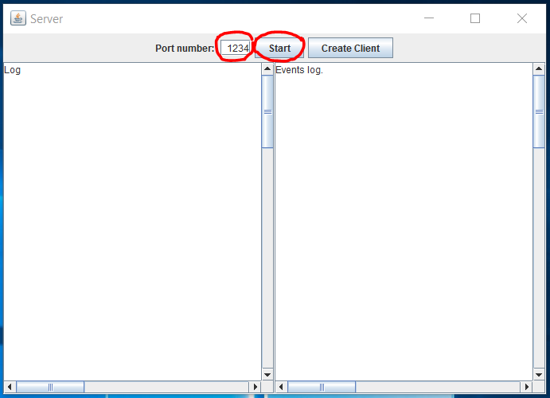

* Enter the port number and click on start button. Default port number is 1234

### 3.2 Compile and run ClientGUI.java

* To run enter following commands

Javac ClientGUI.java

Java ClientGUI

* Client application will start and will look like follows:

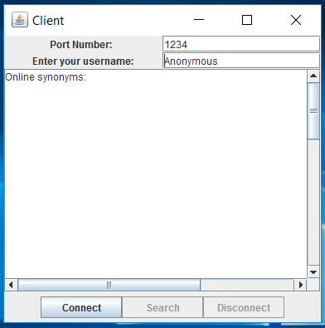

* Enter port number and name of client, then click on connect. By default the username will be Anonymous

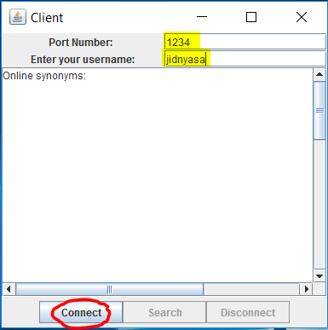

* After successful connection Server will display client connected message on display

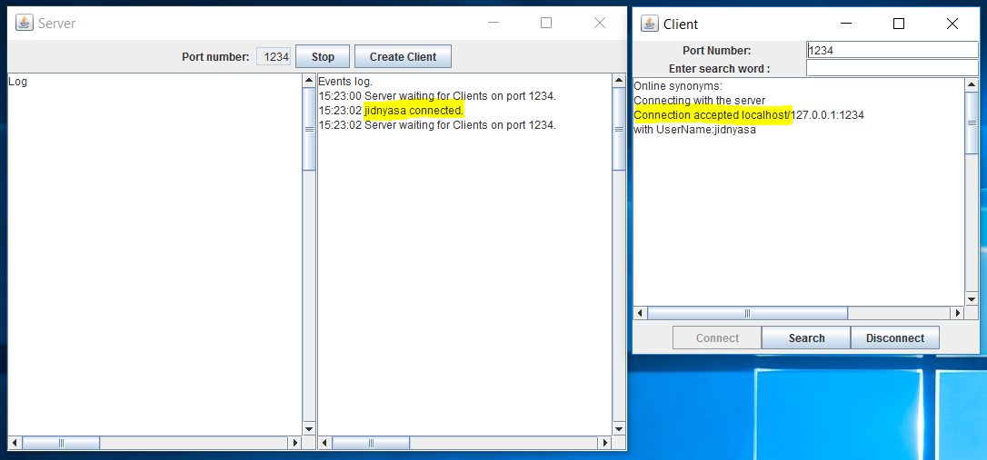

### Search synonym

* Enter search word in text field and click search button

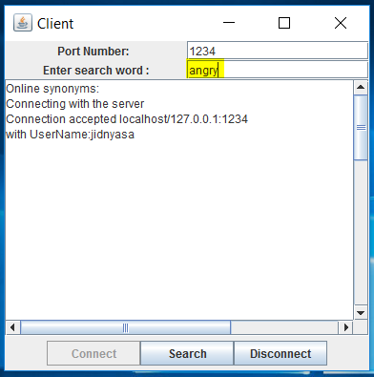

### Server Response

Case 1: Search word match found (search word: angry): Server responds back with synonyms for the word

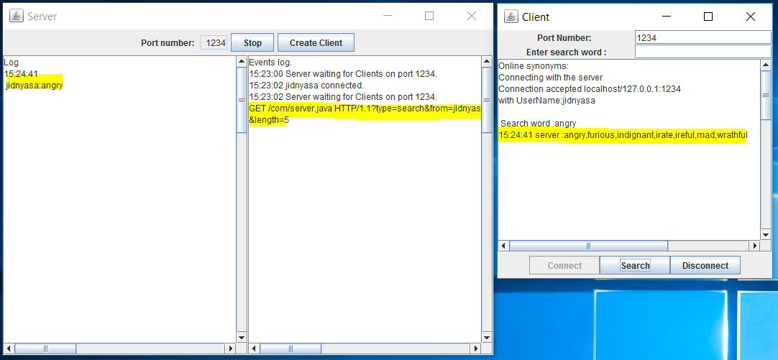

Case 2: Search word match not found (search word: zinc): Server responds back with ‘No Knowledge’ for the word

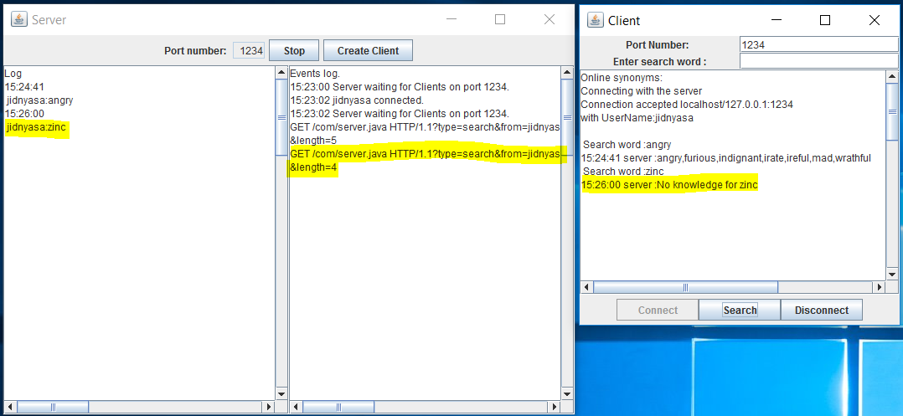

### Disconnect Client

* Clients can disconnect from server by clicking disconnect button

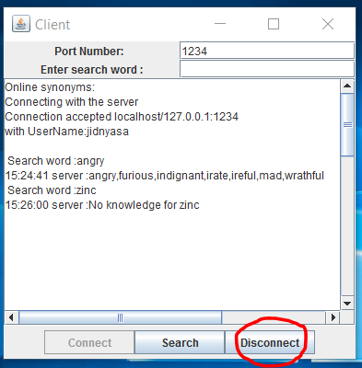

* Following message is displayed when client disconnects

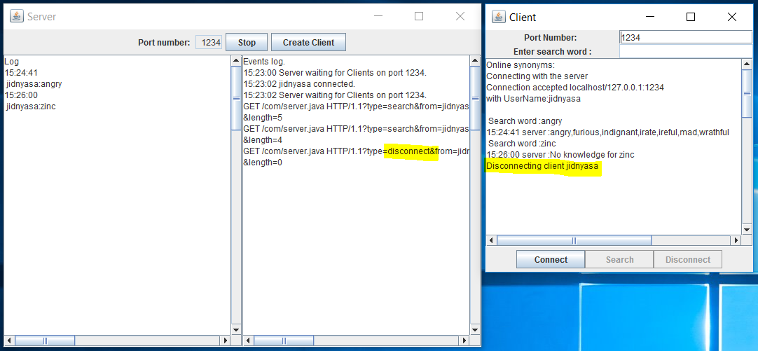

### Stop Server

* Server can be stopped by clicking the sop button on server

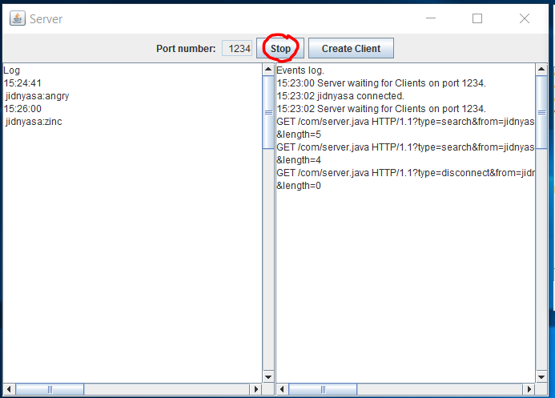

* After clicking stop following message is reflected on GUI

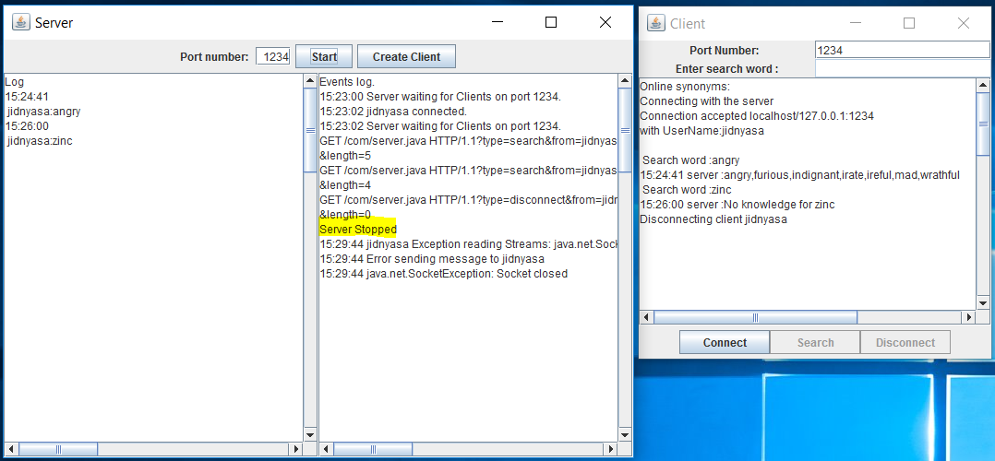

## Assumptions

* No special characters while sending message or giving a username.

As the HTTP message format have characters like ?, /, &, messages with such special characters cannot be parsed correctly at server side.

## Extra functionality

* Multi threaded server
* This can be verified by creating running another server with different port number eg 1500 and connecting new clients to this server
* Additionally u can also create new clients by clicking create client button

## References

* Multi client server chat: https://github.com/Likitha-Seeram/Multi-Client-Server-Chat-System
* A simple Chat program with client/server: http://www.dreamincode.net/forums/topic/259777-a-simple-chat-program-with-clientserver-gui-optionclients/
* synonym.txt: https://github.com/martiniturbide/os2-cse5306-projects/blob/master/os2-cse5306-projects/lab1/SynonymsFile.txt¬¬¬
* online dictionary: https://stackoverflow.com/questions/23759687/client-server-online-dictionary-program-in-java