A Weather Client Using XML

Contents

1. System Requirements 2

2. Project Files 2

3. Steps to run the application 2

4. Limitations 3

5. Assumptions 3

6. References 3

### System Requirements

Following are the system requirements of the project:

* Browser: Chrome/Firefox/IE
* Tested on chrome

## Project Files

* Weather.html

## Steps to run the application

* Double click weather.html which will open it in default browser set on machine
* Sample input:
  + Latitude: 32.7357 Longitude: -97.1081 (Arlington, TX)
  + Latitude: 38.50674 Longitude: -121.49597 (Sacramento, CA)

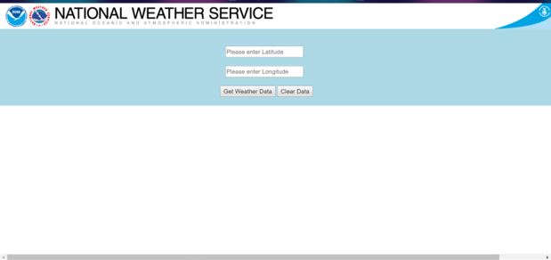

* Enter Latitude and Longitude of the location to get corresponding weather conditions
* Click on Get Weather Data button to view the result

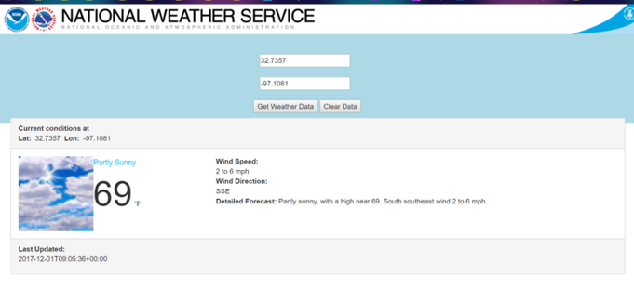

## Limitations

The client only displays information about following parameters:

* Wind Speed
* Wind direction
* Temperature
* Weather icon
* Last updated time

## Assumptions

* Weather data is refreshed every hour. So changes on weather client will be reflected after an hour only

## References

* Data parsed from:

1. https://api.weather.gov/points/32.7357,-97.1081/forecast

* forecast.weather.gov site:

1. http://forecast.weather.gov/MapClick.php?textField1=32.81&textField2=-96.96#.WhOyn0qnE2x

* HTML view:

1. https://www.google.com/search?q=degree+symbol+html&rlz=1C1CHBF_enUS771US771&oq=degree+sy&aqs=chrome.1.0l2j69i57j0l3.4148j0j7&sourceid=chrome&ie=UTF-8
2. https://stackoverflow.com/questions/2076109/how-to-avoid-a-new-line-with-p-tag
3. https://stackoverflow.com/questions/17217766/two-divs-side-by-side-fluid-display
4. https://www.freeformatter.com/html-formatter.html#ad-output
5. https://stackoverflow.com/questions/5604859/adding-a-background-image-to-a-div-element

* Images/Icons:

1. http://forecast.weather.gov/css/images/header_noaa.png
2. http://forecast.weather.gov/css/images/header_nws.png
3. http://forecast.weather.gov/css/images/header_doc.png