# **Website using CodeIgniter framework**

1.Site map:

2.The project has following technologies:

HTML, CSS for styling, CodeIgniter’s MVC structure, MySQL database connectivity, XAMPP(apache and MySQL)

3.Database structure:

CLASS

|  |  |  |
| --- | --- | --- |
| CLASSID | CLASSNAME | DESCRIPTION |

CLIENT

|  |  |  |  |  |  |
| --- | --- | --- | --- | --- | --- |
| CLIENTID | NAME | PHONE | ADDRESS | EMAIL | PASSWORD |

CLIENTSCHEDULE

|  |  |  |  |
| --- | --- | --- | --- |
| CLIENTID | TIMEID | CLASSID | DAYSID |

CONTACT

|  |  |  |
| --- | --- | --- |
| NAME | EMAIL | COMMENTS |

DAYS

|  |  |
| --- | --- |
| DAYSID | DAYSNAME |

SCHEDULE

|  |  |  |
| --- | --- | --- |
| TIMEID | CLASSID | DAYSID |

TIME

|  |  |
| --- | --- |
| TIMEID | DETAILS |

4.Instructions to run:

* Install xampp
* Start apache server and MySQL

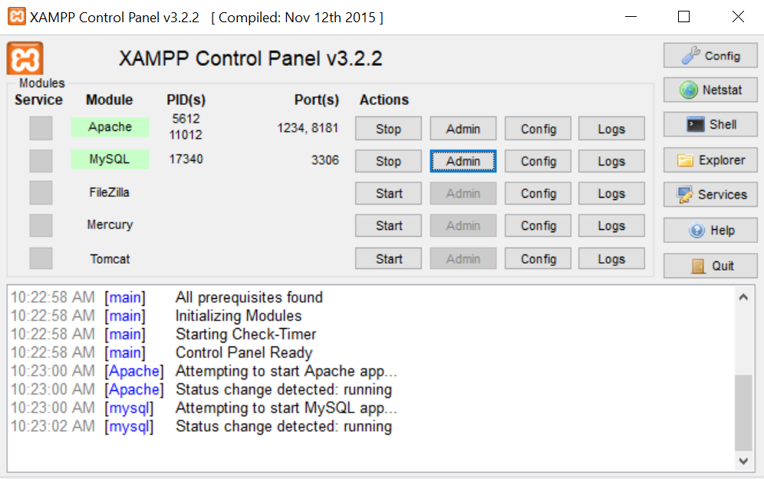

* Click on admin button corresponding to MySQL
* Create new database; or import from yoga.sql file provided.
* Once you have the tables created modify the base URL in code as necessary.
* Current URL to open the pages: <http://localhost:1234/project5/about>
* Style sheet is placed under assets directory along with all the images used on the pages

5.Snapshot of register page:

Register page includes input validations for name/email/phone number /password

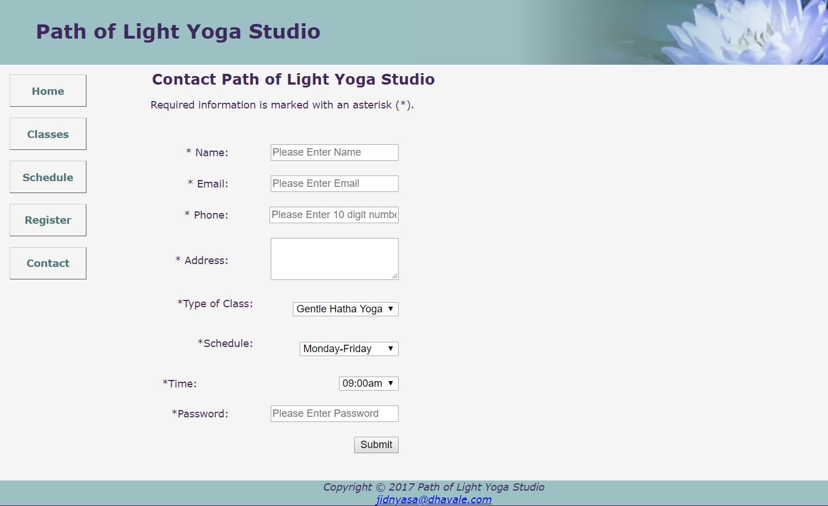

6.Snapshot of schedule page:

All the schedules are displayed through database. Updating the schedule table reflects on the site

