MONGODB
Step 1 – Open Google Chrome and search for mongodb atlas and click on 1st link
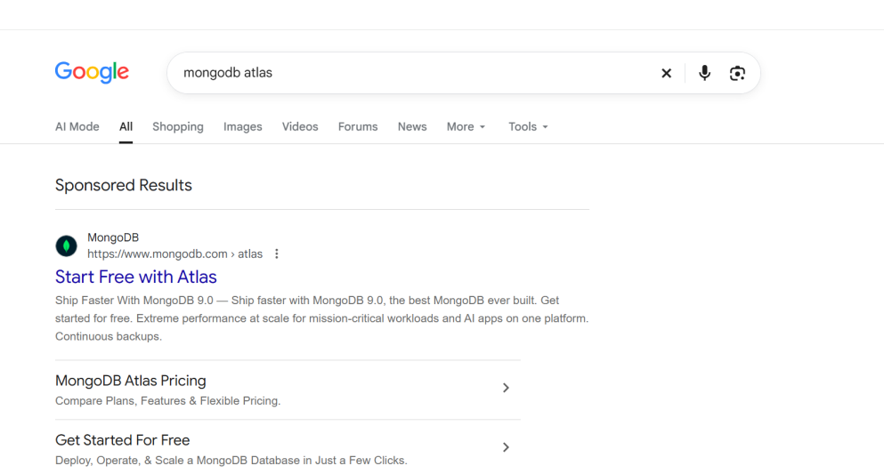

Step 2 – Login Using Google ID any email id for creating mongodb account

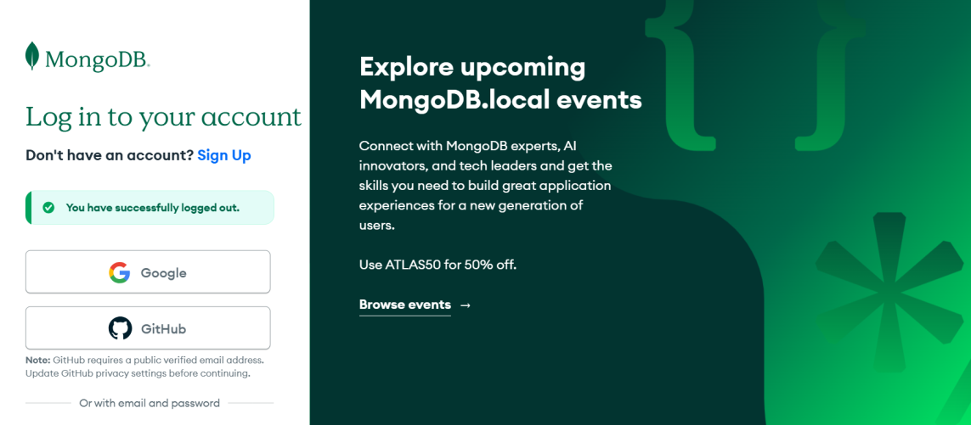

Step 3 – To create a cluster in Mongodb . Click on Cluster and add it.

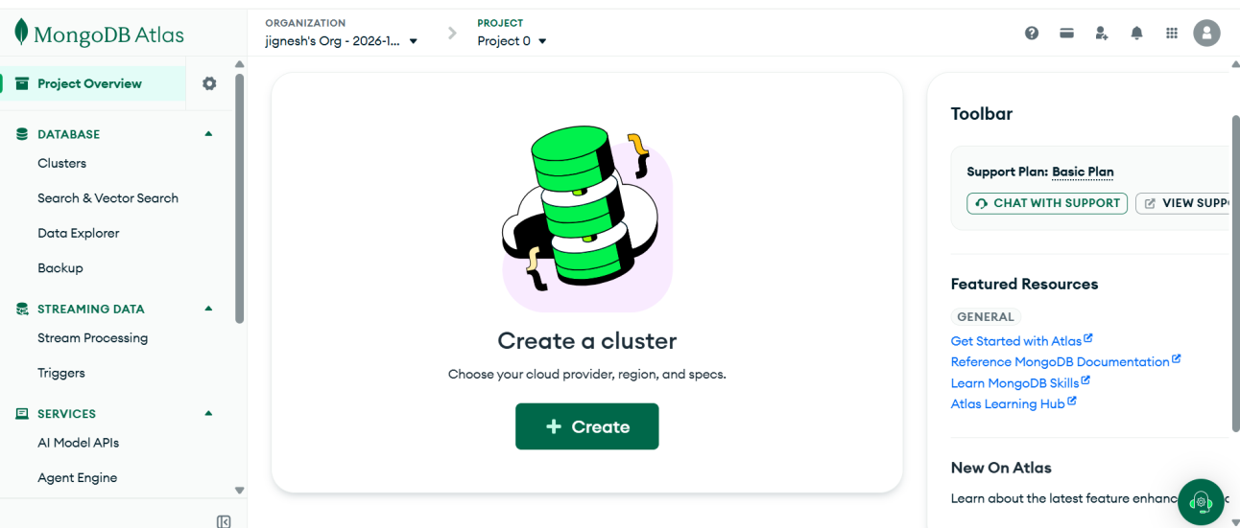

4 – Write the cluster name and also choose the region where you need to deploy your cluster.

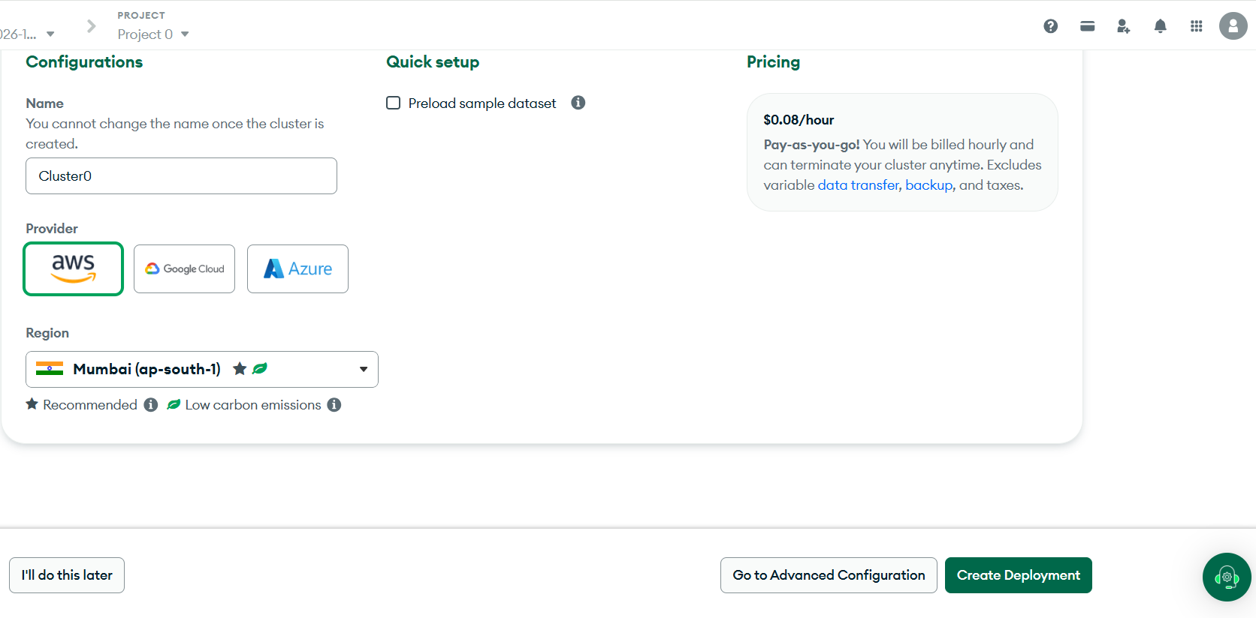
5 - Choose according to your need to deploy your cluster.

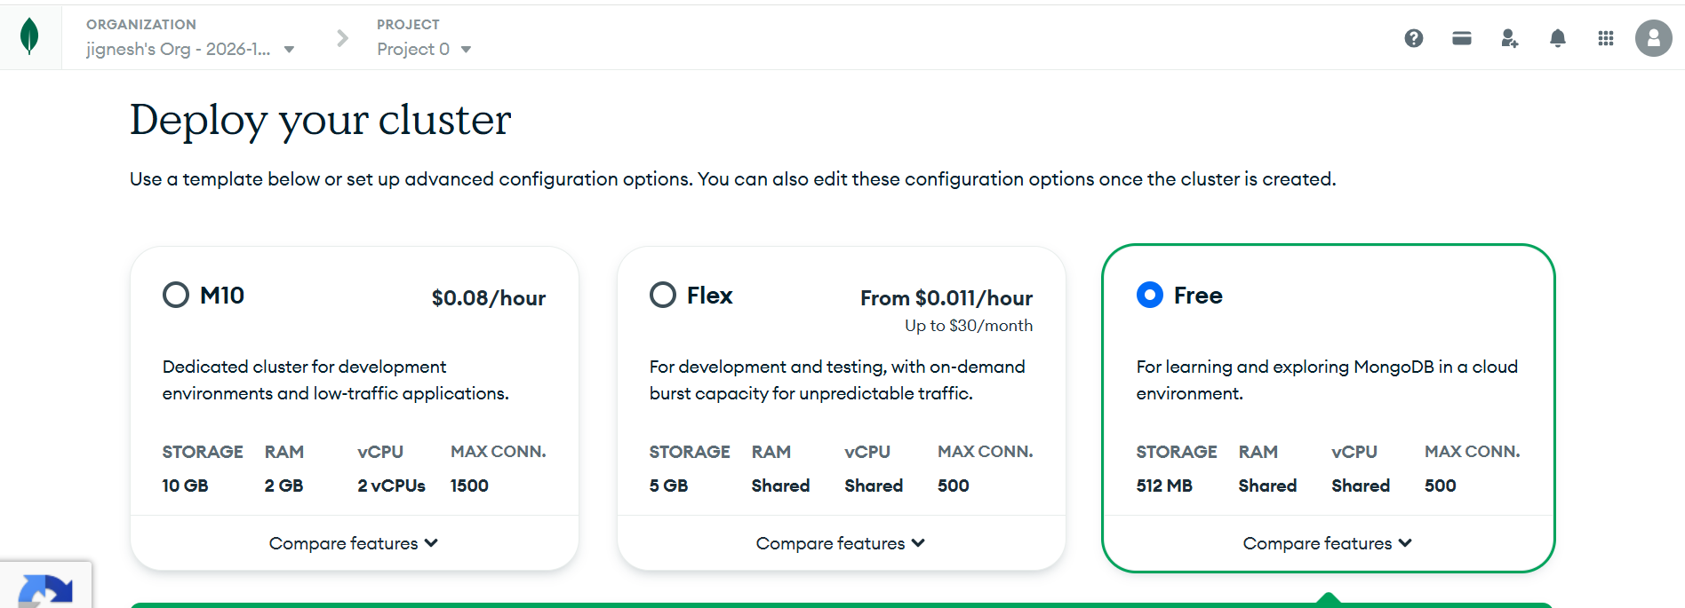

6 – Now to connect to your cluster choose the compass option .

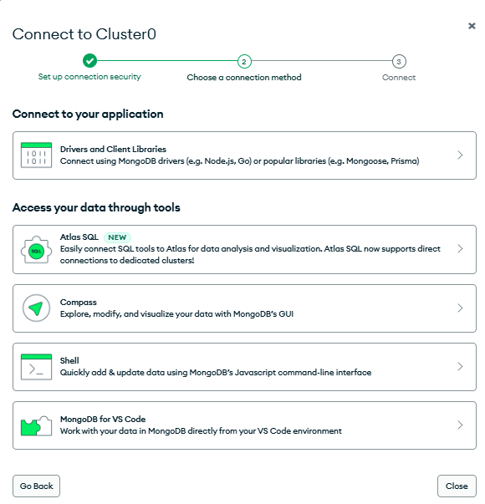
Step 7 – Choose the option to connect the compass with Mongodb.

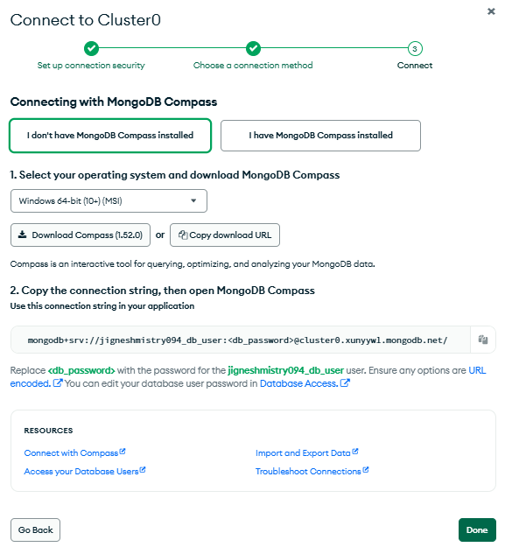

Step 8 – If you choose you don’t have MongoDB Compass Installed the choose according to your operation system and install. Make sure you copied the connection string link given below to open MongoDB.

Step 9 - If you select I have MongoDB Compass installed . The make sure you copied the connection string link given below to open MongoDB.

Step 10 – Open MongoDB in your system

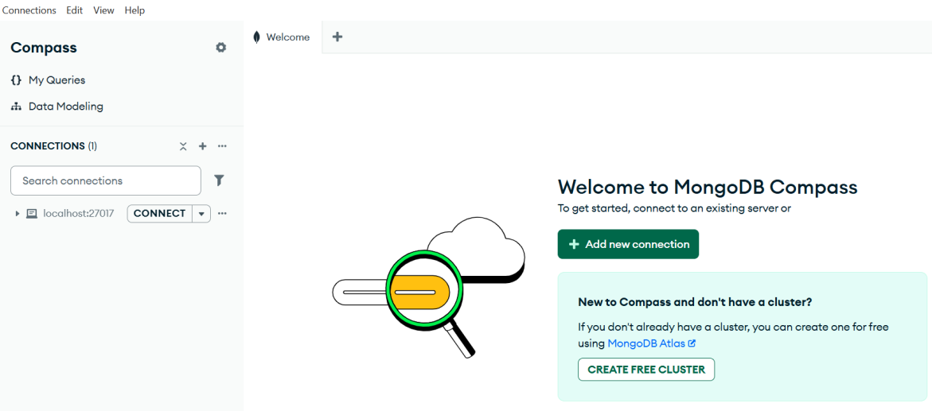

Step 11 – Click on Google Chrome where you have login in MongoDB and choose Database & Network Access and edit the password which you can remember and save it.

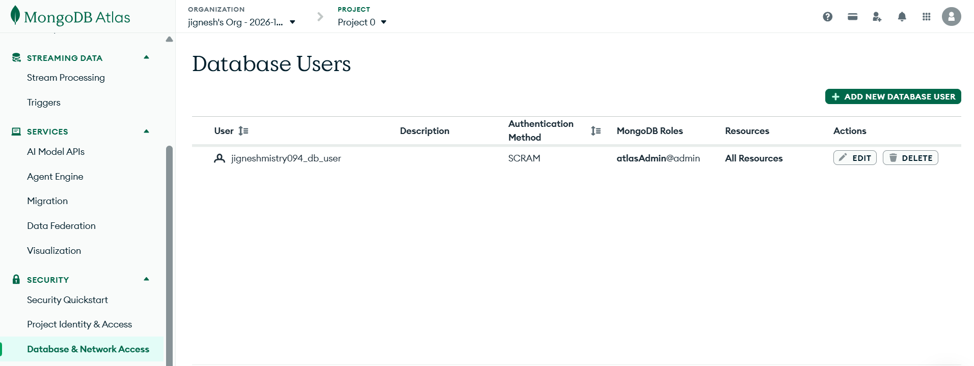

Step 12 – Switch to MongoDB Compass and click on add new connection and copy the string which you have copied while installing mongodb.

Step 13 – now paste the link and change the password which you have put in database and network inside <db_password>

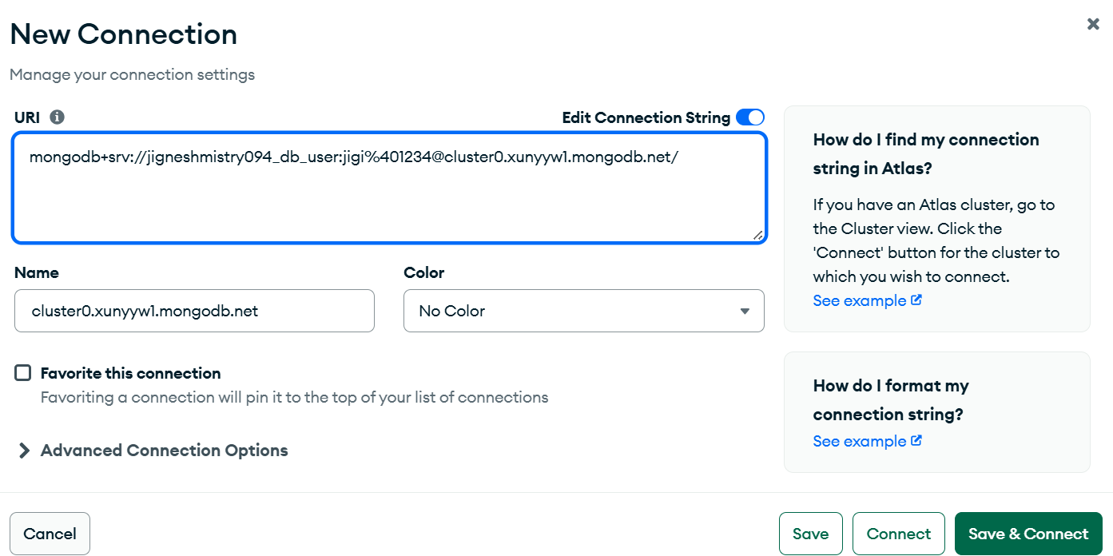

Step 14 – Now you can see that the connection has been made successfully.

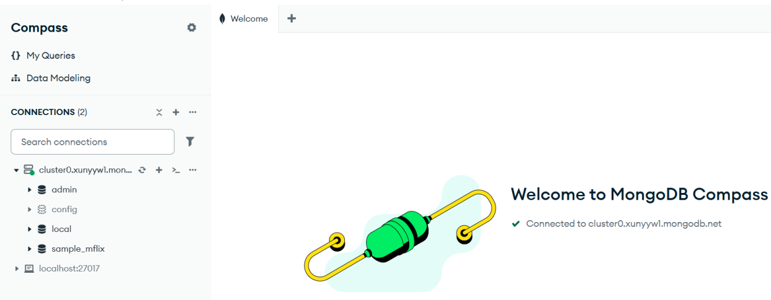

Step 15 – The final
