KPIs in Score Card format for Dashboards

Introduction:
These plug & play KPI cards are the easiest way to visualize and demonstrate Key Performance Indicators of data. They are ready to use KPIs in Card format written in jquery. These cards can be readily placed on your Dashboard web pages. Its simple implementation details are mentioned in this document.

KPI Score Card – Summary view:
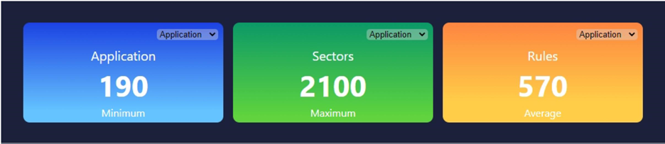

KPI Score Card – Detailed view:
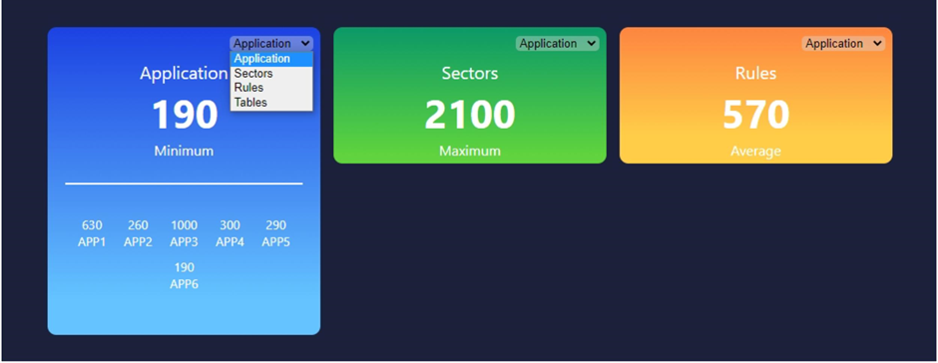

Ready to use files:
Below files are provided with the implementation code for above KPI Score Cards.
- cards.css
- jquery.dynamic_kpi.js

Implementation Steps:
Follow below implementation steps to make the KPI Score Cards ready to use on your Dashboard web page.
- Add the provided files: jquery.dynamic_kpi.js, cards.css to your project directory
- Add below tags in your HTML files
<link rel="stylesheet" href="cards.css">
<script type = "text/javascript" src="https://ajax.googleapis.com/ajax/libs/jquery/2.1.3/jquery.min.js"></script>
<script src = "jquery.dynamic_kpi.js" type = "text/javascript"></script>
- Create a <div> in your HTML and assign wrapper id to it
<div id="wrapper"></div>
- Call following function on your <div> passing your data as parameter
$(function(){
$("#wrapper").dynamic_kpi(datum);
});
That is it! You have successfully added D3 KPI Score Cards to your Dashboard web page.

Data to display:
You need to integrate your actual data in line in the code.
- You Must use the object name as 'data'.
- Pass your data as array of objects, as key value pairs.
- Keys and values can be anything, so you can change names as per your choice

For e.g.-
var datum = { data: {
Application:[{"name":"app1",count:630},{"name":"app2",count:260},{"name":"app3",count:1000},{"name":"app4",count:300},{"name":"app5",count:290},{"name":"app6",count:190}],
Sectors: [{"name":"sec1",count:110},{"name":"sec2",count:2100},{"name":"sec3",count:190},{"name":"sec4",count:200}],
Rules: [{"nm":"rule1",ct:440},{"nm":"rule2",ct:280},{"nm":"rule3",ct:990}],
Tables: [{"nm":"tab1",ct:400},{"nm":"tab2",ct:180},{"nm":"tab3",ct:900}]
}

Styling:
You can update the styling values to change look & feel of the Score Cards.
- Change below values for background colors, text color & font family of cards.
:root {
--card1-background-from: #1c42e2;
--card1-background-to: #65c4ff;
--card2-background-from: #0b9967;
--card2-background-to: #5fd43e;
--card3-background-from: #fd8540;
--card3-background-to: #ffcd48;
--text-color: #FFFFFF;
--text-font-family:'Segoe UI', Tahoma, Geneva, Verdana, sans-serif; }
- Change positioning of cards You must change following css properties to move all cards to left or right
#wrapper{
position: absolute;
display: flex;
top: 5% ;
left: 15% ;
width:1080px;
height:350px;
border-radius: 16px;
}

