SECURE EXAMINATION-PAPER EXCHANGE
Python Cryptography Workshop Report
Student name: ADDLA JIGNASA
Registration number: 24BCS006
GitHub Repository: https://github.com/jignasa-addla/Secure-Exam-Paper-Exchange

1. Objective
The objective of this project is to exchange a confidential examination paper between a faculty member (sender) and an authorised examination coordinator (recipient) over an untrusted channel. The application provides confidentiality, integrity checking, sender authentication, and rejection of invalid packages.

2. Cryptographic Algorithms
Purpose | Algorithm
RSA key pairs | RSA-4096 for sender and recipient; an additional attacker key pair is generated for negative tests.
File encryption | AES-256-GCM with a fresh random 256-bit session key and fresh 96-bit nonce for each encryption.
Session-key protection | RSA-OAEP with SHA-256 using the recipient's public key.
Digital signature | RSA-PSS with SHA-256 using the sender's private key.
Verification | Trusted sender public key verifies the signature; AES-GCM tag is verified before plaintext is written.
Key storage | Private keys are saved in passphrase-encrypted PKCS#8 PEM format.

3. Working of the Application
- Setup: Generate separate RSA key pairs for sender and recipient. Public keys are exchanged through a trusted channel; private keys remain with their owners.
- Sender encryption: Read the examination paper, generate a fresh AES session key and nonce, and encrypt the file using AES-256-GCM.
- Session-key protection: Encrypt the AES session key with the recipient's RSA public key using OAEP and SHA-256.
- Package and signature: Build a package containing metadata, encrypted session key, nonce, ciphertext, and GCM authentication tag. Sign the package fields with RSA-PSS and SHA-256.
- Transfer: Copy the encrypted package through the simulated untrusted channel. Attacker tests modify or replace package fields.
- Recipient verification: Check package structure and verify the signature with a trusted copy of the sender's public key.
- Decryption: Recover the AES session key using the recipient's private key, authenticate/decrypt using AES-GCM, and save plaintext only if checks succeed.

4. Sequence Diagram
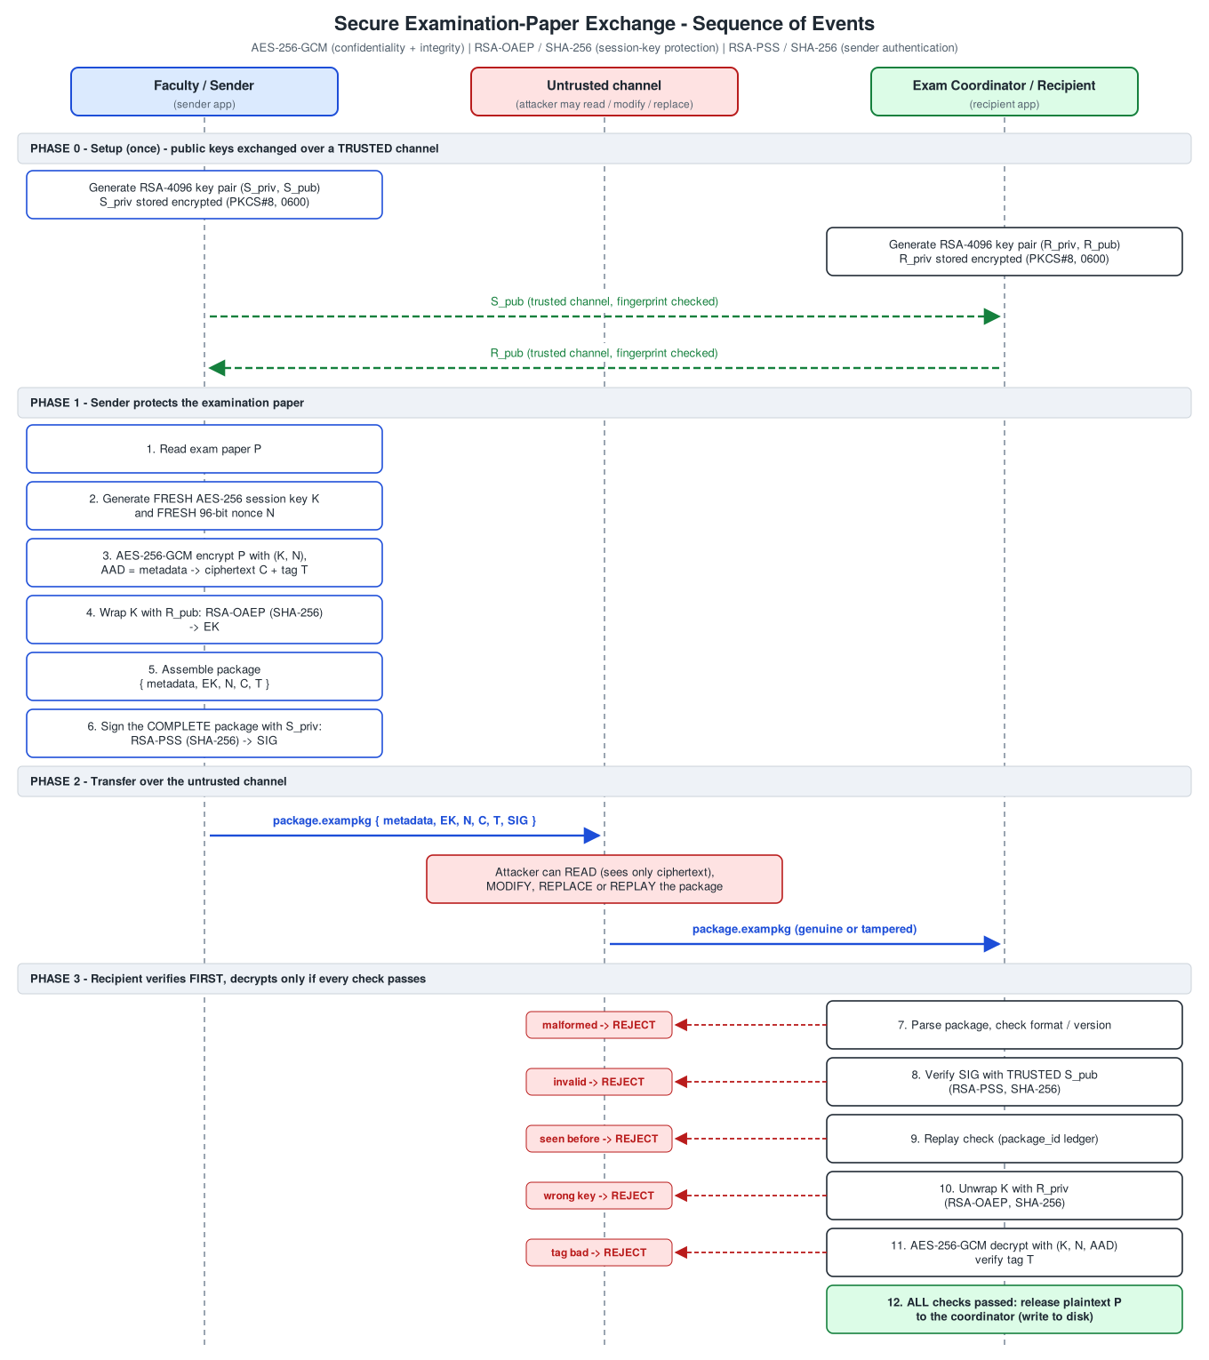
Figure 1. Sequence of events for secure examination-paper exchange.

5. Test Results
The latest local run shown in the terminal reports 18/18 checks passed. Tests cover successful recovery, package tampering, incorrect recipient key, incorrect sender public key, repeated encryption, replay attempts, and the rule that rejected attempts do not write plaintext.
Test | Result
Authorised recipient recovers original file | PASS
Ciphertext / metadata / signature modification | PASS
Incorrect recipient private key | PASS
Incorrect sender public key | PASS
Same file encrypted twice gives different packages | PASS
Rejected attempts do not release plaintext | PASS

6. Test Evidence Screenshots
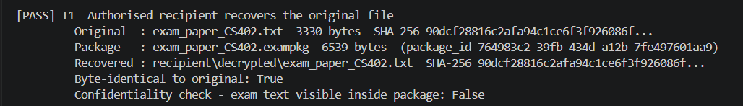
Figure 2. Successful decryption by the authorised recipient; the recovered file is byte-identical to the original.
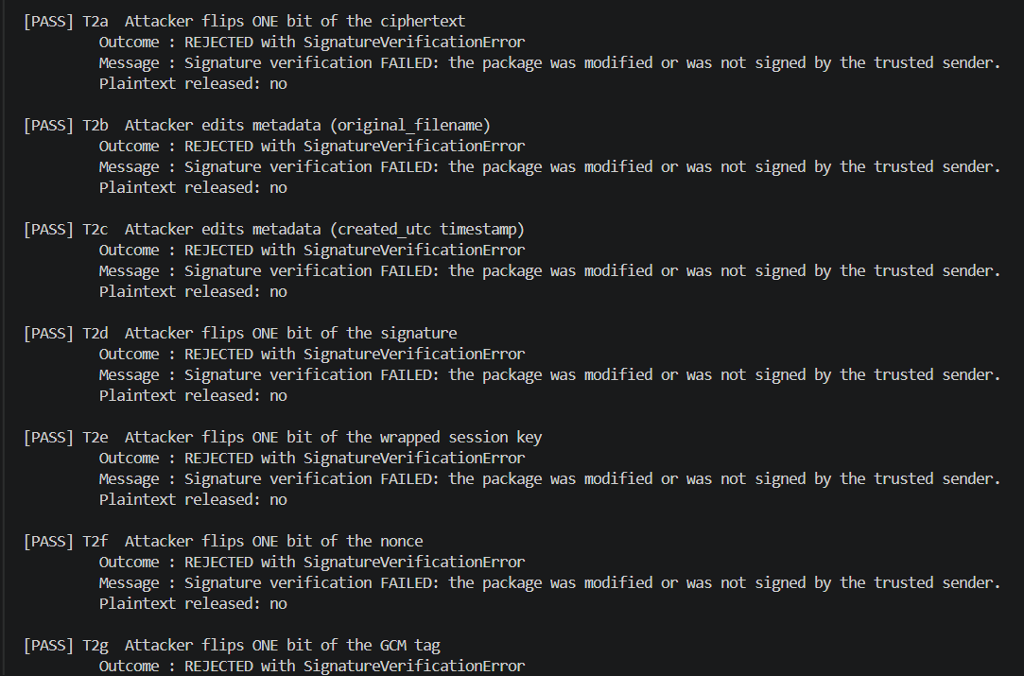
Figure 3. Tampering and package-replacement attempts are rejected; plaintext is not released.
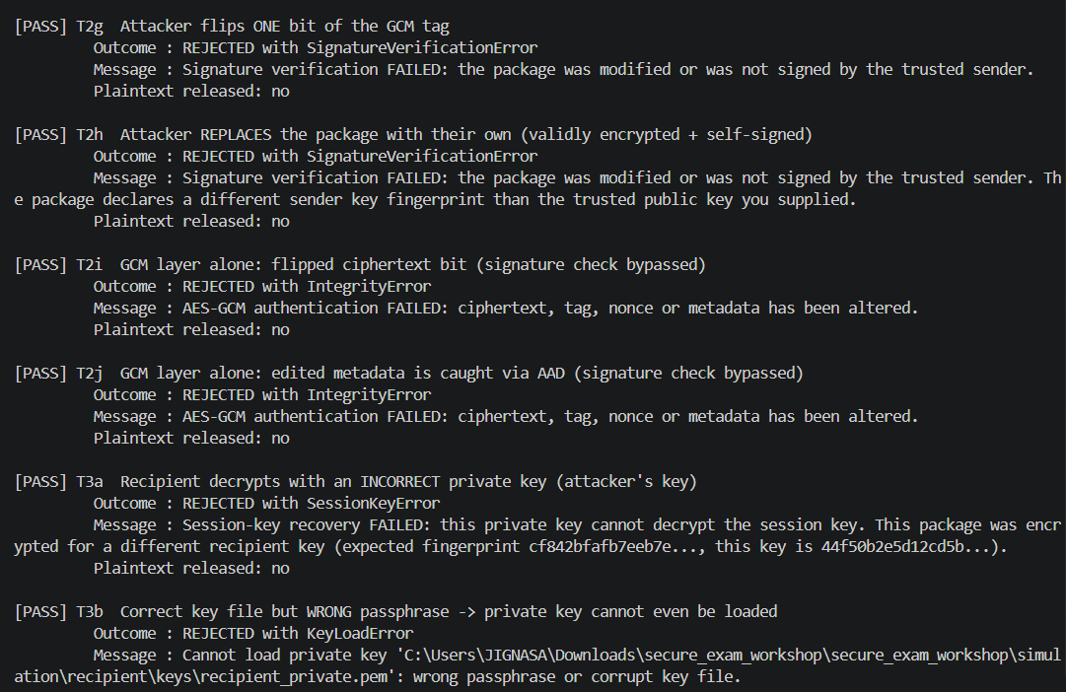
Figure 4. Rejection of an incorrect recipient private key and an incorrect passphrase.
The test log excerpts above show representative successful and rejected cases. The complete run reports 18/18 checks passed.
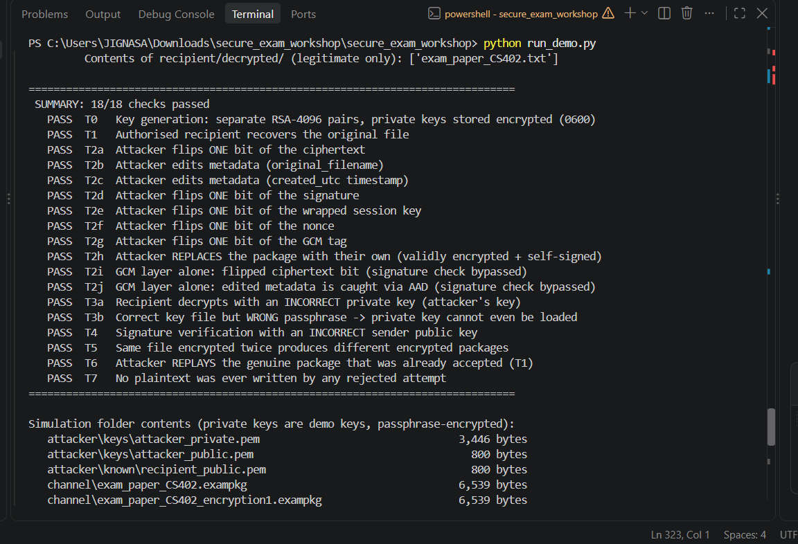

7. Security Properties
Confidentiality: AES-256-GCM encrypts the examination paper. The AES session key is protected with the recipient's RSA public key.
Integrity: RSA-PSS signature verification detects changes to signed package fields. AES-GCM authentication detects ciphertext/tag tampering.
Sender authentication: The recipient verifies the signature using a trusted sender public key, assuming the key was securely associated with the faculty member.
Failure handling: Invalid signatures, wrong keys, and failed authentication checks are rejected. Plaintext is written only after successful authentication/decryption.

8. Conclusion
The project demonstrates hybrid encryption and digital signatures for secure file exchange. The reported tests show that the authorised recipient can recover the original file, while modified packages and incorrect keys are rejected. The same input produces different encrypted packages because a fresh session key and nonce are generated for each encryption.

Execution Output and Test Evidence
The following screenshots were captured from the project test output. They demonstrate successful authorised decryption, rejection of altered packages, and rejection of incorrect recipient credentials.
Figure 1: Successful decryption by the authorised recipient.
Figure 2: Tampered ciphertext, metadata, signature, and package fields are rejected.
Figure 3: Incorrect recipient private key and passphrase are rejected.

Final Test Summary
The reported test run completed with 18/18 checks passed. The screenshots above show representative cases; the full test log (test_results.txt) should also be included in the repository as supporting evidence.

