# JAVA PROGRAMS

## TO ADD TWO NUMBERS ALGORITHM:

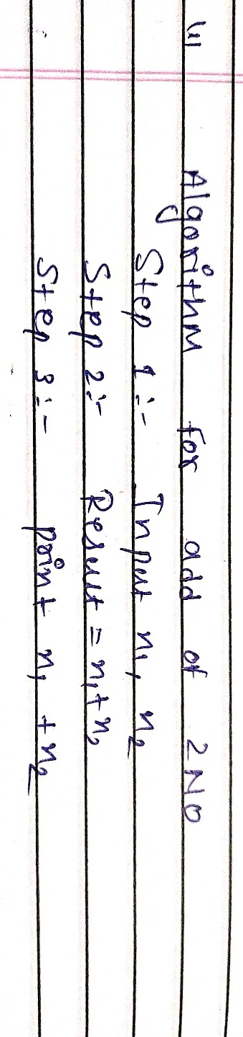

**PROGRAM:**

//To Add Two Numbers

public class Main

{

public static void main(String[] args)

{

int x = 9; int y = 6;

int sum = x + y ;

System.out.println("x + y =" +sum);

}

}

## OUTPUT:

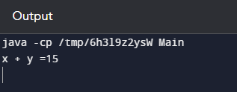

1. **TO PRINT NUMBERS ENTERED BY USER ALGORITHM:**

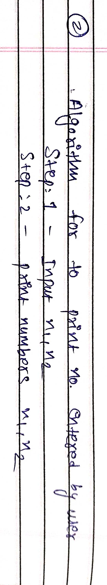

## PROGRAM:

## import java.util.*;

## public class MyClass {

## public static void main(String args[]) {

## int n1, n2,temp;

## Scanner sc = new Scanner(System.in);

## System.out.println("input number 1");

## n1=sc.nextInt(); System.out.println("input number 2");

## n2=sc.nextInt();

## System.out.println(" n1 + n2=" +(n1+n2));

## }

## }

**OUTPUT:**

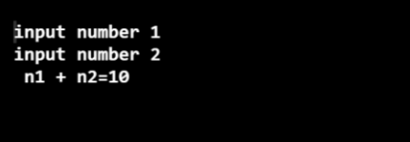

## TO SWAP TWO NUMBERS ALGORITHM:

## 

**PROGRAM:**

//to swap two numbers public class Main

{

public static void main(String[] args)

{

int n1 = 10, n2 = 20;

System.out.println("Before swapping"); System.out.println("First number = " + n1); System.out.println("Second number = " + n2);

n1 = n1 - n2; n2 = n1 + n2; n1 = n2 - n1;

System.out.println("After swapping")

System.out.println("First number = " + n1); System.out.println("Second number = " + n2);

}

}

## OUTPUT:

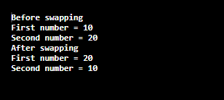

1. **TO CHECK WHETHER NUMBER IS EVEN OR ODD ALGORITHM:**

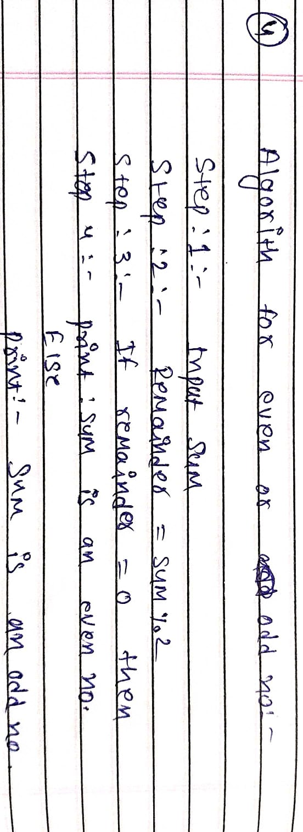

**PROGRAM:**

//to check whether no is even or odd. public class Main

{

public static void main(String[] args)

{

// Declare the integer variable int num = 12;

// If condition to check if the remainder is zero if (num % 2 == 0)

{

// If remainder is zero then this number is even System.out.println("Entered Number is Even")}

else

{

// If remainder is not zero then this number is

// odd

System.out.println("Entered Number is Odd");

}

}

}

## OUTPUT: