|  |  |
| --- | --- |
| **Lab Number:** | **6** |
| **Student Name:** | **Jignesh Harishchandra Bhandi** |
| **Roll No :** | **12** |

# Title:

1. To perform Multiple Inheritance in C++. Create a student class representing student roll number, name and branch and an exam class (derived class of student) representing the scores of the student in various subjects (maths, physics and chemistry) and sports class representing the score in sports. The sports and exam class isinherited by a result class which adds the exam marks and sports score to generate the final result.
2. To perform Hierarchical Inheritance in C++. Create an Employee class with attributes EmpID and EmpSalary. Also create necessary methods/constructors to accept these values from the user. Create classes permenantEmployee and TemporaryEmployee which will be derived classes of Employee. Mention hike attribute in these derived classes and calculate the total salary using generate_salary() method for respective types of employees. Objects of the derived classes should be created and salaries for the permanent and temporary employees should be calculated and displayed on the screen.

# Learning Objective:

* + Students will be able to perform multiple inheritance using C++.

# Learning Outcome:

* + Understanding the inheritance concept and reusability of the code.

# Course Outcome:

|  |  |
| --- | --- |
| **ECL304.2** | Comprehend building blocks of OOPs language, inheritance, package and interfaces |

**Theory:**

* + Explain in details about inheritance, its types, syntaxes and block diagrams.

Solution:- Inheritance is a mechanism of acquiring the features and behaviors of

a class by another class. The class whose members are inherited is called the

base class, and the class thatIS-Ainherits those members is called the deriveclass. InheritanceIS-A

implements

the

relationship.

For example, mammal animal, dog animal as well.

|  |  |  |
| --- | --- | --- |
| IS-A | mammal; Hence dog | IS-A |

12_Jignesh bhandi

OOPs support the six different types of inheritance as given below :

1. Single inheritance
2. Multi-level inheritance
3. Multiple inheritance
4. Multipath inheritance
5. Hierarchical Inheritance
6. Hybrid Inheritance
7. Single inheritance

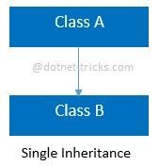

In this inheritance, a derived class is created from a single base class.

In the given example, Class A is the parent class and Class B is the child class since Class B inherits the features and behavior of the parent class A.

Syntax for Single Inheritance

//Base Class class A

{ public void fooA()

{

//TO DO:

}

}

12_Jignesh bhandi

//Derived Class class B : A { public void fooB()

{

//TO DO:

}

}

1. Multi-level inheritance

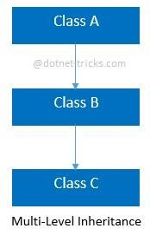

In this inheritance, a derived class is created from another derived class.

In the given example, class c inherits the properties and behavior of class B and class B inherits the properties and behavior of class B. So, here A is the parent class of B and class B is the parent class of C. So, here class C implicitly inherits the pr operties and behavior of class A along with Class B i.e there is a multilevel of inheritance.

Syntax for Multi-level Inheritance

//Base Class class A {

public void fooA()

{

12_Jignesh bhandi

//TO DO:

}

}

//Derived Class class B : A { public void fooB()

{

//TO DO:

}

}

//Derived Class class C : B

{ public void fooC()

{

//TO DO:

}

}

1. Multiple inheritance

12_Jignesh bhandi

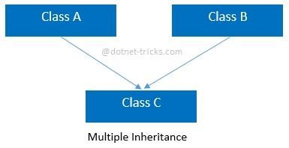

In this inheritance, a derived class is created from more than one base class. This inheritance is not supported by [.NET L](https://www.dotnettricks.com/learn/netframework)anguages like C#, F# etc. and Java Language. In the given example, class c inherits the properties and behavior of class B and class A at same level. So, here A and Class B both are the parent classes for Class C.

Syntax for Multiple Inheritance

//Base Class class A { public void fooA()

{

//TO DO:

}

}

//Base Class class B {

public void fooB()

{

//TO DO:

}

}

12_Jignesh bhandi

//Derived Class class C : A, B

{ public void fooC()

{

//TO DO:

}

}

1. Multipath inheritance

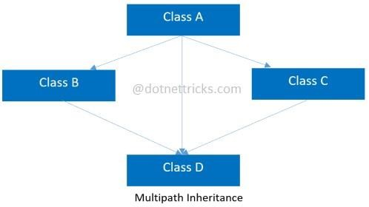

In this inheritance, a derived class is created from another derived classes and the same base class of another derived classes. This inheritance is not supported by .NET Languages like C#, F# etc.

In the given example, class D inherits the properties and behavior of class C and class B as well as Class A. Both class C and class B inherits the Class A. So, Class A is the parent for Class B and Class C as well as Class D. So it's making it Multipath inheritance.

Syntax for Multipath Inheritance

12_Jignesh bhandi

//Base Class class A { public void fooA()

{

//TO DO:

}

}

//Derived Class class B : A { public void fooB()

{

//TO DO:

} }

//Derived Class class C : A

{ public void fooC()

{

//TO DO:

}

}

12_Jignesh bhandi

//Derived Class class D : B, A, C

{ public void fooD()

{

//TO DO:

}

}

1. Hierarchical Inheritance

//Base Class class A { public void fooA()

{

//TO DO:

In this inheritance, more than one derived classes are created from a single base class and futher child classes act as parent classes for more than one child classes. In the given example, class A has two childs class B and class D. Further, class B and class C both are having two childs - class D and E; class F and G respectively.

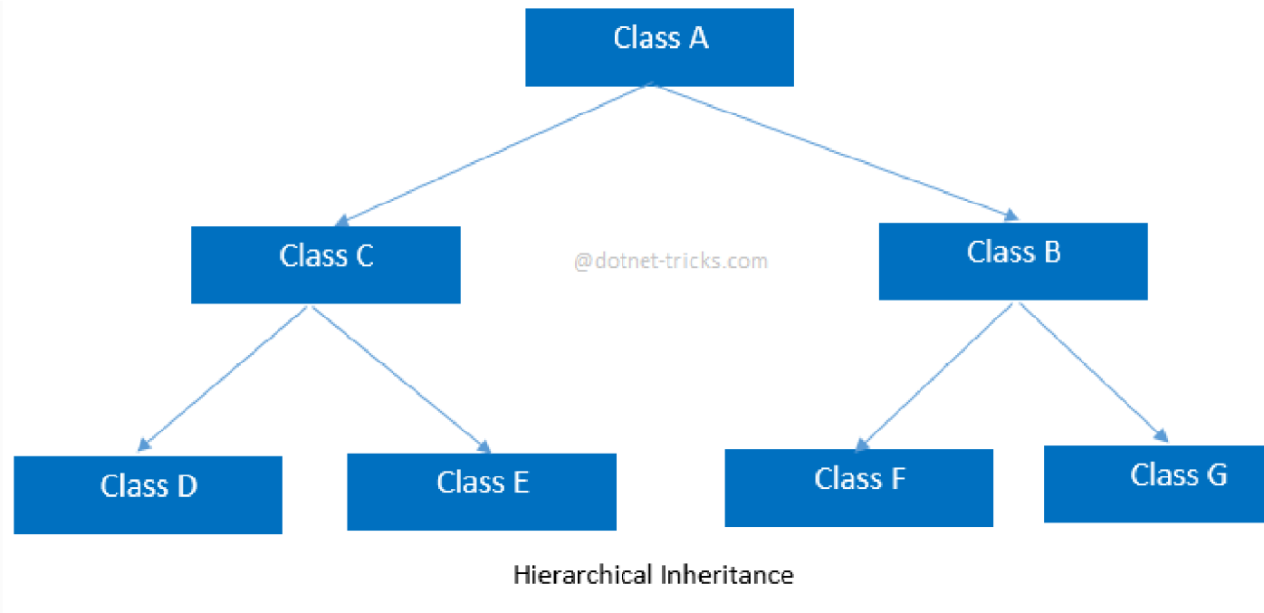

Syntax for Hierarchical Inheritance

}

}

//Derived Class class B : A

{ public void fooB()

12_Jignesh bhandi

{

//TO DO:

}

}

//Derived Class class C : A

{ public void fooC()

{

//TO DO:

}

}

//Derived Class class D : C

{ public void fooD()

{

//TO DO:

}

}

//Derived Class

12_Jignesh bhandi

class E : C

{ public void fooE()

{

//TO DO:

}

}

//Derived Class class F : B

{ public void fooF()

{

//TO DO:

}

}

//Derived Class class G :B

{ public void fooG()

{

//TO DO:

}

}

12_Jignesh bhandi

1. Hybrid inheritance

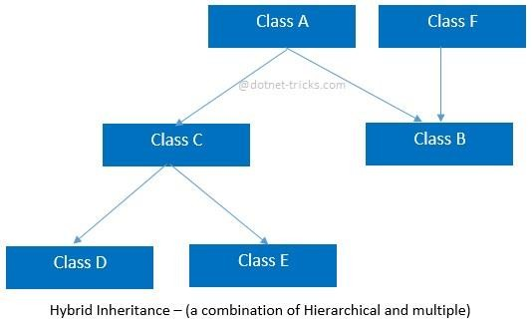

This is combination of more than one inheritance. Hence, it may be a combination of Multilevel and Multiple inheritance or Hierarchical and Multilevel inheritance or Hierarchical and Multipath inheritance or Hierarchical, Multilevel and Multiple inheritance.

Since .NET Languages like [C#,](https://www.dotnettricks.com/learn/csharp) F# etc. does not support multiple and multipath inheritance. Hence hybrid inheritance with a combination of multiple or multipath inheritances is not supported by .NET Languages.

Syntax for Hybrid Inheritance

//Base Class class A { public void fooA()

{

//TO DO:

}

}

12_Jignesh bhandi

//Base Class class F { public void fooF()

{

//TO DO:

}

}

//Derived Class class B : A, F

{ public void fooB()

{

//TO DO:

}

}

//Derived Class class C : A

{ public void fooC()

{

//TO DO:

}

}

//Derived Class class D : C { public void fooD()

{

//TO DO:

}

}

//Derived Class class E : C

{ public void fooE()

{

//TO DO:

}

}

# 6.0(Multiple) :- Input given a=14 b= 22 08 OUTPUT:

12_Jignesh bhandi

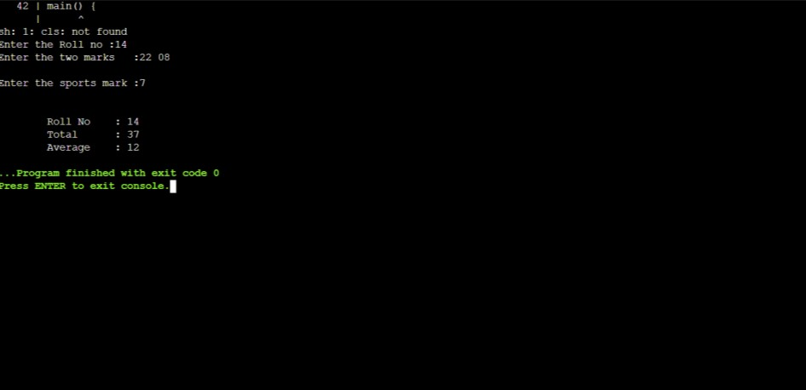

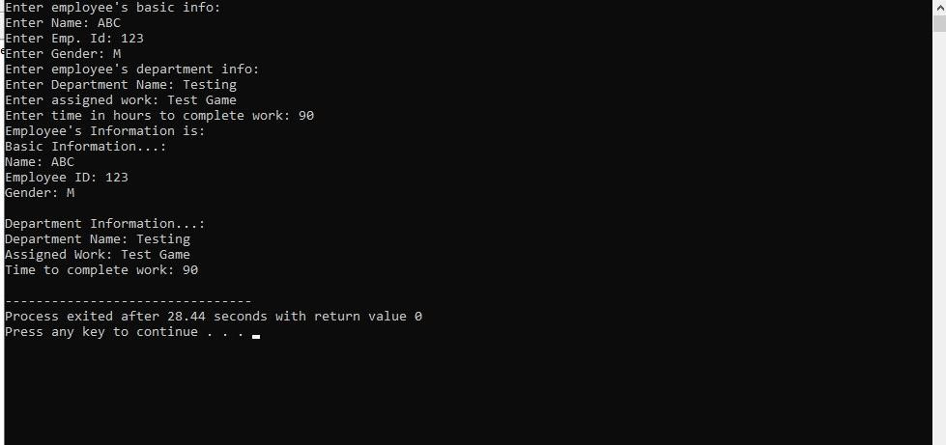**6.1(**Hierarchical) **: - Input given:- a= ABC b= 123 c= M OUTPUT:**