**Chefpuzzle Fixes**

**Date:** 29-07-2025

**1. Recipe displayed in English**

**Description:**  
On the Raw Material page, in the **"Used in Recipe"** section, recipes are displayed in English, even when an Arabic name is available.

**LINK:** [**Chef's Puzzle**](https://chefpuzzle.blubooks.me/raw-material/view?id=njZn)

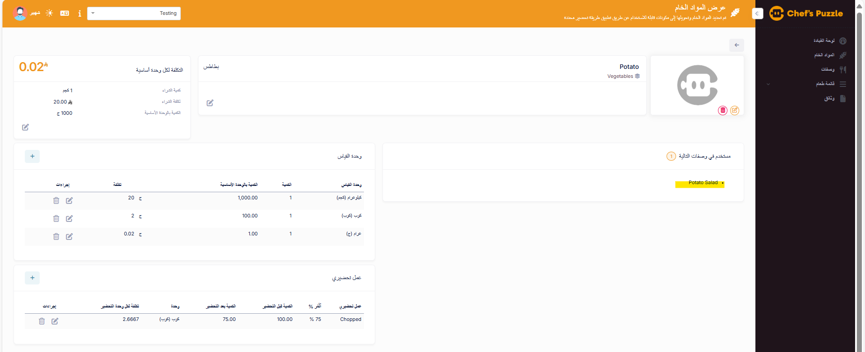

**Issue:**

* Recipe name is displayed in English, despite an existing Arabic name.

**Fixes:**

* Display the Arabic name when available, based on the selected language.

**2. View Recipe Page**

**Description:**

On the **View Recipe** page:

* Raw materials entered without a preparation action are displayed in English.
* In the footer section, the ‘Recipe Create’ and username are also shown in English.

**Expected Behavior:**

All raw materials and Recipe create label should be shown **in Arabic** if Arabic translation exist.

**3. Hours/Minutes labels displayed in English**

**Description:**

The **labels** for Hours and Minutes (e.g., "Hours", "Minutes") are currently shown in **English**, even when the application language is set to **Arabic**

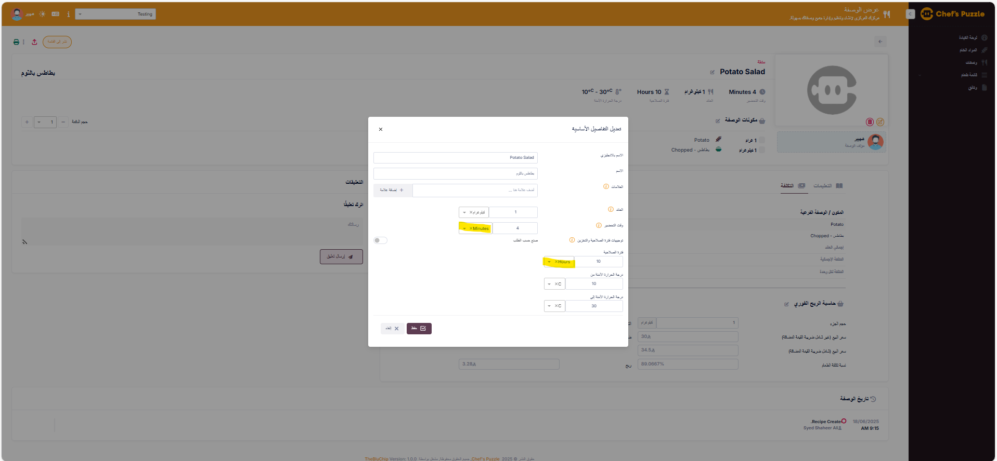

**Expected Behavior:**

The **labels** for Hours and Minutes should be translated and displayed in **Arabic**.

**4. Printing Recipe**

**Description:**

**When printing** from view recipe.The **labels** and **Values** are displayed in English when the application language is set to **Arabic**

**Expected Behavior:**

The **labels** and **Values** should be translated and displayed in **Arabic**.